

The International Committee on Taxonomy of Viruses

Taxonomy Proposal Form, 2025

**Part 1a: Details of taxonomy proposals**

|  |  |
| --- | --- |
| **Title:** | Create one new species in the genus *Kuttervirus* |
| **Code assigned:** | 2025.036B.Kuttervirus_1ns | |

|  |  |  |  |  |
| --- | --- | --- | --- | --- |
| **Author(s), affiliation and email address(es):** | | | | |
| **Given name (+middle initial(s))** | **Surname** | **Affiliation** | **Email address** | **Corr. author(s)** |
| Jinquan | Li | Huazhong Agricultural University, Wuhan, China | [lijinquan2017@163.com](mailto:lijinquan2017@163.com) | X |
| Yang | Zhou | Huazhong Agricultural University, Wuhan, China |  |  |
| Geng | Zou | Huazhong Agricultural University, Wuhan, China |  |  |
| Zhechang | Li | Huazhong Agricultural University, Wuhan, China |  |  |
| Yating | Guo | Huazhong Agricultural University, Wuhan, China |  |  |
|  |  |  |  |  |
|  |  |  |  |  |
|  |  |  |  |  |

**Part 1b: Taxonomy Proposal Submission**

|  |  |  |  |
| --- | --- | --- | --- |
| **ICTV Subcommittee:** | | | |
| Animal DNA Viruses and Retroviruses |  | Bacterial viruses | X |
| Animal minus-strand and dsRNA viruses |  | Fungal and protist viruses |  |
| Animal positive-strand RNA viruses |  | Plant viruses |  |
| Archaeal viruses |  | General - |  |

|  |
| --- |
| **List the ICTV Study Group(s) that have seen or have been involved in creating this proposal:** |
| Bacterial Viruses |

|  |  |  |  |
| --- | --- | --- | --- |
| **Optional – complete only if formally voted on by an ICTV Study Group:** | | | |
| **Study Group** | **Number of members** | | |
| **Votes in support** | **Votes against** | **No vote** |
|  |  |  |  |
|  |  |  |  |

|  |  |
| --- | --- |
| **Submission date:** | 17/02/2025 |

**Part 1c: Feedback from ICTV Executive Committee (EC) meeting**

|  |  |
| --- | --- |
| **Executive Committee Meeting Decision code:** | **X** |
| A – Accept |  |
| Ac – Accept subject to revision by relevant subcommittee chair. No further vote required |  |
| U – Accept without revision but with re-evaluation and email vote by the EC |  |
| Uc – Accept subject to revision and re-evaluation and email vote by the EC |  |
| Ud – Deferred to the next EC meeting, with an invitation to revise based on EC comments |  |
| J - Reject |  |
| W - Withdrawn |  |

|  |
| --- |
| **Comments from the Executive Committee:** |
|  |

**Part 1d: Revised Taxonomy Proposal Submission**

|  |
| --- |
| **Response of proposer:** |
|  |

|  |  |
| --- | --- |
| **Revision date:** |  |

**Part 2:** **GENERAL PROPOSAL**

|  |
| --- |
| **Abstract for General Proposal:** |
| *Brief description of current situation:*  *Proposed changes:*  *Justification:* |

|  |
| --- |
| **Text of General Proposal:** |
| *Background:*  *Proposed* *changes:*  *Justification:* |

|  |
| --- |
| **References:** |
|  |

|  |  |
| --- | --- |
| **Accompanying files:** | |
| **Filename** | **Description of contents** |
|  |  |
|  |  |

|  |
| --- |
| **Tables, Figures:** |

<Start here>

**Part 3:** **TAXONOMIC PROPOSAL**

<https://ictv.global/taxonomy/templates>

|  |  |  |  |
| --- | --- | --- | --- |
| **Taxonomic changes proposed:** | | | |
| Establish new taxon | **X** | Split taxon |  |
| Abolish taxon |  | Merge taxon |  |
| Move taxon |  | Promote taxon |  |
| Rename taxon |  | Demote taxon |  |
| Move and rename |  |

|  |  |
| --- | --- |
| **Etymology (origin) of proposed taxonomic names:** | |
| **Taxon name** | **Etymology of the term** |
|  |  |
|  |  |
|  |  |
|  |  |

|  |  |  |
| --- | --- | --- |
| **Permission for use of names derived from a living person:** | | |
| **Taxon name** | **Full name of person from whom the name is derived** | **Attached** |
|  |  |  |
|  |  |  |
|  |  |  |
|  |  |  |

|  |
| --- |
| **Abstract of Taxonomy Proposal:** |
| *Taxonomic rank(s) affected*:  Realm *Duplodnaviria*, kingdom *Heunggongvirae*, phylum *Uroviricota*, class *Caudoviricetes* , family *Ackermannviridae,* subfamily *Cvivirinae*  *Description of current taxonomy*:  The genus *Kuttervirus* was established in 2017 (proposal [2017.001B.A.v3.Ackermannviridae)](https://ictv.global/ictv/proposals/2017.001B.A.v3.Ackermannviridae.zip) The genus consists of 40 species.  *Proposed* *taxonomic change(s):*  To create one new species “*Kuttervirus LPST100”* in the genus *Kuttervirus*.  *Justification*:  A new *Salmonella* phage LPST100 was isolated. VIRIDIC and ViPTree analysis showed that LPST100 has 94.6% identity with *Salmonella* phageBSP101, classified as the species *Kuttervirus* BSP101. *Salmonella* phageLPST100 shares many properties with BSP101but differs significantly enough (less than 95% identity with *Kuttervirus* BSP101 species) to classify it as a separate species of this genus. Thus, this proposal will placeLPST100 in the genus *Kuttervirus* as a new species*.* |

|  |
| --- |
| * **Text of Taxonomy proposal:** |
| *Taxonomic rank(s) affected*:  Realm *Duplodnaviria*, kingdom *Heunggongvirae*, phylum *Uroviricota*, class *Caudoviricetes* , family *Ackermannviridae,* subfamily *Cvivirinae*  *Description of current taxonomy*:  The genus *Kuttervirus* was established in 2017 (proposal [2017.001B.A.v3.Ackermannviridae)](https://ictv.global/ictv/proposals/2017.001B.A.v3.Ackermannviridae.zip) The genus consists of 40 species.  *Proposed* *taxonomic change(s)*:  To create one new species “*Kuttervirus LPST100”* in the genus *Kuttervirus*.  *Demarcation criteria:*  Species demarcation: Two phages are assigned to the same species if their genomes are more than 95% identical over their genome length for isolates. These values can be calculated by a number of tools, such as BLASTn – usually calculated using intergenomic distance calculator VIRIDIC [1].  Genus demarcation:The Bacterial Viruses Subcommittee has established 70% nucleotide identity of the genome length as the cut-off for genera. Genus-level groupings should always be monophyletic in the signature genes, as tested with a phylogenetic tree. [2]  *Justification*:  A tblastx distance tree of *Salmonella* phage LPST100 was constructed using VIPTree[3-4] (Figure 1). LPST100, along with 40 other phages fell formed a single clade and 12 phages were selected for VIRIDIC analysis. VIRIDIC analysis computed the pairwise genomic distances and similarities between the phage genomes, revealing significant divergence between LPST100 from the phages of other species, with homology levels below 95%(Figure 2). Furthermore, a maximum-likelihood (ML) tree was constructed using the terminase large subunit of the 20 phages, with 1000 bootstrap replicates [5-6] . (Figure 3)In conclusion, we propose a new species, *Kuttervirus LPST100* within the genus *Kuttervirus.* |

|  |
| --- |
| **References:** |
| 1. Moraru C, Varsani A, Kropinski AM (2020) VIRIDIC-A Novel Tool to Calculate the Intergenomic Similarities of Prokaryote-Infecting Viruses. Viruses 12(11):1268. PMID: 33172115 / PMCID: PMC7694805 doi: 10.3390/v12111268. 2. Turner D, Kropinski AM, Adriaenssens EM (2021) A Roadmap for Genome-Based Phage Taxonomy. Viruses 13(3):506. PMID: 33803862 / PMCID: PMC8003253 doi: 10.3390/v13030506. 3. Nishimura Y, Yoshida T, Kuronishi M et al (2017) ViPTree: the viral proteomic tree server. Bioinformatics 33(15):2379-2380. PMID: 28379287. doi: 10.1093/bioinformatics/btx157. 4. Rohwer F, Edwards R (2002) The Phage Proteomic Tree: a genome-based taxonomy for phage. J Bacteriol 184(16):4529-35. PMID: 12142423 / PMCID: PMC135240. doi: 10.1128/jb.184.16.4529-4535.2002. 5. Nishijima S, Nagata N, Kiguchi Y et al (2022) Extensive gut virome variation and its associations with host and environmental factors in a population-level cohort. Nat Commun 13(1):5252. PMID: 36068216 / PMCID: PMC9448778 doi: 10.1038/s41467-022-32832-w 6. L. Nguyen, H.A. Schmidt, A. von Haeseler, B.Q. Minh (2015) IQ-TREE: A Fast and Effective Stochastic Algorithm for Estimating Maximum-Likelihood Phylogenies. *Mol. Biol. and Evol.*, 32:268-274. |

|  |  |
| --- | --- |
| **Accompanying files:** | |
| **Filename** | **Description of contents** |
|  |  |
|  |  |

|  |
| --- |
| **Tables, Figures:** |

Figure 1. **ViPTree analysis:** ViPTree analysis (https://www.genome.jp/viptree/; [3]) is based upon Rohwer and Edwards (2002) Phage Proteomic Tree [4]. The phages of interest are indicated with **red box and LPST100 by a red star**.

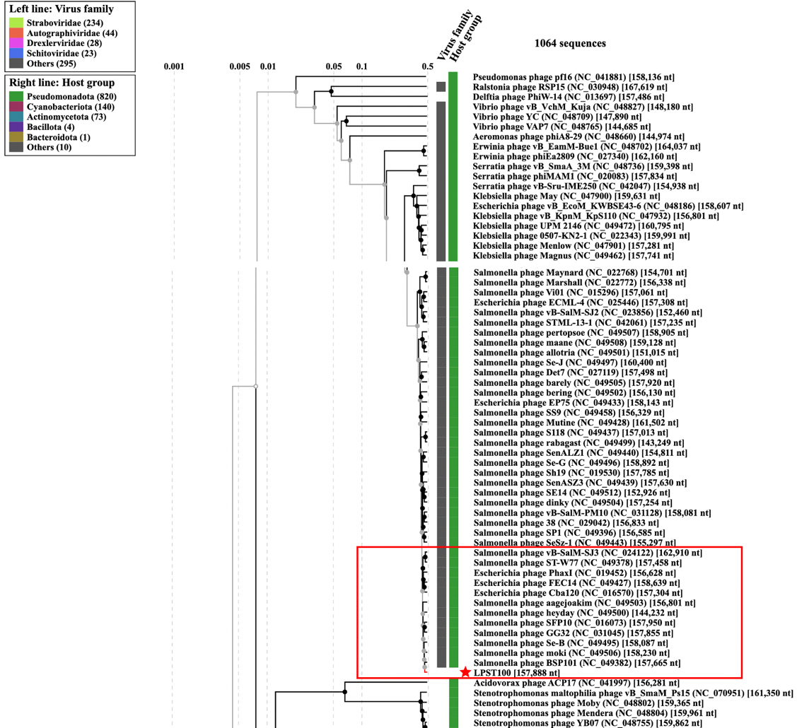

Figure 1

**Figure 2. VIRIDIC heat map:** VIRIDIC (Virus Intergenomic Distance Calculator [1]; http://rhea.icbm.uni-oldenburg.de/VIRIDIC/) computes pairwise intergenomic distances/similarities amongst phage genomes.

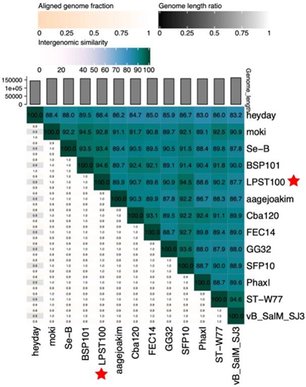

Figure 2. **Phylogeny:** The phylogenetic tree was constructed using the major head protein of phages. Clustal Omega was used for multiple alignment and IQ-TREE was used for inferring the phylogenetic tree using the maximum-likelihood method with 1000 bootstrap replicates. The tree is rooted at the mid-point.

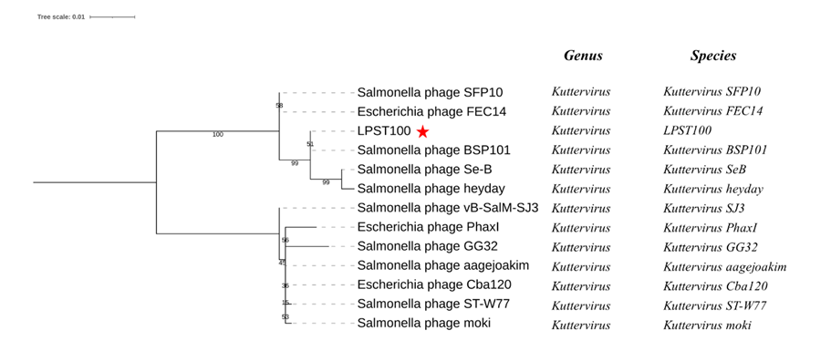Figure 3

**Historical aspects:** Salmonella phage LPST100 was isolated in 2022 by Huazhong Agricultural University, using *Salmonella Typhimurium ATCC13311* the host bacterium.

**Genome summary:**

|  |  |  |  |  |  |
| --- | --- | --- | --- | --- | --- |
| Phage name | INSDC | Size (Kb) | GC% | Protein | tRNA |
| Salmonella phage LPST100 | PP895301 | 157,888 | 44.6 | 209 | 0 |