

The International Committee on Taxonomy of Viruses

Taxonomy Proposal Form, 2025

**Part 1a: Details of taxonomy proposals**

|  |  |
| --- | --- |
| **Title:** | Create a new genus (*Koserivirus*) with a single species to the *Tevenvirinae* subfamily (class *Caudoviricetes*, order *Pantevenvirales*, family *Straboviridae*) |
| **Code assigned:** | 2025.035B.Koserivirus_1ng_1ns | |

|  |  |  |  |  |
| --- | --- | --- | --- | --- |
| **Author(s), affiliation and email address(es):** | | | | |
| **Given name (+middle initial(s))** | **Surname** | **Affiliation** | **Email address** | **Corresponding author(s)** |
| Michał J. | Wójcicki | Bacteriophage Laboratory, Department of Phage Therapy, Hirszfeld Institute of Immunology and Experimental Therapy, Polish Academy of Sciences, Wroclaw, Poland | [michal.wojcicki@hirszfeld.pl](mailto:michal.wojcicki@hirszfeld.pl) | X |
| Martyna A. | Cieślik | Bacteriophage Laboratory, Department of Phage Therapy, Hirszfeld Institute of Immunology and Experimental Therapy, Polish Academy of Sciences, Wroclaw, Poland | [martyna.cieslik@hirszfeld.pl](mailto:martyna.cieslik@hirszfeld.pl) | X |

**Part 1b: Taxonomy Proposal Submission**

|  |  |  |  |
| --- | --- | --- | --- |
| **ICTV Subcommittee:** | | | |
| Animal DNA Viruses and Retroviruses |  | Bacterial viruses | X |
| Animal minus-strand and dsRNA viruses |  | Fungal and protist viruses |  |
| Animal positive-strand RNA viruses |  | Plant viruses |  |
| Archaeal viruses |  | General |  |

|  |
| --- |
| **List the ICTV Study Group(s) that have seen or have been involved in creating this proposal:** |
| *Caudoviricetes Study Group* |

|  |  |  |  |
| --- | --- | --- | --- |
| **Optional – complete only if formally voted on by an ICTV Study Group:** | | | |
| **Study Group** | **Number of members** | | |
| **Votes in support** | **Votes against** | **No vote** |
|  |  |  |  |
|  |  |  |  |

|  |  |
| --- | --- |
| **Submission date:** | 20/03/2025 |

**Part 1c: Feedback from ICTV Executive Committee (EC) meeting**

|  |  |
| --- | --- |
| **Executive Committee Meeting Decision code:** | **X** |
| A – Accept |  |
| Ac – Accept subject to revision by relevant subcommittee chair. No further vote required |  |
| U – Accept without revision but with re-evaluation and email vote by the EC |  |
| Uc – Accept subject to revision and re-evaluation and email vote by the EC |  |
| Ud – Deferred to the next EC meeting, with an invitation to revise based on EC comments |  |
| J - Reject |  |
| W - Withdrawn |  |

|  |
| --- |
| **Comments from the Executive Committee:** |
|  |

**Part 1d: Revised Taxonomy Proposal Submission**

|  |
| --- |
| **Response of proposer:** |
|  |

|  |  |
| --- | --- |
| **Revision date:** |  |

**Part 3:** **TAXONOMIC PROPOSAL**

|  |  |  |  |
| --- | --- | --- | --- |
| **Taxonomic changes proposed:** | | | |
| Establish new taxon | X | Split taxon |  |
| Abolish taxon |  | Merge taxon |  |
| Move taxon |  | Promote taxon |  |
| Rename taxon |  | Demote taxon |  |
| Move and rename |  |

|  |  |
| --- | --- |
| **Etymology (origin) of proposed taxonomic names:** | |
| **Taxon name** | **Etymology of the term** |
| *Koserivirus* | The name of the genus derived from the name of the bacterial host for this phage, which is the only representative of the newly created species – *Citrobacter koseri* (according to the GenBank database) |
| *Koserivirus CkP1* | Species name derived from the phage name in the GenBank database – Citrobacter phage CkP1 |

|  |  |  |
| --- | --- | --- |
| **Permission for use of names derived from a living person** | | |
| **Taxon name** | **Full name of person from whom the name is derived** | **Attached** |
|  |  |  |

|  |
| --- |
| **Abstract of Taxonomy Proposal:** |
| *Taxonomic rank(s) affected*:  *Realm Duplodnaviria, kingdom Heunggongvirae, phylum Uroviricota, class Caudoviricetes*, order *Pantevenvirales*, family *Straboviridae.*  *Description of current taxonomy*:  Currently, the order *Pantevenvirales* includes three families: *Ackermannviridae*, *Kyanoviridae*, and *Straboviridae*. Within the *Straboviridae* family, three subfamilies have been distinguished: *Emmerichvirinae*, *Tevenvirinae*, and *Twarogvirinae*. The *Tevenvirinae* subfamily comprises 15 genera and 148 species.  *Proposed* *taxonomic change(s):*  We performed genomic analysis of Citrobacter phage CkP1. Genome and protein analyses suggest that this bacteriophage belongs to the *Tevenvirinae* subfamily. Still, the differences are too great to assign it to one of the 15 genera within this subfamily. Therefore, we propose to create a new genus, “*Koserivirus”*, with one species – “*Koserivirus CkP1”*.  *Justification*:  DNA and protein analysis to other species and genera in the family *Straboviridae* supports the establishment of a new genus. |

|  |
| --- |
| **Text of Taxonomy proposal:** |
| *Taxonomic rank(s) affected*:  *Realm Duplodnaviria, kingdom Heunggongvirae, phylum Uroviricota, class Caudoviricetes*, order *Pantevenvirales*, family *Straboviridae.*  *Description of current taxonomy*:  Currently, the order *Pantevenvirales* includes three families: *Ackermannviridae*, *Kyanoviridae*, and *Straboviridae*. Within the *Straboviridae* family, three subfamilies have been distinguished: *Emmerichvirinae*, *Tevenvirinae*, and *Twarogvirinae*. The *Tevenvirinae* subfamily comprises 15 genera and 148 species.  *Proposed* *taxonomic change(s)*:  We performed genomic analysis of Citrobacter phage CkP1. Genome and protein analyses suggest that this bacteriophage belongs to the *Tevenvirinae* subfamily. However, the differences are too great to assign it to one of the 15 existing genera within this subfamily. Therefore, we propose to create a new genus, “*Koserivirus”*, with one species – “*Koserivirus CkP1”*.  *Demarcation criteria:*  **Species demarcation criteria:** Two phages are assigned to the same species if their genomes are more than 95% identical over their genome length for isolates.  These values can be calculated by several tools, such as BLASTn [1] – usually calculated using the intergenomic distance calculator VIRIDIC [2].  **Genus demarcation criteria:** In search for criteria that create cohesive and distinct genera that are reproducible and monophyletic, the Bacterial Viruses Subcommittee has established 70% nucleotide identity of the genome length as the cut-off for genera. Genus-level groupings should always be monophyletic in the signature genes, as tested with a phylogenetic tree [3].  *Justification*:  DNA and protein analysis to other species and genera in the family *Straboviridae* support the establishment of a new genus. |

|  |
| --- |
| **References:** |
| 1. Sayers EW, Beck J, Bolton EE, Bourexis D, Brister JR, Canese K, Comeau DC, Funk K, Kim S, Klimke W, Marchler-Bauer A, Landrum M, Lathrop S, Lu Z, Madden TL, O'Leary N, Phan L, Rangwala SH, Schneider VA, Skripchenko Y, Wang J, Ye J, Trawick BW, Pruitt KD, Sherry ST. Database resources of the National Center for Biotechnology Information. *Nucleic Acids Res.* 2021, 49(D1):D10-D17. 2. Moraru C, Varsani A, Kropinski AM. VIRIDIC - a novel tool to calculate the intergenomic similarities of prokaryote-infecting viruses. *Viruses* 2020, 12(11):1268. 3. Turner D, Kropinski AM, Adriaenssens EM. A roadmap for genome-based phage taxonomy. *Viruses* 2021, 13(3):506. 4. Nishimura Y, Yoshida T, Kuronishi M, Uehara H, Ogata H, Goto S. ViPTree: the viral proteomic tree server. *Bioinformatics* 2017, 33(15):2379-2380. 5. Rohwer F, Edwards R. The Phage Proteomic Tree: a genome-based taxonomy for phage. *J. Bacteriol.* 2002, 184(16):4529-35. 6. Mihara T, Nishimura Y, Shimizu Y, Nishiyama H, Yoshikawa G, Uehara H, Hingamp P, Goto S, Ogata H. Linking virus genomes with host taxonomy. *Viruses* 2016 8(3):66. |

|  |  |
| --- | --- |
| **Accompanying files:** | |
| **Filename** | **Description of contents** |
|  |  |
| **Tables, Figures:** | |

**Figure 1. VIRIDIC heat map:** VIRIDIC (Virus Intergenomic Distance Calculator [2]; http://rhea.icbm.uni-oldenburg.de/VIRIDIC/) computes pairwise intergenomic distances/similarities amongst phage genomes. The **red boxes** delineate Citrobacter phage CkP1.

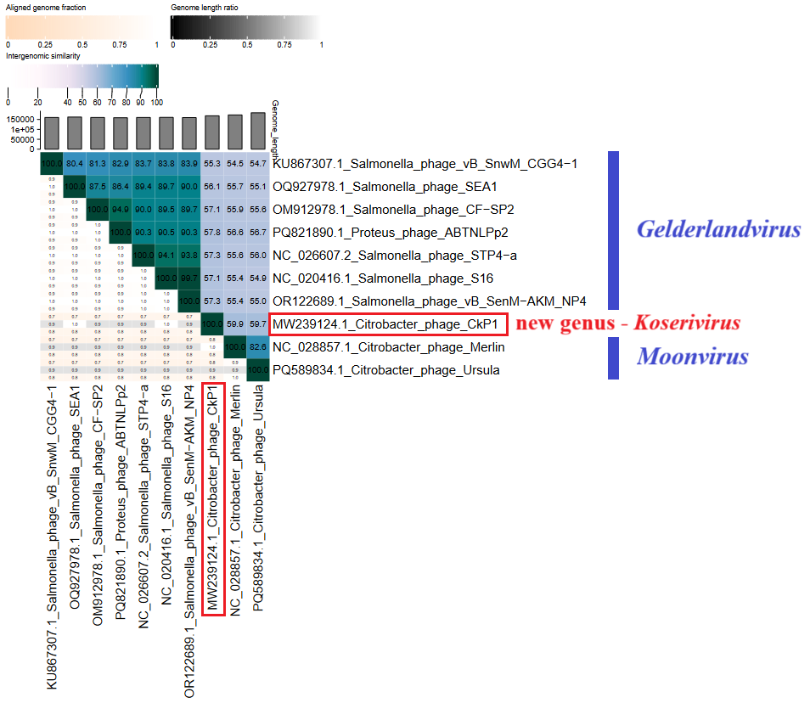

**Figure 2. ViPTree analysis*:** ViPTree analysis (https://www.genome.jp/viptree/; [4]) is based upon Rohwer and Edwards (2002) Phage Proteomic Tree [5]. The Citrobacter phage CkP1 is indicated with a **red line**.

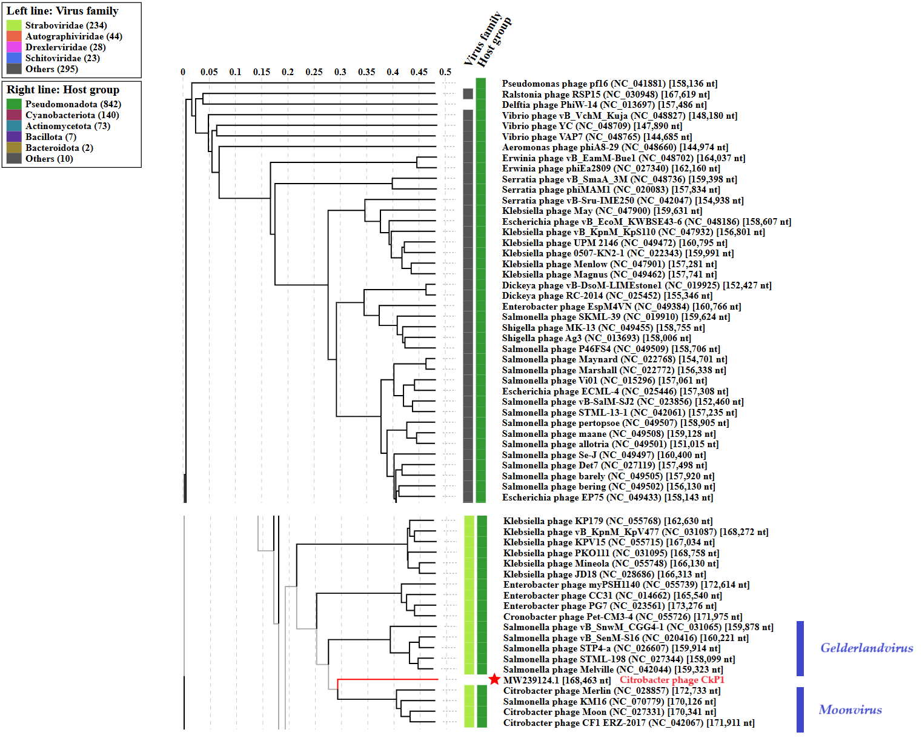

* The *Autographiviridae* family shown in **Figure 2** (automatically labeled by the software) is outdated. In 2025, the *Autographiviridae* family was elevated to the rank of order and renamed *Autographivirales*.

The viral proteomic tree of the Citrobacter phage CkP1 is below shown in a circular view. The branch represented by the phage under study is marked with a **red asterisk**. The colored rings indicate the virus family (inner rings) and host groups (at the phylum level; outer rings). The tree was calculated by BIONJ based on the genomic distance matrix and rooted at the midpoint. Branch lengths are log-scaled. Sequence and taxonomic data were based on the Virus-Host DB [6]. The tree shown was generated using the ViPTree server**\*** [4].

**Figure 3.** The viral proteomic tree of Citrobacter phage CkP1 and other phage genomes are represented in the circular view.

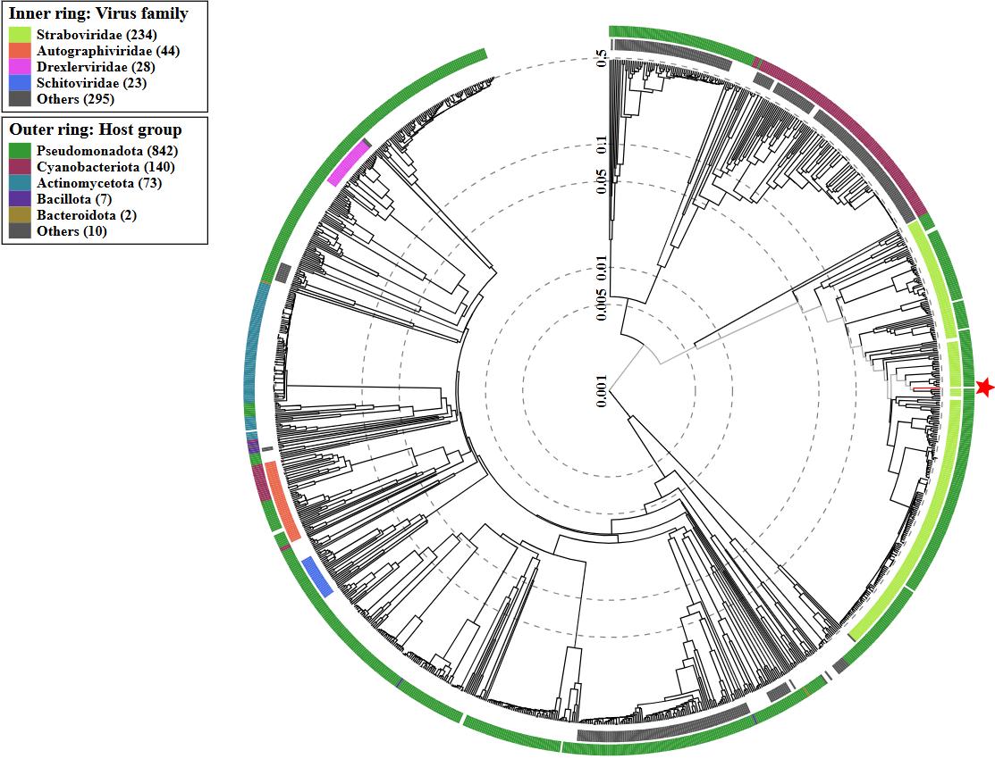

* The *Autographiviridae* family shown in **Figure 3** (automatically labeled by the software) is outdated. In 2025, the *Autographiviridae* family was elevated to the rank of order and renamed *Autographivirales*.

**Genome summary:**

|  |  |  |  |  |  |  |
| --- | --- | --- | --- | --- | --- | --- |
| **Phage name** | **GenBank accession number** | **Size (bp)** | **GC%** | **Genes** | **Protein-coding** | **tRNA** |
| Citrobacter phage CkP1 | MW239124.1 | 168,463 | 36.9 | 302 | 291 | 11 |

**Rationale:** Based on the comparison of its protein regions, Citrobacter phage CkP1 is related to phages from the *Caudoviricetes* class, *Straboviridae* family and *Tevenvirinae* subfamily.Genome and protein analyses suggest that this bacteriophage belongs to the *Tevenvirinae* subfamily, but the differences are too great to assign it to one of the 15 genera within this subfamily.Therefore, we propose to create a new genus, *Koserivirus*, with one species – *Koserivirus CkP1*.