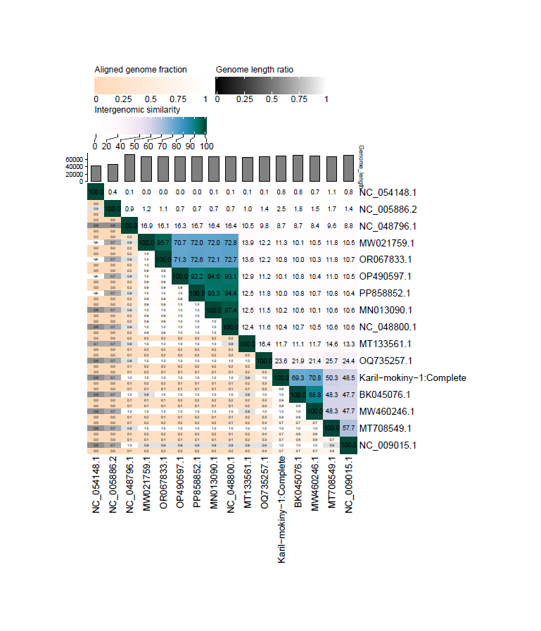

**Figure 1: Average nucleotide identity (ANI %) of Karil-mokiny-1 with 18 of its closest relative viruses available in NCBI.** Analysis was completed using the VIRIDIC Web Based Server tool with default parameters. Analysis retrieved 18.03.25