

The International Committee on Taxonomy of Viruses

Taxonomy Proposal Form, 2024

<https://ictv.global/taxonomy/templates>**Part 1a: Details of taxonomy proposals**

|  |  |  |
| --- | --- | --- |
| **Title:** | Establishment of a new *Burkholderia* phage genus “*Karilavirus*” with a single species | |
| **Code assigned:** | 2025.033B.Karilavirus_1ng_1ns |

|  |  |  |  |
| --- | --- | --- | --- |
| **Author(s), affiliation and email address(es):** | | | |
| **Name** | **Affiliation** | **Email address** | **Corresponding author(s)** X |
| **Canning JS** | Wal-Yan Respiratory Research Centre, Telethon Kids Institute, Perth, Australia | **Jack.canning@thekids.org.au** | **X** |
| **Ling K** | Wal-Yan Respiratory Research Centre, Telethon Kids Institute, Perth, Australia |  |  |
| **Laucirica DR** | Wal-Yan Respiratory Research Centre, Telethon Kids Institute, Perth, Australia |  |  |
| **Iszatt JJ** | Wal-Yan Respiratory Research Centre, Telethon Kids Institute, Perth, Australia |  |  |
| **Vaitekenas A** | Wal-Yan Respiratory Research Centre, Telethon Kids Institute, Perth, Australia |  |  |
| **Stick SM** | Wal-Yan Respiratory Research Centre, Telethon Kids Institute, Perth, Australia |  |  |
| **Kicic A** | Wal-Yan Respiratory Research Centre, Telethon Kids Institute, Perth, Australia |  |  |

**Part 1b: Taxonomy Proposal Submission**

|  |  |  |  |
| --- | --- | --- | --- |
| **ICTV Subcommittee:** | | | |
| Animal DNA Viruses and Retroviruses |  | Bacterial viruses | **X** |
| Animal minus-strand and dsRNA viruses |  | Fungal and protist viruses |  |
| Animal positive-strand RNA viruses |  | Plant viruses |  |
| Archaeal viruses |  | General - |  |

|  |
| --- |
| **List the ICTV Study Group(s) that have seen or have been involved in creating this proposal:** <https://ictv.global/sc> |
| Caudoviricetes Study Group |

|  |  |  |  |
| --- | --- | --- | --- |
| **Optional – complete only if formally voted on by an ICTV Study Group:** | | | |
| **Study Group** | **Number of members** | | |
| **Votes in support** | **Votes against** | **No vote** |
|  |  |  |  |
|  |  |  |  |

|  |  |
| --- | --- |
| **Submission date:** | 16/12/2025 |

**Part 1c: Feedback from ICTV Executive Committee (EC) meeting**

|  |  |
| --- | --- |
| **Executive Committee Meeting Decision code:** | **X** |
| A – Accept |  |
| Ac – Accept subject to revision by relevant subcommittee chair. No further vote required |  |
| U – Accept without revision but with re-evaluation and email vote by the EC |  |
| Uc – Accept subject to revision and re-evaluation and email vote by the EC |  |
| Ud – Deferred to the next EC meeting, with an invitation to revise based on EC comments |  |
| J - Reject |  |
| W - Withdrawn |  |

|  |
| --- |
| **Comments from the Executive Committee:** |
|  |

**Part 1d: Revised Taxonomy Proposal Submission**

|  |
| --- |
| **Response of proposer:** |
|  |

|  |  |
| --- | --- |
| **Revision date:** | DD/MM/YYYY |

**Part 3:** **TAXONOMIC PROPOSAL**

<https://ictv.global/taxonomy/templates>

|  |
| --- |
| **Name of accompanying Excel module:** |
| Karilavirus_1ng_1ns.xlsx |

|  |  |  |  |
| --- | --- | --- | --- |
| **Taxonomic changes proposed:** | | | |
| Establish new taxon | **X** | Split taxon |  |
| Abolish taxon |  | Merge taxon |  |
| Move taxon |  | Promote taxon |  |
| Rename taxon |  | Demote taxon |  |
| Move and rename |  |

|  |  |  |
| --- | --- | --- |
| **Is any taxon name used here derived from that of a living person:** | | **No** |
| **Taxon name** | **Person from whom the name is derived** | **Attached X** |
| N/A | N/A | N/A |
|  |  |  |
|  |  |  |

|  |
| --- |
| **Abstract of Taxonomy Proposal:** |
| *Taxonomic rank(s) affected*:  We propose a new single-species genus in this taxonomy, and hence this will be the only rank affected.  *Description of current taxonomy*:  The current taxonomy for dsDNA bacterial viruses for the proposed change is as follows; *Duplodnaviria, Heunggongvirae, Uroviricota, Caudoviricetes, Bcepfunavirus*  *Proposed* *taxonomic change(s):*  We propose to establish a new genus of viruses in the *Caudoviricetes* class, which we tentatively name “*Karilavirus*”.  *Justification*:  The new species of phage possessed significant sequence divergence from known dsDNA bacterial viruses which meet the criteria for the establishment of a new genus. Karil-mokiny-1 possessed 48.4% average nucleotide identity (ANI%) to meet the requirements for a new genus of viruses. Its closest relative is a *Bcepfunavirus*, BcepF1. Currently, the genus *Bcepfunavirus* fall under the following ICTV taxonomy; *Duplodnaviria, Heunggongvirae, Uroviricota, Caudoviricetes.* |

|  |
| --- |
| * **Text of Taxonomy proposal:** |
| *Taxonomic rank(s) affected*:  The *Caudoviricetes* class of dsDNA bacterial viruses will have a new genus, *Karilavirus*  *Description of current taxonomy*:  Currently, the most related virus to Karil-mokiny-1 is a *Bcepfunavirus* named BcepF1. This phage uses *Burkholderia ambifaria* as its host. The current taxonomic ranking of Bcepfunavirus is as follows; *Duplodnaviria, Heunggongvirae, Uroviricota, Caudoviricetes, Bcepfunavirus.*  *Proposed* *taxonomic change(s)*:  We propose the addition of a new phage genus, *Karilavirus* in the Caudoviricetes class of bacterial dsDNA viruses. The name originates from that of its founding member, Karil-mokiny-kep-djiraly-karakaata-Wadjak (Karil-mokiny-1). This project was conducted on the traditional homelands of the Noongar people, with phages isolated from waters across Noongar Wadjak. We thank Sharon Gregory and Walyalap Waangkan Noongar language team, who named the phages in this study in Wadjak Noongar language. Karil-mokiny-kep-djiraly-karakaata-Wadjak-1 translates as “crab-like (from) water northern karrakatta-wadjak”.  *Demarcation criteria:*  We followed the ICTV demarcation criteria for species and genus level cutoffs, which are currently set at <95% and <70% average nucleotide identity (ANI%), respectively (1).  *Justification*:  The whole genome of Karil-mokiny-1 was aligned to its closest relative available on NCBI. We found that Karil-mokiny-1 possesses only 48.4% average nucleotide identity with BcepF1 (Fig 1). Based on current ICTV taxonomy, the requirement for the establishment of a new viral genus is < 70% ANI (1). Due to low ANI% with its closest relative, we also wished to view the novelty of Karil-mokiny’s genome in a broader context. We constructed a proteomic tree using ViPTree (2), and found that Karil-mokiny fits into a clade with other phages without family level classification (Fig 2). We concluded that Karil-mokiny likely shares a family with these phages and hence, we propose that Karil-mokiny-1 likely represents the first described member of a new genus, which we tentatively name the *Karilavirus* genus. Karil-mokiny-1 currently possesses 2 known hosts; a *B. cenocepacia* and *B. latens* clinical isolate from CF sputum. BcepF1 uses a *B. ambifaria* isolate as its host, which is one of the 24 species within the *Burkholderia cepacia* complex, along with *B. cenocepacia* and *B. latens*. Therefore, “*Karilavirus”* represents a new genus of phage infecting members of the *B. cepacia* complex, and hence should share a taxonomic rank with *Bcepfunavirus* to the next highest described taxa (class *Caudoviricetes*) |

|  |
| --- |
| **References:** |
| 1. Turner D, Kropinski AM, Adriaenssens EM. A roadmap for genome-based phage taxonomy. Viruses. 2021;13(3):506.  2. Nishimura Y, Yoshida T, Kuronishi M, Uehara H, Ogata H, Goto S. ViPTree: the viral proteomic tree server. Bioinformatics. 2017;33(15):2379-80. |

|  |
| --- |
| **Tables, Figures:** |

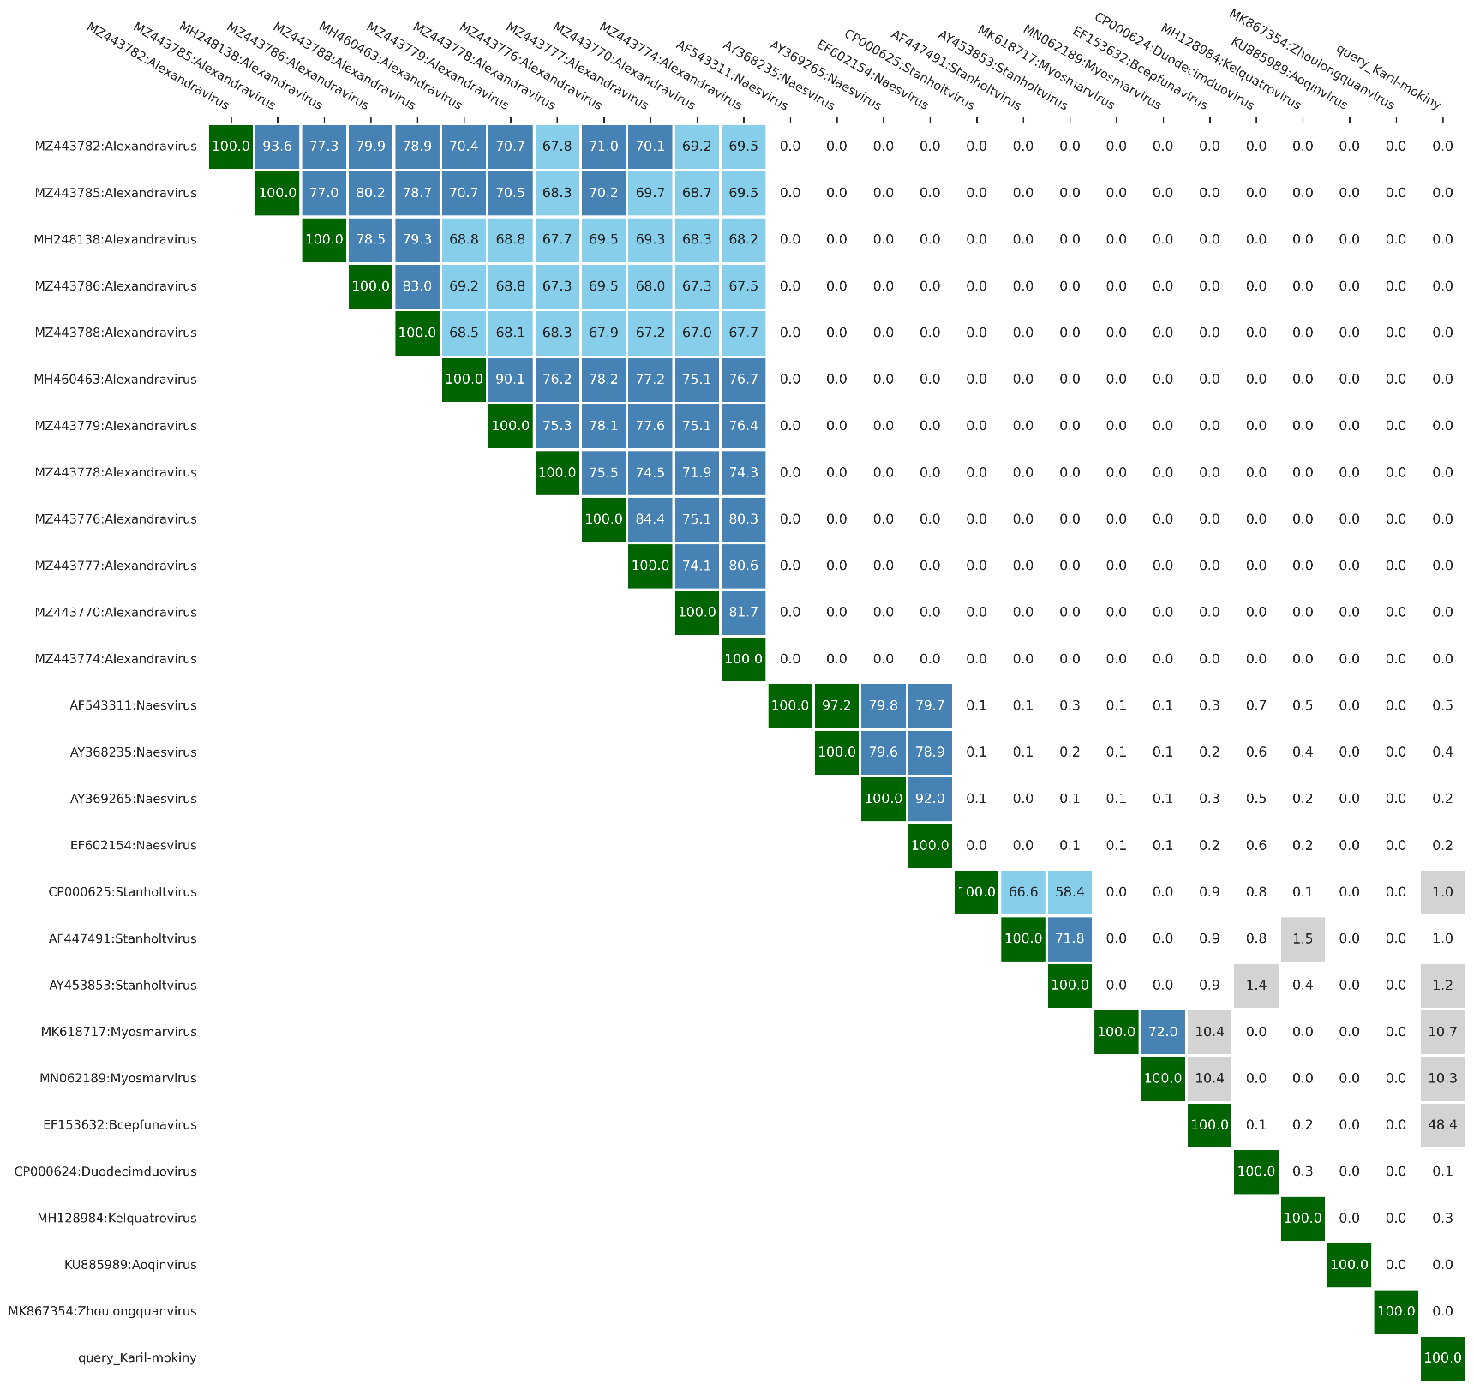**Figure 1: Average nucleotide identity (ANI %) of Karil-mokiny-1 with 26 of its closest relative viruses available in NCBI.** ANI of Karil-mokiny-1 and *Bcepfunavirus* BcepF1 is indicated by the red asterisk. Analysis retrieved 28.11.24

*

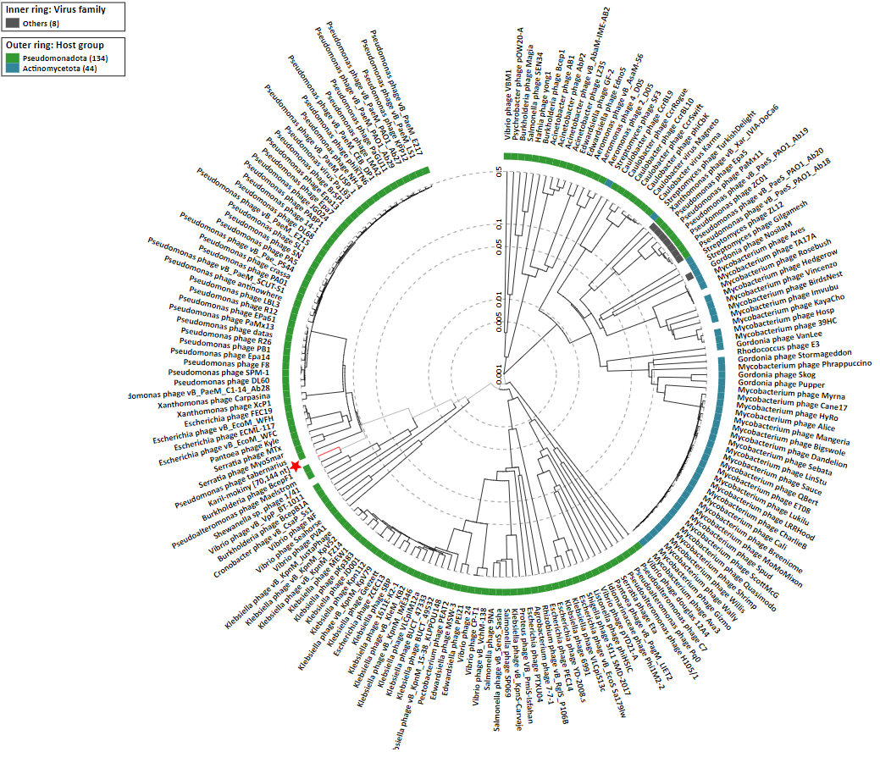**Figure 2: Proteomic tree of Karil-mokiny and 183 related phages created with ViPTree (https://www.genome.jp/viptree/; [2]).** Karil-mokiny is indicated with a red star. Retrieved 05.12.24.