

The International Committee on Taxonomy of Viruses

Taxonomy Proposal Form, 2025

**Part 1a: Details of taxonomy proposals**

|  |  |
| --- | --- |
| **Title:** | Create one new species in the genus *Irusalimvirus* (class *Caudoviricetes)* |
| **Code assigned:** | *2025.033B.Ac.v3.Irusalimvirus_1ns* | |

|  |  |  |  |  |
| --- | --- | --- | --- | --- |
| **Author(s), affiliation and email address(es):** | | | | |
| **Given name (+middle initial(s))** | **Surname** | **Affiliation** | **Email address** | **Corr. author(s)** |
| Jack S | Canning | Wal-Yan Respiratory Research Centre, Telethon Kids Institute, Perth, Australia | Jack.canning@thekids.org.au | X |
| Kak-Ming | Ling | Wal-Yan Respiratory Research Centre, Telethon Kids Institute, Perth, Australia | Kak-ming.ling@thekids.org.au |  |
| Daniel R | Laucirica | Wal-Yan Respiratory Research Centre, Telethon Kids Institute, Perth, Australia | Daniel.laucirica@thekids.org.au |  |
| Joshua J | Iszatt | Wal-Yan Respiratory Research Centre, Telethon Kids Institute, Perth, Australia | [Joshua.Iszatt@thekids.org.au](mailto:Joshua.Iszatt@thekids.org.au) |  |
| Andrew | Vaitekenas | Wal-Yan Respiratory Research Centre, Telethon Kids Institute, Perth, Australia | Andrew.Vaitekenas@thekids.org.au |  |
| Stephen M | Stick | Wal-Yan Respiratory Research Centre, Telethon Kids Institute, Perth, Australia | Stephen.Stick@thekids.org.au |  |
| Anthony | Kicic | Wal-Yan Respiratory Research Centre, Telethon Kids Institute, Perth, Australia | Anthony.Kicic@thekids.org.au |  |
|  |  |  |  |  |

**Part 1b: Taxonomy Proposal Submission**

|  |  |  |  |
| --- | --- | --- | --- |
| **ICTV Subcommittee:** | | | |
| Animal DNA Viruses and Retroviruses |  | Bacterial viruses | **X** |
| Animal minus-strand and dsRNA viruses |  | Fungal and protist viruses |  |
| Animal positive-strand RNA viruses |  | Plant viruses |  |
| Archaeal viruses |  | General - |  |

|  |
| --- |
| **List the ICTV Study Group(s) that have seen or have been involved in creating this proposal:** |
| Caudoviricetes Study Group |

|  |  |  |  |
| --- | --- | --- | --- |
| **Optional – complete only if formally voted on by an ICTV Study Group:** | | | |
| **Study Group** | **Number of members** | | |
| **Votes in support** | **Votes against** | **No vote** |
|  |  |  |  |
|  |  |  |  |

|  |  |
| --- | --- |
| **Submission date:** |  |

**Part 1c: Feedback from ICTV Executive Committee (EC) meeting**

|  |  |
| --- | --- |
| **Executive Committee Meeting Decision code:** | **X** |
| A – Accept |  |
| Ac – Accept subject to revision by relevant subcommittee chair. No further vote required | **X** |
| U – Accept without revision but with re-evaluation and email vote by the EC |  |
| Uc – Accept subject to revision and re-evaluation and email vote by the EC |  |
| Ud – Deferred to the next EC meeting, with an invitation to revise based on EC comments |  |
| J - Reject |  |
| W - Withdrawn |  |

|  |
| --- |
| **Comments from the Executive Committee:** |
| Please update the proposal to the latest version of the proposal template. Please provide first names and initials of authors. |

**Part 1d: Revised Taxonomy Proposal Submission**

|  |
| --- |
| **Response of proposer:** |
| Corrected. |

|  |  |
| --- | --- |
| **Revision date:** | 01/09/2025 |

**Part 3:** **TAXONOMIC PROPOSAL**

<https://ictv.global/taxonomy/templates>

|  |  |  |  |
| --- | --- | --- | --- |
| **Taxonomic changes proposed:** | | | |
| Establish new taxon | **X** | Split taxon |  |
| Abolish taxon |  | Merge taxon |  |
| Move taxon |  | Promote taxon |  |
| Rename taxon |  | Demote taxon |  |
| Move and rename |  |

|  |  |
| --- | --- |
| **Etymology (origin) of proposed taxonomic names:** | |
| **Taxon name** | **Etymology of the term** |
| **Karil-mokiny-1** | This project was conducted on the traditional homelands of the Noongar people, with phages isolated from waters across Noongar Wadjak. We thank Sharon Gregory and Walyalap Waangkan Noongar language team, who named the phages in this study in Wadjak Noongar language. Karil-mokiny-kep-djiraly-karakaata-Wadjak-1 translates as “crab-like (from) water northern karrakatta-wadjak”. |
|  |  |
|  |  |
|  |  |

|  |  |  |
| --- | --- | --- |
| **Permission for use of names derived from a living person:** | | |
| **Taxon name** | **Full name of person from whom the name is derived** | **Attached** |
| N/A |  |  |
|  |  |  |
|  |  |  |
|  |  |  |

|  |
| --- |
| **Abstract of Taxonomy Proposal:** |
| *Taxonomic rank(s) affected*:  Species  *Description of current taxonomy*:  The current taxonomy for dsDNA bacterial viruses for the proposed change is as follows; *Duplodnaviria, Heunggongvirae, Uroviricota, Caudoviricetes, Irusalimvirus*  *Proposed* *taxonomic change(s):*  We propose to establish a new species in the genus *Irusalimvirus*  *Justification*:  Karil-mokiny-1 possesses 70.8% average nucleotide identity (ANI%) to *Irusalimvirus BCSR52*, meeting the requirements for a new species within the genus *Irusalimvirus*. Currently, the genus *Irusalimvirus* fall under the following ICTV taxonomy; *Duplodnaviria, Heunggongvirae, Uroviricota, Caudoviricetes, Irusalimvirus* |

|  |
| --- |
| * **Text of Taxonomy proposal:** |
| *Taxonomic rank(s) affected*:  Species  *Description of current taxonomy*:  Currently, the most related virus to Karil-mokiny-1 is *Irusalimvirus BCSR52*. The current taxonomic ranking of Bcepfunavirus is as follows; *Duplodnaviria, Heunggongvirae, Uroviricota, Caudoviricetes, Irusalimvirus*  *Proposed* *taxonomic change(s)*:  We propose the addition of a new phage species, *Karil-mokiny-1* in the Caudoviricetes class of bacterial dsDNA viruses. The name originates from that of its founding member, Karil-mokiny-kep-djiraly-karakaata-Wadjak (Karil-mokiny-1). This project was conducted on the traditional homelands of the Noongar people, with phages isolated from waters across Noongar Wadjak. We thank Sharon Gregory and Walyalap Waangkan Noongar language team, who named the phages in this study in Wadjak Noongar language. Karil-mokiny-kep-djiraly-karakaata-Wadjak-1 translates as “crab-like (from) water northern karrakatta-wadjak”.  *Demarcation criteria:*  We followed the ICTV demarcation criteria for species and genus level cutoffs, which are currently set at <95% and <70% average nucleotide identity (ANI%), respectively (1).  *Justification*:  The whole genome of Karil-mokiny-1 was aligned to its closest relative available on NCBI. We found that Karil-mokiny-1 possesses only 70.8% average nucleotide identity with BCSR52 (Fig 1). Based on current ICTV taxonomy, the requirement for the establishment of a new viral genus is < 70% ANI and <95% for species(1). Due to low ANI% with its closest relative, we also wished to view the novelty of Karil-mokiny’s genome in a broader context. Based on the ICTV demarcation criteria, we propose thaTherefore, “*Karilavirus”* represents a new genus of phage infecting members of the *B. cepacia* complex, and hence should share a taxonomic rank with *Bcepfunavirus* to the next highest described taxa (class *Caudoviricetes*) |

|  |
| --- |
| **References:** |
| 1. Turner D, Kropinski AM, Adriaenssens EM. A roadmap for genome-based phage taxonomy. Viruses. 2021;13(3):506.  2. Nishimura Y, Yoshida T, Kuronishi M, Uehara H, Ogata H, Goto S. ViPTree: the viral proteomic tree server. Bioinformatics. 2017;33(15):2379-80. |

|  |  |
| --- | --- |
| **Accompanying files:** | |
| **Filename** | **Description of contents** |
|  |  |
|  |  |

|  |
| --- |
| **Tables, Figures:** |

**Figure 1: Average nucleotide identity (ANI %) of Karil-mokiny-1 with 5of its closest relative viruses available in NCBI.** Analysis retrieved 01.09.25

*

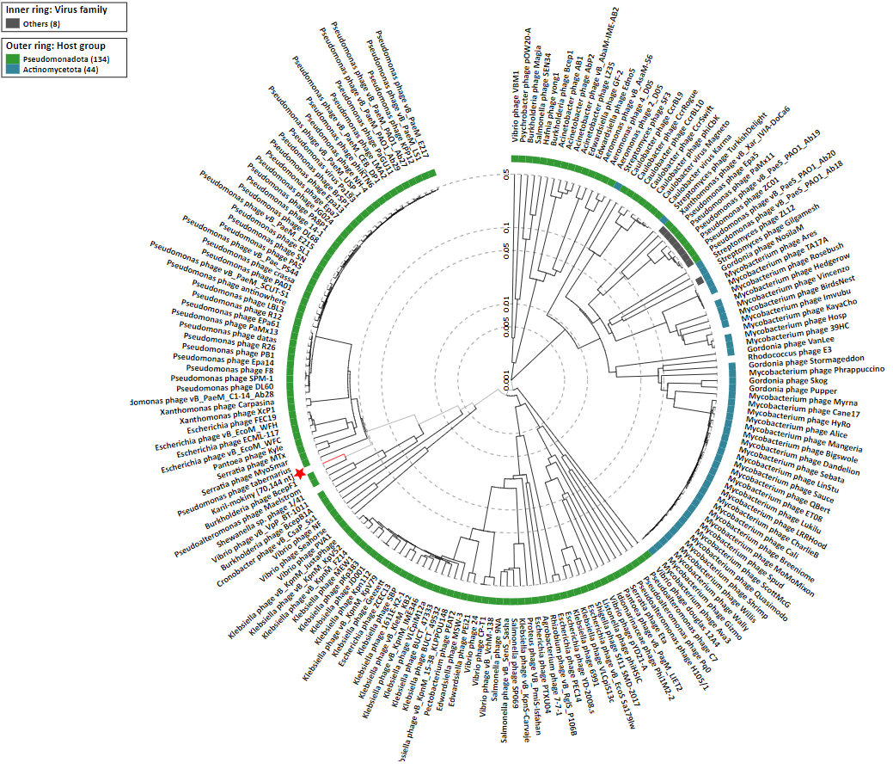**Figure 2: Proteomic tree of Karil-mokiny and 183 related phages created with ViPTree (https://www.genome.jp/viptree/; [2]).** Karil-mokiny is indicated with a red star. Retrieved 05.12.24.