

The International Committee on Taxonomy of Viruses

Taxonomy Proposal Form, 2025

**Part 1a: Details of taxonomy proposals**

|  |  |
| --- | --- |
| **Title:** | Create 14 new species in the genus *Karamvirus* (class *Caudoviricetes*, order *Pantevenvirales*, family *Straboviridae*, subfamily *Tevenvirinae*) |
| **Code assigned:** | 2025.032B.Karamvirus_14ns | |

|  |  |  |  |  |
| --- | --- | --- | --- | --- |
| **Author(s), affiliation and email address(es):** | | | | |
| **Given name (+middle initial(s))** | **Surname** | **Affiliation** | **Email address** | **Corresponding author(s)** |
| Michał J. | Wójcicki | Bacteriophage Laboratory, Department of Phage Therapy, Hirszfeld Institute of Immunology and Experimental Therapy, Polish Academy of Sciences, Wroclaw, Poland | [michal.wojcicki@hirszfeld.pl](mailto:michal.wojcicki@hirszfeld.pl) | X |
| Martyna A. | Cieślik | Bacteriophage Laboratory, Department of Phage Therapy, Hirszfeld Institute of Immunology and Experimental Therapy, Polish Academy of Sciences, Wroclaw, Poland | [martyna.cieslik@hirszfeld.pl](mailto:martyna.cieslik@hirszfeld.pl) |  |
| Andrzej | Górski | Bacteriophage Laboratory, Department of Phage Therapy, Hirszfeld Institute of Immunology and Experimental Therapy, Polish Academy of Sciences, Wroclaw, Poland | [andrzej.gorski@hirszfeld.pl](mailto:andrzej.gorski@hirszfeld.pl) |  |
| Ewa M. | Jończyk-Matysiak | Bacteriophage Laboratory, Department of Phage Therapy, Hirszfeld Institute of Immunology and Experimental Therapy, Polish Academy of Sciences, Wroclaw, Poland | [ewa.jonczyk-matysiak@hirszfeld.pl](mailto:ewa.jonczyk-matysiak@hirszfeld.pl) | X |

**Part 1b: Taxonomy Proposal Submission**

|  |  |  |  |
| --- | --- | --- | --- |
| **ICTV Subcommittee:** | | | |
| Animal DNA Viruses and Retroviruses |  | Bacterial viruses | X |
| Animal minus-strand and dsRNA viruses |  | Fungal and protist viruses |  |
| Animal positive-strand RNA viruses |  | Plant viruses |  |
| Archaeal viruses |  | General |  |

|  |
| --- |
| **List the ICTV Study Group(s) that have seen or have been involved in creating this proposal:** |
| *Caudoviricetes Study Group* |

|  |  |  |  |
| --- | --- | --- | --- |
| **Optional – complete only if formally voted on by an ICTV Study Group:** | | | |
| **Study Group** | **Number of members** | | |
| **Votes in support** | **Votes against** | **No vote** |
|  |  |  |  |
|  |  |  |  |

|  |  |
| --- | --- |
| **Submission date:** | 16/03/2025 |

**Part 1c: Feedback from ICTV Executive Committee (EC) meeting**

|  |  |
| --- | --- |
| **Executive Committee Meeting Decision code:** | **X** |
| A – Accept |  |
| Ac – Accept subject to revision by relevant subcommittee chair. No further vote required |  |
| U – Accept without revision but with re-evaluation and email vote by the EC |  |
| Uc – Accept subject to revision and re-evaluation and email vote by the EC |  |
| Ud – Deferred to the next EC meeting, with an invitation to revise based on EC comments |  |
| J - Reject |  |
| W - Withdrawn |  |

|  |
| --- |
| **Comments from the Executive Committee:** |
|  |

**Part 1d: Revised Taxonomy Proposal Submission**

|  |
| --- |
| **Response of proposer:** |
|  |

|  |  |
| --- | --- |
| **Revision date:** |  |

**Part 3:** **TAXONOMIC PROPOSAL**

|  |  |  |  |
| --- | --- | --- | --- |
| **Taxonomic changes proposed:** | | | |
| Establish new taxon | X | Split taxon |  |
| Abolish taxon |  | Merge taxon |  |
| Move taxon |  | Promote taxon |  |
| Rename taxon |  | Demote taxon |  |
| Move and rename |  |

|  |  |
| --- | --- |
| **Etymology (origin) of proposed taxonomic names:** | |
| **Taxon name** | **Etymology of the term** |
| *Karamvirus KMB20* | species name derived from the phage name in the GenBank database – Enterobacter phage vB-EclM_KMB20 |
| *Karamvirus KMB17* | species name derived from the phage name in the GenBank database – Enterobacter phage vB-EclM_KMB17 |
| *Karamvirus EnC07* | species name derived from the phage name in the GenBank database – Enterobacter phage EnC07 |
| *Karamvirus PS49* | species name derived from the phage name in the GenBank database – Aeromonas phage PS49 |
| *Karamvirus RZH* | species name derived from the phage name in the GenBank database – Enterobacter phage vB_EluP_RZH |
| *Karamvirus CW742* | species name derived from the phage name in the GenBank database – Enterobacter phage vB_ECC_CW742 |
| *Karamvirus EnC15* | species name derived from the phage name in the GenBank database – Enterobacter phage EnC15 |
| *Karamvirus Entb43* | species name derived from the phage name in the GenBank database – Enterobacter phage Entb_43 |
| *Karamvirus VPA32* | species name derived from the phage name in the GenBank database – Klebsiella phage vB_KpnM_VPA32 |
| *Karamvirus UFV01* | species name derived from the phage name in the GenBank database – Enterobacter phage vB_EclM-UFV01 |
| *Karamvirus Ent31* | species name derived from the phage name in the GenBank database – Enterobacter phage vB_Ent31 |
| *Karamvirus AS6* | species name derived from the phage name in the GenBank database – Enterobacter phage vB_EclM_AS6 |
| *Karamvirus fGhEcl01* | species name derived from the phage name in the GenBank database – Enterobacter phage fGh-Ecl01 |
| *Karamvirus EnA02* | species name derived from the phage name in the GenBank database – Enterobacter phage EnA02 |

|  |  |  |
| --- | --- | --- |
| **Permission for use of names derived from a living person** | | |
| **Taxon name** | **Full name of person from whom the name is derived** | **Attached** |
|  |  |  |

|  |
| --- |
| **Abstract of Taxonomy Proposal:** |
| *Taxonomic rank(s) affected*:  Realm *Duplodnaviria*, kingdom *Heunggongvirae*, phylum *Uroviricota*, class *Caudoviricetes,* order *Pantevenvirales*, family *Straboviridae*, subfamily *Tevenvirinae*.  *Description of current taxonomy*:  Currently, the order *Pantevenvirales* includes three families: *Ackermannviridae*, *Kyanoviridae*, and *Straboviridae*. Within the *Straboviridae* family, three subfamilies have been distinguished: *Emmerichvirinae*, *Tevenvirinae*, and *Twarogvirinae*. The *Tevenvirinae* subfamily comprises 15 genera and 148 species. Currently, the *Karamvirus* genus includes four species: *Karamvirus cc31*, *Karamvirus mypsh1140*, *Karamvirus petcm34*, and *Karamvirus pg7*.  *Proposed* *taxonomic change(s):*  We performed a genomic analysis of phages deposited in the NCBI database. We propose to create 14 new species in the genus *Karamvirus*.  *Justification*:  Based on DNA and protein similarity, the 14 proposed new species are coherent and together with the four known species (*Karamvirus cc31*, *Karamvirus mypsh1140*, *Karamvirus petcm34*, and *Karamvirus pg7*) can be classified in the genus *Karamvirus*. |

|  |
| --- |
| **Text of Taxonomy proposal:** |
| *Taxonomic rank(s) affected*:  Realm *Duplodnaviria*, kingdom *Heunggongvirae*, phylum *Uroviricota*, class *Caudoviricetes,* order *Pantevenvirales*, family *Straboviridae*, subfamily *Tevenvirinae*.  *Description of current taxonomy*:  Currently, the order *Pantevenvirales* includes three families: *Ackermannviridae*, *Kyanoviridae*, and *Straboviridae*. Within the *Straboviridae* family, three subfamilies have been distinguished: *Emmerichvirinae*, *Tevenvirinae*, and *Twarogvirinae*. The *Tevenvirinae* subfamily comprises 15 genera and 148 species. Currently, the *Karamvirus* genus includes four species: *Karamvirus cc31*, *Karamvirus mypsh1140*, *Karamvirus petcm34*, and *Karamvirus pg7*.  *Proposed* *taxonomic change(s)*:  We performed a genomic analysis of phages deposited in the NCBI database. We propose to create 14 new species in the genus *Karamvirus*.  *Demarcation criteria:*  **Species demarcation criteria:** Two phages are assigned to the same species if their genomes are more than 95% identical over their genome length for isolates.  These values can be calculated by several tools, such as BLASTn [1] – usually calculated using the intergenomic distance calculator VIRIDIC [2].  **Genus demarcation criteria:** In search for criteria that create cohesive and distinct genera that are reproducible and monophyletic, the Bacterial Viruses Subcommittee has established 70% nucleotide identity of the genome length as the cut-off for genera. Genus-level groupings should always be monophyletic in the signature genes, as tested with a phylogenetic tree [3].  *Justification*:  Based on DNA and protein similarity, the 14 proposed new species are coherent and together with the four known species (*Karamvirus cc31*, *Karamvirus mypsh1140*, *Karamvirus petcm34*, and *Karamvirus pg7*) can be classified in the genus *Karamvirus*. |

|  |
| --- |
| **References:** |
| 1. Sayers EW, Beck J, Bolton EE, Bourexis D, Brister JR, Canese K, Comeau DC, Funk K, Kim S, Klimke W, Marchler-Bauer A, Landrum M, Lathrop S, Lu Z, Madden TL, O'Leary N, Phan L, Rangwala SH, Schneider VA, Skripchenko Y, Wang J, Ye J, Trawick BW, Pruitt KD, Sherry ST. Database resources of the National Center for Biotechnology Information. *Nucleic Acids Res.* 2021, 49(D1):D10-D17. 2. Moraru C, Varsani A, Kropinski AM. VIRIDIC - a novel tool to calculate the intergenomic similarities of prokaryote-infecting viruses. *Viruses* 2020, 12(11):1268. 3. Turner D, Kropinski AM, Adriaenssens EM. A roadmap for genome-based phage taxonomy. *Viruses* 2021, 13(3):506. 4. Nishimura Y, Yoshida T, Kuronishi M, Uehara H, Ogata H, Goto S. ViPTree: the viral proteomic tree server. *Bioinformatics* 2017, 33(15):2379-2380. 5. Rohwer F, Edwards R. The Phage Proteomic Tree: a genome-based taxonomy for phage. *J. Bacteriol.* 2002, 184(16):4529-35. 6. Meier-Kolthoff JP, Göker M. VICTOR: Genome-based Phylogeny and Classification of Prokaryotic Viruses. *Bioinformatics* 2017, 33:3396-3404. 7. Meier-Kolthoff JP, Auch AF, Klenk H-P, Göker M. Genome sequence-based species delimitation with confidence intervals and improved distance functions. *BMC Bioinformatics* 2013, 14:60. 8. Lefort V, Desper R, Gascuel O. FastME 2.0: A comprehensive, accurate, and fast distance-based phylogeny inference program. *Mol. Biol. Evol.* 2015, 32:2798-2800. 9. Farris JS. Estimating phylogenetic trees from distance matrices. Am Nat 1972, 106:645-667. 10. Yu G. Using ggtree to visualize data on tree-like structures. *Curr. Protoc. Bioinforma.* 2020, 69:1-18. 11. Göker M, García-Blázquez G, Voglmayr H, Tellería MT, Martín MP. Molecular taxonomy of phytopathogenic fungi: A case study in Peronospora. *PLoS One* 2009, 4:8-10. 12. Meier-Kolthoff JP, Hahnke RL, Petersen J, Scheuner C, Michael V, Fiebig A, Rohde C, Rohde M, Fartmann B, Goodwin LA, Chertkov O, Reddy TBK, Pati A, Ivanova NN, Markowitz V, Kyrpides NC, Woyke T, Göker M, Klenk H-P. Complete genome sequence of DSM 30083T, the type strain (U5/41T) of *Escherichia coli*, and a proposal for delineating subspecies in microbial taxonomy. *Stand. Genomic. Sci.* 2014, 9:2. 13. Turner D, Reynolds D, Seto D, Mahadevan P. CoreGenes3.5: a webserver for the determination of core genes from sets of viral and small bacterial genomes. *BMC Res. Notes.* 2013, 6:140. |

|  |  |
| --- | --- |
| **Accompanying files:** | |
| **Filename** | **Description of contents** |
|  |  |

|  |
| --- |
| **Tables, Figures:** |

**Figure 1. VIRIDIC heat map:** VIRIDIC (Virus Intergenomic Distance Calculator [2]; http://rhea.icbm.uni-oldenburg.de/VIRIDIC/) computes pairwise intergenomic distances/similarities amongst phage genomes. Phages belonging to the same species (nucleotide similarity above 95%) are marked with a **red** frame. The currently **classified** four species belonging to the genus *Karamvirus* are marked in **blue**.

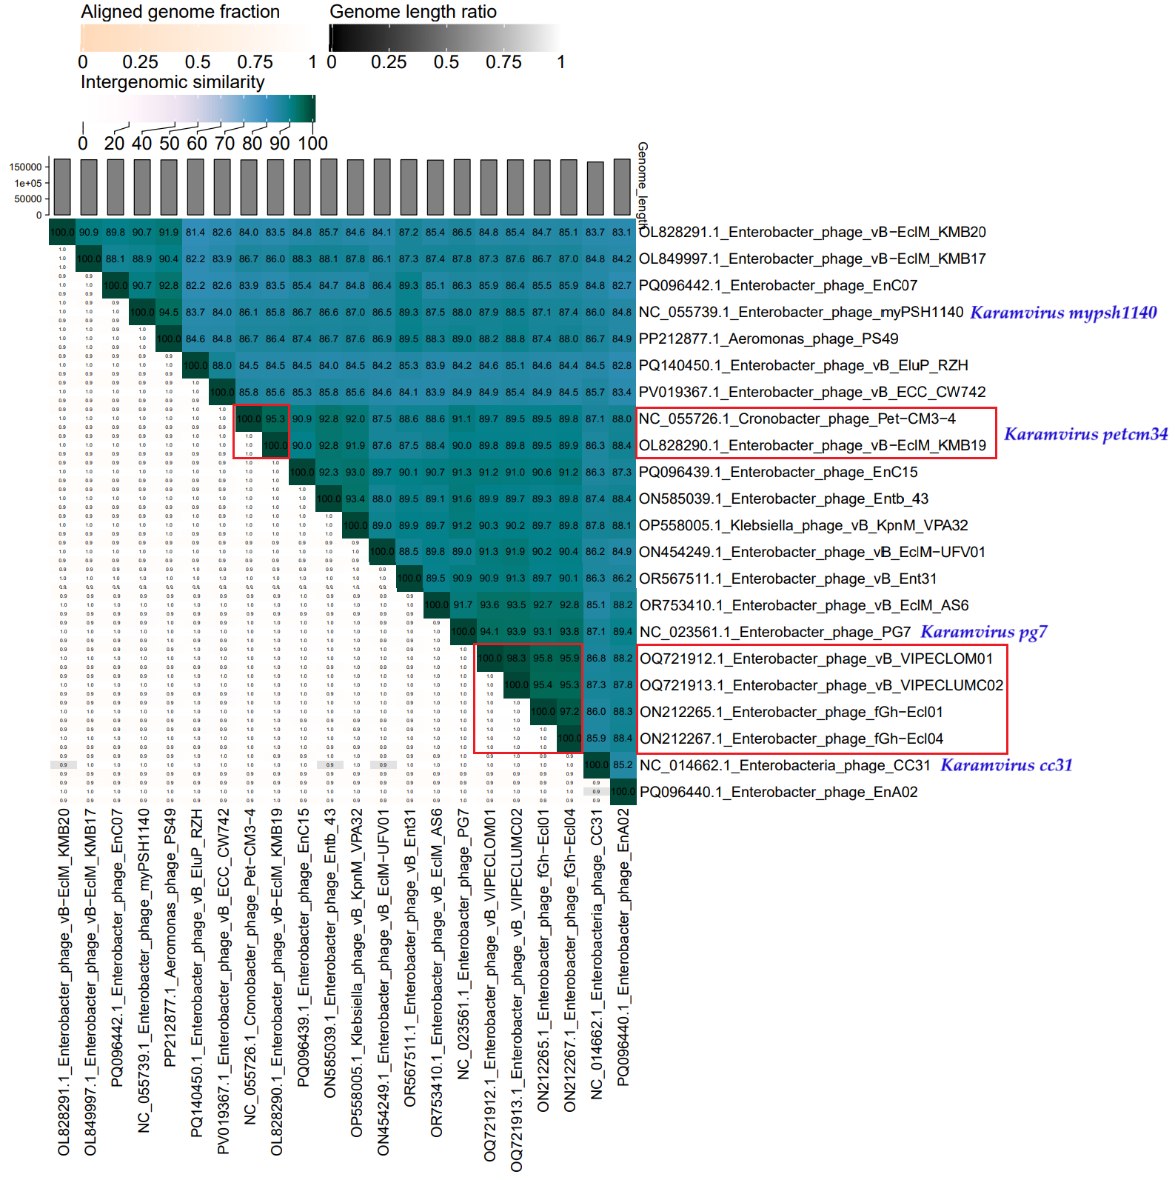

**Figure 2. ViPTree analysis*:** ViPTree analysis (https://www.genome.jp/viptree/; [4]) is based upon Rohwer and Edwards (2002) Phage Proteomic Tree [5]. The phages of interest are indicated with a **red stars** and a **blue bar**.

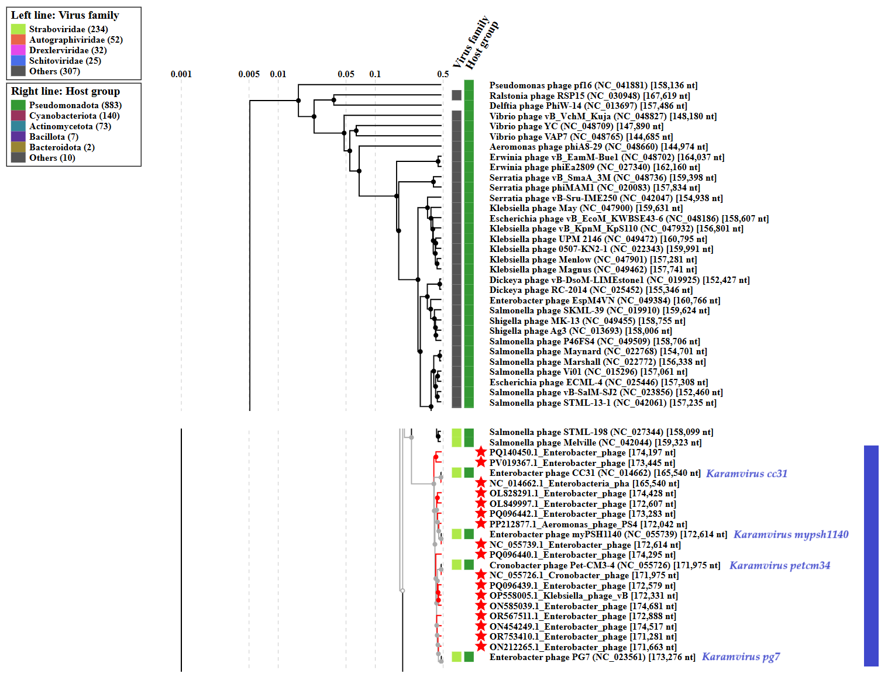

* The *Autographiviridae* family shown in **Figure 2** (automatically labeled by the software) is outdated. In 2025, the *Autographiviridae* family was elevated to the rank of order and renamed *Autographivirales*.

The entire analysis was carried out by the VICTOR webserver (https://victor.dsmz.de), a method for the genome-based phylogeny and classification of prokaryotic viruses [6]. All pairwise comparisons of the nucleotide sequences were conducted using the Genome-BLAST Distance Phylogeny (GBDP) method [7] under settings recommended for prokaryotic viruses [6].

The resulting intergenomic distances were used to infer a balanced minimum evolution tree with branch support via FASTME including SPR postprocessing [8] for formula D0. Branch support was inferred from 100 pseudo-bootstrap replicates. Trees were rooted at the midpoint [9] and visualized with ggtree [10].

Taxon boundaries at the species, genus and family level were estimated with the OPTSIL program [11], the recommended clustering thresholds [6], and an F value (fraction of links required for cluster fusion) of 0.5 [12].

**Figure 3. VICOR webserver:** Phylogenomic GBDP tree inferred using the formulas D0 and yielding average support of 2%.

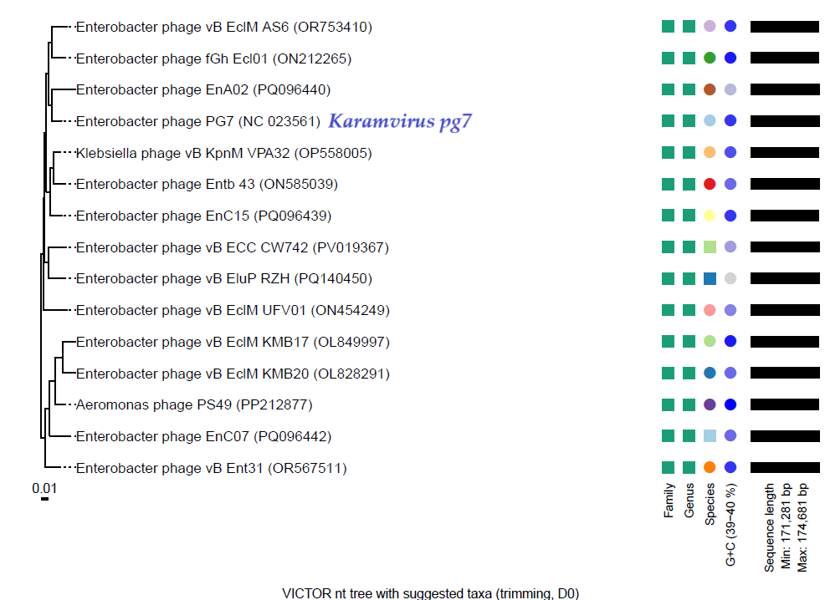

In the Figure 3, we show the phylogenomic GBDP tree inferred using the formulas D0 and yielding average support of 2%. The numbers above branches are GBDP pseudo-bootstrap support values from 100 replications. The branch lengths of the resulting VICTOR trees are scaled in terms of the respective distance formula used.

The OPTSIL clustering yielded fifteen species clusters (i.e., *Karamvirus pg7* as reference genome, and new 14 species). At the genus level, one clusters resulted. The number of clusters determined at the family level were one.

**Genome summary:**

|  |  |  |  |  |  |  |  |
| --- | --- | --- | --- | --- | --- | --- | --- |
| Phage name | RefSeq No. | INSDC | Size (bp) | GC% | Protein | Overall % DNA sequence identity (*) | Overall % homologous proteins (**) |
| **Enterobacter phage PG7**  **(*Karamvirus pg7*; reference genome)** | **NC_023561.1** | **NC_023561** | **173,276** | **39.8** | **294** | **100.0** | **100.00** |
| Enterobacter phage vB-EclM_KMB20 |  | OL828291 | 174,428 | 39.7 | 276 | 86.5 | 86.05 |
| Enterobacter phage vB-EclM_KMB17 |  | OL849997 | 172,607 | 39.8 | 275 | 87.8 | 85.37 |
| Enterobacter phage EnC07 |  | PQ096442 | 173,283 | 39.7 | 290 | 86.3 | 90.14 |
| Aeromonas phage PS49 |  | PP212877 | 172,042 | 39.9 | 294 | 89.0 | 92.86 |
| Enterobacter phage vB_EluP_RZH |  | PQ140450 | 174,197 | 39.5 | 312 | 84.2 | 91.50 |
| Enterobacter phage vB_ECC_CW742 |  | PV019367 | 173,445 | 39.6 | 308 | 84.9 | 92.86 |
| Enterobacter phage EnC15 |  | PQ096439 | 172,579 | 39.8 | 284 | 91.3 | 90.82 |
| Enterobacter phage Entb_43 |  | ON585039 | 174,681 | 39.7 | 295 | 91.6 | 93.54 |
| Klebsiella phage vB_KpnM_VPA32 |  | OP558005 | 172,331 | 39.8 | 292 | 91.2 | 93.20 |
| Enterobacter phage vB_EclM-UFV01 |  | ON454249 | 174,517 | 39.7 | 285 | 89.0 | 89.46 |
| Enterobacter phage vB_Ent31 |  | OR567511 | 172,888 | 39.8 | 292 | 90.9 | 91.50 |
| Enterobacter phage vB_EclM_AS6 |  | OR753410 | 171,281 | 39.8 | 306 | 91.7 | 93.88 |
| Enterobacter phage fGh-Ecl01 |  | ON212265 | 171,663 | 39.8 | 288 | 93.1 | 94.22 |
| Enterobacter phage EnA02 |  | PQ096440 | 174,295 | 39.6 | 289 | 89.4 | 91.16 |

(*) determined using VIRIDIC [2]

(**) determined using CoreGenes 3.5 [13]