

The International Committee on Taxonomy of Viruses

Taxonomy Proposal Form, 2025

**Part 1a: Details of taxonomy proposals**

|  |  |  |
| --- | --- | --- |
| **Title:** | Create 10 new species and abolish one species (Class: *Caudoviricetes*) |  |
| **Code assigned:** | 2025.025B.Caudoviricetes_10ns_1rms | |

|  |  |  |  |  |
| --- | --- | --- | --- | --- |
| **Author(s), affiliation and email address(es):** | | | | |
| **Given name (+middle initial(s))** | **Surname** | **Affiliation** | **Email address** | **Corr. author(s)** |
| Ivan M. | Pchelin | Department of Molecular Microbiology, Institute of Experimental Medicine, Saint Petersburg, Russia | arcella.oraia@gmail.com | X |
|  |  |  |  |  |
|  |  |  |  |  |
|  |  |  |  |  |
|  |  |  |  |  |
|  |  |  |  |  |
|  |  |  |  |  |
|  |  |  |  |  |

**Part 1b: Taxonomy Proposal Submission**

|  |  |  |  |
| --- | --- | --- | --- |
| **ICTV Subcommittee:** | | | |
| Animal DNA Viruses and Retroviruses |  | Bacterial viruses | **X** |
| Animal minus-strand and dsRNA viruses |  | Fungal and protist viruses |  |
| Animal positive-strand RNA viruses |  | Plant viruses |  |
| Archaeal viruses |  | General |  |

|  |
| --- |
| **List the ICTV Study Group(s) that have seen or have been involved in creating this proposal:** A list of study groups and their members is provided at <https://ictv.global/sc>. |
|  |

|  |  |  |  |
| --- | --- | --- | --- |
| **Optional – complete only if formally voted on by an ICTV Study Group:** <To be completed by Study Group> | | | |
| **Study Group** | **Number of members** | | |
| **Votes in support** | **Votes against** | **No vote** |
|  |  |  |  |
|  |  |  |  |

|  |  |
| --- | --- |
| **Submission date:** | 12/06/2025 |

Enter date of the initial submission (DD/MM/YYYY).

**Part 1c: Feedback from ICTV Executive Committee (EC) meeting** <To be completed by the subcommittee chair after EC evaluation>

|  |  |
| --- | --- |
| **Executive Committee Meeting Decision code:** | **X** |
| A – Accept |  |
| Ac – Accept subject to revision by relevant subcommittee chair. No further vote required |  |
| U – Accept without revision but with re-evaluation and email vote by the EC |  |
| Uc – Accept subject to revision and re-evaluation and email vote by the EC |  |
| Ud – Deferred to the next EC meeting, with an invitation to revise based on EC comments |  |
| J - Reject |  |
| W - Withdrawn |  |

|  |
| --- |
| **Comments from the Executive Committee:** |
|  |

**Part 1d: Revised Taxonomy Proposal Submission** <To be completed for the revised version>

|  |
| --- |
| **Response of proposer:** |
|  |

|  |  |
| --- | --- |
| **Revision date:** |  |

Enter date of the revised version (DD/MM/YYYY).

**Part 3:** **TAXONOMIC PROPOSAL**

|  |  |  |  |
| --- | --- | --- | --- |
| **Taxonomic changes proposed:** | | | |
| Establish new taxon | **X** | Split taxon |  |
| Abolish taxon | **X** | Merge taxon |  |
| Move taxon |  | Promote taxon |  |
| Rename taxon |  | Demote taxon |  |
| Move and rename |  |  |  |

|  |  |
| --- | --- |
| **Etymology (origin) of proposed taxonomic names:** | |
| **Taxon name** | **Etymology of the term** |
| *“Pakpunavirus mediocris”* | In Latin, the species epithet means “ordinary” or “normal” |
| *“Pakpunavirus js”* | The species epithet is derived from exemplar virus name |
| *“Pakpunavirus hhbs181”* | The species epithet is derived from exemplar virus name |
| *“Pakpunavirus hhbs91”* | The species epithet is derived from exemplar virus name |
| *“Pbunavirus hhbs511”* | The species epithet is derived from exemplar virus name |
| *“Pbunavirus hhbs122”* | The species epithet is derived from exemplar virus name |
| *“Webervirus gbh029”* | The species epithet is derived from exemplar virus name |
| *“Drulisvirus gbh038”* | The species epithet is derived from exemplar virus name |
| *“Drulisvirus gbh001”* | The species epithet is derived from exemplar virus name |
| *“Przondovirus gbh014”* | The species epithet is derived from exemplar virus name |

|  |
| --- |
| **Abstract of Taxonomy Proposal:** |
| *Taxonomic rank(s) affected:*  Realm: *Duplodnaviria*; Kingdom: *Heunggongvirae*; Phylum: *Uroviricota*; Class: *Caudoviricetes*  Proposed taxonomic change(s):  We propose;   1. Abolition of 1 species 2. The creation of 10 new species   Justification:  The proposed species share ≤95% genome similarity with the existing ones. By genome similarity and clustering analysis, all these potential new species reside within existing genera. To the contrary, the three species proposed for removal share >95% genome similarity with other existing species. |

|  |
| --- |
| **Text of Taxonomy proposal:** |
| *Taxonomic rank(s) affected:*  *Realm: Duplodnaviria; Kingdom: Heunggongvirae; Phylum: Uroviricota; Class: Caudoviricetes*  *Proposed taxonomic change(s):*  We propose the removal of 1 existing species and establishment of 10 new species.  *Demarcation criteria:*  Species were demarcated from pairwise intergenomic distances and employing current ICTV BVS demarcation criteria where species are defined as genomes exhibiting ≤95% similarity and genera as possessing ≥70% similarity over their genome length [1].  *Justification:*  The proposed species share ≤95% genome similarity with the existing ones. By genome similarity and clustering analysis, all these potential new species reside within existing genera. To the contrary, the three species proposed for removal share >95% genome similarity with other existing species. |

|  |
| --- |
| **References:** |
| [1] Turner D, Kropinski AM, Adriaenssens EM. A Roadmap for Genome-Based Phage Taxonomy. Viruses. 2021; 13(3): 506. doi: 10.3390/v13030506. |

|  |  |
| --- | --- |
| **Accompanying files:** | |
| **Filename** | **Description of contents** |
|  |  |

|  |
| --- |
| **Tables, Figures:** |

|  |  |  |  |  |  |
| --- | --- | --- | --- | --- | --- |
|  | Virus name | Genome accession | Proposal | Nucleotide identity evidence | Clustering evidence |
| 1 | *Pbunavirus pv141* | MN615700 | Abolish species | Figure 1, VIRIDIC | Figure 2, ViPTree |
| 2 | *Pakpunavirus hhbs91* | PQ287655 | Create new species | Figure 1, VIRIDIC | Figure 2, ViPTree |
| 3 | *Pakpunavirus mediocris* | PQ758387 | Create new species | Figure 1, VIRIDIC | Figure 2, ViPTree |
| 4 | *Pakpunavirus js* | OQ210008 | Create new species | Figure 1, VIRIDIC | Figure 2, ViPTree |
| 5 | *Pakpunavirus hhbs181* | PQ287651 | Create new species | Figure 1, VIRIDIC | Figure 2, ViPTree |
| 6 | *Pbunavirus hhbs511* | PQ287641 | Create new species | Figure 1, VIRIDIC | Figure 2, ViPTree |
| 7 | *Pbunavirus hhbs122* | PQ287652 | Create new species | Figure 1, VIRIDIC | Figure 2, ViPTree |
| 8 | *Webervirus gbh029* | OU342755 | Create new species | Table 2, taxMyPhage | Figure 3, ViPTree |
| 9 | *Drulisvirus gbh038* | OU509533 | Create new species | Table 2, taxMyPhage | Figure 4, ViPTree |
| 10 | *Drulisvirus gbh001* | OU509534 | Create new species | Table 2, taxMyPhage | Figure 4, ViPTree |
| 11 | *Przondovirus gbh014* | OU342754 | Create new species | Table 2, taxMyPhage | Figure 5, ViPTree |

Table 1. Summary of proposed changes.

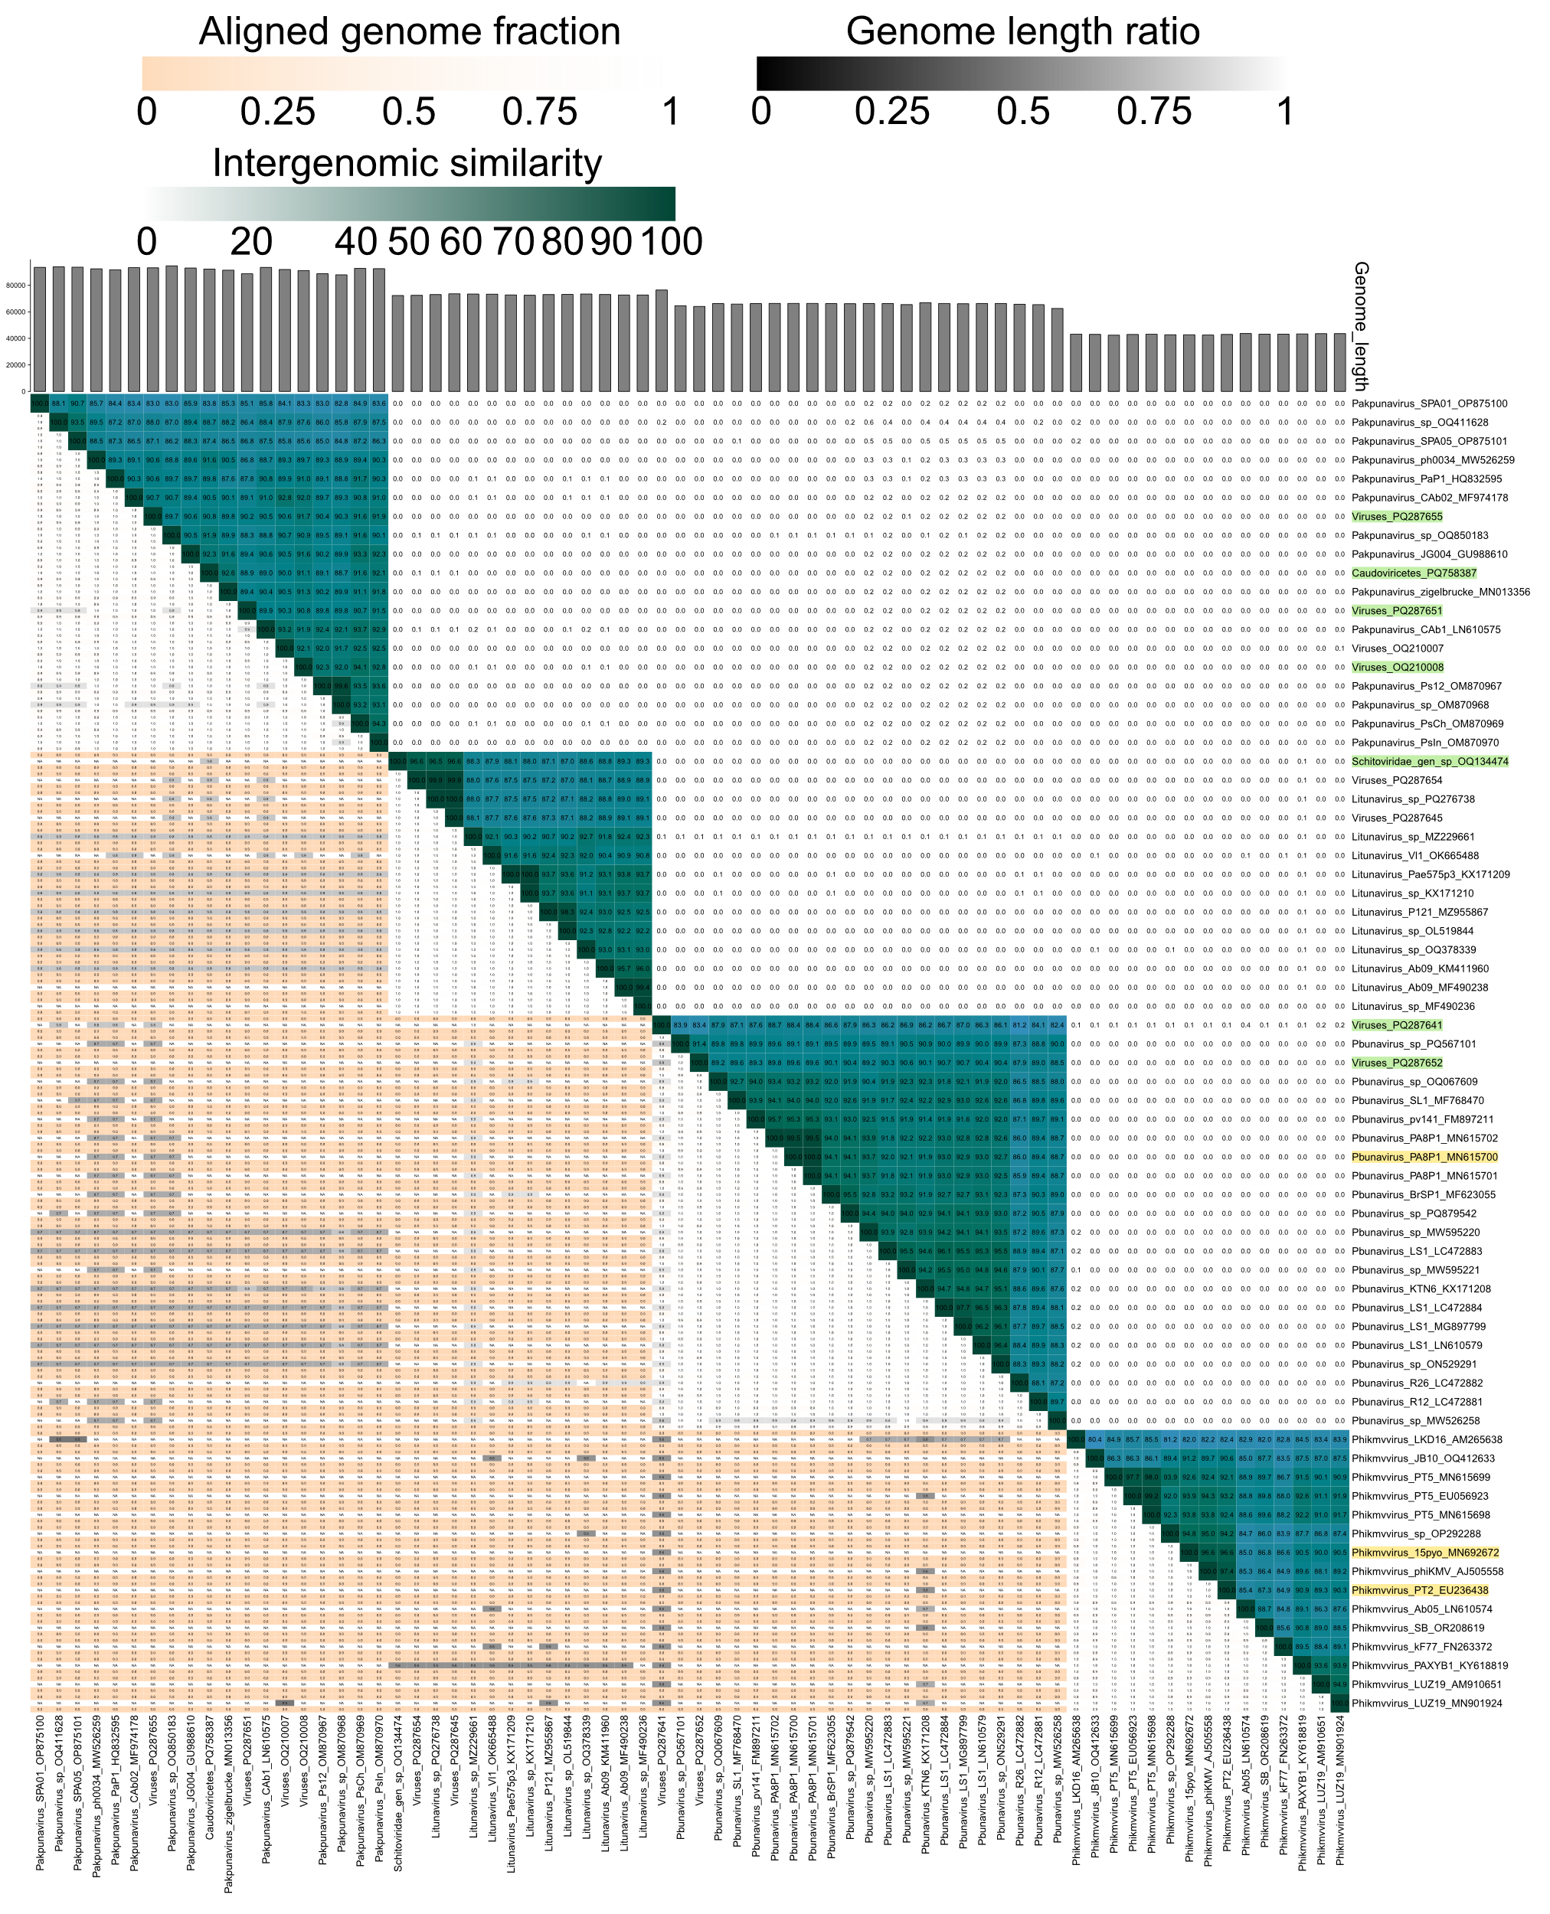

**Figure 1.** VIRIDIC analysis of *Pseudomonas* phages. The sequences related to species to be removed are highlighted yellow. The exemplar GenBank accession numbers of the proposed new species are shown in green.

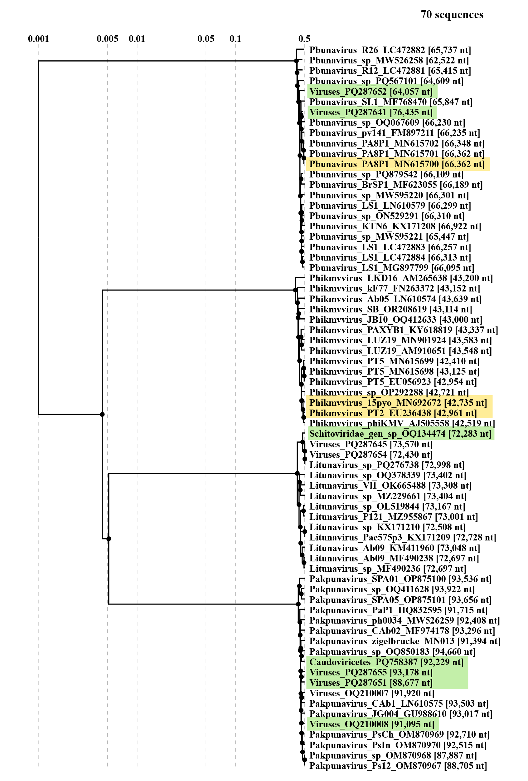

**Figure 2.** ViPTree 4.0 analysis of *Pseudomonas* phages. The sequences related to species mergers are highlighted yellow. The exemplar GenBank accession numbers of the proposed new species are shown in green.

|  |  |  |  |  |  |  |
| --- | --- | --- | --- | --- | --- | --- |
| **Bacteriophage** | **Genome** | **Class** | **Family** | **Genus** | **Species** | **Proposed species** |
| vB_Kpn_GBH029 | OU342755.1 | *Caudoviricetes* | *Drexlerviridae* | *Webervirus* | new | *Webervirus gbh029* |
| vB_Kpn_GBH038 | OU509533.1 | *Caudoviricetes* | *Autoscriptoviridae* | *Drulisvirus* | new | *Drulisvirus* *gbh038* |
| vB_Kpn_GBH001 | OU509534.1 | *Caudoviricetes* | *Autoscriptoviridae* | *Drulisvirus* | new | *Drulisvirus* *gbh001* |
| vB_Kpn_GBH014 | OU342754.1 | *Caudoviricetes* | *Autotranscriptaviridae* | *Przondovirus* | new | *Przondovirus* *gbh014* |

**Table 2.** Taxonomic identity of *Klebsiella* bacteriophages as determined by the taxMyPhage 3.3.6 tool (https://ptax.ku.dk/, accessed on 09 June 2025) and the proposed names of new species.

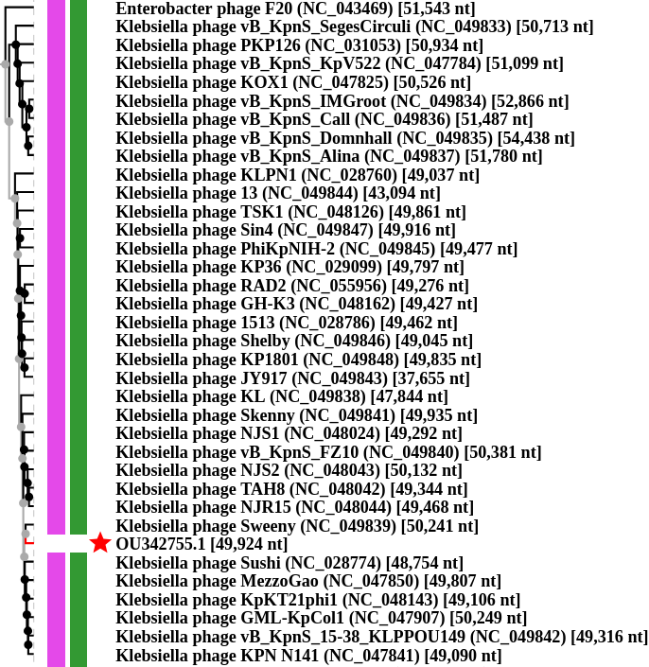

**Figure 3.** ViPTree 4.0 phylogenomic analysis of Klebsiella phage vB_Kpn_GBH029 (OU342755). The sequence clusters with *Webervirus* genomes of bacteriophages Klebsiella phage Sweeny (*Webervirus sweeny*) and Klebsiella phage Sushi (*Webervirus sushi*).

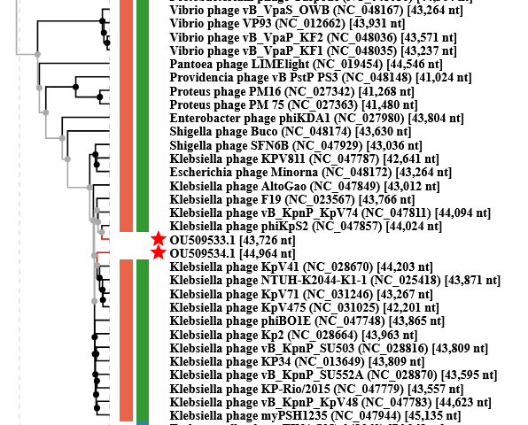

**Figure 4.** ViPTree 4.0 phylogenomic analysis of Klebsiella phage vB_Kpn_GBH038 (OU509533) and Klebsiella phage vB_Kpn_GBH001 (OU509534). The two sequences cluster with *Drulisvirus* genomes of bacteriophages phiKpS2 (*Drulisvirus KpS2*) and vB_KpnP_KpV41 (*Drulisvirus KpV41*).

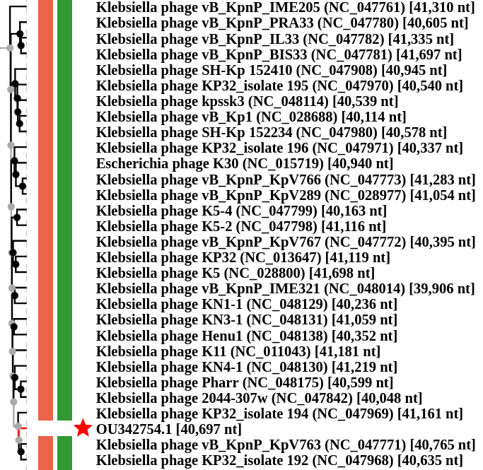

**Figure 5.** ViPTree 4.0 phylogenomic analysis of Klebsiella phage vB_Kpn_GBH014 (OU342754). The sequence clusters with *Przondovirus* genomes of Klebsiella phage KP32 (*Przondovirus KP32i194*) and Klebsiella phage vB_KpnP_KpV763 (*Przondovirus KpV763*).