

The International Committee on Taxonomy of Viruses

Taxonomy Proposal Form, 2025

**Part 1a: Details of taxonomy proposals**

|  |  |
| --- | --- |
| **Title:** | Create a new genus *Guangguvirus* including one new species (Class *Caudoviricetes)* |
| **Code assigned:** | 2025.022B.Guangguvirus_1ng_1ns | |

|  |  |  |  |  |
| --- | --- | --- | --- | --- |
| **Author(s), affiliation and email address(es):** | | | | |
| **Given name (+middle initial(s))** | **Surname** | **Affiliation** | **Email address** | **Corr. author(s)** |
| Jinquan | LI | Huazhong Agricultural University, Wuhan, China | [lijinquan2017@163.com](mailto:lijinquan2017@163.com) | X |
| Yang | ZHOU | Huazhong Agricultural University, Wuhan, China |  |  |
| Zhiyong | SONG | Huazhong Agricultural University, Wuhan, China |  |  |
| Yubo | YAN | Huazhong Agricultural University, Wuhan, China |  |  |
| Liwen | QIU | Huazhong Agricultural University, Wuhan, China |  |  |
|  |  |  |  |  |
|  |  |  |  |  |

**Part 1b: Taxonomy Proposal Submission**

|  |  |  |  |
| --- | --- | --- | --- |
| **ICTV Subcommittee:** | | | |
| Animal DNA Viruses and Retroviruses |  | Bacterial viruses | X |
| Animal minus-strand and dsRNA viruses |  | Fungal and protist viruses |  |
| Animal positive-strand RNA viruses |  | Plant viruses |  |
| Archaeal viruses |  | General - |  |

|  |
| --- |
| **List the ICTV Study Group(s) that have seen or have been involved in creating this proposal:** |
| Bacterial Viruses |

|  |  |  |  |
| --- | --- | --- | --- |
| **Optional – complete only if formally voted on by an ICTV Study Group:** | | | |
| **Study Group** | **Number of members** | | |
| **Votes in support** | **Votes against** | **No vote** |
|  |  |  |  |
|  |  |  |  |

|  |  |
| --- | --- |
| **Submission date:** | 17/02/2025 |

**Part 1c: Feedback from ICTV Executive Committee (EC) meeting**

|  |  |
| --- | --- |
| **Executive Committee Meeting Decision code:** | **X** |
| A – Accept |  |
| Ac – Accept subject to revision by relevant subcommittee chair. No further vote required |  |
| U – Accept without revision but with re-evaluation and email vote by the EC |  |
| Uc – Accept subject to revision and re-evaluation and email vote by the EC |  |
| Ud – Deferred to the next EC meeting, with an invitation to revise based on EC comments |  |
| J - Reject |  |
| W - Withdrawn |  |

|  |
| --- |
| **Comments from the Executive Committee:** |
|  |

**Part 1d: Revised Taxonomy Proposal Submission**

|  |
| --- |
| **Response of proposer:** |
|  |

|  |  |
| --- | --- |
| **Revision date:** | DD/MM/YYYY |

**Part 3:** **TAXONOMIC PROPOSAL**

<https://ictv.global/taxonomy/templates>

|  |  |  |  |
| --- | --- | --- | --- |
| **Taxonomic changes proposed:** | | | |
| Establish new taxon | X | Split taxon |  |
| Abolish taxon |  | Merge taxon |  |
| Move taxon |  | Promote taxon |  |
| Rename taxon |  | Demote taxon |  |
| Move and rename |  |

|  |  |
| --- | --- |
| **Etymology (origin) of proposed taxonomic names:** | |
| **Taxon name** | **Etymology of the term** |
| *Guangguvirus* | The name comes from Guanggu, a district in Wuhan, Hubei Province, China. |
|  |  |
|  |  |
|  |  |

|  |  |  |
| --- | --- | --- |
| **Permission for use of names derived from a living person:** | | |
| **Taxon name** | **Full name of person from whom the name is derived** | **Attached** |
|  |  |  |
|  |  |  |
|  |  |  |
|  |  |  |

|  |
| --- |
| **Abstract of Taxonomy Proposal:** |
| *Taxonomic rank(s) affected*:  Realm *Duplodnaviria*, kingdom *Heunggongvirae*, phylum *Uroviricota*, class *Caudoviricetes*  *Description of current taxonomy*:  The bacterial viruses described in this proposal are currently unclassified  *Proposed* *taxonomic change(s):*  Create a new genus, *“Guangguvirus”* and a single species, “*Guangguvirus LPPA15”*.  *Justification*:  We isolated a new *Pseudomonas aeruginosa phage LPPA15*. Based on the analysis of VIRIDIC and ViPTree, *LPPA15* was significantly different from other genera. Thus, this proposal will create a new genus *Guangguvirus,* containing a new species *Guangguvirus LPPA15.* |

|  |
| --- |
| **Text of Taxonomy proposal:** |
| *Taxonomic rank(s) affected*:  Realm *Duplodnaviria*, kingdom *Heunggongvirae*, phylum *Uroviricota*, class *Caudoviricetes*  *Description of current taxonomy*:  The bacterial viruses described in this proposal are currently unclassified  *Proposed* *taxonomic change(s)*:  *Create a new genus, “Guangguvirus”* and a single species, “*Guangguvirus LPPA15”*.  *Demarcation criteria:*  **Species demarcation criteria:** Two phages are assigned to the same species if their genomes are more than 95% identical over their genome length for isolates. These values can be calculated by a number of tools, such as BLASTn – usually calculated using intergenomic distance calculator VIRIDIC [1].  **Genus demarcation criteria:** The Bacterial Viruses Subcommittee has established 70% nucleotide identity of the genome length as the cut-off for genera. Genus-level groupings should always be monophyletic in the signature genes, as tested with a phylogenetic tree. [2]  *Justification*:  A tblastx distance tree of *Pseudomonas aeruginosa phage LPPA15* was constructed using VIPTree [3-4]. *LPPA15*, along with 18 other phages, formed a shallow-branching clade on the VIPTree distance-based phylogeny, and were subsequently selected for VIRIDIC analysis. VIRIDIC analysis computed the pairwise genomic distances and similarities between the phage genomes, revealing that *LPPA15* exhibited nucleotide similarity below 70% to these close branching phages. Furthermore, a maximum-likelihood (ML) tree was constructed using the terminase large subunit of the 18 phages, with 500 bootstrap replicates [5-6]. The topology of the ML tree supports the results of VIPTree. In conclusion, we propose a new genus, *Guangguvirus*, containing one new species, *Guangguvirus LPPA15.* |

|  |
| --- |
| **References:** |
| 1. Moraru C, Varsani A, Kropinski AM (2020) VIRIDIC-A Novel Tool to Calculate the Intergenomic Similarities of Prokaryote-Infecting Viruses. Viruses 12(11):1268. PMID: 33172115 / PMCID: PMC7694805 doi: 10.3390/v12111268.  2. Turner D, Kropinski AM, Adriaenssens EM (2021) A Roadmap for Genome-Based Phage Taxonomy. Viruses 13(3):506. PMID: 33803862 / PMCID: PMC8003253 doi: 10.3390/v13030506.  3. Nishimura Y, Yoshida T, Kuronishi M et al (2017) ViPTree: the viral proteomic tree server. Bioinformatics 33(15):2379-2380. PMID: 28379287. doi: 10.1093/bioinformatics/btx157.  4. Rohwer F, Edwards R (2002) The Phage Proteomic Tree: a genome-based taxonomy for phage. J Bacteriol 184(16):4529-35. PMID: 12142423 / PMCID: PMC135240. doi: 10.1128/jb.184.16.4529-4535.2002.  5. Nishijima S, Nagata N, Kiguchi Y et al (2022) Extensive gut virome variation and its associations with host and environmental factors in a population-level cohort. Nat Commun 13(1):5252. PMID: 36068216 / PMCID: PMC9448778 doi: 10.1038/s41467-022-32832-w.  6. Kozlov AM, Darriba D, Flouri T et al (2019) RAxML-NG: a fast, scalable and user-friendly tool for maximum likelihood phylogenetic inference. Bioinformatics 35(21):4453-4455. PMID: 31070718 / PMCID: PMC6821337 doi: 10.1093/bioinformatics/btz305. |

|  |  |
| --- | --- |
| **Accompanying files:** | |
| **Filename** | **Description of contents** |
|  |  |
|  |  |

|  |
| --- |
| **Tables, Figures:** |

**ViPTree analysis:** ViPTree analysis (https://www.genome.jp/viptree/) is based upon Rohwer and Edwards (2002) Phage Proteomic Tree. The phages of interest are indicated with a **red box**.

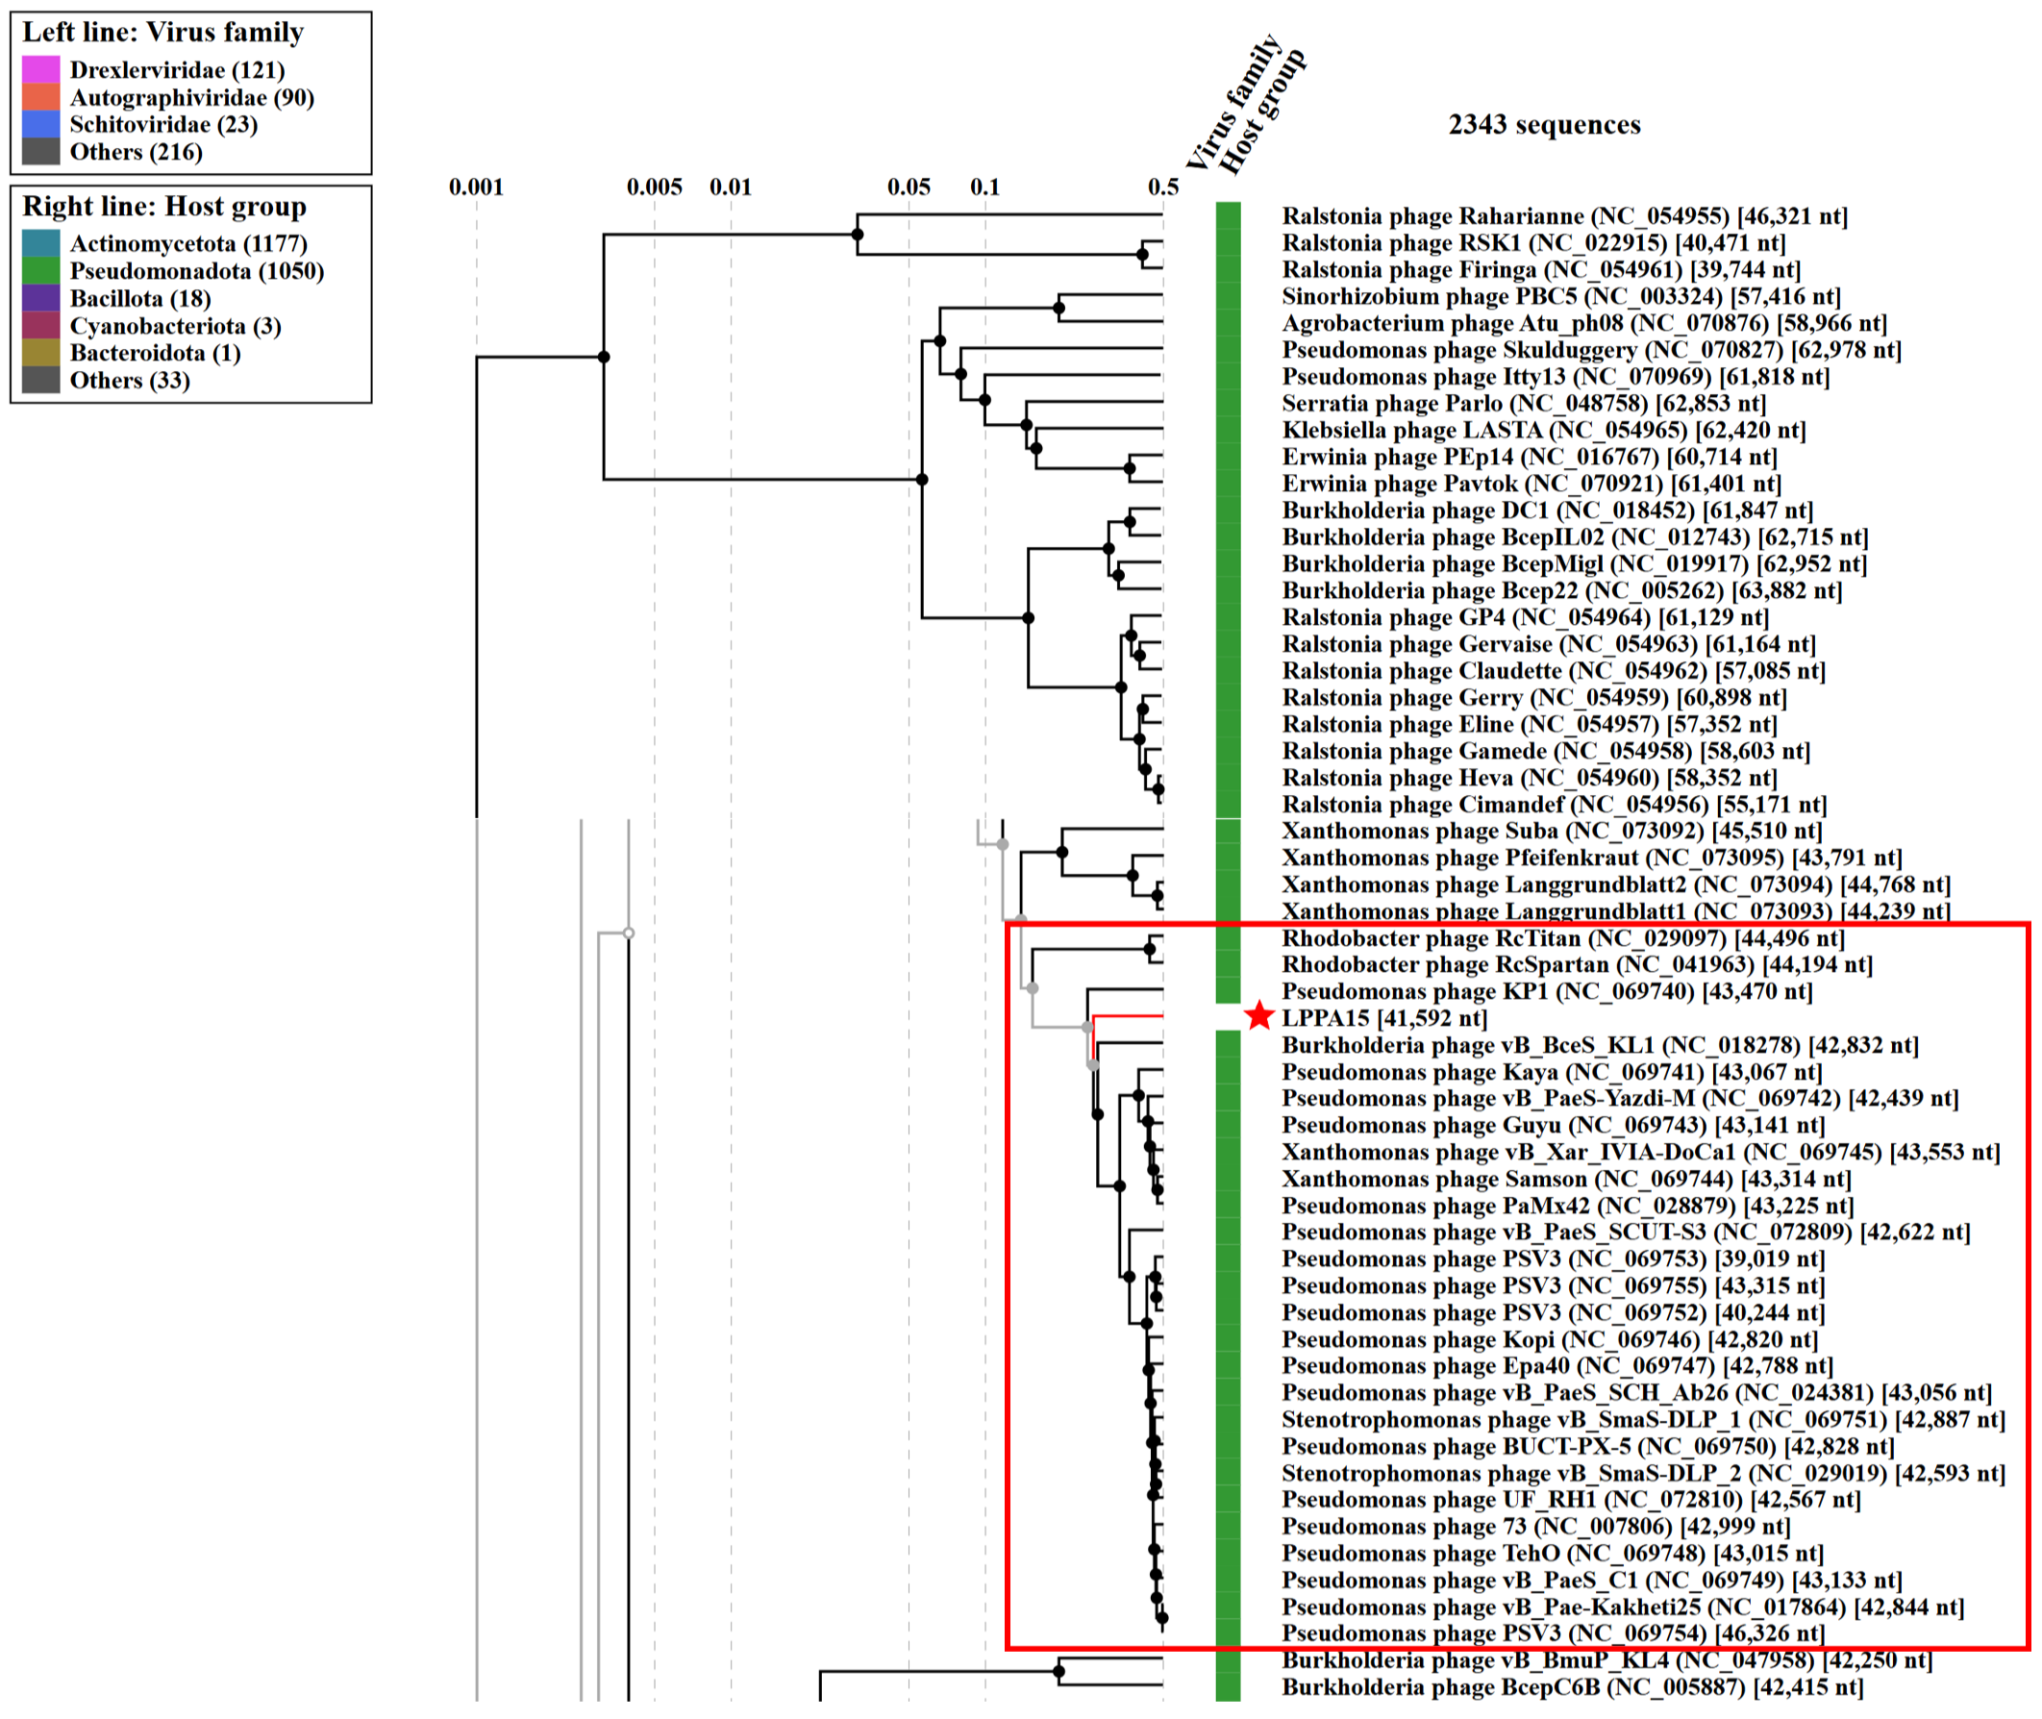

**VIRIDIC heatmap:** VIRIDIC (Virus Intergenomic Distance Calculator; http://rhea.icbm.uni-oldenburg.de/VIRIDIC/) computes pairwise intergenomic distances/similarities amongst phage genomes.

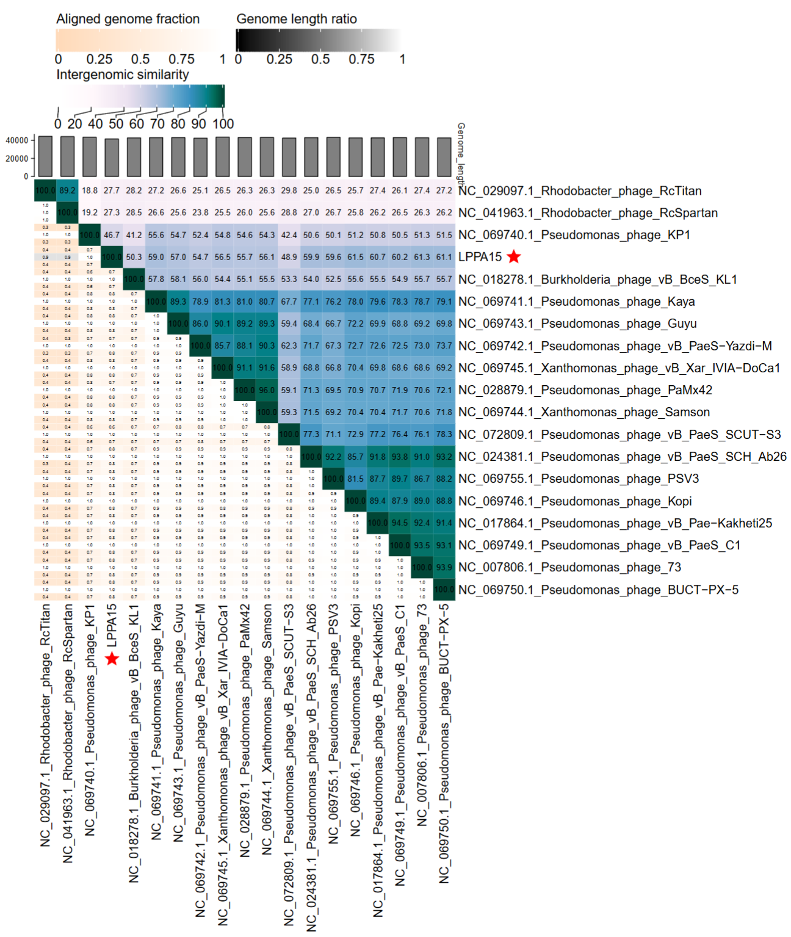

**Phylogeny:** The phylogenetic tree was constructed using the terminase large subunit of phages. Clustal Omega was used for multiple sequence alignment and RAxML-NG was used for building phylogenetic tree using maximum-likelihood method with 500 bootstrap replicates. The new genus is indicated with **red box** and new species is indicated with **red star**.

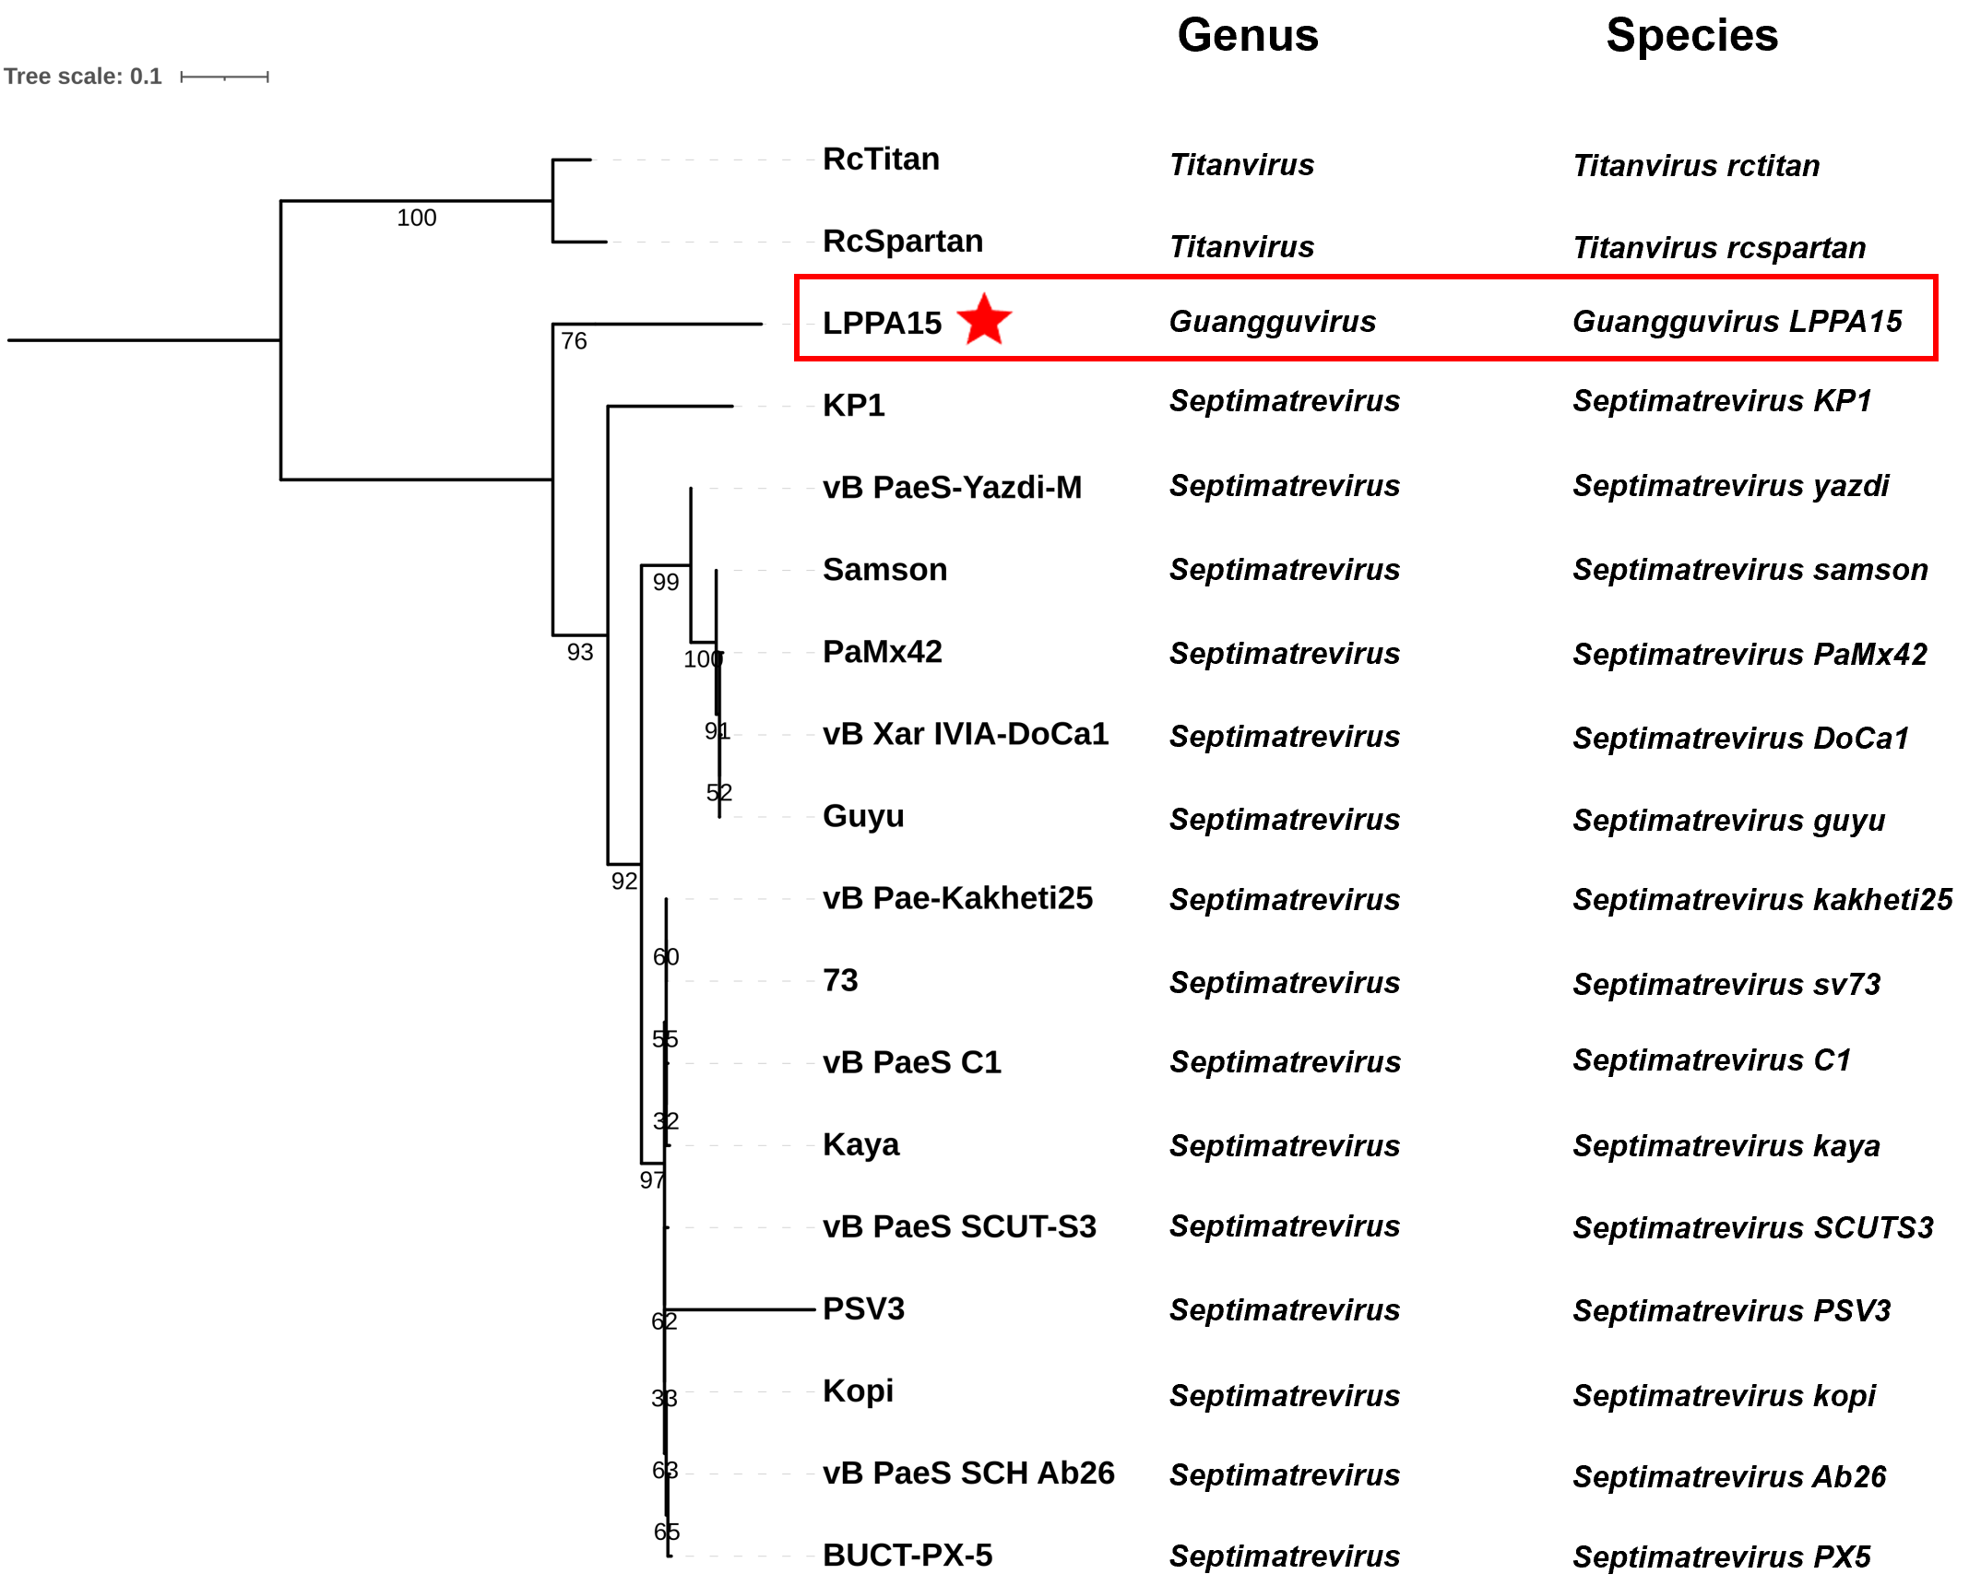

**Origin of the name of this taxon:** The name comes from Guanggu, a district in Wuhan, Hubei Province, China.

**Historical aspects:** Phage samples are sourced from water samples in Hubei Province.

**Specific References:** None

**Genome summary:**

|  |  |  |  |  |  |
| --- | --- | --- | --- | --- | --- |
| Phage name | INSDC | Size (Kb) | GC% | Protein | tRNA |
| Pseudomonas phage LPPA15 | PV112476 | 41.592 | 50.8 | 57 | 0 |