

The International Committee on Taxonomy of Viruses

Taxonomy Proposal Form, 2025

**Part 1a: Details of taxonomy proposals**

|  |  |
| --- | --- |
| **Title:** | Create one new species in the genus *Drulisvirus* |
| **Code assigned:** | 2025.015B.Drulisvirus_1ns | |

|  |  |  |  |  |
| --- | --- | --- | --- | --- |
| **Author(s), affiliation and email address(es):** | | | | |
| **Given name (+middle initial(s))** | **Surname** | **Affiliation** | **Email address** | **Corr. author(s)** |
| Aubrey Joy P. | Tejada | Industrial Technology Development Institute, Department of Science and Technology (DOST – ITDI), DOST Compound, Taguig, 1631, Philippines | [ajptejada@gmail.com](mailto:ajptejada@gmail.com) | X |
| Michael Angelou L. | Nada | Industrial Technology Development Institute, Department of Science and Technology (DOST – ITDI), DOST Compound, Taguig, 1631, Philippines | [mikeangelounada@gmail.com](mailto:mikeangelounada@gmail.com) |  |
| Ruth Antoinette D. | Chin | Industrial Technology Development Institute, Department of Science and Technology (DOST – ITDI), DOST Compound, Taguig, 1631, Philippines | chinruthantoinette@gmail.com |  |
| Janna Ysabelle O. | Casidsid | Industrial Technology Development Institute, Department of Science and Technology (DOST – ITDI), DOST Compound, Taguig, 1631, Philippines | jycasidsid@gmail.com |  |
| Joseph B. | Ancla | Industrial Technology Development Institute, Department of Science and Technology (DOST – ITDI), DOST Compound, Taguig, 1631, Philippines | anclajoseph8492 |  |
| Marel Jan G. | Joloro | Industrial Technology Development Institute, Department of Science and Technology (DOST – ITDI), DOST Compound, Taguig, 1631, Philippines | mgjoloro.dostvip@gmail.com |  |
| Mark Christian C. | Reterta | Industrial Technology Development Institute, Department of Science and Technology (DOST – ITDI), DOST Compound, Taguig, 1631, Philippines | mcreterta@gmail.com |  |
| Anton Roi G. | Collado | Industrial Technology Development Institute, Department of Science and Technology (DOST – ITDI), DOST Compound, Taguig, 1631, Philippines | colladoantonr@gmail.com |  |
| Sharmen C. | Berlin | Industrial Technology Development Institute, Department of Science and Technology (DOST – ITDI), DOST Compound, Taguig, 1631, Philippines | scberlin@up.edu.ph |  |
| Arra B. | Asejo | Industrial Technology Development Institute, Department of Science and Technology (DOST – ITDI), DOST Compound, Taguig, 1631, Philippines | nmry.dostvip@gmail.com |  |
| Nikka Marie R. | Yadao | Industrial Technology Development Institute, Department of Science and Technology (DOST – ITDI), DOST Compound, Taguig, 1631, Philippines | abasejo.dost@gmail.com |  |
| Virgilio Jr. P. | De Paz | Industrial Technology Development Institute, Department of Science and Technology (DOST – ITDI), DOST Compound, Taguig, 1631, Philippines | [virgdepazimperial@gmail.com](mailto:virgdepazimperial@gmail.com) |  |
| Ursela G. | Bigol | Industrial Technology Development Institute, Department of Science and Technology (DOST – ITDI), DOST Compound, Taguig, 1631, Philippines | [ugbigol@itdi.dost.gov.ph](mailto:ugbigol@itdi.dost.gov.ph) |  |
| Rommel J. | Gestuveo | Industrial Technology Development Institute, Department of Science and Technology (DOST – ITDI), DOST Compound, Taguig, 1631, Philippines | rjgestuveo@gmail.com |  |

**Part 1b: Taxonomy Proposal Submission**

|  |  |  |  |
| --- | --- | --- | --- |
| **ICTV Subcommittee:** | | | |
| Animal DNA Viruses and Retroviruses |  | Bacterial viruses |  |
| Animal minus-strand and dsRNA viruses |  | Fungal and protist viruses |  |
| Animal positive-strand RNA viruses |  | Plant viruses |  |
| Archaeal viruses |  | General - |  |

|  |
| --- |
| **List the ICTV Study Group(s) that have seen or have been involved in creating this proposal:** |
| Caudoviricetes Study Group |

|  |  |  |  |
| --- | --- | --- | --- |
| **Optional – complete only if formally voted on by an ICTV Study Group:** | | | |
| **Study Group** | **Number of members** | | |
| **Votes in support** | **Votes against** | **No vote** |
|  |  |  |  |
|  |  |  |  |

|  |  |
| --- | --- |
| **Submission date:** | 12/04/2025 |

**Part 1c: Feedback from ICTV Executive Committee (EC) meeting**

|  |  |
| --- | --- |
| **Executive Committee Meeting Decision code:** | **X** |
| A – Accept |  |
| Ac – Accept subject to revision by relevant subcommittee chair. No further vote required |  |
| U – Accept without revision but with re-evaluation and email vote by the EC |  |
| Uc – Accept subject to revision and re-evaluation and email vote by the EC |  |
| Ud – Deferred to the next EC meeting, with an invitation to revise based on EC comments |  |
| J - Reject |  |
| W - Withdrawn |  |

|  |
| --- |
| **Comments from the Executive Committee:** |
|  |

**Part 1d: Revised Taxonomy Proposal Submission**

|  |
| --- |
| **Response of proposer:** |
|  |

|  |  |
| --- | --- |
| **Revision date:** |  |

**Part 3:** **TAXONOMIC PROPOSAL**

<https://ictv.global/taxonomy/templates>

|  |  |  |  |
| --- | --- | --- | --- |
| **Taxonomic changes proposed:** | | | |
| Establish new taxon | **X** | Split taxon |  |
| Abolish taxon |  | Merge taxon |  |
| Move taxon |  | Promote taxon |  |
| Rename taxon |  | Demote taxon |  |
| Move and rename |  |

|  |  |
| --- | --- |
| **Etymology (origin) of proposed taxonomic names:** | |
| **Taxon name** | **Etymology of the term** |
| *Drulisvirus workingina* | workingina - “ina” is a Filipino term of “mother”, used to honor of working Filipino mothers in science |
|  |  |
|  |  |
|  |  |

|  |  |  |
| --- | --- | --- |
| **Permission for use of names derived from a living person:** | | |
| **Taxon name** | **Full name of person from whom the name is derived** | **Attached** |
|  |  |  |
|  |  |  |
|  |  |  |
|  |  |  |

|  |
| --- |
| **Abstract of Taxonomy Proposal:** |
| *Taxonomic rank(s) affected*:  Realms *Duplodnaviria*, Kingdom *Heunggongvirae*, Phylum *Uroviricota*, Class *Caudoviricetes*, Order *Autographivirales*, Family *Autoscriptoviridae*, Subfamily *Slopekvirinae*, Genus *Drulisvirus*  *Description of current taxonomy*:  The genus *Drulisvirus* currently includes 19 species.  *Proposed* *taxonomic change(s):*  Create one new species, “*Drulisvirus workingina”*  *Justification*:  Based on VIRIDIC analysis, we propose the creation of a new phage species, *Drulisvirus workingina* in honor of the working mothers and diverse individuals of the Virology and Vaccine Institute of the Philippines Program. |

|  |
| --- |
| **Text of Taxonomy proposal:** |
| *Taxonomic rank(s) affected*:  Realms *Duplodnaviria*, Kingdom *Heunggongvirae*, Phylum *Uroviricota*, Class *Caudoviricetes*, Order *Autographivirales*, Family *Autoscriptoviridae*, Subfamily *Slopekvirinae*, Genus *Drulisvirus*  *Description of current taxonomy*:  The genus *Drulisvirus* currently includes 19 species.  *Proposed* *taxonomic change(s):*  Create one new species, “*Drulisvirus workingina”*  *Demarcation criteria:*  *Species Demarcation criteria:*  Two phages are assigned to the same species if their genomes are more than 95% identical over their genome length using VIRIDIC [2].  *Justification*:  The *Escherichia p*hage vB_VIPECOTPH05B was isolated from Tarlac Provincial Hospital, Tarlac, Philippines. Our taxonomic analyses revealed that *Escherichia p*hage vB_VIPECOTPH05B remains unclassified at the species level. Here, we proposed the creation of a new species, *Drulisvirus workingina* under the Realms *Duplodnaviria*, Kingdom *Heunggongvirae*, Phylum *Uroviricota*, Class *Caudoviricetes*, Order *Autographivirales*, Family *Autoscriptoviridae*, Subfamily *Slopekvirinae*, Genus *Drulisvirus*. The genome is complete with DTR based on checkV [1] analysis and is publicly available in NCBI GenBank database. As a result of genomic characterization using VIRIDIC (Figure 1), we propose the addition of one new species, “*Drulisvirus workingina”* |

|  |
| --- |
| **References:** |
| 1. Nayfach, S., Camargo, A. P., Schulz, F., Eloe-Fadrosh, E., Roux, S., & Kyrpides, N. C. (2021). CheckV assesses the quality and completeness of metagenome-assembled viral genomes. *Nature biotechnology*, *39*(5), 578-585. 2. Turner, D., Kropinski, A. M., & Adriaenssens, E. M. (2021). A roadmap for genome-based phage taxonomy. *Viruses*, *13*(3), 506. 3. Millard, A. D., Denise, R., Lestido, M., Thomas, M., Webster, D., Turner, D., & Sicheritz-Ponten, T. (2024). taxmyPHAGE: Automated taxonomy of dsDNA phage genomes at the genus and species. *bioRxiv*, 2024-08. 4. Nishimura, Y., Yoshida, T., Kuronishi, M., Uehara, H., Ogata, H., & Goto, S. (2017). ViPTree: the viral proteomic tree server. *Bioinformatics*, *33*(15), 2379-2380. 5. Moraru, C. (2023). VirClust—A tool for hierarchical clustering, core protein detection and annotation of (prokaryotic) viruses. *Viruses*, *15*(4), 1007. 6. Ondov, B. D., Treangen, T. J., Melsted, P., Mallonee, A. B., Bergman, N. H., Koren, S., & Phillippy, A. M. (2016). Mash: fast genome and metagenome distance estimation using MinHash. *Genome biology*, *17*, 1-14. 7. Cook, R., Brown, N., Redgwell, T., Rihtman, B., Barnes, M., Clokie, M., ... & Millard, A. (2021). INfrastructure for a PHAge REference database: identification of large-scale biases in the current collection of cultured phage genomes. *Phage*, *2*(4), 214-223. 8. Moraru, C., Varsani, A., & Kropinski, A. M. (2020). VIRIDIC—A novel tool to calculate the intergenomic similarities of prokaryote-infecting viruses. *Viruses*, *12*(11), 1268. 9. Tamura, K., Stecher, G., & Kumar, S. (2021). MEGA11: molecular evolutionary genetics analysis version 11. *Molecular biology and evolution*, *38*(7), 3022-3027. 10. Edgar, R. C. (2004). MUSCLE: multiple sequence alignment with high accuracy and high throughput. *Nucleic acids research*, *32*(5), 1792-1797. |

|  |  |
| --- | --- |
| **Accompanying files:** | |
| **Filename** | **Description of contents** |
| Drulisvirus_1ns.xlsx | An excel file containing the taxonomic classification for new species |
|  |  |

|  |
| --- |
| **Tables, Figures:** |

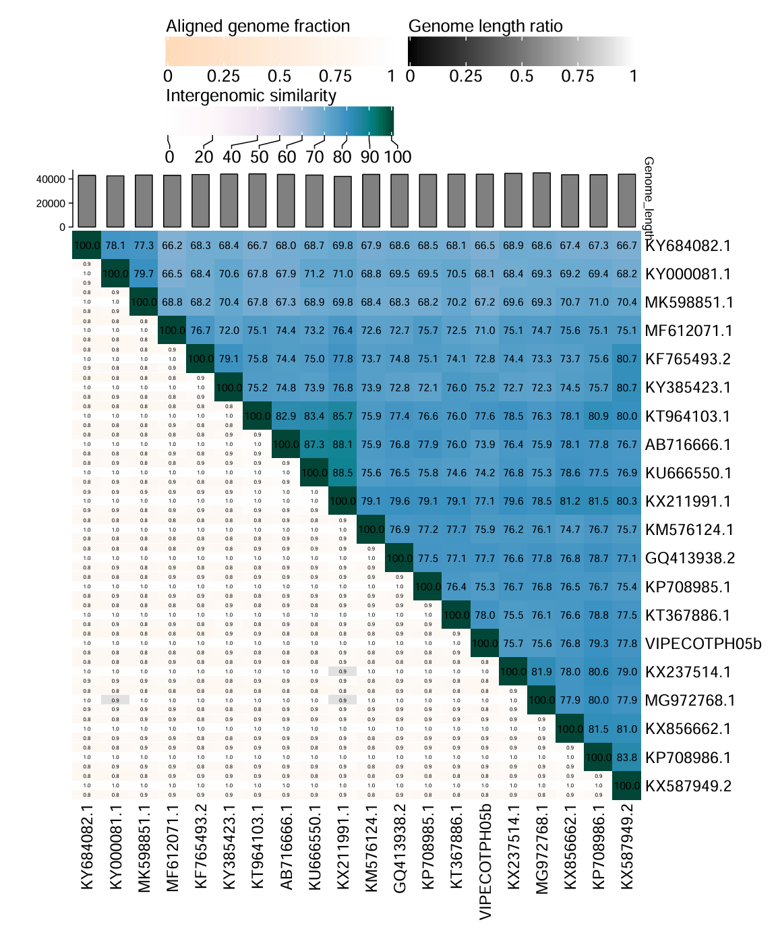

Figure 1. Heatmap of intergenomic similarities among members of the genus *Drulisvirus* and VIPECOTPH05b.