

The International Committee on Taxonomy of Viruses

Taxonomy Proposal Form, 2025

**Part 1a: Details of taxonomy proposals**

|  |  |
| --- | --- |
| **Title:** | Create a new genus of *Chaozhouvirus* including one new species |
| **Code assigned:** | 2025.010B.Chaozhouvirus_1ng_1ns | |

|  |  |  |  |  |
| --- | --- | --- | --- | --- |
| **Author(s), affiliation and email address(es):** | | | | |
| **Given name (+middle initial(s))** | **Surname** | **Affiliation** | **Email address** | **Corr. author(s)** |
| Jinquan | Li | Huazhong Agricultural University, Wuhan, China | [lijinquan2017@163.com](mailto:lijinquan2017@163.com) | X |
| Yang | Zhou | Huazhong Agricultural University, Wuhan, China | zhouyang@mail.hzau.edu.cn |  |
| Geng | Zou | Huazhong Agricultural University, Wuhan, China | zougeng19900918@126.com |  |
| Renwei | Wu | Huazhong Agricultural University, Wuhan, China |  |  |
| Zhechang | Li | Huazhong Agricultural University, Wuhan, China | l |  |
| Yating | Guo | Huazhong Agricultural University, Wuhan, China |  |  |
|  |  |  |  |  |
|  |  |  |  |  |

**Part 1b: Taxonomy Proposal Submission**

|  |  |  |  |
| --- | --- | --- | --- |
| **ICTV Subcommittee:** | | | |
| Animal DNA Viruses and Retroviruses |  | Bacterial viruses | X |
| Animal minus-strand and dsRNA viruses |  | Fungal and protist viruses |  |
| Animal positive-strand RNA viruses |  | Plant viruses |  |
| Archaeal viruses |  | General - |  |

|  |
| --- |
| **List the ICTV Study Group(s) that have seen or have been involved in creating this proposal:** |
| Caudoviricetes Study Group |

|  |  |  |  |
| --- | --- | --- | --- |
| **Optional – complete only if formally voted on by an ICTV Study Group:** | | | |
| **Study Group** | **Number of members** | | |
| **Votes in support** | **Votes against** | **No vote** |
|  |  |  |  |
|  |  |  |  |

|  |  |
| --- | --- |
| **Submission date:** | 17/02/2025 |

**Part 1c: Feedback from ICTV Executive Committee (EC) meeting**

|  |  |
| --- | --- |
| **Executive Committee Meeting Decision code:** | **X** |
| A – Accept |  |
| Ac – Accept subject to revision by relevant subcommittee chair. No further vote required |  |
| U – Accept without revision but with re-evaluation and email vote by the EC |  |
| Uc – Accept subject to revision and re-evaluation and email vote by the EC |  |
| Ud – Deferred to the next EC meeting, with an invitation to revise based on EC comments |  |
| J - Reject |  |
| W - Withdrawn |  |

|  |
| --- |
| **Comments from the Executive Committee:** |
|  |

**Part 1d: Revised Taxonomy Proposal Submission**

|  |
| --- |
| **Response of proposer:** |
|  |

|  |  |
| --- | --- |
| **Revision date:** |  |

**Part 2:** **GENERAL PROPOSAL**

|  |
| --- |
| **Abstract for General Proposal:** |
| *Brief description of current situation:*  *Proposed changes:*  *Justification:* |

|  |
| --- |
| **Text of General Proposal:** |
| *Background:*  *Proposed* *changes:*  *Justification:* |

|  |
| --- |
| **References:** |
|  |

|  |  |
| --- | --- |
| **Accompanying files:** | |
| **Filename** | **Description of contents** |
|  |  |
|  |  |

|  |
| --- |
| **Tables, Figures:** |

<Start here>

**Part 3:** **TAXONOMIC PROPOSAL**

<https://ictv.global/taxonomy/templates>

|  |  |  |  |
| --- | --- | --- | --- |
| **Taxonomic changes proposed:** | | | |
| Establish new taxon |  | Split taxon |  |
| Abolish taxon |  | Merge taxon |  |
| Move taxon |  | Promote taxon |  |
| Rename taxon |  | Demote taxon |  |
| Move and rename |  |

|  |  |
| --- | --- |
| **Etymology (origin) of proposed taxonomic names:** | |
| **Taxon name** | **Etymology of the term** |
|  |  |
|  |  |
|  |  |
|  |  |

|  |  |  |
| --- | --- | --- |
| **Permission for use of names derived from a living person:** | | |
| **Taxon name** | **Full name of person from whom the name is derived** | **Attached** |
| *Chaozhouvirus* | Based on Chaozhou District of Chaozhou City where the phage LPLM20 was isolated |  |
|  |  |  |
|  |  |  |
|  |  |  |

|  |
| --- |
| **Abstract of Taxonomy Proposal:** |
| *Taxonomic rank(s) affected*:  Realm *Duplodnaviria*, kingdom *Heunggongvirae*, phylum *Uroviricota*, class  *Description of current taxonomy*:  The bacterial viruses described in this proposal are currently unclassified  *Proposed* *taxonomic change(s):*  We propose the creation of a new genus *“Chaozhouvirus”* with a single species  *Justification*:  We isolated a new *Listeria* phage LPLM20. Based on the analysis of VIRIDIC and ViPTree, LPLM20 was significantly different from other genera (less than 70% identity with phages of other genera)*.* Thus, this proposal will create a new genus “*Chaozhouvirus”,* containing one new species, “*Chaozhouvirus LPLM20”.* |

|  |
| --- |
| * **Text of Taxonomy proposal:** |
| *Taxonomic rank(s) affected*:  Realm *Duplodnaviria*, kingdom *Heunggongvirae*, phylum *Uroviricota*, class  *Description of current taxonomy*:  The bacterial viruses described in this proposal are currently unclassified  *Proposed* *taxonomic change(s)*:  We propose the creation of a new genus *“Chaozhouvirus”* with a single species  *Demarcation criteria:*  **Species demarcation criteria:** Two phages are assigned to the same species if their genomes are more than 95% identical over their genome length for isolates. These values can be calculated by a number of tools, such as BLASTn – usually calculated using intergenomic distance calculator VIRIDIC [1].  **Genus demarcation criteria:** The Bacterial Viruses Subcommittee has established 70% nucleotide identity of the genome length as the cut-off for genera. Genus-level groupings should always be monophyletic in the signature genes, as tested with a phylogenetic tree. [2]  *Justification*:  A phylogenetic tree of *Listeria phage LPLM20* was constructed using VIPTree [3-4] (Figure 1). *LPLM20*, along with 14 other *Listeria* *phages*, formed a deep-branching clade in the ViPTree analysis and were subsequently selected for VIRIDIC analysis. VIRIDIC analysis computed the pairwise genomic distances and similarities between the phage genomes, revealing significant divergence between *LPLM20* from the phages of other genera, with nucleotide similarity below 70% (Figure 2). Furthermore, a maximum-likelihood (ML) tree was constructed using the terminase large subunit of the 20 phages, with 1000 bootstrap replicates [5-6] (Figure 3). In summary, these data support the proposal of a new genus, “*Chaozhouvirus”*, containing one new species, “*Chaozhouvirus LPLM20”*. |

|  |
| --- |
| **References:** |
| 1. Moraru C, Varsani A, Kropinski AM (2020) VIRIDIC-A Novel Tool to Calculate the Intergenomic Similarities of Prokaryote-Infecting Viruses. Viruses 12(11):1268. PMID: 33172115 / PMCID: PMC7694805 doi: 10.3390/v12111268. 2. Turner D, Kropinski AM, Adriaenssens EM (2021) A Roadmap for Genome-Based Phage Taxonomy. Viruses 13(3):506. PMID: 33803862 / PMCID: PMC8003253 doi: 10.3390/v13030506. 3. Nishimura Y, Yoshida T, Kuronishi M et al (2017) ViPTree: the viral proteomic tree server. Bioinformatics 33(15):2379-2380. PMID: 28379287. doi: 10.1093/bioinformatics/btx157. 4. Rohwer F, Edwards R (2002) The Phage Proteomic Tree: a genome-based taxonomy for phage. J Bacteriol 184(16):4529-35. PMID: 12142423 / PMCID: PMC135240. doi: 10.1128/jb.184.16.4529-4535.2002. 5. Nishijima S, Nagata N, Kiguchi Y et al (2022) Extensive gut virome variation and its associations with host and environmental factors in a population-level cohort. Nat Commun 13(1):5252. PMID: 36068216 / PMCID: PMC9448778 doi: 10.1038/s41467-022-32832-w 6. L. Nguyen, H.A. Schmidt, A. von Haeseler, B.Q. Minh (2015) IQ-TREE: A Fast and Effective Stochastic Algorithm for Estimating Maximum-Likelihood Phylogenies. *Mol. Biol. and Evol.*, 32:268-274. |

|  |  |
| --- | --- |
| **Accompanying files:** | |
| **Filename** | **Description of contents** |
|  |  |
|  |  |

|  |
| --- |
| **Tables, Figures:** |

**Figure 1. ViPTree analysis:** ViPTree analysis (https://www.genome.jp/viptree/; [3]) is based upon Rohwer and Edwards (2002) Phage Proteomic Tree [4]. The phages of interest are indicated with **red box and LPLM20 by a red star**.

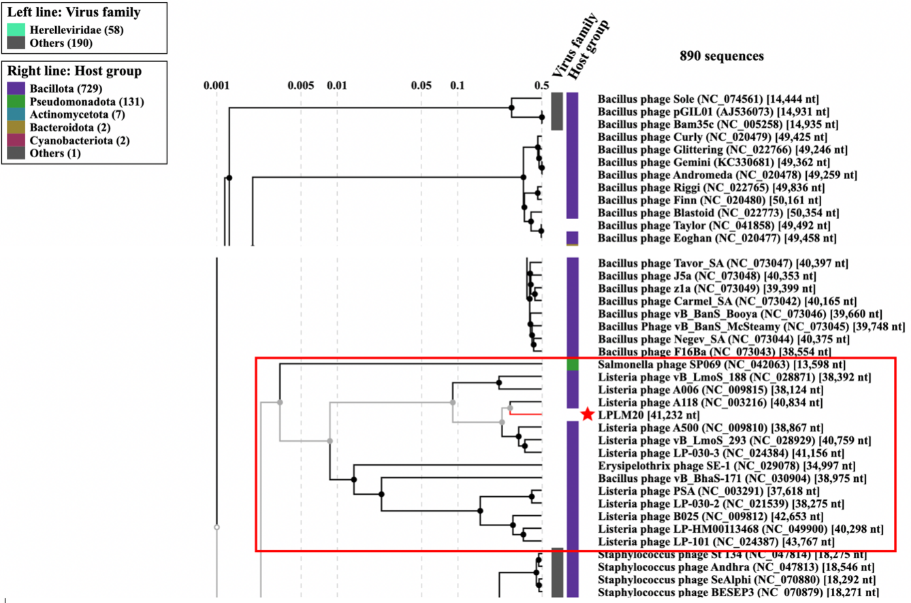

Figure 1

**Figure 2. VIRIDIC heat map:** VIRIDIC (Virus Intergenomic Distance Calculator [1]; http://rhea.icbm.uni-oldenburg.de/VIRIDIC/) computes pairwise intergenomic distances/similarities amongst phage genomes.

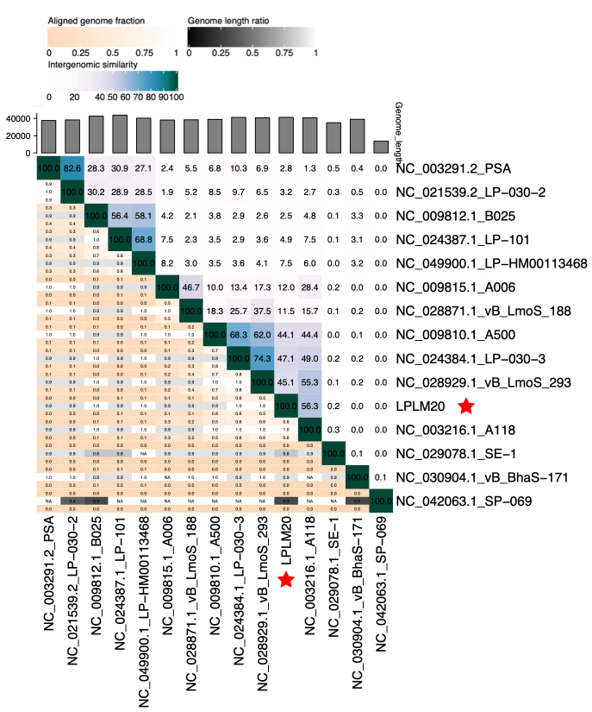Figure 2

**Figure 3. Phylogeny:** The phylogenetic tree was constructed using the major head protein of phages. Clustal Omega was used for multiple alignment and IQ-TREE was used for inferring the phylogenetic tree using the maximum-likelihood method with 1000 bootstrap replicates. The tree is rooted at the mid-point.

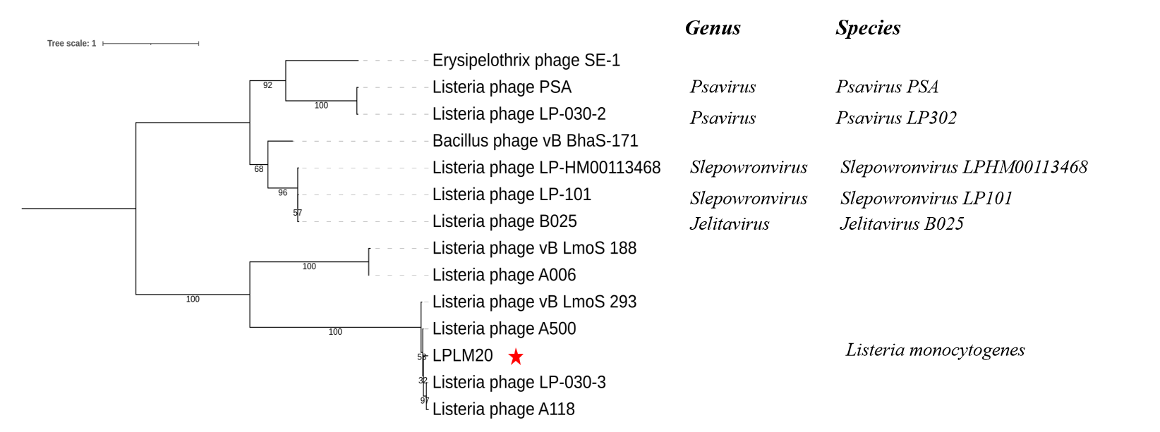Figure 3

**Origin of the name of this taxon:** This genus is named, based on Chaozhou District of Chaozhou City where the phage was isolated.

**Historical aspects:** *Listeria* phage LPLM20 was isolated in 2024 by Chaozhou, using *Listeria monocytogenes* as the host bacterium.

**Genome summary:**

|  |  |  |  |  |  |
| --- | --- | --- | --- | --- | --- |
| Phage name | INSDC | Size (Kb) | GC% | Protein | tRNA |
| Listeria phage LPLM20 | PP895302 | 41,232 | 36.6 | 67 | 0 |