

The International Committee on Taxonomy of Viruses

Taxonomy Proposal Form, 2025

<https://ictv.global/taxonomy/templates>**Part 1a: Details of taxonomy proposals**

|  |  |
| --- | --- |
| **Title:** | To create three new species, in the genus *Shangdongvirus* (class *Caudoviricetes*) |
| **Code assigned:** | 2025.004B.Shandongvirus_3ns | |

|  |  |  |  |  |
| --- | --- | --- | --- | --- |
| **Author(s), affiliation and email address(es):** | | | | |
| **Given name (+middle initial(s))** | **Surname** | **Affiliation** | **Email address** | **Corr. author(s)** |
| Sezin | Ünlü | Baskent University, Faculty of Medicine, Department of Medical Microbiology, Ankara, Turkiye | sezinnunlu@gmail.com | X |
| Aylin | Üsküdar Güçlü | Baskent University, Faculty of Medicine, Department of Medical Microbiology, Ankara, Turkiye | uskudaraylin@gmail.com | X |

**Part 1b: Taxonomy Proposal Submission**

|  |  |  |  |
| --- | --- | --- | --- |
| **ICTV Subcommittee:** | | | |
| Animal DNA Viruses and Retroviruses |  | Bacterial viruses | **X** |
| Animal minus-strand and dsRNA viruses |  | Fungal and protist viruses |  |
| Animal positive-strand RNA viruses |  | Plant viruses |  |
| Archaeal viruses |  | General - |  |

|  |
| --- |
| **List the ICTV Study Group(s) that have seen or have been involved in creating this proposal:** <https://ictv.global/sc> |
|  |

|  |  |  |  |
| --- | --- | --- | --- |
| **Optional – complete only if formally voted on by an ICTV Study Group:** | | | |
| **Study Group** | **Number of members** | | |
| **Votes in support** | **Votes against** | **No vote** |
|  |  |  |  |
|  |  |  |  |

|  |  |
| --- | --- |
| **Submission date:** | 14/04/2025 |

**Part 1c: Feedback from ICTV Executive Committee (EC) meeting**

|  |  |
| --- | --- |
| **Executive Committee Meeting Decision code:** | **X** |
| A – Accept |  |
| Ac – Accept subject to revision by relevant subcommittee chair. No further vote required |  |
| U – Accept without revision but with re-evaluation and email vote by the EC |  |
| Uc – Accept subject to revision and re-evaluation and email vote by the EC |  |
| Ud – Deferred to the next EC meeting, with an invitation to revise based on EC comments |  |
| J - Reject |  |
| W - Withdrawn |  |

|  |
| --- |
| **Comments from the Executive Committee:** |
|  |

**Part 1d: Revised Taxonomy Proposal Submission**

|  |
| --- |
| **Response of proposer:** |
|  |

|  |  |
| --- | --- |
| **Revision date:** |  |

**Part 3:** **TAXONOMIC PROPOSAL**

<https://ictv.global/taxonomy/templates>

|  |  |  |  |
| --- | --- | --- | --- |
| **Taxonomic changes proposed:** | | | |
| Establish new taxon | **x** | Split taxon |  |
| Abolish taxon |  | Merge taxon |  |
| Move taxon |  | Promote taxon |  |
| Rename taxon |  | Demote taxon |  |
| Move and rename |  |

|  |  |
| --- | --- |
| **Etymology (origin) of proposed taxonomic names:** | |
| **Taxon name** | **Etymology of the term** |
|  |  |
|  |  |
|  |  |
|  |  |

|  |  |  |
| --- | --- | --- |
| **Permission for use of names derived from a living person:** | | |
| **Taxon name** | **Full name of person from whom the name is derived** | **Attached** |
|  |  |  |
|  |  |  |
|  |  |  |
|  |  |  |

|  |
| --- |
| **Abstract of Taxonomy Proposal:** Phylogenetic, VIRIDIC, and vConTACT2 analysis of a newly isolated phage Baskent_P4_1 infecting *Pseudomonas aeruginosa* suggests that this phage may belong to a new genus with three other species, *Pseudomonas* phage PSASB_03, *Stenotrophomonas* phage vB_SM_ytsc_ply2008005c and *Stenotrophomonas* vB_SmaS_Bhz54, sharing no more than 95% nucleotide identity with known phages within the class *Caudoviricetes*. |
| *Taxonomic rank(s) affected*: Realm *Duplodnaviria*, kingdom *Heunggongvirae*, phylum *Uroviricota*, class  *Description of current taxonomy*:  The virus classified in this proposal does not have a current taxonomic assignment.  *Proposed* *taxonomic change(s):*  We propose three new species in the genus *Shangdongvirus*  *Justification*:  From vConTACT2 analysis, the newly isolated bacteriophage Baskend_p4_1 falls outside of currently classified taxa in the class *Caudoviricetes.* Analysis of genome similarity, TBLASTX distances and phylogeny of the major capsid protein supports the creation of a new genus “*Shangdongvirus*” with four new species. |

|  |
| --- |
| **Text of Taxonomy proposal:** |
| *Taxonomic rank(s) affected*: Realm *Duplodnaviria*, kingdom *Heunggongvirae*, phylum *Uroviricota*, class  *Description of current taxonomy*:  The virus classified in this proposal does not have a current taxonomic classification.  *Proposed* *taxonomic change(s)*:  We propose three new species in the genus *Shangdongvirus*  *Demarcation criteria:*  **Species demarcation criteria:** Two phages are assigned to the same species if their genomes are more than 95% identical over their genome length for isolates (1). The newly isolated phage Baskent_P4_1 differs from the others with more than 5% at the DNA level as confirmed with the BLASTN algorithm. Transmission electron microscopy shows the phage is a siphovirus-like phage with an icosahedral head (70 nm) and a long non-contractile tail (150 nm).  **Genus demarcation**: For the proposed genus, there are two different host bacteria for the phages, *Pseudomonas aeruginosa* and *Stenotrophomonas maltophilia*. Phylogenetic (figure 1, figure 2), BLASTN (table 1) and vConTACT2 (Supplementary file) analysis indicate these species belong to the existing genus *Shangdongvirus*. On average, the genomes of members of this genus are roughly 41 to 42 kb and encode between 53 and 57 proteins (Table 1).  *Justification*:  Bioinformatics analysis of these phage genomes shows that these are virulent phages. vConTACT2 analysis showed that phage Baskent_p4_1 falls outside of the existing genera and remains unassigned. Additional VIRIDIC analysis (figure 3) has shown that phage Baskent_P4_1 did not show similarity with phages more than 94.6%. VIRIDIC revealed *Pseudomonas* phage PSASB_03 and *Stenotrophomonas* phage vB_SM_ytsc_ply2008005c showed 95% intergenomic similarity. According to species demarcation criteria, since their genomes over their genome length are not more than 95% identical, two phages are assigned to the different species. BLASTN analysis showed phage Baskent_P4_1 demonstrate similarity with only three phages, two of which infect *S. maltophilia* and all of them were classified only the class *Caudoviricetes*, and no further taxonomic classification was made. |

|  |
| --- |
| **References:** |
| 1. Turner D, Kropinski AM, Adriaenssens EM (2021) A Roadmap for Genome-Based Phage Taxonomy. Viruses 13(3):506. https://doi.org/10.3390/v13030506 |

|  |  |
| --- | --- |
| **Accompanying files:** | |
| **Filename** | **Description of contents** |
|  |  |
|  |  |

|  |
| --- |
| **Tables, Figures:** |

<Start here>

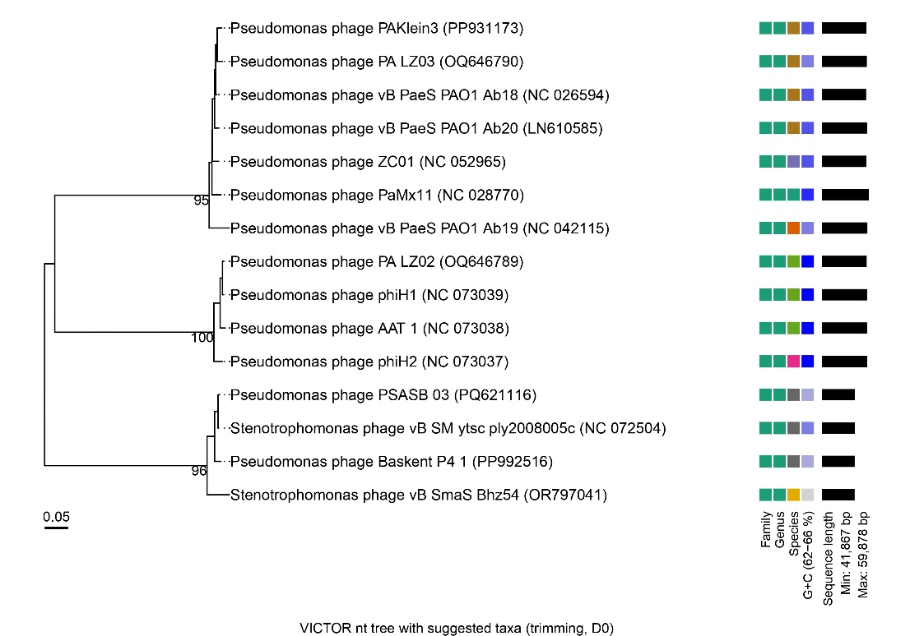

**Figure 1:** Phylogenetic trees based on whole genome sequences of phage Baskent_P4_1. The tree was inferred using the formula D0 with a bootstrap support value from 100 replications. Complete genome sequences were used to construct the phylogenetic tree using the VICTOR tool. Genome BLAST distance phylogeny (GBDP), configured for prokaryotic viruses, was employed.

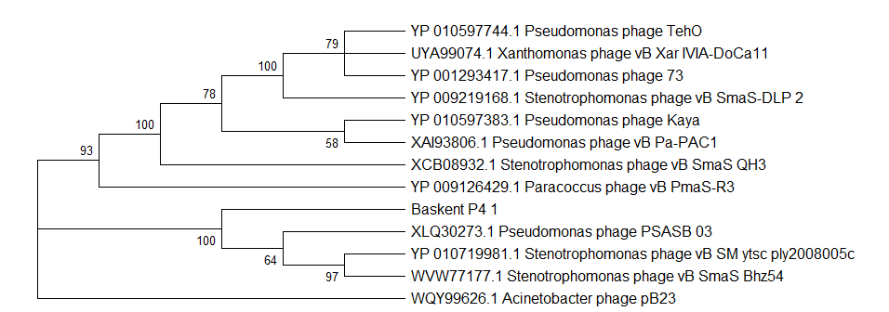

Figure 2: Maximum Likelihood phylogenetic tree based on major capsid protein sequences. The tree was constructed using the Maximum Likelihood (ML) method and bootstrap analysis was performed with 1000 replicates to assess branch support, and bootstrap values (≥50%) are shown next to the branches. The tree is drawn to scale, with branch lengths measured in the number of substitutions per site. The tree was rooted using *Acinetobacter* phage pB23 as an outgroup.



**Figure 3:** The VIRIDIC pairwise intergenomic distances/similarities between phage Baskent_P4_1 and the most similar sequences according to BLASTn analysis. Aligned genome fraction, genome length ratio and intergenomic similarity ratios were given with color density. Gray bars represent genome length.

**Table 1:** Properties of the four phages representing the species belonging to the genus We propose three new species in the genus *Shangdongvirus*

. Percentage identity and query coverage are relative to Pseudomonas phage Baskent_P4_1

|  |  |  |  |  |  |
| --- | --- | --- | --- | --- | --- |
|  | Accession | Genome Length | Coding Sequence | Percent Identity | Query Coverage |
| *Pseudomonas* phage Baskent_P4_1 | PP992516.1 | 41947 | 53 | 100% | 100% |
| *Pseudomonas* phage PSASB_03 | PQ621116.1 | 42348 | 57 | 96.90% | 98% |
| *Stenotrophomonas* phage vB_SM_ytsc_ply2008005c | OK562670.1 | 42318 | 54 | 96.25% | 94% |
| *Stenotrophomonas* phage vB_SmaS_Bhz54 | OR797041.1 | 41867 | 54 | 96.66% | 89% |