

The International Committee on Taxonomy of Viruses

Taxonomy Proposal Form, 2025

**Part 1a: Details of taxonomy proposals**

|  |  |
| --- | --- |
| **Title:** | To create three new species, in the genus *Shangdongvirus* (class *Caudoviricetes*) |
| **Code assigned:** | 2025.004B.Ac.v3Shangdongvirus_3ns | |

|  |  |  |  |  |
| --- | --- | --- | --- | --- |
| **Author(s), affiliation and email address(es):** | | | | |
| **Given name (+middle initial(s))** | **Surname** | **Affiliation** | **Email address** | **Corr. author(s)** |
| Sezin | Ünlü | Baskent University, Faculty of Medicine, Department of Medical Microbiology, Ankara, Turkiye | sezinnunlu@gmail.com | X |
| Aylin | Üsküdar Güçlü | Baskent University, Faculty of Medicine, Department of Medical Microbiology, Ankara, Turkiye | uskudaraylin@gmail.com | X |

**Part 1b: Taxonomy Proposal Submission**

|  |  |  |  |
| --- | --- | --- | --- |
| **ICTV Subcommittee:** | | | |
| Animal DNA Viruses and Retroviruses |  | Bacterial viruses | **X** |
| Animal minus-strand and dsRNA viruses |  | Fungal and protist viruses |  |
| Animal positive-strand RNA viruses |  | Plant viruses |  |
| Archaeal viruses |  | General - |  |

|  |
| --- |
| **List the ICTV Study Group(s) that have seen or have been involved in creating this proposal:** <https://ictv.global/sc> |
|  |

|  |  |  |  |
| --- | --- | --- | --- |
| **Optional – complete only if formally voted on by an ICTV Study Group:** | | | |
| **Study Group** | **Number of members** | | |
| **Votes in support** | **Votes against** | **No vote** |
|  |  |  |  |
|  |  |  |  |

|  |  |
| --- | --- |
| **Submission date:** | 14/04/2025 |

**Part 1c: Feedback from ICTV Executive Committee (EC) meeting**

|  |  |
| --- | --- |
| **Executive Committee Meeting Decision code:** | **X** |
| A – Accept |  |
| Ac – Accept subject to revision by relevant subcommittee chair. No further vote required | **x** |
| U – Accept without revision but with re-evaluation and email vote by the EC |  |
| Uc – Accept subject to revision and re-evaluation and email vote by the EC |  |
| Ud – Deferred to the next EC meeting, with an invitation to revise based on EC comments |  |
| J - Reject |  |
| W - Withdrawn |  |

|  |
| --- |
| **Comments from the Executive Committee:** |
| The word document mentions multiple times (including title) that a new genus is created, but it already exists. The proposal needs to be improved in wording. Is the new species Shangdongvirus kolkata sufficiently warranted? On the edge of demarcation criteria. |

**Part 1d: Revised Taxonomy Proposal Submission**

|  |
| --- |
| **Response of proposer:** |
| The proposal text has been revised to account for this error. We have opted to retain the species as it falls just below the demarcation criteria. |

|  |  |
| --- | --- |
| **Revision date:** | 18/08/2025 |

**Part 3:** **TAXONOMIC PROPOSAL**

<https://ictv.global/taxonomy/templates>

|  |  |  |  |
| --- | --- | --- | --- |
| **Taxonomic changes proposed:** | | | |
| Establish new taxon | **x** | Split taxon |  |
| Abolish taxon |  | Merge taxon |  |
| Move taxon |  | Promote taxon |  |
| Rename taxon |  | Demote taxon |  |
| Move and rename |  |

|  |  |
| --- | --- |
| **Etymology (origin) of proposed taxonomic names:** | |
| **Taxon name** | **Etymology of the term** |
|  |  |
|  |  |
|  |  |
|  |  |

|  |  |  |
| --- | --- | --- |
| **Permission for use of names derived from a living person:** | | |
| **Taxon name** | **Full name of person from whom the name is derived** | **Attached** |
|  |  |  |
|  |  |  |
|  |  |  |
|  |  |  |

|  |
| --- |
| **Abstract of Taxonomy Proposal:** |
| *Taxonomic rank(s) affected*:  Genus, species  *Description of current taxonomy*:  The virus classified in this proposal does not have a current taxonomic assignment.  The *genus Shangdongvirus*was created in 2023 and currently includes a single species ([2023.054B.Queuovirinae_reorg](https://ictv.global/ictv/proposals/2023.054B.Queuovirinae_reorg.zip)[)](https://ictv.global/ictv/proposals/2020.149B.R.Shandongvirus.zip)  *Proposed* *taxonomic change(s):*  We propose three new species in the genus *Shandongvirus*  *Justification*:  Phylogenetic, VIRIDIC, and vConTACT2 analysis of a newly isolated phage Baskent_P4_1 infecting *Pseudomonas aeruginosa* suggests that this phage is related to three other bacterial viruses; *Pseudomonas* phage PSASB_03, *Stenotrophomonas* phage vB_SM_ytsc_ply2008005c and *Stenotrophomonas* vB_SmaS_Bhz54. Analysis of genome similarity, TBLASTX distances and phylogeny of the major capsid protein supports its inclusion as new species in the genus *Shangdongvirus*. |
|  |

|  |
| --- |
| **Text of Taxonomy proposal:** |
| *Taxonomic rank(s) affected*:  Genus, species  *Description of current taxonomy*:  The virus classified in this proposal does not have a current taxonomic assignment.  The *genus Shandongvirus*was created in 2020 and currently includes a single species ([2020.149B.R.Shandongvirus)](https://ictv.global/ictv/proposals/2020.149B.R.Shandongvirus.zip)  *Proposed* *taxonomic change(s)*:  We propose three new species in the genus *Shangdongvirus*  *Demarcation criteria:*  **Species demarcation criteria:** Two phages are assigned to the same species if their genomes exhibit greater than or equal to 95% similarity over their genome length [1].  **Genus demarcation criteria**: The Bacterial and Archaeal Virus Subcommittee established 70% inter-genomic similarity threshold for genus classification.  *Justification*:  The newly isolated phage Baskent_P4_1 is a siphovirus-like phage with an icosahedral head (70 nm) and a long non-contractile tail (150 nm). BLASTN analysis (table 1) showed phage Baskent_P4_1 exhibits similarity with three other phages, two of which infect *S. maltophilia*. Phylogenetic (figure 1, figure 2), BLASTN (table 1), VIRIDIC [2] (figure 3) and vConTACT2 [3] (Supplementary file) analysis indicate these species belong to the existing genus *Shangdongvirus*. On average, the genomes of members of this genus are roughly 41 to 42 kb and encode between 53 and 57 proteins (Table 1). |

|  |
| --- |
| **References:** |
| 1. Turner D, Kropinski AM, Adriaenssens EM (2021) A Roadmap for Genome-Based Phage Taxonomy. Viruses 13(3):506. <https://doi.org/10.3390/v13030506> 2. Moraru C, Varsani A, Kropinski AM. VIRIDIC-A Novel Tool to Calculate the Intergenomic Similarities of Prokaryote-Infecting Viruses. Viruses. 2020 Nov 6;12(11):1268. doi: 10.3390/v12111268. PMID: 33172115; PMCID: PMC7694805. <http://kronos.icbm.uni-oldenburg.de/viridic/> 3. Bin Jang H, Bolduc B, Zablocki O, Kuhn JH, Roux S, Adriaenssens EM, Brister JR, Kropinski AM, Krupovic M, Lavigne R, Turner D, Sullivan MB. Taxonomic assignment of uncultivated prokaryotic virus genomes is enabled by gene-sharing networks. Nat Biotechnol. 2019 Jun;37(6):632-639. doi: 10.1038/s41587-019-0100-8 |

|  |  |
| --- | --- |
| **Accompanying files:** | |
| **Filename** | **Description of contents** |
|  |  |
|  |  |

|  |
| --- |
| **Tables, Figures:** |

<Start here>

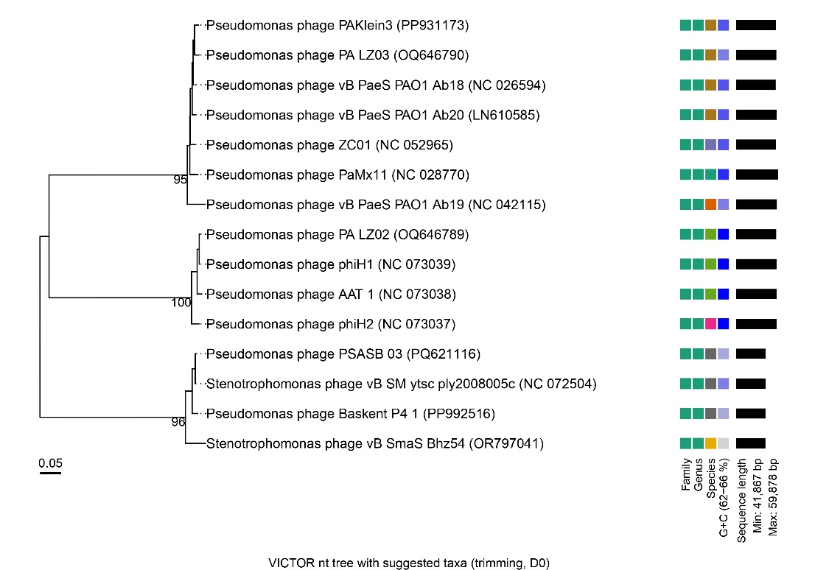

**Figure 1:** Phylogenetic trees based on whole genome sequences of phage Baskent_P4_1. The tree was inferred using the formula D0 with a bootstrap support value from 100 replications. Complete genome sequences were used to construct the phylogenetic tree using the VICTOR tool. Genome BLAST distance phylogeny (GBDP), configured for prokaryotic viruses, was employed.

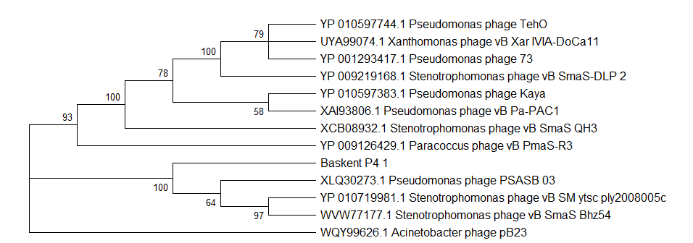

Figure 2: Maximum Likelihood phylogenetic tree based on major capsid protein sequences. The tree was constructed using the Maximum Likelihood (ML) method and bootstrap analysis was performed with 1000 replicates to assess branch support, and bootstrap values (≥50%) are shown next to the branches. The tree is drawn to scale, with branch lengths measured in the number of substitutions per site. The tree was rooted using *Acinetobacter* phage pB23 as an outgroup.



**Figure 3:** The VIRIDIC pairwise intergenomic distances/similarities between phage Baskent_P4_1 and the most similar sequences according to BLASTn analysis. Aligned genome fraction, genome length ratio and intergenomic similarity ratios were given with color density. Gray bars represent genome length.

**Table 1:** Properties of the four phages representing the species belonging to the genus Shangdongvirus. Percentage identity and query coverage are relative to Pseudomonas phage Baskent_P4_1

|  |  |  |  |  |  |
| --- | --- | --- | --- | --- | --- |
|  | Accession | Genome Length | Coding Sequence | Percent Identity | Query Coverage |
| *Pseudomonas* phage Baskent_P4_1 | PP992516.1 | 41947 | 53 | 100% | 100% |
| *Pseudomonas* phage PSASB_03 | PQ621116.1 | 42348 | 57 | 96.90% | 98% |
| *Stenotrophomonas* phage vB_SM_ytsc_ply2008005c | OK562670.1 | 42318 | 54 | 96.25% | 94% |
| *Stenotrophomonas* phage vB_SmaS_Bhz54 | OR797041.1 | 41867 | 54 | 96.66% | 89% |