

The International Committee on Taxonomy of Viruses

Taxonomy Proposal Form, 2025

**Part 1a: Details of taxonomy proposals**

|  |  |
| --- | --- |
| **Title:** | Create a new family for classification of a spindle-shaped virus infecting a hyperthermophilic archaeon *Aeropyrum pernix* |
| **Code assigned:** | 2025.006A.N.v2.Yamazakiviridae_1nf | |

|  |  |  |  |  |
| --- | --- | --- | --- | --- |
| **Author(s), affiliation and email address(es):** | | | | |
| **Given name (+middle initial(s))** | **Surname** | **Affiliation** | **Email address** | **Corr. author(s)** |
| Tomohiro | Mochizuki | Faculty of Pharmacy, Osaka Ohtani University, Osaka, Japan | mochizutomo@osaka-ohtani.ac.jp | X |
| David | Prangishvili | Ivane Javakhishvili Tbilisi State University, Tbilisi, Georgia | david.prangishvili@pasteur.fr |  |
| Mart | Krupovic | Institut Pasteur, Université Paris Cité, CNRS UMR6047, Archaeal Virology Unit, Paris, France | mart.krupovic@pasteur.fr |  |

**Part 1b: Taxonomy Proposal Submission**

|  |  |  |  |
| --- | --- | --- | --- |
| **ICTV Subcommittee:** | | | |
| Animal DNA Viruses and Retroviruses |  | Bacterial viruses |  |
| Animal minus-strand and dsRNA viruses |  | Fungal and protist viruses |  |
| Animal positive-strand RNA viruses |  | Plant viruses |  |
| Archaeal viruses | **X** | General - |  |

|  |
| --- |
| **List the ICTV Study Group(s) that have seen or have been involved in creating this proposal:** |
| Desulfurococcales viruses Study Group |

|  |  |  |  |
| --- | --- | --- | --- |
| **Optional – complete only if formally voted on by an ICTV Study Group:** | | | |
| **Study Group** | **Number of members** | | |
| **Votes in support** | **Votes against** | **No vote** |
|  |  |  |  |
|  |  |  |  |

|  |  |
| --- | --- |
| **Submission date:** | 25.06.2025 |

**Part 1c: Feedback from ICTV Executive Committee (EC) meeting**

|  |  |
| --- | --- |
| **Executive Committee Meeting Decision code:** | **X** |
| A – Accept |  |
| Ac – Accept subject to revision by relevant subcommittee chair. No further vote required |  |
| U – Accept without revision but with re-evaluation and email vote by the EC |  |
| Uc – Accept subject to revision and re-evaluation and email vote by the EC |  |
| Ud – Deferred to the next EC meeting, with an invitation to revise based on EC comments |  |
| J - Reject |  |
| W - Withdrawn |  |

|  |
| --- |
| **Comments from the Executive Committee:** |
|  |

**Part 1d: Revised Taxonomy Proposal Submission**

|  |
| --- |
| **Response of proposer:** |
|  |

|  |  |
| --- | --- |
| **Revision date:** |  |

**Part 3:** **TAXONOMIC PROPOSAL**

|  |  |  |  |
| --- | --- | --- | --- |
| **Taxonomic changes proposed:** | | | |
| Establish new taxon | **X** | Split taxon |  |
| Abolish taxon |  | Merge taxon |  |
| Move taxon |  | Promote taxon |  |
| Rename taxon |  | Demote taxon |  |
| Move and rename |  |

|  |  |
| --- | --- |
| **Etymology (origin) of proposed taxonomic names:** | |
| **Taxon name** | **Etymology of the term** |
| *Yamazakiviridae* | Named after late Dr. Syuji Yamazaki, who performed pioneering work on *Aeropyrum pernix*, the host of APSV1. |
| *Kodayamazakivirus* | Prefix “koda” refers to the place of isolation, a coastal solfataric vent at **Koda**kara-Jima Island, Japan; stem “Yamazaki” refers to the family name, “*Yamazakiviridae*”. |
| *Kodayamazakivirus kyodaii* | The species epithet, “kyodaii”, refers to the short name of Kyoto University (**kyodai**), an institution in which *A. pernix* was isolated and described. |

|  |  |  |
| --- | --- | --- |
| **Permission for use of names derived from a living person:** | | |
| **Taxon name** | **Full name of person from whom the name is derived** | **Attached** |
|  |  |  |

|  |
| --- |
| **Abstract of Taxonomy Proposal:** |
| *Taxonomic rank(s) affected*:  We propose creating a new family for classification of Aeropyrum pernix spindle-shaped virus 1. The family will not be assigned to a higher-level taxon.  *Description of current taxonomy*:  Viruses with spindle-shaped virions are classified into 8 families, none of which has been assigned to higher-level taxonomic ranks.  *Proposed* *taxonomic change(s):*  We propose classifying Aeropyrum pernix spindle-shaped virus 1 (APSV1) into a new species within a new genus and a new family, “*Yamazakiviridae*”.  *Justification*:  APSV1 is not closely related to other spindle-shaped viruses and in the VipTree proteomic tree the virus formed a separate branch. |

|  |
| --- |
| **Text of Taxonomy proposal:** |
| *Taxonomic rank(s) affected*:  We propose creating a new family for classification of Aeropyrum pernix spindle-shaped virus 1. The family will not be assigned to a higher-level taxon.  *Description of current taxonomy*:  Viruses with spindle-shaped virions are classified into 8 families, none of which has been assigned to higher-level taxonomic ranks.  *Proposed* *taxonomic change(s)*:  We propose classifying Aeropyrum pernix spindle-shaped virus 1 (APSV1) into a new species within a new genus and a new family, “*Yamazakiviridae*”.  *Demarcation criteria:*  There is presently no systematic criterium established for classification of spindle-shaped viruses, which have much less sequenced representatives compared, for instance, to the head-tailed archaeal viruses. However, we propose using 95% sequence identity as a species demarcation threshold, to be consistent with the classification of other bacterial and archaeal viruses. For family demarcations, we used proteome-wide phylogenomic analysis with VipTree.  *Justification*:  APSV1 is a temperate virus which was discovered upon its induction from the hyperthermophilic aerobic archaeon *Aeropyrum pernix* strain K1 (Mochizuki et al., 2011). The APSV1 virions are pleomorphic spindle-shaped particles, ∼180 to 210 nm in length and ∼40 to 55 nm in width (Figure 1a). The purified virions carried a single tail or two tails protruding from pointed ends of the particles (Figure 1b to d). Three short filaments were attached to one end of the particles, tailless as well as single tailed (Figure 1c, inset). The virions have a tendency to attach to each other with their filament-carrying ends, sometimes forming rosette-like structures (Figure 1e).  APSV1 genome is integrated into the tRNA-Val gene of the host but upon oxygen limitation, the excision and replication of the virus genome are activated. The excised genome is a circular dsDNA molecule of 38,049 bp and is predicted to encodes 53 proteins (Figure 2). Of these only 10 display sequence similarity (Blastp, E<0.05) to proteins encoded by known viruses, with only 3 homologs (ORF12, ORF26, and ORF31) being encoded by other archaeal spindle-shaped viruses. The distant relationship to other known viruses is confirmed by proteome-wide clustering analysis using VipTree (Nishimura et al., 2017) in which APSV1 formed a separate branch (Fig. 3). Thus, we propose classifying APSV1 into a new species within a new genus, “*Kodayamazakivirus*”, and a new family, “*Yamazakiviridae*”. |

|  |
| --- |
| **References:** |
| Mochizuki T, Sako Y, Prangishvili D. Provirus induction in hyperthermophilic archaea: characterization of Aeropyrum pernix spindle-shaped virus 1 and Aeropyrum pernix ovoid virus 1. J Bacteriol. 2011; 193(19):5412-9. doi: 10.1128/JB.05101-11. PMID: 21784945  Nishimura Y, Yoshida T, Kuronishi M, Uehara H, Ogata H, Goto S. ViPTree: the viral proteomic tree server. Bioinformatics. 2017 Aug 1;33(15):2379-2380. doi: 10.1093/bioinformatics/btx157. PMID: 28379287 |

|  |  |
| --- | --- |
| **Accompanying files:** | |
| **Filename** | **Description of contents** |
|  |  |

|  |
| --- |
| **Tables, Figures:** |

<Start here>

**Table 1.** Proposed taxonomy and properties of APSV1.

|  |  |  |  |  |  |
| --- | --- | --- | --- | --- | --- |
| **Family** | **Genus** | **Species** | **Virus name** | **GenBank accession** | **Genome size, bp** |
| *Yamazakiviridae* | *Kodayamazakivirus* | *Kodayamazakivirus kyodaii* | Aeropyrum pernix spindle-shaped virus 1 (APSV1) | HE580238 | 38049 |

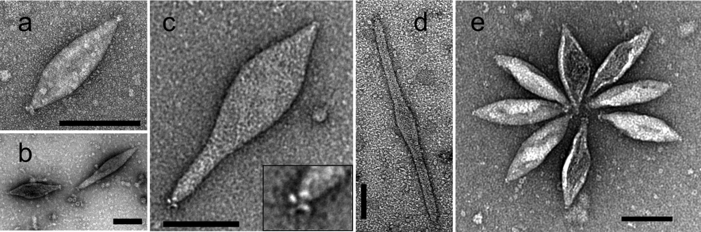

**Figure 1.** Transmission electron micrographs of APSV1 virions. Scale bars = 100 nm. Samples were negatively stained with 2% uranyl acetate. Reproduced from Mochizuki et al., 2011.

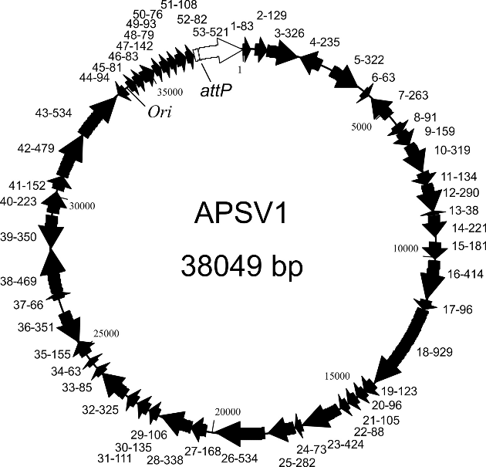

**Figure 2.** Genome map of APSV1. The integrase gene is white. *ori* and *attP* sites are indicated. Reproduced from Mochizuki et al., 2011.

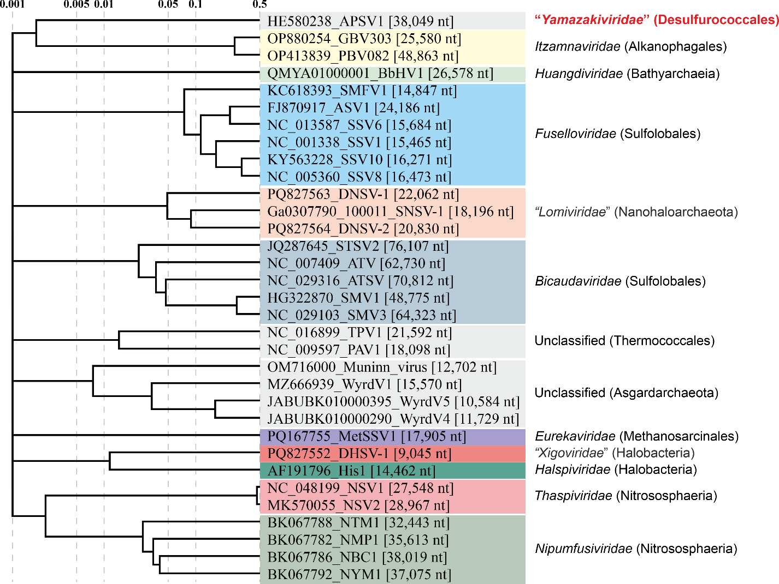

**Figure 3.** Genome-wide proteomic tree of representative archaeal spindle-shaped viruses. The new proposed family including APSV1 is highlighted in red. The proteomic trees are based on all-versus-all proteomic similarity matrix and are mid-point rooted. Branch lengths are log-scaled.