

The International Committee on Taxonomy of Viruses

Taxonomy Proposal Form, 2025

**Part 1a: Details of taxonomy proposals**

|  |  |
| --- | --- |
| **Title:** | Create a new family for classification of a spindle-shaped virus infecting a hyperthermophilic archaeon *Aeropyrum pernix* |
| **Code assigned:** | 2025.006A.Ac.v3.Yamazakiviridae_1nf | |

|  |  |  |  |  |
| --- | --- | --- | --- | --- |
| **Author(s), affiliation and email address(es):** | | | | |
| **Given name (+middle initial(s))** | **Surname** | **Affiliation** | **Email address** | **Corr. author(s)** |
| Tomohiro | Mochizuki | Faculty of Pharmacy, Osaka Ohtani University, Osaka, Japan | mochizutomo@osaka-ohtani.ac.jp | X |
| David | Prangishvili | Ivane Javakhishvili Tbilisi State University, Tbilisi, Georgia | david.prangishvili@pasteur.fr |  |
| Mart | Krupovic | Institut Pasteur, Université Paris Cité, CNRS UMR6047, Cell Biology and Virology of Archaea Unit, Paris, France | mart.krupovic@pasteur.fr |  |

**Part 1b: Taxonomy Proposal Submission**

|  |  |  |  |
| --- | --- | --- | --- |
| **ICTV Subcommittee:** | | | |
| Animal DNA Viruses and Retroviruses |  | Bacterial viruses |  |
| Animal minus-strand and dsRNA viruses |  | Fungal and protist viruses |  |
| Animal positive-strand RNA viruses |  | Plant viruses |  |
| Archaeal viruses | **X** | General - |  |

|  |
| --- |
| **List the ICTV Study Group(s) that have seen or have been involved in creating this proposal:** |
| Desulfurococcales viruses Study Group |

|  |  |  |  |
| --- | --- | --- | --- |
| **Optional – complete only if formally voted on by an ICTV Study Group:** | | | |
| **Study Group** | **Number of members** | | |
| **Votes in support** | **Votes against** | **No vote** |
|  |  |  |  |
|  |  |  |  |

|  |  |
| --- | --- |
| **Submission date:** | 25.06.2025 |

**Part 1c: Feedback from ICTV Executive Committee (EC) meeting**

|  |  |
| --- | --- |
| **Executive Committee Meeting Decision code:** | **X** |
| A – Accept |  |
| Ac – Accept subject to revision by relevant subcommittee chair. No further vote required | **X** |
| U – Accept without revision but with re-evaluation and email vote by the EC |  |
| Uc – Accept subject to revision and re-evaluation and email vote by the EC |  |
| Ud – Deferred to the next EC meeting, with an invitation to revise based on EC comments |  |
| J - Reject |  |
| W - Withdrawn |  |

|  |
| --- |
| **Comments from the Executive Committee:** |
| Update “taxonomic rank affected”, check copyright of figures or replace |

**Part 1d: Revised Taxonomy Proposal Submission**

|  |
| --- |
| **Response of proposer:** |
| “Taxonomic rank affected” has been updated. The two figures with copyright were replaced with original ones. |

|  |  |
| --- | --- |
| **Revision date:** | 24.08.2025 |

**Part 3:** **TAXONOMIC PROPOSAL**

|  |  |  |  |
| --- | --- | --- | --- |
| **Taxonomic changes proposed:** | | | |
| Establish new taxon | **X** | Split taxon |  |
| Abolish taxon |  | Merge taxon |  |
| Move taxon |  | Promote taxon |  |
| Rename taxon |  | Demote taxon |  |
| Move and rename |  |

|  |  |
| --- | --- |
| **Etymology (origin) of proposed taxonomic names:** | |
| **Taxon name** | **Etymology of the term** |
| *Yamazakiviridae* | Named after late Dr. Syuji Yamazaki, who performed pioneering work on *Aeropyrum pernix*, the host of APSV1. |
| *Kodayamazakivirus* | Prefix “koda” refers to the place of isolation, a coastal solfataric vent at **Koda**kara-Jima Island, Japan; stem “Yamazaki” refers to the family name, “*Yamazakiviridae*”. |
| *Kodayamazakivirus kyodaii* | The species epithet, “kyodaii”, refers to the short name of Kyoto University (**kyodai**), an institution in which *A. pernix* was isolated and described. |

|  |  |  |
| --- | --- | --- |
| **Permission for use of names derived from a living person:** | | |
| **Taxon name** | **Full name of person from whom the name is derived** | **Attached** |
|  |  |  |

|  |
| --- |
| **Abstract of Taxonomy Proposal:** |
| *Taxonomic rank(s) affected*:  Family, genus, species  *Description of current taxonomy*:  Viruses with spindle-shaped virions are classified into 8 families, none of which has been assigned to higher-level taxonomic ranks.  *Proposed* *taxonomic change(s):*  We propose classifying Aeropyrum pernix spindle-shaped virus 1 (APSV1) into a new species within a new genus and a new family, “*Yamazakiviridae*”.  *Justification*:  APSV1 is not closely related to other spindle-shaped viruses and in the VipTree proteomic tree the virus formed a separate branch. |

|  |
| --- |
| **Text of Taxonomy proposal:** |
| *Taxonomic rank(s) affected*:  Family, genus, species  *Description of current taxonomy*:  Viruses with spindle-shaped virions are classified into 8 families, none of which has been assigned to higher-level taxonomic ranks.  *Proposed* *taxonomic change(s)*:  We propose classifying Aeropyrum pernix spindle-shaped virus 1 (APSV1) into a new species within a new genus and a new family, “*Yamazakiviridae*”.  *Demarcation criteria:*  There is presently no systematic criterium established for classification of spindle-shaped viruses, which have much less sequenced representatives compared, for instance, to the head-tailed archaeal viruses. However, we propose using 95% sequence identity as a species demarcation threshold, to be consistent with the classification of other bacterial and archaeal viruses. For family demarcations, we used proteome-wide phylogenomic analysis with VipTree.  *Justification*:  APSV1 is a temperate virus which was discovered upon its induction from the hyperthermophilic aerobic archaeon *Aeropyrum pernix* strain K1 (Mochizuki et al., 2011). The APSV1 virions are pleomorphic spindle-shaped particles, ∼180 to 210 nm in length and ∼40 to 55 nm in width (Figure 1a). The purified virions occasionally carried a single tail or two tails protruding from pointed ends of the particles, or were extended into tubular structures (Figure 1b). One end of the particle is decorated with a terminal structure (Figure 1a) consisting of three short filaments (Mochizuki et al., 2011). The virions have a tendency to attach to each other, sometimes forming rosette-like structures (Figure 1a).  APSV1 genome is integrated into the tRNA-Val gene of the host but upon oxygen limitation, the excision and replication of the virus genome are activated. The excised genome is a circular dsDNA molecule of 38,049 bp and is predicted to encodes 53 proteins (Figure 2). Of these only 10 display sequence similarity (Blastp, E<0.05) to proteins encoded by known viruses, with only 3 homologs (ORF12, ORF26, and ORF31) being encoded by other archaeal spindle-shaped viruses. The distant relationship to other known viruses is confirmed by proteome-wide clustering analysis using VipTree (Nishimura et al., 2017) in which APSV1 formed a separate branch (Figure 3). Thus, we propose classifying APSV1 into a new species within a new genus, “*Kodayamazakivirus*”, and a new family, “*Yamazakiviridae*”. |

|  |
| --- |
| **References:** |
| Mochizuki T, Sako Y, Prangishvili D. Provirus induction in hyperthermophilic archaea: characterization of Aeropyrum pernix spindle-shaped virus 1 and Aeropyrum pernix ovoid virus 1. J Bacteriol. 2011; 193(19):5412-9. doi: 10.1128/JB.05101-11. PMID: 21784945  Nishimura Y, Yoshida T, Kuronishi M, Uehara H, Ogata H, Goto S. ViPTree: the viral proteomic tree server. Bioinformatics. 2017 Aug 1;33(15):2379-2380. doi: 10.1093/bioinformatics/btx157. PMID: 28379287 |

|  |  |
| --- | --- |
| **Accompanying files:** | |
| **Filename** | **Description of contents** |
|  |  |

|  |
| --- |
| **Tables, Figures:** |

**Table 1.** Proposed taxonomy and properties of APSV1.

|  |  |  |  |  |  |
| --- | --- | --- | --- | --- | --- |
| **Family** | **Genus** | **Species** | **Virus name** | **GenBank accession** | **Genome size, bp** |
| *Yamazakiviridae* | *Kodayamazakivirus* | *Kodayamazakivirus kyodaii* | Aeropyrum pernix spindle-shaped virus 1 (APSV1) | HE580238 | 38049 |

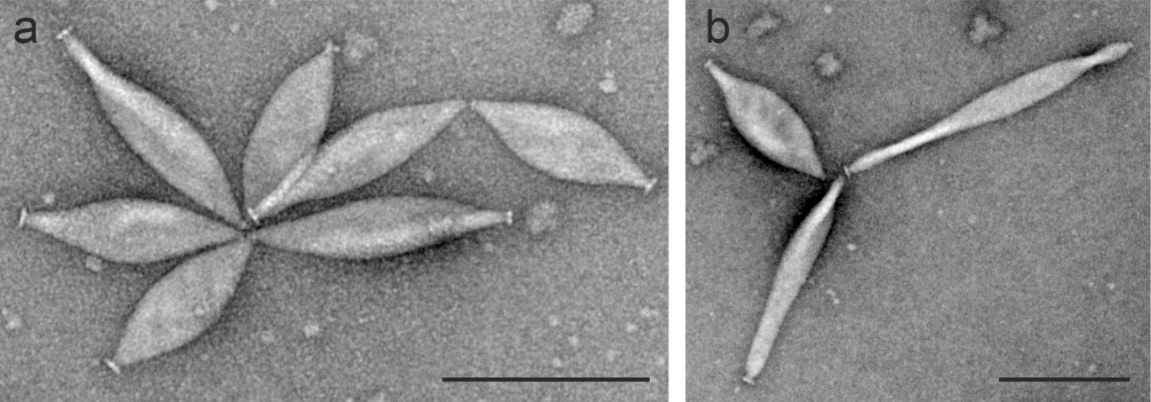

**Figure 1.** Transmission electron micrographs of APSV1 virions. Scale bars = 200 nm. Samples were negatively stained with 2% uranyl acetate.

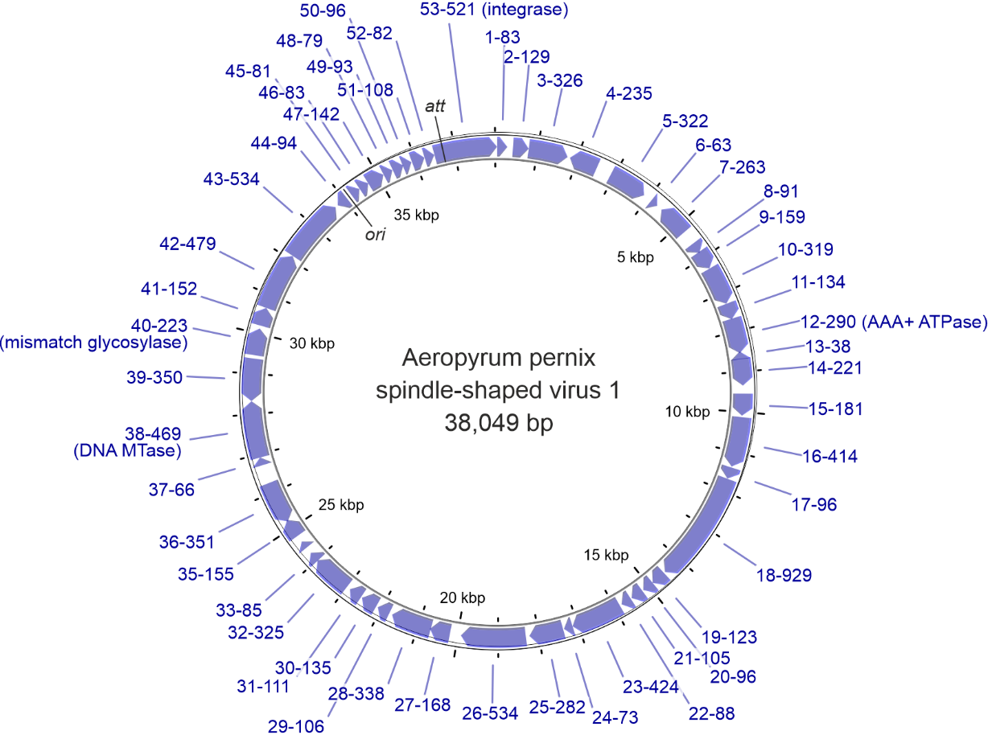

**Figure 2.** Genome map of APSV1. The integrase gene is white. Origin of replication (*ori*) and attachment (*att*) sites are indicated.

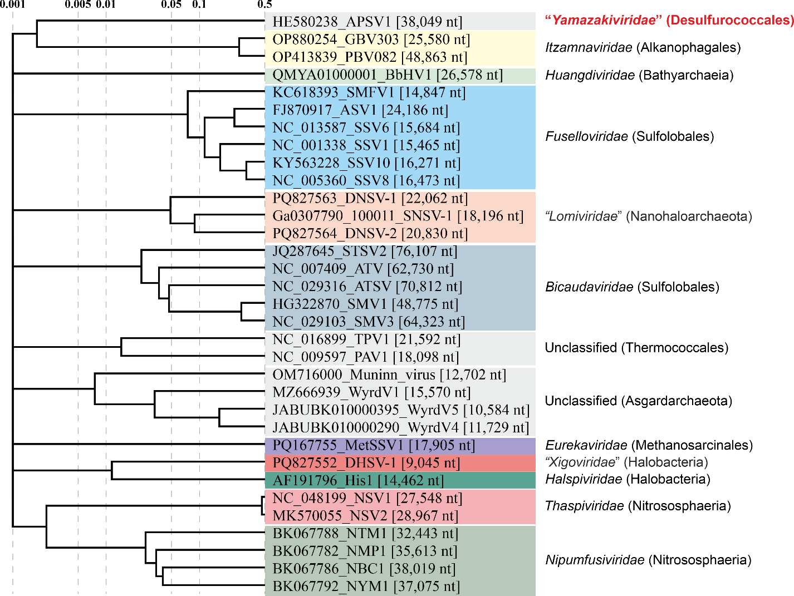

**Figure 3.** Genome-wide proteomic tree of representative archaeal spindle-shaped viruses. The new proposed family including APSV1 is highlighted in red. The proteomic trees are based on all-versus-all proteomic similarity matrix and are mid-point rooted. Branch lengths are log-scaled.