

The International Committee on Taxonomy of Viruses

Taxonomy Proposal Form, 2025

**Part 1a: Details of taxonomy proposals**

|  |  |
| --- | --- |
| **Title:** | Create 2 new families of spindle-shaped archaeal viruses |
| **Code assigned:** | 2025.005A.Ac.v3.Spindle-shaped_viruses_2nf_3ns | |

|  |  |  |  |  |
| --- | --- | --- | --- | --- |
| **Author(s), affiliation and email address(es):** | | | | |
| **Given name (+middle initial(s))** | **Surname** | **Affiliation** | **Email address** | **Corr. author(s)** |
| Yifan | Zhou | Institut Pasteur, Université Paris Cité, CNRS UMR6047, Cell Biology and Virology of Archaea Unit, Paris, France | [yifan.zhou@pasteur.fr](mailto:yifan.zhou@pasteur.fr) |  |
| Ana | Gutiérrez-Preciado | Ecologie Systématique Evolution, CNRS, Université Paris-Saclay, AgroParisTech, Gif-sur-Yvette, France | [ana.gutierrez@universite-paris-saclay.fr](mailto:ana.gutierrez@universite-paris-saclay.fr) |  |
| David | Moreira | Ecologie Systématique Evolution, CNRS, Université Paris-Saclay, AgroParisTech, Gif-sur-Yvette, France | [david.moreira@universite-paris-saclay.fr](mailto:david.moreira@universite-paris-saclay.fr) |  |
| Michail M. | Yakimov | Extreme Microbiology, Biotechnology and Astrobiology Group, Institute of Polar Sciences, ISP-CNR, Messina, Italy | [mikhail.iakimov@cnr.it](mailto:mikhail.iakimov@cnr.it) |  |
| Purificación | López-García | Ecologie Systématique Evolution, CNRS, Université Paris-Saclay, AgroParisTech, Gif-sur-Yvette, France | [puri.lopez@universite-paris-saclay.fr](mailto:puri.lopez@universite-paris-saclay.fr) |  |
| Mart | Krupovic | Institut Pasteur, Université Paris Cité, CNRS UMR6047, Cell Biology and Virology of Archaea Unit, Paris, France | [mart.krupovic@pasteur.fr](mailto:mart.krupovic@pasteur.fr) | X |

**Part 1b: Taxonomy Proposal Submission**

|  |  |  |  |
| --- | --- | --- | --- |
| **ICTV Subcommittee:** | | | |
| Animal DNA Viruses and Retroviruses |  | Bacterial viruses |  |
| Animal minus-strand and dsRNA viruses |  | Fungal and protist viruses |  |
| Animal positive-strand RNA viruses |  | Plant viruses |  |
| Archaeal viruses | **X** | General - |  |

|  |
| --- |
| **List the ICTV Study Group(s) that have seen or have been involved in creating this proposal:** |
|  |

|  |  |  |  |
| --- | --- | --- | --- |
| **Optional – complete only if formally voted on by an ICTV Study Group:** | | | |
| **Study Group** | **Number of members** | | |
| **Votes in support** | **Votes against** | **No vote** |
|  |  |  |  |
|  |  |  |  |

|  |  |
| --- | --- |
| **Submission date:** | 20.06.2025 |

**Part 1c: Feedback from ICTV Executive Committee (EC) meeting**

|  |  |
| --- | --- |
| **Executive Committee Meeting Decision code:** | **X** |
| A – Accept |  |
| Ac – Accept subject to revision by relevant subcommittee chair. No further vote required | **X** |
| U – Accept without revision but with re-evaluation and email vote by the EC |  |
| Uc – Accept subject to revision and re-evaluation and email vote by the EC |  |
| Ud – Deferred to the next EC meeting, with an invitation to revise based on EC comments |  |
| J - Reject |  |
| W - Withdrawn |  |

|  |
| --- |
| **Comments from the Executive Committee:** |
| Update “taxonomic rank affected” and correct typos. |

**Part 1d: Revised Taxonomy Proposal Submission**

|  |
| --- |
| **Response of proposer:** |
| All corrected. |

|  |  |
| --- | --- |
| **Revision date:** | 24.08.2025 |

**Part 3:** **TAXONOMIC PROPOSAL**

|  |  |  |  |
| --- | --- | --- | --- |
| **Taxonomic changes proposed:** | | | |
| Establish new taxon | **X** | Split taxon |  |
| Abolish taxon |  | Merge taxon |  |
| Move taxon |  | Promote taxon |  |
| Rename taxon |  | Demote taxon |  |
| Move and rename |  |

|  |  |
| --- | --- |
| **Etymology (origin) of proposed taxonomic names:** | |
| **Taxon name** | **Etymology of the term** |
| *Xigoviridae* | after **xigô**, lemon in Afar language |
| *Lomiviridae* | after ሎሚ (**lomī**), lemon in Amharic language |
| *Ispindelvirus* | after **ispindel** for spindle in Afar language |
| *Gomizavirus* | after ጎምዛዛ (**gomiza**za) for sour in Amharic language |
| *danakilense* | Latinized species epithet is derived from **Danakil** depression, source of isolation/sequencing |
| *assalense* | Latinized species epithet is derived from Lake **Assale**, source of isolation/sequencing |

|  |  |  |
| --- | --- | --- |
| **Permission for use of names derived from a living person:** | | |
| **Taxon name** | **Full name of person from whom the name is derived** | **Attached** |
|  |  |  |

|  |
| --- |
| **Abstract of Taxonomy Proposal:** |
| *Taxonomic rank(s) affected*:  Families, genera, species  *Description of current taxonomy*:  Spindle-shaped viruses of halophilic archaea are currently classified into the family *Halspiviridae*, which includes a single species, *Salterprovirus australiense*. Spindle-shaped archaeal viruses have not been assigned to any higher-level taxonomic rank.  *Proposed* *taxonomic change(s):*  We propose creating two new families for the classification of spindle-shaped viruses associated with haloarchaeal and nanohaloarchaeal hosts. The family “*Xigoviridae*” will include a single species, “*Ispindelvirus danakilense*”, whereas family “*Lomiviridae*” will include two species, “*Gomizavirus danakilense*” and “*Gomizavirus assalense*”.  *Justification*:  Members of the proposed families “*Xigoviridae*” and “*Lomiviridae*” are not closely related to each other or to previously characterized and classified viruses, justifying the creation of the new families. This conclusion is consistent with VipTree analysis in which the two groups of viruses clustered separately. |

|  |
| --- |
| **Text of Taxonomy proposal:** |
| *Taxonomic rank(s) affected*:  Families, genera, species  *Description of current taxonomy*:  Spindle-shaped viruses of halophilic archaea are currently classified into the family *Halspiviridae*, which includes a single species, *Salterprovirus australiense*. Spindle-shaped archaeal viruses have not been assigned to any higher-level taxonomic rank.  *Proposed* *taxonomic change(s)*:  We propose creating two new families for the classification of spindle-shaped viruses associated with haloarchaeal and nanohaloarchaeal hosts. The family “*Xigoviridae*” will include a single species, “*Ispindelvirus danakilense*”, whereas family “*Lomiviridae*” will include two species, “*Gomizavirus danakilense*” and “*Gomizavirus assalense*”.  *Demarcation criteria:*  There is presently no systematic criterium established for classification of spindle-shaped viruses, which have much less sequenced representatives compared, for instance, to the head-tailed archaeal viruses. However, we propose using 95% sequence identity as a species demarcation threshold, to be consistent with the classification of other bacterial and archaeal viruses. For family demarcations, we used proteome-wide phylogenomic analysis with VipTree, which was further supported by comparative genomics and analysis of the protein structures.  *Justification*:  Geothermally influenced salt lakes in the Danakil Depression, Ethiopia, some of the most extreme ecosystems known, are dominated by microbial communities consisting of haloarchaea and nanohaloarchaea (Belilla et al., 2021; Gutiérrez-Preciado et al., 2024). Analysis of metagenomes from Lake Assale or Karum (samples Ass and 9Ass collected during different years), cave reservoir at the Dallol proto-volcano salt canyons (9Gt) and two of the Western-Canyon Lakes (WCL2 and WCL3) (Gutiérrez-Preciado et al., 2024) using geNomad (Camargo et al., 2024) and VirSorter2 (Guo et al., 2021) yielded 2,085 viral contigs (≥5 kb). Among these, two complete virus genomes (circular contigs, i.e., with direct terminal redundancies) could be assigned to haloarchaeal and nanohaloarchaeal hosts, respectively, based on specific CRISPR spacer-protospacer matches (Zhou et al., 2025). Based on the presence of signature hydrophobic major capsid proteins, three viruses were predicted to form spindle-shaped virus particles. Here, we propose classifying the three viruses into two new families(Table 1).  The circular genomes of Danakil Halobacteriales spindle-shaped virus 1 (DHSV1) is 9045 bp-long, whereas genomes of Danakil Nanohaloarchaeota tailed virus 1 (DNSV1) and DNSV2 are nearly twice larger (Table 1, Figure 1). Although all three viruses share only a few genes with other known viruses, they encode homologs of the putative major capsid protein specific of spindle-shaped archaeal viruses. To assess the relationship between DHSV1, DNSV1 and DNSV2 as well as a related virus identified in IMG/VR database (SNSV1; Ga0307790_1000112) to previously characterized spindle-shaped viruses, we performed their proteome-wide comparisons using VipTree (Nishimura et al., 2017). This analysis confirmed the monophyly of the previously established families of spindle-shaped viruses and suggested that DHSV1 on the one hand and DNSV1/DNSV2/SNSV1, on the other hand, form distinct groups (Figure 2). Thus, we propose the creation of two new families for classification of the two virus groups. Notably, in the VipTree analysis DHSV1 clusters with His1, the sole member of the family *Halspiviridae.* However, the two viruses are sufficiently distinct to justify their classification into distinct families. First, the two viruses share only 3 genes. Second, the genome of His1 is linear, that of DHSV1 is circular. Third, whereas His1 encodes a protein-primed family B DNA polymerase, DHSV1 lacks such a gene, suggesting a distinct mode of genome replication (Fig. 3a).  DNSV1 and DNSV2 are only distantly related (Fig. 3b). Nevertheless, at this time, we propose placing them in the same genus, until more representatives are identified and characterized. |

|  |
| --- |
| **References:** |
| Belilla J, Iniesto M, Moreira D, Benzerara K, López-García JM, López-Archilla AI, Reboul G, Deschamps P, Gérard E, López-García P. Archaeal overdominance close to life-limiting conditions in geothermally influenced hypersaline lakes at the Danakil Depression, Ethiopia. Environ Microbiol. 2021; 23(11):7168-7182. doi: 10.1111/1462-2920.15771. PMID: 34519149  Camargo AP, Roux S, Schulz F, Babinski M, Xu Y, Hu B, Chain PSG, Nayfach S, Kyrpides NC. Identification of mobile genetic elements with geNomad. Nat Biotechnol. 2024; 42(8):1303-1312. doi: 10.1038/s41587-023-01953-y. PMID: 37735266  Guo J, Bolduc B, Zayed AA, Varsani A, Dominguez-Huerta G, Delmont TO, Pratama AA, Gazitúa MC, Vik D, Sullivan MB, Roux S. VirSorter2: a multi-classifier, expert-guided approach to detect diverse DNA and RNA viruses. Microbiome. 2021; 9(1):37. doi: 10.1186/s40168-020-00990-y. PMID: 33522966  Gutiérrez-Preciado A, Dede B, Baker BA, Eme L, Moreira D, López-García P. Extremely acidic proteomes and metabolic flexibility in bacteria and highly diversified archaea thriving in geothermal chaotropic brines. Nat Ecol Evol. 2024 Oct;8(10):1856-1869. doi: 10.1038/s41559-024-02505-6. PMID: 39134651  Nishimura Y, Yoshida T, Kuronishi M, Uehara H, Ogata H, Goto S. ViPTree: the viral proteomic tree server. Bioinformatics. 2017 Aug 1;33(15):2379-2380. doi: 10.1093/bioinformatics/btx157. PMID: 28379287  Zhou Y, Gutiérrez-Preciado A, Liu Y, Moreira D, Yakimov MM, López-García P, Krupovic M. Nested parasitism in hypersaline environments: viruses and virus satellites of haloarchaea and their nanosized cellular symbionts. bioRxiv. 2025; doi: https://doi.org/10.1101/2025.02.15.638363. |

|  |  |
| --- | --- |
| **Accompanying files:** | |
| **Filename** | **Description of contents** |
|  |  |

|  |
| --- |
| **Tables, Figures:** |

<Start here>**Table 1.** Proposed taxonomy and classified viruses.

|  |  |  |  |  |  |
| --- | --- | --- | --- | --- | --- |
| **Family** | **Genus** | **Species** | **Virus name** | **GenBank accession** | **Genome size, bp** |
| *Xigoviridae* | *Ispindelvirus* | *Ispindelvirus danakilense* | Danakil Halobacteriales spindle-shaped virus 1 (DHSV1) | PQ827552 | 9045 |
| *Lomiviridae* | *Gomizavirus* | *Gomizavirus danakilense* | Danakil Nanohaloarchaeota spindle-shaped virus 1 (DNSV1) | PQ827563 | 22062 |
| *Lomiviridae* | *Gomizavirus* | *Gomizavirus assalense* | Danakil Nanohaloarchaeota spindle-shaped virus 2 (DNSV2) | PQ827564 | 20830 |

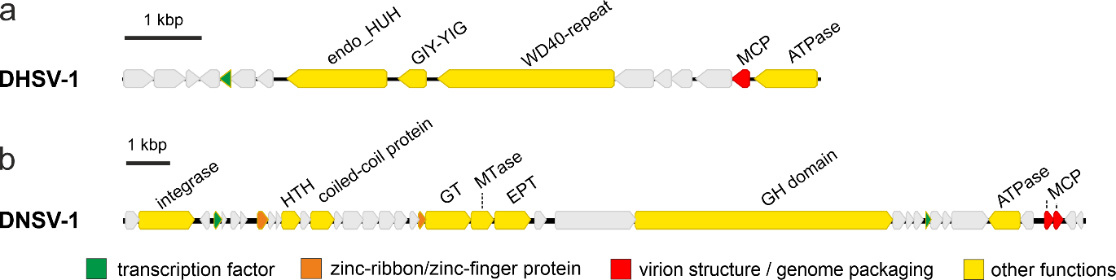

**Figure 1.** Genome maps of new spindle-shaped viruses. a. Danakil Halobacteriales spindle-shaped virus 1 (DHSV1). b. Danakil Nanohaloarchaeota spindle-shaped virus 1 (DNSV1). MCP, major capsid protein; MTase, methyltransferase; GH, glycoside hydrolase; HTH, helix-turn-helix domain DNA-binding protein; EPT, ethanolamine phosphate transferase; WD40 repeat, WD40 repeat-containing protein; GIY-YIG, GIY-YIG family nuclease.

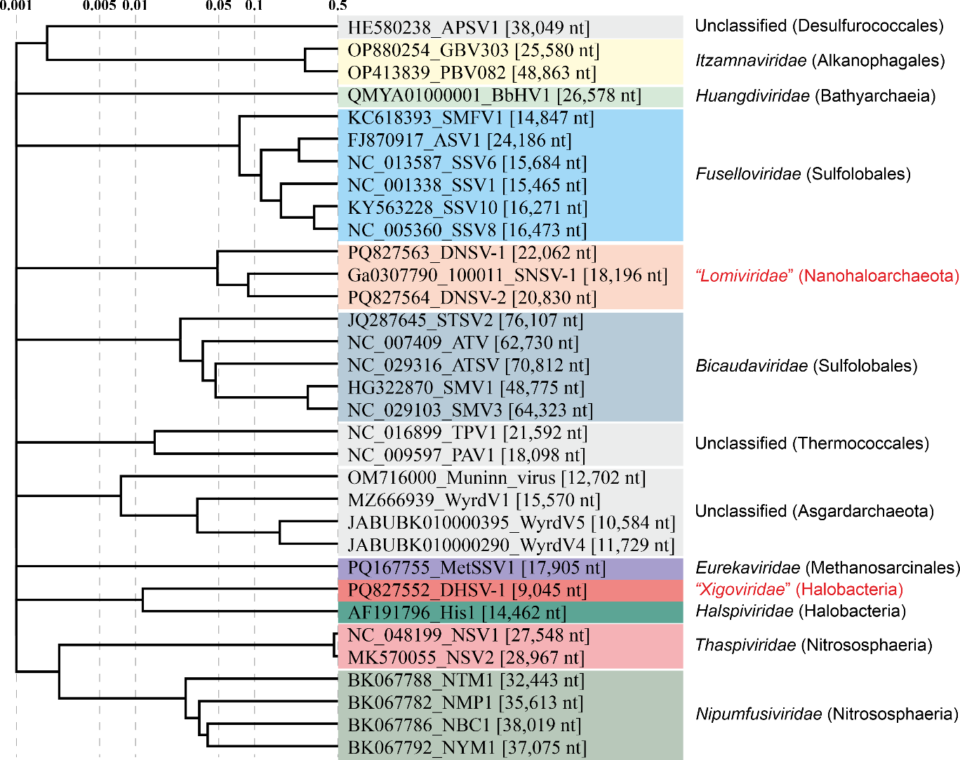

**Figure 2.** Genome-wide proteomic tree of representative archaeal spindle-shaped viruses. The two new proposed families for viruses from Danakil Depression are highlighted in red. The proteomic trees are based on all-versus-all proteomic similarity matrix and are mid-point rooted. Branch lengths are log-scaled.

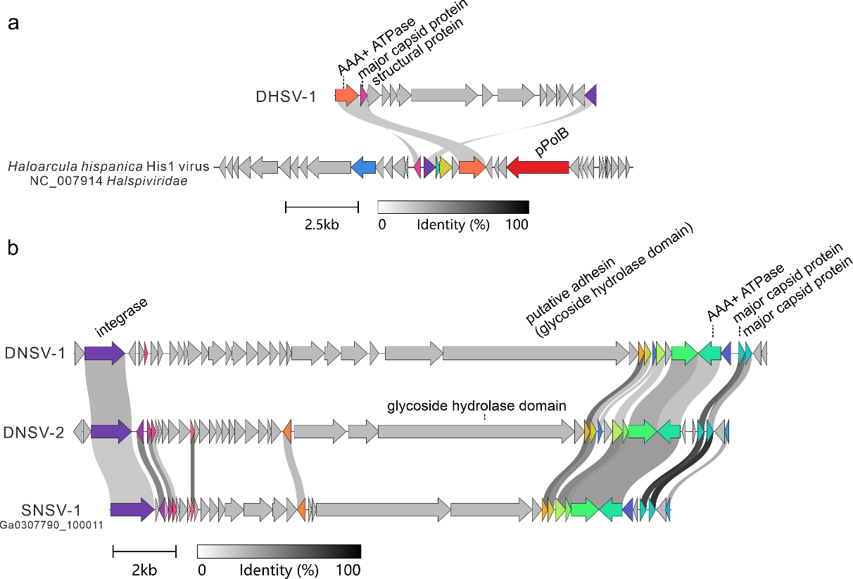

**Figure 3.** Comparison of spindle-shaped viruses from Danakil Depression with their closest relatives. a. Comparison between DHSV1 and His1. b. Comparison of DNSV1 with DNSV2 and SNSV1. Homologous genes (>25% identity) are highlighted using the same color and linked via shadings.