

The International Committee on Taxonomy of Viruses

Taxonomy Proposal Form, 2025

**Part 1a: Details of taxonomy proposals**

|  |  |
| --- | --- |
| **Title:** | Create one new family and two new species within order *Haloruvirales* |
| **Code assigned:** | 2025.004A.Ac.v3.Pleomorphic_1nf_2ns | |

|  |  |  |  |  |
| --- | --- | --- | --- | --- |
| **Author(s), affiliation and email address(es):** | | | | |
| **Given name (+middle initial(s))** | **Surname** | **Affiliation** | **Email address** | **Corr. author(s)** |
| Yifan | Zhou | Institut Pasteur, Université Paris Cité, CNRS UMR6047, Cell Biology and Virology of Archaea Unit, Paris, France | [yifan.zhou@pasteur.fr](mailto:yifan.zhou@pasteur.fr) |  |
| Ana | Gutiérrez-Preciado | Ecologie Systématique Evolution, CNRS, Université Paris-Saclay, AgroParisTech, Gif-sur-Yvette, France | [ana.gutierrez@universite-paris-saclay.fr](mailto:ana.gutierrez@universite-paris-saclay.fr) |  |
| David | Moreira | Ecologie Systématique Evolution, CNRS, Université Paris-Saclay, AgroParisTech, Gif-sur-Yvette, France | [david.moreira@universite-paris-saclay.fr](mailto:david.moreira@universite-paris-saclay.fr) |  |
| Michail M. | Yakimov | Extreme Microbiology, Biotechnology and Astrobiology Group, Institute of Polar Sciences, ISP-CNR, Messina, Italy | [mikhail.iakimov@cnr.it](mailto:mikhail.iakimov@cnr.it) |  |
| Purificación | López-García | Ecologie Systématique Evolution, CNRS, Université Paris-Saclay, AgroParisTech, Gif-sur-Yvette, France | [puri.lopez@universite-paris-saclay.fr](mailto:puri.lopez@universite-paris-saclay.fr) |  |
| Mart | Krupovic | Institut Pasteur, Université Paris Cité, CNRS UMR6047, Cell Biology and Virology of Archaea Unit, Paris, France | [mart.krupovic@pasteur.fr](mailto:mart.krupovic@pasteur.fr) | X |

**Part 1b: Taxonomy Proposal Submission**

|  |  |  |  |
| --- | --- | --- | --- |
| **ICTV Subcommittee:** | | | |
| Animal DNA Viruses and Retroviruses |  | Bacterial viruses |  |
| Animal minus-strand and dsRNA viruses |  | Fungal and protist viruses |  |
| Animal positive-strand RNA viruses |  | Plant viruses |  |
| Archaeal viruses | **X** | General - |  |

|  |
| --- |
| **List the ICTV Study Group(s) that have seen or have been involved in creating this proposal:** |
| The TaxoProp has been seen by the Chair of the *Pleolipoviridae* Study Group |

|  |  |  |  |
| --- | --- | --- | --- |
| **Optional – complete only if formally voted on by an ICTV Study Group:** | | | |
| **Study Group** | **Number of members** | | |
| **Votes in support** | **Votes against** | **No vote** |
|  |  |  |  |
|  |  |  |  |

|  |  |
| --- | --- |
| **Submission date:** | 20.06.2025 |

**Part 1c: Feedback from ICTV Executive Committee (EC) meeting**

|  |  |
| --- | --- |
| **Executive Committee Meeting Decision code:** | **X** |
| A – Accept |  |
| Ac – Accept subject to revision by relevant subcommittee chair. No further vote required | **X** |
| U – Accept without revision but with re-evaluation and email vote by the EC |  |
| Uc – Accept subject to revision and re-evaluation and email vote by the EC |  |
| Ud – Deferred to the next EC meeting, with an invitation to revise based on EC comments |  |
| J - Reject |  |
| W - Withdrawn |  |

|  |
| --- |
| **Comments from the Executive Committee:** |
| Update “taxonomic rank affected” and correct typos. |

**Part 1d: Revised Taxonomy Proposal Submission**

|  |
| --- |
| **Response of proposer:** |
| All corrected. |

|  |  |
| --- | --- |
| **Revision date:** | 24.08.2025 |

**Part 3:** **TAXONOMIC PROPOSAL**

|  |  |  |  |
| --- | --- | --- | --- |
| **Taxonomic changes proposed:** | | | |
| Establish new taxon | **X** | Split taxon |  |
| Abolish taxon |  | Merge taxon |  |
| Move taxon |  | Promote taxon |  |
| Rename taxon |  | Demote taxon |  |
| Move and rename |  |

|  |  |
| --- | --- |
| **Etymology (origin) of proposed taxonomic names:** | |
| **Taxon name** | **Etymology of the term** |
| *Nanopleoviridae* | from **Nano**haloarchaea+**pleo**morphic, referring to host and inferred virion morphology |
| *Milaagivirus* | after **milaagi** for shifting in Afar language, referring to inferred pleomorphic virion morphology |
| *danakilense* | Latinized species epithet is derived from **Danakil** depression, source of isolation/sequencing |

|  |  |  |
| --- | --- | --- |
| **Permission for use of names derived from a living person:** | | |
| **Taxon name** | **Full name of person from whom the name is derived** | **Attached** |
|  |  |  |

|  |
| --- |
| **Abstract of Taxonomy Proposal:** |
| *Taxonomic rank(s) affected*:  Families, genera, species  *Description of current taxonomy*:  Monodnavirian kingdom *Trapavirae* currently comprises two families, *Pleolipoviridae* (phylum *Saleviricota*, class *Huolimaviricetes,* order *Haloruvirales*) (Liu et al., 2022), which includes haloarchaeal viruses with enveloped pleomorphic virions and single-stranded (ss) or double-stranded (ds) DNA genomes, and *Thalassapleoviridae* (phylum *Calorviricota*, class *Caminiviricetes*, order *Ageovirales*) (Baquero et al., 2024), which contains pleomorphic viruses infecting hyperthermophilic anaerobic archaea of the class Archaeoglobi. Both families comprise three genera.  *Proposed* *taxonomic change(s):*  We propose creating one new species within genus *Betapleolipovirus* (family *Pleolipoviridae*) and one new family, “*Nanopleoviridae*”, within the order *Haloruvirales*, for classification of viruses associated with archaea of the candidate phylum Nanohaloarchaeota.  *Justification*:  Previously established demarcation criteria for the family *Pleolipoviridae* suggested that Danakil Halobacteriales pleomorphic virus 1 should be placed within genus *Betapleolipovirus*. By contrast, Danakil Nanohaloarchaeota pleomorphic virus 1 branched outside of the *Pleolipoviridae*, suggesting that it represents a separate virus family. |

|  |
| --- |
| **Text of Taxonomy proposal:** |
| *Taxonomic rank(s) affected*:  Families, genera, species  *Description of current taxonomy*:  Monodnavirian kingdom *Trapavirae* currently comprises two families, *Pleolipoviridae* (phylum *Saleviricota*, class *Huolimaviricetes,* order *Haloruvirales*), which includes haloarchaeal viruses with enveloped pleomorphic virions and single-stranded (ss) or double-stranded (ds) DNA genomes, and *Thalassapleoviridae* (phylum *Calorviricota*, class *Caminiviricetes*, order *Ageovirales*), which contains pleomorphic viruses infecting hyperthermophilic anaerobic archaea of the class Archaeoglobi. Both families comprise three genera.  *Proposed* *taxonomic change(s)*:  We propose creating one new species within genus *Betapleolipovirus* (family *Pleolipoviridae*) and one new family, “*Nanopleoviridae*”, within the order *Haloruvirales*, for classification of viruses associated with archaea of the candidate phylum Nanohaloarchaeota.  *Demarcation criteria:*  Demarcation criteria for family *Pleolipoviridae* (Liu et al., 2022):  Genera are identified by the gene content and well-supported monophyletic groups based on phylogenomic analysis of the whole genome sequences. The following criteria are used to differentiate genera in the family:   * Genome type i.e. linear or circular   + Alphapleolipoviruses have either single-stranded or double-stranded circular DNA.   + Betapleolipoviruses have circular double-stranded DNA genomes that can contain single-stranded discontinuities.   + Gammapleolipoviruses have linear double-stranded DNA genomes. * Besides the conserved cluster of five genes shared by all pleolipoviruses (genes 3, 4 and 8; ORFs 6 and 7 of Halorubrum pleomorphic virus 1 (HRPV-1)):   + *Alphapleolipovirus* genomes share an ORF coding for a rolling circle replication initiation proteins (RCR Rep).   + *Betapleolipovirus* genomes share two ORFs coding for proteins of unknown function (e.g. Halorubrum pleomorphic virus 3 ORFs 6 and 9). One of those is predicted to contain a winged helix-turn-helix (wHTH) domain.   + *Gammapleolipovirus* genomes have a gene encoding a putative type B DNA polymerase   Proposed demarcation criteria for the “*Nanopleoviridae*”:  We propose using 95% sequence identity as a species demarcation criterion, to be consistent with the classification of other bacterial and archaeal DNA viruses, including pleolipovirids (Liu et al., 2022). Viruses will be assigned to different genera based on differences in the gene contents and if they form monophyletic groups in phylogenomic analyses of the whole genome proteomes.  *Justification*:  Geothermally influenced salt lakes in the Danakil Depression, Ethiopia, some of the most extreme ecosystems known, are dominated by microbial communities consisting of haloarchaea and nanohaloarchaea (Belilla et al., 2021; Gutiérrez-Preciado et al., 2024). Analysis of metagenomes from Lake Assale or Karum (samples Ass and 9Ass collected during different years), cave reservoir at the Dallol proto-volcano salt canyons (9Gt) and two of the Western-Canyon Lakes (WCL2 and WCL3) (Gutiérrez-Preciado et al., 2024) using geNomad (Camargo et al., 2024) and VirSorter2 (Guo et al., 2021) yielded 2,085 viral contigs (≥5 kb). Among these, two complete virus genomes (circular contigs, i.e., with direct terminal redundancies) could be assigned to haloarchaeal and nanohaloarchaeal hosts, respectively, based on specific CRISPR spacer-protospacer matches (Zhou et al., 2025). Based on the presence of signature genes involved in virion morphogenesis, these viruses could be assigned to *Haloruvirales*, an order of DNA viruses with enveloped pleomorphic virions composed of two major structural proteins, a membrane fusion/spike protein (homologous to HRPV-1 VP4, gene *4*) and a membrane-embedded matrix protein (homologous to HRPV-1 VP3, gene *3*) (Figure 1). Here, we propose classifying Danakil Halobacteriales pleomorphic virus 1 (DHPV1) into a new species, “*Betapleolipovirus danakilense*”, within genus *Betapleovirus* (family *Pleolipoviridae*) and Danakil Nanohaloarchaeota pleomorphic virus 1 (DNPV1) into a new family, “*Nanopleoviridae*” within the order *Haloruvirales* (Table 1).  To assess the relationship between DHPV1 and DNPV1 with other members of the kingdom *Trapavirae*, we performed phylogenomic analysis using the VICTOR, a tool previously applied for analyzing the relationships between virus groups within kingdom *Trapavirae* and for delineation of genera within *Pleolipoviridae* (Liu et al., 2022). This analysis confirmed the monophyly of the previously established families *Pleolipoviridae* (Liu et al., 2022)and *Thalassapleoviridae* (Baquero et al., 2024) and showed that DHPV1 was nested within a clade corresponding to the *Pleolipoviridae* genus *Betapleolipovirus*, whereas DNPV1 and a related provirus (Atlit Nanohaloarchaeota pleomorphic virus 1, ANPV1; Zhou et al., 2025) formed a separate group outside of *Pleolipoviridae* (Figure 2). Notably, unlike all classified viruses in the genus *Betapleolipovirus*, DHPV1 does not encode a signature protein suspected of being involved in genome replication. Instead, the virus encodes a rolling circle replication initiation endonuclease (Rep). Although rolling circle Reps are typical of members of the genus *Alphapleolipovirus*, the Rep of DHPV1 is not recognizably similar to any of these proteins. Instead, BlastP analysis showed that DHPV1 Rep is related to homologs encoded by simulovirids Haloterrigena jeotgali icosahedral virus 1 and SNJ1 (30% sequence identity to both). In this respect, DHPV1 resembles Haloferax volcanii pleomorphic virus 1 (HVPV-1), an unclassified pleolipovirid which is nested within the genus *Betapleolipovirus* but lacks the signature gene typical of viruses in this genus (Alarcón-Schumacher et al., 2022). Notably, however, HVPV-1 also lacks the gene for the rolling-circle Rep. Thus, consideration of the replication protein gene as a demarcation criterion might prove to be impractical and at odds with the phylogenomic analysis. Alternatively, with the expanding diversity of pleolipovirids discovered through metagenomics (Alarcón-Schumacher et al., 2023), *Betapleolipovirus* genus in particular and *Pleolipoviridae* family, in general, might need revision.  As noted above, DNPV1 and related provirus ANPV1 formed a separate group outside of *Pleolipoviridae* and all other clades of related viruses, including viruses of the family *Thalassapleoviridae* infecting hyperthermophilic archaea of the class Archaeoglobi (Baquero et al., 2024) as well as the unclassified pleomorphic viruses associated with methanogenic archaea of the Mathanomassiliicoccales and Mathanonatronarchaea (Medvedeva et al., 2023; Figure 2). DNPV1 and ANPV1 represent the first pleomorphic viruses associated with ultra-small symbiotic archaea of the phylum Nanohaloarchaeota (Zhou et al., 2025). Separation of pleomorphic viruses in phylogenomic analyses according to their host phylogeny suggests deep divergence of the corresponding viruses from their common ancestor and co-evolution with their respective hosts. We propose classifying DNPV1 into a separate family, “*Nanopleoviridae*”, and to place this family into order *Haloruvirales*, which currently includes *Pleolipoviridae.* We note, however, that given the vast diversity of haloarchaeal pleolipoviruses, most of which are unclassified (Alarcón-Schumacher et al., 2023), it is expected that the family will be elevated to an order level. In such case, “*Nanopleoviridae*” would have to be moved to a separate order. |

|  |
| --- |
| **References:** |
| Alarcón-Schumacher T, Lücking D, Erdmann S. Revisiting evolutionary trajectories and the organization of the *Pleolipoviridae* family. PLoS Genet. 2023; 19(10):e1010998. doi: 10.1371/journal.pgen.1010998. PMID: 37831715  Alarcón-Schumacher T, Naor A, Gophna U, Erdmann S. Isolation of a virus causing a chronic infection in the archaeal model organism *Haloferax volcanii* reveals antiviral activities of a provirus. Proc Natl Acad Sci U S A. 2022; 119(35):e2205037119. doi: 10.1073/pnas.2205037119. PMID: 35994644  Baquero DP, Bignon EA, Krupovic M. Pleomorphic viruses establish stable relationship with marine hyperthermophilic archaea. ISME J. 2024 Jan 8;18(1):wrae008. doi: 10.1093/ismejo/wrae008. PMID: 38366050  Belilla J, Iniesto M, Moreira D, Benzerara K, López-García JM, López-Archilla AI, Reboul G, Deschamps P, Gérard E, López-García P. Archaeal overdominance close to life-limiting conditions in geothermally influenced hypersaline lakes at the Danakil Depression, Ethiopia. Environ Microbiol. 2021; 23(11):7168-7182. doi: 10.1111/1462-2920.15771. PMID: 34519149  Camargo AP, Roux S, Schulz F, Babinski M, Xu Y, Hu B, Chain PSG, Nayfach S, Kyrpides NC. Identification of mobile genetic elements with geNomad. Nat Biotechnol. 2024; 42(8):1303-1312. doi: 10.1038/s41587-023-01953-y. PMID: 37735266  Guo J, Bolduc B, Zayed AA, Varsani A, Dominguez-Huerta G, Delmont TO, Pratama AA, Gazitúa MC, Vik D, Sullivan MB, Roux S. VirSorter2: a multi-classifier, expert-guided approach to detect diverse DNA and RNA viruses. Microbiome. 2021; 9(1):37. doi: 10.1186/s40168-020-00990-y. PMID: 33522966  Gutiérrez-Preciado A, Dede B, Baker BA, Eme L, Moreira D, López-García P. Extremely acidic proteomes and metabolic flexibility in bacteria and highly diversified archaea thriving in geothermal chaotropic brines. Nat Ecol Evol. 2024 Oct;8(10):1856-1869. doi: 10.1038/s41559-024-02505-6. PMID: 39134651  Liu Y, Dyall-Smith M, Oksanen HM. ICTV Virus Taxonomy Profile: *Pleolipoviridae* 2022. J Gen Virol. 2022;103(11). doi: 10.1099/jgv.0.001793. PMID: 36374180  Medvedeva S, Borrel G, Krupovic M, Gribaldo S. A compendium of viruses from methanogenic archaea reveals their diversity and adaptations to the gut environment. Nat Microbiol. 2023; 8(11):2170-2182. doi: 10.1038/s41564-023-01485-w. PMID: 37749252  Meier-Kolthoff JP, Göker M. VICTOR: genome-based phylogeny and classification of prokaryotic viruses. Bioinformatics. 2017; 33(21):3396-3404. doi: 10.1093/bioinformatics/btx440. PMID: 29036289  Zhou Y, Gutiérrez-Preciado A, Liu Y, Moreira D, Yakimov MM, López-García P, Krupovic M. Nested parasitism in hypersaline environments: viruses and virus satellites of haloarchaea and their nanosized cellular symbionts. bioRxiv. 2025; doi: https://doi.org/10.1101/2025.02.15.638363. |

|  |  |
| --- | --- |
| **Accompanying files:** | |
| **Filename** | **Description of contents** |
|  |  |

|  |
| --- |
| **Tables, Figures:** |

**Table 1.** Proposed taxonomy and classified viruses.

|  |  |  |  |  |  |  |
| --- | --- | --- | --- | --- | --- | --- |
| **Order** | **Family** | **Genus** | **Species** | **Virus name** | **GenBank accession** | **Genome size, bp** |
| *Haloruvirales* | *Pleolipoviridae* | *Betapleolipovirus* | *Betapleolipovirus danakilense* | Danakil Halobacteriales pleomorphic virus 1 (DHPV1) | PQ827551 | 9186 |
| *Haloruvirales* | *Nanopleoviridae* | *Milaagivirus* | *Milaagivirus danakilense* | Danakil Nanohaloarchaeota pleomorphic virus 1 (DNPV1) | PQ827562 | 9084 |

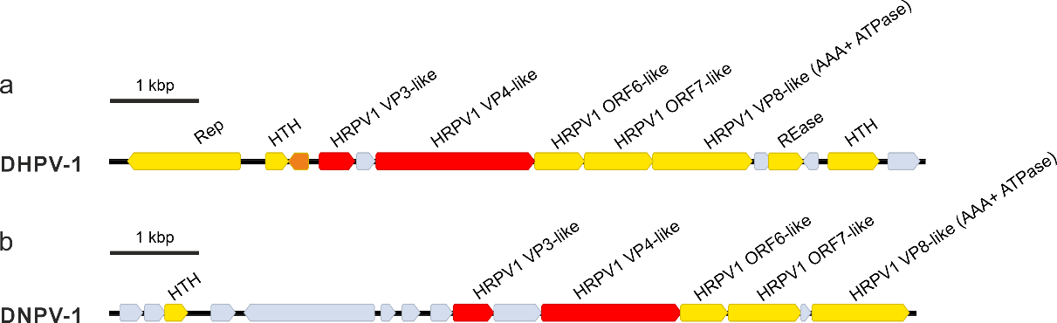

**Figure 1.** Genome maps of new haloruvirals. a. Danakil haloarchaeal pleomorphic virus 1 (DHPV1). b. Danakil nanohaloarchaeal pleomorphic virus 1 (DNPV1). HTH, helix-turn-helix domain protein; REase, restriction endonuclease; Rep, rolling circle replication initiation protein; HRPV-1, Halorubrum pleomorphic virus 1.

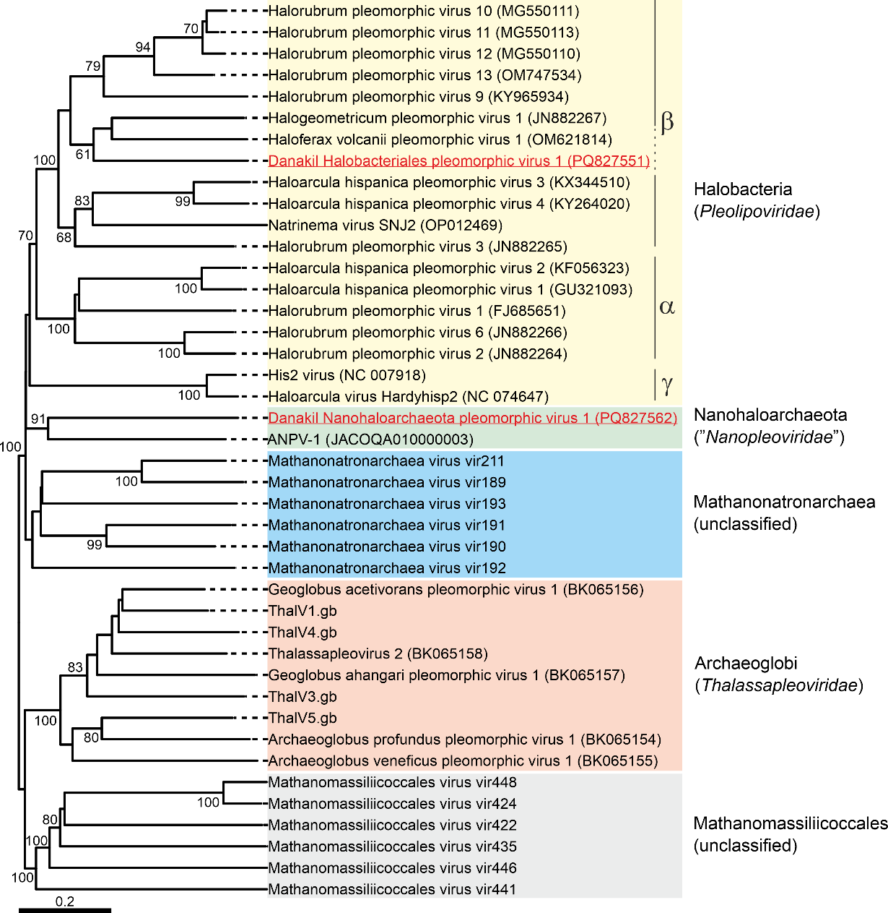

**Figure 2.** Inferred phylogenomic tree of pleomorphic viruses associated with different archaeal lineages. The tree is based on whole genome VICTOR analysis at the amino acid level (Meier-Kolthoff and Göker, 2017). The tree is midpoint rooted and the branch length is scaled in terms of the Genome BLAST Distance Phylogeny (GBDP) distance formula D6. The numbers above branches are GBDP pseudo-bootstrap support values from 100 replications.