

The International Committee on Taxonomy of Viruses

Taxonomy Proposal Form, 2025

**Part 1a: Details of taxonomy proposals**

|  |  |
| --- | --- |
| **Title:** | Two new families of tailless icosahedral archaeal viruses |
| **Code assigned:** | 2025.003A.Ac.v3.Tailless_icosahedral_2nf | |

|  |  |  |  |  |
| --- | --- | --- | --- | --- |
| **Author(s), affiliation and email address(es):** | | | | |
| **Given name (+middle initial(s))** | **Surname** | **Affiliation** | **Email address** | **Corr. author(s)** |
| Yifan | Zhou | Institut Pasteur, Université Paris Cité, CNRS UMR6047, Cell Biology and Virology of Archaea Unit, Paris, France | [yifan.zhou@pasteur.fr](mailto:yifan.zhou@pasteur.fr) |  |
| Ana | Gutiérrez-Preciado | Ecologie Systématique Evolution, CNRS, Université Paris-Saclay, AgroParisTech, Gif-sur-Yvette, France | [ana.gutierrez@universite-paris-saclay.fr](mailto:ana.gutierrez@universite-paris-saclay.fr) |  |
| David | Moreira | Ecologie Systématique Evolution, CNRS, Université Paris-Saclay, AgroParisTech, Gif-sur-Yvette, France | [david.moreira@universite-paris-saclay.fr](mailto:david.moreira@universite-paris-saclay.fr) |  |
| Michail M. | Yakimov | Extreme Microbiology, Biotechnology and Astrobiology Group, Institute of Polar Sciences, ISP-CNR, Messina, Italy | [mikhail.iakimov@cnr.it](mailto:mikhail.iakimov@cnr.it) |  |
| Purificación | López-García | Ecologie Systématique Evolution, CNRS, Université Paris-Saclay, AgroParisTech, Gif-sur-Yvette, France | [puri.lopez@universite-paris-saclay.fr](mailto:puri.lopez@universite-paris-saclay.fr) |  |
| Mart | Krupovic | Institut Pasteur, Université Paris Cité, CNRS UMR6047, Cell Biology and Virology of Archaea Unit, Paris, France | [mart.krupovic@pasteur.fr](mailto:mart.krupovic@pasteur.fr) | X |

**Part 1b: Taxonomy Proposal Submission**

|  |  |  |  |
| --- | --- | --- | --- |
| **ICTV Subcommittee:** | | | |
| Animal DNA Viruses and Retroviruses |  | Bacterial viruses |  |
| Animal minus-strand and dsRNA viruses |  | Fungal and protist viruses |  |
| Animal positive-strand RNA viruses |  | Plant viruses |  |
| Archaeal viruses | **X** | General - |  |

|  |
| --- |
| **List the ICTV Study Group(s) that have seen or have been involved in creating this proposal:** |
|  |

|  |  |  |  |
| --- | --- | --- | --- |
| **Optional – complete only if formally voted on by an ICTV Study Group:** | | | |
| **Study Group** | **Number of members** | | |
| **Votes in support** | **Votes against** | **No vote** |
|  |  |  |  |
|  |  |  |  |

|  |  |
| --- | --- |
| **Submission date:** | 20.06.2025 |

**Part 1c: Feedback from ICTV Executive Committee (EC) meeting**

|  |  |
| --- | --- |
| **Executive Committee Meeting Decision code:** | **X** |
| A – Accept |  |
| Ac – Accept subject to revision by relevant subcommittee chair. No further vote required | **X** |
| U – Accept without revision but with re-evaluation and email vote by the EC |  |
| Uc – Accept subject to revision and re-evaluation and email vote by the EC |  |
| Ud – Deferred to the next EC meeting, with an invitation to revise based on EC comments |  |
| J - Reject |  |
| W - Withdrawn |  |

|  |
| --- |
| **Comments from the Executive Committee:** |
| Update “taxonomic rank affected” and correct typos. |

**Part 1d: Revised Taxonomy Proposal Submission**

|  |
| --- |
| **Response of proposer:** |
| All corrected. |

|  |  |
| --- | --- |
| **Revision date:** | 24.08.2025 |

**Part 3:** **TAXONOMIC PROPOSAL**

|  |  |  |  |
| --- | --- | --- | --- |
| **Taxonomic changes proposed:** | | | |
| Establish new taxon | **X** | Split taxon |  |
| Abolish taxon |  | Merge taxon |  |
| Move taxon |  | Promote taxon |  |
| Rename taxon |  | Demote taxon |  |
| Move and rename |  |

|  |  |
| --- | --- |
| **Etymology (origin) of proposed taxonomic names:** | |
| **Taxon name** | **Etymology of the term** |
| *Salinicovirales* | from **salin**e (referring to the source environment) and **ico**sahedral |
| *Ducavirales* | from **du** (Lithuanian for two) and **ca**psid, referring to two major capsid proteins |
| *Halicoviridae* | from **hal**oarchaeal **ico**sahedral virus |
| *Nanicoviridae* | from **nan**ohaloarchaeal **ico**sahedral virus |
| *Ertavirus* | after volcano **Erta** Ale which rises southeast of Lake Assale (Karum), source of isolation/sequencing |
| *Alevirus* | after volcano Erta **Ale** which rises southeast of Lake Assale (Karum), source of isolation/sequencing |
| *danakilense* | Latinized species epithet is derived from **Danakil** depression, source of isolation/sequencing |

|  |  |  |
| --- | --- | --- |
| **Permission for use of names derived from a living person:** | | |
| **Taxon name** | **Full name of person from whom the name is derived** | **Attached** |
|  |  |  |

|  |
| --- |
| **Abstract of Taxonomy Proposal:** |
| *Taxonomic rank(s) affected*:  Orders, families, genera, species  *Description of current taxonomy*:  Class *Laserviricetes* currently includes one order, *Halopanivirales*, with 3 families of viruses infecting halophilic archaea of the class Halobacteria (*Simuloviridae* and *Sphaerolipoviridae*) and thermophilic bacteria of the genus *Thermus* (*Matsushitaviridae*).  *Proposed* *taxonomic change(s):*  Create two new monotypic orders, “*Salinicovirales*” and “*Ducavirales*”, for classification of viruses associated with haloarchaea (new family “*Halicoviridae*”) and nanohaloarchaea (new family “*Nanicoviridae*”), respectively.  *Justification*:  The two recently discovered viruses encode divergent single jelly-roll major capsid proteins, justifying their inclusion in the *Singelaviria* realm. However, their relationship to each other as well as to currently known members of the order *Halopanivirales* is very distant, detectable only through sensitive profile-profile comparisons and structure-based searches. Consistently, VipTree analysis showed that both viruses form distinct branches in the proteome-wide phylogenomic tree. |

|  |
| --- |
| **Text of Taxonomy proposal:** |
| *Taxonomic rank(s) affected*:  Orders, families, genera, species  *Description of current taxonomy*:  Class *Laserviricetes* currently includes one order, *Halopanivirales*, with 3 families of viruses infecting halophilic archaea of the class Halobacteria (*Simuloviridae* and *Sphaerolipoviridae*) and thermophilic bacteria of the genus *Thermus* (*Matsushitaviridae*).  *Proposed* *taxonomic change(s)*:  Create two new monotypic orders, “*Salinicovirales*” and “*Ducavirales*”, for classification of viruses associated with haloarchaea (new family “*Halicoviridae*”) and nanohaloarchaea (new family “*Nanicoviridae*”), respectively.  *Demarcation criteria:*  We propose using 95% sequence identity as a species demarcation threshold, to be consistent with the classification of other bacterial and archaeal viruses. For family and order demarcations, we used proteome-wide phylogenomic analysis with VipTree, which was further supported by comparative genomics and analysis of the protein structures.  *Justification*:  Geothermally influenced salt lakes in the Danakil Depression, Ethiopia, some of the most extreme ecosystems known, are dominated by microbial communities consisting of haloarchaea and nanohaloarchaea (Belilla et al., 2021; Gutiérrez-Preciado et al., 2024). Analysis of metagenomes from Lake Assale or Karum (samples Ass and 9Ass collected during different years), cave reservoir at the Dallol proto-volcano salt canyons (9Gt) and two of the Western-Canyon Lakes (WCL2 and WCL3) (Gutiérrez-Preciado et al., 2024) using geNomad (Camargo et al., 2024) and VirSorter2 (Guo et al., 2021) yielded 2,085 viral contigs (≥5 kb). Among these, two complete virus genomes (circular contigs, i.e., with direct terminal redundancies) could be assigned to haloarchaeal and nanohaloarchaeal hosts, respectively, based on specific CRISPR spacer-protospacer matches (Zhou et al., 2025). Based on the presence of signature genes involved in virion morphogenesis, these viruses could be assigned to *Singelaviria*, a realm including dsDNA viruses with tailless icosahedral capsids formed from single jelly-roll fold major capsid proteins. Here, we propose classifying the two viruses into two new orders and two new families(Table 1).  **Family “*Halicoviridae*”**  Danakil haloarchaeal icosahedral virus 1 (DHIV1) genome was assembled as a circular molecule of 13.6 kb (Fig. 1a). BlastP analysis did not reveal significant hits to signature proteins encoded by previously characterized viruses. However, sensitive profile-profile comparison with HHsearch showed that DHIV1 encodes a homolog of one of the two single jelly-roll (SJR) major capsid proteins (MCP) typical of members of the order *Halopanivirales*. Structural modeling of the putative major capsid protein followed by structure-based searches using DALI and FoldSeek confirmed the relationship between the MCP of DHIV1 and halopanivirals. Notably, proviruses distantly related to halopanivirals and encoding only one of the two MCPs have been observed previously in other archaea, such as *Archaeoglobus veneficus* (Makarova et al., 2014). It has been hypothesized that halopanivirals have evolved from an ancestor with a single SJR MCP (Makarova et al., 2014; Krupovic et al., 2019). Thus, DHIV1 might represent a virus group more closely resembling the ancestor of halopanivirals. Consistently, in the tree based on whole-proteome comparison, DHIV1 branched outside of a group comprising *Halopanivirales* (Fig. 2). Furthermore, the genome of DHIV1 (13.6 kb) is considerably shorter than those of halopanivirals (16-31 kb). Based on high divergence of the DHIV1 proteins, including the MCP, and the fact that this virus encodes only one of the two MCPs, we propose classifying DHIV1 outside of *Halopanivirales*, into a new order, “*Salinicovirales*”, and new family “*Halicoviridae*”.  **Family “*Nanicoviridae*”**  Danakil nanohaloarchaeal icosahedral virus 1 (DNIV1) genome was assembled as a circular molecule of 18 kb (Fig. 1b). Three related complete virus genomes were identified in the IMG/VR database (Fig. 3). Two of these viruses, namely, DNIV1 and SNIV1, similar to members of *Halopanivirales*,encode two SJR MCPs, which are identifiable similar to the homologs encoded by simuloviruses. Notably, however, the two other viruses, CNIV1 and CNIV2, encode distinct variants of the two MCPs, suggesting horizontal gene transfer between simuloviruses and DNIV1 ancestor. This hypothesis was confirmed by phylogenetic analysis of the two MCPs (Fig. 4a). Notably, in the phylogeny of the putative genome packaging ATPase, all four DNIV1-like viruses clustered together, outside of a group including halopanivirals and related proviruses (Fig. 4b). Importantly, besides the two MCP genes, none of the DNIV1-like viruses shared considerable similarity with halopanivirals or other viruses in the databases. Consistently, in the VipTree analysis, the four DNIV1-like viruses formed a group distinct from other known viruses. Thus, we propose classifying DNIV1 into a new order, “*Ducavirales*”, and new family “*Nanicoviridae*”. Although SNIV1, CNIV1 and CNIV2 genomes are complete, they are not available in GenBank. Thus, at this time, we will only classify DNIV1. |

|  |
| --- |
| **References:** |
| Belilla J, Iniesto M, Moreira D, Benzerara K, López-García JM, López-Archilla AI, Reboul G, Deschamps P, Gérard E, López-García P. Archaeal overdominance close to life-limiting conditions in geothermally influenced hypersaline lakes at the Danakil Depression, Ethiopia. Environ Microbiol. 2021; 23(11):7168-7182. doi: 10.1111/1462-2920.15771. PMID: 34519149  Camargo AP, Roux S, Schulz F, Babinski M, Xu Y, Hu B, Chain PSG, Nayfach S, Kyrpides NC. Identification of mobile genetic elements with geNomad. Nat Biotechnol. 2024; 42(8):1303-1312. doi: 10.1038/s41587-023-01953-y. PMID: 37735266  Capella-Gutiérrez S, Silla-Martínez JM, Gabaldón T. trimAl: a tool for automated alignment trimming in large-scale phylogenetic analyses. Bioinformatics. 2009; 25(15):1972-3. doi: 10.1093/bioinformatics/btp348. PMID: 19505945  Edgar RC. Muscle5: High-accuracy alignment ensembles enable unbiased assessments of sequence homology and phylogeny. Nat Commun. 2022; 13(1):6968. doi: 10.1038/s41467-022-34630-w. PMID: 36379955  Guo J, Bolduc B, Zayed AA, Varsani A, Dominguez-Huerta G, Delmont TO, Pratama AA, Gazitúa MC, Vik D, Sullivan MB, Roux S. VirSorter2: a multi-classifier, expert-guided approach to detect diverse DNA and RNA viruses. Microbiome. 2021; 9(1):37. doi: 10.1186/s40168-020-00990-y. PMID: 33522966  Gutiérrez-Preciado A, Dede B, Baker BA, Eme L, Moreira D, López-García P. Extremely acidic proteomes and metabolic flexibility in bacteria and highly diversified archaea thriving in geothermal chaotropic brines. Nat Ecol Evol. 2024 Oct;8(10):1856-1869. doi: 10.1038/s41559-024-02505-6. PMID: 39134651  Krupovic M, Dolja VV, Koonin EV. Origin of viruses: primordial replicators recruiting capsids from hosts. Nat Rev Microbiol. 2019; 17(7):449-458. doi: 10.1038/s41579-019-0205-6. PMID: 31142823  Makarova KS, Wolf YI, Forterre P, Prangishvili D, Krupovic M, Koonin EV. Dark matter in archaeal genomes: a rich source of novel mobile elements, defense systems and secretory complexes. Extremophiles. 2014; 18(5):877-93. doi: 10.1007/s00792-014-0672-7. PMID: 25113822  Minh BQ, Schmidt HA, Chernomor O, Schrempf D, Woodhams MD, von Haeseler A, Lanfear R. IQ-TREE 2: New Models and Efficient Methods for Phylogenetic Inference in the Genomic Era. Mol Biol Evol. 2020; 37(5):1530-1534. doi: 10.1093/molbev/msaa015. PMID: 32011700  Zhou Y, Gutiérrez-Preciado A, Liu Y, Moreira D, Yakimov MM, López-García P, Krupovic M. Nested parasitism in hypersaline environments: viruses and virus satellites of haloarchaea and their nanosized cellular symbionts. bioRxiv. 2025; doi: https://doi.org/10.1101/2025.02.15.638363.  Zhou Y, Wang Y, Prangishvili D, Krupovic M. Exploring the archaeal virosphere by metagenomics. Methods Mol Biol. 2024;2732:1-22. doi: 10.1007/978-1-0716-3515-5_1. PMID: 38060114 |

|  |  |
| --- | --- |
| **Accompanying files:** | |
| **Filename** | **Description of contents** |
|  |  |

|  |
| --- |
| **Tables, Figures:** |

**Table 1.** Proposed taxonomy and classified viruses.

|  |  |  |  |  |  |  |
| --- | --- | --- | --- | --- | --- | --- |
| **Order** | **Family** | **Genus** | **Species** | **Virus name** | **GenBank accession** | **Genome size, bp** |
| *Salinicovirales* | *Halicoviridae* | *Ertavirus* | *Ertavirus danakilense* | DHIV1 | PQ827550 | 13570 |
| *Ducavirales* | *Nanicoviridae* | *Alevirus* | *Alevirus danakilense* | DNIV1 | PQ827561 | 18021 |

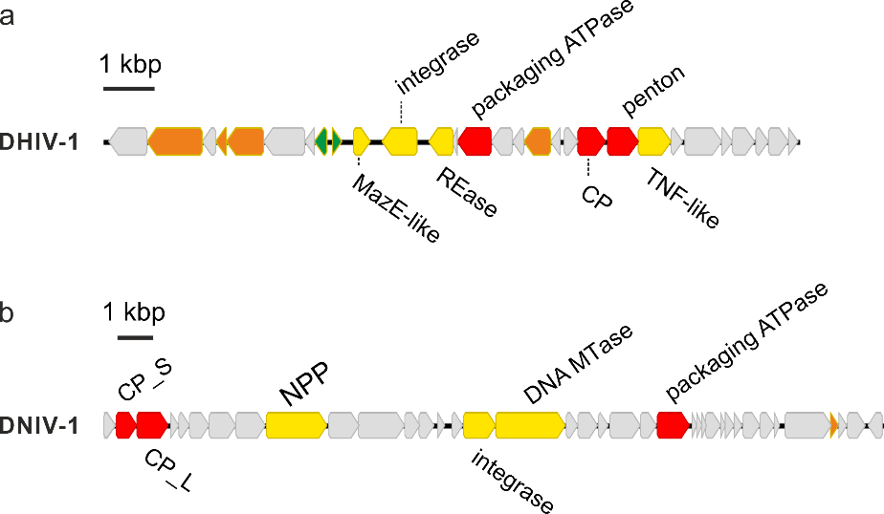

**Figure 1.** Genome maps of new singelaviruses. a. Danakil haloarchaeal icosahedral virus 1 (DHIV1). b. Danakil nanohaloarchaeal icosahedral virus 1 (DNIV1). CP_S, capsid protein (small); CP_L, capsid protein (large); REase, restriction endonuclease; TNF-like, TNF-like jelly-roll domain protein; NPP, nucleotide pyrophosphatase/phosphodiesterase.

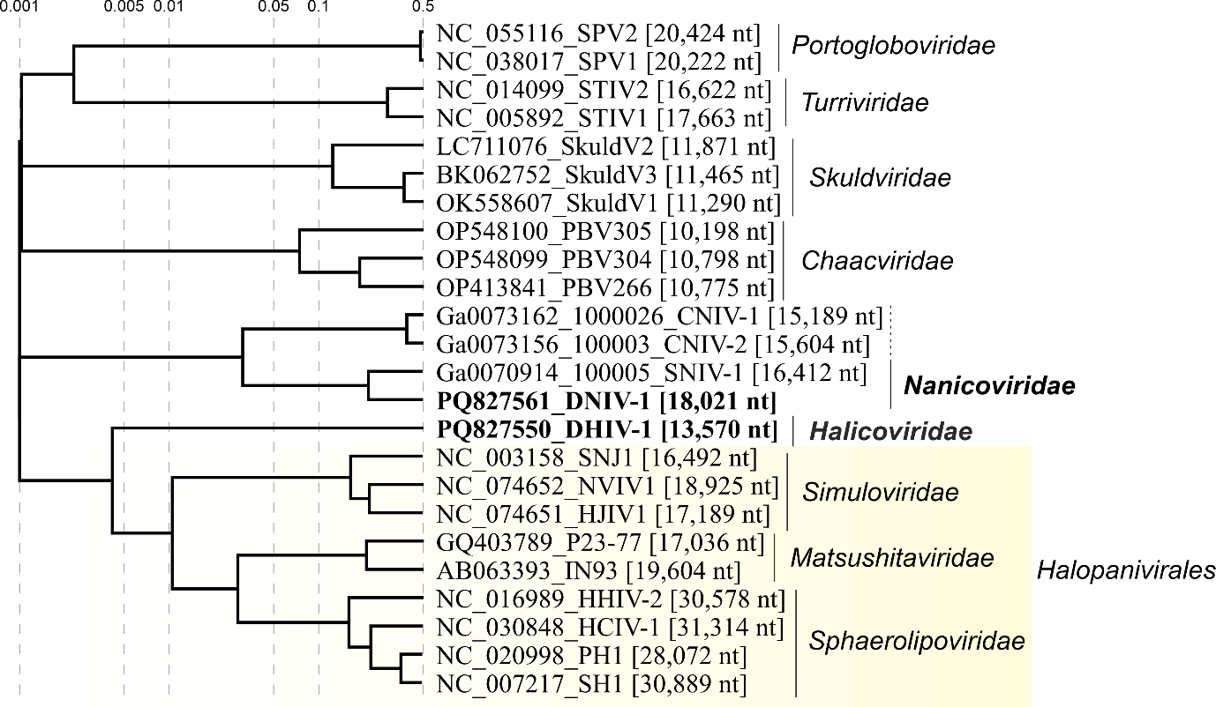

**Figure 2.** Genome-wide proteomic tree of representative archaeal tailless icosahedral viruses. Viruses from the Danakil Depression are highlighted in bold font. The proteomic trees are based on all-versus-all proteomic similarity matrix and are mid-point rooted. Branch lengths are log-scaled.

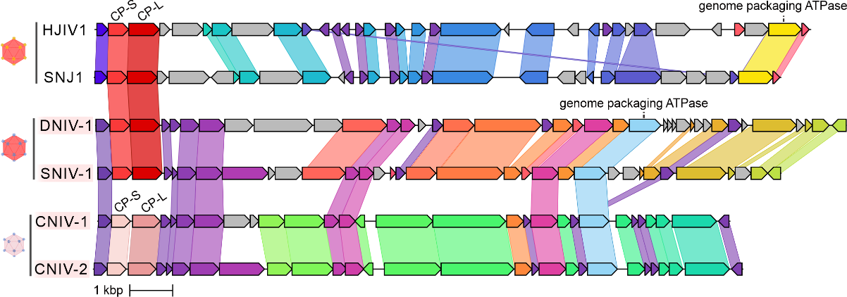

**Figure 3.** Comparison of four DNIV1-like viruses and two halopanivirals. HJIV1 and SNJ1 belong to family *Simuloviridae* (order *Halopanivirales*). Homologous genes (>25% identity) are highlighted using the same color and linked via shadings.

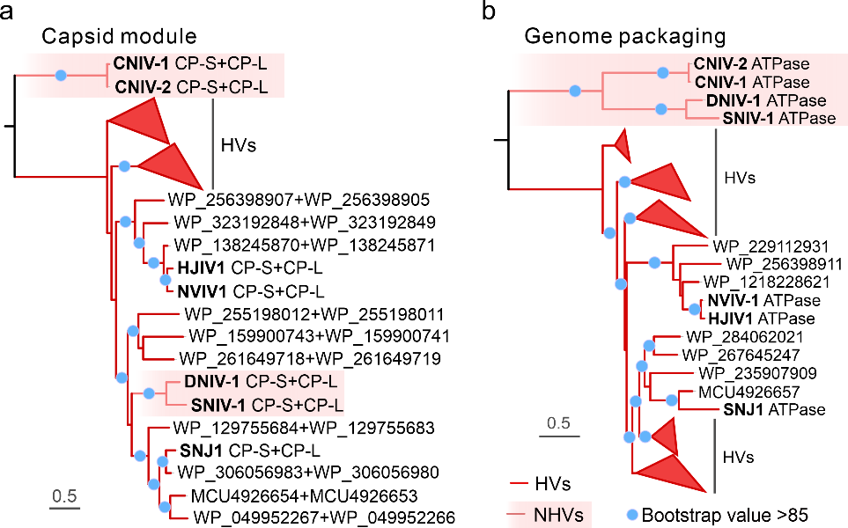

**Figure 4.** Maximum likelihood phylogenies of the major capsid proteins and genome packaging ATPase of archaeal signelavirians. a. Phylogenetic analysis based on the concatenated alignment of the two SJR MCPs. Note that DNIV1 and SNIV1 are nested among simulovirid homologs, whereas CNIV1 and CNIV2 cluster outside. b. Phylogenetic analysis based on the putative genome packaging ATPase. All four DNIV1-like viruses cluster outside of halopanivirals. Branches with bootstrap support values higher than 85% are indicated with blue circles. The sequences were aligned using Muscle5 with default parameters (Edgar, 2022), and non-informative columns were removed from the alignment using trimAl v1.2 with option -gt 0.2 (Capella-Gutiérrez et al., 2009). Next, a phylogenetic tree was constructed based on the trimmed alignment using IQ-TREE v2.2.2.2 with the following parameters: -m MFP, -alrt 1000 (Minh et al., 2020). The best fitting models for phylogenetic reconstructions were Q.pfam+F+I+R4 (for a) and Q.pfam+I+G4 (for b), respectively.