

The International Committee on Taxonomy of Viruses

Taxonomy Proposal Form, 2025

**Part 1a: Details of taxonomy proposals**

|  |  |
| --- | --- |
| **Title:** | Create 6 new families and 1 new species of viruses infecting archaea found in basalt-hosted crustal fluid |
| **Code assigned:** | 2025.001A.N.v2.crust_viruses_6nf | |

|  |  |  |  |  |
| --- | --- | --- | --- | --- |
| **Author(s), affiliation and email address(es):** | | | | |
| **Given name (+middle initial(s))** | **Surname** | **Affiliation** | **Email address** | **Corr. author(s)** |
| Cherise R | Spotkaeff | College of Computational and Natural Sciences, Hawaii Pacific University, Honolulu, HI, USA | cspotkae@my.hpu.edu |  |
| Michael S | Rappe | Hawaii Institute of Marine Biology, University of Hawaii, Kaneohe, HI USA | rappe@hawaii.edu |  |
| Grieg | Steward | Department of Oceanography, University of Hawaii, Honolulu, HI USA | grieg@hawaii.edu |  |
| Olivia D | Nigro | College of Computational and Natural Sciences, Hawaii Pacific University, Honolulu, HI, USA | onigro@hpu.edu | X |

**Part 1b: Taxonomy Proposal Submission**

|  |  |  |  |
| --- | --- | --- | --- |
| **ICTV Subcommittee:** | | | |
| Animal DNA Viruses and Retroviruses |  | Bacterial viruses |  |
| Animal minus-strand and dsRNA viruses |  | Fungal and protist viruses |  |
| Animal positive-strand RNA viruses |  | Plant viruses |  |
| Archaeal viruses | **X** | General - |  |

|  |
| --- |
| **List the ICTV Study Group(s) that have seen or have been involved in creating this proposal:** |
|  |

|  |  |  |  |
| --- | --- | --- | --- |
| **Optional – complete only if formally voted on by an ICTV Study Group:** | | | |
| **Study Group** | **Number of members** | | |
| **Votes in support** | **Votes against** | **No vote** |
|  |  |  |  |
|  |  |  |  |

|  |  |
| --- | --- |
| **Submission date:** | 17.06.2025 |

**Part 1c: Feedback from ICTV Executive Committee (EC) meeting**

|  |  |
| --- | --- |
| **Executive Committee Meeting Decision code:** | **X** |
| A – Accept |  |
| Ac – Accept subject to revision by relevant subcommittee chair. No further vote required |  |
| U – Accept without revision but with re-evaluation and email vote by the EC |  |
| Uc – Accept subject to revision and re-evaluation and email vote by the EC |  |
| Ud – Deferred to the next EC meeting, with an invitation to revise based on EC comments |  |
| J - Reject |  |
| W - Withdrawn |  |

|  |
| --- |
| **Comments from the Executive Committee:** |
|  |

**Part 1d: Revised Taxonomy Proposal Submission**

|  |
| --- |
| **Response of proposer:** |
|  |

|  |  |
| --- | --- |
| **Revision date:** |  |

**Part 3:** **TAXONOMIC PROPOSAL**

|  |  |  |  |
| --- | --- | --- | --- |
| **Taxonomic changes proposed:** | | | |
| Establish new taxon | **X** | Split taxon |  |
| Abolish taxon |  | Merge taxon |  |
| Move taxon |  | Promote taxon |  |
| Rename taxon |  | Demote taxon |  |
| Move and rename |  |

|  |  |
| --- | --- |
| **Etymology (origin) of proposed taxonomic names:** | |
| **Taxon name** | **Etymology of the term** |
| *Basaltiviridae* | Latin *basaltis* for basalt, referencing the environment in which this virus was found |
| *Tsigisvirus* | From the Quatsino word, Tsigis, referring to a monster of the deep, which references one of the names of the proposed marine protected area (MPA) containing the sample sites |
| *Tsigisvirus beckeri* | Latinized binomial species name honoring Keir Becker |
| *Tsigisvirus orcuttae* | Latinized binomial species name honoring Beth Orcutt |
| *Yumkaaxvirus juandefucaense* | Latinized binomial species name that references the mid-ocean spreading center, Juan de Fuca Ridge, near where the sample sites are located |
| *Seadebiviridae* | Phonetic translation of C-DEBI (Center for Dark Energy Biosphere Investigations), the NSF Science and Technology Center that helped drive research in the deep biosphere |
| *Hacxwiqakvirus* | From the Nuu-chah-nulth and Pacheedaht word, Hacxwiqak, meaning deepest part of the ocean, referring to a part of the name of the MPA in which the CORKs are located |
| *Hacxwiqakvirus coweni* | Latinized binomial species name honoring James “Jim” Cowen (deceased) |
| *Hacxwiqakvirus wheati* | Latinized binomial species name honoring Charles Geoff Wheat |
| *Hacxwiqakvirus orphanae* | Latinized binomial species name honoring Victoria Orphan |
| *Altumviridae* | From the latin, *altum,* meaning deep or deep sea, referring to the environment from which these viruses were found |
| *Calorvirus* | From the latin, *calor,* meaning heat, referencing the geothermally-heated crustal fluid in which these viruses were identified |
| *Calorvirus huberae* | Latinized binomial species name honoring Julie Huber |
| *Calorvirus bachi* | Latinized binomial species name honoring Wolfgang Bach |
| *Jasonviridae* | References the remote operated vehicle (ROV) Jason that has been responsible for deploying and collecting most of the sampling equipment |
| *Obscurovirus* | From Latin *obscurum* for darkness, referencing the dark environment of the basaltic crust in which the virus was found |
| *Obscurovirus verheini* | latinized binomial species name honoring Korey Verhein |
| *Infernusviridae* | From the Latin *infernus* meaning bottom or deep, referencing the location of the basaltic crust at the bottom of the ocean |
| *Tanggwanvirus* | From the Haida word, Tanggwan, meaning deep ocean, referencing the name of the proposed MPA |
| *Tanggwanvirus davisi* | Latinized binomial species name honoring Earl Davis |
| *Tenebraviridae* | From the Latin word *tenebrae,* meaning darkness. This references the deep dark ocean where the CORKs are located |
| *Caldusvirus* | From the Latin word *caldus,* meaning warm or hot, which references the geothermally-heated crustal fluids in which the virus was found |
| *Caldusvirus fisheri* | Latinized binomial species name honoring Andrew Fisher |

|  |  |  |
| --- | --- | --- |
| **Permission for use of names derived from a living person:** | | |
| **Taxon name** | **Full name of person from whom the name is derived** | **Attached** |
| bachi | Wolfgang Bach | X |
| beckeri | Keir Becker | X |
| davisi | Earl Davis | X |
| fisheri | Andrew Fisher | X |
| huberae | Julie Huber | X |
| orcuttae | Beth Orcutt | X |
| orphanae | Victoria Orphan | X |
| verheini | Korey Verhein | X |
| wheati | Charles Geoffrey Wheat | X |

|  |
| --- |
| **Abstract of Taxonomy Proposal:** |
| *Taxonomic rank(s) affected*:    Class: *Caudoviricetes* (5 new families)  Genus: *Yumkaaxvirus* (1 new species)  Spindle-shaped viruses: 1 new family (currently, no higher order taxonomic classification)  *Description of current taxonomy*:  Currently, there are 34 families in the class *Caudoviricetes* of archaea-infecting viruses, one representative in the genus *Yumkaaxvirus* and eight defined families of spindle-shaped viruses.  *Proposed* *taxonomic change(s):*  Create 6 new families and 1 new species for archaea-infecting viruses with predicted spindle, rod (realm: *Adnaviria*), and head-tail like (realm: *Duplodnaviria*) morphologies, identified in pristine crustal fluid collected from CORKs (Circulation Obviation Retrofit Kits).  *Justification*:  Though the proposed viruses share hallmark genes of their characterized taxa, they share little other genomic similarity with classified viruses. Through a combination of methods including gene-sharing network construction, analysis of gene synteny, VIPTree proteomic analysis, terminase and PolB phylogenetic reconstruction, and previously established demarcation criteria for prokaryotic viruses (specifically, for archaeal tailed viruses), we propose the classification of 11 archaea-infecting viruses for which complete genome sequences are available. |

|  |
| --- |
| **Text of Taxonomy proposal:** |
| One of the remaining frontiers in the quest to understand the evolution, diversity and origin of life on our planet is the exploration of the oceanic basement biosphere [1]. The ocean “basement” refers to the igneous, basaltic rock portion of the seafloor, which contains an expansive and understudied aquifer. The deep subseafloor basement is one of the largest potential reservoirs of microbial life on Earth, through which the entire volume of the global ocean circulates on the order of once every 50 to 100K years [2]. Our knowledge of oceanic deep subsurface viruses has been largely limited to those found in deep-sea sediments (e.g. [3–5]) or collected from diffusive flow hydrothermal vents (e.g. [6, 7]), which are fundamentally different environments from the ocean basement. Here we present viruses derived from metagenomes that were created using fluids obtained from CORK (Circulation Obviation Retrofit Kits) borehole observatories located within the basalt-hosted basement of the Juan de Fuca Ridge (JdFR) flank.  The development and insertion of CORK observatories (CORKs) into boreholes drilled through the sediments and into the underlying basalt revolutionized deep biosphere research by allowing the direct, large-volume sampling of crustal fluids. In a CORK, sampling lines terminating at different horizons deep in the borehole run upward through packers that seal the borehole from intrusion of sediment pore water and bottom seawater, thus providing pristine crustal fluids [8]. There are only two locations with CORKs designed with features specifically for microbiological sampling of rock-hosted subseafloor fluids: the CORK-fitted boreholes along the JdFR flank and North Pond in the Mid-Atlantic [9, 10]. Our study focuses on the JdFR CORKs, which access basement fluids that become increasingly chemically altered with distance from the ridge axis, coinciding with increasing temperature (~2℃ at bottom seawater entry point to >60℃). Although salinity, alkalinity, and pH remain similar to bottom seawater, oxygen and nitrate are quickly exhausted from the crustal fluid, leaving sulfate as the likely dominant electron acceptor based on standing stock concentrations [11, 12].  Previously, two microbial metagenomes were created from genomic DNA extracted from microbes in JdFR flank borehole fluid sampled in 2011. The genomic DNA sequence datasets contained deeply-branching lineages of Chloroflexi, Nitrospirae, Acetothermia (OP1), EM3, Aminicenantes (OP8), Archaeoglobi, Bathyarchaeota, and Hydrothermarchaeota [13]. Moreover, an initial study from our laboratory [14] documented the presence of viruses within crustal fluids of the ocean basement using epifluorescence and transmission electron microscopy (TEM), and metagenomics.  In order to collect sufficient biomass for the creation of metagenomes from the nominal viru-size fraction (<0.2 µm, >100,000 MW), we developed a large *in-situ* sampler, consisting of two filters in tandem, a 0.2 µm capsule filter (Polycap 75; Whatman) upstream of a 100k-Da nominal molecular weight cutoff (NMWCO) filter (Pellicon 2 [2 m2]). During its deployment, approximately 10,000 L of pristine, geothermally-heated (60℃) crustal fluid was filtered. Viruses were recovered from the ultrafilter by repeated recirculation and backflushing, then concentrated further by centrifugal ultrafiltration [14]. Viruses were fractionated based on their equilibrium buoyant density in a CsCl continuous gradient and 17 fractions with densities ranging from 1.24 – 1.59 g/ml were collected. After buffer exchange to remove the CsCl, a portion of each fraction was fixed and viral particles deposited onto grids for examination by transmission electron microscopy (TEM). For the remainder, DNA was extracted and metagenomes were created from each of the fractions. TEM analysis revealed diverse morphologies, some of which resemble the known distinctive shapes of archaeal viruses [14], particularly in those fractions with buoyant densities corresponding to known archaeal-virus buoyant densities, which tend to be less dense than the common bacterial viruses in the class *Caudoviricetes*.  Here, we present eleven complete viral genomes with predicted archaeal hosts from JdFR crustal fluid. Thirteen genomes were assembled from the metagenomes prepared from gradient fractions and are being submitted with their associated buoyant density ranges. One genome is a previously described prophage from the microbial metagenomes from the same environment [13]. Through homologous protein searches (NCBI’s BLAST and conserved domains database) and structural predictions (HHPred and Alphafold2), these genomes are predicted to be distantly related to spindle-shaped, rod-shaped (realm: *Adnaviria*), and head-tail like viruses (realm: *Duplodnaviria*). Based on vConTACT2 gene-sharing network analysis [15], these complete genomes form ten different clades, eight of which are contained in separate modules consisting mostly of assembled genomes from JdFR (Figure 1).  To further refine family-level taxonomic classification of viruses predicted to be in the class *Caudoviricetes*, we constructed viral proteomic trees using ViPTree [16] (branch length cutoff of 0.05 for family-level affiliation). We used a combination of all publicly available archaeal members of class-level taxonomic classification and assembled incomplete genomes assigned to the same viral cluster (VC) from vConTACT2 analysis.  Putative hosts for these genomes were inferred through CRISPR spacer linkage to microbial bins from a companion study [13] and a blast-based consensus taxonomic approach (for domain level host affiliation only). Through CRISPR spacer linkages, viral hosts of Bathyarchaeota and *Archaeoglobus* were assigned to four viral genomes. For viruses predicted to be in the class *Caudoviricetes*, maximum likelihood phylogenetic analysis of specific hallmark genes, polymerase B (Figure 3B) and terminase (Figure 4A), were also constructed to provide further evidence of an archaeal-host affiliation.  With the evidence presented here, we propose to create six new families, and one new species of archaeal virus taxonomy. This proposal represents the first viral families submitted to ICTV from oceanic basalt-hosted crustal fluids, to our knowledge.  Family *Basaltiviridae* Genus *Tsigisvirus*  **Clade 1** in the vConTACT2 network contains one new family of spindle-shaped viruses with two complete representatives, JdFR013 and JdFR006, assigned to a genus-level cluster (Figure 1). These viruses have circularized genomes that are ~13 kbp and an estimated buoyant density of 1.35-1.39 g/ml to 1.49-1.65 g/ml (Figure 2A). Though most of these genomes yielded proteins that showed no homologous matches to other known viruses, we were able to identify spindle-shaped virus-specific structural proteins through HHpred functional predictions: major capsid protein (vp1), capsid protein associated with DNA binding (vp2), and end filament proteins (vp4). Similar to other spindle-shaped viruses, these genomes contain integrases. Though the host of most of these viruses could not be identified past the domain level, JdFR006 was identified as a prophage within a species of Bathyarchaeota in the microbial metagenomes from the same environment.  **Clade 1 Etymology**   * *Basaltiviridae*, from Latin *basaltis* for basalt, referencing the environment in which this virus was found. * *Tsigisvirus,* from the Quatsino word, Tsigis, referring to a monster of the deep, which references one of the names of the proposed marine protected area (MPA) containing these CORK sites (pronunciation and description can be found here: <https://cpawsbc.org/tangwan-hacxwiqak-tsigis-mpa-deepsea-oasis/>). * *Tsigisvirus beckeri* and *Tsigisvirus orcuttae,* latinized binomial species names honoring Keir Becker and Beth Orcutt, respectively, both of whom contributed significantly to furthering research at CORKs and in the deep subsurface, particularly at JdFR.   **Demarcation Criteria**  We propose a 95% sequence identity threshold for new species, keeping consistency with other prokaryotic virus classification criteria.  Species *Yumkaaxvirus juandefucaense*  **Clade 2** contains one new species of rod-shaped viruses (Figure 1) in the genus *Yumkaaxvirus* (Figure 2B). JdFR077 is a complete linear genome (evidenced by 99 bp inverted terminal repeats) that is 15.5 kbp with an estimated buoyant density of 1.34-1.35 g/ml. Through gene-sharing network construction with vConTACT2, JdFR077 was placed in the same genus as Methanophagales virus PBV300, a phage identified in hydrothermal vent sediment in the Guaymas Basin. However, following previously defined species thresholds (95% sequence identity), JdFR077 represents a separate species. Similar to Methanophagales virus PBV300, JdFR077 also contains divergent homologues of core proteins of the family *Rudiviridae*, including two major capsids, a minor structural, and a terminal fiber protein.  **Clade 2 Etymology**   * *Yumkaaxvirus juandefucaense,* latinized binomial species name that references the mid-ocean spreading center, Juan de Fuca Ridge, near where the CORKs are located.   Clades 3-7 (Figure 1) consists of five new families of viruses in the class *Caudoviricetes* delineated by ViPTree [16] proteomic tree analysis of all head-tail archaea-infecting viruses (Figure 3A). The buoyant density of all predicted head-tail like genomes ranges from 1.39 to 1.51 g/ml. All of these viruses contain typical *Caudoviricetes* hallmark genes, including capsid, portal, terminase, tape measure and tail proteins.  Family *Seadebiviridae,* Genus *Hacxwiqakvirus*  **Clade 3** is a new family with three complete genome representatives, JdFR009, JdFR012, and JdFR114, ranging in size from 47 to 77.8 kbp and a buoyant density from 1.39 to 1.45 g/ml. Through the analysis of CRISPR spacer sequences from previously described JdFR microbial metagenomes [13], viral hosts were identified for JdFR012 (Bathyarchaeota sp.).  **Clade 3 Etymology**   * *Seadebiviridae* is the phonetic translation of C-DEBI (Center for Dark Energy Biosphere Investigations), the NSF Science and Technology Center that helped drive research in the deep biosphere. * *Hacxwiqakvirus,* from the Nuu-chah-nulth and Pacheedaht word, Hacxwiqak, meaning deepest part of the ocean, referring to a part of the name of the MPA in which the CORKs are located (pronunciation and description can be found here: <https://cpawsbc.org/tangwan-hacxwiqak-tsigis-mpa-deepsea-oasis/>). * *Hacxwiqakvirus coweni, Hacxwiqakvirus wheati,* and *Hacxwiqakvirus orphanae,* latinized binomial names in which the epithet honors influential members of the C-DEBI (James Cowen, Charles Geoff Wheat, and Victoria Orphan, respectively). Without their vision, leadership, and direction, microbial research in the deep biosphere would not have advanced to its current status.   Family *Altumviridae,* Genus *Calorvirus*  **Clade 4** is a new family containing two complete genomes, JdFR416 and prophage JdFR1000234 [14]. JdFR416 is 48 kbp with a buoyant density of 1.45-1.46 g/ml and, through CRISPR spacer sequence analysis, is predicted to infect species of *Archaeoglobus*.  **Clade 4 Etymology**   * *Altumviridae* from the latin, *altum,* meaning deep or deep sea, referring to the environment from which these viruses were found. * *Calorvirus* from the latin, *calor,* meaning heat, referencing the geothermally-heated crustal fluid in which these viruses were identified. * *Calorvirus huberae* and *Calorvirus bachi* latinized binomial species name honoring Julie Huber and Wolfgang Bach, respectively. They are both leaders in deep sea microbial ecology.   Family *Jasonviridae,* Genus *Obscurovirus*  **Clade 5** consists of a new family with one complete representative, JdFR019. This virus is 75.3 kbp with a buoyant density of 1.49-1.51 g/ml.  **Clade 5 Etymology**   * *Jasonviridae* references the remote operated vehicle (ROV) Jason that has been responsible for deploying and collecting most of our sampling equipment. * *Obscurovirus* from Latin *obscurum* for darkness, referencing the dark environment of the basaltic crust in which the virus was found. * *Obscurovirus verheini* latinized binomial species name with the latter referring to Korey Verhein, a skilled ROV Jason pilot who has been fundamental in the development, deployment and retrieval of specialized microbial sampling equipment.   In addition to the shared *Caudoviricetes* hallmark genes, clades 3-5 each contain a polymerase B (*polB*) gene. Phylogenetic analysis of the *polB* gene (Figure 3B) further supports the hypothesis of an archaeal host for these viruses, as the closes relative appears to be species of archaea. Similar to the family *Druskaviridae*, another shared feature between clades 3-4 (with the exception of prophage JdFR100234) is the presence of the entire preQ0/G+ biosynthesis pathway, consisting of the genes *queC*, *queD*, *queE*, *folE*/*folE2*. Regardless of the presence of the preQ0/G+ pathway, all of the genomes in clades 3-5 contain have a shared gene synteny consisting of a *polB*, PD-(D/E)XK nuclease, ERCC4 endonuclease, and ribonucleotide reductase (RNR).  Family *Infernusviridae,* Genus *Tanggwanvirus*  **Clade 6** is a new family with a single circularized representative genome, JdFR002, around 31.6 kbp with a buoyant density of 1.42-1.51 g/ml. JdFR002 also contains an integrase.  **Clade 6 Etymology**   * *Infernusviridae,* from the Latin *infernus* meaning bottom or deep, referencing the location of the basaltic crust at the bottom of the ocean. * *Tanggwanvirus* referring to another part of the name of the proposed MPA where the virus was found. Tanggwan is a Haida word meaning deep ocean (pronunciation and description can be found here: <https://cpawsbc.org/tangwan-hacxwiqak-tsigis-mpa-deepsea-oasis/>). * *Tanggwanvirus davisi* latinized binomial species name with the latter honoring Earl Davis, who was also a significant contributor to the design and installation of the first CORKs at JdFR.   Family *Tenebraviridae,* Genus *Caldusvirus*  **Clade 7** is a new family consisting of a complete virus ~43 kbp and a buoyant density of 1.4-1.42 g/ml to 1.49-1.51 g/ml that infects multiple novel species of *Archaeoglobus*. In addition to hallmark genes associated with *Caudoviricetes*, JdFR005 has a diversity generating retroelement (DGR) cassette (Figure 4B). This cassette consists of a reverse transcriptase, a DGR target protein, a template and variable region. The variable region was identified in an adjacent protein putatively identified as a tail protein. The DGR contained in JdFR005 is predicted to create hyper variation in the tail fiber protein, potentially diversifying the hosts it can infect.  **Clade 7 Etymology**   * *Tenebraviridae* from the Latin word *tenebrae,* meaning darkness. This references the deep dark ocean where the CORKs are located. * *Caldusvirus* from the Latin word *caldus,* meaning warm or hot, which references the geothermally-heated crustal fluids in which the virus was found. * *Caldusvirus fisheri* latinized binomial species name honoring Andrew Fisher, who participated in the senior leadership of C-DEBI and was fundamental in installing CORK borehole observatories on the JdFR flank.   Clades 6 and 7 (Figure 4) also share additional phage head proteins, protease, and head morphogenesis proteins, but do not have a *polB* gene. A maximum-likelihood phylogeny of their shared terminase genes (Figure 4A) further supports their divergent nature and predicted archaeal host.  **Demarcation Criteria**  We propose a 95% sequence identity threshold for new species, keeping consistency with other prokaryotic virus classification criteria. |

|  |
| --- |
| **References:** |
| 1. Edwards K, Fisher A, Wheat CG (2012) The Deep Subsurface Biosphere in Igneous Ocean Crust: Frontier Habitats for Microbiological Exploration. Frontiers in Microbiology 3:  2. Johnson HP, Pruis MJ (2003) Fluxes of fluid and heat from the oceanic crustal reservoir. Earth and Planetary Science Letters 216:565–574. https://doi.org/10.1016/S0012-821X(03)00545-4  3. Middelboe M, Glud R, Filippini M (2011) Viral abundance and activity in the deep sub-seafloor biosphere. Aquat Microb Ecol 63:1–8. https://doi.org/10.3354/ame01485  4. Bird DF, Juniper SK, Ricciardi-Rigault M, et al (2001) Subsurface viruses and bacteria in Holocene/Late Pleistocene sediments of Saanich Inlet, BC: ODP Holes 1033B and 1034B, Leg 169S. Marine Geology 174:227–239. https://doi.org/10.1016/S0025-3227(00)00152-3  5. Engelhardt T, Kallmeyer J, Cypionka H, Engelen B (2014) High virus-to-cell ratios indicate ongoing production of viruses in deep subsurface sediments. The ISME Journal 8:1503–1509. https://doi.org/10.1038/ismej.2013.245  6. Ortmann AC, Suttle CA (2005) High abundances of viruses in a deep-sea hydrothermal vent system indicates viral mediated microbial mortality. Deep-Sea Research Part I: Oceanographic Research Papers 52:1515–1527. https://doi.org/10.1016/j.dsr.2005.04.002  7. Anderson RE, Brazelton WJ, Baross JA (2011) Is the genetic landscape of the deep subsurface biosphere affected by viruses? Frontiers in Microbiology 2:1–16. https://doi.org/10.3389/fmicb.2011.00219  8. Wheat CG, Jannasch HW, Kastner M, et al (2011) Fluid sampling from oceanic borehole observatories: design and methods for CORK activities (1990–2010). Proceedings of the IODP 327:. https://doi.org/10.2204/iodp.proc.327.2011  9. Edwards KJ, Wheat CG, Orcutt BN, et al (2012) Design and deployment of borehole observatories and experiments during IODP Exp. 336. Mid-Atlantic Ridge flank at North Pond. Proceedings of the Integrated Ocean Drilling Program 336:109. https://doi.org/10.2204/iodp.proc.336.109.2012  10. Meyer JL, Jaekel U, Tully BJ, et al (2016) A distinct and active bacterial community in cold oxygenated fluids circulating beneath the western flank of the Mid-Atlantic ridge. Nature Publishing Group 1–14. https://doi.org/10.1038/srep22541  11. Lin H-T, Cowen JP, Olson EJ, et al (2012) Inorganic chemistry, gas compositions and dissolved organic carbon in fluids from sedimented young basaltic crust on the Juan de Fuca Ridge flanks. Geochimica et Cosmochimica Acta 85:213–227. https://doi.org/10.1016/j.gca.2012.02.017  12. Lin H-T, Cowen JP, Olson EJ, et al (2014) Dissolved hydrogen and methane in the oceanic basaltic biosphere. Earth and Planetary Science Letters 405:62–73. https://doi.org/10.1016/j.epsl.2014.07.037  13. Jungbluth SP, Amend JP, Rappé MS (2017) Metagenome sequencing and 98 microbial genomes from Juan de Fuca Ridge flank subsurface fluids. Sci Data 4:170037. https://doi.org/10.1038/sdata.2017.37  14. Nigro OD, Jungbluth SP, Lin H, et al (2017) Viruses in the Oceanic Basement. mBio 8:1–15  15. Bin Jang H, Bolduc B, Zablocki O, et al (2019) Taxonomic assignment of uncultivated prokaryotic virus genomes is enabled by gene-sharing networks. Nature Biotechnology 37:632–639. https://doi.org/10.1038/s41587-019-0100-8  16. Nishimura Y, Yoshida T, Kuronishi M, et al (2017) ViPTree: the viral proteomic tree server. Bioinformatics 33:2379–2380. https://doi.org/10.1093/bioinformatics/btx157  17. Elderfield H, Schultz A (1996) Mid-Ocean Ridge Hydrothermal Fluxes and the Chemical Composition of the Ocean. Annu Rev Earth Planet Sci 24:191–224. https://doi.org/10.1146/annurev.earth.24.1.191  18. Deming JW, Baross JA (1993) Deep-sea smokers: Windows to a subsurface biosphere? Geochimica et Cosmochimica Acta 57:3219–3230. https://doi.org/10.1016/0016-7037(93)90535-5  19. Davis EE, Becker K, Pettigrew T, et al (1992) 3. CORK: A HYDROLOGIC SEAL AND DOWNHOLE OBSERVATORY FOR Holes in Igneous Crust Requirements Holes in Accretionary Prisms. Proceedings of the Ocean Drilling Program, Initial Reports 139:43–53 |

|  |  |
| --- | --- |
| **Accompanying files:** | |
| **Filename** | **Description of contents** |
| 2025.001A_crust_viruses_6nf consent.pdf | Consent forms from all living person for use of their names in taxonomy |

|  |
| --- |
| **Tables, Figures:** |

<Start here>

**Table 1. Overview of viruses for new proposed taxonomy**

|  |  |  |  |  |  |  |  |  |  |
| --- | --- | --- | --- | --- | --- | --- | --- | --- | --- |
| **Clade #** | **Predicted Morphology** | **Virus**  **Name (short)** | **Host?** | **Family** | **Genus** | **Species** | **Size (bp)** | **Buoyant Density Range (g/ml)** | **Genbank Accesion** |
| 1 | Spindle | JdFR006 | Bathyarchaeota | *Basaltiviridae* | *Tsigisvirus* | *Tsigisvirus beckeri* | 13,970 | 1.35-1.39  1.49-1.65 | PQ111734 |
|  | Spindle | JdFR013 | -- | *Basaltiviridae* | *Tsigisvirus* | *Tsigisvirus orcuttae* | 13,328 | PQ111735 |
| 2 | Rod | JdFR077 | -- | *Ahmunviridae* | *Yumkaaxvirus* | *Yumkaaxvirus juandefucaense* | 15,570 | 1.34-1.35 | PQ111746 |
| 3 | Head-Tail | JdFR009 | -- | *Seadebiviridae* | *Hacxwiqakvirus* | *Hacxwiqakvirus coweni* | 47,442 | 1.39-1.42 | PQ111736 |
|  | Head-Tail | JdFR012 | Bathyarchaeota | *Seadebiviridae* | *Hacxwiqakvirus* | *Hacxwiqakvirus wheati* | 77,875 | 1.41-1.46 | PQ111737 |
|  | Head-Tail | JdFR114 | -- | *Seadebiviridae* | *Hacxwiqakvirus* | *Hacxwiqakvirus orphanae* | 51,075 | 1.41-1.45 | PQ111738 |
| 4 | Head-Tail | JdFR416 | *Archaeoglobus* | *Altumviridae* | *Calorvirus* | *Calorvirus huberae* | 48,071 | 1.45-1.46 | PQ111739 |
|  | Head-Tail | JdFR1000234 | -- | *Altumviridae* | *Calorvirus* | *Calorvirus bachi* | 55,906 | -- | KY229235 |
| 5 | Head-Tail | JdFR019 | -- | *Jasonviridae* | *Obscurovirus* | *Obscurovirus verheini* | 75,375 | 1.49-1.51 | PQ111740 |
| 6 | Head-Tail | JdFR002 | -- | *Infernusviridae* | *Tanggwanvirus* | *Tanggwanvirus davisi* | 31,658 | 1.42-1.51 | PQ111741 |
| 7 | Head-Tail | JdFR005 | *Archaeoglobus* | *Tenebraviridae* | *Caldusvirus* | *Caldusvirus fisheri* | 43,094 | 1.40-1.42  1.49-1.51 | PQ111742 |

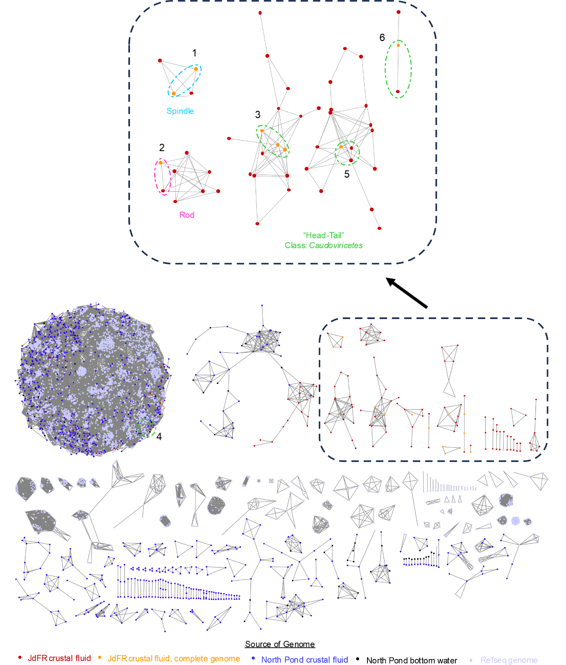Figure 1. Gene-sharing network constructed with vConTACT2, showing the viral community in the JdFR crustal fluid (red) is distinct from viruses in other crustal fluid environments (North Pond, blue, and North Pond Bottom Water, black) and viruses in the refseq database (purple). Subset of vConTACT2 gene-sharing network containing complete genomes for new proposed taxa. Dashed groupings, colored by putative morphology, indicate clades 1-7 of viruses for new proposed taxonomy. Clade 7 is not displayed on network as it was classified as a singleton by vConTACT2.

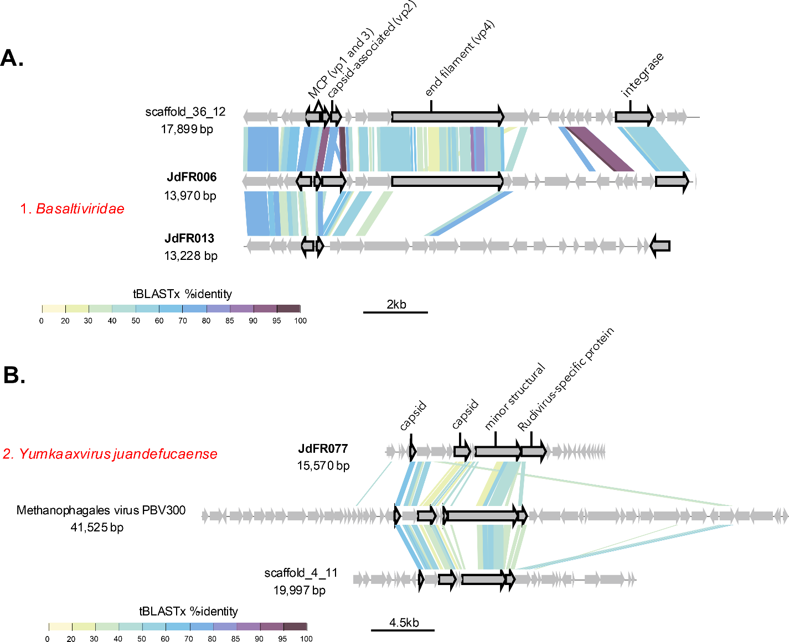Figure 2. Clades 1-2 of new taxa of spindle and rod-shaped viruses

A. New proposed family of predicted spindle-shaped viruses (clade 1). Hallmark genes associated with spindle-shaped viruses are highlighted.

B. New species of virus in the genus *Yumkaaxvirus* (clade 2). Hallmark genes associated with rod-shaped viruses are highlighted.

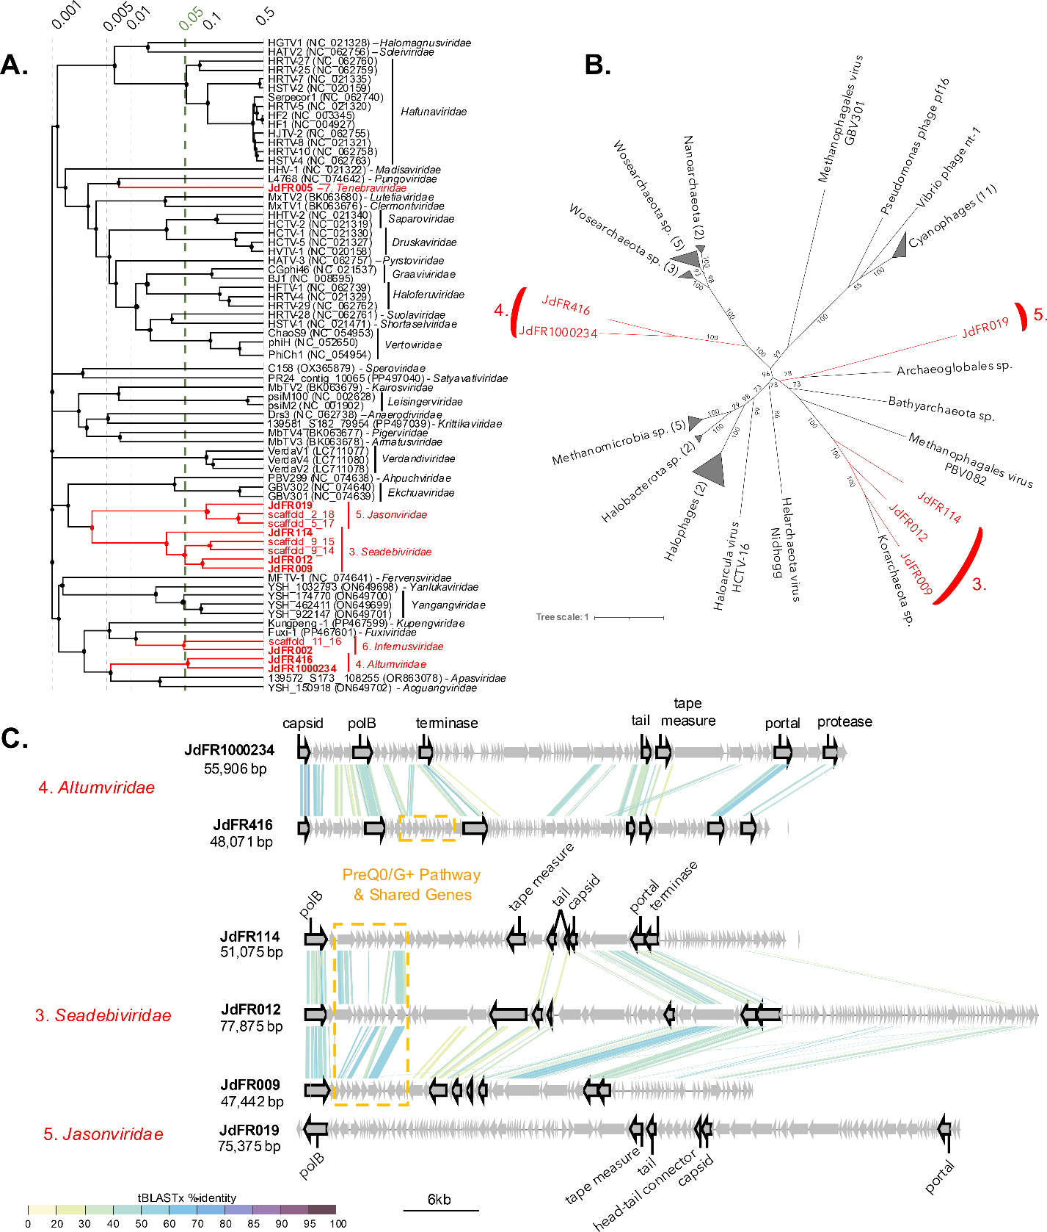Figure 3. Clades 3-5 of novel archaea-infecting viruses in the class *Caudoviricetes*

A. VIPTree proteomic analysis of publicly available archaea-infecting viruses in the class *Caudoviricetes*,labelled by family level taxonomy. Clades displayed in red indicate novel viruses. The family-level classification cutoff (0.05) is indicated in green.

B. Maximum-likelihood phylogenetic analysis of polymerase B (polB) gene shared by clades 3-5.

C. Viruses in the proposed family-level taxonomic classification. Caudoviricetes-specific hallmark genes and shared features (e.g. preQ0/G+ pathway) are highlighted.

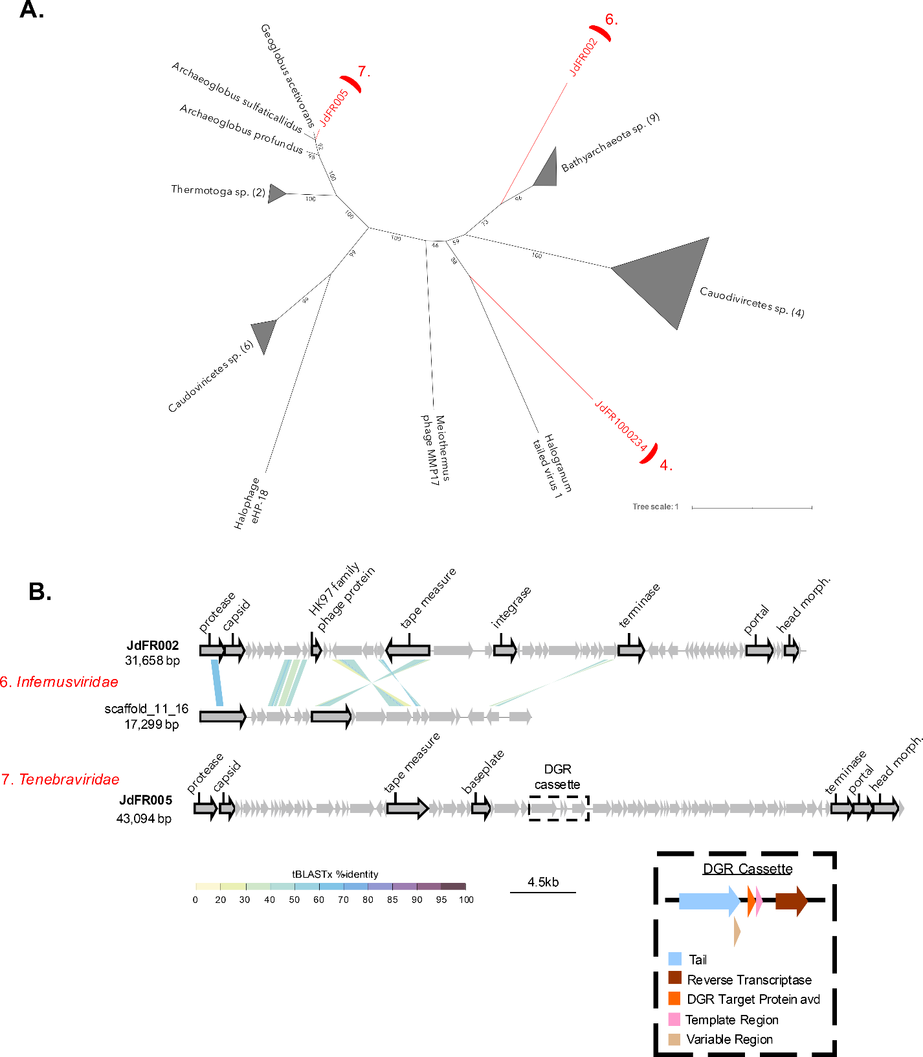Figure 4. Clades 6-7 of novel archaea-infecting viruses in the class *Caudoviricetes*

A. Maximum likelihood phylogeny of terminase gene. The viruses proposed for new taxonomy are highlighted in red and labelled by their respective clade number.

B. Genomes of viruses, labelled by clade and proposed family-level classification. Caudoviricete-specific hallmark genes and synteny between shared features are displayed. Distinguishing features of the genomes, such as the diversity generating retroelement (DGR) cassette present in clade 7, are also highlighted.