

The International Committee on Taxonomy of Viruses

Taxonomy Proposal Form, 2025

**Part 1a: Details of taxonomy proposals**

|  |  |
| --- | --- |
| **Title:** | Create one new species in the genus *Tupavirus* (*Mononegavirales*: *Rhabdoviridae*) |
| **Code assigned:** | 2025.010M.N.v3.Tupavirus_1nsp | |

|  |  |  |  |  |
| --- | --- | --- | --- | --- |
| **Author(s), affiliation and email address(es):** | | | | |
| **Given name (+middle initial(s))** | **Surname** | **Affiliation** | **Email address** | **Corresponding author(s)** |
| Oksana | Vernygora | National Centre for Foreign Animal Disease, Canadian Food Inspection Agency, Winnipeg, MB, Canada | oksana.vernygora@inspection.gc.ca |  |
| Laura | Bourque | Canadian Wildlife Health Cooperative, Atlantic Region, Charlottetown, Canada | lbourque@cwhc-rcsf.ca |  |
| Megan EB | Jones | Canadian Wildlife Health Cooperative, Atlantic Region, Charlottetown, Canada | mjones@cwhc-rcsf.ca |  |
| Ole | Nielsen | Fisheries and Oceans Canada, Winnipeg, MB, Canada | ole.nielsen@dfo-mpo.gc.ca |  |
| Carissa | Embury-Hyatt | National Centre for Foreign Animal Disease, Canadian Food Inspection Agency, Winnipeg, MB, Canada | carissa.emburyhyatt@inspection.gc.ca |  |
| Estella | Moffat | National Centre for Foreign Animal Disease, Canadian Food Inspection Agency, Winnipeg, MB, Canada | estella.moffat@inspection.gc.ca |  |
| Tonya | Wimmer | Marine Animal Response Society, Nova Scotia Museum, Halifax, NS | twimmer@marineanimals.ca |  |
| Oliver | Lung | National Centre for Foreign Animal Disease, Canadian Food Inspection Agency, Winnipeg, MB, Canada | oliver.lung@inspection.gc.ca | X |

**Part 1b: Taxonomy Proposal Submission**

|  |  |  |  |
| --- | --- | --- | --- |
| **ICTV Subcommittee:** | | | |
| Animal DNA Viruses and Retroviruses |  | Bacterial viruses |  |
| Animal minus-strand and dsRNA viruses | **X** | Fungal and protist viruses |  |
| Animal positive-strand RNA viruses |  | Plant viruses |  |
| Archaeal viruses |  | General - |  |

|  |
| --- |
| **List the ICTV Study Group(s) that have seen or have been involved in creating this proposal:** |
| Submission to Rhabdoviridae Study Group C-chairs Drs. Peter Walker and Nicolás Bejerman |

|  |  |  |  |
| --- | --- | --- | --- |
| **Optional – complete only if formally voted on by an ICTV Study Group:** | | | |
| **Study Group** | **Number of members** | | |
| **Votes in support** | **Votes against** | **No vote** |
| *Rhabdoviridae* SG | 14 | 0 | 1 |
|  |  |  |  |

|  |  |
| --- | --- |
| **Submission date:** | 06/06/2025 |

**Part 1c: Feedback from ICTV Executive Committee (EC) meeting**

|  |  |
| --- | --- |
| **Executive Committee Meeting Decision code:** | **X** |
| A – Accept |  |
| Ac – Accept subject to revision by relevant subcommittee chair. No further vote required |  |
| U – Accept without revision but with re-evaluation and email vote by the EC |  |
| Uc – Accept subject to revision and re-evaluation and email vote by the EC | **X** |
| Ud – Deferred to the next EC meeting, with an invitation to revise based on EC comments |  |
| J - Reject |  |
| W - Withdrawn |  |

|  |
| --- |
| **Comments from the Executive Committee:** |
| Accession numbers needed |

**Part 1d: Revised Taxonomy Proposal Submission**

|  |
| --- |
| **Response of proposer:** |
|  |

|  |  |
| --- | --- |
| **Revision date:** |  |

**Part 3:** **TAXONOMIC PROPOSAL**

|  |  |  |  |
| --- | --- | --- | --- |
| **Taxonomic changes proposed:** | | | |
| Establish new taxon | **X** | Split taxon |  |
| Abolish taxon |  | Merge taxon |  |
| Move taxon |  | Promote taxon |  |
| Rename taxon |  | Demote taxon |  |
| Move and rename |  |

|  |  |
| --- | --- |
| **Etymology (origin) of proposed taxonomic names:** | |
| **Taxon name** | **Etymology of the term** |
| *Tupavirus delphini* | The specific epithet is derived from the Latin for dolphin. |

|  |
| --- |
| **Abstract of Taxonomy Proposal:** |
| *Taxonomic rank(s) affected*:  Create a new species in the *Tupavirus* genus (*Mononegavirales*: *Rhabdoviridae*) based on the recently sequenced dolphin tupavirus (DTV).  *Description of current taxonomy*:  Currently, *Tupavirus* genus comprises nine recognized species (ICTV Master Species List 40v1, 2025) described from various terrestrial mammal and avian hosts such as bats, tree shrews, rodents, and coots.  *Proposed* *taxonomic change(s):*  We propose the creation of a new species in the *Tupavirus* genus (*Mononegavirales*: *Rhabdoviridae*) based on the recently sequenced dolphin tupavirus (DTV). The sequence was obtained from the post-mortem brain tissue of a stranded Atlantic white-sided dolphin (*Lagenorhynchus acutus*). We suggest the species name *Tupavirus delphini* in line with the new binomial species nomenclature and the specific epithet derived from the Latin for dolphin.  *Justification*:  The assembled DTV genome has a typical rhabdovirus structure including the coding regions for five proteins (N, P, M, G, and L) and an additional putative small hydrophobic protein (SH). The nucleotide BLAST search showed that the closest match was the member of the *Tupavirus* genus, Wenzhou Myotis laniger tupavirus 1 (GenBank accession OM030290.1), having an overall 50.72% genome-wide nucleotide identity. Amino acid sequence divergence in the N protein between the DTV and the closest BLAST match (Wufeng bat tupavirus 2; GenBank accession OQ715690.1) was 45.12%. Amino acid sequence divergence between the DTV and the closest BLAST match was 69.38% (Wufeng bat tupavirus 2; GenBank accession OQ715690.1) and 44.64% (Klamath virus; GenBank accession KM204999.1) in the G and L proteins, respectively. Dolphin tupavirus is the first known member of the *Tupavirus* genus described from an aquatic mammal host. |

|  |
| --- |
| **Text of Taxonomy proposal:** |
| *Taxonomic rank(s) affected*:  Create a new species in the genus *Tupavirus* (*Mononegavirales*: *Rhabdoviridae*)  *Description of current taxonomy*:  Currently, *Tupavirus* comprises nine recognized species (ICTV Master Species List 40v1, 2025) described from various terrestrial mammal and avian hosts such as bats, tree shrews, rodents, and coots.  *Proposed* *taxonomic change(s)*:  We propose the creation of a new species in the *Tupavirus* genus (*Mononegavirales*: *Rhabdoviridae*) based on the recently sequenced dolphin tupavirus (DTV). The sequence was obtained from the post-mortem brain tissue of a stranded Atlantic white-sided dolphin (*Lagenorhynchus acutus*). We suggest the species name *Tupavirus delphini* in line with the new binomial species nomenclature. The specific epithet is derived from the Latin for dolphin.  *Demarcation criteria:*  Dolphin tupavirus complies with the following species demarcation criteria within the genus *Tupavirus*:   1. Criterion: minimum amino acid sequence divergence of 5% in the N proteins;   Amino acid sequence divergence in the N protein between the DTV and the closest BLAST match (Wufeng bat tupavirus 2; GenBank accession OQ715690.1) is **45.12%** .   1. Criterion: minimum amino acid sequence divergence of 10% in the L proteins;   Amino acid sequence divergence in the L protein between the DTV and the closest BLAST match (Klamath virus; GenBank accession KM204999.1) is **44.64%**.   1. Criterion: minimum amino acid sequence divergence of 15% in the G proteins;   Amino acid sequence divergence between the DTV and the closest BLAST match (Wufeng bat tupavirus 2; GenBank accession OQ715690.1) is **69.38%**.   1. Criterion: occupy different ecological niches as evidenced by differences in hosts and/or arthropod vectors;   **dolphin tupavirus is the first known member of the *Tupavirus* genus described from an aquatic mammal host.**  *Justification*:  The sequence of a new rhabdovirus, tentatively named dolphin tupavirus (DTV) was obtained from the brain of a stranded dead Atlantic white-sided dolphin (*Lagenorhynchus acutus*) collected in Prince Edward Island, Canada, in 2024 (**Table 1**). The 11,088-nt complete genome has a structure typical of members of the *Rhabdoviridae* comprising five major open reading frames which correspond to the nucleocapsid (N), phosphoprotein (P), matrix (M), glycoprotein (G), and RNA-dependent RNA polymerase (L) proteins and a putative small hydrophobic protein between the M and G proteins (**Figure 1**, **Table 2**) (Walker et al., 2022). The P protein also contains a putative C protein in an overlapping reading frame (**Figure 1**), as has also been described in other tupaviruses and some rhabdoviruses (Springfeld et al., 2005; Allison et al., 2011; McAllister et al., 2014). The presence of an ORF encoding an additional small hydrophobic protein between the M and G ORFs is typical of the members of the *Tupavirus* genus (**Table 3**), although this protein has little sequence similarity among the members of the genus (Allison et al., 2011; Walker et al., 2015). Each ORF of the DTV genome is flanked by conserved transcription initiation (UUGUC) and termination/polyadenylation (AWCU7) signals and an inferred untranscribed intergenic sequence (GG or GA) similar to other members of the genus, e.g. tupaia rhabdovirus, Durham virus, Klamath virus (Springfeld et al., 2005; Allison et al., 2011)*.* The L protein of DTV contains an LDSPL motif, a modification of the animal rhabdovirus conserved motif (LNSPL), also found in Durham tupavirus (Kuzmin et al., 2008; Allison et al., 2011).  Phylogenetic analysis of the complete L-protein sequences across the *Rhabdoviridae* family revealed that the new species is placed within the tupavirus clade (**Figure 2A**). The phylogenetic placement of DTV within the clade of viruses assigned to the *Tupavirus* genus was strongly supported with 98% and 97.7% ultrafast bootstrap and approximate likelihood-ratio test values, respectively (**Figure 2B**). The phylogenetic bracket of the dolphin tupavirus includes a more basal Durham virus and a large crown clade comprising the rest of the *Tupavirus* member viruses.  Based on the nucleotide and amino acid identity (**Table 2**), genome organization (**Figure 1**), and phylogenetic analysis (**Figure 2**), we propose that dolphin tupavirus should be classified as a new member within the *Tupavirus* genus and suggest a binomial species name *Tupavirus delphini* with the specific epithet derived from the Latin for dolphin.  The dolphin tupavirus genome sequence has been uploaded to GenBank with accession number PV683224. |
|  |

|  |
| --- |
| **References:** |
| Allison AB, Palacios G, da Rosa AT, Popov VL, Lu L, Xiao SY, DeToy K, Briese T, Lipkin WI, Keel MK, Stallknecht DE (2011) Characterization of Durham virus, a novel rhabdovirus that encodes both a C and SH protein. Virus Research. 155(1):112-22.  Guindon S, Dufayard JF, Lefort V, et al (2010) New algorithms and methods to estimate maximum-likelihood phylogenies: assessing the performance of PhyML 3.0. Systematic biology. 59:307-21. [doi.org/10.1093/sysbio/syq010](https://doi.org/10.1093/sysbio/syq010)  Hoang DT, Chernomor O, Von Haeseler A, et al (2018) UFBoot2: improving the ultrafast bootstrap approximation. Molecular biology and evolution. 35:518-22. doi.org/ 10.1093/molbev/msx281  Kalyaanamoorthy S, Minh BQ, Wong TK, et al (2017) ModelFinder: fast model selection for accurate phylogenetic estimates. Nature methods. 14:587-9. [doi.org/10.1038/nmeth.4285](http://doi.org/10.1038/nmeth.4285)  Kuzmin IV, Wu X, Tordo N, Rupprecht CE (2008) Complete genomes of Aravan, Khujand, Irkut and West Caucasian bat viruses, with special attention to the polymerase gene and non-coding regions. Virus research. 136(1-2):81-90.  Minh BQ, Schmidt HA, Chernomor O, Schrempf D, Woodhams MD, Von Haeseler A, Lanfear R (2020) IQ-TREE 2: new models and efficient methods for phylogenetic inference in the genomic era. Molecular biology and evolution. 37(5):1530-4. [doi.org/10.1093/molbev/msaa015](http://doi.org/10.1093/molbev/msaa015)  McAllister J, Gauci PJ, Mitchell IR, Boyle DB, Bulach DM, Weir RP, Melville LF, Davis SS, Gubala AJ (2014) Genomic characterisation of Almpiwar virus, Harrison Dam virus and Walkabout Creek virus; three novel rhabdoviruses from northern Australia. Virology Reports. 3:1-7.  Ning S, Dai Z, Zhao C, Feng Z, Jin K, Yang S, Shen Q, Wang X, Sun R, Zhang W. Novel putative pathogenic viruses identified in pangolins by mining metagenomic data. J Med Virol. 2022 Jun;94(6):2500-2509. Epub 2022 Jan 11. Doi: 10.1002/jmv.27564.  Schwarz G (1978) Estimating the dimension of a model. The annals of statistics 1:461-4. doi.org/ 10.1214/aos/1176344136  Springfeld C, Darai G, Cattaneo R (2005) Characterization of the Tupaia rhabdovirus genome reveals a long open reading frame overlapping with P and a novel gene encoding a small hydrophobic protein. Journal of virology. 79(11):6781-90.  Walker PJ, Firth C, Widen SG, Blasdell KR, Guzman H, Wood TG, Paradkar PN, Holmes EC, Tesh RB, Vasilakis N (2015) Evolution of genome size and complexity in the Rhabdoviridae. PLoS pathogens. 11(2):e1004664.  Walker PJ, Bigarré L, Kurath G, Dacheux L, Pallandre L (2022) Revised taxonomy of rhabdoviruses infecting fish and marine mammals. Animals. 12(11):1363. |

|  |  |
| --- | --- |
| **Accompanying files:** | |
| **Filename** | **Description of contents** |
|  |  |
| **2025.010M.tupavirus_1nsp_genome.fasta** |  |

|  |
| --- |
| **Tables, Figures:** |

**Table 1:** Summary of details regarding the proposed novel *Tupavirus* species

|  |  |  |  |  |  |  |
| --- | --- | --- | --- | --- | --- | --- |
| **Virus name** | **Species name** | **GenBank accession** | **Virus acronym** | **Isolate ID** | **Country of Isolate** | **Host/isolation source** |
| dolphin tupavirus | *Tupavirus delphini* | PV683224 | DTV | PEI/2024 | Canada | *Lagenorhynchus acutus* (Atlantic white-sided dolphin) / Brain |

**Table 2. Top BLAST matches and identity of the dolphin tupavirus protein sequences**

|  |  |  |  |  |
| --- | --- | --- | --- | --- |
| **Protein** | **NT top match**  **(blastn)** | **% identity, nt** | **AA top match (DELTA-BLAST)** | **% identity, AA** |
| Nucleocapsid (N) | MZ328291.1 | 68.54 | WPV62772.1 | 54.88 |
| Phosphoprotein (P) | n/a | n/a | UBB42388.1 | 17.55 |
| Matrix protein (M) | n/a | n/a | WGC86350.1 | 32.68 |
| Small hydrophobic protein (SH) | n/a | n/a | n/a | n/a |
| Glycoprotein (G) | n/a | n/a | WPV62776.1 | 30.62 |
| Polymerase (L) | OM030290.1 | 55.42 | AJR28401.1 | 55.36 |

**Table 3. Hydrophobic score of small hydrophobic protein (SH) in tupaviruses**

|  |  |  |  |  |  |
| --- | --- | --- | --- | --- | --- |
| **Species** | **Virus** | **Accession** | **Size** | **% hydrophobic AA** | **Hydrophathy index** |
| *Tupavirus tupaia* | tupaia rhabdovirus | AY840978.1 | 279nt/93aa | 55.91 | 0.671 |
| *Tupavirus pearsonii* | Wufeng Rhinolophus pearsonii tupavirus 1 | MZ328291.1 | 285nt/95aa | 56.84 | 0.813 |
| *Tupavirus sp.* | Wufeng bat tupavirus 1 | OQ715688.1 | 285nt/95aa | 56.84 | 0.813 |
| *Tupavirus laniger* | Wenzhou Myotis laniger tupavirus 1 | OM030290.1 | 273nt/91aa | 53.83 | 0.521 |
| *Tupavirus klamath* | Klamath virus | KM204999.1 | 276nt/92aa | 54.35 | 0.420 |
| *Tupavirus durham* | Durham virus | FJ952155.1 | 231nt/77aa | 57.14 | 0.790 |
| ***Tupavirus delphini*** | **dolphin tupavirus** | **PV683224** | **213nt/71aa** | **60.56** | **0.566** |

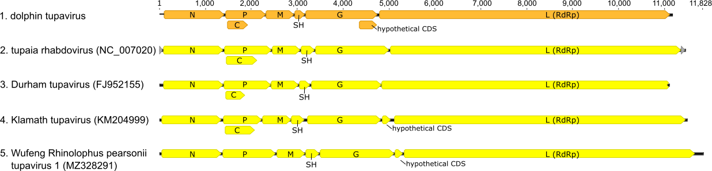

**Figure 1:** Dolphin tupavirusgenome layout and organization compared to that of other members of the *Tupavirus* genus.

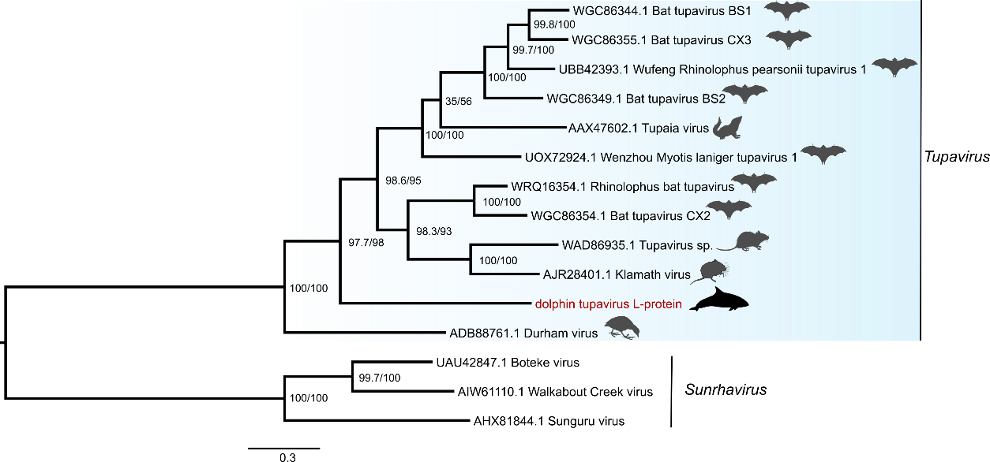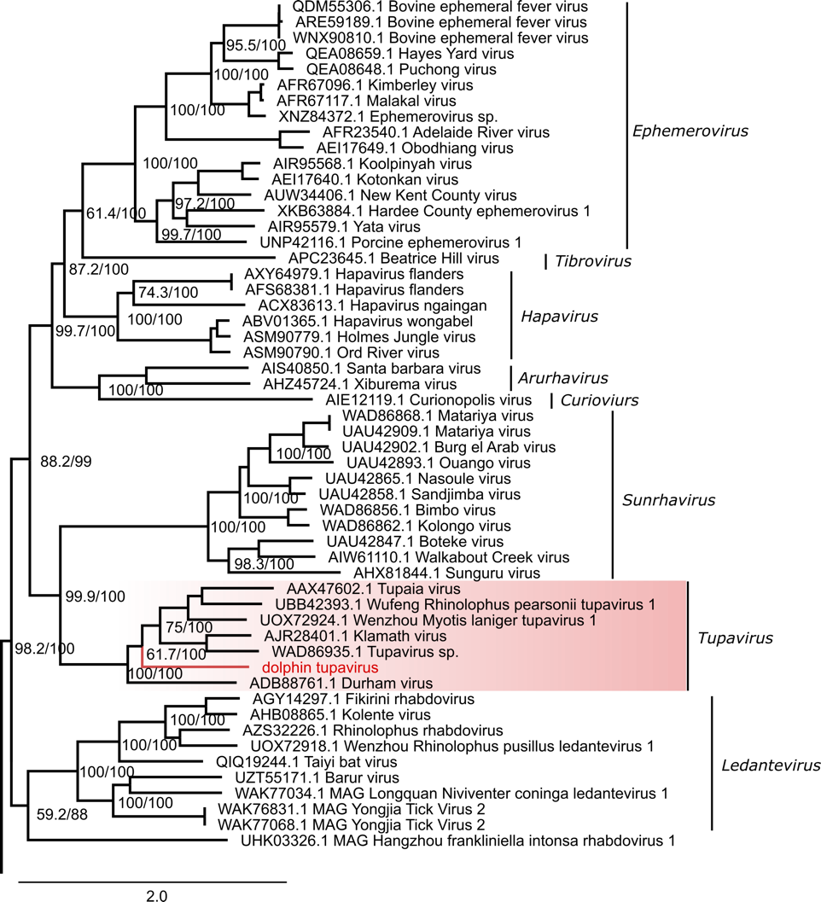

A

B

**Figure 2:** Maximum likelihood phylogenetic trees of rhabdoviruses reconstructed based on the full-length amino acid sequences of the L protein. The high-level phylogeny (A) includes a subset of representative members across the *Rhabdoviridae* family to identify the placement of the new virus within the family. The genus-level phylogeny (B) provides a fine-level assessment of the phylogenetic affinities of the new virus within the *Tupavirus* genus. The sequence of the novel tupavirus is shown in red; the phylogenetic bracket of the dolphin tupavirus includes a basal Durham virus and a large crown clade comprising the rest of the *Tupavirus* member viruses. Phylogenetic analysis was performed using IQ-TREE 2 (Minh et al., 2020). The best-fit model of sequence evolution was selected based on the Bayesian information criterion (BIC) score (Schwarz, 1978) calculated by ModelFinder (Kalyaanamoorthy et al., 2017), LG+F+I+R10 and LG+F+I+G4 models were selected as the best-fitting for rhabdovirus and tupavirus data sets, respectively. Node support was estimated by ultrafast bootstrap (Hoang et al., 2018) and the SH-aLRT test (Guindon et al., 2010) with 1,000 replicates each. Support values are shown at the nodes (SSH-aLRT/Ultrafast bootstrap). The rhabdovirus tree (A) was rooted at the midpoint, and the *Tupavirus* genus tree (B) was rooted to the outgroup members of the *Sunrhavirus* genus, Boteke, Sunguru, and Walkabout Creek viruses. Scale bars represent the estimated average number of substitutions per site.