

The International Committee on Taxonomy of Viruses

Taxonomy Proposal Form, 2025

**Part 1a: Details of taxonomy proposals**

|  |  |
| --- | --- |
| **Title:** | Create one new genus, and three new species in the family *Phenuiviridae.* |
| **Code assigned:** | 2025.007M.Ac.v3.Phenuiviridae_1ng_3nsp | |

|  |  |  |  |  |
| --- | --- | --- | --- | --- |
| **Author(s), affiliation and email address(es):** | | | | |
| **Given name (+middle initial(s))** | **Surname** | **Affiliation** | **Email address** | **Corr. author(s)** |
| Holly R. | Hughes | Centers for Disease Control and Prevention, Arboviral Diseases Branch, Fort Collins Colorado, USA | LTR8@cdc.gov | x |
| Takahide | Sasaya | Bio-oriented Technology Research Advancement Institution, NARO, Tsukuba, Japan | sasaya.takahide907@naro.go.jp |  |
| Gustavo | Palacios | Department of Microbiology, Icahn School of Medicine at Mount Sinai, New York, USA | gustavo.palacios@mssm.edu |  |
| Thomas | Briese | Center for Infection and Immunity, and Department of Epidemiology, Columbia University, New York, USA | thomas.briese@columbia.edu |  |
| Cécile | Desbiez | Pathologie Végétale, INRAE, Montfavet, France | cecile.desbiez@inrae.fr |  |
| Francesco | Di Serio | Institute for Sustainable Plant Protection-CNR, Bari, Italy | francesco.diserio@ipsp.cnr.it |  |
| Dimitre | Mollov | USDA-APHIS, Plant Protection and Quarantine, Riverdale, MD 20737 | dimitre.mollov@ars.usda.gov |  |
| Yutaro | Neriya | Faculty of Agriculture, Utsunomiya University, Utsunomiya, Japan | neriya@a.utsunomiya-u.ac.jp |  |
| Jin-Won | Song | Department of Microbiology, Korea University, Seou, Republic of Korea | jwsong@korea.ac.kr |  |
| Yasuhiro | Tomitaka | Institute for Plant Protection, NARO, Tsukuba, Japan | tomitaka.yasuhiro839@naro.go.jp |  |
| Massimo | Turina | Institute for Sustainable Plant Protection-CNR, Torino, Italy | massimo.turina@ipsp.cnr.it |  |

**Part 1b: Taxonomy Proposal Submission**

|  |  |  |  |
| --- | --- | --- | --- |
| **ICTV Subcommittee** | | | |
| Animal DNA Viruses and Retroviruses |  | Bacterial viruses |  |
| Animal minus-strand and dsRNA viruses | **x** | Fungal and protist viruses | **x** |
| Animal positive-strand RNA viruses |  | Plant viruses |  |
| Archaeal viruses |  | General - |  |

|  |
| --- |
| **List the ICTV Study Group(s) that have seen or have been involved in creating this proposal:** |
| *Phenuiviridae* SG |

|  |  |  |  |
| --- | --- | --- | --- |
| **Optional – complete only if formally voted on by an ICTV Study Group:** < | | | |
| **Study Group** | **Number of members** | | |
| **Votes in support** | **Votes against** | **No vote** |
| Phenuiviridae | 10 |  |  |
|  |  |  |  |

|  |  |
| --- | --- |
| **Submission date:** | 05/06/2025 |

**Part 1c: Feedback from ICTV Executive Committee (EC) meeting**

|  |  |
| --- | --- |
| **Executive Committee Meeting Decision code:** | **X** |
| A – Accept |  |
| Ac – Accept subject to revision by relevant subcommittee chair. No further vote required | **X** |
| U – Accept without revision but with re-evaluation and email vote by the EC |  |
| Uc – Accept subject to revision and re-evaluation and email vote by the EC |  |
| Ud – Deferred to the next EC meeting, with an invitation to revise based on EC comments |  |
| J - Reject |  |
| W - Withdrawn |  |

|  |
| --- |
| **Comments from the Executive Committee:** |
| Ac for minor typographical edits and consistent Abstracts formatting across all Subcommittees |

**Part 1d: Revised Taxonomy Proposal Submission** >

|  |
| --- |
| **Response of proposer:** |
|  |

|  |  |
| --- | --- |
| **Revision date:** | 19/08/2025 |

.

**Part 3:** **TAXONOMIC PROPOSAL**

|  |  |  |  |
| --- | --- | --- | --- |
| **Taxonomic changes proposed:** | | | |
| Establish new taxon | **x** | Split taxon |  |
| Abolish taxon |  | Merge taxon |  |
| Move taxon |  | Promote taxon |  |
| Rename taxon |  | Demote taxon |  |
| Move and rename |  |

|  |  |
| --- | --- |
| **Etymology (origin) of proposed taxonomic names:** | |
| **Taxon name** | **Etymology of the term** |
| *Fusavirus* | Name after *Fusarium asiaticum*, host Fusarium asiaticum mycobunyavirus 1 |
| *Fusavirus alternariae* | Name after host genus name *Alternaria*, where AtNSRV2 was discovered |
| *Fusavirus yangzi* | Named after 揚子江(Yángzǐ Jiāng) Plain, China, where FaMBV1 was discovered |
| *Fusavirus sclerotiniae* | Name after host genus name *Sclerotinia*, where SsNSRV5 was discovered |

|  |  |  |
| --- | --- | --- |
| **Permission for use of names derived from a living person** | | |
| **Taxon name** | **Full name of person from whom the name is derived** | **Attached** X |
| NA | NA |  |

|  |
| --- |
| **Abstract of Taxonomy Proposal:** |
| *Taxonomic rank(s) affected*:  Genus and species in the family *Phenuiviridae.*  *Description of current taxonomy*:  In the family *Phenuiviridae,* there are currently 23 genera and 159 species.  *Proposed* *taxonomic change(s):*  Create one new genus *Fusavirus,* including three new species for phenuiviridis detected in fungi.  *Justification*:  The three viruses create a well-supported monophyletic clade separated phylogenetically from other existing genera within the family *Phenuiviridae*. |

|  |
| --- |
| **Text of Taxonomy proposal:** |
| *Taxonomic rank(s) affected*:  Genus and species in the family *Phenuiviridae.*  *Description of current taxonomy*:  The family *Phenuiviridae* currently contains 23 genera and 159 species. The viral species represent a vast diversity of viruses that are detected in animals, plants, and fungi. Three genera (*Bocivirus, Entovirus and Lentinuvirus*) contain species describing viruses present in fungi.  *Proposed* *taxonomic change(s)*:  Create one new genus *Fusavirus,* and three new species in the family *Phenuiviridae.*  Three viruses were recently described in high-throughput sequencing of fungi isolated from plants. The virus Fusarium asiaticum mycobunyavirus 1 (FaMBV1) was detected in *Fusarium asiaticum,* the causative agent of Fusarium head blight (1). Alternaria tenuissima negative-stranded RNA virus 2 (AtNSRV2) was detected in fungal isolates of *Alternaria tenuissima* obtained from an asymptomatic grapevine (2). Sclerotinia sclerotiorum negative-stranded RNA virus 5 (SsNSRV5) was detected in the plant pathogen *Sclerotinia sclerotiorum* (3)*.* These viruses were shown to be distantly related to currently classified phenuivirids. We propose the creation of the genus *Fusavirus* to accommodate the new viruses*,* and the assignment of FaMBV1 to the species *Fusavirus yangzi,* AtNSRV2 to the species *Fusavirus alternariae*, and SsNSRV5 to the species *Fusavirus sclerotiniae.*  *Demarcation criteria:*  Demarcation of genera is based upon comprehensive considerations of virus phylogenetic relationships, genome organization and ecology. Viruses assigned to different species have less than 95% identity in the amino acid sequence of the RdRP.  *Justification*:  The fungal associated viruses assigned to the current genera *Bocivirus, Entovirus and Lentinuvirus,* possess at least two segments, where the RNA2 encodes for the MP (cell-to-cell movement protein). In contrast, the viruses assigned to the newly proposed genus, *Fusavirus,* possess the three canonical segments Large, Medium, and Small, with an M segment the encodes a putative glycoprotein. The three new viruses are phylogenetically separate from current phenuivirid genera (Figure).  The three viruses have an amino acid identity of the RdRP of less than 95% (Table) suggesting the viruses are exemplars of three new species. |

|  |
| --- |
| **References:** |
| 1. Huang H, Hua X, Pang X, Zhang Z, Ren J, Cheng J, et al. Discovery and Characterization of Putative Glycoprotein-Encoding Mycoviruses in the *Bunyavirales*. J Virol. 2023;97(1):e0138122. DOI: 10.1128/jvi.01381-222. Nerva L, Turina M, Zanzotto A, Gardiman M, Gaiotti F, Gambino G, et al. Isolation, molecular characterization and virome analysis of culturable wood fungal endophytes in esca symptomatic and asymptomatic grapevine plants. Environ Microbiol. 2019;21(8):2886-904. DOI: 10.1111/1462-2920.14651  3. Marzano SL, Nelson BD, Ajayi-Oyetunde O, Bradley CA, Hughes TJ, Hartman GL, et al. Identification of Diverse Mycoviruses through Metatranscriptomics Characterization of the Viromes of Five Major Fungal Plant Pathogens. J Virol. 2016;90(15):6846-63. DOI: 10.1128/JVI.00357-16 |

|  |  |
| --- | --- |
| **Accompanying files:** | |
| **Filename** | **Description of contents** |
| **NA** | **NA** |

|  |
| --- |
| **Tables, Figures:** |

Table. Percent identity of the RdRP amino acid sequences of exemplar viruses in the proposed genus *Fusavirus.* Sequences were aligned with MAFFT and the pairwise p-distance was calculated in Mega vX.

|  |  |  |  |
| --- | --- | --- | --- |
| Species 1 | Species 2 | Dist | % Identity |
| KF913892_Sclerotinia_sclerotiorum_negative-stranded_RNA_virus_5 | MK584855_Alternaria_tenuissima_negative-stranded_RNA_virus_2 | 0.730 | 27 |
| KF913892_Sclerotinia_sclerotiorum_negative-stranded_RNA_virus_5 | MZ969068_Fusarium_asiaticum_mycobunyavirus_1 | 0.746 | 25.4 |
| MK584855_Alternaria_tenuissima_negative-stranded_RNA_virus_2 | MZ969068_Fusarium_asiaticum_mycobunyavirus_1 | 0.663 | 33.7 |

<Start here>

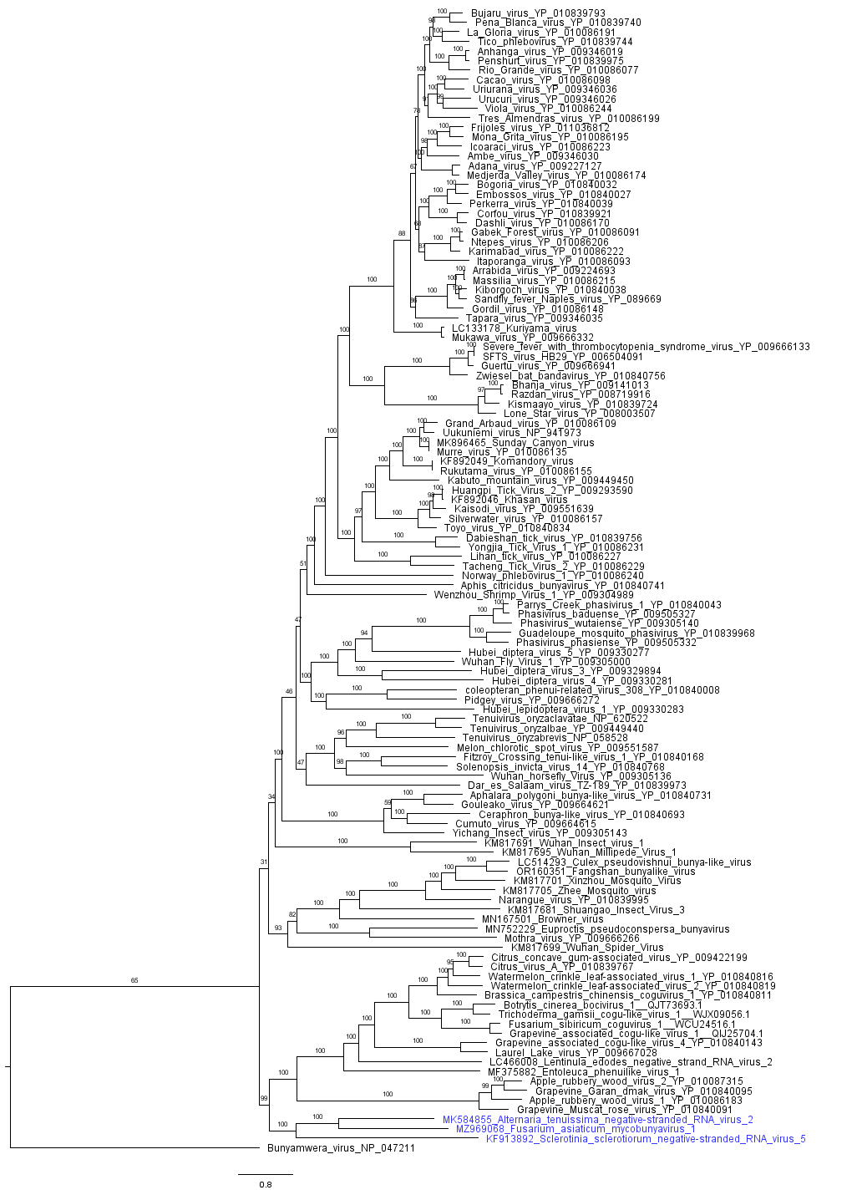

Figure. Phylogenetic inference of the L protein of the family *Phenuiviridae.* 119 complete coding phenuivirid RdRP amino acid sequences were downloaded from NCBI virus. At least one virus representative of all 23 genera is presented. Amino acids were aligned with MAFFT, and phylogenetic inference was completed with IQ-Tree using the WAG model and 5,000 bootstrap replicates. The branches are labeled with the bootstrap support percent. Previously classified taxa are labeled with virus name and protein accession number. Viruses highlighted in blue text are exemplar viruses of the newly proposed genus *Fusavirus* and are labeled with the GenBank accession of the L segment and the virus name. Bunyamwera virus RdRP was specified as the out group.