

The International Committee on Taxonomy of Viruses

Taxonomy Proposal Form, 2025

**Part 1a: Details of taxonomy proposals**

|  |  |
| --- | --- |
| **Title:** | Create one new genus and six new species in the family *Lispiviridae* (*Mononegavirales*) |
| **Code assigned:** | 2025.004M.N.v2.Lispiviridae_1ng_6nsp | |

|  |  |  |  |  |
| --- | --- | --- | --- | --- |
| **Author(s), affiliation and email address(es):** | | | | |
| **Given name (+middle initial(s))** | **Surname** | **Affiliation** | **Email address** | **Corr. author(s)** |
| Jun-Min | Li | Institute of Plant Virology, Ningbo University, Ningbo, PR China. | lijunmin@nbu.edu.cn | X |
| Gong-Yin | Ye | Institute of Insect Sciences, Zhejiang University, Hangzhou, PR China. | chu@zju.edu.cn |  |
| Fei | Wang | Wuhan Institute of Virology, Chinese Academy of Sciences, Wuhan, PR China. | wangfei@wh.iov.cn |  |
| Zhuang-Xin | Ye | Institute of Plant Virology, Ningbo University, Ningbo, PR China. | yzx244522794@163.com |  |
|  |  |  |  |  |

**Part 1b: Taxonomy Proposal Submission**

|  |  |  |  |
| --- | --- | --- | --- |
| **ICTV Subcommittee:** | | | |
| Animal DNA Viruses and Retroviruses |  | Bacterial viruses |  |
| Animal minus-strand and dsRNA viruses | **X** | Fungal and protist viruses |  |
| Animal positive-strand RNA viruses |  | Plant viruses |  |
| Archaeal viruses |  | General - |  |

|  |
| --- |
| **List the ICTV Study Group(s) that have seen or have been involved in creating this proposal:** |
| *Lispiviridae* Study Group |

|  |  |  |  |
| --- | --- | --- | --- |
| **Optional – complete only if formally voted on by an ICTV Study Group:** | | | |
| **Study Group** | **Number of members** | | |
| **Votes in support** | **Votes against** | **No vote** |
| *Lispiviridae* Study Group | 3 | 0 | 0 |
|  |  |  |  |

|  |  |
| --- | --- |
| **Submission date:** | 23/05/2025 |

**Part 1c: Feedback from ICTV Executive Committee (EC) meeting**

|  |  |
| --- | --- |
| **Executive Committee Meeting Decision code:** | **X** |
| A – Accept |  |
| Ac – Accept subject to revision by relevant subcommittee chair. No further vote required |  |
| U – Accept without revision but with re-evaluation and email vote by the EC |  |
| Uc – Accept subject to revision and re-evaluation and email vote by the EC |  |
| Ud – Deferred to the next EC meeting, with an invitation to revise based on EC comments |  |
| J - Reject |  |
| W - Withdrawn |  |

|  |
| --- |
| **Comments from the Executive Committee:** |
|  |

**Part 1d: Revised Taxonomy Proposal Submission**

|  |
| --- |
| **Response of proposer:** |
|  |

|  |  |
| --- | --- |
| **Revision date:** |  |

**Part 3:** **TAXONOMIC PROPOSAL**

|  |  |  |  |
| --- | --- | --- | --- |
| **Taxonomic changes proposed:** | | | |
| Establish new taxon | **X** | Split taxon |  |
| Abolish taxon |  | Merge taxon |  |
| Move taxon |  | Promote taxon |  |
| Rename taxon |  | Demote taxon |  |
| Move and rename |  |

|  |  |
| --- | --- |
| **Etymology (origin) of proposed taxonomic names:** | |
| **Taxon name** | **Etymology of the term** |
| *Crocevirus* | from the combination of the host genus *Crocidura* and the sampling location in the eastern coastal region of China |
| *donghaiense* | from the geographic origin “Donghai” in eastern China |
| *crysecense* | from the host species *Cryptotermes secundus* |
| *macbelense* | from the host species *Macrotermes bellicosus* |
| *macnatense* | from the host species *Macrotermes natalensis* |
| *macsubense* | from the host species *Macrotermes subhyalinus* |
| *illinense* | from the geographic origin illinois |

|  |  |  |
| --- | --- | --- |
| **Permission for use of names derived from a living person:** | | |
| **Taxon name** | **Full name of person from whom the name is derived** | **Attached** |
| NA |  |  |

|  |
| --- |
| **Abstract of Taxonomy Proposal:** |
| *Taxonomic rank(s) affected*:  Mononegaviral family *Lispiviridae*.  *Description of current taxonomy*:  Currently, the family *Lispiviridae* includes 30 genera and 45 species according to ICTV Master Species List (MSL40.v1).  *Proposed* *taxonomic change(s):*  We propose the creation of 1 new genus and 6 new species to be included in mononegaviral family *Lispiviridae*.  *Justification*:  Genus (and species) demarcation is proposed to be based on coding-complete genome sequence analyses, phylogenetic analyses, and pairwise sequence comparisons similar to established genus/species demarcation criteria for other mononegaviral families. |

|  |
| --- |
| **Text of Taxonomy proposal:** |
| *Taxonomic rank(s) affected*:  Mononegaviral family *Lispiviridae*.  *Description of current taxonomy*:  Currently, the family *Lispiviridae* includes 30 genera and 45 species according to ICTV Master Species List (MSL40.v1).  *Proposed* *taxonomic change(s)*:  We propose the creation of 1 new genus and 6 new species to be included in mononegaviral family *Lispiviridae*.  *Demarcation criteria:*  Species and genera are proposed for classification according to the established classification criteria:  • a coding-complete RNA-directed RNA polymerase (RdRp)  • at least 20% amino acid identity of the RdRp sequence  The above criteria are similar to those used for other mononegaviral families.  According to ICTV Report of *Lispiviridae* (https://ictv.global/report/chapter/lispiviridae/lispiviridae), the lispivirid genus demarcation criterion requires a coding-complete RdRp with amino acid identity between 20-49%, and the lispivirid species demarcation criterion a coding-complete RdRp with amino acid identity 50-84%. Thus, based on amino acid identity and the present phylogenetic analysis shown in **Figure 1**, we propose the demarcation of 1 new genus and 6 new species.  *Justification*:  Etymologies:  •*Crocevirus donghaiense*, representing Crocidura lasiura lispivirus 2 (accession: PP272508.1), was identified through high-throughput sequencing (HTS) in *Crocidura lasiura* (Ussuri white-toothed shrew) collected in China. The virus encodes an RdRp that shares 39% amino acid identity with the RdRp of Coleopteran arli-related virus OKIAV107 (accession: NC_076877.1), a member of *Cybitervirus niederense*. As the amino acid identity falls within the genus demarcation criteria for *Lispiviridae* (20-49%), a new genus, “*Crocevirus”*, is proposed. The proposed genus name is derived from the host genus Crocidura and the eastern coastal region of China, where the host was sampled. The species epithet “*donghaiense*” refers to the geographic origin, “Donghai” (东海), in eastern China.  •*Coroavirus crysecense*, representing Cryptotermes secundus lispivirus 1 (accession: BK067115.1), was identified from publicly available RNA-Seq datasets derived from Blattodea (cockroaches and termites). The RdRp of this the virus shares 55% amino acid identity with the RdRp of Blattodean arli-related virus OKIAV101 (accession: MT153397.1), a member of *Coroavirus germense*. The genus name *Coroavirus* is retained, and the species epithet “*crysecense*” is derived from the host species *Cryptotermes secundus*.  •*Copasivirus macbelense*, representing Macrotermes bellicosus lispivirus 1 (accession: BK067117.1), was identified from publicly available RNA-Seq datasets associated with Blattodea (cockroaches and termites). The viral RdRp shares 60% amino acid identity with that of Jimsystermes virus (accession: NC_076915.1), a member of *Copasivirus manlyvaleense*. The genus name *Copasivirus* is retained, and the species epithet “*macbelense*” is derived from the host species *Macrotermes bellicosus*.  •*Copasivirus macnatense*, representing Macrotermes natalensis lispivirus 1 (accession: BK067120.1), was identified from publicly available RNA-Seq datasets derived from Blattodea (cockroaches and termites). The viral RdRp shares 60% amino acid identity with that of Jimsystermes virus (accession: NC_076915.1), a member of *Copasivirus manlyvaleense*. The genus name *Copasivirus* is retained, and the species epithet “*macnatense*” is derived from the host species *Macrotermes natalensis*.  •*Copasivirus macsubense*, representing Macrotermes subhyalinus lispivirus 1 (accession: BK067121.1), was identified from publicly available RNA-Seq datasets associated with Blattodea (cockroaches and termites). The viral RdRp shares 60% amino acid identity with that of Jimsystermes virus (accession: NC_076915.1), a member of *Copasivirus manlyvaleense*. The genus name *Copasivirus* is retained, and the species epithet “*macsubense*” is derived from the host species *Macrotermes subhyalinus*.  •*Robevirus illinense*, representing Empoasca fabae lispivirus 1 (accession: PP946284.1), was identified by HTS from the potato leafhopper (*Empoasca fabae*) collected in Illinois, USA. The viral RdRp shares 50% amino acid identity with that of Hangzhou lispivirus 1 (accession: MZ209712.1), a member of *Robevirus hanzense*. The genus *Robevirus* is retained and the species epithet “*illinense*” is derived from the geographic origin of the sample, illinois, USA. |

|  |
| --- |
| **References:** |
| 1. Zhang JT, Hu ZY, Tang F, Liu YT, Tan WL, Ma XF, Zhang YF, Si GQ, Zhang L, Zhang MQ, Peng C, Fu BK, Fang LQ, Zhang XA, Liu W. Decoding the RNA viromes in shrew lungs along the eastern coast of China. NPJ Biofilms Microbiomes. 2024 Aug 8;10(1):68. doi: 10.1038/s41522-024-00543-3. 2. Wu H, Li W, Fan J, Jiang S, Li J, Hu P, Yu Z, Li Y, Pang R, Wu H. The hidden RNA viruses in Blattodea (cockroaches and termites). Microb Genom. 2024 Jul;10(7):001265. doi: 10.1099/mgen.0.001265. 3. Thekke-Veetil T, Lagos-Kutz D, Domier LL, McCoppin NK, Hartman GL, Clough SJ. Exploring Virus Diversity in the Potato leafhopper (*Empoasca fabae*), an Economically Important Agricultural Pest. Viruses. 2024 Aug 16;16(8):1305. doi: 10.3390/v16081305. 4. Li JM, Wang F, Ye GY, Paraskevopoulou S. ICTV Virus Taxonomy Profile: Lispiviridae 2023. 2023 Jul; 104(7): 001869. doi: 10.1099/jgv.0.001869. |

|  |  |
| --- | --- |
| **Accompanying files:** | |
| **Filename** | **Description of contents** |
| Lispiviridae_RdRp.Tree.20250522.pdf | Phylogenetic tree of the six proposed new species and other lispivirid species |
| Lispiviridae_RdRp.SDT.20250522.pdf | Pairwise identity of the six proposed new species with other lispivirid species |

|  |
| --- |
| **Tables, Figures:** |

<Start here>

**Figure 1**

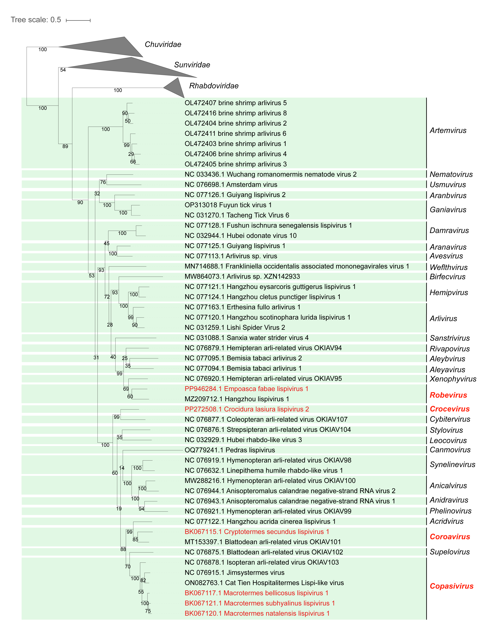**Figure 1**: Phylogenetic relationships of lispivirids. The phylogenetic tree is based on a MAFFT-alignment of the RdRp amino acid sequences using the L-INS-i algorithm and was inferred using ModelTest-NG and the LG+I+G4+F model. Numbers on branch nodes represent transfer bootstrap expectation values (1,000 replicates). The proposed new lispivirid genus and species are shown in red font. The tree is rooted to the viruses of the family *Chuviridae*.