

The International Committee on Taxonomy of Viruses

Taxonomy Proposal Form, 2025

**Part 1a: Details of taxonomy proposals**

|  |  |
| --- | --- |
| **Title:** | Create one new species in genus *Crustavirus* (*Mononegavirales*: *Nyamiviridae*) |
| **Code assigned:** | 2025.002M.Ac.v4.Crustavirus_1nsp | |

|  |  |  |  |  |
| --- | --- | --- | --- | --- |
| **Author(s), affiliation and email address(es):** | | | | |
| **Given name (+middle initial(s))** | **Surname** | **Affiliation** | **Email address** | **Corresponding author(s)** |
| Rebecca M | Grimwood | Department of Microbiology and Immunology, University of Otago, Dunedin, New Zealand | rebecca.grimwood@postgrad.otago.ac.nz | X |
| Leo N | Zamora | Cawthron Institute, Nelson, New Zealand; Institute of Marine Science, University of Auckland, Auckland, New Zealand | Leo.Zamora@cawthron.org.nz |  |
| Jessica A | Darnley | Department of Microbiology and Immunology, University of Otago, Dunedin, New Zealand | darje834@student.otago.ac.nz |  |
| Lizenn | Delisle | Cawthron Institute, Nelson, New Zealand | lizenn.delisle@cawthron.org.nz |  |
| Kate S | Hutson | Cawthron Institute, Nelson, New Zealand; Centre for Sustainable Fisheries and Aquaculture, College of Science and Engineering, James Cook University, Townsville, Australia | kate.hutson@cawthron.org.nz |  |
| Jemma L | Geoghegan | Department of Microbiology and Immunology, University of Otago, Dunedin, New Zealand; Institute of Environmental Science and Research, Wellington, New Zealand | jemma.geoghegan@otago.ac.nz | X |

**Part 1b: Taxonomy Proposal Submission**

|  |  |  |  |
| --- | --- | --- | --- |
| **ICTV Subcommittee:** | | | |
| Animal DNA Viruses and Retroviruses |  | Bacterial viruses |  |
| Animal minus-strand and dsRNA viruses | **X** | Fungal and protist viruses |  |
| Animal positive-strand RNA viruses |  | Plant viruses |  |
| Archaeal viruses |  | General - |  |

|  |
| --- |
| **List the ICTV Study Group(s) that have seen or have been involved in creating this proposal:** |
|  |

|  |  |  |  |
| --- | --- | --- | --- |
| **Optional – complete only if formally voted on by an ICTV Study Group:** | | | |
| **Study Group** | **Number of members** | | |
| **Votes in support** | **Votes against** | **No vote** |
| *Monjinviricetes* | 9 |  | 5 |
|  |  |  |  |

|  |  |
| --- | --- |
| **Submission date:** | 05/04/2025 |

**Part 1c: Feedback from ICTV Executive Committee (EC) meeting**

|  |  |
| --- | --- |
| **Executive Committee Meeting Decision code:** | **X** |
| A – Accept |  |
| Ac – Accept subject to revision by relevant subcommittee chair. No further vote required | **X** |
| U – Accept without revision but with re-evaluation and email vote by the EC |  |
| Uc – Accept subject to revision and re-evaluation and email vote by the EC |  |
| Ud – Deferred to the next EC meeting, with an invitation to revise based on EC comments |  |
| J - Reject |  |
| W - Withdrawn |  |

|  |
| --- |
| **Comments from the Executive Committee:** |
| No SG for the family, class SG looked at it. Poor demarcation criteria in general for family.  Ac: update Word document to accept track changes and fix typos |

**Part 1d: Revised Taxonomy Proposal Submission**

|  |
| --- |
| **Response of proposer:** |
|  |

|  |  |
| --- | --- |
| **Revision date:** |  |

**Part 3:** **TAXONOMIC PROPOSAL**

|  |  |  |  |
| --- | --- | --- | --- |
| **Taxonomic changes proposed:** | | | |
| Establish new taxon | **X** | Split taxon |  |
| Abolish taxon |  | Merge taxon |  |
| Move taxon |  | Promote taxon |  |
| Rename taxon |  | Demote taxon |  |
| Move and rename |  |

|  |  |
| --- | --- |
| **Etymology (origin) of proposed taxonomic names:** | |
| **Taxon name** | **Etymology of the term** |
| *Crustavirus jasusedwardsii* | Name derived from the viral genus and host species name. |
|  |  |
|  |  |
|  |  |

|  |  |  |
| --- | --- | --- |
| **Permission for use of names derived from a living person** | | |
| **Taxon name** | **Full name of person from whom the name is derived** | **Attached** |
| NA | NA |  |

|  |
| --- |
| **Abstract of Taxonomy Proposal:** |
| *Taxonomic rank(s) affected*: *Mononegavirales; Nyamiviridae; Crustavirus*  *Description of current taxonomy*: There are currently three recognised species in the *Crustavirus* genus.  *Proposed* *taxonomic change(s):* Establishment of one new species in the genus *Crustavirus* for Red rock lobster virus, identified in a spiny lobster (*Jasus edwardsii* (Hutton, 1875)) from New Zealand.  *Justification*: While there are no current species demarcation criteria for viruses from the *Nyamiviridae* beyond phylogeny and host, the divergence of the coding-complete genome sequences of Red rock lobster virus, phylogenetic placement, and the novel host of the virus suggests it to be a new species in the *Crustavirus* genus. |

|  |
| --- |
| * **Text of Taxonomy proposal** |
| *Taxonomic rank(s) affected*: *Mononegavirales; Nyamiviridae; Crustavirus*  *Description of current taxonomy*: There are currently three recognised species in the *Crustavirus* genus.  *Proposed* *taxonomic change(s)*: Addition of a new species to the nyamivirid genus *Crustavirus*.  *Demarcation criteria:* There are no demarcation criteria for the *Nyamiviridae* family beyond phylogeny and host.  *Justification*: A distinct crustavirus, named Red rock lobster virus (RRLV), was detected in uropod and haemolymph tissue samples from 15 Red rock lobsters (*Jasus edwardsii* (Hutton, 1875)) with tail fan necrosis caught off the east coast of the top of the South Island, New Zealand (Grimwood et al., 2025). Metagenomic sequencing recovered a coding-complete genome and the RRLV’s presence in the lobster tissues was confirmed with RT-PCR (GenBank accession: PQ440166.1).  The deduced amino acid sequence of the RNA-dependent RNA polymerase from RRLV shares 61% amino acid identity with Wenzhou Crab Virus 1, the exemplar virus of the species *Crustavirus wenzhouense* (Li et al., 2015). It also sits amongst the three current viruses within the *Crustavirus* genus in its phylogeny (Figure 1). Notably, the RRLV genome does not encode a glycoprotein (Figure 1). As no glycoprotein sequences were able to be recovered upon further sequence analysis and reassembly, and other viruses in the *Nyamiviridae* have also been identified lacking glycoproteins, such as the crustavirus, Wenling crustacean virus 12. |

|  |
| --- |
| **References:** |
| Grimwood RM, Zamora LN, Darnley JA, Delisle L, Hutson KS, Hills J, Geoghegan JL. bioRxiv 2025.03.10.642514; doi: <https://doi.org/10.1101/2025.03.10.642514>  Li CX, Shi M, Tian JH, Lin XD, Kang YJ, Chen LJ, Qin XC, Xu J, Holmes EC, Zhang YZ. Unprecedented genomic diversity of RNA viruses in arthropods reveals the ancestry of negative-sense RNA viruses. Elife. 2015.01.29;4:e05378; doi: <https://doi.org/10.7554/eLife.05378> |

|  |  |
| --- | --- |
| **Accompanying files:** | |
| **Filename** | **Description of contents** |
| 2025.002M.Crustavirus_1nsp | Completed taxonomic proposal for Red rock lobster virus |
|  |  |

|  |
| --- |
| **Tables, Figures:** |

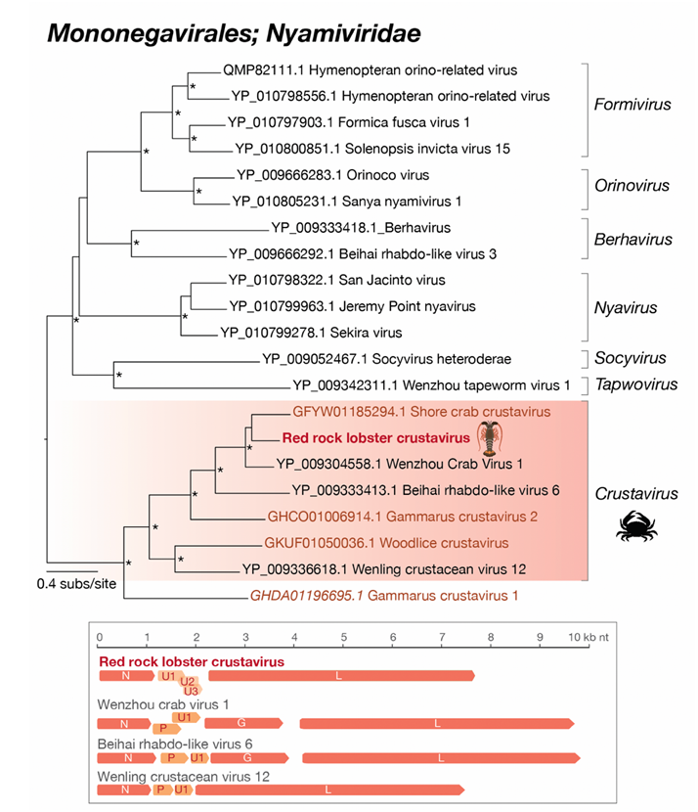

**Figure 1**: *Nyamiviridae* RNA-dependent RNA polymerase maximum likelihood phylogenetic tree based on translated amino acid sequences (top) and genome organisations of viruses from the *Crustavirus* genus (bottom). The tree was inferred using IQ-Tree v1.6.12 using the MFP option to select the most appropriate amino acid substitution model and 1,000 ultra-fast bootstrapping replicates. The tree was visualised in FigTree (<http://tree.bio.ed.ac.uk/software/figtree/>). The bar on the bottom left of the tree indicates amino acid substitutions per site and the asterisks at the nodes represent ultra-fast bootstrap support values of >= 95%. The RRLV sequence is indicated in red and the *Crustavirus* genus is highlighted in red. Recognised species in the *Crustavirus* genus are in black. N = Nucleoprotein; U = unknown protein; L = RdRp; G = Glycoprotein; and P = phosphoprotein.