

The International Committee on Taxonomy of Viruses

Taxonomy Proposal Form, 2025

**Part 1a: Details of taxonomy proposals**

|  |  |
| --- | --- |
| **Title:** | Creation of new species “*Whispovirus lacteolymphae*” in *Nimaviridae* |
| **Code assigned:** | 2025.007D.v2.Whispovirus_1nsp | |

|  |  |  |  |  |
| --- | --- | --- | --- | --- |
| **Author(s), affiliation and email address(es):** | | | | |
| **Given name (+middle initial(s))** | **Surname** | **Affiliation** | **Email address** | **Corr. author(s)** |
| Satoshi | Kawato | Institute for Aquaculture Biotechnology, Tokyo University of Marine Science and Technology, Tokyo, Japan | kawato@kaiyodai.ac.jp | X |
| Tadashi | Isshiki | Graduate School of Bioresources, Mie University, Mie, Japan | isshiki@bio.mie-u.ac.jp |  |
| Ikuo | Hirono | Laboratory of Genome Science, Tokyo University of Marine Science and Technology, Tokyo, Japan | hirono@kaiyodai.ac.jp |  |

**Part 1b: Taxonomy Proposal Submission**

|  |  |  |  |
| --- | --- | --- | --- |
| **ICTV Subcommittee:** | | | |
| Animal DNA Viruses and Retroviruses | **X** | Bacterial viruses |  |
| Animal minus-strand and dsRNA viruses |  | Fungal and protist viruses |  |
| Animal positive-strand RNA viruses |  | Plant viruses |  |
| Archaeal viruses |  | General - |  |

|  |
| --- |
| **List the ICTV Study Group(s) that have seen or have been involved in creating this proposal:** |
| Nimaviridae Study Group |

|  |  |  |  |
| --- | --- | --- | --- |
| **Optional – complete only if formally voted on by an ICTV Study Group:** | | | |
| **Study Group** | **Number of members** | | |
| **Votes in support** | **Votes against** | **No vote** |
|  |  |  |  |
|  |  |  |  |

|  |  |
| --- | --- |
| **Submission date:** | 18/06/2025 |

**Part 1c: Feedback from ICTV Executive Committee (EC) meeting**

|  |  |
| --- | --- |
| **Executive Committee Meeting Decision code:** | **X** |
| A – Accept |  |
| Ac – Accept subject to revision by relevant subcommittee chair. No further vote required |  |
| U – Accept without revision but with re-evaluation and email vote by the EC |  |
| Uc – Accept subject to revision and re-evaluation and email vote by the EC |  |
| Ud – Deferred to the next EC meeting, with an invitation to revise based on EC comments |  |
| J - Reject |  |
| W - Withdrawn |  |

|  |
| --- |
| **Comments from the Executive Committee:** |
|  |

**Part 1d: Revised Taxonomy Proposal Submission**

|  |
| --- |
| **Response of proposer:** |
|  |

|  |  |
| --- | --- |
| **Revision date:** |  |

**Part 2:** **GENERAL PROPOSAL**

|  |
| --- |
| **Abstract for General Proposal:** |
| *Brief description of current situation:*  *Proposed changes:*  *Justification:* |

|  |
| --- |
| **Text of General Proposal:** |
| *Background:*  *Proposed* *changes:*  *Justification:* |

|  |
| --- |
| **References:** |
|  |

|  |  |
| --- | --- |
| **Accompanying files:** | |
| **Filename** | **Description of contents** |
|  |  |
|  |  |

|  |
| --- |
| **Tables, Figures:** |

<Start here>

**Part 3:** **TAXONOMIC PROPOSAL**

<https://ictv.global/taxonomy/templates>

|  |  |  |  |
| --- | --- | --- | --- |
| **Taxonomic changes proposed:** | | | |
| Establish new taxon | **X** | Split taxon |  |
| Abolish taxon |  | Merge taxon |  |
| Move taxon |  | Promote taxon |  |
| Rename taxon |  | Demote taxon |  |
| Move and rename |  |

|  |  |
| --- | --- |
| **Etymology (origin) of proposed taxonomic names:** | |
| **Taxon name** | **Etymology of the term** |
| ***“Whispovirus lacteolymphae*”** | Formed from the classical Latin adjective *lacteus* (“milky, milk-white”) and the feminine noun *lympha*, -*ae* (“clear water; lymph”).  The epithet is a singular genitive noun (“of milky lymph”), referring to the characteristic milky hemolymph observed in snow crabs *Chionoecetes* spp. infected by Chionoecetes opilio bacilliform virus (the exemplar of the species). The binomial therefore reads “the *Whispovirus* of milky hemolymph”, directly pointing to the most characteristic clinical sign (milky hemolymph disease) observed in the infected host. |
|  |  |
|  |  |
|  |  |

|  |  |  |
| --- | --- | --- |
| **Permission for use of names derived from a living person:** | | |
| **Taxon name** | **Full name of person from whom the name is derived** | **Attached** |
|  |  |  |
|  |  |  |
|  |  |  |
|  |  |  |

|  |
| --- |
| **Abstract of Taxonomy Proposal:** |
| **Taxonomic rank(s) affected**:  Create “*Whispovirus lacteolymphae”*,a new species within the genus *Whispovirus* in the family *Nimaviridae.*  **Description of current taxonomy**:  The family *Nimaviridae* currently includes one species: *White spot syndrome virus*, which belongs to the genus *Whispovirus.*  **Proposed taxonomic change(s)**:  Create “*Whispovirus lacteolymphae”*, a new species within genus *Whispovirus* in *Nimaviridae*.  **Justification**:  Chionoecetes opilio bacilliform virus (CoBV), which was initially described as the causative agent of the milky hemolymph disease in the snow crab(*Chionoecetes opilio*)in the Sea of Japan (Kon et al., 2011; Motobayashi et al., 2018), has recently been characterized at the genomic level (Kawato et al., 2023). CoBV possesses a circular, double-stranded DNA genome ranging 240 kbp in size with 105 predicted protein-coding genes, including 76 WSSV orthologs (Kawato et al., 2023).  Phylogenetic analysis using conserved naldaviral core genes (Kawato et al., 2019; 2023) confirms the placement of CoBV within the family *Nimaviridae*. Nimaviral core gene phylogeny (Kawato et al., 2024) and Jaccard similarity clustering based on shared orthologs (File S1) both support a coherent grouping of CoBV with WSSV. Taken together, although CoBV is substantially divergent from WSSV (average amino acid identity: 34.7%; File S1), its position within the overall diversity of *Nimaviridae* is consistent with inclusion in the genus *Whispovirus*. Therefore, we propose the creation of a new species, “*Whispovirus lacteolymphae*”, to accommodate CoBV. |

|  |
| --- |
| * **Text of Taxonomy proposal:** |
| **Taxonomic rank(s) affected:** “*Whispovirus lacteolymphae*”  Create “*Whispovirus lacteolymphae”* a new species within *Nimaviridae.*  **Description of current taxonomy:**  The family *Nimaviridae* currently includes one species: *White spot syndrome virus*, which belongs to the genus *Whispovirus.*  **Proposed taxonomic change(s):**  Create “*Whispovirus lacteolymphae”*, a new species within genus *Whispovirus* in *Nimaviridae*.  **Diagnosis:**  “*Whispovirus lacteolymphae*” The genome sequence of Chionoecetes opilio bacilliform virus (INSDC Accession no. LC741431.1) is similar to *White spot syndrome virus* only at the amino acid level (average amino acid identity: 34.7%; File S1). The genome size of CoBV (240 kb) is smaller than that of WSSV (up to 312 kb). The known host range of CoBV is limited to cold-water crabs (*Chionoecetes* spp.) and is not known to infect penaeid shrimps and other decapod crustaceans.  Establishing the demarcation criteria for species and genera in *Nimaviridae* is difficult due to the lack of diversity in isolated nimaviruses. However, given that closely related metagenome-assembled genomes (MAGs) of nimaviruses exhibiting genome-wide collinearity share over 90% of average nucleotide identity (ANI) , we propose the adoption of 90% ANI as a provisional species demarcation criterion for *Nimaviridae*. Furthermore, we propose that the genus *Whispovirus* be defined cladistically as the monophyletic group that includes the most recent common ancestor of WSSV and CoBV and all its descendants. This definition is supported by the widespread conservation of WSSV orthologs across members of this lineage, including both exogenous and endogenous nimaviruses.  ***Justification*:**  CoBV was first described as the etiological agent of milky hemolymph disease in the snow crab *Chionoecetes opilio* from the Sea of Japan (Kon et al., 2011; Motobayashi et al., 2018). Genomic analysis revealed that CoBV possesses a circular, double-stranded DNA genome ranging 240 kbp in size encoding 105 predicted protein-coding genes, including 76 white spot syndrome virus (WSSV) orthologs (Kawato et al. 2023) A closely related bacilliform virus isolated from *C. bairdi* on the Pacific coast of Kamchatka (Ryazanova et al., 2023; Eliseikina et al., 2024) shares 99% nucleotide identity with CoBV (CbBV: INSDC Accession no. OQ911497.1), indicating that CoBV is widely distributed among *Chionoecetes* species in the North Pacific.  Phylogenetic analysis using conserved naldaviral core genes (Kawato et al., 2019; 2023) confirms the placement of CoBV within the family *Nimaviridae*. While the AAI between CoBV and WSSV is only 34.7%, clustering based on shared orthologs (Jaccard similarity) and core gene phylogeny both support a coherent grouping of CoBV with WSSV. Notably, CoBV clusters within a well-supported clade that includes WSSV, as seen in a phylogenomic analysis of 30 nimaviral genomes, including 28 metagenome-assembled genomes (MAGs) of endogenous nimaviruses (Kawato et al., 2024).  Although CoBV is substantially divergent from WSSV, its position within the overall diversity of *Nimaviridae* is consistent with inclusion in the genus *Whispovirus*. Therefore, we propose the creation of a new species, *Whispovirus lacteolymphae*, to accommodate CoBV. |

|  |
| --- |
| **References:** |
| Kon, T., Isshiki, T., Miyadai, T. *et al.* Milky hemolymph syndrome associated with an intranuclear bacilliform virus in snow crab *Chionoecetes opilio* from the Sea of Japan. *Fish Sci* **77**, 999–1007 (2011). https://doi.org/10.1007/s12562-011-0405-0  Motobayashi, H., Miyadai, T. & Isshiki, T. Experimental infection of snow crab *Chionoecetes opilio* with the *Chionoecetes opilio* bacilliform virus (*Co*BV). *Fish Sci* **84**, 17–24 (2018). https://doi.org/10.1007/s12562-017-1146-5  Kawato S, Shitara A, Wang YNozaki R, Kondo H, Hirono I. 2019. Crustacean Genome Exploration Reveals the Evolutionary Origin of White Spot Syndrome Virus. *J Virol* **93,** e01144-18 (2019).  https://doi.org/10.1128/jvi.01144-18  Kawato, S., Fujishima, S., Nozaki, R. *et al.* Genome sequence of Chionoecetes opilio bacilliform virus, a nimavirus infecting the snow crab *Chionoecetes opilio*. *Arch Virol* **168**, 101 (2023). https://doi.org/10.1007/s00705-023-05731-8  Kawato S, Nozaki R, Kondo H, Hirono I. 2024. Integrase-associated niche differentiation of endogenous large DNA viruses in crustaceans. *Microbiol Spectr***12,** e00559-23 (2024).  https://doi.org/10.1128/spectrum.00559-23  Ryazanova V.T., Eliseikina G. M., Kukhlevsky D. A. Milky hemolymph syndrome (MHS) associated with a virus in tanner crab *Chionoecetes bairdi* off the Pacific coast of Kamchatka.  *J Invertebr Pathol* **196,** 107864 (2023). https://doi.org/10.1016/j.jip.2022.107864  Eliseikina G. M., Boyko V.A., Shamshurina V.E., Ryazanova V.T. Complete genome of the new bacilliform virus that causes Milky Hemolymph Syndrome in *Chionoecetes bairdi* (Rathbun, 1924). *J Invertebr Pathol* **206,**108179 (2024). https://doi.org/10.1016/j.jip.2024.108179 |

|  |  |
| --- | --- |
| **Accompanying files:** | |
| **Filename** | **Description of contents** |
| **2025.007D.v2.Whispovirus_1nsp_ File_S1.pdf** | **Figures S1-3 and Tables S1-4.** |
| **2025.007D.v2.Whispovirus_1nsp_ File_S2.xslx** | **Table S5.** |
| **2025.007D.v2.Whispovirus_1nsp_ File_S3.pdf** | **Bioinformatic scripts used in the analyses.** |

|  |
| --- |
| **Tables, Figures:** |

<Start here>

グラフ, レーダー チャート

AI 生成コンテンツは誤りを含む可能性があります。

**Fig 1.** Circular diagram of the Chionoecetes opilio bacilliform virus (CoBV) genome.

Arrows indicate open reading frames and their transcriptional orientations. Generated using gbdraw v0.2.0 followed by manual editing.



**Fig 2.** Genome synteny between CoBV and CbBV.

Arrows indicate open reading frames and their transcriptional orientations. Gray bands indicate pairwise BLASTN hits (e-value cutoff, 1e-30; bit score cutoff, 1000; identity cutoff, 90%). Generated using gbdraw v0.2.0 followed by manual editing.

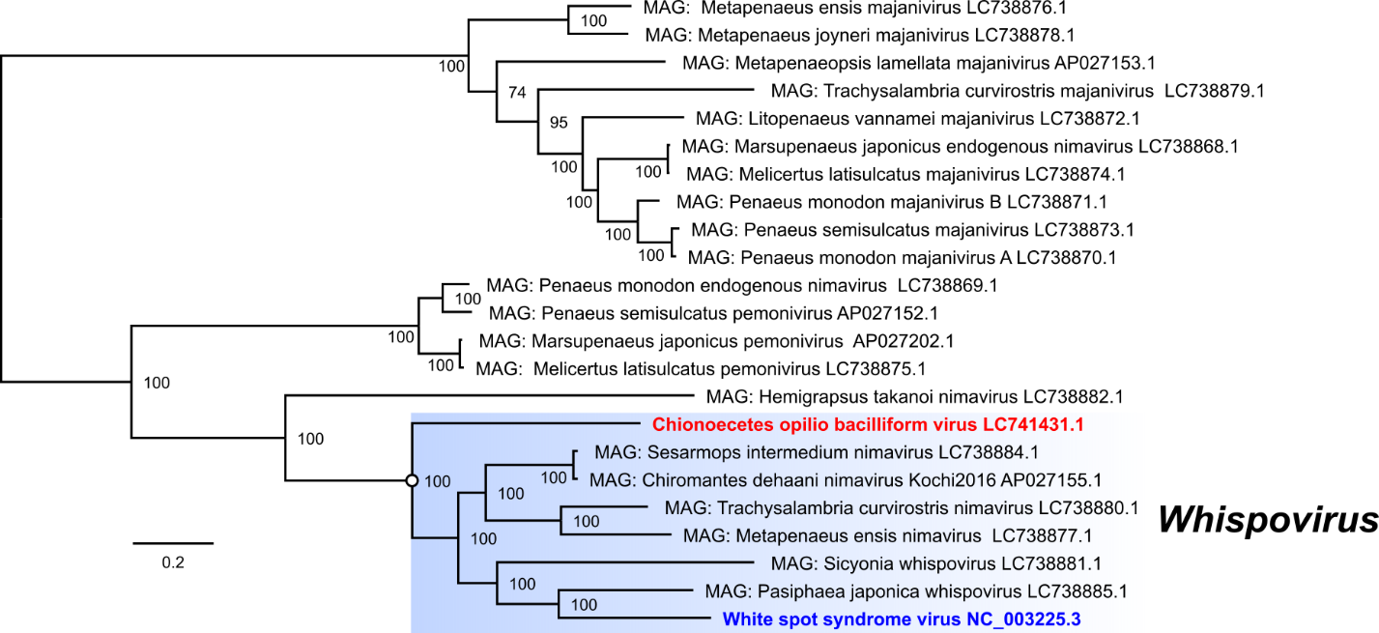

**Fig 3.** Phylogenetic analysis of *Nimaviridae.*

Amino acid sequences of 30 nimaviral core genes were aligned using MAFFT v7.525. The resulting alignments were trimmed using trimAl v1.5.0, and maximum likelihood phylogenetic analysis was performed using IQ-TREE2 v2.3.6 (20,867 sites; LG+F+R5 model). The tree was visualized using FigTree v1.4.4 and then manually edited. Values beside the branches represent the ultrafast bootstrap values. The bar in the lower left denotes amino acid substitution per site. Metagenome-assembled genomes (MAGs) are indicated as “MAG: “. The white node indicates the root of the expanded *Whispovirus* genus, which is shaded with blue.

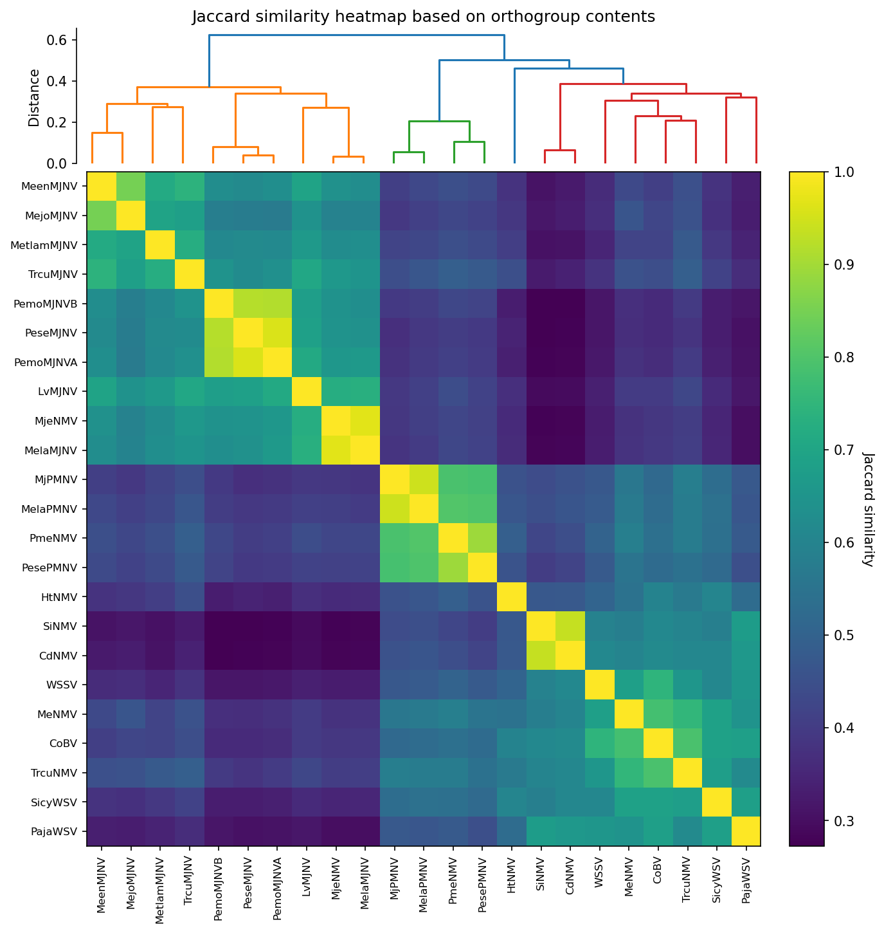**Fig 4.** Clustering nimaviruses based on shared gene contents.

Genomic relatedness was quantified for 237 orthogroups obtained with OrthoFinder v2.5.5. A total of 21 orthogroups were manually merged into single orthogroups to avoid artificial splits. A binary presence/absence matrix (237 orthogroups × 23 genomes) was converted to pairwise Jaccard distances (1 – similarity) with SciPy v1.11 (pdist, metric = “jaccard”). Hierarchical clustering used the Unweighted Pair Group Method with Arithmetic mean (UPGMA; linkage(method="average")). The dendrogram leaf order (SciPy leaves_list) was applied to the 1 – distance matrix to give a heat-map of Jaccard similarities (0–1 scale; color bar at right). Tick labels are genome acronyms; branch length units are Jaccard distance. WSSV, CoBV, and other nimavirus genomes that cluster at Jaccard similarity ≥ 0.60 form a coherent clade, supporting the assignment of CoBV to the genus *Whispovirus*. See Table S1 for the abbreviations of the virus names.