**Table S1.** Nimaviral genomes used in this study.

|  |  |  |  |  |  |  |
| --- | --- | --- | --- | --- | --- | --- |
| **Virus** | **Abbreviation** | **Accession** | **Length** | **GC%** | **CDS** | **Completeness** |
| Marsupenaeus japonicus endogenous nimavirus | MjeNMV | LC738868.1 | 306,008 | 33 | 111 | Complete |
| Melicertus latisulcatus majanivirus | MelaMJNV | LC738874.1 | 287,061 | 32 | 104 | Complete |
| Metapenaeopsis lamellata majanivirus | MetlamMJNV | AP027153.1 | 267951 | 27 | 106 | Complete |
| Penaeus monodon majanivirus A | PemoMJNVA | LC738870.1 | 294144 | 40 | 115 | Complete |
| Penaeus monodon majanivirus B | PemoMJNVB | LC738871.1 | 360,489 | 35 | 114 | Complete |
| Litopenaeus vannamei majanivirus | LvMJNV | LC738872.1 | 280452 | 35 | 119 | Complete |
| Penaeus semisulcatus majanivirus | PeseMJNV | LC738873.1 | 291934 | 42 | 110 | Complete |
| Metapenaeus ensis majanivirus | MeenMJNV | LC738876.1 | 292,272 | 29 | 101 | Complete |
| Metapenaeus joyneri majanivirus | MejoMJNV | LC738878.1 | 401182 | 26 | 124 | Complete |
| Trachysalambria curvirostris majanivirus | TrcuMJNV | LC738879.1 | 283150 | 28 | 101 | Complete |
| Marsupenaeus japonicus pemonivirus | MjPMNV | AP027202.1 | 323944 | 48 | 102 | Complete |
| Melicertus latisulcatus pemonivirus | MelaPMNV | LC738875.1 | 359647 | 48 | 109 | Complete |
| Penaeus monodon endogenous nimavirus | PmeNMV | LC738869.1 | 300002 | 45 | 94 | Complete |
| Penaeus semisulcatus pemonivirus | PesePMNV | AP027152.1 | 277334 | 43 | 102 | Complete |
| Hemigrapsus takanoi nimavirus | HtNMV | LC738882.1 | 251731 | 47 | 111 | Coding-complete |
| Trachysalambria curvirostris nimavirus | TrcuNMV | LC738880.1 | 331684 | 47 | 107 | Complete |
| Sesarmops intermedium nimavirus | SiNMV | LC738884.1 | 267936 | 44 | 104 | Complete |
| Chiromantes dehaani nimavirus | CdNMV | AP027155.1 | 285096 | 44 | 99 | Complete |
| Metapenaeus ensis nimavirus | MeNMV | LC738877.1 | 341,283 | 44 | 117 | Complete |
| Sicyonia whispovirus | SicyWSV | LC738881.1 | 347,493 | 54 | 89 | Complete |
| Pasiphaea japonica whispovirus | PajaWSV | LC738885.1 | 276272 | 35 | 86 | Complete |
| Chionoecetes opilio bacilliform virus | CoBV | LC741431.1 | 243979 | 40 | 105 | Complete |
| White spot syndrome virus | WSSV | NC_003225.3 | 309286 | 41 | 177 | Complete |

**Table S2.** ANI matrix for closely related penaeid endogenous nimavirus MAGs (1).

|  |  |  |  |  |  |
| --- | --- | --- | --- | --- | --- |
| **ANI** | **MjeNMV** | **MlMJNV** | **PemoMJNVA** | **PeseMJNV** | **PemoMJNVB** |
| **MjeNMV** | 100% | 97.50% | -- | -- | -- |
| **MlMJNV** | 97.50% | 100% | -- | -- | -- |
| **PemoMJNVA** | -- | -- | 100% | 92.89% | 81.01% |
| **PeseMJNV** | -- | -- | 92.89% | 100% | 80.63% |
| **PemoMJNVB** | -- | -- | 81.01% | 80.63% | 100% |

See Table S1 for the abbreviations of the virus names. --: ANI undetermined (too few matches to meet the threshold defined by ani.rb).

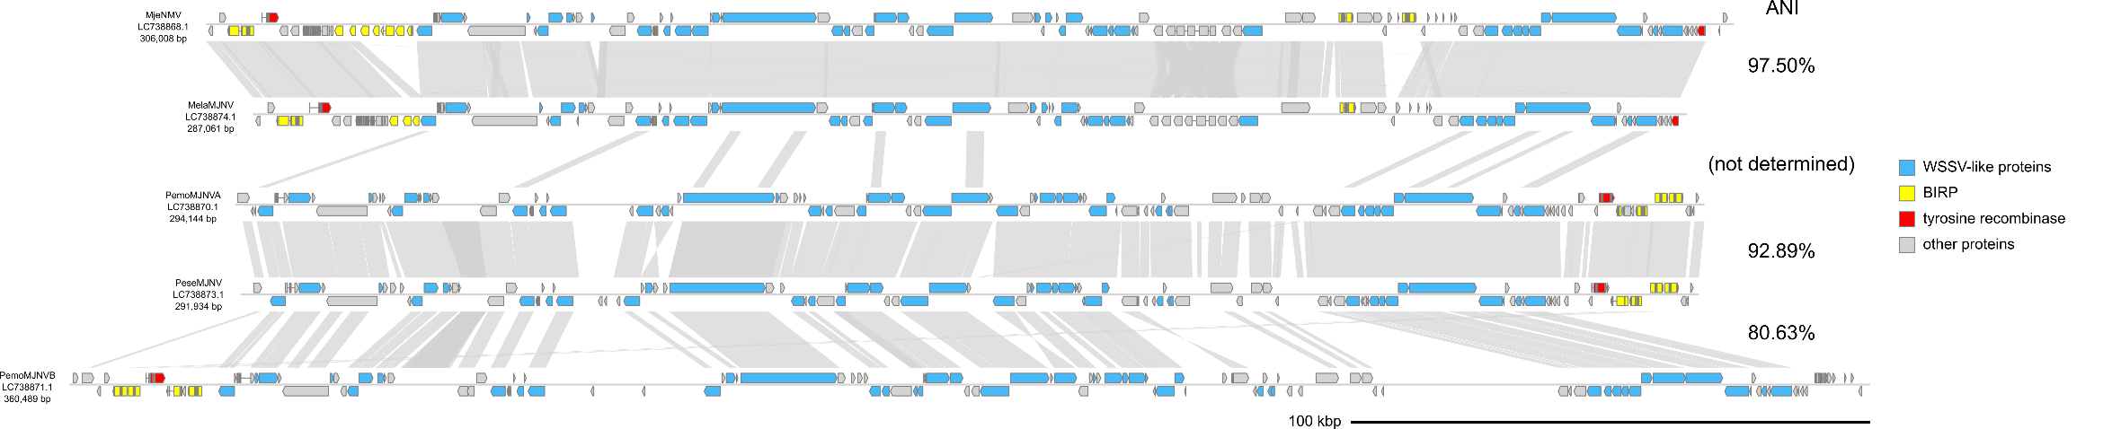

**Figure S1.** Genome diagrams of closely related penaeid endogenous nimavirus MAGs (1).

Arrows indicate predicted genes and their transcriptional orientations. Gray ribbons indicate pairwise BLASTN hits (*e*-value :1−e20, bitscore: 1000, identity: 70%). See Table S1 for the abbreviations of the virus names.

**Table S3.** ANI matrix for closely related penaeid endogenous nimavirus MAGs (2).

|  |  |  |  |  |
| --- | --- | --- | --- | --- |
| **ANI** | **PmeNMV** | **PesePMNV** | **MjPMNV** | **MlPMNV** |
| **PmeNMV** | 100% | 81.34% | 75.75% | -- |
| **PesePMNV** | 81.34% | 100% | -- | -- |
| **MjPMNV** | 75.75% | -- | 100% | 96.29% |
| **MlPMNV** | -- | -- | 96.29% | 100% |

See Table S1 for the abbreviations of the virus names. --: ANI undetermined (too few matches to meet the threshold defined by ani.rb).

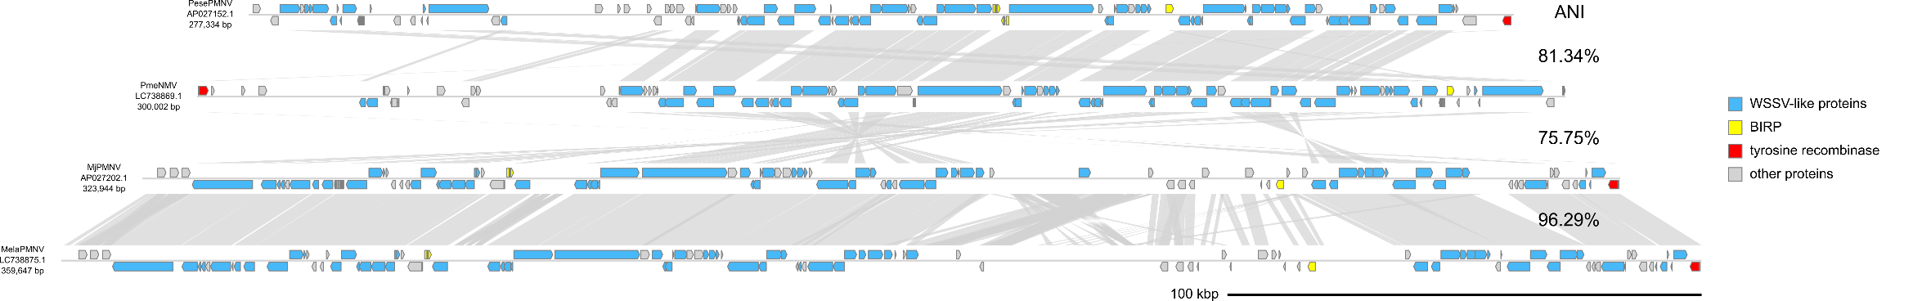

**Figure S2.** Genome diagrams of closely related penaeid endogenous nimavirus MAGs (2).

Arrows indicate predicted genes and their transcriptional orientations. Gray ribbons indicate pairwise BLASTN hits (*e*-value :1−e20, bitscore: 1000, identity: 70%). See Table S1 for the abbreviations of the virus names.

**Table S4.** ANI matrix for closely related sesarmid endogenous nimavirus MAGs.

|  |  |  |
| --- | --- | --- |
| **ANI** | **SiNMV** | **CdNMV** |
| **SiNMV** | 100% | 95.11% |
| **CdNMV** | 95.11% | 100% |

See Table S1 for the abbreviations of the virus names.



**Figure S3.** Genome diagrams of closely related sesarmid endogenous nimavirus MAGs.

Arrows indicate predicted genes and their transcriptional orientations. Gray ribbons indicate pairwise BLASTN hits (*e*-value :1−e20, bitscore: 1000, identity: 70%). See Table S1 for the abbreviations of the virus names.