

The International Committee on Taxonomy of Viruses

Taxonomy Proposal Form, 2025

**Part 1a: Details of taxonomy proposals**

|  |  |
| --- | --- |
| **Title:** | Create 20 new species in the genera *Aviadenovirus*, *Mastadenovirus* and *Siadenovirus* (*Rowavirales*: *Adenoviridae*) |
| **Code assigned:** | *2025.004D.v3.Adenoviridae_20ns* |

|  |  |  |  |  |
| --- | --- | --- | --- | --- |
| **Author(s), affiliation and email address(es):** | | | | |
| **Given name (+middle initial(s))** | **Surname** | **Affiliation** | **Email address** | **Corr. author(s)** |
| Balázs | Harrach | HUN-REN Veterinary Medical Research Institute, Budapest, Hungary | [harrach.balazs@vmri.hun-ren.hu](mailto:harrach.balazs@vmri.hun-ren.hu) | X |
| Mária | Benkő | HUN-REN Veterinary Medical Research Institute, Budapest, Hungary | [maribenko@gmail.com](mailto:maribenko@gmail.com) |  |
| Győző L. | Kaján | HUN-REN Veterinary Medical Research Institute, Budapest, Hungary | kajan.gyozo@vmri.hun-ren.hu |  |
| Thomas S. | Postler | Vaccine Design and Development Lab, IAVI, Jersey City, NJ, USA | [TPostler@iavi.org](mailto:TPostler@iavi.org) |  |
| Arvind | Varsani | The Biodesign Center for Fundamental and Applied Microbiomics, Arizona State University, Tempe, Arizona, USA | arvind.varsani@asu.edu |  |
| Márton Z. | Vidovszky | HUN-REN Veterinary Medical Research Institute, Budapest, Hungary | vidovszky.marton@vmri.hun-ren.hu |  |
|  |  |  |  |  |
|  |  |  |  |  |

**Part 1b: Taxonomy Proposal Submission**

|  |  |  |  |
| --- | --- | --- | --- |
| **ICTV Subcommittee:** | | | |
| Animal DNA Viruses and Retroviruses | **X** | Bacterial viruses |  |
| Animal minus-strand and dsRNA viruses |  | Fungal and protist viruses |  |
| Animal positive-strand RNA viruses |  | Plant viruses |  |
| Archaeal viruses |  | General - |  |

|  |
| --- |
| **List the ICTV Study Group(s) that have seen or have been involved in creating this proposal:** |
| Adenoviridae SG |

|  |  |  |  |
| --- | --- | --- | --- |
| **Optional – complete only if formally voted on by an ICTV Study Group:** | | | |
| **Study Group** | **Number of members** | | |
| **Votes in support** | **Votes against** | **No vote** |
|  |  |  |  |
|  |  |  |  |

|  |  |
| --- | --- |
| **Submission date:** | 09/06/2025 |

**Part 1c: Feedback from ICTV Executive Committee (EC) meeting**

|  |  |
| --- | --- |
| **Executive Committee Meeting Decision code:** | **X** |
| A – Accept |  |
| Ac – Accept subject to revision by relevant subcommittee chair. No further vote required | **X** |
| U – Accept without revision but with re-evaluation and email vote by the EC |  |
| Uc – Accept subject to revision and re-evaluation and email vote by the EC |  |
| Ud – Deferred to the next EC meeting, with an invitation to revise based on EC comments |  |
| J - Reject |  |
| W - Withdrawn |  |

|  |
| --- |
| **Comments from the Executive Committee:** |
| Minor typing errors |

**Part 1d: Revised Taxonomy Proposal Submission**

|  |
| --- |
| **Response of proposer:** |
| The minor typing errors have been corrected. |

|  |  |
| --- | --- |
| **Revision date:** | 31/08/2025 |

**Part 3:** **TAXONOMIC PROPOSAL**

<https://ictv.global/taxonomy/templates>

|  |  |  |  |
| --- | --- | --- | --- |
| **Taxonomic changes proposed:** | | | |
| Establish new taxon | **X** | Split taxon |  |
| Abolish taxon |  | Merge taxon |  |
| Move taxon |  | Promote taxon |  |
| Rename taxon | **X** | Demote taxon |  |
| Move and rename |  |

|  |  |
| --- | --- |
| **Etymology (origin) of proposed taxonomic names:** | |
| **Taxon name** | **Etymology of the term** |
| “*Aviadenovirus cinerei*” | from the Latin *cinereum*, meaning “ash-coloured” (referring to Timneh grey parrot) |
| “*Mastadenovirus aethiopiense*” | from the Latin *Aethiopia*, referring to the Ethiopian Highlands where the gelada is restricted at present |
| “*Mastadenovirus arundinis*” | from the Latin *arundo*, meaning “bamboo” (referring to greater bamboo bat) |
| “*Mastadenovirus asiense*” | from the Latin *Asia*, meaning “Asia”, referring to the name of the continent in the English name of the host: Asian parti-colored bat (*Vespertilio sinensis*), minor typing mistake correction (unnecessary duplication of an “s”) |
| “*Mastadenovirus bestiae*” | from the Latin *bestia*, referring to the genus *Theropichecus*, a name derived from the Greek root words for "beast-ape" (θηρο-πίθηκος: thēro-píthēkos) |
| “*Mastadenovirus eliomysis*” | from the genus name of *Eliomys* (referring to *Eliomys quercinus*, garden dormouse) |
| “*Mastadenovirus eothenomysis*” | from the genus name of *Eothenomys* (referring to *Eothenomys cachinus*, Cricetidae; Kachin red-backed vole) |
| “*Mastadenovirus ferrumequini*” | from the species epithet of *Rhinolophus ferrumequinum* (referring to the largest of the horseshoe bats in Europe) |
| “*Mastadenovirus geladae*” | from the species epithet of *Theropithecus gelada* |
| “*Mastadenovirus hylobatidae*” | from the family name Hylobatidae (gibbons) |
| “*Mastadenovirus himalaiense*” | from the Sanskrit *Himalaya*, meaning “house of cold” (referring to the Himalayas Mountain range in Asia, and the English name of the Himalayan whiskered bat) |
| “*Mastadenovirus kuhlii*” | from the species epithet of *Pipistrellus kuhlii* (referring to Heinrich Kuhl German naturalist regarded as the authority) |
| “*Mastadenovirus noctulae*” | from the species epithet of *Nyctalus noctula* (noctula means “little night creature”, a diminutive form of noctua, which is “creature / beast of the night”) |
| “*Mastadenovirus pollicis*” | from the Latin *pollex*, meaning "thumb" referring to the host “colobus”, which name comes from the Greek κολοβός (kolobós, “docked”, “maimed”) and refers to the stump-like thumb |
| “*Mastadenovirus mastomysis*” | from the genus name of *Mastomys* (referring to *Mastomys natalensis*, natal multimammate mouse) |
| “*Mastadenovirus portugalense* | from the name of the country Portugal where it was described (however, the greater mouse-eared bat *Myotis myotis* can be found throughout Europe) |
| “*Mastadenovirus rattasiense*” | from the combined Latin words referring to *rattus Asiaticus* (Asian rat) |
| “*Mastadenovirus rhinolophidae*” | from the family name of the host: Rhinolophidae (*Rhinolophus sinicus*); minor typing mistake correction (missing “h” from “*rhinolophidae”)* |
| “*Mastadenovirus sanguineicordis*” | from the Latin *sanguineus* and *cor*, meaning “bleeding” and “heart” (combined), referring to the English name “bleeding-heart monkey” |
| “*Siadenovirus columbae*” | from the Latin *columba*, meaning “pigeon” (pigeon AdV-4) |
| “*Siadenovirus coturnicis*” | from the Latin *coturnix*, meaning “quail” |
| “*Siadenovirus sulawense*” | from the name *Sulawesi*, an island in Indonesia, referring to the first recognized host of this virus: Sulawesi tortoise |

|  |  |  |
| --- | --- | --- |
| **Permission for use of names derived from a living person:** | | |
| **Taxon name** | **Full name of person from whom the name is derived** | **Attached** |
|  |  |  |

|  |
| --- |
| **Abstract of Taxonomy Proposal:** |
| *Taxonomic rank(s) affected*:  Species  *Description of current taxonomy*:  125 species in 6 genera in the family *Adenoviridae*.  *Proposed* *taxonomic change(s):*  Adding 20 new species; 16 to genus *Mastadenovirus*, 3 to *Siadenovirus*, 1 to *Aviadenovirus;* correcting two minor typing errors in the names of two mastadenovirus species.  *Justification*:  Novel adenovirus sequences have been submitted to GenBank, reflecting very rich diversity (https://sites.google.com/site/adenoseq). From these sequences, 20 full or almost full (coding-complete) vertebrate adenovirus genomes originating from 13 mammalian, 3 avian and 1 turtle species merit the establishment of new species for them. The phylogenetic distance of their DNA polymerase amino acid sequences shows adequate evolutionary distance to members of accepted adenovirus species (Fig. 1). A divergence in pairwise amino acid identity of the DNA polymerase sequence exceeding 15% is the main demarcation criterion. In case of 14-15% pairwise identity divergence, other criteria (e.g. different host species, genome organization or whole-genome GC% difference) and the monophyletic clustering of the available pol sequences helped to classify the adenoviruses into species. |

|  |
| --- |
| * **Text of Taxonomy proposal:** |
| *Taxonomic rank(s) affected*:  Species.  *Description of current taxonomy*:  Six genera and 125 species in the family *Adenoviridae*:  genus *Mastadenovirus*: 63 species,  genus *Aviadenovirus*: 28 species,  genus *Barthadenovirus*: 21 species,  genus *Siadenovirus*: 11 species,  genus *Ichtadenovirus*: 1 species,  genus *Testadenovirus*: 1 species  (<https://sites.google.com/site/adenoseq>).  *Proposed* *taxonomic change(s)*:  Establish 20 new species (total species number in the family: 145):  genus *Mastadenovirus*: 16 new species (6 viruses from primates, 4 from rodents, 6 from bats; total virus species: 79),  genus *Aviadenovirus*: 1 new species (for a psittacine adenovirus; total 29),  genus *Siadenovirus*: 3 new species (2 viruses from birds, 1 from a turtle; total 24).  *Demarcation criteria:*  In the family *Adenoviridae*, species demarcation depends on at least two of the following characteristics (Benkő et al., 2022):  Phylogenetic distance (>10–15%, based on maximum likelihood analysis of the DNA polymerase amino acid sequences),  genome organization (characteristically in the right terminal region),  host range,  nucleotide composition,  cross-neutralization,  pathogenicity.  *Justification*:  In recent years, several new adenovirid genomes have been sequenced completely or almost completely from mammals: including 6 viruses from primates, 4 from rodents, 6 from bats (Buigues et al., 2024a, 2024b; Moonga et al., 2024; Piewbang et al., 2024; Speranskaya et al. 2024; Wang et al., 2024). Similarly, adenovirus (AdV) genomes have been described from birds, and these AdVs belong either to the genus *Aviadenovirus* like the Timneh grey parrot adenovirus (Das et al., 2024) or to the genus *Siadenovirus*: pigeon adenovirus 4 and quail adenovirus 1 (Lukaszuk et al., 2025). A turtle AdV (from farmed and diseased Chinese soft-shelled turtles) proved to belong to siadenoviruses, too (Tian et al., 2025). This virus seems to be equivalent with the so-called Sulawesi tortoise adenovirus detected earlier by a general PCR in different turtle species (Rivera et al., 2009; Schumacher et al., 2012; Vincent et al. 2023; Ready et al., 2025a, 2025b). (Only partial polymerase sequences were detected from these previous turtle siadenoviruses and they have identical or very similar polymerase aa sequences.)  Twenty of these AdVs merit the establishment of new species for them: 16 mastadenoviruses, 3 siadenoviruses and 1 aviadenovirus.  In the case of the present species candidates, almost all exemplar strains of the proposed novel species shared DNA polymerase (amino acid) sequence identity with the closest related reference strain below 85%. In case of 14-15% difference, other criteria (e.g. different host species, genome organization or whole-genome GC% difference) and the monophyletic clustering of the available DNA polymerase sequences helped to classify the adenoviruses into species.  The ICTV requires the application of a binomial species naming system. For adenovirid species, we use Latinized species epithets derived by applying various approaches (Postler et al., 2022). |

|  |
| --- |
| **References:** |
| Benkő M, Aoki K, Arnberg N, Davison AJ, Echavarría M, Hess M, Jones MS, Kaján GL, Kajon AE, Mittal SK, Podgorski II, San Martín C, Wadell G, Watanabe H, Harrach B (2022) ICTV Virus Taxonomy Profile: *Adenoviridae* 2022. J Gen Virol 103: 001721, PMID: 35262477, doi: 10.1099/jgv.0.001721  Buigues J, Viñals A, Martínez-Recio R, Monrós JS, Sanjuán R, Cuevas JM (2024a) Complete genomes of DNA viruses in fecal samples from small terrestrial mammals in Spain. Viruses 16: 1885. PMID: 39772193, doi: 10.3390/v16121885.  Buigues J, Viñals A, Martínez-Recio R, Monrós JS, Sanjuán R, Cuevas JM (2024b) Full-genome sequencing of dozens of new DNA viruses found in Spanish bat feces. Microbiol Spectr 11: e0067524. PMID: 38990026, doi: 10.1128/spectrum.00675-24.  Das T, Nath BK, Hume S, Gowland DJ, Crawley LS, Forwood JK, Raidal SR, Das S (2024) Novel pathogenic adenovirus in Timneh grey parrot (*Psittacus timneh*) unveils distinct lineage within *Aviadenovirus*. Virology 598: 110173. PMID: 39018684, doi: 10.1016/j.virol.2024.110173.  Łukaszuk E, Dziewulska D, Pratnicka A, Custer JM, Kraberger S, Varsani A, Stenzel T (2025) Characterization, phylogeny and prevalence of the coding-complete genomes of aviadenoviruses and siadenovirus in young racing pigeons. Virology 603: 110400. PMID: 39799612, doi: 10.1016/j.virol.2025.110400.  Moonga LC, Chipinga J, Collins JP, Kapoor V, Saasa N, Nalubamba KS, Hang'ombe BM, Namangala B, Lundu T, Lu XJ, Yingst S, Wickiser JK, Briese T (2024) Application of a sensitive capture sequencing approach to reservoir surveillance detects novel viruses in Zambian wild rodents. Viruses 16: 1754. PMID: 39599868, doi: 10.3390/v16111754.  Piewbang C, Wardhani SW, Poonsin P, Lohavicharn P, Tengtawon R, Charoenrat T, Lacharoje S, Kesdangsakonwut S, Kasantikul T, Kosoltanapiwat N, Techangamsuwan S (2024) Novel mastadenovirus infection as cause of pneumonia in imported black-and-white colobuses (*Colobus guereza*), Thailand. Emerg Infect Dis 30: 2544-2558. PMID: 39592267, doi: 10.3201/eid3012.241042.  Postler TS, Rubino L, Adriaenssens EM, Dutilh BE, Harrach B, Junglen S, Kropinski AM, Krupovic M, Wada J, Crane A, Kuhn JH, Mushegian A, Rumnieks J, Sabanadzovic S, Simmonds P, Varsani A, Zerbini M, Callanan J, Draper LA, Hill C, Stockdale RR (2022) Guidance for creating individual and batch latinized binomial virus species names. J Gen Virol 103: 001800, PMID: 36748479,[doi: 10.1099/jgv.0.001800](https://doi.org/10.1099/jgv.0.001800)  Ready ZC, Adamovicz L, Daleo M, Simmons A, Glowacki G, Graser W, Anchor C, Thompson D, Allender MC (2025a) [Epidemiology of Sulawesi tortoise adenovirus in free-living Blanding's turtles (*Emydoidea* *blandingii*), painted turtles (*Chrysemys picta*), and red-eared sliders (*Trachemys scripta elegans*) in Illinois, USA.](https://pubmed.ncbi.nlm.nih.gov/40048565/) J Wildl Dis. 61: 408-418. PMID: 40048565, doi: 10.7589/JWD-D-24-00124.  Ready ZC, Adamovicz L, Wellehan JFX, Daleo M, Simmons A, Glowacki G, Graser W, Anchor C, Thompson D, Allender MC (2005b) Detection of adenoviruses in free-ranging Blanding's turtles (*Emydoidea* *blandingii*), painted turtles (*Chrysemys* *picta*), and red-eared sliders (*Trachemys* *scripta* *elegans*) in Illinois, USA. J Wildl Dis 61: 370-381. PMID: 40040353, doi: 10.7589/JWD-D-24-00087.  Rivera S, Wellehan JF, McManamon R, Innis CJ, Garner MM, Raphael BL, Gregory CR, Latimer KS, Rodriguez CE, Diaz-Figueroa O, Marlar AB, Nyaoke A, Gates AE, Gilbert K, Childress AL, Risatti GR, Frasca S (2009) Systemic adenovirus infection in Sulawesi tortoises (*Indotestudo forsteni*) caused by a novel siadenovirus. J Vet Diagn Invest 21: 415-426. PMID 19564489, doi: 10.1177/104063870902100402.  Schumacher VL, Innis CJ, Garner MM, Risatti GR, Nordhausen RW, Gilbert-Marcheterre K, Wellehan JF, Childress AL, Frasca S (2012) Sulawesi tortoise adenovirus-1 in two impressed tortoises (*Manouria impressa*) and a Burmese star tortoise (*Geochelone platynota*). J Zoo Wildl Med 43: 501-10. PMID 23082513, doi: 10.1638/2011-0228R.1.  Speranskaya AS, Dorokhin AV, Korneenko EV, Chudinov IK, Samoilov AE, Kruskop SV (2024) [A novel mastadenovirus from *Nyctalus noctula* which represents a distinct evolutionary branch of viruses from bats in Europe.](https://pubmed.ncbi.nlm.nih.gov/39205181/) Viruses 16: 1207. PMID: 39205181, doi: 10.3390/v16081207.  Tian F, Wang H, Zhang Z, Jin L, Zhan Z (2025) Establishment of a continuous kidney cell line and its application in molecular characterization of a novel adenovirus from Chinese soft-shelled turtle*, Pelodiscus sinensis.* Aquaculture 606: 742574. doi: 10.1016/j.aquaculture.2025.742574.  Vincent EC, Fayette MA, Griffioen JA, Litwiler G, Adamovicz L, Ospina E, Allender MC (2023) Health assessment of painted turtles (*Chrysemys picta*) in a restored wetland habitat in Northwestern Indiana, USA. J Wildl Dis 59: 245-58. PMID: 37099728, doi: 10.7589/JWD-D-22-00088.  Wang Y, Xu P, Han Y, Zhao W, Zhao L, Li R, Zhang J, Zhang S, Lu J, Daszak P, Jin Q, Wu Z (2024) Unveiling bat-borne viruses: a comprehensive classification and analysis of virome evolution. Microbiome 12: 235. PMID: 39543683, doi: 10.1186/s40168-024-01955-1. |

|  |  |
| --- | --- |
| **Accompanying files:** | |
| **Filename** | **Description of contents** |
| 2025.004D.v3.Adenoviridae_20ns.xlsx | Accompanying Excel sheet |
|  |  |

|  |
| --- |
| **Tables, Figures:** |

<Start here>

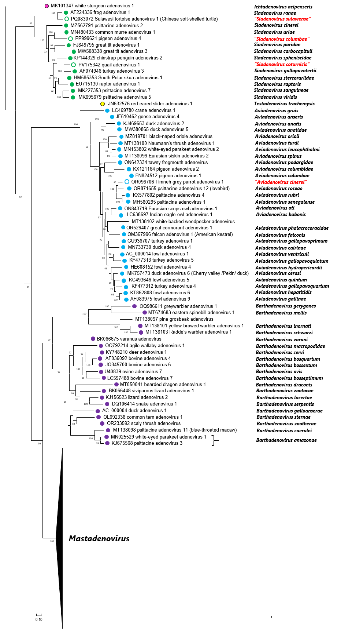

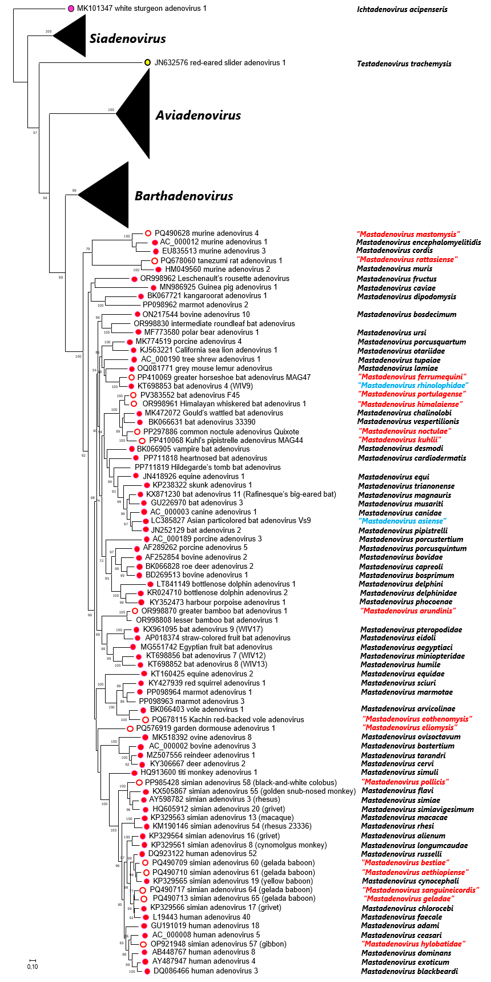

**Fig. 1. Phylogenetic tree of representative members of accepted and proposed adenovirid species based on complete DNA-dependent DNA polymerase amino acid sequences.** Official species are designated by colored dots, proposed species are signed by colored circles and emphasized in red letters. Viruses with no complete genome (but complete polymerase gene) are shown without dots or circle signs. The two species names in blue are those with proposed minor typo corrections in their species names. Multiple alignment: MultAlin; manual edition: BioEdit 7.2.5 (the length of the edited alignment was 1023 amino acids), model selection: ProtTest 2.4; maximum likelihood calculation: PhyML 3.1 with model LG+I+G and branch support Shimodaira-Hasegawa (SH) on the Galaxy/Pasteur platform. Unrooted calculation; the phylogenetic tree was visualized using MEGA11, white sturgeon adenovirus 1 was selected as outgroup for visualization. The bar indicates 10% difference between two neighboring sequences. SH branch support values above 50 are shown at the nodes. Viruses are represented by GenBank accession number, virus name (with type or strain designation), and species name if available or proposed (in quotation marks if proposed herein).