

The International Committee on Taxonomy of Viruses

Taxonomy Proposal Form, 2025

**Part 1a: Details of taxonomy proposals**

|  |  |
| --- | --- |
| **Title:** | Reclassification of *Orthoflavivirus encephalitidis* and *O. loupingi* (*Flaviviridae: Orthoflavivirus*) |
| **Code assigned:** | 2025.007S.N.v1.Orthoflavivirus_encephalitidis_3reorgsp | |

|  |  |  |  |  |
| --- | --- | --- | --- | --- |
| **Author(s), affiliation and email address(es):** | | | | |
| **Surname** | **Initials** | **Affiliation** | **Email address** | **Corr. author(s)** |
| Bondaryuk | AN | Irkutsk Antiplague Research Institute of Siberia and the Far East, Irkutsk, Russia | ui.artem.ui@gmail.com | X |
| Andaev | EI | Irkutsk Antiplague Research Institute of Siberia and the Far East, Irkutsk, Russia | e.andaev@gmail.com |  |
| Dzhioev | YP | Irkutsk State Medical University, Irkutsk, Russia | alanir07@mail.ru |  |
| Zlobin | VI | Irkutsk State Medical University, Irkutsk, Russia | vizlobin@mail.ru |  |
| Tkachev | SE | Institute of Chemical Biology and Fundamental Medicine, Siberian Branch of the Russian Academy of Sciences, Novosibirsk, Russia | tkachev@niboch.nsc.ru |  |
| Kozlova | IV | Scientific Centre for Family Health and Human Reproduction Problems, Irkutsk, Russia | diwerhoz@rambler.ru |  |
| Pestov | NB | Chumakov Institute of Poliomyelitis and Viral Encephalitis, Moscow, Russia | pestov_nb@chumakovs.su |  |
| Bukin | YS | Limnological Institute, Siberian Branch of the Russian Academy of Sciences, Irkutsk, Russia | bukinyura@mail.ru |  |

**Part 1b: Taxonomy Proposal Submission**

|  |  |  |  |
| --- | --- | --- | --- |
| **ICTV Subcommittee:** | | | |
| Animal DNA Viruses and Retroviruses |  | Bacterial viruses |  |
| Animal minus-strand and dsRNA viruses |  | Fungal and protist viruses |  |
| Animal positive-strand RNA viruses | **X** | Plant viruses |  |
| Archaeal viruses |  | General - |  |

|  |
| --- |
| **List the ICTV Study Group(s) that have seen or have been involved in creating this proposal:** |
|  |

|  |  |  |  |
| --- | --- | --- | --- |
| **Optional – complete only if formally voted on by an ICTV Study Group:** | | | |
| **Study Group** | **Number of members** | | |
| **Votes in support** | **Votes against** | **No vote** |
|  |  |  |  |
|  |  |  |  |

|  |  |
| --- | --- |
| **Submission date:** | 04/02/2025 |

**Part 1c: Feedback from ICTV Executive Committee (EC) meeting**

|  |  |
| --- | --- |
| **Executive Committee Meeting Decision code:** | **X** |
| A – Accept |  |
| Ac – Accept subject to revision by relevant subcommittee chair. No further vote required |  |
| U – Accept without revision but with re-evaluation and email vote by the EC |  |
| Uc – Accept subject to revision and re-evaluation and email vote by the EC |  |
| Ud – Deferred to the next EC meeting, with an invitation to revise based on EC comments |  |
| J - Reject |  |
| W - Withdrawn |  |

|  |
| --- |
| **Comments from the Executive Committee:** |
|  |

**Part 1d: Revised Taxonomy Proposal Submission**

|  |
| --- |
| **Response of proposer:** |
|  |

|  |  |
| --- | --- |
| **Revision date:** |  |

**Part 3:** **TAXONOMIC PROPOSAL**

<https://ictv.global/taxonomy/templates>

|  |  |  |  |
| --- | --- | --- | --- |
| **Taxonomic changes proposed:** | | | |
| Establish new taxon | **X** | Split taxon | **X** |
| Abolish taxon |  | Merge taxon |  |
| Move taxon |  | Promote taxon |  |
| Rename taxon |  | Demote taxon |  |
| Move and rename |  |

|  |  |
| --- | --- |
| **Etymology (origin) of proposed taxonomic names:** | |
| **Taxon name** | **Etymology of the term** |
| *Orthoflavivirus neudoerflense* | After Neudörfl — a town in Austria where virus was isolated |
| *Orthoflavivirus zilber* | After Lev A. Zilber — discovery of TBEV in 1937 |
| *Orthoflavivirus* *mediterraneanense* | After theMediterranean where GGEV and TSEV were isolated |
|  |  |

|  |  |  |
| --- | --- | --- |
| **Permission for use of names derived from a living person:** | | |
| **Taxon name** | **Full name of person from whom the name is derived** | **Attached** |
|  |  |  |
|  |  |  |
|  |  |  |
|  |  |  |

|  |
| --- |
| **Abstract of Taxonomy Proposal:** |
| *Taxonomic rank(s) affected*: *Orthoflavivirus* *encephalitidis*  *Description of current taxonomy*: Currently, the species *Orthoflavivirus encephalitidis* constitutes a paraphyletic group including at least four subtypes of tick-borne encephalitis virus (TBEV) and excluding louping-ill virus (LIV). Besides, there are four unclassified isolates which are phylogenetically close to LIV: Spanish sheep encephalitis virus (SSEV), Spanish goat encephalitis virus (SGEV), Turkish sheep encephalitis virus (TSEV) and Greek goat encephalitis virus (GGEV).  *Proposed* *taxonomic change(s):* To resolve the paraphyletic issue, we propose to split *Orthoflavivirus encephalitidis* into two species: *Orthoflavivirus zilber* and *Orthoflavivirus neudoerflense.* According to our proposal, the demarcation threshold runs between the European subtype of TBEV (TBEV-EU)(*Orthoflavivirus neudoerflense*) and the other TBEV subtypes (*Orthoflavivirus zilber*). Considering unclassified LIV-like isolates, we propose to fuse LIV, SSEV, SGEV in a single species, and TSEV together with GGEV should also be assigned as the separate species *Orthoflavivirus* *mediterranense* to keep monophyly within the clade of TBEV+LIV+TSEV+GGEV.  *Justification*: Ee provided species delimitation analysis (278 complete open reading frame (ORF) amino acid sequences) and compared evolutionary protein distances of the surface antigenic determinants of the TBEV and LIV E gene (812 sequences) *in silico*. The results of both analyses show that TBEV-EU is significantly different from the other TBEV subtypes and LIV.  Our conclusion is also supported by the other species demarcation criteria for the genus *Orthoflavivirus*: disease associations (as well as tissue tropism, disease course, case fatality rate, pathogenicity for humans and animals), antigenic characteristics, geographic association, vector association and ecological characteristics. |

|  |
| --- |
| * **Text of Taxonomy proposal:** |
| *Taxonomic rank(s) affected*:  *Orthoflavivirus* *encephalitidis*  *Description of current taxonomy*:  At the moment, the species *Orthoflavivirus encephalitidis* constitutes a paraphyletic group of viruses including at least four tick-borne encephalitis virus (TBEV) subtypes: Far-Eastern (TBEV-FE), European (TBEV-EU), Siberian (TBEV-Sib), and Baikalian (TBEV-Bkl). The paraphyly results from the exclusion of louping-ill virus (LIV) clade from the common TBEV+LIV+LIV-like clade and considering LIV as a member of a separate species. *Orthoflavivirus loupingi* (Fig. 1). Besides, there are four unclassified isolates which are phylogenetically close to LIV (LIV-like): Spanish sheep encephalitis virus (SSEV), Spanish goat encephalitis virus (SGEV), Turkish sheep encephalitis virus (TSEV) and Greek goat encephalitis virus (GGEV). According to the ICTV Code, “A species is a *monophyletic* group of MGEs whose properties can be distinguished from those of other species by multiple criteria”. Besides the paraphyly issue, over several decades, a large body of data has been accumulated in the literature showing that TBEV-EU is different in its properties and phenotype from the other TBEV subtypes. Thus, the current taxonomic status of *Orthoflavivirus encephalitidis* needs to be revised.  *Proposed* *taxonomic change(s)*:  We suggest splitting *Orthoflavivirus encephalitidis* into two species: *Orthoflavivirus neudoerflense* (TBEV-E) and *Orthoflavivirus zilber* (TBEV-FE+TBEV-Bkl+TBEV-S)*.* According to our proposal, the demarcation threshold runs between the European subtype of TBEV (*Orthoflavivirus neudoerflense*) and the other TBEV subtypes (*Orthoflavivirus zilber*). Considering unclassified LIV-like isolates, we suggest assigning LIV, SSEV, SGEV to the existing species *Orthoflavivirus loupingi*, and TSEV together with GGEV should also be assigned as the separate species *Orthoflavivirus* *mediterraneanense* to keep monophyly within the clade of TBEV+LIV+TSEV+GGEV.  *.*  The names’ origins are listed below.   * *Orthoflavivirus neudoerflense* refers to the Neudörfl — a town in Austria, where the prototype strain “Neudoerfl” was isolated. The genome of Neudoerfl is also the first complete TBEV genome sequenced [19]; * *Orthoflavivirus zilber* refers to Lev A. Zilber — the leader of the Soviet Far East expedition, which resulted in the discovery of TBEV in 1937 [29]; * *Orthoflavivirus* *mediterraneanense* refers to the Mediterranean as the GGEV and TSEV isolation territory.   *Demarcation criteria:*  We considered the demarcation criteria established by the Flaviviridae Study Group (<https://ictv.global/report/chapter/flaviviridae/flaviviridae/orthoflavivirus>):   * Nucleotide and deduced amino acid (aa) sequence data; * Antigenic characteristics; * Disease association; * Geographic association; * Vector and host association; * Ecological characteristics.   *Justification*:   1. Analysis of nucleotide and deduced amino acid sequence data   To delimit species within the tick-borne flavivirus group [2], we employed three bioinformatic delimitation methods: GMYC, [10], ABGD [22], and PTP [28] (Fig. 2a). The data set structure is represented in Table 1. As part of our proposal, hereafter, we will consider only the TBEV+LIV clade (Fig. 2b). For species delimitation within this clade, we used 211 complete amino acid sequences of a polyprotein of TBEV, LIV, and LIV-like viruses. Despite discordance in the number of species within the TBEV+LIV clade (Fig. 2b), all three methods reject the hypothesis that the TBEV+LIV clade represents a single species, thereby distinguishing TBEV-EU from the other TBEV subtypes.  We relied on the results of ABGD (Fig. 2b) as more parsimony and consistent with published data on the other species demarcation criteria (see the next sections). ABGD merged TBEV-FE+TBEV-B+TBEV-S into a single species unit but separated Himalayan isolates of TBEV into a separate species. In the publications available, there is no additional reliable data on virus properties (e.g., vector and host association, tissue tropism, etc.) to separate TBEV-S from TBEV-FE, or split TBEV-S into multiple species or to delineate the Himalayan TBEV clade. Considering the TBEV-E and LIV+LIV-like clades, ABGD delimited those clades into three species.  Our results contradict the previous proposals to consider TBEV and LIV as one species [4, 13]. The weak point of both studies is that the authors, at that time, had a small number of TBEV and LIV samples (4 ORF sequences for TBEV and 4 ORFs for LIV in Grard, et al. [13]; 4 ORFs for TBEV and 9 E gene aa sequences for LIV in Charrel, et al. [4]).  Recently, Deviatkin, et al. [8] have offered a dN/dS (non-synonymous substitutions per nonsynonymous site/synonymous substitutions per synonymous site) threshold as a species criterion. The authors claimed that according to the criterion, TBEV (including all subtypes) and Omsk hemorrhagic fever virus (OHFV) belonging to the species *Orthoflavivirus omskense* should be considered as a single species. We provide the next counterarguments against this proposal:   * The major issue that should be addressed is the fact that the authors did not test their data on nucleotide substitution saturation, which drastically biases the calculation of the number of synonymous substitutions per synonymous site (dS) especially in the case of the third codon position, leading to dN/dS miscalculation. If the saturation of the third codon position is presented between a pair of taxa, then dS stops to increase, meanwhile, dN continues to grow, resulting in the rise of dN/dS itself (false positive evidence for positive selection). Therefore, in the presence of saturation, the more evolutionary distant taxa will have higher values of dN/dS than those observed in the study of Deviatkin, et al. [8]. For example, dN/dS for the pair of TBEV and OHFV is lower, than for TBEV and Langat virus (Figure 2 in Deviatkin, et al. [8]). * Now dozens of papers demonstrate examples of natural selection affecting synonymous substitutions due to codon usage bias (10.1016/j.ympev.2015.08.026), secondary RNA structure (10.1016/j.ympev.2015.08.026), translational efficiency (10.1093/molbev/msq077), etc. These factors lead to synonymous substitution rate variation (SRV). The authors used the simple Nei-Gojobori method and PAML software, which do not take into account SRV across sites, which could bias dN/dS ration evaluation. It was shown [27] that even moderate levels of SRV produce very high *false positive rates*; * The proposal of Deviatkin, et al. [8] ignores remarkable differences between TBEV and OHFV on the other demarcation species criteria. In particular, two different vectors (*Ixodes* spp. for TBEV and *Dermacentor* spp. for OHFV) occupy two different ecological niches (or follow two different evolutionary trajectories), which decreases interspecies competition and triggers the speciation process. This leads to viruses differing in clinical manifestation, virulence for humans, tissue tropism, and ecological characteristics. Thus, merging TBEV and OHFV based on the dN/dS ratio only is at least a one-sided approach.  1. Antigenic characteristics    1. Comparing evolutionary distances of E protein surface regions of TBEV and LIV *in silico*   In GenBank, we found 812 E protein aa sequences of TBEV (TBEV-FE, -E, -S, -B) and LIV and extracted surface regions determined by Rey, et al. [23]. The alignment obtained was used for the subsequent phylogenetic reconstruction in IQTREE (maximum likelihood inference) with 1000 ultrafast bootstrap replicates (for technical details see our publication [2]). The analysis revealed that LIV statistically differed from all TBEV subtypes (Fig. 3a, h, i, j). TBEV-E was significantly distinguished from the other TBEV subtypes (Fig. 3c, g) with the exception of the Siberian subtype of TBEV (TBEV-S) — the case where the slightly credible interval overlap is observed, Fig. 3e.  Amino acid rate matrices for phylogenetic reconstruction were derived from pair‐wise substitution frequencies of amino acid residues, different structural environments of residues, and, among other things, physico‐chemical properties of residues. Thus, the revealed differences in evolutionary distances between surface amino acids of the E protein can be interpreted as differences in physicochemical properties defining tissue tropism and antigenic characteristics. Our calculations coincide with literature data on antigenic similarities of TBEV and LIV [16] (see Section 2.2) and the other species demarcation criteria.  We will further consider the literature data only.   * 1. Antigenic relationships of TBEV-FE, TBEV-E, LIV, and LIV-like   Two geographic and antigenic variants of TBEV (Eastern and Western) have been known for 40 years [21]. First analyses of virus antigenic properties revealed two antigen subtypes: Eastern and Western [7] or ‘Persulcatus’ and ‘Ricinus’ antigen variants according to viral ecology [6].  Hubálek, et al. [16] applied indirect immunofluorescence tests and demonstrated a clear difference between isolates of TBEV-E and TBEV-FE (72% overall similarity in antigenic relationships). On the UPGMA tree, TBEV-E and LIV isolates formed a common clade with similarity ranging between 84.0% (TBEV-E to TSEV) and 96.6% (TBEV-E to SSEV); TBEV-FE (prototype strain Sofjin) played a role of an outgroup for the TBEV-E+LIV+LIV-like clade.   1. Disease association    1. Neuroinvasiveness and neurotropism of TBEV-FE and TBEV-E   In a number of studies, sheep received virus solution containing TBEV-FE and TBEV-E subcutaneously and by intracerebral infection (15 and 24 sheep for TBEV-FE and -E experiments on intracerebral infection, respectively) [26]. It was shown that subcutaneous infection of sheep with TBEV-E as well as infection via ticks did not yield transition of BBB but induced only meningitis. In the case of intracerebral infectious, TBEV-E showed a clear biphasic course with neurological symptoms (anisocoria, ptosis, myelitic paresis, tonic-clonic spasm) and a mortality rate of only 12,5%. The viral titer in the different parts of the brain (cortex, cerebellum, medulla, cervical, lumbar) during the first phase (fever phase) ranged from 1.2–2.8 lgLD50 (mean = 2.0) (Table 1). In the blood, virus titer averaged 2.5 lgLD50 and was higher than in the CNS. The morphological studies of the CNS showed glial nodes took 8.5–21.5% of microscope fields of view (FOV; mean – 14,6%). Neuronophagia took only 5.6–10.0% of FOV (mean – 7.4%). Damage to the neurons occurs only in some animals as a secondary inflammatory effect arising from infection of glial cells. In contrast, the intracerebral infection of sheep with TBEV-FE (the strain “198”) demonstrated a mortality rate of 100%. The course of the disease was monophasic and severe and developed rapidly. Already on days 2–3, sheep rapidly developed signs of focal brain damage and fever. The viral titer in the CNS was on average 1.3 lgLD50 higher (1.2–1.8 lgLD50) than in the blood (for details, see Table 1). Primary degenerative CNS disorders prevailed. Neuronophagia took 32.5–42.5% of FOV (mean – 37.5%). Glial nodes ranged widely from 34.0–99.0% of FOV (mean – 56.1%). Results of those studies provide strong evidence of differences between neurotropism of TBEV-E and -FE at least in sheep infection.  Votiakov, et al. [25] (see also Gritsun, et al. [14]) in the experiments with monkeys and sheep also demonstrated that the European virus (TBEV-E) initially did not replicate in or damage neuronal cells even after intracerebral infection. Instead, the primary target of the European virus was lymphoid tissue and the virus subsequently appeared in the brains, 6–9 days after inoculation (in the cerebellum predominantly) of those animals that developed encephalitis. In turn, the Far-Eastern virus (TBEV-FE) directly infected and damaged neurons in the brain, resulting in severe encephalitis. These facts indicate that TBEV-FE is more neurotropic than TBEV-E.   * 1. Disease course and case fatality rate   A biphasic course is observed in 74% of tick-borne encephalitis (TBE) patients infected with TBEV-E [18], but TBEV-FE and -S infections are mostly monophasic, in only a small fraction of cases demonstrating a biphasic pattern [20]. Importantly, TBEV-FE infections in most cases cause an illness with a gradual onset, more severe course, and higher rates of severe neurologic sequelae compared to TBEV-E infections [1].  Case fatality rate (CFR) for TBEV-E ranges between 1% and 2% [1, 15]. The case-fatality rate for TBEV-FE infections is approximately 20%, compared with 1–2% for the European form [9].   1. Vector association and ecological characteristics   TBEV-FE and TBEV-S are *predominantly* associated with *Ixodes persulcatus* ticks, TBEV-E — *I. rinicus*. *I. persulcatus* inhabits mainly coniferous forests of Asia and Eastern Europe, while *I. Ricinus* inhabits deciduous and mixed forests in the British Isles, in Continental Europe, and Western Asia. Thus, the spatial distribution of TBEV subtypes is determined mainly by the habitats of these tick species and reservoir hosts.  In Northern and Central Europe, the seasonal activity of *I. ricinus* often has 2 peaks, the first one in spring (May–June) and the second one at the end of summer (September-October) [5]. *I. persulcatus* tick activity is characterized by 1 peak in May-June [3]. It potentially causes the number of virus replications per year for TBEV-E to increase, as well as that for TBEV-FE and TBEV-S.  TBEV prevalence in *I. persulcatus* generally is higher compared to those in *I. ricinus* which could be caused by the ecology or biology of the individual vectors [5].  Experimental studies [24] showed that three TBEV subtypes (TBEV-FE, -E, -S) are able to induce encephalitis in bank voles (*Myodes glareolus*) but cause neuronal death in this natural host in very rare cases. However, RNA of TBEV-FE was detected significantly more often than RNA of the other two subtypes in all organs studied. Moreover, TBEV-FE also induced prolonged viremia which can be a potential maintenance factor and may suggest a different transmission pattern as compared to TBEV-E.  All of the differences described indicate that TBEV-E and TBEV-FE occupied distinct ecological niches.   1. Discrepancy between LIV and TBEV   As mentioned above, we disagree with the hypothesis on the merger of TBEV and LIV. In this section, we additionally review the remarkable differences between these viruses.  LIV induces encephalitis in sheep annually, with morbidity and mortality rates ranging from 5 to 60% [9]. The mortality rate for red grouse is even higher (78%) [7]. In contrast, TBEV seems to show nonvirulence for livestock (there are no reports of mass epizootics in Eurasia), and, apparently, persists in wild rodents asymptomatically.  The modern study of immune response to LIV and TBEV-E (subcutaneous infection) in sheep demonstrated the detection of virus-specific neutralising antibodies in both cases, but only antibodies against TBEV-E showed the control of infection, whereas LIV progressed to a febrile infection which is followed by neuroinvasion [11]. In other words, TBEV is less pathogenic for sheep than LIV.  In the case of human LIV infection, only 1 lethal case was described [16]. This is opposite to TBEV-E and the other TBEV subtypes with lethal cases reported annually.  Regarding reservoir transmission hosts, LIV once again shows a clear difference from TBEV. Unlike all TBEV subtypes, LIV is mainly found in red grouses and sheep inducing encephalitis with a high mortality rate in both (78% in red grouses [12], 5–60% in sheep [17]), but not in small rodents. Although rodents such as field voles (*Microtus agrestis*), bank voles (*M. glareolus*) and wood mice (*Apodemus sylvaticus*) raised an antibody response to infection, they could not produce a substantial viremia and did not support non-viraemic transmission between co-feeding ticks [11]. Furthermore, red grouses tend not to feed adult *I. ricinus* and are not therefore able to maintain the transmission cycle without the aid of another host that feeds adult ticks (e.g. deer, so-called “reproduction hosts” [12]). This leads to LIV’s patchy spatial distribution with different mixtures of reservoir hosts occurring. This is the opposite of the TBEV transmission patterns and natural foci structure formed by primarily small rodents. |

|  |
| --- |
| **References:** |
| 1. Bogovic P, Strle F (2015) Tick-borne encephalitis: A review of epidemiology, clinical characteristics, and management. World J Clin Cases 3:430-441 DOI:10.12998/wjcc.v3.i5.430  2. Bondaryuk AN, Andaev EI, Dzhioev YP, Zlobin VI, Tkachev SE, Kozlova IV, Bukin YS (2022) Delimitation of the tick-borne flaviviruses. Resolving the tick-borne encephalitis virus and louping-ill virus paraphyletic taxa. Mol Phylogenet Evol 169:107411 DOI:10.1016/j.ympev.2022.107411  3. Bugmyrin SV, Bespyatova LA (2023) Seasonal Activity of Adult Ticks Ixodes persulcatus (Acari, Ixodidae) in the North-West of the Distribution Area. Animals (Basel) 13 DOI:10.3390/ani13243834  4. Charrel RN, Zaki AM, Attoui H, Fakeeh M, Billoir F, Yousef AI, de Chesse R, De Micco P, Gould EA, de Lamballerie X (2001) Complete coding sequence of the Alkhurma virus, a tick-borne flavivirus causing severe hemorrhagic fever in humans in Saudi Arabia. Biochem Biophys Res Commun 287:455-461 DOI:10.1006/bbrc.2001.5610  5. Chitimia-Dobler L, Mackenstedt U, Kahl O (2022) Transmission/natural cycle. In: Dobler G, Erber W, Bröker M, Schmitt HJ (eds) The TBE Book. Global Health Press, Singapore  6. Chumakov MP, Rubin SG, Linev MB (1975) Three antigen types of tick-borne encephalitis virus, their dependence on arthropod vectors and geography. Problems of Medical Virology (Мoscow):371-375  7. Clarke DH (1964) Further studies on antigenic relationships among the viruses of the Group B tick-borne complex. Bulletin of the World Health Organization 31:45-56  8. Deviatkin AA, Aleshina YA, Karganova GG, Lukashev AN (2024) Selection Pressure Profile Suggests Species Criteria among Tick-Borne Orthoflaviviruses. Viruses 16 DOI:10.3390/v16101554  9. Dobler G, Erber W, Bröker M, Schmitt HJ (2022) TBE in adults. In: Dobler G, Erber W, Bröker M, Schmitt HJ (eds) The TBE Book. Global Health Press, Singapore  10. Fujisawa T, Barraclough TG (2013) Delimiting species using single-locus data and the Generalized Mixed Yule Coalescent approach: a revised method and evaluation on simulated data sets. Syst Biol 62:707-724 DOI:10.1093/sysbio/syt033  11. Gilbert L, Jones LD, Hudson PJ, Gould EA, Reid HW (2000) Role of small mammals in the persistence of Louping-ill virus: field survey and tick co-feeding studies. Med Vet Entomol 14:277-282 DOI:10.1046/j.1365-2915.2000.00236.x  12. Gilbert L (2016) Louping ill virus in the UK: a review of the hosts, transmission and ecological consequences of control. Exp Appl Acarol 68:363-374 DOI:10.1007/s10493-015-9952-x  13. Grard G, Moureau G, Charrel RN, Lemasson JJ, Gonzalez JP, Gallian P, Gritsun TS, Holmes EC, Gould EA, de Lamballerie X (2007) Genetic characterization of tick-borne flaviviruses: new insights into evolution, pathogenetic determinants and taxonomy. Virology 361:80-92 DOI:10.1016/j.virol.2006.09.015  14. Gritsun TS, Lashkevich VA, Gould EA (2003) Tick-borne encephalitis. Antivir Res 57:129-146 DOI:10.1016/s0166-3542(02)00206-1  15. Holzmann H, Aberle SW, Stiasny K, Werner P, Mischak A, Zainer B, Netzer M, Koppi S, Bechter E, Heinz FX (2009) Tick-borne Encephalitis from Eating Goat Cheese in a Mountain Region of Austria. Emerging Infectious Diseases 15:1671-1673 DOI:10.3201/eid1510.090743  16. Hubálek Z, Pow I, Reid HW, Hussain MH (1995) Antigenic similarity of central European encephalitis and louping-ill viruses. Acta Virologica 39:251-256  17. Jeffries CL, Mansfield KL, Phipps LP, Wakeley PR, Mearns R, Schock A, Bell S, Breed AC, Fooks AR, Johnson N (2014) Louping ill virus: an endemic tick-borne disease of Great Britain. J Gen Virol 95:1005-1014 DOI:10.1099/vir.0.062356-0  18. Kaiser R (1999) The clinical and epidemiological profile of tick-borne encephalitis in southern Germany 1994-98: a prospective study of 656 patients. Brain 122 ( Pt 11):2067-2078 DOI:10.1093/brain/122.11.2067  19. Mandl CW, Heinz FX, Stockl E, Kunz C (1989) Genome sequence of tick-borne encephalitis virus (Western subtype) and comparative analysis of nonstructural proteins with other flaviviruses. Virology 173:291-301 DOI:10.1016/0042-6822(89)90246-8  20. Mansfield KL, Johnson N, Phipps LP, Stephenson JR, Fooks AR, Solomon T (2009) Tick-borne encephalitis virus - a review of an emerging zoonosis. J Gen Virol 90:1781-1794 DOI:10.1099/vir.0.011437-0  21. O. K, Pogodina VV, Poponnikova T, Süss J, I. Zlobin VI (2022) A short history of TBE. In: Dobler G, Erber W, Bröker M, Schmitt HJ (eds) The TBE Book. Global Health Press, Singapore  22. Puillandre N, Lambert A, Brouillet S, Achaz G (2012) ABGD, Automatic Barcode Gap Discovery for primary species delimitation. Mol Ecol 21:1864-1877 DOI:10.1111/j.1365-294X.2011.05239.x  23. Rey FA, Heinz FX, Mandl C, Kunz C, Harrison SC (1995) The envelope glycoprotein from tick-borne encephalitis virus at 2 A resolution. Nature 375:291-298 DOI:10.1038/375291a0  24. Tonteri E, Kipar A, Voutilainen L, Vene S, Vaheri A, Vapalahti O, Lundkvist A (2013) The three subtypes of tick-borne encephalitis virus induce encephalitis in a natural host, the bank vole (Myodes glareolus). PLoS One 8:e81214 DOI:10.1371/journal.pone.0081214  25. Votiakov VI, Protas II, Zhdanov VM (1978) Western Tick-Borne Encephalitis. Belarus, Minsk  26. Votiakov VI, Zlobin VI, Mishaeva NP (2002) Tick-borne encephalitis of Eurasia (ecology, molecular epidemiology, nosology, evolution). Nauka, Novosibirsk  27. Wisotsky SR, Kosakovsky Pond SL, Shank SD, Muse SV (2020) Synonymous Site-to-Site Substitution Rate Variation Dramatically Inflates False Positive Rates of Selection Analyses: Ignore at Your Own Peril. Mol Biol Evol 37:2430-2439 DOI:10.1093/molbev/msaa037  28. Zhang J, Kapli P, Pavlidis P, Stamatakis A (2013) A general species delimitation method with applications to phylogenetic placements. Bioinformatics 29:2869-2876 DOI:10.1093/bioinformatics/btt499  29. Zlobin VI, Pogodina VV, Kahl O (2017) A brief history of the discovery of tick-borne encephalitis virus in the late 1930s (based on reminiscences of members of the expeditions, their colleagues, and relatives). Ticks Tick Borne Dis 8:813-820 DOI:10.1016/j.ttbdis.2017.05.001 |

|  |  |
| --- | --- |
| **Accompanying files:** | |
| **Filename** | **Description of contents** |
|  |  |
|  |  |

|  |
| --- |
| **Tables, Figures:** |

Table 1. Results of virological and pathoformological studies of various parts of the central nervous system in sheep after intracerebral infectious with the European and Far-Eastern variants of TBEV

|  |  |  |  |  |  |  |  |  |  |  |
| --- | --- | --- | --- | --- | --- | --- | --- | --- | --- | --- |
| Disease phase | CNS part | European variant (-E) | | | Far-Eastern variant (-FE) | | | How many times -FE greater than -E | | |
| Virus titer (lg LD5) | Glial nodes (FOV, %) | Neuronophagia (FOV, %) | Virus titer (lg LD50) | Glial nodes (FOV, %) | Neuronophagia (FOV, %) | Difference between virus titre (lg LD50) | Glial nodes | Neuronophagia |
| The first phase (fever phase) | The whole CNS | 2.0 | 15.7 | 5.6 | 3.2 | 56.1 | 37.5 | 1.2 | 1 : 3.5 | 1 : 7.0 |
| Cerebral cortex | 1.8 | 15.5 | X | 3.0 | 67.5 | X | 1.2 | 1 : 4.0 | X |
| Cerebellum | 1.2 | 7.0 | X | 3.2 | 34.0 | X | 2 | 1 : 5.0 | X |
| Medulla | X | 21.5 | 5.8 | X | 99.0 | 42.5 | X | 1 : 5.0 | 1 : 8.0 |
| Cervical spinal cord | 2.2 | 8.5 | 8.3 | 3.6 | 40.0 | 37.5 | 1.8 | 1 : 5.0 | 1 : 3.5 |
| Lumbar | 2.8 | 19.5 | 10.0 | 3.3 | 40.0 | 32.5 | 1.5 | 1 : 2.0 | 1 : 3.0 |
| Mean value | 2 | 14.6 | 7.4 | 3.3 | 56.1 | 37.5 | 1.3 | 1 : 3.2 | 1 : 5.0 |
| **Blood** | **2.5** | **–** | **–** | **1.9** | **–** | **–** | **–** | **–** | **–** |
| The second phase (encephalitis phase) | Blood | 0.4 | – | – | – | – | – | – | – | – |
| CNS | 1.2 | – | – | 3.6 | – | – | 2.4 | – | – |

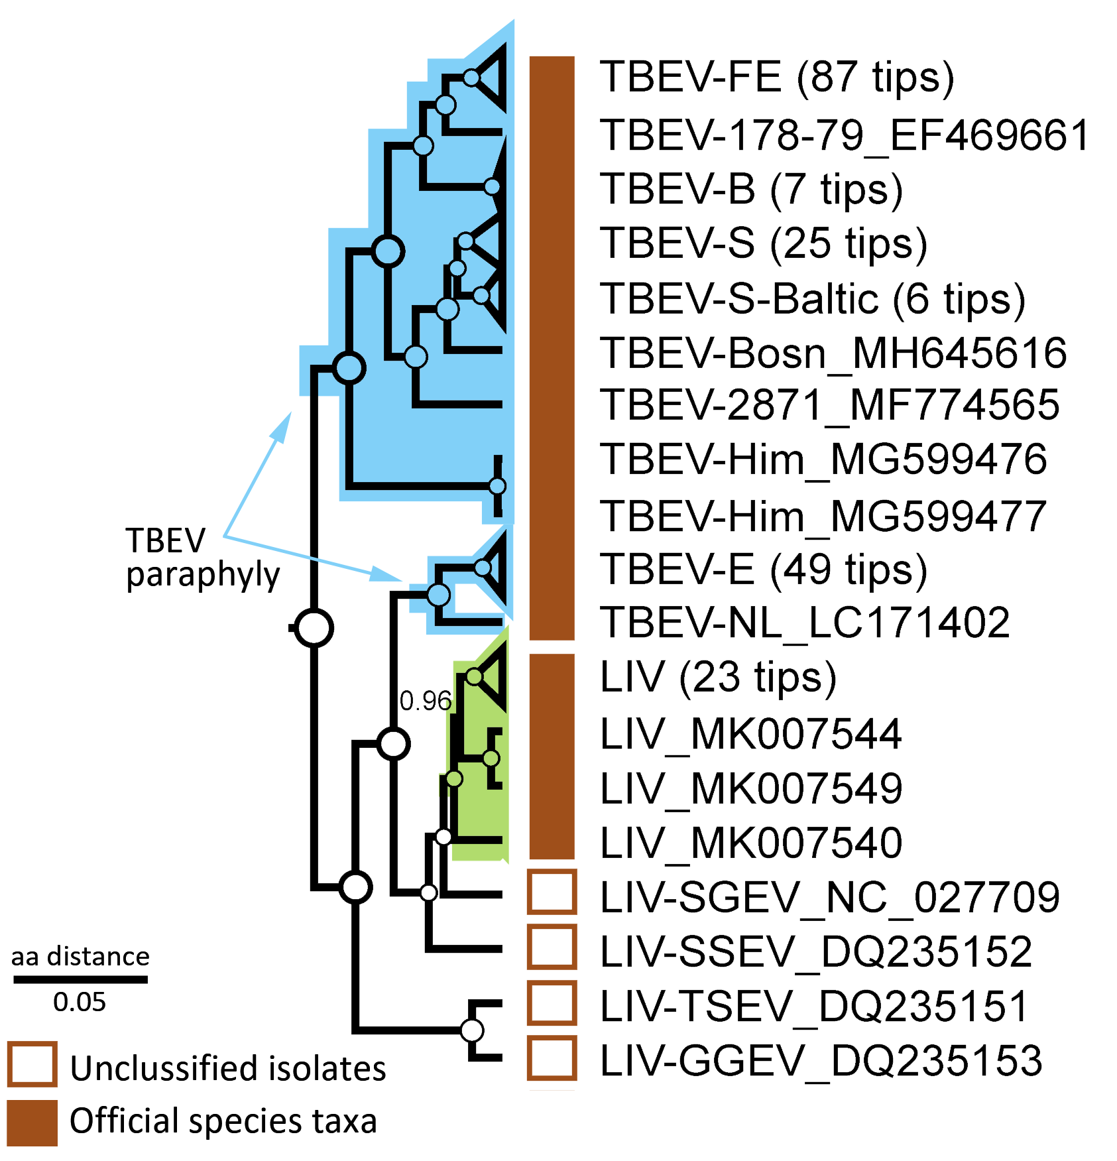

Fig. 1. The fragment of a maximum clade credibility tree (MCCT) of tick-borne encephalitis virus (TBEV, 181 samples), louping-ill virus (LIV, 30 samples). The entire phylogeny of tick-borne flavivirus (see Figure 2) was reconstructed in v.2.6.3 using complete 278 amino acid polyprotein sequences (3414 aa) available as of July 2021.

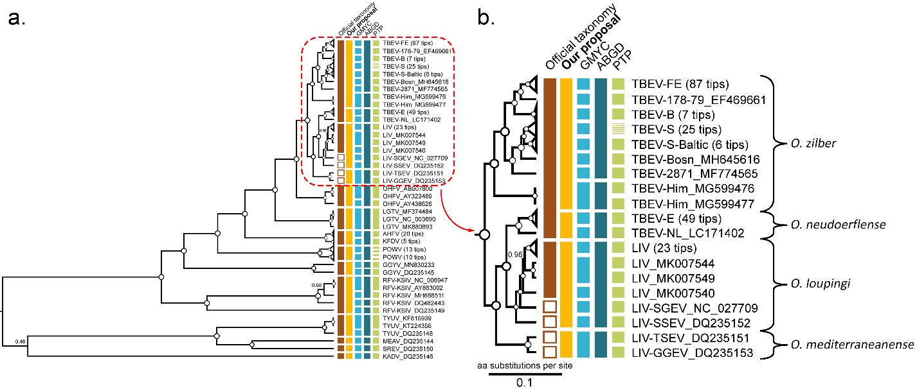

Fig. 2 *a* — Maximum clade credibility tree of tick-borne flaviviruses reconstructed in BEAST v.2.6.3 using complete 278 amino acid sequences (3414 aa) of a polyprotein, 181 of which are related to TBEV and 30 to LIV and LIV-like viruses (Spanish goat encephalitis virus (SGEV), Spanish sheep encephalitis virus (SSEV), Turkish sheep encephalitis virus (TSEV), Greek goat encephalitis virus (GGEV)). For better visualization, some of the wide clades were collapsed. The vertical bars to the right of tree tips indicate official classification (brown), unclassified isolate of LIV-like viruses (empty brown squares), our taxonomy proposal (orange), and delimitation results (light blue, dark blue, green). The internal nodes with posterior probability = 1 are marked as white circles, otherwise support values are shown by numbers ranging from 0 to 1; *b* — TBEV+LIV+LIV-like clade. Curly braces indicate our taxonomic proposal with appropriate species names.

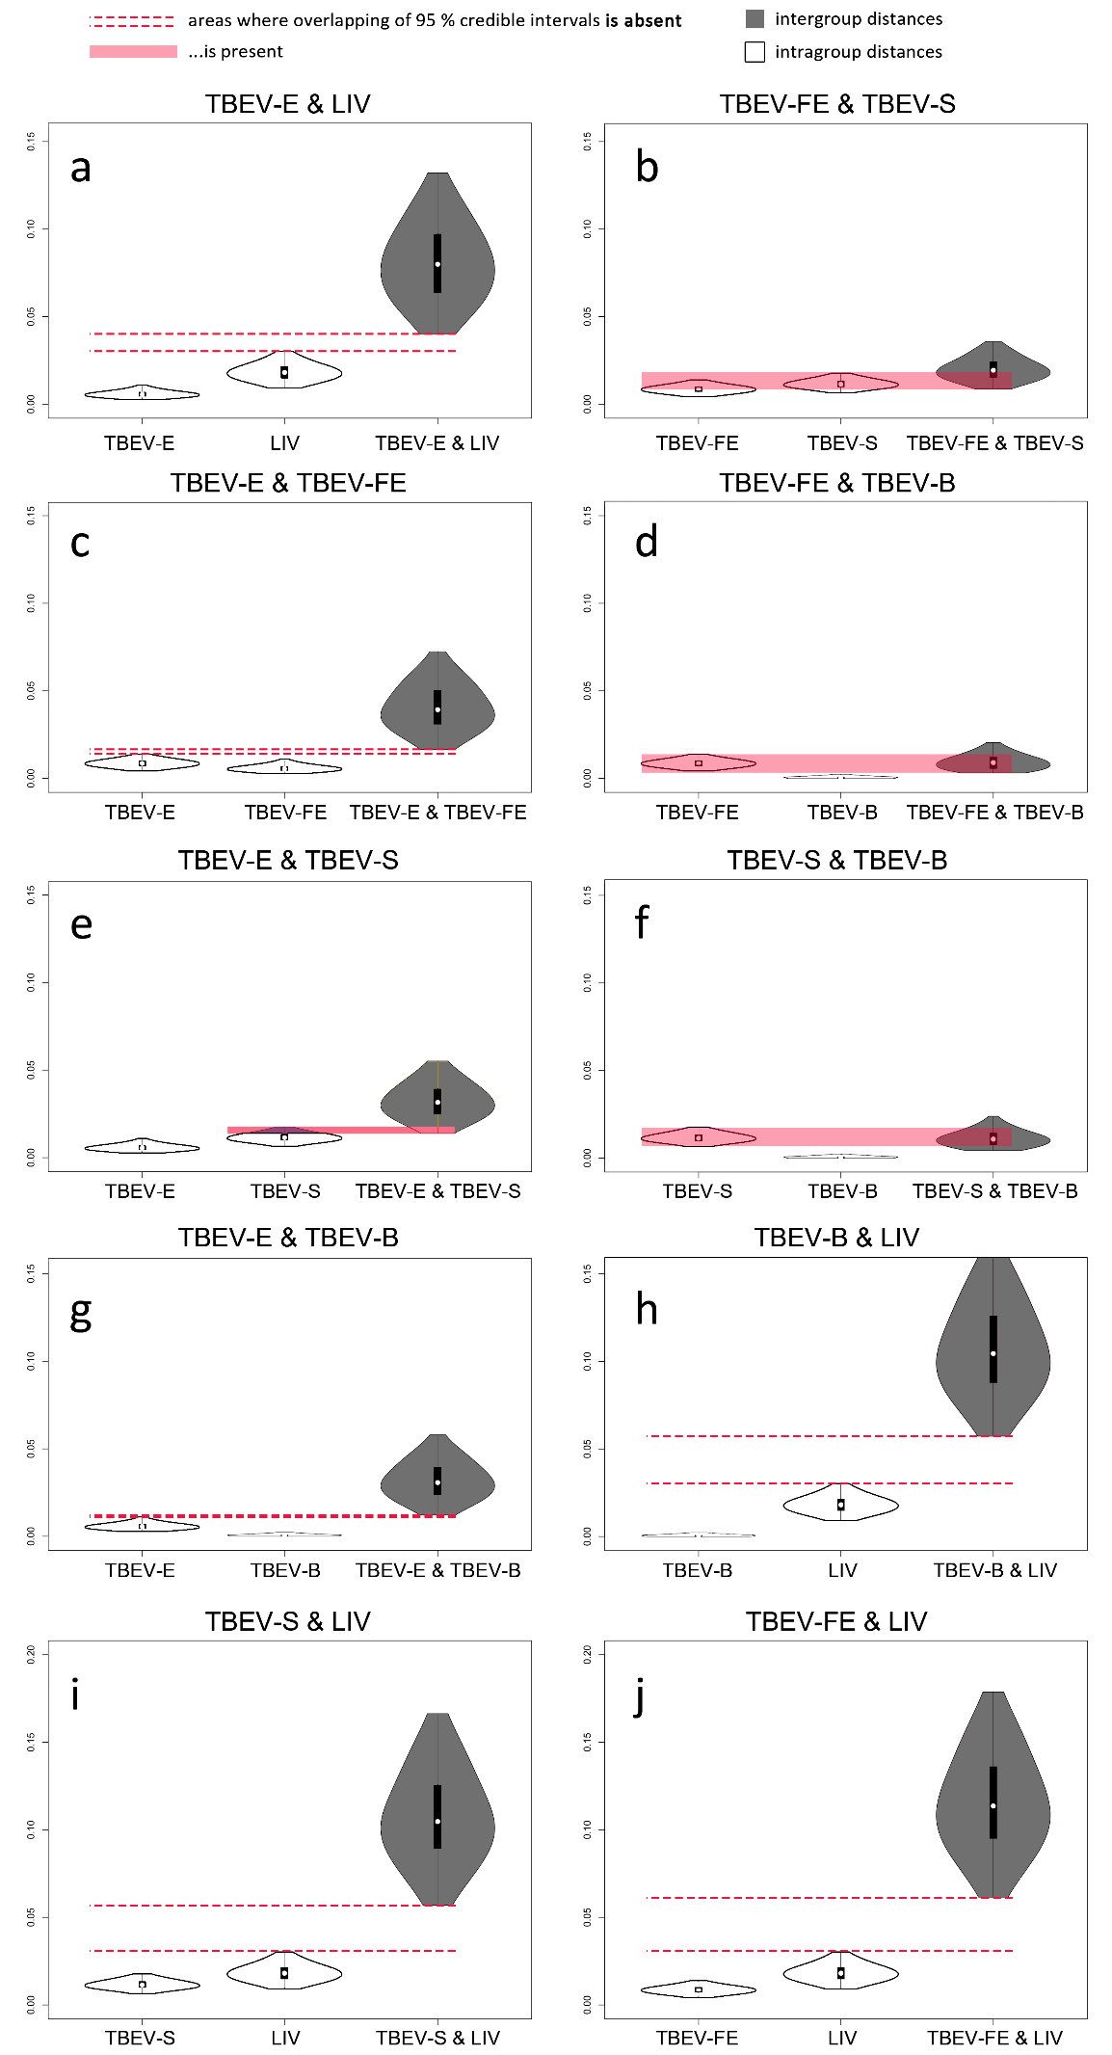

Fig. 3. Pairwise comparison of the evolutionary protein distances (in aa substitutions per site, Y-axis) of the E protein surface regions of TBEV and LIV (812 sequences with length of 224 aa) calculated via maximum likelihood trees from 1000 ultrafast bootstrap replicates inferred with IQTREE software. The upper and lower boundaries of violin plots are 95% credible intervals; black vertical bars within plots are standard deviation, white circles are mean values. The grey violin plots are intergroup distance distributions, the white plots are intragroup distances. Dashed pink lines indicate non-overlapping inter- and intragroup distances; solid bars show the overlap inter- and intragroup distances.