

The International Committee on Taxonomy of Viruses

Taxonomy Proposal Form, 2025

**Part 1a: Details of taxonomy proposals**

|  |  |
| --- | --- |
| **Title:** | In the genus *Mamastrovirus*,family *Astroviridae*, rename 1 species and establish 8 new species |
| **Code assigned:** | 2025.002S.Ac.v3.Mamastrovirus_8nsp_1spren | |

|  |  |  |  |  |
| --- | --- | --- | --- | --- |
| **Author(s), affiliation and email address(es):** | | | | |
| **Initials** | **Surname** | **Affiliation** | **Email address** | **Corresponding author(s)** | |
| Yulia | Aleshina | Martsinovsky Institute of Medical Parasitology, Tropical and Vector Borne Diseases; Sechenov First Moscow State Medical University; Moscow; Russian Federation | vjulia94@gmail.com | X | |
| Alexander N | Lukashev | Martsinovsky Institute of Medical Parasitology, Tropical and Vector Borne Diseases; Sechenov First Moscow State Medical University; Moscow; Russian Federation | alexander_lukashev@hotmail.com |  | |
| Torsten | Seuberlich | Division of Neurological Sciences, Vetsuisse Faculty, University of Bern, Bern, Switzerland | torsten.seuberlich@unibe.ch |  | |

**Part 1b: Taxonomy Proposal Submission**

|  |  |  |  |
| --- | --- | --- | --- |
| **ICTV Subcommittee:** | | | |
| Animal DNA Viruses and Retroviruses |  | Bacterial viruses |  |
| Animal minus-strand and dsRNA viruses |  | Fungal and protist viruses |  |
| Animal positive-strand RNA viruses | **X** | Plant viruses |  |
| Archaeal viruses |  | General - |  |

|  |
| --- |
| **List the ICTV Study Group(s) that have seen or have been involved in creating this proposal:** |
| ICTV *Astroviridae* Study Group |

|  |  |  |  |
| --- | --- | --- | --- |
| **Optional – complete only if formally voted on by an ICTV Study Group:** | | | |
| **Study Group** | **Number of members** | | |
| **Votes in support** | **Votes against** | **No vote** |
| ICTV *Astroviridae* Study Group | 3 | 0 | 1 |
|  |  |  |  |

|  |  |
| --- | --- |
| **Submission date:** | 19/06/2025 |

**Part 1c: Feedback from ICTV Executive Committee (EC) meeting**

|  |  |
| --- | --- |
| **Executive Committee Meeting Decision code:** | **X** |
| A – Accept |  |
| Ac – Accept subject to revision by relevant subcommittee chair. No further vote required | **X** |
| U – Accept without revision but with re-evaluation and email vote by the EC |  |
| Uc – Accept subject to revision and re-evaluation and email vote by the EC |  |
| Ud – Deferred to the next EC meeting, with an invitation to revise based on EC comments |  |
| J - Reject |  |
| W - Withdrawn |  |

|  |
| --- |
| **Comments from the Executive Committee:** |
| Double-check and if necessary correct proposed species epithets; minor typo corrections |

**Part 1d: Revised Taxonomy Proposal Submission**

|  |
| --- |
| **Response of proposer:** |
| Done. |

|  |  |
| --- | --- |
| **Revision date:** | 09/19/2025 |

**Part 3:** **TAXONOMIC PROPOSAL**

<https://ictv.global/taxonomy/templates>

|  |  |  |  |
| --- | --- | --- | --- |
| **Taxonomic changes proposed:** | | | |
| Establish new taxon | **X** | Split taxon |  |
| Abolish taxon |  | Merge taxon |  |
| Move taxon |  | Promote taxon |  |
| Rename taxon | **X** | Demote taxon |  |
| Move and rename |  |

|  |  |
| --- | --- |
| **Etymology (origin) of proposed taxonomic names:** | |
| **Taxon name** | **Etymology of the term** |
| *Mamastrovirus suisorientalis* | Since several classified and unclassified mamastroviruses can infect pigs, we suggest adding the geographic location to the species name of *Mamastrovirus suis* for consistency with names of proposed species. Contraction of the host genus *Sus* and the continent of initial isolation (*orientalis* for eastern) (PMID 2107200) |
| *Mamastrovirus suisencephalomyelitidis* | Viruses were shown to cause polioencephalomyelitis in swine (PMID 34578440). Contraction of host genus (*Sus*) and the disease (encephalomyelitis). |
| *Mamastrovirus suisvulgaris* | These viruses infecting pigs are prevalent globally and were detected in feces from pigs with diarrhea and in nasal swabs from pigs with clinical respiratory disease (PMIDs: 35891364, 27329081, 40303813). Contraction of the host genus *Sus* and *vulgaris* for “ordinary”. |
| *Mamastrovirus rodentiamericaense* | This species includes viruses isolated from mice (the USA) and rats in (China). Contraction of the host order Rodentia and the continent of initial isolation (*americaense* is location genitive for *America*) (based on PMID 29666290 and GenBank information). |
| *Mamastrovirus rattorientalis* | Contraction of the host genus (*Rattus*) and the continent of initial isolation (based on GenBank information and PMID 28537544). |
| *Mamastrovirus bovisamericaense* | Contraction of the host genus *Bos* and the continent of initial isolation (*americaense* is location genitive for *America*) (PMID 25740998). |
| *Mamastrovirus bubali* | Genitive singular of the host genus name *Bubalus*(based on GenBank information). |
| *Mamastrovirus bovisorientalis* | Contraction of the host genus *Bos* and continent of initial isolation (*orientalis* for eastern)(based on GenBank information and PMID 26212364). |
| *Mamastrovirus bovisencephalitidis* | Contraction of the host genus *Bos* and the disease (encephalitis) (PMIDs: 31231334, 32102857, 29869035). |

|  |  |  |
| --- | --- | --- |
| **Permission for use of names derived from a living person:** | | |
| **Taxon name** | **Full name of person from whom the name is derived** | **Attached** |
|  |  |  |
|  |  |  |
|  |  |  |
|  |  |  |

|  |
| --- |
| **Abstract of Taxonomy Proposal:** |
| *Taxonomic rank(s) affected*: species  *Description of current taxonomy*: The family *Astroviridae* includes two genera (*Mamastrovirus* and *Avastrovirus*)for viruses. The genus *Mamastrovirus* includes 19 established species.  The demarcation of species according to the 9th ICTV Report (2010) was based on analysis of ORF2 sequences with consideration of the host information. Previous species criteria were vaguely defined and did not provide unambiguous assignment of recently discovered astroviruses. A few recent publications suggested more specific criteria and several novel species; however, they have not been accommodated into the formal ICTV taxonomy.  *Proposed* *taxonomic change(s):*  To establish 8 new species:  *Mamastrovirus suisencephalomyelitidis*  *Mamastrovirus suisvulgaris*  *Mamastrovirus rodentiamericaense*  *Mamastrovirus rattorientalis*  *Mamastrovirus bovisamericaense*  *Mamastrovirus bubali*  *Mamastrovirus bovisorientalis*  *Mamastrovirus bovisencephalitidis*  To rename one species:  Rename *Mamastrovirus suis* as *Mamastrovirus suisorientalis*  *Justification*:  292 of the complete astrovirid genomes obtained since 2011 cannot be assigned to the established species. ORF2 amino acid sequence p-distances do not provide a threshold that could reliably distinguish several established species and is of limited use to identify distinct groups among unclassified astrovirids that were isolated recently, predominantly from cattle and pigs. A 17% nucleotide sequence distance cut-off in ORF1b clearly distinguished the established species and several groups among the unclassified viruses. Recombination at the ORF1b/ORF2 was ubiquitous within, but never between established and putative new species. As each single criterion has minor exclusions, it is suggested to use collectively ORF1b genetic distance, ORF2 phylogenetic grouping, recombination patterns, and host information to assign eight new species. |

|  |
| --- |
| * **Text of Taxonomy proposal:** |
| *Taxonomic rank(s) affected*: the genus *Mamastrovirus*  *Description of current taxonomy*: The family *Astroviridae* includes two genera—*Mamastrovirus* and *Avastrovirus*—for viruses that infect mammals and birds respectively. The genus *Mamastrovirus* includes 19 established species:  *Mamastrovirus californiani*,  *Mamastrovirus canis*,  *Mamastrovirus felis*,  *Mamastrovirus guangxiense*,  *Mamastrovirus hipposideri*,  *Mamastrovirus hominis*,  *Mamastrovirus homustovis*,  *Mamastrovirus melbournense*,  *Mamastrovirus miniopteri*,  *Mamastrovirus mustelae*,  *Mamastrovirus ovis*,  *Mamastrovirus pipistrelli*,  *Mamastrovirus pusilli*,  *Mamastrovirus suis*,  *Mamastrovirus taphozoi*,  *Mamastrovirus tursiopis*,  *Mamastrovirus vespertilionis*,  *Mamastrovirus virginiaense*, and  *Mamastrovirus zalophi.*  The demarcation of species according to the 9th ICTV Report (2010) was based on analysis of ORF2 sequences with consideration of the host information. Previous species criteria did not provide unambiguous assignment of recently discovered astroviruses and were vaguely defined:  “Based on these new data, the *Astroviridae* Study Group states that a classification based on genetic criteria is more appropriate. A phylogenetic analysis of mamastroviruses based on the amino acid sequence of the full length ORF2, which encodes the capsid polyprotein, results in 19 groups or species. Mean amino acid genetic distances (p-dist) range between 0.378-0.750, and 0.006-0.312 between and within groups, respectively. All groups are supported by a high bootstrap value.” (2010 ICTV proposal)  “The current mamastrovirus species are based on the hosts from which they were isolated. As such the species do not correspond to genetic phylogenies. … Based on genetic analysis of the complete capsid region at the amino acid level, mammalian astroviruses will be divided into two main genogroups: genogroup I and genogroup II. Each genogroup includes astroviruses infecting different host species, and can be further subdivided based on both genetic and host species criteria. Mean amino acid genetic distances (p-dist) between the two genogroups is 0.671±0.016. Within each genogroup, amino acid genetic distances between genotypes range between 0.338 and 0.783. Serotypes within each genotype are defined on the basis of 20-fold, or greater, two-way cross-neutralization titers, and are given consecutive numbers.” (ICTV 9th Report 2011)  “Classification within each genus was based initially only on the species of the host of origin, but at present genera are divided into “viral species” or “genotypes” on the basis of host range but also on genetic differences in the complete capsid sequence (viruses with differences at the capsid protein level that are higher than approximately 0.30 to 0.35 are regarded as different genotype species). On average, the mean amino acid distance (p-dist) between the two genera is 0.83, while within genera, mean distances are 0.72 and 0.64 for MAstV [mamastroviruses] and AAstV [avastroviruses], respectively.” (Bosch et al. 2014)  A later study suggested narrowing down the ORF2 sequence distance cut-off. This clarified the established taxonomy; however, this recommendation has not been formally accepted by ICTV:  “With this in mind, the classification system proposed by the ICTV *Astroviridae* Study Group in 2010 recommended classification based on the amino acid sequence of the ORF2 genome region, recommending that different strains of the same astrovirus species should share >75% identity in the capsid proteins (ICTV 9th Report 2011).” (Donato and Vijaykrishna 2017)  *Proposed* *taxonomic change(s)*:  To create new 8 species:  *Mamastrovirus suisencephalomyelitidis*  *Mamastrovirus suisvulgaris*  *Mamastrovirus rodentiamericaense*  *Mamastrovirus rattorientalis*  *Mamastrovirus bovisamericaense*  *Mamastrovirus bubali*  *Mamastrovirus bovisorientalis*  *Mamastrovirus bovisencephalitidis*  To rename one species:  Rename *Mamastrovirus suis* as *Mamastrovirus suisorientalis*  *Demarcation criteria:*  Common recombination and dissimilar patterns of divergence in ORF1 and ORF2, as well as occasional dead-end spillover events, suggest that mamastrovirus species should be designated only when a complete or near-complete genome sequence is available for several members of a provisional species (ideally, sampled in distinct locations) to take into account recombination patterns in addition to sequence distances. The combination of distance criteria (17% nucleotide p-distance cutoff in ORF1b region), consistent grouping on phylogenetic trees built using ORF1b and ORF2 sequences, and the major hosts should be considered when assigning new mamastrovirus species.  *Justification*  This taxonomic proposal is based on the results of a study of all available mamastrovirus sequences (Aleshina and Lukashev, 2025). Since 2011, hundreds of new mammalian astrovirids have been sequenced (full genomes or ORF2 that is often the primary target for sequencing). Approximately half of all currently known ORF2 sequences could not be assigned to the currently established mamastrovirus species. Previous studies suggested that mammalian astrovirids that share >75% identity in the amino acid sequence of ORF2 and infect the same host could be assigned to the same virus species (Bosch et al. 2012, 2014, Donato and Vijaykrishna 2017). However, this criterion has exclusions even among the established species. The distribution of amino acid sequence distances in ORF2 (Figure 2A) indicates that a robust taxon criterion might not be feasible at all (Aleshina and Lukashev, 2025). Moreover, it might be challenging to produce a reliable sequence alignment in ORF2 due to extreme variability outside the VP34 region (Figure 3). A 17% nucleotide sequence distance cut-off in ORF1b fairly distinguished the established species and suggested several species-rank groups among the unclassified viruses (Figure 2B). To justify use of two genome regions for mamastrovirus species assignment, recombination that is common at the junction between ORF1b and ORF2 should be also considered. Our analysis suggests that it is ubiquitous within the established species, but there is no evidence of recent recombination between viruses of different species (Aleshina and Lukashev, 2025). Therefore, there is good correspondence between species assignment based on ORF1b and ORF2 (Figure 4). Consequently, species that are defined by sequence distance criteria correspond to biological events that may be termed reproductive isolation. Several mechanisms may drive this reproductive isolation, including host specificity and incompatibility of genome fragments between viruses of separate species. The molecular taxonomy generally corresponded to the host. Thus, four criteria collectively define mamastrovirus species: ORF1b nucleotide genetic distance, ORF2 amino acid distance and phylogenetic grouping, recombination pattern and host species (*sensu lato*, including hosts f related species). As there were minor exclusions for each of these potential taxonomic criteria, they should be used collectively. Specifically, as mamastroviruses commonly switch hosts, and it is impossible to distinguish a true host switch from a dead-end spillover, species should be formally assigned only after several representatives of a suggested species have been reported from independent samples.  It should be noted that the suggested revised criteria enabled assignment of eight new species. However, 147 genomes were left unassigned. 16 genomes could correspond to nine putative species that were represented by too few genomes and thus were not assigned at this stage. Additionally, two clades of viruses from pigs and cows identified in ORF1b were shuffled by recombination between them in the ORF2 phylogenetic tree relative to ORF1b and ORF1a (Figure 4, clade p’ of porcine mamastroviruses and clade b’ of bovine mamastroviruses). The assignment of these viruses requires further investigation.  Since several classified and unclassified mamastroviruses can infect pigs, we suggest adding the geographic location to the species name of *Mamastrovirus suis* for consistency with names of proposed species and rename it as *Mamastrovirus suisorientalis*. |

|  |
| --- |
| **References:** |
| Aleshina Y., Lukashev A. (2025). Mamastrovirus species are shaped by recombination and can be reliably distinguished in ORF1b genome region. Virus Evolution, 11(1), veaf006. https://doi.org/10.1093/ve/veaf006  Bosch, A., Guix, S., Krishna, N. K., Méndez, E., Monroe, S. S., Pantin-Jackwood, M., & Schultz-Cherry, S. (2012). Family—Astroviridae. In Virus Taxonomy: Ninth Report of the International Committee on Taxonomy of Viruses (pp. 953–959). Elseiver.  Bosch, A., Pintó, R. M., & Guix, S. (2014). Human astroviruses. Clinical Microbiology Reviews, 27(4), 1048–1074. https://doi.org/10.1128/CMR.00013-14  Donato, C., & Vijaykrishna, D. (2017). The broad host range and genetic diversity of mammalian and avian astroviruses. Viruses, 9(5), 1–18. https://doi.org/10.3390/v9050102 |

|  |  |
| --- | --- |
| **Accompanying files:** | |
| **Filename** | **Description of contents** |
| 2025.002S.Ac.v3.Mamastrovirus_8nsp_1spren | Excel module |
| 2025.002S.Ac.v3.Mamastrovirus_8nsp_1spren_MAstV_ORF2.pdf | The maximum likelihood phylogenetic trees inferred by IQ-TREE 2 of ORF2 from mamastroviruses with available complete genome sequences in GenBank. The nodes with ultrafast bootstrap support values of less than 95% are marked red. |
| 2025.002S.Ac.v3.Mamastrovirus_8nsp_1spren_MAstV_ORF1b.pdf | The maximum likelihood phylogenetic trees inferred by IQ-TREE 2 of ORF1b from mamastroviruses with available complete genome sequences in GenBank. The nodes with ultrafast bootstrap support values of less than 95% are marked red. |

|  |
| --- |
| **Tables, Figures:** |

<Start here>

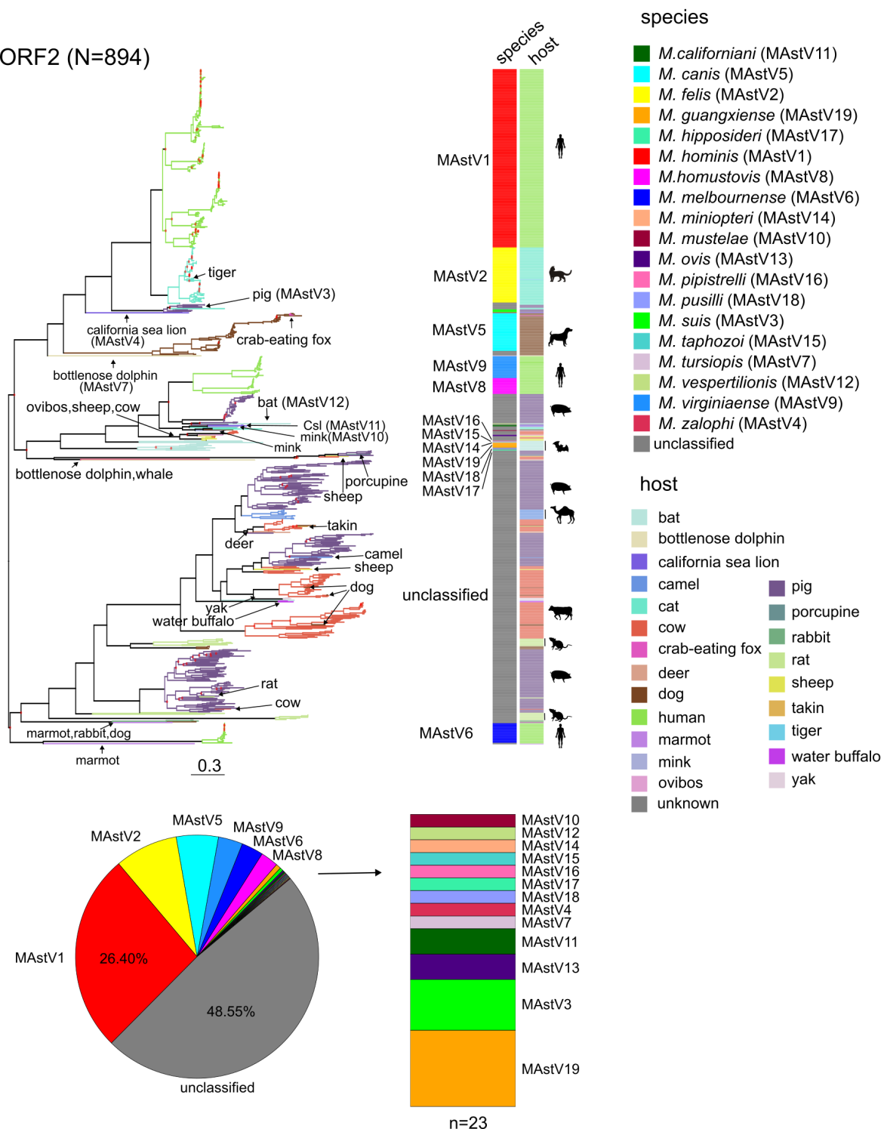Figure 1. The maximum likelihood phylogenetic trees inferred by IQ-TREE 2 (Minh et al. 2020) of ORF2 (*n* = 894) mamastrovirus (MAstV) sequences are available in GenBank as of June 2023. The scale bars indicate nucleotide substitutions per site. The nodes with ultrafast bootstrap support values of <80% are marked with red circles. The information about virus species according to current release of ICTV and their hosts was visualized as a color bar. The silhouettes of major hosts are shown near the heatmap. The tree branches are colored according to the virus host. Rare hosts and species are indicated by arrows on the tree. The lower panel shows the ratio of virus species in the ORF2 and ORF1b datasets, respectively. Csl, California sea lion. Figure source: (Aleshina and Lukashev, 2025) with minor modifications.

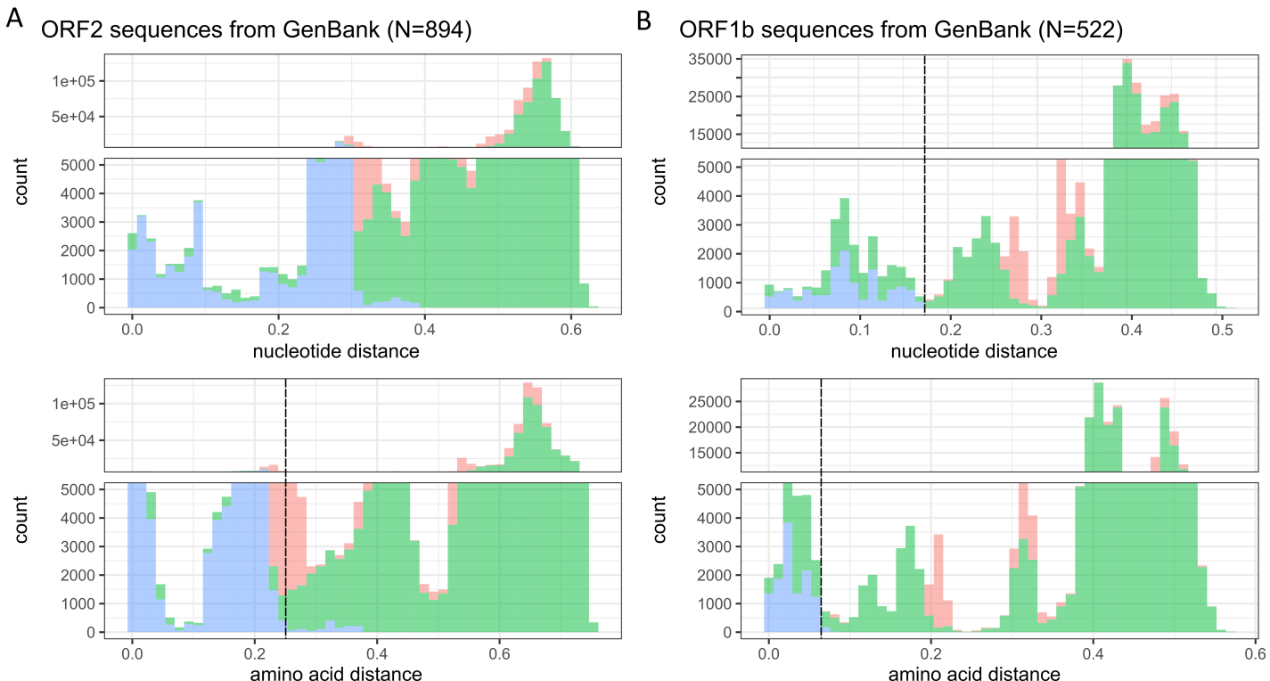

Figure 2. Distribution of pairwise nucleotide (upper panel) and amino acid p-distances (lower panel) in ORF2 (A) and ORF1b (B) of all available sequences within the genus *Mamastrovirus* as of June 2023. The species thresholds of 25% amino acid difference in ORF2 and 17% nucleotide sequence difference in ORF1b are indicated by dashed lines. The information about virus species was retrieved from the ICTV Master Species List [https://ictv.global/msl] and GenBank metadata. This was further verified by phylogenetic grouping in the ORF2 region. Viruses that were missing in the ICTV list and did not have that information in metadata were assigned as unknown species if they were outgroups to viruses with established species (all of them also differed by >30% amino acid sequence in ORF2). Viruses that were within a phylogenetic group corresponding to an established species were assigned a species of their phylogenetic neighbors. Figure source: (Aleshina and Lukashev, 2025) with modifications.

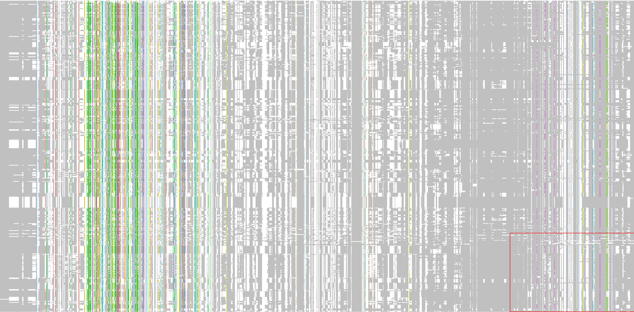

Figure 3. Overview of ORF2 amino acid sequence alignment for complete mamastrovirus genomes (N=478) available in GenBank as of June 2023.The amino acid residues that appear in more than 50% of sequences in a column are colored according to the Clustal color scheme. The rest amino acids are colored white, gaps are colored grey. The alignment is visualized in JalView program [10.1093/bioinformatics/btp033]

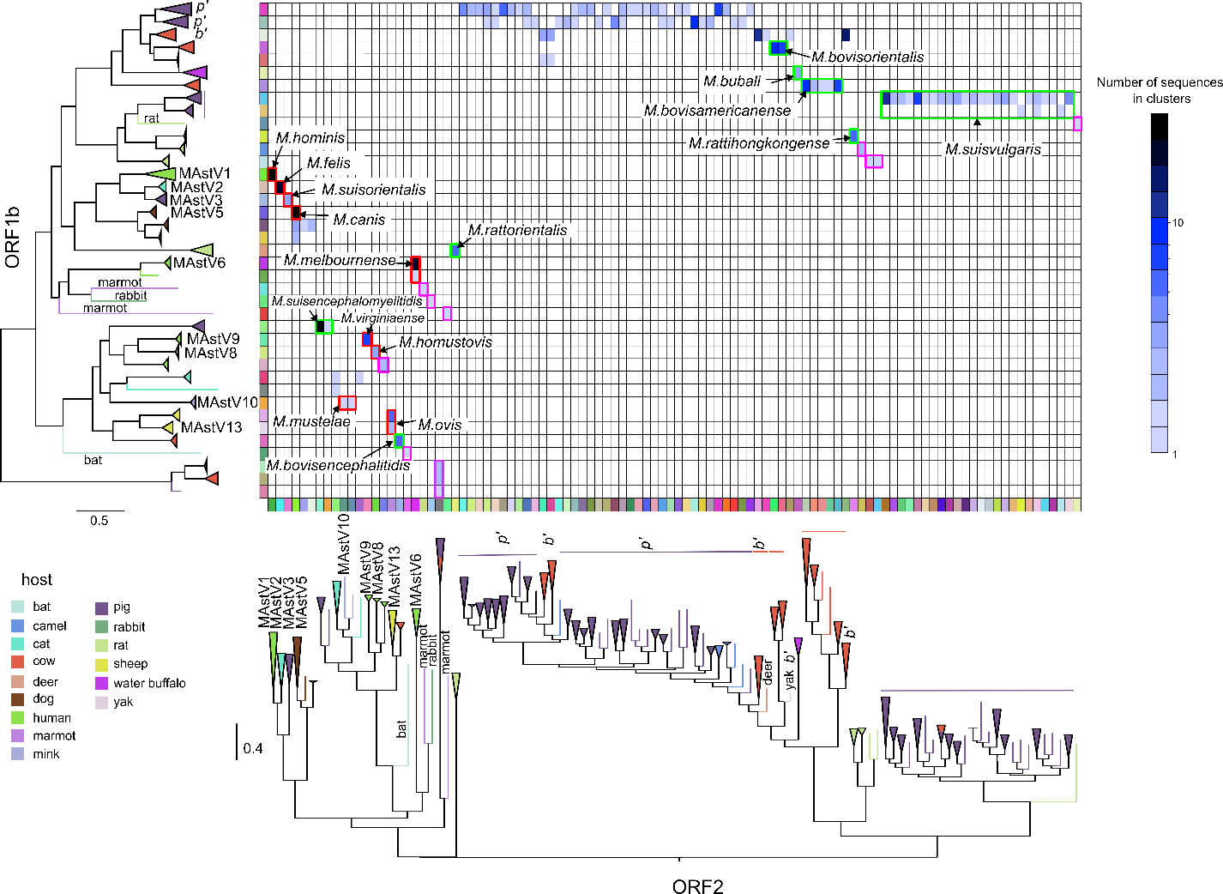

Figure 4. Correspondence of mamastrovirus groups determined based on the ORF1b-nt17% and ORF2-aa25% distance criteria. Sequences from ORF1b and ORF2 clusters were collapsed on the corresponding ML trees, so that each row and column on the matrix indicates the ORF1b-nt17% and ORF2-aa25% groups respectively. The collapsed clades are colored by the major virus host. The colors of matrix cells indicate the number of sequences that belong to a pair of groups that are concordant in ORF1b and ORF2. The cells that correspond to the established mamastrovirus species are marked with red rectangles. The groups that are proposed to be assigned as new species are marked with green rectangles. The cells that correspond to nine putative species that were represented by too few genomes and thus were not assigned at this stage are marked with magenta rectangles. Figure source: (Aleshina and Lukashev, 2025) with changes.