

The International Committee on Taxonomy of Viruses

Taxonomy Proposal Form, 2024

**Part 1a: Details of taxonomy proposals**

|  |  |  |
| --- | --- | --- |
| **Title:** | Establish five new species in the genus *Mastrevirus* | |
| **Code assigned:** | 2024.009P.A.v1.Geminiviridae_Mastrevirus_5nsp |

|  |  |  |  |
| --- | --- | --- | --- |
| **Author(s), affiliation and email address(es):** | | | |
| **Name** | **Affiliation** | **Email address** | **Corresponding author(s)** X |
| Varsani, Arvind | The Biodesign Center for Fundamental and Applied Microbiomics, Center for Evolution and Medicine, School of Life Sciences, Arizona State University, Tempe, Arizona, USA | Arvind.varsani@asu.edu | x |
| Martin, Darren P. | Institute of Infectious Disease and Molecular Medicine, University of Cape Town, Cape Town, South Africa | darrenpatrickmartin@gmail.com |  |
| Roumagnac, Philippe | CIRAD, UMR PHIM, Montpellier, France | philippe.roumagnac@cirad.fr |  |
| Ascencio-Ibanez, Jose | North Carolina State University, Raleigh, USA | jtascenc@ncsu.edu |  |
| Lett, Jean-Michel | CIRAD, UMR PVBMT, Saint Pierre de la Réunion, France | lett@cirad.fr |  |
| López-Lambertini, Paola M. | INTA-CIAP-IPAVE, Universidad Nacional de Córdoba, Córdoba, Argentina | plopezlambertini@gmail.com |  |
| Navas-Castillo, Jesús | Instituto de Hortofruticultura Subtropical y Mediterránea “La Mayora” (IHSM-UMA-CSIC), Málaga, Spain | jnavas@eelm.csic.es |  |
| Ribeiro, Simone | Embrapa Recursos Genéticos e Biotecnologia, Brasília, Brazil | simone.ribeiro@embrapa.br |  |
| Urbino, Cica | CIRAD, UMR PHIM, Montpellier, France | cica.urbino@cirad.fr |  |
| Zerbini, F. Murilo | Universidade Federal de Viçosa, Viçosa, Brasil | [zerbini@ufv.br](mailto:zerbini@ufv.br) |  |

**Part 1b: Taxonomy Proposal Submission**

|  |  |  |  |
| --- | --- | --- | --- |
| **ICTV Subcommittee:** | | | |
| Animal DNA Viruses and Retroviruses |  | Bacterial viruses |  |
| Animal minus-strand and dsRNA viruses |  | Fungal and protist viruses |  |
| Animal positive-strand RNA viruses |  | Plant viruses | **x** |
| Archaeal viruses |  | General - |  |

|  |
| --- |
| **List the ICTV Study Group(s) that have seen or have been involved in creating this proposal:** |
| *Geminiviridae* and *Tolecusatellitidae* Study Group |

|  |  |  |  |
| --- | --- | --- | --- |
| **Optional – complete only if formally voted on by an ICTV Study Group:** | | | |
| **Study Group** | **Number of members** | | |
| **Votes in support** | **Votes against** | **No vote** |
| *Geminiviridae* and *Tolecusatellitidae* Study Group | 10 | 0 | 0 |
|  |  |  |  |

|  |  |
| --- | --- |
| **Submission date:** | 10/06/2024 |

**Part 1c: Feedback from ICTV Executive Committee (EC) meeting**

|  |  |
| --- | --- |
| **Executive Committee Meeting Decision code:** | **X** |
| A – Accept | **X** |
| Ac – Accept subject to revision by relevant subcommittee chair. No further vote required |  |
| U – Accept without revision but with re-evaluation and email vote by the EC |  |
| Uc – Accept subject to revision and re-evaluation and email vote by the EC |  |
| Ud – Deferred to the next EC meeting, with an invitation to revise based on EC comments |  |
| J - Reject |  |
| W - Withdrawn |  |

|  |
| --- |
| **Comments from the Executive Committee:** |
|  |

**Part 1d: Revised Taxonomy Proposal Submission**

|  |
| --- |
| **Response of proposer:** |
|  |

|  |  |
| --- | --- |
| **Revision date:** | DD/MM/YYYY |

Part 3: TAXONOMIC PROPOSAL

|  |
| --- |
| **Name of accompanying Excel module:** |
| 2024.009P.A.v1.Geminiviridae_Mastrevirus_5nsp.xlsx |

|  |  |  |  |
| --- | --- | --- | --- |
| **Taxonomic changes proposed:** | | | |
| Establish new taxon | **x** | Split taxon |  |
| Abolish taxon |  | Merge taxon |  |
| Move taxon |  | Promote taxon |  |
| Rename taxon |  | Demote taxon |  |
| Move and rename |  |

|  |  |  |
| --- | --- | --- |
| **Is any taxon name used here derived from that of a living person:** | | **N** |
| **Taxon name** | **Person from whom the name is derived** | **Attached X** |
|  |  |  |
|  |  |  |
|  |  |  |

|  |
| --- |
| **Abstract of Taxonomy Proposal:** |
| *Taxonomic rank(s) affected*:  Species  *Description of current taxonomy*:  Mastreviruses are currently classified according to the following hierarchy:  *Monodnaviria*; *Shotokuvirae*; *Cressdnaviricota*; *Repensiviricetes*; *Geplafuvirales*; *Geminiviridae*; *Mastrevirus.*  Within the genus *Mastrevirus*, viruses are classified into species based on a 78% genome-wide pairwise identity threshold [1].  *Proposed* *taxonomic change(s):*  We propose the establishment of five new species to classify a suite of new mastreviruses that have been identified over the last year or so.  *Justification*:  The members of the five new proposed species in the genus *Mastrevirus* share < 78% genome-wide pairwise identity with sequences of members of currently established mastrevirus species. |

|  |
| --- |
| * **Text of Taxonomy proposal:** |
| *Taxonomic rank(s) affected*:  Species  *Description of current taxonomy*:  There are currently 45 established species in the genus *Mastrevirus*.  *Proposed* *taxonomic change(s)*:  We propose to establish five new species in the genus *Mastrevirus*.  *Demarcation criteria:*  78% genome-wide pairwise identity threshold [1].  *Justification*:  The sequences of the viruses summarized in Table 1 can be classified into five new species that share <78% genome-wide pairwise identity with all classified mastreviruses (Figure 1). Furthermore, this is supported by maximum likelihood phylogenetic analysis (Figure 2). |

|  |
| --- |
| **References:** |
| 1. Muhire B, Martin DP, Brown JK, Navas-Castillo J, Moriones E, Zerbini FM, Rivera-Bustamante R, Malathi VG, Briddon RW, Varsani A. A genome-wide pairwise-identity-based proposal for the classification of viruses in the genus Mastrevirus (family Geminiviridae). Arch Virol. 2013 Jun;158(6):1411-24. doi: 10.1007/s00705-012-1601-7. Epub 2013 Jan 23. PMID: 23340592. 2. Muhire BM, Varsani A, Martin DP. SDT: a virus classification tool based on pairwise sequence alignment and identity calculation. PLoS One. 2014 Sep 26;9(9):e108277. doi: 10.1371/journal.pone.0108277. PMID: 25259891; PMCID: PMC4178126. 3. Katoh K, Rozewicki J, Yamada KD. MAFFT online service: multiple sequence alignment, interactive sequence choice and visualization. Brief Bioinform. 2019 Jul 19;20(4):1160-1166. doi: 10.1093/bib/bbx108. PMID: 28968734; PMCID: PMC6781576. 4. Guindon S, Dufayard JF, Lefort V, Anisimova M, Hordijk W, Gascuel O. New algorithms and methods to estimate maximum-likelihood phylogenies: assessing the performance of PhyML 3.0. Syst Biol. 2010 May;59(3):307-21. doi: 10.1093/sysbio/syq010. Epub 2010 Mar 29. PMID: 20525638. 5. Darriba D, Taboada GL, Doallo R, Posada D. jModelTest 2: more models, new heuristics and parallel computing. Nat Methods. 2012 Jul 30;9(8):772. doi: 10.1038/nmeth.2109. PMID: 22847109; PMCID: PMC4594756. 6. Bandoo RA, Kraberger S, Varsani A. Two Novel Geminiviruses Identified in Bees (*Apis mellifera* and *Nomia* sp.). Viruses. 2024 Apr 13;16(4):602. doi: 10.3390/v16040602. PMID: 38675943; PMCID: PMC11053556. 7. Moubset O, Filloux D, Fontes H, Julian C, Fernandez E, Galzi S, Blondin L, Chehida SB, Lett JM, Mesléard F, Kraberger S, Custer JM, Salywon A, Makings E, Marais A, Chiroleu F, Lefeuvre P, Martin DP, Candresse T, Varsani A, Ravigné V, Roumagnac P. Virome release of an invasive exotic plant species in southern France. Virus Evol. 2024 Mar 9;10(1):veae025. doi: 10.1093/ve/veae025. PMID: 38566975; PMCID: PMC10986800. |

|  |
| --- |
| **Tables, Figures:** |

<Start here>

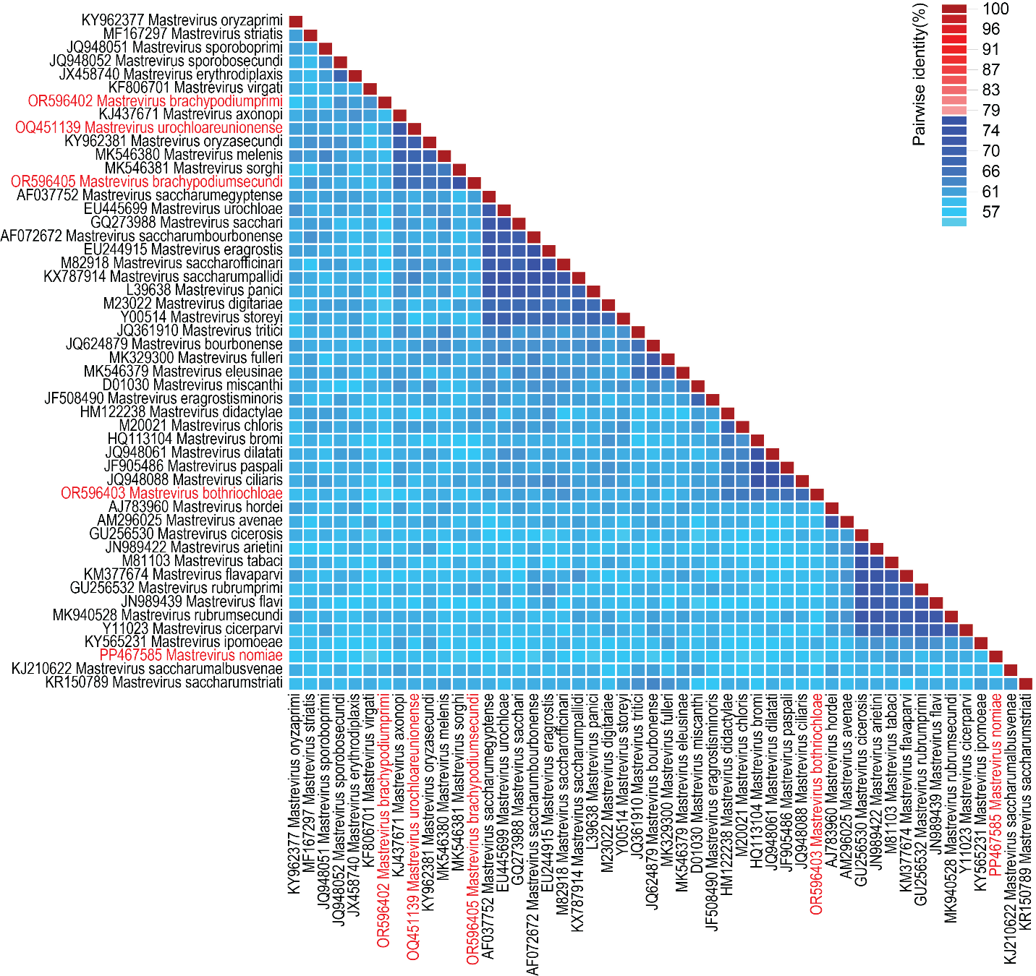**Figure 1:** A ‘two color’ genome-wide pairwise identity matrix of genomes from each mastrevirus species inferred using SDT v1.2 [2]. Representative sequences from the proposed new species (n=5) are shown in red font.

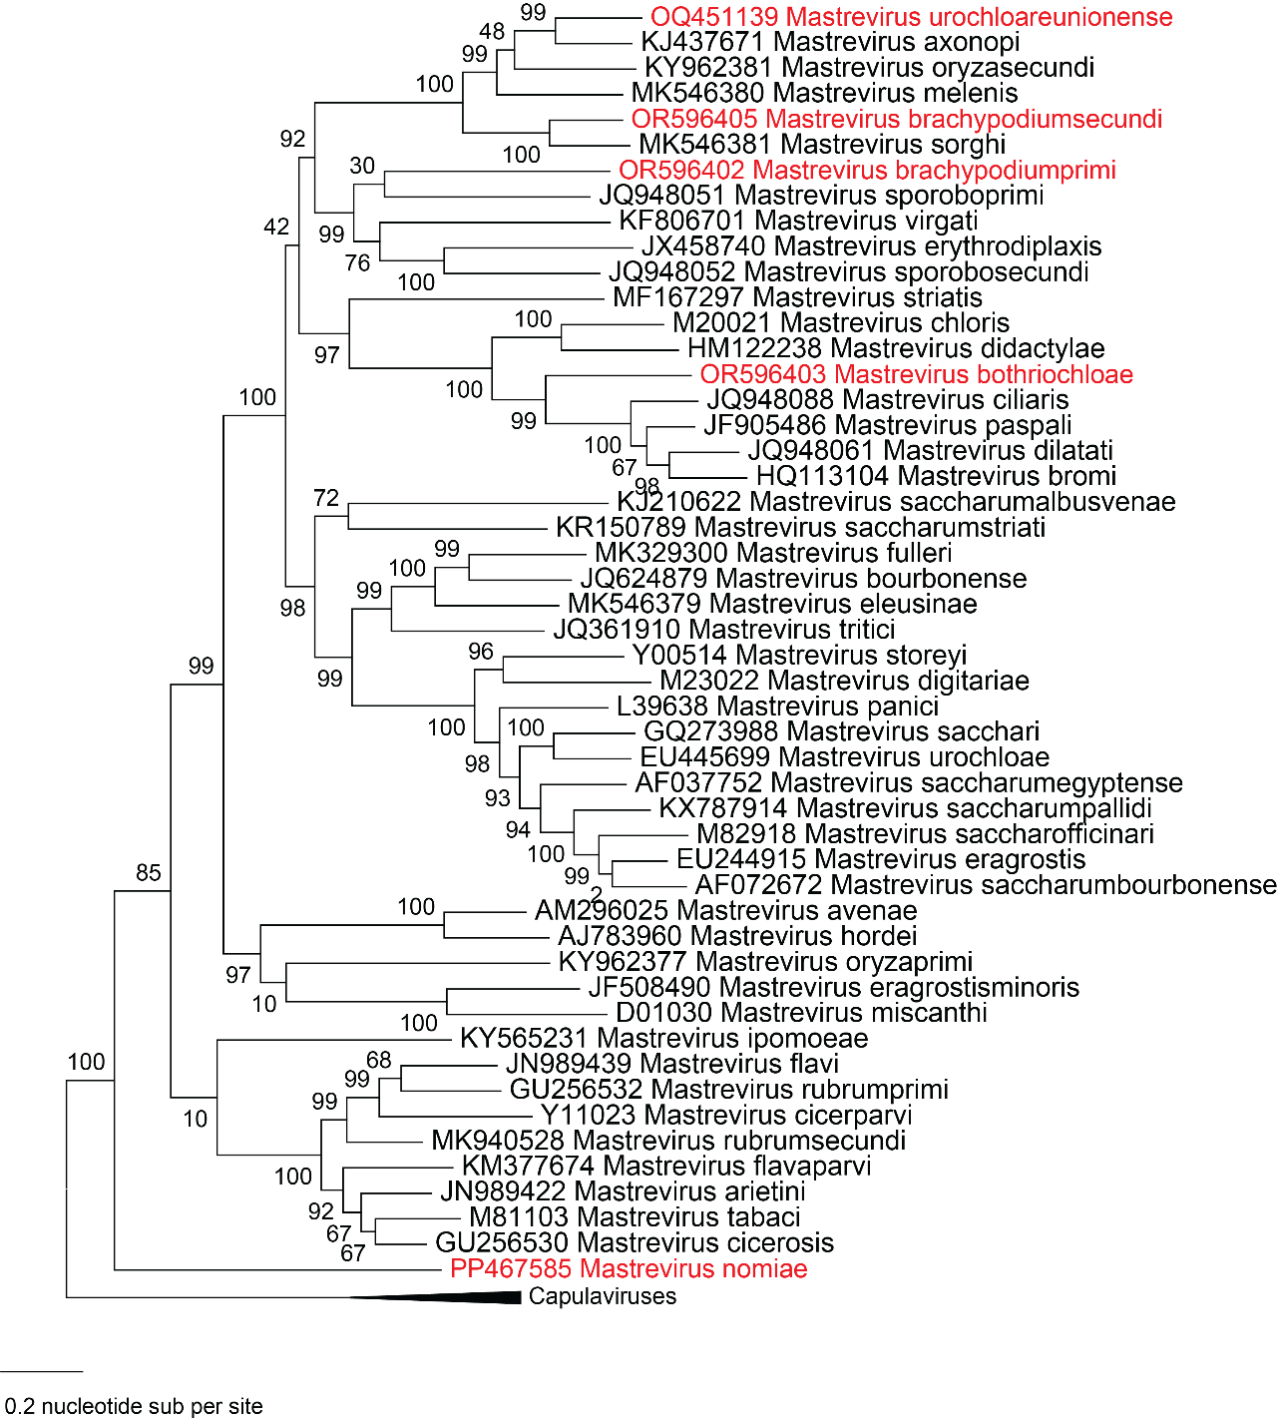**Figure 2:** Maximum likelihood phylogenetic tree of representative genomes from each mastrevirus species (aligned with MAFFT v7 [3]) inferred using PHYML [4] with GTR+I+G4 chosen as the best fit model (using jModelTest [5]. The phylogenetic tree is rooted with genome sequences of capulaviruses. Proposed new species are in red font.

**Table 1:** Summary of the five new species in the genus *Mastrevirus* and their members.

|  |  |  |  |  |  |  |
| --- | --- | --- | --- | --- | --- | --- |
| **Species names** | **Accession** | **Virus name** | **Isolate** | **Country** | **Host / source** | **Reference** |
| *Mastrevirus urochloareunionense* | OQ451139 | Urochloa decumbens associated virus | Reunion-Colimacons-Urochloa decumbens-21_REU_E0807_D | France: Reunion | *Urochloa decumbens* | *-* |
| *Mastrevirus nomiae* | PP467585 | Nomiamastrel virus | NSB1_13 | USA | *Nomia* sp. | [6] |
| *Mastrevirus brachypodiumprimi* | OR596402 | Brachypodium phoenicoides associated virus 1 | 3-N2-4 | France | *Brachypodium phoenicoides* | [7] |
| *Mastrevirus bothriochloae* | OR596403 | Bothriochloa barbinodis associated virus | 4-E1-7 | France | *Bothriochloa barbinodis* | [7] |
|  | OR596404 | Bothriochloa barbinodis associated virus | 3-E1-8 | France | *Bothriochloa barbinodis* | [7] |
| *Mastrevirus brachypodiumsecundi* | OR596405 | Brachypodium phoenicoides associated virus 2 | 2-N3-1 | France | *Brachypodium phoenicoides* | [7] |