

The International Committee on Taxonomy of Viruses

Taxonomy Proposal Form, 2024

**Part 1a: Details of taxonomy proposals**

|  |  |  |
| --- | --- | --- |
| **Title:** | Create two new species in the genus *Citlodavirus (Geplafuvirales: Geminiviridae*) | |
| **Code assigned:** | 2024.008P.A.v1.Geminiviridae_Citlodavirus_2nsp |

|  |  |  |  |
| --- | --- | --- | --- |
| **Author(s), affiliation and email address(es):** | | | |
| **Name** | **Affiliation** | **Email address** | **Corresponding author(s)** X |
| Roumagnac, Philippe | CIRAD, UMR PHIM, Montpellier, France | philippe.roumagnac@cirad.fr | X |
| Ascencio-Ibanez, Jose | North Carolina State University, Raleigh, USA | jtascenc@ncsu.edu |  |
| Lett, Jean-Michel | CIRAD, UMR PVBMT, Saint Pierre de la Réunion, France | lett@cirad.fr |  |
| López-Lambertini, Paola M. | INTA-CIAP-IPAVE, Universidad Nacional de Córdoba, Córdoba, Argentina | plopezlambertini@gmail.com |  |
| Martin, Darren P. | Institute of Infectious Disease and Molecular Medicine, University of Cape Town, Cape Town, South Africa | darrenpatrickmartin@gmail.com |  |
| Navas-Castillo, Jesús | Instituto de Hortofruticultura Subtropical y Mediterránea “La Mayora” (IHSM-UMA-CSIC), Málaga, Spain | jnavas@eelm.csic.es |  |
| Ribeiro, Simone | Embrapa Recursos Genéticos e Biotecnologia, Brasília, Brazil | simone.ribeiro@embrapa.br |  |
| Urbino, Cica | CIRAD, UMR PHIM, Montpellier, France | cica.urbino@cirad.fr |  |
| Varsani, Arvind | The Biodesign Center for Fundamental and Applied Microbiomics, Center for Evolution and Medicine, School of Life Sciences, Arizona State University, Tempe,Arizona, USA | Arvind.varsani@asu.edu |  |
| Zerbini, F. Murilo | Dep. de Fitopatologia, Universidade Federal de Viçosa, Viçosa, Brasil | [zerbini@ufv.br](mailto:zerbini@ufv.br) |  |

**Part 1b: Taxonomy Proposal Submission**

|  |  |  |  |
| --- | --- | --- | --- |
| **ICTV Subcommittee:** | | | |
| Animal DNA Viruses and Retroviruses |  | Bacterial viruses |  |
| Animal minus-strand and dsRNA viruses |  | Fungal and protist viruses |  |
| Animal positive-strand RNA viruses |  | Plant viruses | **X** |
| Archaeal viruses |  | General - |  |

|  |  |  |  |
| --- | --- | --- | --- |
| **List the ICTV Study Group(s) that have seen or have been involved in creating this proposal:** | | | |
| *Geminiviridae* and *Tolecusatellitidae* Study Group | | | |
| **Optional – complete only if formally voted on by an ICTV Study Group:** | | | |
| **Study Group** | **Number of members** | | |
| **Votes in support** | **Votes against** | **No vote** |
| Roumagnac, Philippe  Ascencio-Ibanez, Jose  Lett, Jean-Michel  López-Lambertini, Paola M.  Martin, Darren  Navas-Castillo, Jesús  Ribeiro, Simone  Urbino, Cica  Varsani, Arvind  Zerbini, F. Murilo | Y  Y  Y  Y  Y  Y  Y  Y  Y  Y |  |  |
|  |  |  |  |

|  |  |
| --- | --- |
| **Submission date:** | 10/06/2024 |

**Part 1c: Feedback from ICTV Executive Committee (EC) meeting**

|  |  |
| --- | --- |
| **Executive Committee Meeting Decision code:** | **X** |
| A – Accept | **A** |
| Ac – Accept subject to revision by relevant subcommittee chair. No further vote required |  |
| U – Accept without revision but with re-evaluation and email vote by the EC |  |
| Uc – Accept subject to revision and re-evaluation and email vote by the EC |  |
| Ud – Deferred to the next EC meeting, with an invitation to revise based on EC comments |  |
| J - Reject |  |
| W - Withdrawn |  |

|  |
| --- |
| **Comments from the Executive Committee:** |
|  |

**Part 1d: Revised Taxonomy Proposal Submission**

|  |  |
| --- | --- |
| **Response of proposer:** | |
|  | |
| **Revision date:** | DD/MM/YYYY |

**Part 3:** **TAXONOMIC PROPOSAL**

|  |
| --- |
| **Name of accompanying Excel module:** |
| 2024.008P.A.v1.Geminiviridae_Citlodavirus_2nsp.xlsx |

|  |  |  |  |
| --- | --- | --- | --- |
| **Taxonomic changes proposed:** | | | |
| Establish new taxon | **x** | Split taxon |  |
| Abolish taxon |  | Merge taxon |  |
| Move taxon |  | Promote taxon |  |
| Rename taxon |  | Demote taxon |  |
| Move and rename |  |

|  |  |  |
| --- | --- | --- |
| **Is any taxon name used here derived from that of a living person:** | | **N** |
| **Taxon name** | **Person from whom the name is derived** | **Attached X** |
|  |  |  |
|  |  |  |
|  |  |  |

|  |
| --- |
| **Abstract of Taxonomy Proposal:** |
| *Proposed changes:*  Add two species in the*Citlodavirus* genus  *Taxonomic rank(s) affected*:  *Citlodavirus* genus in the *Geminiviridae* family  *Description of current taxonomy*:  *Monodnaviria* / *Shotokuvirae* / *Cressdnaviricota* / *Repensiviricetes* / *Geplafuvirales* / *Geminiviridae* / *Citlodavirus*  *Proposed* *taxonomic change(s):*  We proposed to add two new species to the *Citlodavirus* genus, *Citlodavirus* *apijamaicaense* and *Citlodavirus* *myricae*.  *Justification:*  Similar to members of the *Citlodavirus* genus, members of the proposed new species *Citlodavirus* *apijamaicaense* and *Citlodavirus* *myricae* have the virion-strand origin of replication nonanucleotide motif ‘TAA TAT TAC’, a relatively large genome (3918 nt and 3775 nt, respectively) and unique genome arrangements that, in both cases, include the putative *mp* gene (888 nt and 912 nt, respectively) that is similar in size to the *mp* gene in the DNA-B of bipartite begomoviruses. Genome-wide pairwise analysis of the representative genomes of citlodaviruses showed that *Citlodavirus* *apijamaicaense* and *Citlodavirus* *myricae* share less than 78% identity with all representative genomes of citlodaviruses and between each other. Since 78% nucleotide identity is the genome-wide species demarcation threshold for citlodaviruses, we conclude that *Citlodavirus* *apijamaicaense* and *Citlodavirus* *myricae* represent two new species in the genus *Citlodavirus*. |

|  |
| --- |
| **Text of Taxonomy proposal:** |
| *Taxonomic rank(s) affected*:  *Citlodavirus* genus in the *Geminiviridae* family (Order *Geplafuvirales*)  *Description of current taxonomy*:  *Monodnaviria* / *Shotokuvirae* / *Cressdnaviricota* / *Repensiviricetes* / *Geplafuvirales* / *Geminiviridae* / *Citlodavirus*  Four species are currently assigned to the *Citlodavirus* genus in the *Geminiviridae* family:   * *Citlodavirus broussonetiae* * *Citlodavirus camelliae* * *Citlodavirus citri* * *Citlodavirus passiflorae*   *Proposed* *taxonomic change(s)*:  We propose to add two new species to the *Citlodavirus* genus: (i) *Citlodavirus* *apijamaicaense*, which was isolated from honeybees (*Apis mellifera*) collected from Westmoreland, Jamaica (Bandoo et al., 2024); and (ii) *Citlodavirus* *myricae*, which was isolated from *Myrica rubra* plants in Yunnan, China (Gao et al., 2023).  *Demarcation criteria:*  A 78% pairwise identity species demarcation threshold has been proposed and adopted for the genus *Citlodavirus* (Roumagnac et al., 2022).  *Justification*:  A group of closely related viruses isolated from citrus in China, Thailand, and Turkey, *Camellia japonica* and *Camellia sinensis* in China, *Passiflora edulis* in Brazil, and *Broussonetia papyrifera* in China was assigned in 2021 to the genus *Citlodavirus* (Roumagnac et al., 2022). The genome sizes of these viruses are approximately 20% larger than those of other known monopartite geminiviruses, ranging from 3639 to 3763 nt. These viruses have the virion-strand origin of replication nonanucleotide motif ‘TAATATTAC’ and a unique genome arrangement that includes a putative *mp* gene (891–921 nt in size), which likely encodes a protein product homologous to that encoded by the DNA-B component of bipartite begomoviruses (genus *Begomovirus*).  **New *Citlodavirus* species: *Citlodavirus* *apijamaicaense***  One isolate of apiscitlodal virus has been characterized from bees collected from Westmoreland, Jamaica (Bandoo et al., 2024). Its 3918 nt long genome sequence share less than 68.9% with all other known geminiviruses within currently established species (Figure 1), with the highest identity with passion fruit chlorotic mottle virus (MG696802). Reconstruction of the evolutionary relationships of the complete genome sequences of all citlodaviruses and one representative mulcrilevirus (genus *Mulcrilevirus*) reveals that apiscitlodal virus groups with citlodaviruses with strong phylogenetic support (Figure 2). This virus is clearly related to previously recognized geminiviruses, based on genome organization, similarities in the origin of replication (5'-TAATATTAC-3'), and the presence of homologous genes. Specifically, apiscitlodal virus has a genome arrangement similar to those of citlodaviruses (Figure 3), containing the larger putative *mp* gene (888 nt) that is most similar in size to the *mp* gene in the DNA-B molecule of bipartite begomoviruses. Consequently, we propose creating a new *Citlodavirus* species named *Citlodavirus* *apijamaicaense* (origin of the species name: *api* from *apis* the organism from with the virus was isolated and *jamaicaense* from Jamaica, the country where the bees were collected).  **New *Citlodavirus* species: *Citlodavirus* *myricae***  One isolate of Myrica rubra citlodavirus 1 (MRV1) has been characterized from *Myrica rubra* collected in Yunnan, China (Gao et al., 2023). Its 3775 nt long genome sequence shares less than 65.3% with all other known geminiviruses within currently established species (Figure 1), with the highest identity with citrus chlorotic dwarf virus (JQ920490). The reconstruction of the evolutionary relationships of the complete genome sequences of all citlodaviruses and one representative mulcrilevirus reveals that MRV1groups with citlodaviruses, with strong phylogenetic support (Figure 2). This virus is clearly related to previously recognized geminiviruses, based on genome organization, similarities in the origin of replication (5'-TAATATTAC-3'), and the presence of homologous genes. Specifically, similar to members of the *Citlodavirus* genus, MRV1 has a genome arrangement (Figure 3) that includes the larger putative *mp* gene (912 nt) that is most similar in size to the *mp* gene in the DNA-B molecule of bipartite begomoviruses. Consequently, we propose creating a new *Citlodavirus* species named *Citlodavirus* *myricae* (origin of the species name: *myricae* from *Myrica*, the Latin name of the botanical genus of the host from which the virus was isolated). |
| **References:** |
| Bandoo, R.A., Kraberger, S., Varsani, A., 2024. Two novel geminiviruses identified in bees (*Apis mellifera* and *Nomia* sp.). Viruses 16, 602.  Gao, L., Anane, R.F., Chen, Z., He, Y., Li, S., Zi, S., Yang, Z., Chu, B., Wen, G., Zhao, M., 2023. Complete genome sequence analysis of a novel citlodavirus isolated from the leaves of *Myrica rubra* in Yunnan. Arch Virol 168, 139.  Larkin, M.A., Blackshields, G., Brown, N.P., Chenna, R., McGettigan, P.A., McWilliam, H., Valentin, F., Wallace, I.M., Wilm, A., Lopez, R., Thompson, J.D., Gibson, T.J., Higgins, D.G., 2007. Clustal W and Clustal X version 2.0. Bioinformatics 23, 2947-2948.  Muhire, B.M., Varsani, A., Martin, D.P., 2014. SDT: a virus classification tool based on pairwise sequence alignment and identity calculation. PLoS One 9, e108277.  Roumagnac, P., Lett, J.M., Fiallo-Olivé, E., Navas-Castillo, J., Zerbini, F.M., Martin, D.P., Varsani, A., 2022. Establishment of five new genera in the family *Geminiviridae*: *Citlodavirus*, *Maldovirus*, *Mulcrilevirus*, *Opunvirus*, and *Topilevirus*. Arch Virol 167, 695-710. |

**Tables, Figures: Table 1:** Summary of the two new proposed species in the *Citlodavirus* genus of the *Geminiviridae* family. The new species are highlighted in red font.

|  |  |  |  |  |  |  |  |  |
| --- | --- | --- | --- | --- | --- | --- | --- | --- |
| **Genus** | **Species** | **Accession #** | **Virus name** | | **Acronym** | **Isolate** | **Country** | **Host/Source** |
| *Citlodavirus* | *Citlodavirus apijamaicaense* | PP467584 | apiscitlodal virus | --- | | HBJA2_10 | Jamaica | *Apis mellifera* |
|  | *Citlodavirus myricae* | OP374189 | Myrica rubra citlodavirus 1 | MRV1 | | YN | China | *Myrica rubra* |

**Figure 1:** Pairwise identity matrix inferred using SDT v1.2 (Muhire et al., 2014).

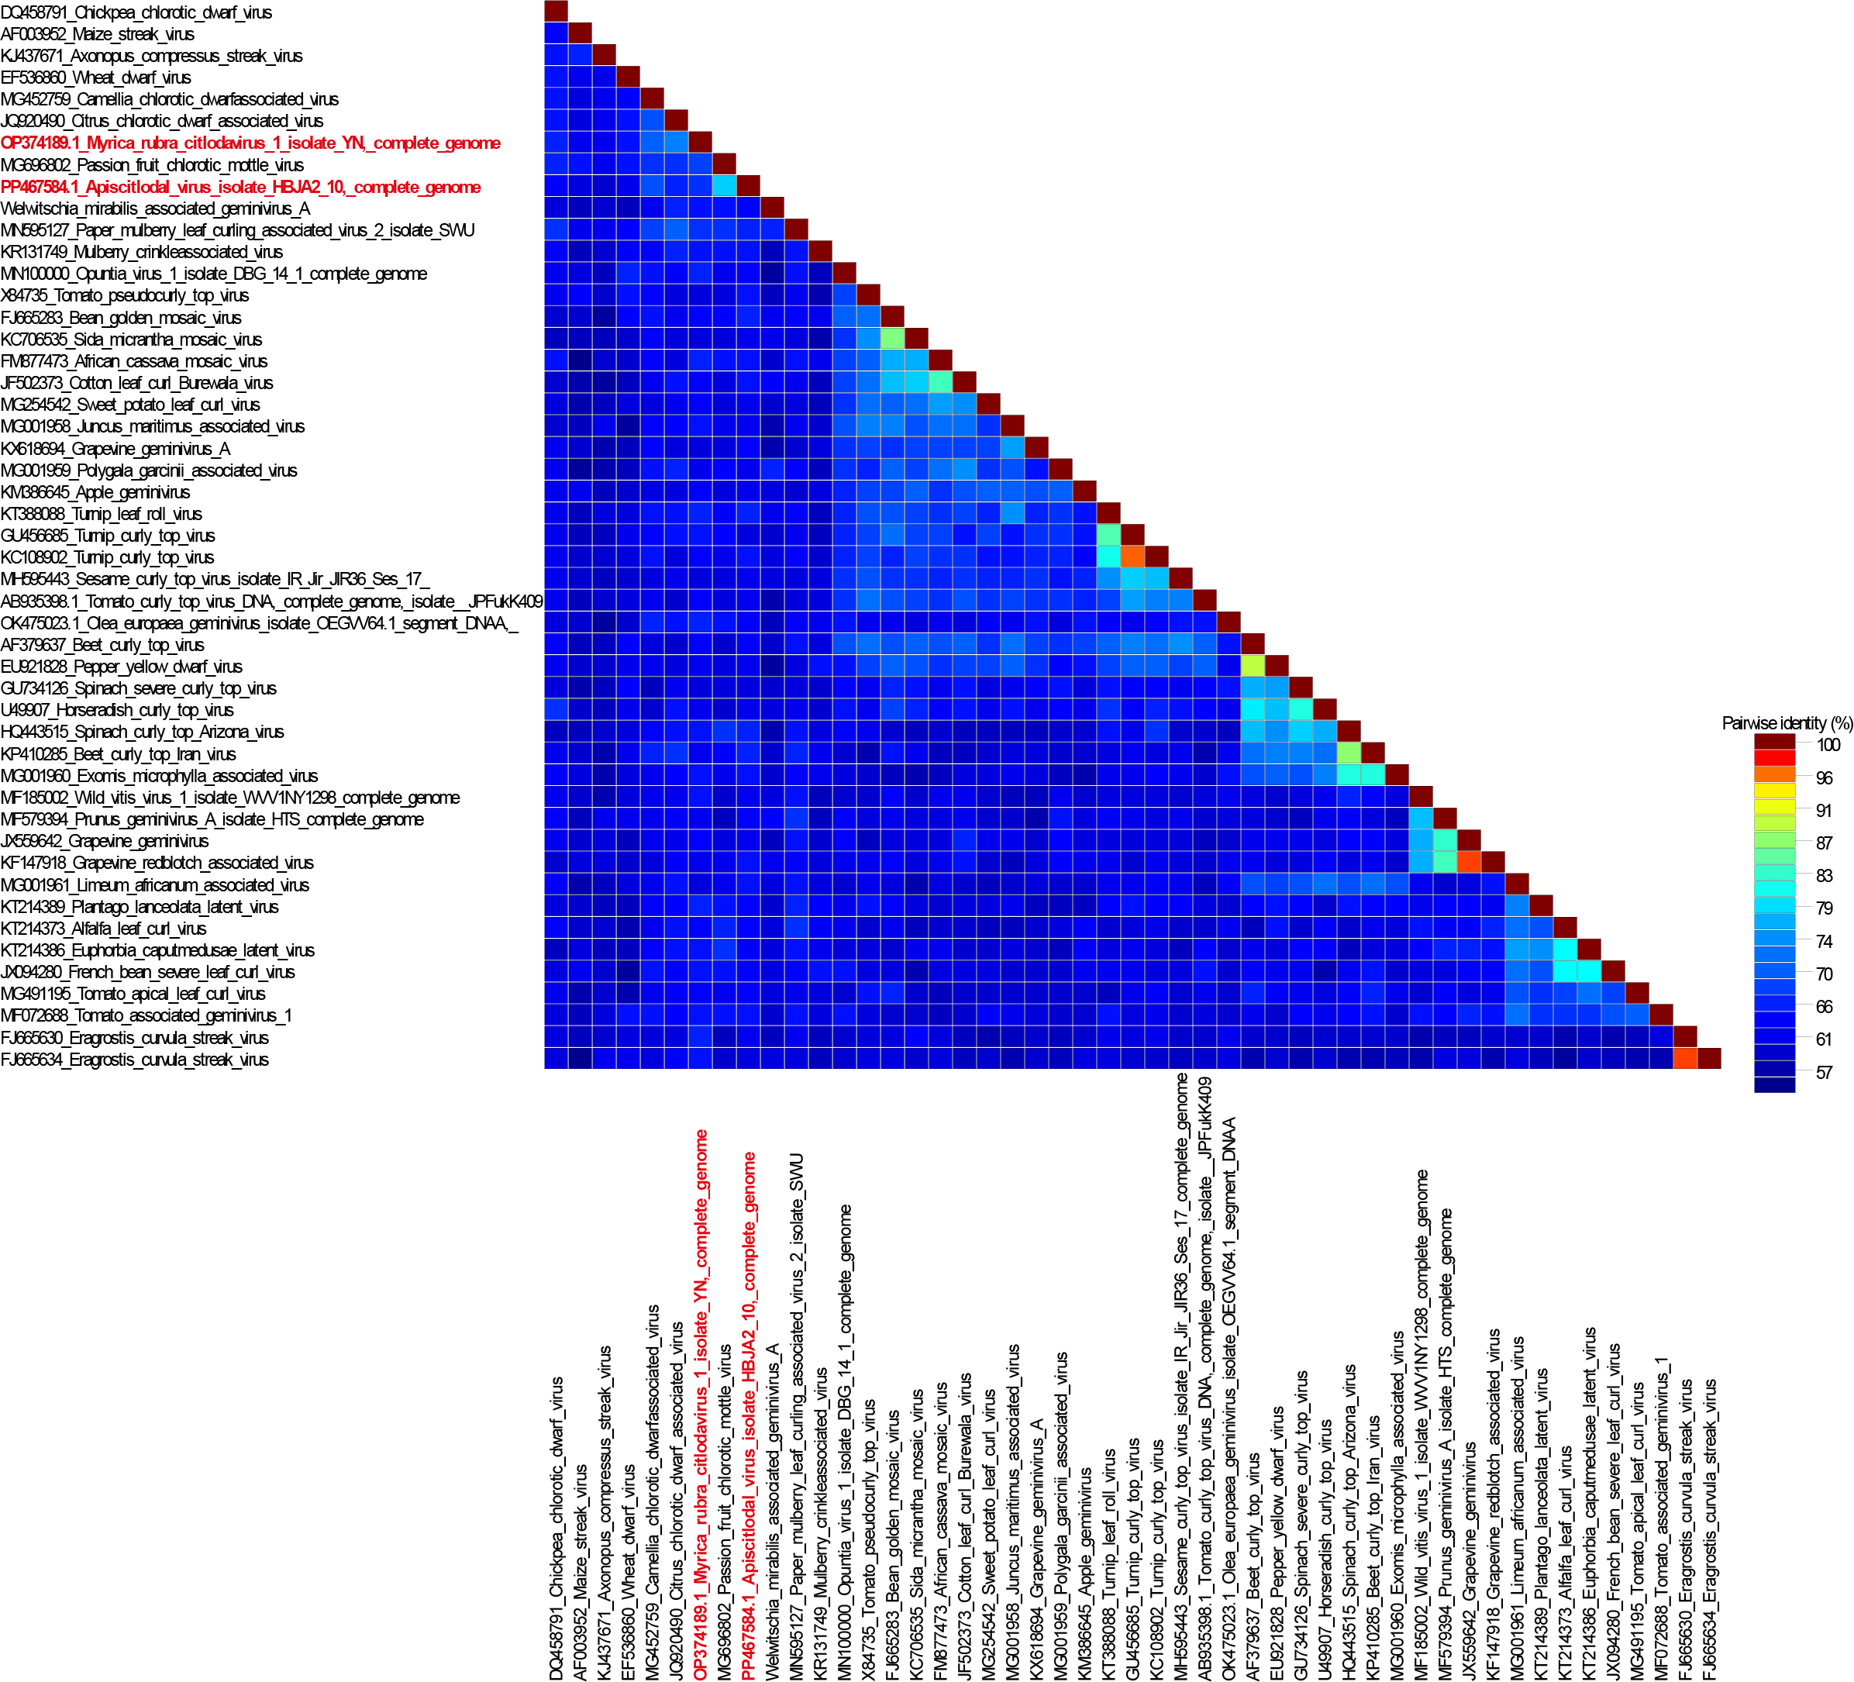

**Figure 2:** Unrooted neighbor-joining tree inferred from aligned full-genome nucleotide sequences of all *Citlodavirus* species, one species of the *Mulcrilevirus* genus, *Citlodavirus apijamaicaense* and *Citlodavirus myricae*. The genomes were aligned using Clustal W (Larkin et al., 2007) and a Neighbor-joining phylogenetic tree was inferred with Jukes Cantor substitution model and 1000 bootstrap iterations.

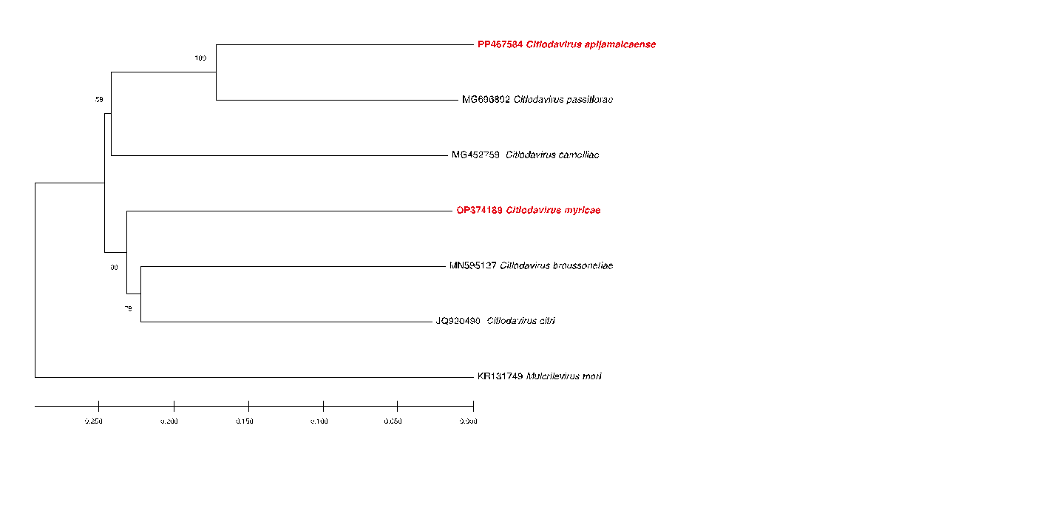

**Figure 3:** Illustration of the genome organization of *Citlodavirus apijamaicaense* and *Citlodavirus myricae*

