

The International Committee on Taxonomy of Viruses

Taxonomy Proposal Form, 2024

**Part 1a: Details of taxonomy proposals**

|  |  |
| --- | --- |
| **Title:** | Create two new species in the genus *Orthotospovirus* (*Elliovirales*: *Tospoviridae*) |
| **Code assigned:** | 2024.003P.A.v1.Tospoviridae_2nsp | |

|  |  |  |  |
| --- | --- | --- | --- |
| **Author(s), affiliation and email address(es):** | | | |
| **Name** | **Affiliation** | **Email address** | **Corresponding author(s)** X |
| Tomitaka Y | Institute for Plant Protection, NARO, Tsukuba, Japan | yasut@affrc.go.jp |  |
| Shimomoto Y | Kochi Agricultural Research Center, Nankoku, Japan | yoshifumi_shimomoto@ken2.pref.kochi.lg.jp |  |
| Sasaya T | Strategic Planning Headquarters, NARO, Tsukuba, Japan | tsasaya@affrc.go.jp | **X** |

**Part 1b: Taxonomy Proposal Submission**

|  |  |  |  |
| --- | --- | --- | --- |
| **ICTV Subcommittee:** | | | |
| Animal DNA Viruses and Retroviruses |  | Bacterial viruses |  |
| Animal minus-strand and dsRNA viruses |  | Fungal and protist viruses |  |
| Animal positive-strand RNA viruses |  | Plant viruses | X |
| Archaeal viruses |  | General - |  |

|  |
| --- |
| **List the ICTV Study Group(s) that have seen or have been involved in creating this proposal:** |
| *Tospoviridae* Study Group: P. Margaria (chair), S. Adkins, A. Ghosh, H. Hughes, N. Rayapati, M. Turina, A. Whitfield |

|  |  |  |  |
| --- | --- | --- | --- |
| **Optional – complete only if formally voted on by an ICTV Study Group:** | | | |
| **Study Group** | **Number of members** | | |
| **Votes in support** | **Votes against** | **No vote** |
| *Tospoviridae* | 7 | - | - |
|  |  |  |  |

|  |  |
| --- | --- |
| **Submission date:** | 13/06/2024 |

**Part 1c: Feedback from ICTV Executive Committee (EC) meeting**

|  |  |
| --- | --- |
| **Executive Committee Meeting Decision code:** | **X** |
| A – Accept | **X** |
| Ac – Accept subject to revision by relevant subcommittee chair. No further vote required |  |
| U – Accept without revision but with re-evaluation and email vote by the EC |  |
| Uc – Accept subject to revision and re-evaluation and email vote by the EC |  |
| Ud – Deferred to the next EC meeting, with an invitation to revise based on EC comments |  |
| J - Reject |  |
| W - Withdrawn |  |

|  |
| --- |
| **Comments from the Executive Committee:** |
|  |

**Part 1d: Revised Taxonomy Proposal Submission**

|  |
| --- |
| **Response of proposer:** |
|  |

|  |  |
| --- | --- |
| **Revision date:** | DD/MM/YYYY |

**Part 3:** **TAXONOMIC PROPOSAL**

|  |
| --- |
| **Name of accompanying Excel module:** |
| 2024.003P.A.v1.Tospoviridae_2nsp.xlsx |

|  |  |  |  |
| --- | --- | --- | --- |
| **Taxonomic changes proposed:** | | | |
| Establish new taxon | **X** | Split taxon |  |
| Abolish taxon |  | Merge taxon |  |
| Move taxon |  | Promote taxon |  |
| Rename taxon |  | Demote taxon |  |
| Move and rename |  |

|  |  |  |
| --- | --- | --- |
| **Is any taxon name used here derived from that of a living person:** | | **Y/N N** |
| **Taxon name** | **Person from whom the name is derived** | **Attached X** |
|  |  |  |
|  |  |  |
|  |  |  |

|  |
| --- |
| **Abstract of Taxonomy Proposal:** |
| We propose the classification of two newly discovered tospovirids into new species in the genus *Orthotospovirus*, on the base of a species demarcation criteria in the amino acid sequence of the RNA-directed RNA polymerase (RdRp) and nucleocapsid protein (N). |

|  |
| --- |
| **Text of Taxonomy proposal:** |
| In the family *Tospoviridae,* the genus *Orthotospovirus* currently includes 26 species, represented by: alstroemeria necrotic streak virus, alstroemeria yellow spot virus, bean necrotic mosaic virus, calla lily chlorotic spot virus, capsicum chlorosis virus, chrysanthemum stem necrosis virus, groundnut bud necrosis virus, groundnut chlorotic fan-spot virus, groundnut ringspot virus, groundnut yellow spot virus, hippeastrum chlorotic spot virus, impatiens necrotic spot virus, iris yellow spot virus, melon severe mosaic virus, melon yellow spot virus, mulberry vein banding-associated virus, pepper chlorotic spot virus, polygonum ringspot virus, soybean vein necrosis virus, tomato chlorotic spot virus, tomato spotted wilt virus, tomato yellow ring virus, tomato zonate spot virus, watermelon bud necrosis virus, watermelon silver mottle virus, and zucchini lethal chlorosis virus) [1]. Species demarcation based on sequence identity relies on amino acid sequence identity of the nucleocapsid protein (N) <90% with all other established orthotospoviruses [2].  **Creation of one novel species in the genus *Orthotospovirus*:**  Lisianthus necrotic ringspot virus (LNRV) was discovered in lisianthus (*Eustoma grandiflorum*) showing necrotic spots and ringspots [3]. LNRV genome consists of negative-sense or ambisense RNA molecules, L (large), M (medium), and S (small) segments. The L segment encodes a putative RNA-dependent RNA polymerase (RdRp). The M encodes a non-structural M protein (NSm) and a glycoprotein precursor. The S encodes a nucleocapsid protein (N) and a non-structural S protein (NSs). The genome organization of LNRV is similar to those of orthotospoviruses reported previously. A maximum likelihood phylogenetic tree was generated using amino acid sequences of the RdRp encoded by LNRV and the representative members of *Tospoviridae*, *Pribunyavoridae*, *Cruliviridae*, *Fimoviridae*, *Hantaviridae*, *Tulasviridae*, and *Phasmaviridae* families. In the phylogenetic tree, LNRV falls in the family *Tospoviridae* and forms a clade with groundnut chlorotic fan-spot virus (GCFSV) (Fig. 1). The amino acid identity value obtained with the RdRp of classified viruses in the family *Tospoviridae* is below the species demarcation criterion (<95% identity) of the class *Bunyaviricetes*, and the highest identity value, obtained with the RdRp encoded by GCFSV, is 88.8 %. In addition, a maximum likelihood phylogenetic tree was generated using amino acid sequences of the N protein encoded by LNRV and the member species of the genus *Orthotospovirus*. In the phylogenetic tree, LNRV is clearly distinct from other orthotospoviruses (Fig. 2). The highest identity value of the N aa sequence between LNRV and other orthotospoviruses is 25.7%, which is below the species demarcation criterion (<90%) of the family *Tospoviridae* (Table 2). Based on these reasons, we propose to classify LNRV as a member of a novel species, named *Orthotospovirus eustomae*.  **Origin of the name of the species:** Named after the plant host genus *Eustoma*, where LNRV was discovered  **Creation of a second novel species in the genus *Orthotospovirus*:**  Fatsia japonica ringspot-associated virus (FjRSaV) was discovered in *Fatsia japonica* showing ringspot [4]. FjRSaV genome consists of negative-sense or ambisense RNA molecules, L, M and S segments. The L encodes a putative RdRp. The M encodes an NSm and a glycoprotein precursor. The S encodes an N protein and an NSs protein. The genome organization of FjRSaV is similar to those of orthotospoviruses reported previously. A maximum likelihood phylogenetic tree was generated using amino acid sequences of the RdRp encoded by FjRSaV and the representative members of the *Tospoviridae*, *Pribunyavoridae*, *Cruliviridae*, *Fimoviridae*, *Hantaviridae*, *Tulasviridae*, and *Phasmaviridae* families. In the phylogenetic tree, FjRSaV falls into the family *Tospoviridae* and in the clade with GCFSV (Fig. 1). The amino acid identity value obtained with the RdRp of classified viruses in the family *Tospoviridae* is below the species demarcation criterion (<95% identity) of the class *Bunyaviricetes*, and the highest identity value obtained with the RdRp encoded by TYRV is 38.6%. In addition, a maximum likelihood phylogenetic tree was generated using amino acid sequences of the N encoded by FjRSaV and the members of all the species of the genus *Orthotospovirus*. In the phylogenetic tree, FjRSaV is clearly distinct from any other orthotospoviruses (Fig. 2). The highest identity value of the N between FjRSaV and orthotospoviruses is 83.7%, which is below the species demarcation criterion (<90%) of the family *Tospoviridae* (Table 2). Based on these reasons, we propose to classify FjRSaV as a member of a novel species, named *Orthotospovirus fatsiae*.  **Origin of the name of the species:**Named after the plant host genus *Fatsia*, where FjRSaV was discovered. |

|  |
| --- |
| **References:** |
| 1 Abulikemu Abudurexiti, Scott Adkins, Daniela Alioto, et al. (2019) Taxonomy of the order Bunyavirales: update 2019. Arch. Virol. 164:1949-1965.  2 Richard Kormelink, Jeanmarie Verchot, Xiaorong Tao, Cecile Desbiez. (2021) The Bunyavirales: The Plant-Infecting Counterparts. Viruses. 13:842. https://doi.org/10.3390/v13050842  3 Yoshifumi Shimomoto, Kappei Kobayashi, Mitsuru Okuda. (2014) Identification and characterization of Lisianthus necrotic ringspot virus, a novel distinct tospovirus species causing necrotic disease of lisianthus (*Eustoma grandiflorum*). J. Gen. Plant Pathol. 80:169-175.  4 Yugo Kitazawa, Takamichi Nijo, Masanobu Nishikawa, et al. (2022) Complete genome sequence of a new orthotospovirus associated with ringspot in *Fatsia japonica*. Arch. Virol. 167:615-618. |

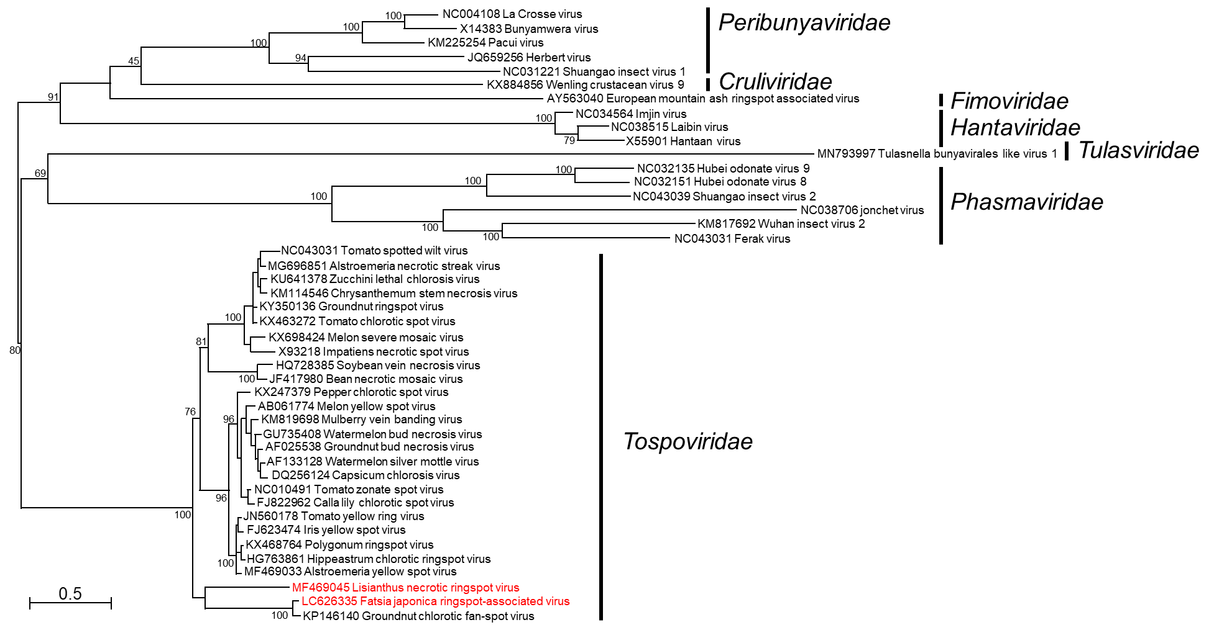**Figure 1.** Maximum likelihood phylogenetic tree of the RNA-dependent RNA polymerase (RdRp) amino acid sequences from members of the *Tospoviridae*, *Pribunyavoridae*, *Cruliviridae*, *Fimoviridae*, *Hantaviridae*, *Tulasviridae*, *Phasmaviridae* families, and two proposed viruses (red colored). MEGAX was used to align the sequences and IQTREE was used to generate the phylogenetic tree. Numbers on branches are bootstrap values (%) obtained from 1,000 replicates. Tree branches are proportional to genetic distances between sequences and the scale bars at the bottom indicate substitutions per amino acid site.

**Table 1.** Amino acid identity (%) matrix of the RNA-dependent RNA polymerase of two proposed viruses (LNRV and FjRSaV) and the closely related members of the genus *Orthotospovirus*.

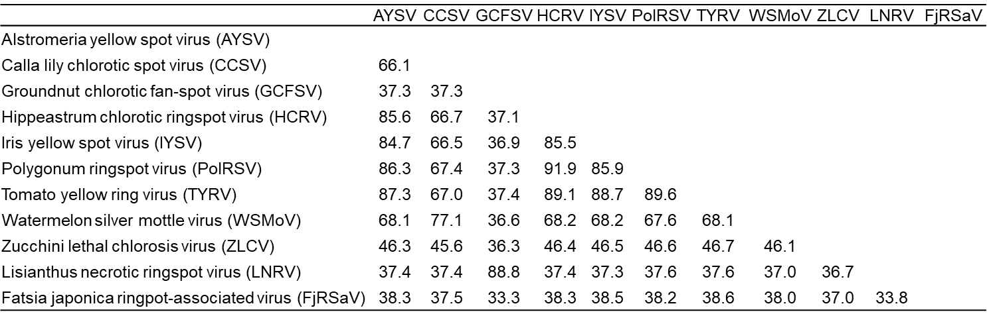

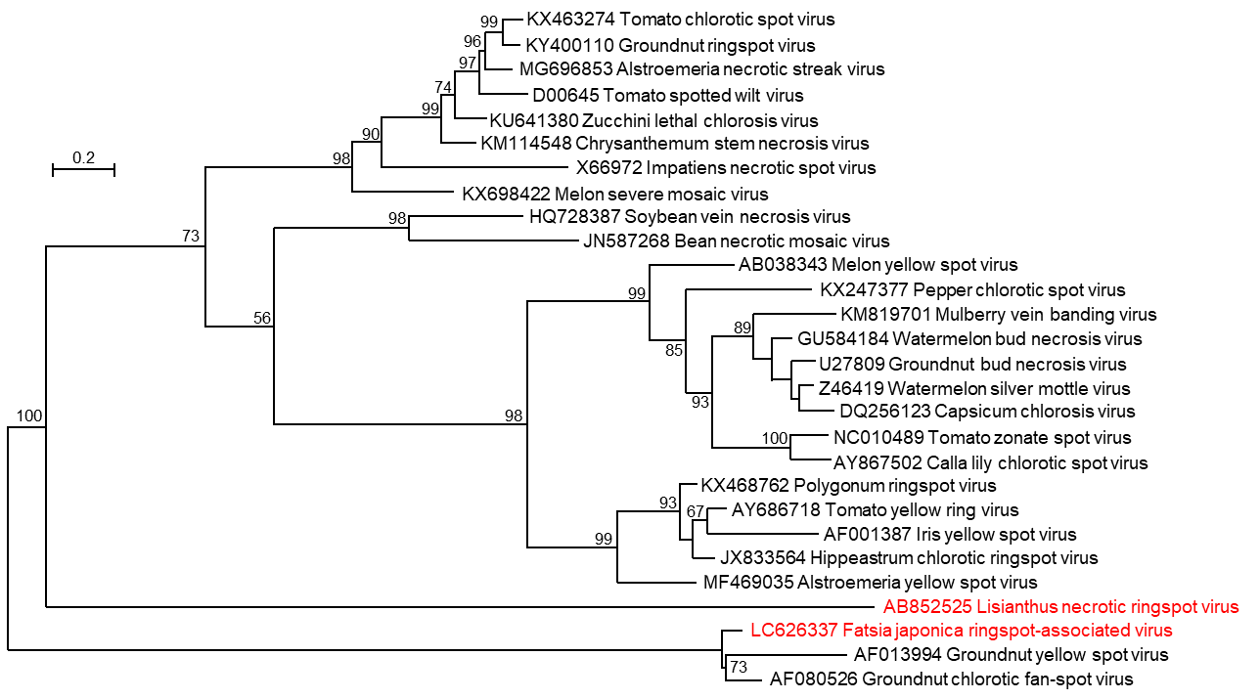

**Figure 2.** Maximum likelihood phylogenetic tree of the nucleocapsid (N) amino acid sequence of the members of the family *Tospoviridae* and two proposed viruses (red colored). MEGAX was used to align the sequences and IQTREE was used to generate phylogenetic tree. Numbers on branches are bootstrap values (%) obtained from 1,000 replicates. Tree branches are proportional to genetic distances between sequences and the scale bars at the top indicate substitutions per amino acid site.

**Table 2.** Amino acid identity (%) matrix of the nucleocapsid protein of two proposed viruses (LNRV and FjRSaV) and the closely related members of the genus *Orthotospovirus*.

