

The International Committee on Taxonomy of Viruses
Taxonomy Proposal Form, 2025

Part 1a: Details of taxonomy proposals

Title: | Creation of 3 new subgenera and 16 new species within the genus Chlorovirus (Phycodnaviridae) to position and name chloroviruses isolates
Code assigned: | 2025.010F.Uc.v3.Chlorovirus_3ngen_16nsp_2mergesp

Author(s), affiliation and email address(es):
Given name (+middle initial(s)) | Surname | Affiliation | Email address | Corr. author(s)
Rodrigo A L | Rodrigues | Dept. Microbiologia, Universidade Federal de Minas Gerais, Belo Horizonte, Brazil | rodriguesral07@gmail.com | X
João Victor RP | Carvalho | Dept. Microbiologia, Universidade Federal de Minas Gerais, Belo Horizonte, Brazil | jvrodrigues934@gmail.com
Letícia R | Henriques | Dept. Microbiologia, Universidade Federal de Minas Gerais, Belo Horizonte, Brazil | henriques.lethicia@gmail.com
David D | Dunigan | Dept. Plant Pathology, University of Nebraska-Lincoln, Lincoln, USA | ddunigan2@unl.edu
James L | Van Etten | Dept. Plant Pathology, University of Nebraska-Lincoln, Lincoln, USA | jvanetten1@unl.edu

Part 1b: Taxonomy Proposal Submission
ICTV Subcommittee:
Animal DNA Viruses and Retroviruses |  | Bacterial viruses
Animal minus-strand and dsRNA viruses |  | Fungal and protist viruses | X
Animal positive-strand RNA viruses |  | Plant viruses
Archaeal viruses |  | General -

List the ICTV Study Group(s) that have seen or have been involved in creating this proposal:
Optional – complete only if formally voted on by an ICTV Study Group:
Study Group | Number of members
Study Group | Votes in support | Votes against | No vote

Submission date: | 20/06/2025

Part 1c: Feedback from ICTV Executive Committee (EC) meeting
Executive Committee Meeting Decision code: | X
A – Accept
Ac – Accept subject to revision by relevant subcommittee chair. No further vote required
U – Accept without revision but with re-evaluation and email vote by the EC
Uc – Accept subject to revision and re-evaluation and email vote by the EC
Ud – Deferred to the next EC meeting, with an invitation to revise based on EC comments
J - Reject
W - Withdrawn

Comments from the Executive Committee:
Please address the following:
- Email address for Dr Etten
- Change RefSeq with GenBank accession number in Table 1 and Excel file
- Check the completeness of genomes in the Excel file are reported correctly
- Proofread for possible typos
- Check the abstract quality

Part 1d: Revised Taxonomy Proposal Submission
Response of proposer:
All comments and recommendations from the EC were properly addressed in this version.

Revision date: | 11/01/2025

Part 3: TAXONOMIC PROPOSAL
https://ictv.global/taxonomy/templates
Taxonomic changes proposed:
Establish new taxon | X | Split taxon
Abolish taxon | X | Merge taxon
Move taxon |  | Promote taxon
Rename taxon |  | Demote taxon
Move and rename | X

Etymology (origin) of proposed taxonomic names:
Taxon name | Etymology of the term
“Alphachlorovirus” | From the Ancient Greek ἄλφα (álpha), the first letter of the Greek alphabet and the current genera Chlorovirus
“Betachlorovirus” | From the Ancient Greek βῆτα (bêta), the second letter of the Greek alphabet and the current genera Chlorovirus
“Gammachlorovirus” | From the Ancient Greek γάμμα (gámma), the third letter of the Greek alphabet and the current genera Chlorovirus
“Chlorovirus primosyngense” | From the first (primo-) isolate to replicate only in the Syngen 2-3 strain (syngense) of Chlorella variabilis
“Chlorovirus alphanebraskense” | A species containing multiple isolates belonging to the subgenus Alphachlorovirus (alpha-), all isolated from lakes located in Nebraska
“Chlorovirus syngense” | A species containing multiple isolates capable of replicating only in the Syngen 2-3 strain (syngense) of Chlorella variabilis
“Chlorovirus alphaalkalinus” | A species containing isolates belonging to the subgenus Alphachlorovirus (alpha-), isolated from Nebraska alkaline lakes (-alkalinus)
“Chlorovirus alphagardense” | A species containing isolates belonging to the proposed Alphachlorovirus (alpha-), isolated from alkaline lakes located at the Garden (-gardense) County of Nebraska, USA
“Chlorovirus betanebraskense” | A species containing multiple isolates belonging to the subgenus Betachlorovirus (beta-), all isolated in Nebraska (nebraskense)
“Chlorovirus longinquus” | A species containing isolates that are phylogenetically distant (longinquus, Latin word for “distant”) from the other betachloroviruses, but still included in the subgenus
“Chlorovirus novaeterrae” | A species containing multiple isolates obtained from different regions of America (novaeterrae, Latin expression for “new world”, referring to the American continent)
“Chlorovirus guatemalense” | A species containing a single isolate obtained from Guatemala
Chlorovirus gammanebraskense | A species containing multiple isolates belonging to the subgenus Gammachlorovirus (gamma-), all isolated in Nebraska (nebraskense)
“Chlorovirus solusgardense” | A species containing only one isolate (“solus-”, Latin word for “only”), obtained from alkaline lakes located at the Garden (-gardense) County of Nebraska, USA
“Chlorovirus gammagardense” | A species containing isolates belonging to the subgenus Gammachlorovirus (gamma-), isolated from alkaline lakes located at the Garden (-gardense) County of Nebraska, USA
“Chlorovirus multilacus” | A species containing isolates obtained from multiple (multi-) lakes (lacus) in the USA
“Chlorovirus insulalacus” | A species containing a single isolate obtained from the Island Lake (insula lacus, Latin words for Island Lake) located in Nebraska, USA
“Chlorovirus minnesotense” | A species containing a single isolate obtained from Minnesota, USA
“Chlorovirus arcticum” | A species containing a single isolate obtained from the Arctic region, specifically from Greenland

Permission for use of names derived from a living person:
Taxon name | Full name of person from whom the name is derived | Attached
NA | NA

Abstract of Taxonomy Proposal:
Taxonomic rank(s) affected: The genus Chlorovirus includes large DNA viruses capable of replicating in chlorella-like green algae. The chloroviruses have been isolated since the 1980s, found in inland waters worldwide. Genomic and biological data indicate the existence of three groups of chloroviruses.

Description of current taxonomy: Included in the family Phycodnaviridae, there are currently six species of chloroviruses. Dozens of isolates have been described over the last years, but a formal proposal to adequately classify these viruses has not yet been made.

Proposed taxonomic change(s): Here, we propose the creation of three subgenera, named “Alphachlorovirus”, “Betachlorovirus”, and “Gammachlorovirus”, to classify the different groups of chloroviruses. This classification is demarcated by phylogenetic analysis based on the several genes, usually used for phylogenetic reconstructions of giant viruses. Furthermore, based on the nucleotide identity of the whole viral genome (≥94%), we propose the creation of 16 new chlorovirus species and the abolition of two others, which should be merged with other existing species.

Justification: The genus Chlorovirus was formally created in 1998. Since then, many chloroviruses have been obtained and characterized. However, limited progress has been made regarding the taxonomy. With dozens of isolates with available genomes, it is clear that there are three large groups of chloroviruses that must be properly classified. Furthermore, with many isolates, we can now advance the taxonomy of these viruses and establish new species. This will guide the group's taxonomy, hoping that new viruses can emerge and be properly classified.

- Text of Taxonomy proposal:
Taxonomic rank(s) affected:
This proposal relates to taxonomic updates in the family Phycodnaviridae, genus Chlorovirus, with the creation of subgenera and new species.

Description of current taxonomy:
The family Phycodnaviridae is currently the only taxon included in the order Algavirales. This family contains six genera including large double-stranded DNA viruses that infect a diverse group of algae. The oldest and most studied is the genus Chlorovirus, which currently has six viral species (ICTV proposal 2023.010F.Phycodnaviridae_abolish19sp_spren). Chloroviruses have been isolated worldwide since the early 1980s in inland waters (1). These viruses form large plaques in chlorella-like green algae cells in laboratory conditions, being very specific to their hosts. The virus study model, the Paramecium bursaria Chlorella virus 1 (PBCV-1), previously considered the type species of genus Chlorovirus (ICTV proposal 2020.001G.R.Abolish_type_species), is now named Chlorovirus vanettense. After the isolation of PBCV-1, many other chloroviruses were isolated and characterized (2,3), but only a few were included in the taxonomic classification, resulting in the current six-species taxonomy. However, there was no proper rationale for classifying those isolates into virus species, which requires an urgent update to the current taxonomy of the genus Chlorovirus.

There are three groups of chloroviruses defined a priori by the host cells, commonly named NC64A viruses (i.e., viruses that replicate in Chlorella variabilis NC64A), Pbi viruses (i.e., viruses that replicate in Micractinium conductrix Pbi), and SAG viruses (i.e., viruses that replicate in Chlorella heliozoae SAG 3.83) (1). A few years ago, a new group of chloroviruses was discovered, capable of replicating only in Chlorella variabilis Syngen 2-3 cells, hereinafter referred to as OSy viruses (i.e., Only-Syngen viruses) (4). Genomics and phylogenetic analyses corroborate the existence of the three groups, while the OSy viruses are included within the NC64A viruses’ group (3,4). Notably, a formal proposal to properly classify these viruses has not yet been made. In recent years, many new chloroviruses have been isolated, especially from alkaline lakes located in Nebraska (USA), which has improved our understanding of the diversity and evolution of these viruses (5).

Proposed taxonomic change(s):
Here we propose the creation of three subgenera within the genus Chlorovirus, the creation of 16 new species, and the abolition of two species included in the current taxonomy.

To this end we analyzed 131 chlorovirus genomes using both a concatenated phylogenetic approach (Figure 1) and by examining pairwise average nucleotide identity (ANI; Figures 2 to 5). The tree relies on the concatenated alignment of 33 genes shared among chloroviruses and ostreococcus viruses (genus Prasinovirus), resulting in robust phylogenetic placement of new isolates. To define the core genes, we used OrthoFinder (6) to build orthologous groups of genes considering the amino acid sequences of all predicted genes of the viruses. This strategy improves the resolution of trees, especially considering the existence of divergent viruses, as observed for some viruses infecting Micractinium conductrix (3). We included prasinoviruses (genus Prasinovirus, family Phycodnaviridae) as an outgroup in phylogenetic analyses. Subgenera are demarcated as they have approximately equivalent phylogenetic breadths (i.e., distance from the root). Species are demarcated based on genome identity analysis.

Guidelines used for new names:

Proposed subgenera have Greek letters as prefixes, being “Alpha-”, “Beta-”, and “Gamma-”, followed by the genus name “chlorovirus”. This will facilitate the possible creation of other subgenera, in case new divergent chloroviruses are discovered in the future. For species, we adopted binomial names, as requested by the ICTV. The genus is the one already established (Chlorovirus), while the specific epithet refers to subgenera and/or geography where the viruses were sampled or isolated (ex: alphanebraskense denoting a species belonging to the proposed Alphachlorovirus subgenera that contains viruses isolated in Nebraska, USA). A full list of all proposed binomial names is included in the above section. Table 1 contains all the proposed species and isolates related to each taxon.

Demarcation criteria:
Members of the same species have pairwise ANI ≥ 94% considering the whole viral genome. Most species contain multiple viral isolates meeting these criteria (Table 1, Figure 2). Based on this, the species Chlorovirus illinois and Chlorovirus newyorkense included in the current taxonomy should be considered the same species as Chlorovirus vanettense and Chlorovirus americanus, respectively. Therefore, we propose to abolish these two species and retain Chlorovirus vanettense, which contains the isolate PBCV-1, and Chlorovirus americanus, which contains isolates from different regions of North America, with the specific epithet being more appropriate.

Subgenera are defined as monophyletic clades within the genus Chlorovirus where the concatenated tree has high bootstrap support (100%) and approximately equivalent phylogenetic breadth (Figure 1A). The tree relies on the concatenated alignment of 33 genes (Table 2) shared among chloroviruses and prasinoviruses (genus Prasinovirus), resulting in robust phylogenetic placement of new isolates. We randomly chose a representative isolate (in cases where species are composed of more than one viral isolate) to build a species tree considering the 33 core genes, and the topology is clearly related to the ANI pattern (Figure 1B), reinforcing the criteria used to demarcate the proposed taxa. In addition, the viral species included in each subgenus contain isolates with a very stringent host range, whereby viruses included in a subgenus do not infect hosts that are usually exploited by viruses from another subgenus (e.g.: viruses from the subgenus “Alphachlorovirus” infect only Chlorella variabilis, while viruses from the subgenus “Betachlorovirus” infect only Micractinium conductrix). Therefore, we propose using the viral hosts as an additional line of evidence for the creation of three distinct subgenera in the genus Chlorovirus.

Justification:
The genus Chlorovirus was formally created in 1998, replacing the original genus Phycodnavirus, which included the previously known species Paramecium bursaria Chlorella virus 1, now renamed Chlorovirus vanettense. Since then, many isolates have been obtained and characterized, improving our understanding of chlorovirus genomics and evolution. However, limited progress has been made regarding the group's taxonomy, which includes only 6 species in the current taxonomy. With over a hundred isolates with available genomes, it is clear that there exist three large groups of chloroviruses that must be properly classified at their own taxa rank. Furthermore, with so many isolates, we can now advance the taxonomy of these viruses and establish new species. This will guide the group's taxonomy, hoping that new viruses can emerge and be properly classified using the standards proposed here.

References:
- Van Etten JL, Agarkova IV, Dunigan DD. Chloroviruses. Viruses. 2019 Dec 23;12(1):20. doi: 10.3390/v12010020. PMID: 31878033; PMCID: PMC7019647.
- Bubeck JA, Pfitzner AJP. Isolation and characterization of a new type of chlorovirus that infects an endosymbiotic Chlorella strain of the heliozoon Acanthocystis turfacea. J Gen Virol. 2005 Oct;86(Pt 10):2871-2877. doi: 10.1099/vir.0.81068-0. PMID: 16186243.
- Jeanniard A, Dunigan DD, Gurnon JR, Agarkova IV, Kang M, Vitek J, Duncan G, McClung OW, Larsen M, Claverie JM, Van Etten JL, Blanc G. Towards defining the chloroviruses: a genomic journey through a genus of large DNA viruses. BMC Genomics. 2013 Mar 8;14:158. doi: 10.1186/1471-2164-14-158. PMID: 23497343; PMCID: PMC3602175.
- Quispe CF, Esmael A, Sonderman O, McQuinn M, Agarkova I, Battah M, Duncan GA, Dunigan DD, Smith TPL, De Castro C, Speciale I, Ma F, Van Etten JL. Characterization of a new chlorovirus type with permissive and non-permissive features on phylogenetically related algal strains. Virology. 2017 Jan;500:103-113. doi: 10.1016/j.virol.2016.10.013. Epub 2016 Oct 27. PMID: 27816636; PMCID: PMC5127778.
- Carvalho JVRP, Carlson RM, Ghosh J, Queiroz VF, de Oliveira EG, Botelho BB, Filho CAC, Agarkova IV, McClung OW, Van Etten JL, Dunigan DD, Rodrigues RAL. Genomics and evolutionary analysis of Chlorella variabilis-infecting viruses demarcate criteria for defining species of giant viruses. J Virol. 2024 Oct 15:e0036124. doi: 10.1128/jvi.00361-24. Epub ahead of print. PMID: 39404263.
- Emms DM, Kelly S. OrthoFinder: phylogenetic orthology inference for comparative genomics. Genome Biol. 2019 Nov 14;20(1):238. doi: 10.1186/s13059-019-1832-y. PMID: 31727128; PMCID: PMC6857279.

Accompanying files:
Filename | Description of contents
2025.010F.Uc.v3.Chlorovirus_3ngen_16nsp_2mergesp.xlsx

Tables, Figures:
<Start here>

Table 1: Proposed taxonomy
Subgenus | Species | Virus isolate | NCBI access.
“Alphachlorovirus” | Chlorovirus vanettense | Paramecium bursaria Chlorella 1 (PBCV-1) | JF411744
 |  | chlorovirus XZ-3A | PP681882
 |  | chlorovirus 40-NE-3 | PP681862
 |  | chlorovirus s 40-NE-4 | PP681863
 |  | chlorovirus 41-NE-5 | PP681866
 |  | Paramecium bursaria Chlorella NE-JV-4 | JX997179
 |  | chlorovirus WNE-11A-L2 | PP681876
 |  | Paramecium bursaria Chlorella IL-3A | JX997169
 |  | Paramecium bursaria Chlorella AN69C | JX997153
 |  | chlorovirus CA-4B | PP681878
 |  | chlorovirus NC-1A | PP681879
 |  | chlorovirus XZ-5C | PP681884
 |  | chlorovirus SH-6A | PP681881
 |  | chlorovirus XZ-6E | PP681885
 |  | Paramecium bursaria Chlorella KS1B | JX997171
 |  | chlorovirus NY-2C | PP681880
 |  | chlorovirus CA-4A | PP681877
 |  | Paramecium bursaria Chlorella MA-1E | JX997173
 |  | Paramecium bursaria Chlorella CviKI | JX997162
 |  | Paramecium bursaria Chlorella CvsA1 | JX997165
 |  | chlorovirus XZ-4C | PP681883
 | Chlorovirus americanus | chlorovirus WNE-10B-S1 | PP681875
 |  | Paramecium bursaria Chlorella MA-1D | JX997172
 |  | Paramecium bursaria Chlorella NYs1 | JX997183
 |  | Paramecium bursaria Chlorella IL-5-2-s1 | JX997170
 |  | Paramecium bursaria Chlorella NY-2B | JX997182
 |  | Paramecium bursaria Chlorella AR158 | DQ491003
 |  | Paramecium bursaria Chlorella NY-2A | DQ491002
 | Chlorovirus primosyngense | chlorovirus NE-41-1-L | PP681870
 |  | chlorovirus OSyNE-5A-L1 | PP681911
 |  | Chlorovirus OSyNE-4B-L2 | PP681908
 |  | Chlorovirus O-NE-17 | PP681893
 |  | chlorovirus O-NE-20 | PP681896
 |  | chlorovirus NE-O-9-L | PP681907
 |  | chlorovirus O-NE-24 | PP681899
 |  | chlorovirus NE-O-8-L | PP681906
 |  | chlorovirus OSyNE-ZA | PP681914
 |  | chlorovirus O-NE-28 | PP681903
 |  | chlorovirus s O-NE-15 | PP681891
 |  | only Syngen Nebraska virus 5 | KX857749
 |  | chlorovirus OSyNE-5B-S1 | PP681913
 |  | chlorovirus O-NE-10 | PP681886
 |  | chlorovirus OSyNE-4B-M2 | PP681909
 |  | chlorovirus OSyNE-5B-M2 | PP681912
 |  | chlorovirus OSyNE-4B-S1 | PP681910
 |  | chlorovirus O-NE-16 | PP681892
 | Chlorovirus alphanebraskense | chlorovirus NE-41-3-s | PP681872
 |  | chlorovirus NE-40-2-s | PP681869
 |  | chlorovirus 41-NE-4 | PP681865
 |  | chlorovirus 40-NE-5 | PP681864
 |  | chlorovirus N-NE-5 | PP681874
 |  | chlorovirus NE-40-1-m | PP681868
 |  | chlorovirus NE-41-2-m | PP681871
 |  | chlorovirus O-NE-12 | PP681874
 |  | chlorovirus O-NE-26 | PP681901
 |  | chlorovirus 41-NE-6 | PP681867
 |  | chlorovirus N-NE-4 | PP681873
 | Chlorovirus syngense | chlorovirus O-NE-25 | PP681900
 |  | chlorovirus O-NE-27 | PP681902
 |  | chlorovirus O-NE-29 | PP681904
 |  | chlorovirus O-NE-19 | PP681895
 |  | chlorovirus O-NE-22 | PP681897
 |  | chlorovirus NE-O-7-s | PP681905
 |  | chlorovirus O-NE-23 | PP681898
 |  | chlorovirus O-NE-18 | PP681894
 | Chlorovirus alphaalkalinus | chlorovirus O-NE-11 | PP681887
 |  | chlorovirus O-NE-14 | PP681890
 | Chlorovirus alphagardense | chlorovirus O-NE-13 | PP681889
“Betachlorovirus” | Chlorovirus conductrix | Paramecium bursaria Chlorella virus MT325 | DQ491001
 |  | chlorovirus P-NE-10 | PV288770
 |  | Paramecium bursaria Chlorella virus Can18-4 | JX997157
 |  | chlorovirus P-NE-9 | PV288769
 |  | Paramecium bursaria Chlorella virus CVG-1 | JX997161
 |  | Paramecium bursaria Chlorella virus NW665.2 | JX997181
 |  | Paramecium bursaria Chlorella virus CVM-1 | JX997163
 |  | Paramecium bursaria Chlorella virus CVR-1 | JX997164
 |  | Paramecium bursaria Chlorella virus CVA-1 | JX997159
 |  | Paramecium bursaria Chlorella virus AP110A | JX997154
 |  | Paramecium bursaria Chlorella virus FR483 | DQ890022
 |  | Paramecium bursaria Chlorella virus CVB-1 | JX997160
 | Chlorovirus betanebraskense | chlorovirus NE-P-1-L | PV288763
 |  | chlorovirus P-NE-13 | PV288773
 |  | chlorovirus NE-P-2-m | PV288764
 |  | chlorovirus P-NE-11 | PV288771
 |  | Paramecium bursaria Chlorella virus Fr5L | JX997167
 |  | Paramecium bursaria Chlorella virus CZ-2 | JX997166
 |  | Paramecium bursaria Chlorella virus OR0704.2.2 | JX997184
 |  | chlorovirus NE-P-3-s | PV288765
 |  | chlorovirus P-NE-12 | PV288772
 |  | chlorovirus NE-P-4-fs | PV288766
 |  | chlorovirus NE-P-8-f | PV288768
 | Chlorovirus longinquus | chlorovirus NE-JV-1 | JX997176
 |  | chlorovirus NE-P-6-s | PV288767
“Gammachlorovirus” | Chlorovirus heliozoae | chlorovirus NES-5A-S1 | PQ067549
 |  | Acanthocystis turfacea Chlorella virus OR0704.3 | JX997185
 |  | chlorovirus LP-F3a-4a | PQ067565
 |  | Acanthocystis turfacea Chlorella virus Can0610SP | JX997156
 |  | chlorovirus S-NE-9 | PQ067552
 |  | Acanthocystis turfacea Chlorella virus NE-JV-2 | JX997177
 |  | chlorovirus S-NE-12 | PQ067555
 |  | chlorovirus S-NE-17 | PQ067559
 |  | chlorovirus S-NE-19 | PQ067561
 |  | chlorovirus S-NE-16 | PQ067558
 |  | chlorovirus S-NE-23 | PQ067564
 |  | chlorovirus S-NE-15 | PQ067557
 |  | Acanthocystis turfacea Chlorella virus NE-JV-3 | JX997178
 |  | Acanthocystis turfacea Chlorella virus 1 | EF101928
 |  | Acanthocystis turfacea Chlorella virus MO0605SPH | JX997175
 |  | chlorovirus S-NE-10 | PQ067553
 |  | Acanthocystis turfacea Chlorella virus WI0606 | JX997187
 |  | Chlorovirus NES-4B-L1 | PQ067546
 | Chlorovirus novaeterrae | Acanthocystis turfacea Chlorella virus Br0604L | JX997155
 |  | Acanthocystis turfacea Chlorella virus TN603.4.2 | JX997186
 |  | chlorovirus CL-S-1-m | PQ067543
 | Chlorovirus guatemalense | Acanthocystis turfacea Chlorella virus GM0701.1 | JX997168
 | Chlorovirus gammanebraskense | chlorovirus S-NE-7 | PQ067550
 |  | Acanthocystis turfacea Chlorella virus NTS-1 | JX997180
 |  | chlorovirus S-NE-13 | PQ067556
 | Chlorovirus solusgardense | chlorovirus S-NE-20 | PQ067562
 | Chlorovirus gammagardense | chlorovirus NES-5A-L1 | PQ067547
 |  | chlorovirus NES-4A-M1 | PQ067544
 |  | chlorovirus S-NE-18 | PQ067560
 |  | chlorovirus NES-5A-M1 | PQ067548
 | Chlorovirus multilacus | chlorovirus S-NE-8 | PQ067551
 |  | chlorovirus NES-4A-S1 | PQ067545
 |  | Acanthocystis turfacea Chlorella virus Canal-1 | JX997158
 |  | chlorovirus S-NE-22 | PQ067563
 | Chlorovirus insulalacus | chlorovirus S-NE-11 | PQ067554
 | Chlorovirus minnesotense | Acanthocystis turfacea Chlorella virus MN0810.1 | JX997174
 | Chlorovirus arcticum | chlorovirus GNLD-22 | PQ067566
Table 2: Genes used for phylogenetic reconstructions
#Gene | Function | PBCV-1  homolog | #Gene | Function | PBCV-1  homolog
01 | Protein of unknown function DUF5871 | A312L | 18 | P9 mCP; tape-measure protein | A407L
02 | DNA topoisomerase II large subunit | A583L | 19 | ATP-dependent RNA helicase | A153R
03 | Hypothetical protein | A470R | 20 | Ubiquitin carboxyl-terminal hydrolase | A105L
04 | Hypothetical protein | A471R | 21 | Hypothetical protein | A527R
05 | PCNA | A193L | 22 | Metallopeptidase WLM | A521aL
06 | DNA primase | A468R | 23 | Pox VLTF3 late transcription factor | A494R
07 | Cas4-like nuclease | A467L | 24 | Hypothetical protein | A488R
08 | Phage/plasmid primase, ATPase, superfamily III helicase | A456L | 25 | Hypothetical protein | A485R
09 | RNAse III | A464R | 26 | VLTF2 type transcription factor | A482R
10 | Ribonucleotide reductase large subunit | A629R | 27 | Hypothetical protein | A410L
11 | Hypothetical protein | A439R | 28 | ATP synthase | A401R
12 | P11 mCP; tape-measure protein | A352L | 29 | DNA packaging ATPase A32 | A382R
13 | P2 mCP; tape-measure protein | A342L | 30 | Hypothetical protein | A324L
14 | Poxvirus A22-like protein | A265L | 31 | Hypothetical protein | A127R
15 | Cas4-like nuclease | A166R | 32 | Transcription factor IIS | A125L
16 | Hypothetical protein | A602L | 33 | mRNA-capping enzyme | A103R
17 | Protein kinase | A445L

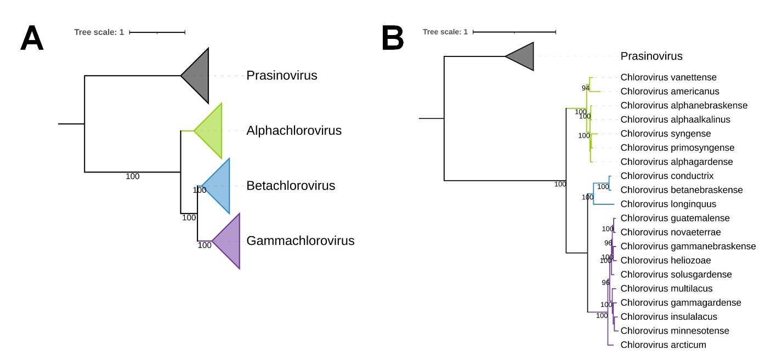Figure 1: Phylogeny of the genus Chlorovirus. A) Phylogenetic tree based on a concatenated alignment of 33 genes shared among chloroviruses and prasinoviruses (see main text for details), indicating the proposed subgenus, comprising 135 chlorovirus isolates; B) Phylogenetic tree representing the chloroviruses species, using a representative isolate from each species defined by nucleotide composition. Trees were rooted using prasinoviruses as outgroup. Bootstraps higher than 90 are shown. The Maximum Likelihood based phylogenies were constructed using IQ-TREE 2.2.0 and trees were visualized using iToL. Scale bars indicate the rate of substitution.
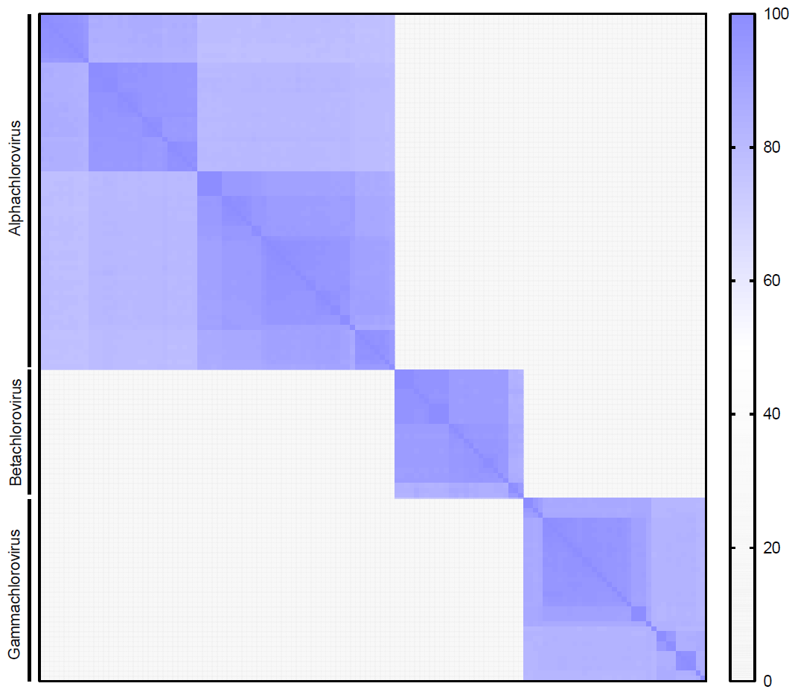Figure 2: Pairwise Average Nucleotide Identity (ANI) including 135 viral isolates in the genus Chlorovirus. ANI was calculated only if the average alignment fraction was >75%; otherwise, ANI was set to 0. Nucleotide comparisons were performed with FastANI.
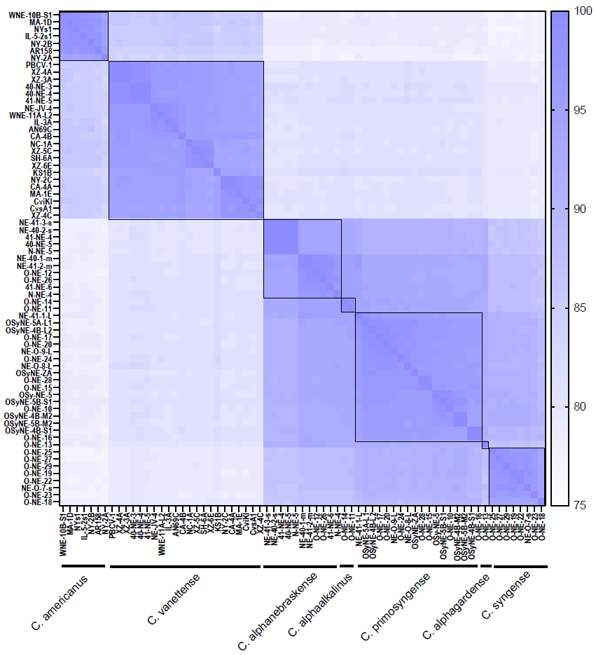Figure 3: Pairwise Average Nucleotide Identity (ANI) of the proposed subgenus “Alphachlorovirus”. ANI was calculated only if the average alignment fraction was >75%. Nucleotide comparisons were performed with FastANI. Black squares demarcate isolates sharing ANI ≥ 94%. Proposed species names are indicated below the graph.
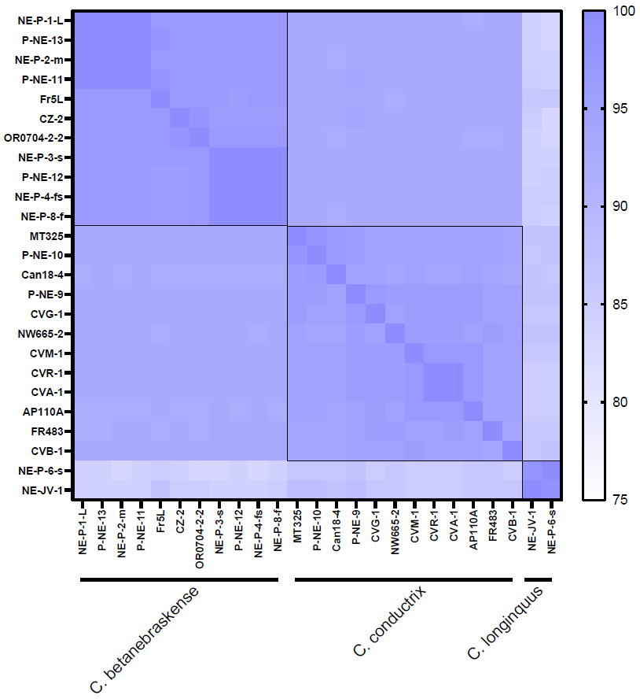Figure 4: Pairwise Average Nucleotide Identity (ANI) of the proposed subgenus “Betachlorovirus”. ANI was calculated only if the average alignment fraction was >75%. Nucleotide comparisons were performed with FastANI. Black squares demarcate isolates sharing ANI ≥ 94%. Proposed species names are indicated below the graph.
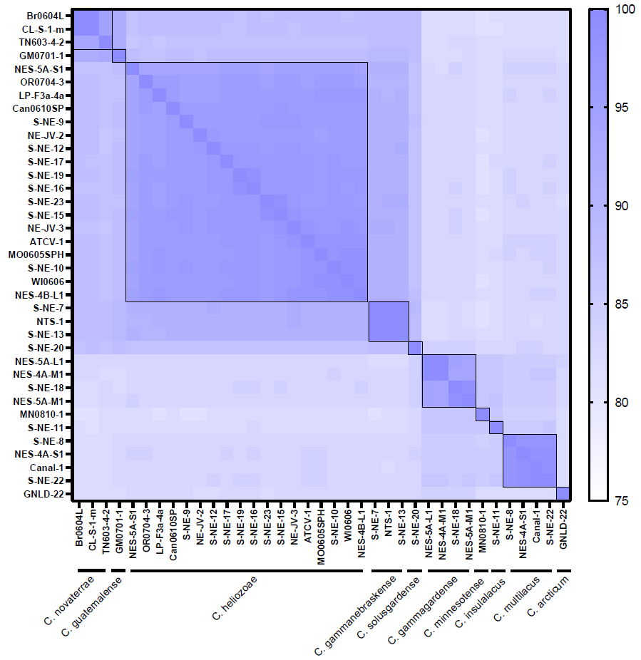Figure 5: Pairwise Average Nucleotide Identity (ANI) of the proposed subgenus “Gammachlorovirus”. ANI was calculated only if the average alignment fraction was >75%. Nucleotide comparisons were performed with FastANI. Black squares demarcate isolates sharing ANI ≥ 94%. Proposed species names are indicated below the graph.

