

The International Committee on Taxonomy of Viruses

Taxonomy Proposal Form, 2024

**Part 1a: Details of taxonomy proposals**

|  |  |  |
| --- | --- | --- |
| **Title:** | Rename and split an existing genus of the family *Cystoviridae* (*Vidaverviricetes: Mindivirales*), rename seven virus species, create two new species and genera | |
| **Code assigned:** | 2024.043B |

|  |  |  |  |
| --- | --- | --- | --- |
| **Author(s), affiliation and email address(es):** | | | |
| **Name** | **Affiliation** | **Email address** | **Corresponding author(s)** X |
| Poranen MM | Molecular and Integrative Biosciences Research Programme, Faculty of Biological and Environmental Sciences, University of Helsinki, Helsinki, Finland | minna.poranen@helsinki.fi | X |
| Mäntynen S | Molecular and Integrative Biosciences Research Programme, Faculty of Biological and Environmental Sciences, University of Helsinki, Helsinki, Finland | sari.mantynen@helsinki.fi |  |

**Part 1b: Taxonomy Proposal Submission**

|  |  |  |  |
| --- | --- | --- | --- |
| **ICTV Subcommittee:** | | | |
| Animal DNA Viruses and Retroviruses |  | Bacterial viruses | X |
| Animal minus-strand and dsRNA viruses | **(X)** | Fungal and protist viruses |  |
| Animal positive-strand RNA viruses |  | Plant viruses |  |
| Archaeal viruses |  | General - |  |

|  |
| --- |
| **List the ICTV Study Group(s) that have seen or have been involved in creating this proposal:** |
| *Cystoviridae* Study Group |

|  |  |  |  |
| --- | --- | --- | --- |
| **Optional – complete only if formally voted on by an ICTV Study Group:** | | | |
| **Study Group** | **Number of members** | | |
| **Votes in support** | **Votes against** | **No vote** |
|  |  |  |  |
|  |  |  |  |

|  |  |
| --- | --- |
| **Submission date:** | 21/06/2024 |

**Part 1c: Feedback from ICTV Executive Committee (EC) meeting**

|  |  |
| --- | --- |
| **Executive Committee Meeting Decision code:** | **X** |
| A – Accept |  |
| Ac – Accept subject to revision by relevant subcommittee chair. No further vote required |  |
| U – Accept without revision but with re-evaluation and email vote by the EC |  |
| Uc – Accept subject to revision and re-evaluation and email vote by the EC |  |
| Ud – Deferred to the next EC meeting, with an invitation to revise based on EC comments |  |
| J – Reject |  |
| W – Withdrawn |  |

|  |
| --- |
| **Comments from the Executive Committee:** |
| Amend excel module so that species moved with split genus are also renamed. |

**Part 1d: Revised Taxonomy Proposal Submission**

|  |
| --- |
| **Response of proposer:** |
| Corrected. |

|  |  |
| --- | --- |
| **Revision date:** | 30/09/2024 |

**Part 3:** **TAXONOMIC PROPOSAL**

|  |
| --- |
| **Name of accompanying Excel module:** |
| 2024.043B.A.v2.Cystoviridae_6ng_2nsp_1rng_7rnsp.xlsx |

|  |  |  |  |
| --- | --- | --- | --- |
| **Taxonomic changes proposed:** | | | |
| Establish new taxon | **X** | Split taxon | **X** |
| Abolish taxon |  | Merge taxon |  |
| Move taxon |  | Promote taxon |  |
| Rename taxon | **X** | Demote taxon |  |
| Move and rename |  |

|  |  |  |
| --- | --- | --- |
| **Is any taxon name used here derived from that of a living person:** | | **N** |
| **Taxon name** | **Person from whom the name is derived** | **Attached** |
|  |  |  |
|  |  |  |
|  |  |  |

|  |
| --- |
| **Abstract of Taxonomy Proposal:** |
| *Taxonomic rank(s) affected*: The proposal affects species and genus ranks under the *Cystoviridae* family.  *Description of current taxonomy*: The *Cystoviridae* family currently includes one genus *Cystovirus* and seven species, *Cystovirus phi6*, *Cystovirus phi8*, *Cystovirus phi12*, *Cystovirus phi13*, *Cystovirus phi2954*, *Cystovirus phiNN* and *Cystovirus phiYY*. *Cystoviridae* is the only family of the order *Mindivirales* and the class *Vidaverviricetes* that belongs to the phylum *Duplornaviricota* (*Orthornavirae*, *Riboviria*) together with classes *Resentoviricetes* and *Chrymotiviricetes*.  *Proposed* *taxonomic change(s):* We propose a new name for the genus *Cystovirus* and its splitting into five genera*.* Due to the introduction of the new genera, we propose renaming of all the current species. In addition, we propose to create two new species and two additional new genera in the family *Cystoviridae.*  *Justification*: Seven new dsRNA bacteriophage isolates have been identified and now proposed to be taxonomically classified to create two new species. Sequence comparisons of these viruses and previously classified dsRNA bacteriophages of the genus *Cystovirus* justify splitting of the *Cystovirus* genus and creation of all together seven genera under the *Cystoviridae*. The genus *Cystovirus* is renamed to distinguish the name stems of genus and family rank. |

|  |
| --- |
| * **Text of Taxonomy proposal:** |
| *Taxonomic rank(s) affected*: The proposal affects species and genus ranks under the *Cystoviridae* family.  *Description of current taxonomy*:  The *Cystoviridae* family currently includes one genus *Cystovirus* and seven species, *Cystovirus phi6*, *Cystovirus phi8*, *Cystovirus phi12*, *Cystovirus phi13*, *Cystovirus phi2954*, *Cystovirus phiNN* and *Cystovirus phiYY*. Members of the family have trisegmented dsRNA genome, the virions are enveloped, and they infect bacterial hosts. *Cystoviridae* is the only family of the order *Mindivirales* and the class *Vidaverviricetes* of the phylum *Duplornaviricota* (*Orthornavirae*, *Riboviria*). In addition to *Vidaverviricetes,* *Duplornaviricota* contain classes *Resentoviricetes* and *Chrymotiviricetes*, which include eukaryotic dsRNA viruses infecting animal and plants, and fungi, respectively. The members of the *Duplornaviricota* share a conserved capsid organization, in which 60 asymmetric homo- or heterodimers of the capsid protein are arranged into a T=1 icosahedral lattice (so called “T=2” structure). The viral genome replication and transcription take place within this capsid (known as the polymerase complex, inner capsid or single-layered particle) by the viral RNA-dependent RNA polymerase (RdRp).  *Proposed* *taxonomic change(s)*:  1) Rename *Cystovirus* genus and split it into five genera; rename the virus species. We propose a new name, *Orthocystovirus,* for the genus *Cystovirus* to distinguish the name stems of genus and family rank. Furthermore, we proposed splitting the genus into five genera.  The L segments of known dsRNA phages encode the components of the polymerase complex, including the RdRp (hallmark gene for members of the *Orthornavirae*) and the “T=2” lattice forming capsid protein (shared among *Duplornaviricota*), and is the most conserved part of the viral genome (Fig. 1–3). The M and S segments encode outer capsid and envelope proteins. The envelope proteins, encoded by the M segment and involved in host recognition and host entry, are typically the most divergent proteins among dsRNA phages.  Comparison of the L segment nucleotide sequences of the current members of the *Cystovirus* genus using Clustal Omega revealed that many of these dsRNA phage isolates share less than 50% nucleotide sequence similarity with other members of the genus (Fig. 1A). Furthermore, the amino acid sequence similarities of the RdRp (Fig. 4A) and the “T=2” capsid proteins (Fig. 5A) between the isolates were typically less than 25% and 20%, respectively, justifying the splitting of these viruses into different genera. However, the L segments of Pseudomonas phages phi6 and phiNN (species *Cystovirus phi6* and *Cystovirus phiNN,* respectively) showed almost 80% nucleotide sequence similarity and 95% amino acid sequence similarity in the RdRp and “T=2” capsid proteins (Figs. 1A, 4A and 5A), and we propose that these phages are members of a single genus. Similarly, Pseudomonas phages phi13 and phiYY (species *Cystovirus phi13* and *Cystovirus phiYY*, respectively) share 63% L segment nucleotide sequence identity, and 71% RdRp and 64% “T=2” capsid protein amino acid sequence identity (Fig. 1A, 4A and 5A), and we proposed that phi13 and phiYY belong to same viral genus. Thus, we propose splitting the seven current members of the *Cystovirus* genus into five genera: *Orthocystovirus*, *Alphacystovirus*, *Betacystovirus*, *Gammacystovirus* and *Deltacystovirus*. The virus species are renamed to reflect the genus names (see the attached Excel module).  2) Create two new species and two genera under the family *Cystoviridae.* Seven additional phages with trisegmented dsRNA genomes (Microvirgula phage phiNY, Pseudomonas phage phiZ98, and Acinetobacter phages CAP3, CAP4, CAP5, CAP6 and CAP7) have been isolated and their genomes completely sequenced (Table 1, Cai et al., 2021; Crippen et al., 2021; Li et al., 2022). All these isolates share similar genome and virion organizations with current members of the *Cystoviridae*. Their genomes are composed of three linear dsRNA segments (S, M and L segments) and similar genes can be identified in similar order in each segment. The genome lengths (12.6 kb – 13.5 kb) and GC contents (45.5% – 58.8%) of these virus isolates also resemble those of the *Cystoviridae* members (Table 1).    Comparison of nucleotide sequences of Pseudomonas phage phiYY (species *Cystovirus phiYY*) and Pseudomonas phage phiZ98 showed that their L genome segments are highly similar (almost 99% sequence similarity based on comparison using Clustal Omega; Fig. 1A). Moreover, the RdRp and “T=2” capsid proteins of phiYY and phiZ98 share >99% amino acid sequence similarity (Figs. 4A and 5A). Thus, we propose that Pseudomonas phage phiZ98 is an isolate of the previously established species *Cystovirus phiYY,* which we here propose to be a member of the new genus *Gammacystovirus* (see above), and accordingly renamed *Gammacystovirus phiYY.*  The L segment of Microvirgula phage phiNY shares less than 42% nucleotide sequence similarity with other dsRNA phages (Fig. 1A), and its RdRp and “T=2”capsid proteins share less than 26% and 21% amino acid sequence similarity with other dsRNA phages (Figs. 4A and 5A), respectively. Therefore, we propose a new genus (*Epsiloncystovirus*) and new species (*Epsiloncystovirus phiNY*) to be established in the *Cystoviridae* family.  The L segments of Acinetobacter phages CAP4, CAP5, CAP6 and CAP7 share >99% nucleic acid sequence similarity (based on comparison by Clustal Omega; Fig. 1A), but these sequences are only distantly related to the L segments of previously identified members of the *Cystoviridae,* or phiNY and phiZ98 phages (33–35% similarity). Thus, we proposed that these Acinetobacter phage isolates belong to a single new species of *Cystoviridae*. The L segment of Acinetobacter phage CAP3 is also similar to the L segments of other Acinetobacter phages (CAP4–CAP7), sharing approximately 94% sequence similarity (Fig. 1A). Furthermore, the amino acid sequences of the “T=2” capsid protein and the RdRp of CAP3 are almost identical with the corresponding protein sequences of CAP4, CAP5, CAP6 and CAP7 (Figs. 4A and 5A), justifying placement of Acinetobacter phage CAP3 in the same species as the other Acinetobacter CAP phages. This group of phage isolates shares only moderate sequence similarity with other dsRNA phages (Figs. 1–3) and therefore we propose to create a new genus, *Zetacystovirus* for this new species, which we name accordingly *Zetacystovirus CAP*.    *Demarcation criteria:*  **Species demarcation:** We have chosen 90% RNA sequence similarity of the L segment encoding the polymerase complex as the criterion for demarcation of species within the family *Cystoviridae*. The members of each of the proposed species differ from those of other species by more than 10% at the RNA level as confirmed with the Clustal Omega Multiple Alignment (Figs. 1A, 2A and 3A for L, M and S segments, respectively).  **Genus demarcation:** We propose 60% nucleotide sequence similarity of the L segment as the cut-off for genera.  *Justification*: The L segment of dsRNA phages encodes the viral polymerase complex which is the most conserved part of virus and includes genes encoding both the RdRp (hallmark gene for members of the *Orthornavirae*) and the “T=2” lattice forming capsid protein (hallmark for dsRNA viruses of phylum *Duplornaviricota*). Due to the reassortment of the viral genome sequences, utilization of the whole genome sequences in the classification of these viruses is not useful.  *Origin of names*:  *Orthocystovirus*: the prefix ortho- means “right” or “correct” (Greek). Because phi6 is the first dsRNA phage isolate and the first member of the *Cystoviridae* family, we propose that the genus comprising phi6 and phiNN is named *Orthocystovirus.*  The species are renamed accordingly (see the attached Excel module).  *Alphacystovirus*, *Betacystovirus*, *Gammacystovirus*, *Deltacystovirus*, *Epsiloncystovirus* and *Zetacystovirus:* Greek alphabets alpha, beta, gamma, delta, epsilon and zeta are used as prefixes to identify the different genera of the *Cystoviridae* family. The virus isolates are placed into these genera so that the order of isolation follows the alphabetic order of the genus names. |

|  |
| --- |
| **References:** |
| Cai X, Tian F, Teng L, Liu H, Tong Y, Le S, Zhang T (2021) Cultivation of a lytic double-stranded RNA bacteriophage infecting *Microvirgula aerodenitrificans* reveals a mutualistic parasitic lifestyle. J Virol. 95:e0039921.  Crippen CS, Zhou B, Andresen S, Patry RT, Muszynski A, Parker CT, Cooper KK, Szymanski CM (2021) RNA and sugars, unique properties of bacteriophages infecting multidrug resistant *Acinetobacter radioresistens* strain LH6. Viruses 13: 1652.  Gottlieb P, Potgieter C, Wei H, Toporovsky I (2002a) Characterization of φ12, a bacteriophage related to φ6: nucleotide sequence of the large double-stranded RNA. Virology 295: 266-271.  Gottlieb P, Wei H., Potgieter C, Toporovsky I (2002b) Characterization of φ12, a bacteriophage related to φ6: nucleotide sequence of the small and middle double-stranded RNA. Virology 293: 118- 124.  Hoogstraten D, Qiao X, Sun Y, Hu A, Onodera S, Mindich L (2000) Characterization of φ8, a bacteriophage containing three double-stranded RNA genomic segments and distantly related to φ6. Virology 272: 218-224.  Li D, Li Y, Li P, Han Q, Zhang T, Yang B, Wu W, Yang H (2022) Phage phiZ98: A novel tri-segmented dsRNA cystovirus for controlling *Pseudomonas* strains with defective lipopolysaccharides in foods. Food Res 162: 112197.  Mindich L, Qiao X, Qiao J, Onodera S, Romantschuk M, Hoogstraten D (1999) Isolation of additional bacteriophages with genomes of segmented double-stranded RNA. J Bacteriol 181: 4505-4508.  Mäntynen S, Laanto E, Kohvakka A, Poranen MM, Bamford JKH, Ravantti JJ (2015) New enveloped dsRNA phage from freshwater habitat. Journal of General Virology. 96: 1180-1189.  Mäntynen S, Salomaa MM, Poranen MM (2023) Diversity and current classification of dsRNA bacteriophages. Viruses 15: 2154.  Qiao X, Qiao J, Onodera S, Mindich L (2000) Characterization of φ13, a bacteriophage related to φ6 and containing three dsRNA genomic segments. Virology 275: 218-224.  Qiao X, Sun Y, Qiao J, Di Sanzo F, Mindich L (2010) Characterization of φ2954, a newly isolated bacteriophage containing three dsRNA genomic segments. BMC Microbiol 10: 55-2180-10-55.  Yang Y, Lu S, Shen W, Zhao X, Shen M, Tan Y, Li G, Li M, Wang J, Hu F, Le S (2016) Characterization of the first double-stranded RNA bacteriophage infecting Pseudomonas aeruginosa. Sci Rep 6:38795. |

|  |
| --- |
| **Tables, Figures:** |

Table 1. Properties of the current and proposed members of the *Cystoviridae* family.

|  |  |  |  |  |  |
| --- | --- | --- | --- | --- | --- |
| **Phage isolate** | **GenBank Accession No** | **Genome length (kb)** | **GC%** | **No. CDS**  **(in positive strand)** | **% RNA sequence similarity to the type species** f |
| Pseudomonas phage phi6 (member of the type species) a | M17461;  M17462; M12921 | 13.4 | 55.8 | 13 | 100 |
| Pseudomonas phage phi8 a | AF226851; AF226852; AF226853 | 15 | 54.5 | 19 | 42.4, 44.0 and 44.0 for L, M and S segments |
| Pseudomonas phage phi12 a | AF408636; AY039807; AY034425 | 13.2 | 55.2 | 15 | 43.8, 45.7 and 42.9 for L, M and S |
| Pseudomonas phage phi13 a | AF261668; AF261667; AF261666 | 13.7 | 57.7 | 13 | 50.0, 45.6 and 44.5 for L, M and S |
| Pseudomonas phage phi2954 a | FJ608823;  FJ608824;  FJ608825 | 12.7 | 53.4 | 14 | 44.9, 44.2 and 43.6 for L, M and S |
| Pseudomonas phage phiNN a | KJ957164; KJ957165; KJ957166 | 13.3 | 54.7 | 13 | 78.7, 52.1 and 82.8 for L, M and S |
| Pseudomonas phage phiYY a | KX074201; KX074202; KX074203 | 13.5 | 58.8 | 18 | 50.1, 43.7 and 43.2 for L, M and S |
| Microvirgula phage phiNY b | MW471133 c; MW471134 c; MW471135 c | 13.0 | 57.2 | 17 d | 43.8, 43.6 and 43.2 for L, M and S |
| Pseudomonas phage phiZ98 b | ON960064; ON960065; ON960066 | 13.5 | 58.8 | 27 e | 50.4, 43.8 and 43.1 for L, M and S |
| Acinetobacter phage CAP3 b | MZ558504; MZ558505; MZ558506 | 12.6 | 45.5 | 10 | 44.4, 41.3 and 43.1 for L, M and S |
| Acinetobacter phage CAP4 b | MZ558507; MZ558508; MZ558509 | 13.0 | 45.8 | 12 | 43.3, 42.9 and 41.0 for L, M and S |
| Acinetobacter phage CAP5 b | MZ558510; MZ558511; MZ558512 | 13.0 | 45.8 | 10 | 43.9, 42.8 and 41.0 for L, M and S |
| Acinetobacter phage CAP6 b | MZ558513; MZ558514; MZ558515 | 13.0 | 45.8 | 10 | 43.9, 42.9 and 41.0 for L, M and S |
| Acinetobacter phage CAP7 b | MZ558516; MZ558517; MZ558518 | 13.0 | 45.8 | 10 | 43.9, 42.9 and 41.0 for L, M and S |

a Current member of the *Cystoviridae*

b Proposed member of the *Cystoviridae*

c Nucleotide sequence of phiNY in GenBank database has not been verified.

d There are no CDS annotations for phiNY genome in GenBank database, but Cai et al. (2021) reported 17 open reading frames (ORFs; predicted by RAST) in the phiNY genome.

e 27 ORFs initially reported; 12 ORFs identified based on Non-Redundant Protein Database (Li et al., 2022)

f Determined using EMBOSS Needle Pairwise Sequence Alignment

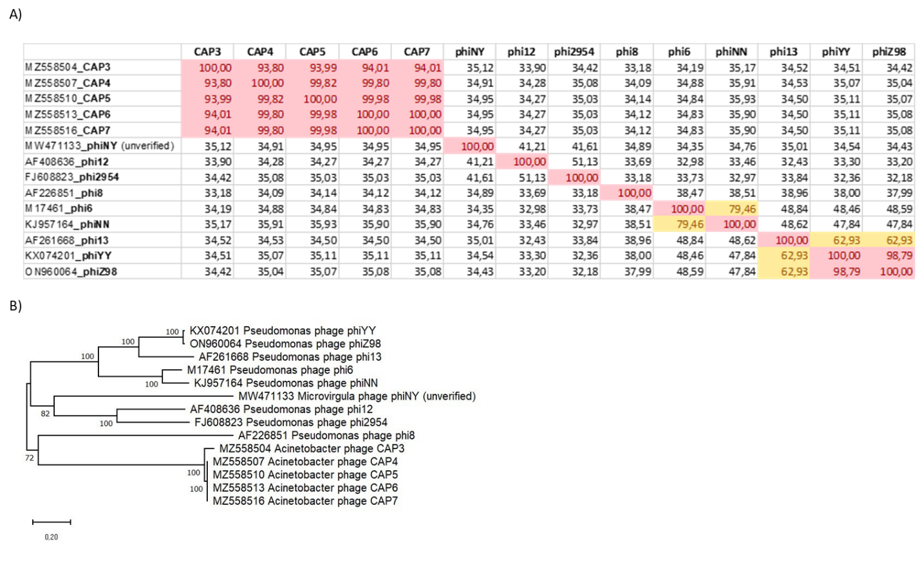

Fig 1. Comparison of the L segments of dsRNA phages. A) Percent identity matrix of dsRNA phage L segments (nucleotide sequences) determined using Clustal Omega Multiple Alignment. Color code: >90% = red; > 60% = yellow. B) Phylogenetic tree showing relationships between current and proposed members of the *Cystoviridae* based onnucleotide sequence comparisons of the L segment. The tree was constructed with maximum likelihood method using Mega 11. The robustness was statistically evaluated by bootstrap analysis with 500 replicates.

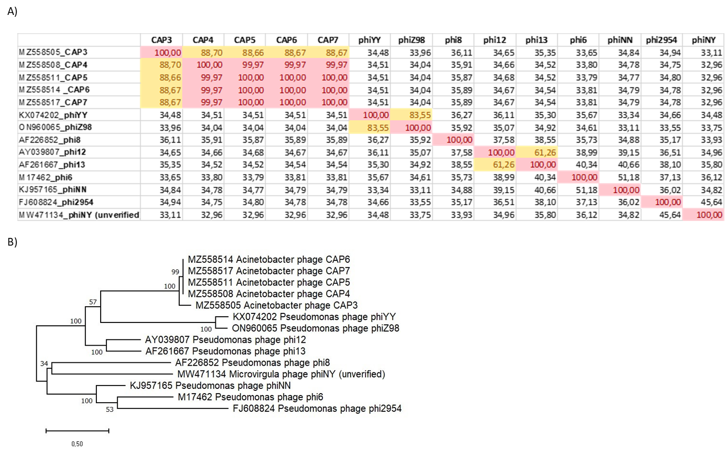

Fig. 2. Comparison of the M segments of dsRNA phages. A) Percent identity matrix of dsRNA phage M segments (nucleotide sequences) determined using Clustal Omega Multiple Alignment. Color code: > 90% = red; > 60% = yellow. B) Phylogenetic tree showing relationships between current and proposed members of the *Cystoviridae* based on nucleotide sequence comparisons of the M segment. The tree was constructed with maximum likelihood method using Mega 11. The robustness was statistically evaluated by bootstrap analysis with 500 replicates.

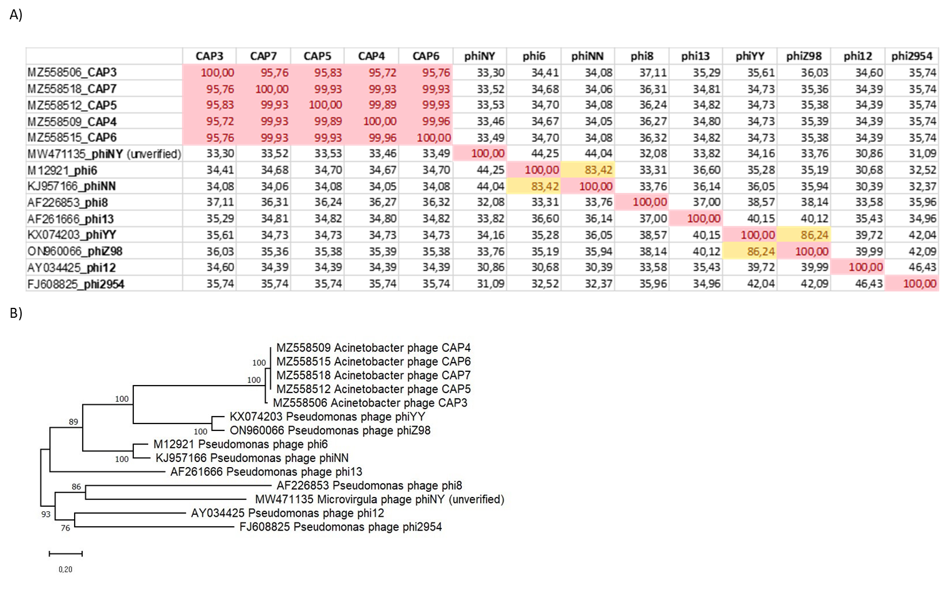

Fig. 3. Comparison of the S segments of dsRNA phages. A) Percent identity matrix of dsRNA phage S segments (nucleotide sequences) determined using Clustal Omega Multiple Alignment. Color code: > 90% = red; > 60% = yellow. B) Phylogenetic tree showing relationships between current and proposed members of the *Cystoviridae* based onnucleotide sequence comparisons of the S segment. The tree was constructed with maximum likelihood method using Mega 11. The robustness was statistically evaluated by bootstrap analysis with 500 replicates.

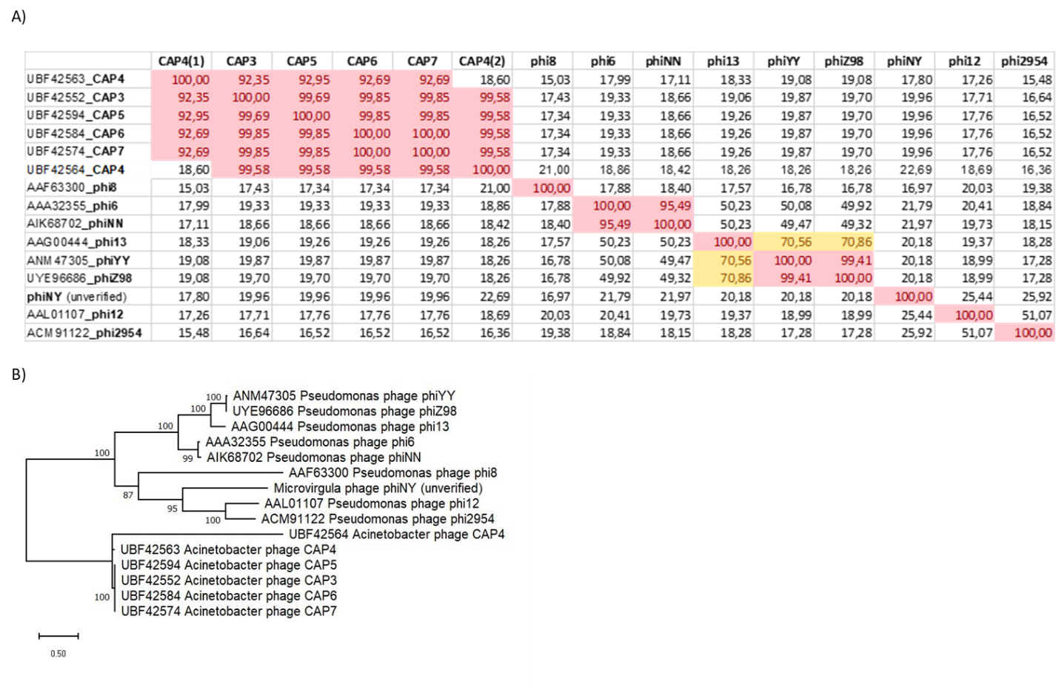

Fig.4. Comparison of the dsRNA phage RdRps. A) Percent identity matrix of dsRNA phage RdRps (amino acid sequences)determined using Clustal Omega Multiple Alignment. GenBank database contains two predicted RdRp CDSs for CAP4. Color code: > 90% = red; > 60% = yellow. B) Phylogenetic tree showing relationships between current and proposed members of the *Cystoviridae* based on amino acid sequence comparisons of the RdRp. The tree was constructed with maximum likelihood method using Mega 11. The robustness was statistically evaluated by bootstrap analysis with 500 replicates.

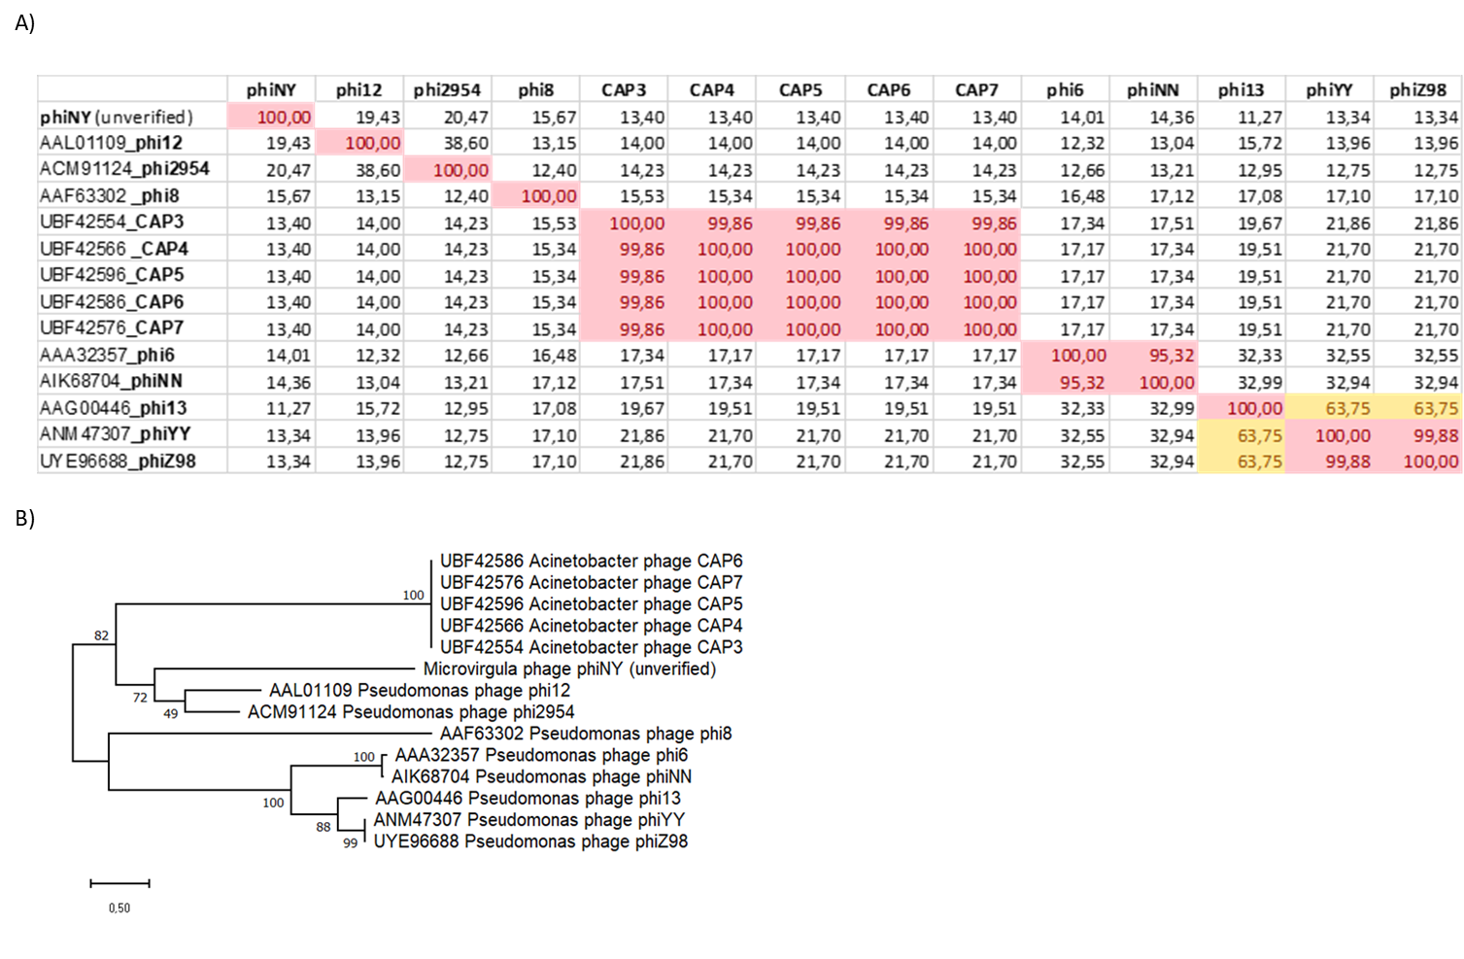

Fig. 5. Comparison of the dsRNA phage “T=2” capsid proteins. A) Percent identity matrix of dsRNA phage “T=2” capsid proteins(amino acid sequences)determined using Clustal Omega Multiple Alignment. Color code: > 90% = red; > 60% = yellow. B) Phylogenetic tree showing relationships between current and proposed members of the *Cystoviridae* based on amino acid sequence comparisons of the “T=2” capsid proteins. The tree was constructed with maximum likelihood method using Mega 11. The robustness was statistically evaluated by bootstrap analysis with 500 replicates.