

The International Committee on Taxonomy of Viruses

Taxonomy Proposal Form, 2024

**Part 1a: Details of taxonomy proposals**

|  |  |  |
| --- | --- | --- |
| **Title:** | Create one new genus, *Lacfervirus*, in the class *Caudoviricetes* | |
| **Code assigned:** | 2024.042B |

|  |  |  |  |
| --- | --- | --- | --- |
| **Author(s), affiliation and email address(es):** | | | |
| **Name** | **Affiliation** | **Email address** | **Corresponding author(s)** X |
| Qiannan Wen | Key Laboratory of Dairy Biotechnology and Engineering, Ministry of Education, Inner Mongolia Agricultural University, 306 Zhaowuda Road, Hohhot 010018, China | [wenqiannan2020@126.com](mailto:wenqiannan2020@126.com) |  |
| Xia Chen | Key Laboratory of Dairy Biotechnology and Engineering, Ministry of Education, Inner Mongolia Agricultural University, 306 Zhaowuda Road, Hohhot 010018, China | chenxia8280@163.com | X |

**Part 1b: Taxonomy Proposal Submission**

|  |  |  |  |
| --- | --- | --- | --- |
| **ICTV Subcommittee:** | | | |
| Animal DNA Viruses and Retroviruses |  | Bacterial viruses | **X** |
| Animal minus-strand and dsRNA viruses |  | Fungal and protist viruses |  |
| Animal positive-strand RNA viruses |  | Plant viruses |  |
| Archaeal viruses |  | General - |  |

|  |
| --- |
| **List the ICTV Study Group(s) that have seen or have been involved in creating this proposal:** |
| Qiannan Wen  Xia Chen |

|  |  |  |  |
| --- | --- | --- | --- |
| **Optional – complete only if formally voted on by an ICTV Study Group:** | | | |
| **Study Group** | **Number of members** | | |
| **Votes in support** | **Votes against** | **No vote** |
|  |  |  |  |
|  |  |  |  |

|  |  |
| --- | --- |
| **Submission date:** | 05/06/2023 |

**Part 1c: Feedback from ICTV Executive Committee (EC) meeting**

|  |  |
| --- | --- |
| **Executive Committee Meeting Decision code:** | **X** |
| A – Accept | **X** |
| Ac – Accept subject to revision by relevant subcommittee chair. No further vote required |  |
| U – Accept without revision but with re-evaluation and email vote by the EC |  |
| Uc – Accept subject to revision and re-evaluation and email vote by the EC |  |
| Ud – Deferred to the next EC meeting, with an invitation to revise based on EC comments |  |
| J - Reject |  |
| W - Withdrawn |  |

|  |
| --- |
| **Comments from the Executive Committee:** |
|  |

**Part 1d: Revised Taxonomy Proposal Submission**

|  |
| --- |
| **Response of proposer:** |
|  |

|  |  |
| --- | --- |
| **Revision date:** | DD/MM/YYYY |

**Part 3:** **TAXONOMIC PROPOSAL**

|  |
| --- |
| **Name of accompanying Excel module:** |
| 2024.042B.A.v1.Lacfervirus_ng.xlsx |

|  |  |  |  |
| --- | --- | --- | --- |
| **Taxonomic changes proposed:** | | | |
| Establish new taxon | **🞩** | Split taxon |  |
| Abolish taxon |  | Merge taxon |  |
| Move taxon |  | Promote taxon |  |
| Rename taxon |  | Demote taxon |  |
| Move and rename |  |

|  |  |  |
| --- | --- | --- |
| **Is any taxon name used here derived from that of a living person:** | | **Y/N** |
| **Taxon name** | **Person from whom the name is derived** | **Attached X** |
|  |  |  |
|  |  |  |
|  |  |  |

|  |
| --- |
| **Abstract of Taxonomy Proposal:** |
| *T**axonomic rank(s) affected*:  Realm *Duplodnaviria*, kingdom *Heunggongvirae*, phylum *Uroviricota*, class *Caudoviricetes*  *Description of current taxonomy*:  The virus classified in this proposal does not have a current taxonomic assignment.  *Proposed* *taxonomic change(s):*  We propose a new genus, *Lacfervirus*, comprised of a single species, Lactobacillus phage LFP01 in the class *Caudoviricetes*.  *Justification*:  The genome of *Lactobacillus* phage LFP01 has very low homology to all other bacteriophage sequences in the GenBank database. A complete genome sequence comparison using the BLASTn method revealed that the genome of *Lactobacillus* phage LFP01 had a maximum nucleotide identity of 92.83% and 55% coverage with *Lactobacillus* phage LF1. The low homology indicated that the newly sequenced bacteriophage likely represents a new genus with a single species, and conforms to the recommendations outlined in [2]. |

|  |
| --- |
| * **Text of Taxonomy proposal:** |
| *Taxonomic rank(s) affected*:  Realm *Duplodnaviria*, kingdom *Heunggongvirae*, phylum *Uroviricota*, class *Caudoviricetes*  *Description of current taxonomy*:  The virus classified in this proposal does not have a current taxonomic assignment.  *Proposed* *taxonomic change(s):*  We propose a new genus, *Lacfervirus*, comprised of a single species, Lactobacillus phage LFP01 in the class *Caudoviricetes*.  *Demarcation criteria:*  Species demarcation criteria: Two phages are assigned to the same species if their genomes are more than 95% identical over their genome length for isolates. These values can be calculated by a number of tools, such as BLASTn – usually calculated using intergenomic distance calculator VIRIDIC (1).Genus demarcation criteria: In search for criteria that create cohesive and distinct genera that are reproducible and monophyletic, the Bacterial Viruses Subcommittee has established 70% nucleotide identity of the genome length as the cut-off for genera. Genus-level groupings should always be monophyletic in the signature genes, as tested with a phylogenetic tree. (2)  *Justification*:  The genome has very low homology to all other bacteriophage sequences in the GenBank database. A complete genome sequence comparison using the BLASTn method revealed that the genome of *Lactobacillus* phage LFP01 had a maximum nucleotide identity of 92.83% and 55% coverage with *Lactobacillus* phage LF1. The low homology indicated that the newly sequenced bacteriophage likely represents a new genus with a single species, and conforms to the recommendations outlined in [2].  **Source of the name of this taxon:** The genus is named after the combination of the first three letters of the genus and species name of *Lactobacillus fermentum*, *Lacfervirus*. This phage was induced from *L. fermentum* IMAU32646 with mitomycin-C |

|  |
| --- |
| **References:** |
| **(1)** Moraru C, Varsani A, Kropinski AM. VIRIDIC-A Novel Tool to Calculate the Intergenomic Similarities of Prokaryote-Infecting Viruses. Viruses. 2020 Nov 6;12(11):1268. doi: 10.3390/v12111268. PMID: 33172115  **(2)** Turner D, Kropinski AM, Adriaenssens EM. A Roadmap for Genome-Based Phage Taxonomy. Viruses. 2021 Mar 18;13(3):506. doi: 10.3390/v13030506. PMID: 33803862  **(3)** Moraru C, Varsani A, Kropinski AM. VIRIDIC-A Novel Tool to Calculate the Intergenomic Similarities of Prokaryote-Infecting Viruses. Viruses. 2020 Nov 6;12(11):1268. doi: 10.3390/v12111268. PMID: 33172115 |

|  |
| --- |
| **Tables, Figures:** |

**GenBank Summary:**

|  |  |  |  |  |  |
| --- | --- | --- | --- | --- | --- |
| Phage name | Genbank accession No. | Size (Kb) | GC% | CDS | tRNAs |
| *Lactobacillus* phage LFP01 | OR048821 | 40.562 | 46.25% | 54 | 0 |

**BLASTN homologs:** The genome has very low homology to all other bacteriophage sequences in the GenBank database. A complete genome sequence comparison using the BLASTn method revealed that the genome of *Lactobacillus* phage LFP01 had a maximum nucleotide identity of 92.83% and 55% coverage with *Lactobacillus* phage LF1. The low homology indicated that the newly sequenced bacteriophage likely represents a new genus with a single species.

**VIRIDIC heat map:** VIRIDIC (Virus Intergenomic Distance Calculator; VIRIDIC (Virus Intergenomic Distance Calculator; (3); http://rhea.icbm.uni-oldenburg.de/VIRIDIC/) computes pairwise intergenomic distances/similarities amongst phage genomes.

VIRIDIC heat map showed that this phage merely had an intergenomic similarity of 50.1% with *Lactobacillus* phage LF1 (Fig. 3), well below the proposed threshold for a new genus of 70% (2).

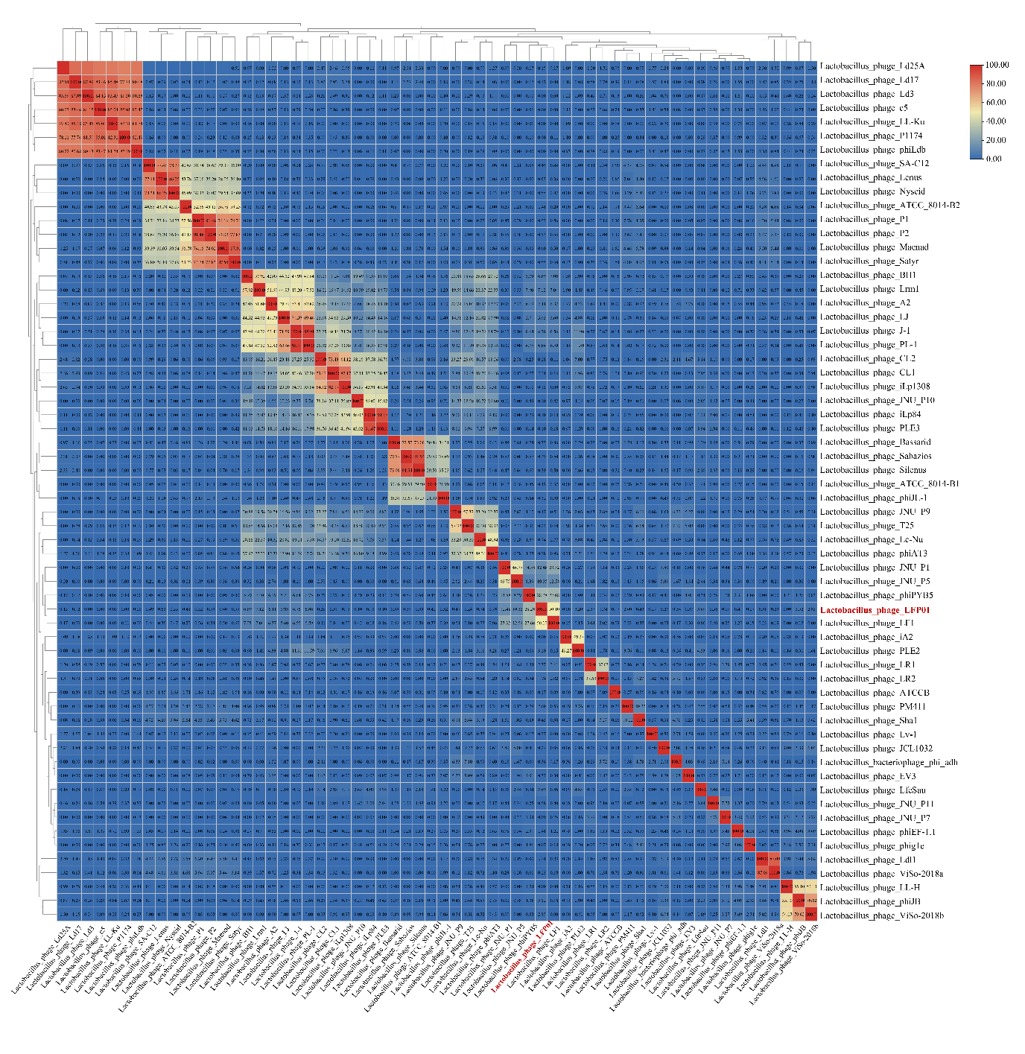

**Electron micrograph:**

Transmission electron microscopy showed that this phage possesses an isometric capsid (diameter; 78.19 ± 3.78 nm) and a long, non-contractile tail (length; 220.42 ± 1.10 nm, width; 9.04 ± 0.27 nm).

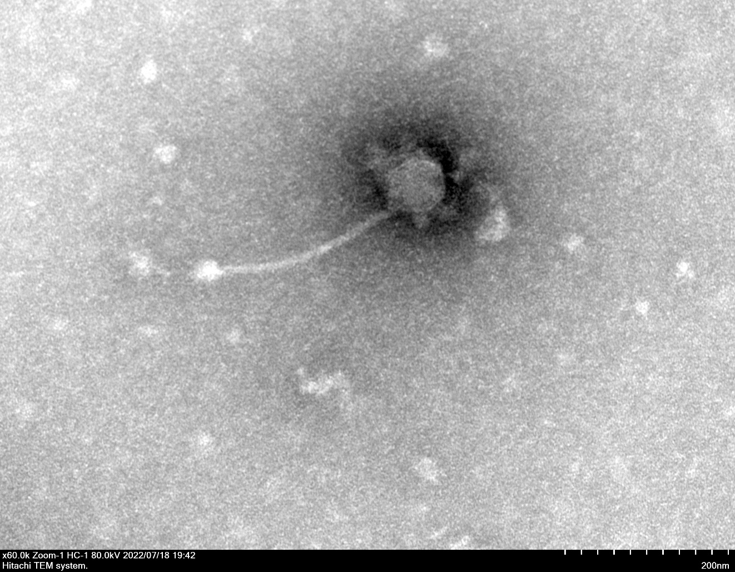

**Phylogeny:**

Phylogenetic trees of *Lactobacillus* phage LFP01 were constructed with 1000 bootstrap replicates using neighbor-joining method based on the (a) *ter*L and (b) MCP sequences. Different color representing the viral genus. *L. fermentum* phage LFP01 is marked in red. There are twenty-one phage genomes that are not annotated to the MCP.

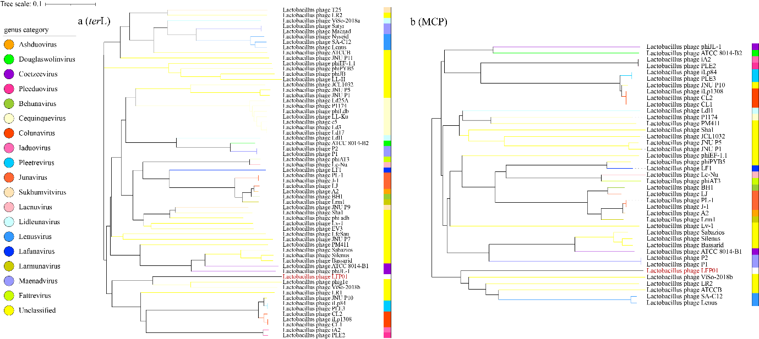

**Protein-sharing network**

Protein-sharing network diagram of phage LFP01 benchmarked against ICTV-accepted viral taxonomy. (a) Each node represents a viral genome, and the connection between nodes represents the relationship between them. (b) The protein cluster where LFP01 was located. Different shape representing the viral genus and each distinct color representing phages with different hosts. Every line has a value, and the greater the value, the more similar they are. *L. fermentum* phage LFP01 is marked in blue.

