

The International Committee on Taxonomy of Viruses

Taxonomy Proposal Form, 2024

**Part 1a: Details of taxonomy proposals**

|  |  |  |
| --- | --- | --- |
| **Title:** | Create a new species *Sharonstreetvirus xiamensis* (*Caudoviricetes*) | |
| **Code assigned:** | 2024.040B |

|  |  |  |  |
| --- | --- | --- | --- |
| **Author(s), affiliation and email address(es):** | | | |
| **Name** | **Affiliation** | **Email address** | **Corresponding author(s)** X |
| Liu H-T | Jimei University, China | 15844493757@163.com | Lin M |

**Part 1b: Taxonomy Proposal Submission**

|  |  |  |  |
| --- | --- | --- | --- |
| **ICTV Subcommittee:** | | | |
| Animal DNA Viruses and Retroviruses |  | Bacterial viruses | X |
| Animal minus-strand and dsRNA viruses |  | Fungal and protist viruses |  |
| Animal positive-strand RNA viruses |  | Plant viruses |  |
| Archaeal viruses |  | General - |  |

|  |
| --- |
| **List the ICTV Study Group(s) that have seen or have been involved in creating this proposal:** |
| Bacterial Viruses Study Groups,Regional Representative |

|  |  |  |  |
| --- | --- | --- | --- |
| **Optional – complete only if formally voted on by an ICTV Study Group:** | | | |
| **Study Group** | **Number of members** | | |
| **Votes in support** | **Votes against** | **No vote** |
|  |  |  |  |
|  |  |  |  |

|  |  |
| --- | --- |
| **Submission date:** | 25/04/2024 |

**Part 1c: Feedback from ICTV Executive Committee (EC) meeting**

|  |  |
| --- | --- |
| **Executive Committee Meeting Decision code:** | **X** |
| A – Accept | **X** |
| Ac – Accept subject to revision by relevant subcommittee chair. No further vote required |  |
| U – Accept without revision but with re-evaluation and email vote by the EC |  |
| Uc – Accept subject to revision and re-evaluation and email vote by the EC |  |
| Ud – Deferred to the next EC meeting, with an invitation to revise based on EC comments |  |
| J - Reject |  |
| W - Withdrawn |  |

|  |
| --- |
| **Comments from the Executive Committee:** |
|  |

**Part 1d: Revised Taxonomy Proposal Submission**

|  |
| --- |
| **Response of proposer:** |
|  |

|  |  |
| --- | --- |
| **Revision date:** | DD/MM/YYYY |

**Part 3:** **TAXONOMIC PROPOSAL**

|  |
| --- |
| **Name of accompanying Excel module:** |
| 2024.040B.A.v1.Sharonstreetvirus_ns.xlsx |

|  |  |  |  |
| --- | --- | --- | --- |
| **Taxonomic changes proposed:** | | | |
| Establish new taxon | X | Split taxon |  |
| Abolish taxon |  | Merge taxon |  |
| Move taxon |  | Promote taxon |  |
| Rename taxon |  | Demote taxon |  |
| Move and rename |  |

|  |  |  |
| --- | --- | --- |
| **Is any taxon name used here derived from that of a living person:** | | **N** |
| **Taxon name** | **Person from whom the name is derived** | **Attached X** |
|  |  |  |
|  |  |  |
|  |  |  |

|  |
| --- |
| **Abstract of Taxonomy Proposal:** |
| We isolated a new Aeromonas phage from aquaculture water of Xiamen named phiA034, and ViPTree analysis classified as a new species of an existing genus *Sharonstreetvirus*, (*Duplodnaviria Heunggongvirae, Uroviricota, Caudoviricetes, Casjensviridae*). Therefore, we propose a new species *Sharonstreetvirus xiamensis*. The genome of phiA034 is available under the accession number OP792756. |

|  |
| --- |
| * **Text of Taxonomy proposal:** |
| Species demarcation criteria: Two phages are assigned to the same species if their genomes are more than 95% identical over their genome length for isolates. These values can be calculated by a number of tools, such as BLASTn – usually calculated using intergenomic distance calculator VIRIDIC [1].  Genus demarcation criteria: In search for criteria that create cohesive and distinct genera that are reproducible and monophyletic, the Bacterial Viruses Subcommittee has established 70% nucleotide identity of the genome length as the cut-off for genera. Genus-level groupings should always be monophyletic in the signature genes, as tested with a phylogenetic tree [2]. |

|  |
| --- |
| **References:** |
| 1: Moraru C, Varsani A, Kropinski AM. VIRIDIC-A Novel Tool to Calculate the Intergenomic Similarities of Prokaryote-Infecting Viruses. Viruses. 2020 Nov 6;12(11):1268. doi: 10.3390/v12111268. PMID: 33172115.  2: Turner D, Kropinski AM, Adriaenssens EM. A Roadmap for Genome-Based Phage Taxonomy. Viruses. 2021 Mar 18;13(3):506. doi: 10.3390/v13030506. PMID: 33803862.  3: Nishimura Y, Yoshida T, Kuronishi M, Uehara H, Ogata H, Goto S. ViPTree: the viral proteomic tree server. Bioinformatics. 2017 Aug 1;33(15):2379-2380. doi: 10.1093/bioinformatics/btx157. PMID: 28379287.  4: Rohwer F, Edwards R. The Phage Proteomic Tree: a genome-based taxonomy for phage. J Bacteriol. 2002 Aug;184(16):4529-35. doi: 10.1128/jb.184.16.4529-4535.2002. PMID: 12142423.  5: Dereeper A, Guignon V, Blanc G, Audic S, Buffet S, Chevenet F, Dufayard JF, Guindon S, Lefort V, Lescot M, Claverie JM, Gascuel O. Phylogeny.fr: robust phylogenetic analysis for the non-specialist. Nucleic Acids Res. 2008;36(Web Server issue):W465-9. doi: 10.1093/nar/gkn180. Epub 2008 Apr 19. PMID: 18424797.  6: Anisimova M, Gascuel O. Approximate likelihood-ratio test for branches: A fast, accurate, and powerful alternative. Syst Biol. 2006;55(4):539-52. doi: 10.1080/10635150600755453. PMID: 16785212.  7: Yingying Y ,Guixiang T ,Gonghao C , et al. The Characterization and Genome Analysis of a Novel Phage phiA034 Targeting Multiple Species of Aeromonas.[J].Virus research,2023,336199193-199193.  8: Turner D, Reynolds D, Seto D, Mahadevan P. CoreGenes3.5: a webserver for the determination of core genes from sets of viral and small bacterial genomes. BMC Res Notes. 2013;6:140. doi: 10.1186/1756-0500-6-140. PMID: 23566564. |

|  |
| --- |
| **Tables, Figures:** |

**ViPTree analysis：** ViPTree analysis (https://www.genome.jp/viptree/; [3]) is based upon Rohwer and Edwards (2002) famous Phage Proteomic Tree [4]. The phages of interest are indicated with red arrow and the family *Casjensviridae* is annotated with a red box.

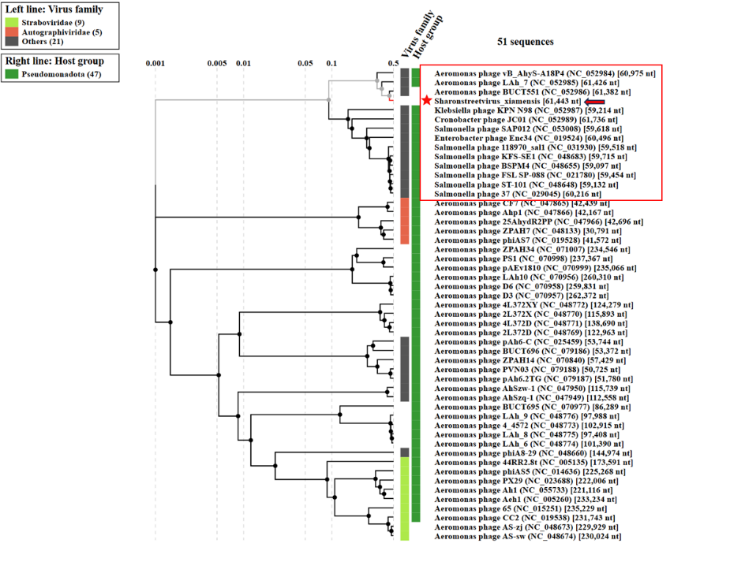

**VIRIDIC heat map:** VIRIDIC (Virus Intergenomic Distance Calculator; [1]; http://rhea.icbm.uni-oldenburg.de/VIRIDIC/) computes pairwise intergenomic distances/similarities amongst phage genomes.

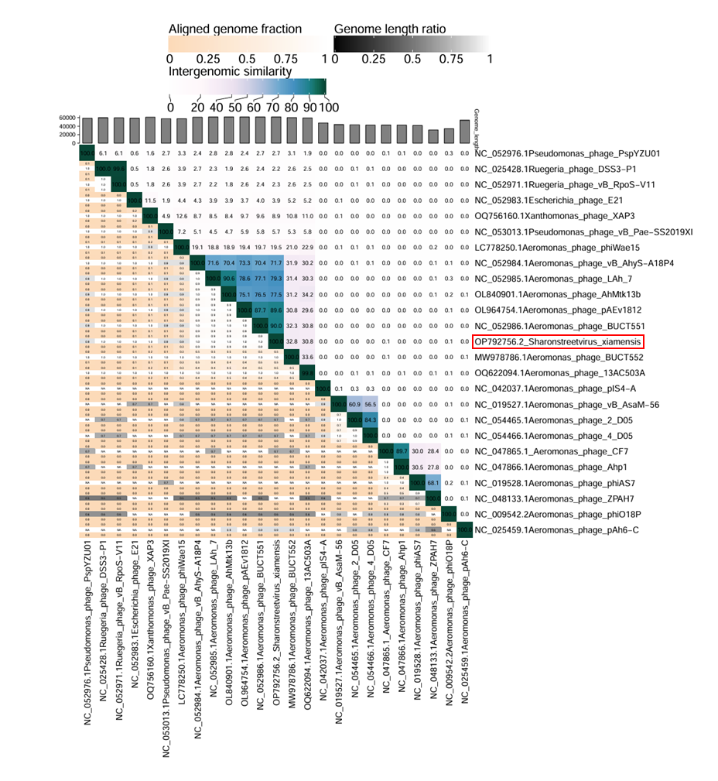

**Phylogeny:** The phylogenetic tree was constructed using the major capsid proteins of phages [5]. MUSCLE was used for multiple alignment and MEGA(v11.0.10) was used for building phylogenetic tree using maximum-likelihood method with 1000 bootstrap replicates [6]. The new species is indicated with a red arrow.

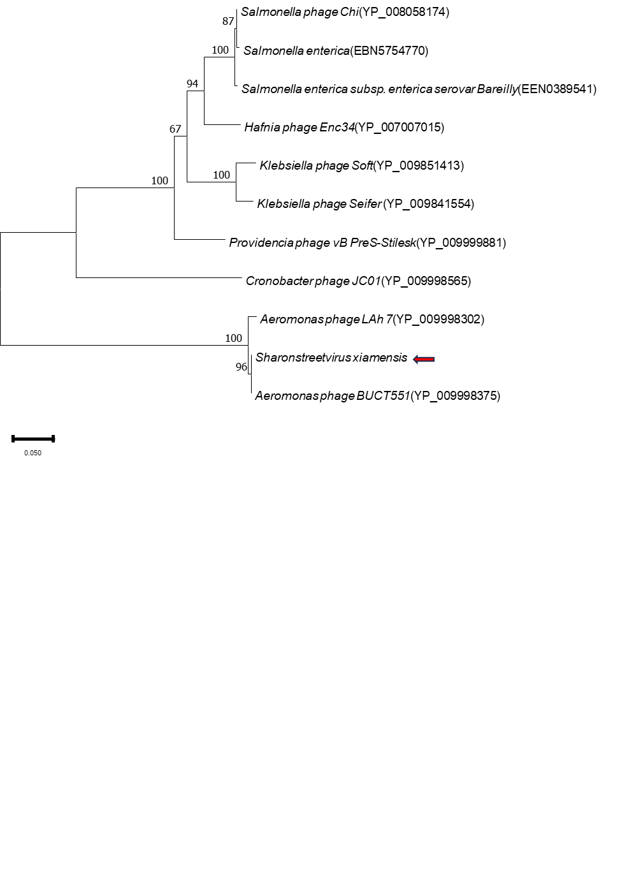

**Electron micrograph:** TEM image revealed that the phage had a capsid of 68.4 ± 2.0 nm in diameter and a tail of 108.9 ± 2.0 nm in length[7]**.**



**Historical aspects:** The phage *Sharonstreetvirus xiamensis* phiA034 was isolated in 2020 from aquaculture water of Xiamen, using *Aeromonas hydrophila* A034 as the host bacterium.

**Specific References:** None

**Genome summary:**

|  |  |  |  |  |  |  |  |  |
| --- | --- | --- | --- | --- | --- | --- | --- | --- |
| Phage name | RefSeq No. | INSDC | Size (Kb) | GC% | Protein | tRNA | Overall % DNA sequence identity (*) | Overall % homologous proteins (**) |
| *Sharonstreetvirus xiamensis* |  | OP792756 | 61.4 | 61.4 | 82 | 0 | 100 | 100 |

**(*) Determined using VIRIDIC [1]**

**(**) Determined using CoreGenes 3.5 at** [**http://binf.gmu.edu:8080/CoreGenes3.5/**](http://binf.gmu.edu:8080/CoreGenes3.5/)**[8]**