

The International Committee on Taxonomy of Viruses

Taxonomy Proposal Form, 2024

**Part 1a: Details of taxonomy proposals**

|  |  |  |
| --- | --- | --- |
| **Title:** | Create three new families *Mestraviridae*, *Asemoviridae*, and *Parnassusviridae*, and move the family *Autolykiviridae* into the order Vinavirales (*Tectiviricetes*, *Preplamiviricota*, *Bamfordvirae*, *Varidnaviria*) | |
| **Code assigned:** | *2024.038B* |

|  |  |  |  |
| --- | --- | --- | --- |
| **Author(s), affiliation and email address(es):** | | | |
| **Name** | **Affiliation** | **Email address** | **Corresponding author(s)** X |
| **Bardy P** | **Department of Chemistry, University of York, York, UK** | **pavol.bardy@york.ac.uk** |  |
| **Fogg PCM** | **Department of Biology, University of York, York, UK** | **paul.fogg@york.ac.uk** |  |
| **Kalatzis PG** | **Globe Institute, University of Copenhagen, Copenhagen, Denmark** | **panos.kalatzis@sund.ku.dk** |  |
| **Middelboe M** | **Marine Biological Section, Department of Biology, University of Copenhagen, Helsingor, Denmark** | **mmiddelboe@bio.ku.dk** |  |
| **Oksanen HM** | **Molecular and Integrative Biosciences Research Programme, Faculty of Biological and Environmental Sciences**  **University of Helsinki, Helsinki, Finland** | **hanna.oksanen@helsinki.fi** | **X** |

**Part 1b: Taxonomy Proposal Submission**

|  |  |  |  |
| --- | --- | --- | --- |
| **ICTV Subcommittee:** | | | |
| Animal DNA Viruses and Retroviruses |  | Bacterial viruses | **X** |
| Animal minus-strand and dsRNA viruses |  | Fungal and protist viruses |  |
| Animal positive-strand RNA viruses |  | Plant viruses |  |
| Archaeal viruses |  | General - |  |

|  |
| --- |
| **List the ICTV Study Group(s) that have seen or have been involved in creating this proposal:** |
| *Corticoviridae* |

|  |  |  |  |
| --- | --- | --- | --- |
| **Optional – complete only if formally voted on by an ICTV Study Group:** | | | |
| **Study Group** | **Number of members** | | |
| **Votes in support** | **Votes against** | **No vote** |
| *Corticoviridae* | 2 | 0 | 0 |
|  |  |  |  |

|  |  |
| --- | --- |
| **Submission date:** | 20/06/2024 |

**Part 1c: Feedback from ICTV Executive Committee (EC) meeting**

|  |  |
| --- | --- |
| **Executive Committee Meeting Decision code:** | **X** |
| A – Accept |  |
| Ac – Accept subject to revision by relevant subcommittee chair. No further vote required | **X** |
| U – Accept without revision but with re-evaluation and email vote by the EC |  |
| Uc – Accept subject to revision and re-evaluation and email vote by the EC |  |
| Ud – Deferred to the next EC meeting, with an invitation to revise based on EC comments |  |
| J - Reject |  |
| W - Withdrawn |  |

|  |
| --- |
| **Comments from the Executive Committee:** |
| Correct the species epithet to lower-case for Jorvik. |

**Part 1d: Revised Taxonomy Proposal Submission**

|  |
| --- |
| **Response of proposer:** |
| Corrected |

|  |  |
| --- | --- |
| **Revision date:** | 30/09/2024 |

**Part 3:** **TAXONOMIC PROPOSAL**

|  |
| --- |
| **Name of accompanying Excel module:** |
| 2024.038B.Ac.v2.Vinavirales_nf.xlsx |

|  |  |  |  |
| --- | --- | --- | --- |
| **Taxonomic changes proposed:** | | | |
| Establish new taxon | **X** | Split taxon |  |
| Abolish taxon |  | Merge taxon |  |
| Move taxon | **X** | Promote taxon |  |
| Rename taxon | **X** | Demote taxon |  |
| Move and rename |  |

|  |  |  |
| --- | --- | --- |
| **Is any taxon name used here derived from that of a living person:** | | **No** |
| **Taxon name** | **Person from whom the name is derived** | **Attached** |
|  |  |  |
|  |  |  |
|  |  |  |

|  |
| --- |
| **Abstract of Taxonomy Proposal:** |
| *Taxonomic rank(s) affected*:  The taxonomic ranks affected are the genus *Corticovirus* in the family *Corticoviridae*, the order *Vinavirales* (*Tectiviricetes*, *Preplamiviricota*, *Bamfordvirae*, *Varidnaviria*), and the family *Autolykiviridae* (*Tectiviricetes*, *Preplamiviricota*, *Bamfordvirae*, *Varidnaviria*). In addition, some species are affected.  *Description of current taxonomy*:  Currently, the order *Vinavirales* (*Tectiviricetes*, *Preplamiviricota*, *Bamfordvirae*, *Varidnaviria)* contains one family *Corticoviridae* composed of one genus *Corticovirus* (2 species). The family *Autolykiviridae* belongs to the class *Tectiviricetes* but is not assigned to any order. The family *Autolykiviridae* is composed of two genera *Livvievirus* (2 species)and *Paulavirus* (3 species).  *Proposed* *taxonomic change(s):*  The genus *Corticovirus* (the family *Corticoviridae*) is renamed as the genus *Merivirus* and its two species are renamed accordingly. The *Vinavirales* order is rearranged so that the family *Autolykiviridae* is placed under the order along with the family *Corticoviridae*. Two new genera *Oliviavirus* and *Ameliavirus* are created in the family *Autolykiviridae*. Both genera consist of a single species *Oliviavirus viph1020o* and *Ameliavirus viph1008o respectively*. The genus of the virus species *Paulavirus viph1044o* is moved to the genus *Paulavirus* (the family *Autolykiviridae*). In addition, three new families *Mestraviridae*, *Asemoviridae,* and *Parnassusviridae* are created in the order *Vinavirales.* Twonew genera *Anticleavirus* and *Polymedevirus* are created in the family *Mestraviridae.* One new species is created in each of the two genera: *Anticleavirus jorvik* and *Polymedevirus YY*. Two new genera *Elsinorevirus* and *Rumoivirus* are created in the family *Asemoviridae*. One new species is created in each of the two genera: *Elsinoreirus NO16* and *Rumoivirus VruC*. One new species *Corycianvirus MfV* is created in a new genus *Corycianvirus* in the family *Parnassusviridae*.  *Justification*:  The inclusion/creation of four families in the order *Vinavirales*, together with the family *Corticoviridae*, is based on the 9 signature genes shared by their members, which corresponds to approximately 50 % of their genome. This demonstrates their common evolutionary origin. Classification of *Paulavirus viph1044o* into the genus *Livvievirus* instead of *Paulavirus* was a mistake. To make the names of the family *Corticoviridae* and the genus *Corticovirus* based on a different word stem, the genus *Corticovirus* is renamed *Merivirus*. |

|  |
| --- |
| * **Text of Taxonomy proposal:** |
| *Taxonomic rank(s) affected*:  The taxonomic ranks affected are the genus *Corticovirus* in the family *Corticoviridae*, the order *Vinavirales* (*Tectiviricetes*, *Preplamiviricota*, *Bamfordvirae*, *Varidnaviria*), and the family *Autolykiviridae* (*Tectiviricetes*, *Preplamiviricota*, *Bamfordvirae*, *Varidnaviria*). The species ranks that are affected list *Corticovirus Cr39582, Corticovirus PM2, Paulavirus viph1044o, Paulavirus viph1020o, and Paulavirus viph1008o*.  *Description of current taxonomy*:  Currently, the order *Vinavirales* (*Tectiviricetes*, *Preplamiviricota*, *Bamfordvirae*, *Varidnaviria)* contains one family, *Corticoviridae,* composed of one genus *Corticovirus* (species *Corticovirus Cr39582, Corticovirus PM2*). The family *Autolykiviridae* belongs to the class *Tectiviricetes* but is not assigned to any order. The family *Autolykiviridae* contains two genera (*Livvievirus, Paulavirus*) and lists species *Livvievirus viph1249a, Paulavirus viph1044o, Paulavirus viph1008o, Paulavirus viph1020o,* and *Paulavirus viph1080o*.  *Proposed* *taxonomic change(s)*:  The genus *Corticovirus* (the family *Corticoviridae*) is renamed as the genus *Merivirus* and its two species are renamed accordingly (*Merivirus PM2* and *Merivirus Cr39582*. The *Vinavirales* order is rearranged so that the family *Autolykiviridae* is placed under the order along with the family *Corticoviridae*. Two new genera *Oliviavirus* and *Ameliavirus* are created in the family *Autolykiviridae*. Both genera consist of a single species *Oliviavirus viph1020o* and *Ameliavirus viph1008o,* which were moved from *the genus Paulavirus (Autolykiviridae*). The genus of *Paulavirus viph1044o* is corrected to the genus *Paulavirus* (the family *Autolykiviridae*). In addition, three new families *Mestraviridae*, *Asemoviridae*, and *Parnassusviridae* are created in the order *Vinavirales* resulting in a total of five families being assigned to the order. Two new genera *Anticleavirus* and *Polymedevirus* are created in the family *Mestraviridae*. One new species is created in each of the two genera: *Anticleavirus jorvik* and *Polymedevirus YY*. Two new genera *Elsinorevirus* and *Rumoivirus* are created in the family *Asemoviridae*. One new species is created in each of the two genera: *Elsinoreirus NO16* and *Rumoivirus VruC*. One new species *Corycianvirus MfV* is created in a new genus *Corycianvirus* in the family *Parnassusviridae*.  *Demarcation criteria:*  Demarcation criteria for the genera and species in the families *Autolykiviridae*, *Mestraviridae* and *Asemoviridae* of the order *Vinavirales* are based on the whole genome nucleotide sequence identity thresholds of 70% and 95%, respectively, as estimated using VIRIDIC (Moraru et al., 2020) (**Fig. 1**). Demarcation criteria for the family in the order *Vinavirales* are derived from cohesive and monophyletic groups of a phylogeny tree (**Fig. 2**) based on a whole genome sequence alignment performed by VICTOR (Meier-Kolthoff and Göker, 2017).  *Justification*:  In the order *Vinavirales*, the members of the families *Autolykiviridae* and *Corticoviridae* as well as new virus species of proposed families *Mestraviridae* and *Asemoviridae* share 9 orthologous signature genes which correspond to around 50 % of their genome (Yutin et al., 2022) (**Fig. 3**) and demonstrates their common evolutionary origin. In the archetypal phage of the *Vinavirales* order PM2, these genes or ORFs are designated as gene *I*, gene *II*, gene *III*, gene *V*, gene *VIII*, gene *IX*, gene *X,* gene *XV* , ORF h (proteins P1, P2, P3, P5, P8, P9, P10, P15, and gp h) (**Fig. 3**) (Oksanen and ICTV Report Consortium, 2017).  In the *Vinavirales* order, the families are formed based on monophyletic groups according to the whole genome sequence alignment (**Fig. 2**), further confirmed by a manual inspection of the genome synteny of representative candidates which show different operons composition and gene order when comparing members of different families (**Fig. 3)**.  The 70% and 95% nucleotide identity cut-offs for the whole genome sequence in the genera and species demarcation criteria correspond to those proposed for the taxonomy of phages (Turner et al., 2021). Using the 70% threshold as a demarcation criterion for the genera of the family *Autolykiviridae*, as recommended by Turner et al., 2021, instead of the lower 50% nucleotide identity threshold previously used to define the genera in the family *Autolykiviridae* (Kauffman et al., 2021), unify the criteria used within the order Vinavirales.  Classification of *Paulavirus viph1044o* into the genus *Livvievirus* instead of *Paulavirus* was clearly a mistake, as demonstrated by the plot showing average nucleotide identity between members of *Paulavirus* and *Livvievirus* genera (**Fig. 1**). To make the names of the family *Corticoviridae* and the genus *Corticovirus* based on a different word stem, the genus *Corticovirus* is renamed *Merivirus*.  Etymology of proposed taxa:  *Merivirus*: from the Finnish word “meri” meaning “sea” which refers to the origin of the bacteriophage PM2. In Hindi, “meri” means “my” and is used before singular feminine nouns; meri virus, my virus.  *Oliviavirus:* named after the most frequently used girl’s name in the UK in 2023, Olivia.  *Ameliavirus:* named after the second most frequently used girl’s name in the UK in 2023, Amelia.  *Mestraviridae*: named after the wife of Autolykus, from whom the name *Autolykiviridae* was derived. She was reported by different sources using three different names, the first of them is Mestra. This name was previously suggested for a predicted clade of *Vinavirales* viruses (Yutin et al., 2022), which are similar to the proposed candidates.  *Anticleavirus:* named after Autolykus and Mestra’s daughter Anticlea  *Polymedevirus:* named after Autolykus and Mestra’s daughter Polymede  *Asemoviridae*: from the Greek word “asemos”, which means “unknown”, “fameless”, or “obscured”. This refers to the fact that phage NO16 after its discovery was found to be globally distributed as a prophage in vibrios but had gone undetected when using standard prophage-finding tools (Kalatzis et al 2022).  *Elsinorevirus*: named after the location of the Marine Biological Section (MBS), University of Copenhagen in Elsinore, where NO16 virus was described.  *Rumoivirus*: named after VruC phage’s isolation strain *Vibrio rumoiensis*  *Parnassusviridae*: named after the mount Parnassus where Autolykus lived  *Corycianvirus*: named after the Corycian Cave on the mountain Parnassus |

|  |
| --- |
| **References:** |
| Bárdy P, MacDonald CIW, Pantůček R, Antson AA, Fogg PCM. Jorvik: A membrane-containing phage that will likely found a new family within *Vinavirales*. iScience. 2023 Sep 29;26(11):108104. doi: 10.1016/j.isci.2023.108104. PMID: 37867962; PMCID: PMC10589892.  Kalatzis PG, Mauritzen JJ, Winther-Have, CS, Michniewski, S, Millard, M.Tsertou, MI, Katharios, P. and Middelboe, M. Staying below the radar: unraveling a new family of ubiquitous “cryptic” non-tailed temperate vibriophages and implications for their bacterial hosts. Int. J. Mol. Sci. 2023, 24, 3937. https://doi.org/10.3390/ijms24043937  Kauffman KM, Hussain FA, Yang J, Arevalo P, Brown JM, Chang WK, VanInsberghe D, Elsherbini J, Sharma RS, Cutler MB, Kelly L, Polz MF. Create one new family (*Autolykiviridae*) of non-tailed dsDNA bacterial viruses in the double jelly roll fold major capsid lineage. Taxonomic Proposal 2020.16B. 2021.  Meier-Kolthoff JP, Göker M. VICTOR: genome-based phylogeny and classification of prokaryotic viruses. Bioinformatics. 2017 Nov 1;33(21):3396-3404. doi: 10.1093/bioinformatics/btx440. PMID: 29036289; PMCID: PMC5860169.  Moraru C, Varsani A, Kropinski AM. VIRIDIC-A novel tool to calculate the intergenomic similarities of prokaryote-infecting viruses. Viruses. 2020 Nov 6;12(11):1268. doi: 10.3390/v12111268. PMID: 33172115; PMCID: PMC7694805.  Oksanen HM, ICTV Report Consortium. ICTV Virus Taxonomy Profile: Corticoviridae. J Gen Virol. 2017 May;98(5):888-889. doi: 10.1099/jgv.0.000795. PMID: 28581380; PMCID: PMC5656799.  Turner D, Kropinski AM, Adriaenssens EM. A roadmap for genome-based phage taxonomy. Viruses. 2021 Mar 18;13(3):506. doi: 10.3390/v13030506. PMID: 33803862; PMCID: PMC8003253.  Yutin N, Rayko M, Antipov D, Mutz P, Wolf YI, Krupovic M, Koonin EV. Varidnaviruses in the human gut: a major expansion of the order *Vinavirales*. Viruses. 2022 Aug 23;14(9):1842. doi: 10.3390/v14091842. PMID: 36146653; PMCID: PMC9502842. |

|  |
| --- |
| **Tables, Figures:** |

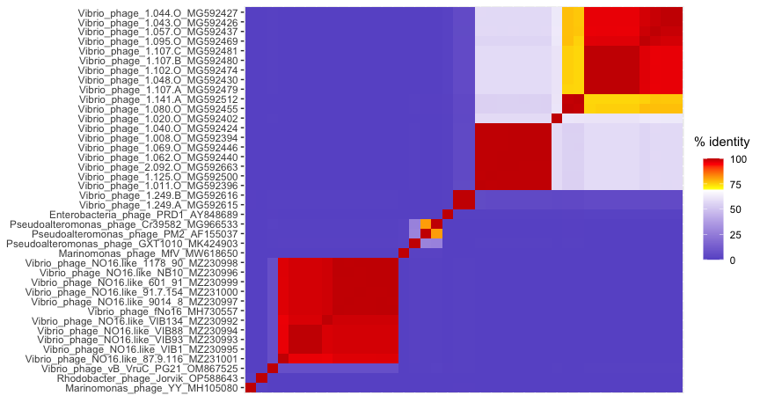**Fig. 1: The pairwise virus intergenomic similarity heat map calculated using VIRIDIC** (Moraru et al., 2020). The thresholds 70 % (yellow) and 95 % (red) were selected as demarcation criteria for genera and species respectively.

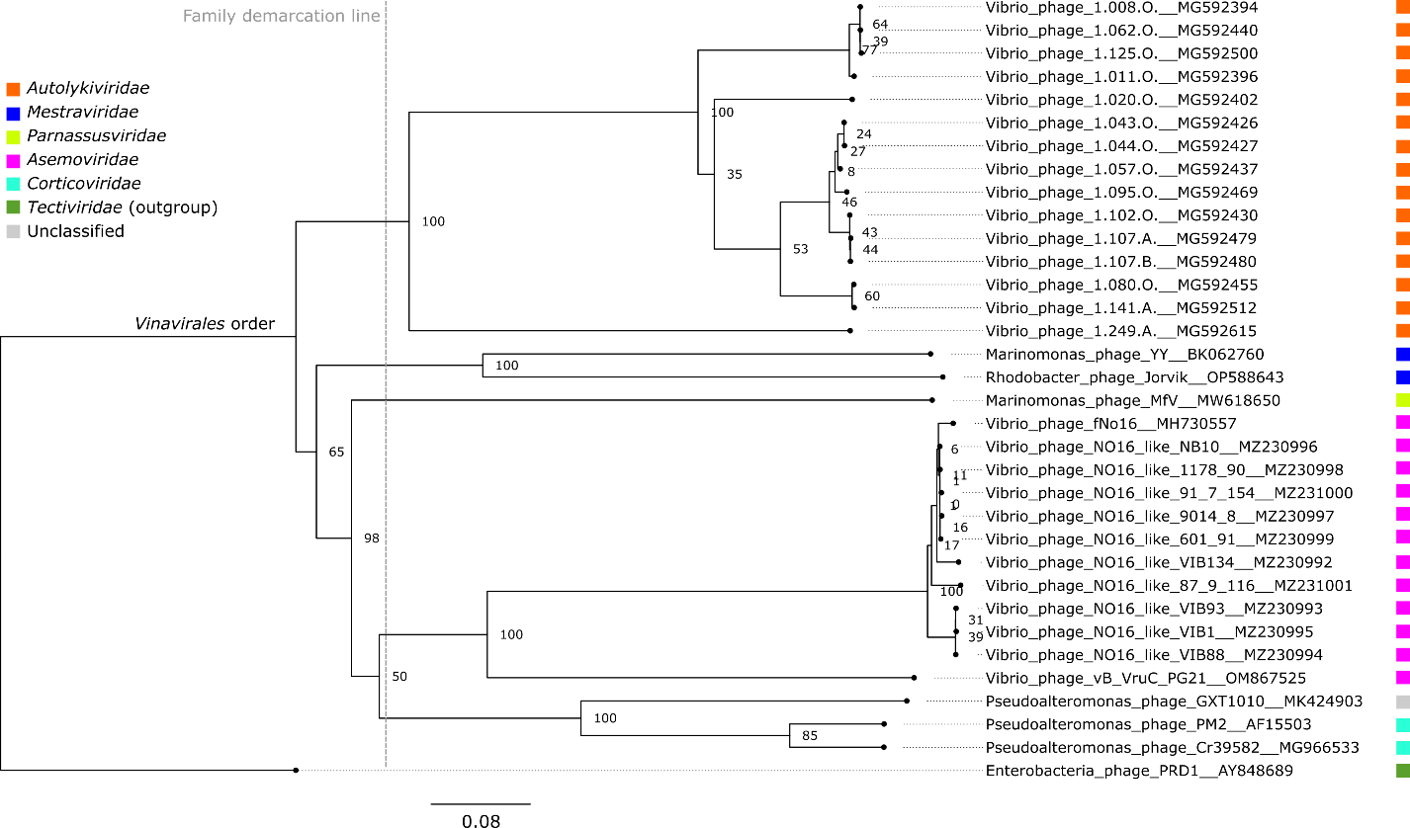**Fig. 2: Phylogenetic tree of *Vinavirales* members and related viruses generated by Genome-BLAST Distance Phylogeny of the predicted amino acid sequence using the web server VICTOR** (Meier-Kolthoff and Göker, 2017). The pseudo-bootstrap support values from 100 replications are shown next to nodes, with an average support equal to 90%. The scale bar defines the branch length, scaled in terms of the D6 distance formula. Phage GXT1010 was not classified as its sequence is annotated as incomplete. Bacteriophage PRD1 (the family *Tectiviridae*) is used as an outgroup. The figure is an updated version adapted from Bárdy et al., 2023.

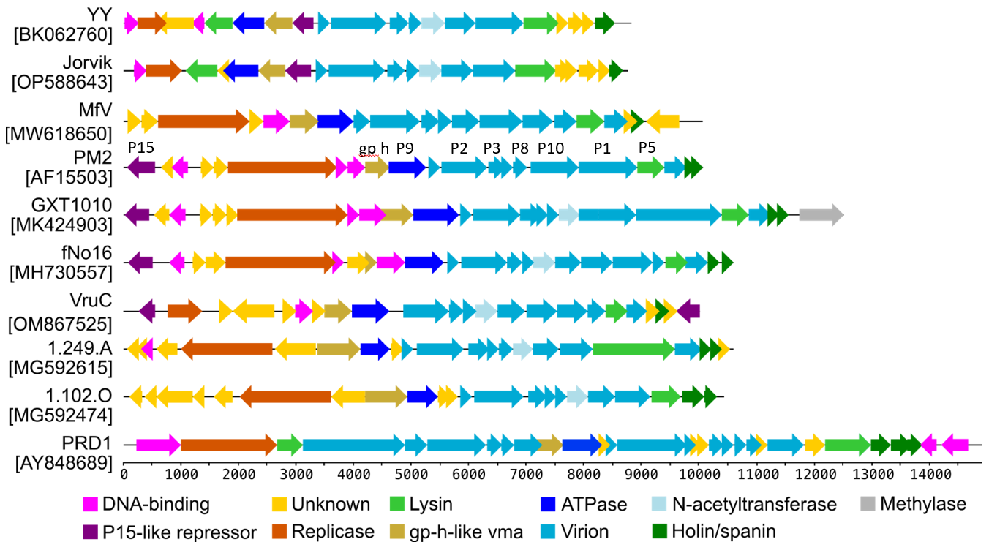

**Fig. 3: Genome synteny of proposed members of the *Vinavirales* order.** Names of phages with GenBank accession numbers are shown on the left. The designation of nine conserved genes is shown at the top of PM2 (labelled by their protein names). The scale bar at the bottom shows the length of the genome in base pairs. Genes are coloured according to their putative function as explained in the legend. The figure is an updated version adapted from Bárdy et al., 2023.