

The International Committee on Taxonomy of Viruses

Taxonomy Proposal Form, 2024

**Part 1a: Details of taxonomy proposals**

|  |  |  |
| --- | --- | --- |
| **Title:** | Create a new family (*Mazoviaviridae*) and a new genus (*Dabrowskivirus*) with a single species (*Caudoviricetes* class) | |
| **Code assigned:** | 2024.033B |  |

|  |  |  |  |
| --- | --- | --- | --- |
| **Author(s), affiliation and email address(es):** | | | |
| **Name** | **Affiliation** | **Email address** | **Corresponding author(s)** |
| Shymialevich D | Department of Microbiology, Prof. Wacław Dąbrowski Institute of Agricultural and Food Biotechnology – State Research Institute, Warsaw, Poland | diana.szymielewicz@ibprs.pl |  |
| Wójcicki M | Department of Microbiology, Prof. Wacław Dąbrowski Institute of Agricultural and Food Biotechnology – State Research Institute, Warsaw, Poland | michal.wojcicki@ibprs.pl | X |
| Sokołowska B | Department of Microbiology, Prof. Wacław Dąbrowski Institute of Agricultural and Food Biotechnology – State Research Institute, Warsaw, Poland | barbara.sokolowska@ibprs.pl |  |

**Part 1b: Taxonomy Proposal Submission**

|  |  |  |  |
| --- | --- | --- | --- |
| **ICTV Subcommittee:** | | | |
| Animal DNA Viruses and Retroviruses |  | Bacterial viruses | **X** |
| Animal minus-strand and dsRNA viruses |  | Fungal and protist viruses |  |
| Animal positive-strand RNA viruses |  | Plant viruses |  |
| Archaeal viruses |  | General |  |

|  |
| --- |
| **List the ICTV Study Group(s) that have seen or have been involved in creating this proposal:** |
| Bacterial Viruses Subcommittee, Caudoviricetes Study Group |

|  |  |  |  |
| --- | --- | --- | --- |
| **Optional – complete only if formally voted on by an ICTV Study Group:** | | | |
| **Study Group** | **Number of members** | | |
| **Votes in support** | **Votes against** | **No vote** |
|  |  |  |  |
|  |  |  |  |

|  |  |
| --- | --- |
| **Submission date:** | 09/06/2024 |

**Part 1c: Feedback from ICTV Executive Committee (EC) meeting**

|  |  |
| --- | --- |
| **Executive Committee Meeting Decision code:** | **X** |
| A – Accept |  |
| Ac – Accept subject to revision by relevant subcommittee chair. No further vote required |  |
| U – Accept without revision but with re-evaluation and email vote by the EC |  |
| Uc – Accept subject to revision and re-evaluation and email vote by the EC | **X** |
| Ud – Deferred to the next EC meeting, with an invitation to revise based on EC comments |  |
| J - Reject |  |
| W - Withdrawn |  |

|  |
| --- |
| **Comments from the Executive Committee:** |
| The family cannot be named after an author of the proposal. Please revise the proposal using an alternative name for the family. |

**Part 1d: Revised Taxonomy Proposal Submission**

|  |
| --- |
| **Response of proposer:** |
| The family name has been altered to *Mazoviaviridae* |

|  |  |
| --- | --- |
| **Revision date:** | 09/10/2024 |

**Part 3:** **TAXONOMIC PROPOSAL**

|  |
| --- |
| **Name of accompanying Excel module:** |
| 2024.033B.Uc.v2.Mazoviaviridae_nf.xlsx |

|  |  |  |  |
| --- | --- | --- | --- |
| **Taxonomic changes proposed:** | | | |
| Establish new taxon | X | Split taxon |  |
| Abolish taxon |  | Merge taxon |  |
| Move taxon |  | Promote taxon |  |
| Rename taxon |  | Demote taxon |  |
| Move and rename |  |  |  |

|  |  |  |
| --- | --- | --- |
| **Is any taxon name used here derived from that of a living person:** | | N |
| **Taxon name** | **Person from whom the name is derived** | **Attached** |
|  |  |  |

|  |
| --- |
| **Abstract of Taxonomy Proposal:** |
| *Taxonomic rank(s) affected*:  Proposal to create a new family (*Mazoviaviridae*) and a new genus (*Dabrowskivirus*) with a single species (*Caudoviricetes* class).  *Description of current taxonomy*:  In 2022, significant changes to the taxonomy of bacterial viruses were introduced: the paraphyletic morphological families *Podoviridae*, *Siphoviridae*, and *Myoviridae* as well as the order *Caudovirales* were abolished, which is replaced by the class *Caudoviricetes* to group all tailed bacterial and archaeal viruses with icosahedral capsids and a double-stranded DNA genome. Moreover, a binomial system of nomenclature for species was established. Based on the morphology and the comparative analysis of its predicted proteins, Alicyclobacillus myophage vB_Aac_IAFB_3916 was assigned to viruses with complex structures (*Caudoviricetes* class).  *Proposed* *taxonomic change(s):*  Analyses of the phylogenetic relationship of Alicyclobacillus myophage vB_Aac_IAFB_3916 prevented its unambiguous assignment to a specific family and genus. The weak similarity with other phage genomes deposited in the databases suggests that the isolated bacteriophage may be a representative of a new genus and new family of tailed bacteriophages.  *Justification*:  The genome of newly isolated Alicyclobacillus myophage vB_Aac_IAFB_3916 possesses no DNA homologs. At the protein level again, this virus is unique. Therefore, we have decided to create a new species (*Dabrowskivirus KKP3916*), genus (*Dabrowskivirus*) and family (*Mazoviaviridae*) for viruses of this type. |

|  |
| --- |
| **Text of Taxonomy proposal:** |
| *Taxonomic rank(s) affected*:  Proposal to create a new family (*Mazoviaviridae*) and a new genus (*Dabrowskivirus*) with a single species (*Caudoviricetes* class).  *Description of current taxonomy*:  In 2022, significant changes to the taxonomy of bacterial viruses were introduced: the paraphyletic morphological families *Podoviridae*, *Siphoviridae*, and *Myoviridae* as well as the order *Caudovirales* were abolished, which is replaced by the class *Caudoviricetes* to group all tailed bacterial and archaeal viruses with icosahedral capsids and a double-stranded DNA genome. Moreover, a binomial system of nomenclature for species was established. Based on the morphology and the comparative analysis of its predicted proteins, Alicyclobacillus myophage vB_Aac_IAFB_3916 was assigned to viruses with complex structures (*Caudoviricetes* class).  *Proposed* *taxonomic change(s)*:  Analyses of the phylogenetic relationship of Alicyclobacillus myophage vB_Aac_IAFB_3916 prevented its unambiguous assignment to a specific family and genus. The weak similarity with other phage genomes deposited in the databases suggests that the isolated bacteriophage may be a representative of a new genus and new family of tailed bacteriophages.  *Demarcation criteria:*  **Species demarcation criteria:** Two phages are assigned to the same species if their genomes are more than 95% identical over their genome length for isolates.  These values can be calculated by several tools, such as BLASTn [1] – usually calculated using the intergenomic distance calculator VIRIDIC [2].  **Genus demarcation criteria:** In search for criteria that create cohesive and distinct genera that are reproducible and monophyletic, the Bacterial Viruses Subcommittee has established 70% nucleotide identity of the genome length as the cut-off for genera. Genus-level groupings should always be monophyletic in the signature genes, as tested with a phylogenetic tree [3].  **Family demarcation criteria:** The family is represented by a cohesive and monophyletic group in the main predicted proteome-based clustering tools (ViPTree, GRAViTy dendrogram, vConTACT2 network). Family members share a significant number of orthologous genes (the number will depend on the genome sizes and number of coding sequences of family members) [3].  *Justification*:  The genome of newly isolated Alicyclobacillus myophage vB_Aac_IAFB_3916 possesses no DNA homologs. At the protein level again, this virus is unique. Therefore, we have decided to create a new species (*Dabrowskivirus KKP3916*), genus (*Dabrowskivirus*) and family (*Mazoviaviridae*) for viruses of this type. |

|  |
| --- |
| **References:** |
| 1. Sayers EW, Beck J, Bolton EE, Bourexis D, Brister JR, Canese K, Comeau DC, Funk K, Kim S, Klimke W, Marchler-Bauer A, Landrum M, Lathrop S, Lu Z, Madden TL, O'Leary N, Phan L, Rangwala SH, Schneider VA, Skripchenko Y, Wang J, Ye J, Trawick BW, Pruitt KD, Sherry ST (2021) Database resources of the National Center for Biotechnology Information. Nucleic Acids Res 49(D1):D10-D17. https://doi.org/10.1093/nar/gkaa892. PMID: 33095870. 2. Moraru C, Varsani A, Kropinski AM (2020) VIRIDIC - a novel tool to calculate the intergenomic similarities of prokaryote-infecting viruses. Viruses 12(11):1268. https://doi.org/10.3390/v12111268. PMID: 33172115; PMCID: PMC7694805. 3. Turner D, Kropinski AM, Adriaenssens EM (2021) A roadmap for genome-based phage taxonomy. Viruses 13(3):506. https://doi.org/10.3390/v13030506. PMID: 33803862; PMCID: PMC8003253. 4. Nishimura Y, Yoshida T, Kuronishi M, Uehara H, Ogata H, Goto S (2017) ViPTree: the viral proteomic tree server. Bioinformatics 33(15):2379-2380. https://doi.org/10.1093/bioinformatics/btx157. PMID: 28379287. 5. Rohwer F, Edwards R (2002) The Phage Proteomic Tree: a genome-based taxonomy for phage. J Bacteriol 184(16):4529-4535. https://doi.org/10.1128/jb.184.16.4529-4535.2002. PMID: 12142423. 6. Mihara T, Nishimura Y, Shimizu Y, Nishiyama H, Yoshikawa G, Uehara H, Hingamp P, Goto S, Ogata H (2016) Linking virus genomes with host taxonomy. Viruses 8(3):66. https://doi.org/10.3390/v8030066. 7. Shymialevich D, Wójcicki M, Świder O, Średnicka P, Sokołowska B (2023) Characterization and genome study of a newly isolated temperate phage belonging to a new genus targeting *Alicyclobacillus acidoterrestris*. Genes 14(6):1303. https://doi.org/10.3390/genes14061303. 8. Proksee Software. Available online: https://proksee.ca/. Accessed 2 March 2023. |

|  |
| --- |
| **Tables, Figures:** |

**VIRIDIC heat map:** VIRIDIC (Virus Intergenomic Distance Calculator [2]; http://rhea.icbm.uni-oldenburg.de/VIRIDIC/) computes pairwise intergenomic distances/similarities amongst phage genomes. The **red boxes** delineate Alicyclobacillus myophage vB_Aac_IAFB_3916 strain.

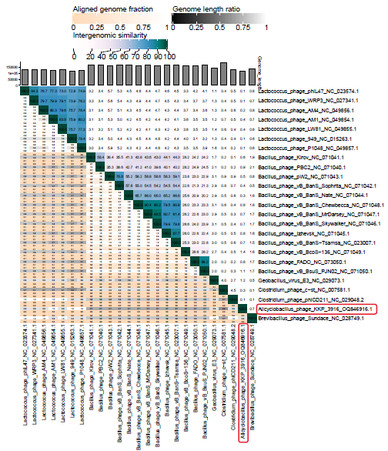

**ViPTree analysis:** ViPTree analysis (https://www.genome.jp/viptree/; [4]) is based upon Rohwer and Edwards (2002) famous Phage Proteomic Tree [5]. The phages of interest are indicated with a **green rectangle**.

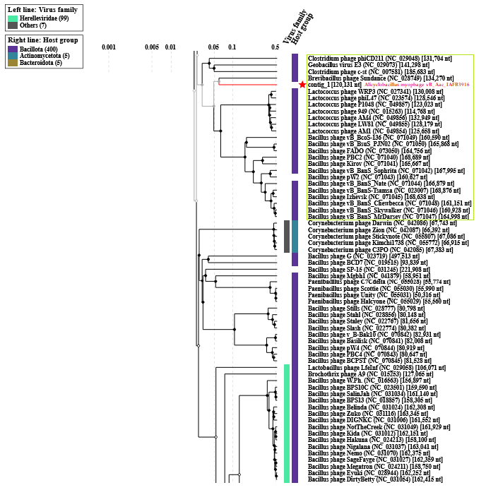

Alicyclobacillus myophage vB_Aac_IAFB_3916 is marked with a red asterisk. The analysis showed that it was most similar to Brevibacillus phage Sundace.

The viral proteomic tree of the Alicyclobacillus myophage vB_Aac_IAFB_3916 is below shown in a circular view. The branch represented by the phage under study is marked with a **red asterisk**. The colored rings indicate the virus family (inner rings) and host groups (at the phylum level; outer rings). The tree was calculated by BIONJ based on the genomic distance matrix and rooted at the midpoint. Branch lengths are log-scaled. Sequence and taxonomic data were based on the Virus-Host DB [6]. The trees shown were generated using the ViPTree server [4].

It indicates that the isolated bacteriophage is a distant relative of phages from the *Herelleviridae* family.

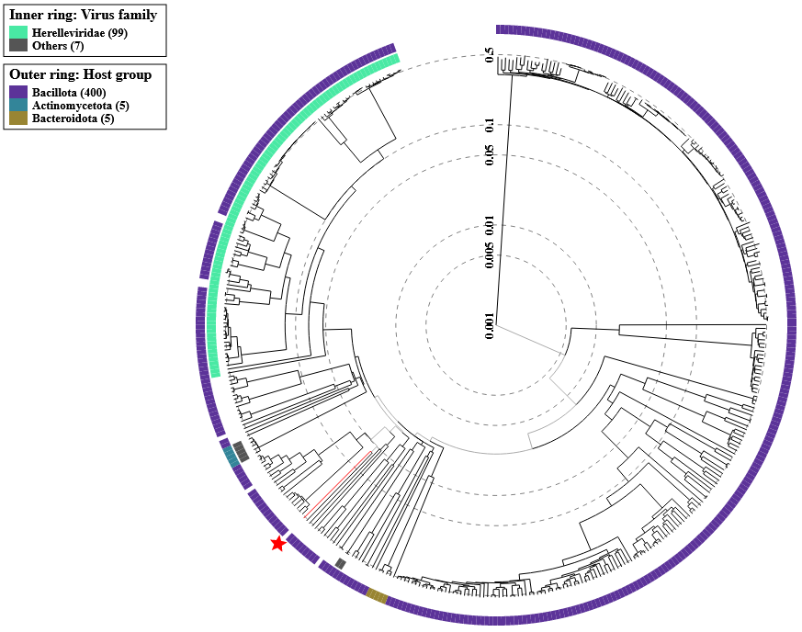

Genome sequence comparison of the Alicyclobacillus myophage vB_Aac_IAFB_3916 with Brevibacillus phage Sundance genome exhibiting co-linearity detected by TBLASTX using ViPTree server [4]. Homologous regions detected by a TBLASTX search are connected by segments colored based on amino acid identity. The color bar shows the % identity of TBLASTX.

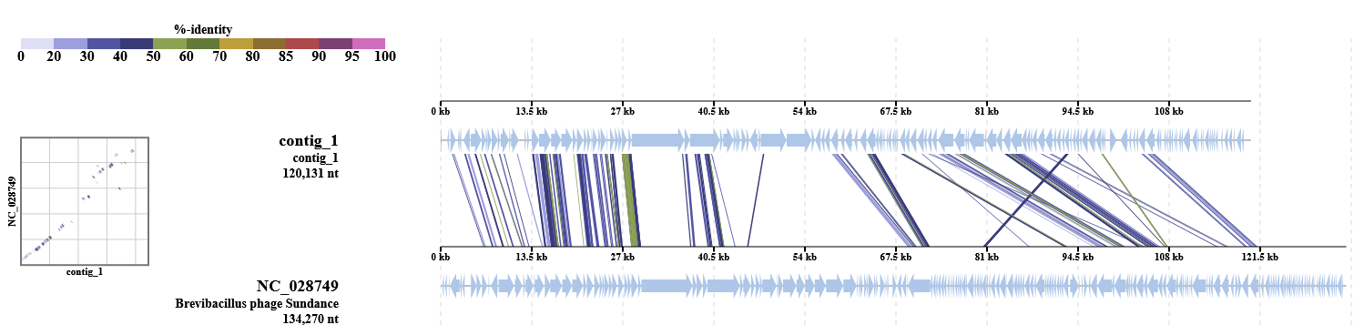

Below is a BLASTn alignment of phage homolog sequences (at the GenBank database; phages marked in a **green box** in the Phage Proteomic Tree) with Alicyclobacillus myophage vB_Aac_IAFB_3916:

|  |  |  |  |  |  |  |  |  |  |
| --- | --- | --- | --- | --- | --- | --- | --- | --- | --- |
| **ID** | **Length** | **Taxid** | **Name** | **Group** | **Host Group** | **Score** | **SG** | **% Mean. Idt** | **% Len.** |
| OQ846916 | 120131 | - | Alicyclobacillus phage KKP 3916 | dsDNA | Bacillota | 80263 | 1 | 100 | 100 |
| NC_028749 | 134270 | 1691958 | Brevibacillus phage Sundance | dsDNA | Bacillota | 5989 | 0.0746 | 41.9 | 16.7 |
| NC_027341 | 130008 | 1560313 | Lactococcus phage WRP3 | dsDNA | Bacillota | 2974 | 0.0371 | 38.4 | 9.1 |
| NC_023574 | 128546 | 1412875 | Lactococcus phage phiL47 | dsDNA | Bacillota | 2941 | 0.0366 | 38 | 9.1 |
| NC_049857 | 123023 | 2662295 | Lactococcus phage P1048 | dsDNA | Bacillota | 2986 | 0.0372 | 38.5 | 9.1 |
| NC_015263 | 114768 | 881953 | Lactococcus phage 949 | dsDNA | Bacillota | 2943.5 | 0.0367 | 39 | 9 |
| NC_049856 | 132949 | 1965472 | Lactococcus phage AM4 | dsDNA | Bacillota | 2951 | 0.0368 | 38.4 | 9.1 |
| NC_049855 | 128179 | 1965482 | Lactococcus phage LW81 | dsDNA | Bacillota | 3223 | 0.0402 | 39 | 9.7 |
| NC_049854 | 125658 | 1965467 | Lactococcus phage AM1 | dsDNA | Bacillota | 2881 | 0.0359 | 39.1 | 8.7 |
| NC_071049 | 160590 | 2419619 | Bacillus phage vB_BcoS-136 | dsDNA | Bacillota | 6921 | 0.0862 | 44.3 | 18.1 |
| NC_071050 | 165868 | 2920374 | Bacillus phage vB_BsuS_PJN02 | dsDNA | Bacillota | 5720.5 | 0.0713 | 44.9 | 14.8 |
| NC_073050 | 164756 | 2917160 | Bacillus phage FADO | dsDNA | Bacillota | 5523 | 0.0688 | 44.9 | 14.4 |
| NC_071040 | 168689 | 1675029 | Bacillus phage PBC2 | dsDNA | Bacillota | 6132.5 | 0.0764 | 42 | 17 |
| NC_071041 | 165667 | 2783539 | Bacillus phage Kirov | dsDNA | Bacillota | 5957 | 0.0742 | 41.7 | 16.8 |
| NC_071042 | 167995 | 2894790 | Bacillus phage vB_BanS_Sophrita | dsDNA | Bacillota | 4656.5 | 0.058 | 40.8 | 13.4 |
| NC_071043 | 160627 | 2500559 | Bacillus phage pW2 | dsDNA | - | 4531 | 0.0565 | 41.1 | 12.9 |
| NC_071044 | 166879 | 2894788 | Bacillus phage vB_BanS_Nate | dsDNA | Bacillota | 4667.5 | 0.0582 | 40.1 | 13.6 |
| NC_023007 | 168876 | 1308863 | Bacillus phage vB_BanS-Tsamsa | dsDNA | Bacillota | 5871.5 | 0.0732 | 42 | 16.5 |
| NC_071045 | 168638 | 2724322 | Bacillus phage Izhevsk | dsDNA | Bacillota | 5807 | 0.0723 | 41.7 | 16.2 |
| NC_071048 | 161151 | 2894786 | Bacillus phage vB_BanS_Chewbecca | dsDNA | Bacillota | 5629 | 0.0701 | 42.2 | 15.8 |
| NC_071046 | 160928 | 2894789 | Bacillus phage vB_BanS_Skywalker | dsDNA | Bacillota | 5751 | 0.0717 | 42.2 | 16 |
| NC_071047 | 164998 | 2894787 | Bacillus phage vB_BanS_MrDarsey | dsDNA | Bacillota | 5761.5 | 0.0718 | 42.3 | 16 |
| NC_029048 | 131704 | 1582152 | Clostridium phage phiCD211 | dsDNA | Bacillota | 784.5 | 0.0098 | 36.9 | 2.5 |
| NC_029073 | 141298 | 1572712 | Geobacillus virus E3 | dsDNA | Bacillota | 3345 | 0.0417 | 48.6 | 8.1 |
| NC_007581 | 185683 | 12336 | Clostridium phage c-st | dsDNA | Bacillota | 1591 | 0.0198 | 41.9 | 3.9 |

**Proposal A. Create a new family, *Mazoviaviridae*.**

**Rationale:** Alicyclobacillus myophage vB_Aac_IAFB_3916 was isolated in the Mazovia region (Poland) and is unique at the DNA, protein, and phylogenetic level.

**Proposal B. Create a new genus, *Dabrowskivirus*.**

The Alicyclobacillus myophage vB_Aac_IAFB_3916 was isolated from orchard soil against the *Alicyclobacillus acidoterrestris* strain KKP 3133. This bacteriophage was characterized in the article by Shymialevich et al. (2023) [7].

**Electron micrograph:** Figure A shows the plaque obtained for the Alicyclobacillus myophage vB_Aac_IAFB_3916. The plaques were characterized by a transparent center with cloudy edges. Electronograms obtained using TEM allowed the visualization of the morphology of the bacteriophage (Figures B and C). The bacteriophage has a complex structure (tailed phages), containing an icosahedral symmetrical head (capsid) and a long, contractile tail (myovirus morphology).

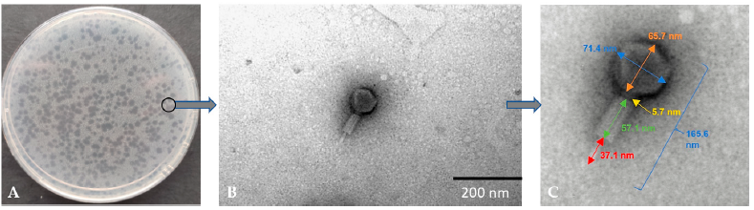

**Genome analysis:** The complete genome of the Alicyclobacillus myophage vB_Aac_IAFB_3916 was sequenced and deposited in the GenBank database under accession number OQ846916. The sequence of the Alicyclobacillus myophage vB_Aac_IAFB_3916 genome in the form of linear dsDNA is 120,131 bp long with 40.3% G+C pair content. Out of the 204 predicted open reading frames (ORFs), 70 ORFs are associated with genes encoding proteins with known functions and 134 ORFs encode hypothetical proteins with unknown functions.

A map of the genomic organization of Alicyclobacillus myophage vB_Aac_IAFB_3916 was generated using the Proksee program [8].

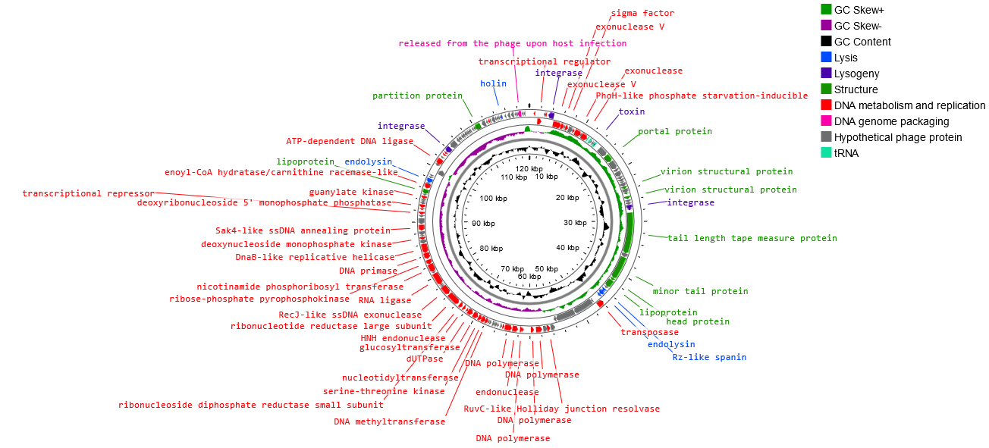

The annotated functional proteins were divided into several groups, depending on their function: activities related to metabolism and replication, genome packaging, structure, lysis, and lysogeny. The main group of proteins whose function was predicted comprised those related to metabolism and replication. Among genes related to replication and metabolism, the following proteins were found in the phage genome: DNA helicase (DnaB-like replicative helicase), DNA primase, RNA ligase, DNA polymerase, DNA methyltransferase, transposase, exonuclease, and other proteins. The group of other proteins included those associated with phage structure, including portal protein, capsid, tail, and lipoprotein. The proteins associated with lysis include, among others, holin, endolysin, and spanin. In the Alicyclobacillus myophage vB_Aac_IAFB_3916 genome, one region encoding Rz-like spanin, two regions encoding holin, and three regions encoding endolysin were predicted. The analysis of the Alicyclobacillus myophage vB_Aac_IAFB_3916 genome showed five tRNAs. No genes related to antibiotic resistance were found in the genome of the newly isolated phage, but four integration-related regions were identified. In addition, other regions associated with lysogeny were noted in the Alicyclobacillus myophage vB_Aac_IAFB_3916 genome: the toxin gene and excisionase.

**Rationale:** Based on the morphology and the comparison of its protein regions, Alicyclobacillus myophage vB_Aac_IAFB_3916 was assigned to viruses with complex structures (*Caudoviricetes* class). However, analyses of the phylogenetic relationship prevented its unambiguous assignment to a specific family and genus. The weak similarity with other phage genomes deposited in the databases suggests that the isolated bacteriophage may be representative of a new genus and new family of tailed bacteriophages.