

The International Committee on Taxonomy of Viruses
Taxonomy Proposal Form, 2024

Part 1a: Details of taxonomy proposals

Title: | Create seven new genera for Rhodococcus siphoviruses [Class: Caudoviricetes]
Code assigned: | 2024.029B

Author(s), affiliation and email address(es):
Name | Affiliation | Email address | Corresponding author(s) X
Kurtböke I | University of the Sunshine Coast, Queensland, Australia | IKurtbok@usc.edu.au
Moraru C | Carl von Ossietzky Universität Oldenburg, Germany | liliana.cristina.moraru@gmail.com
Tolstoy I | National Center for Biotechnology Information, MD, USA | tolstoy@ncbi.nlm.nih.gov
Kropinski AM | University of Guelph, Ontario, Canada | Phage.Canada@gmail.com | x

Part 1b: Taxonomy Proposal Submission
ICTV Subcommittee:
Animal DNA Viruses and Retroviruses |  | Bacterial viruses | x
Animal minus-strand and dsRNA viruses |  | Fungal and protist viruses
Animal positive-strand RNA viruses |  | Plant viruses
Archaeal viruses |  | General -

List the ICTV Study Group(s) that have seen or have been involved in creating this proposal:
Actinophages Study Group
Optional – complete only if formally voted on by an ICTV Study Group:
Study Group | Number of members
 | Votes in support | Votes against | No vote

Submission date: | 09/05/2024

Part 1c: Feedback from ICTV Executive Committee (EC) meeting
Executive Committee Meeting Decision code: | X
A – Accept | X
Ac – Accept subject to revision by relevant subcommittee chair. No further vote required
U – Accept without revision but with re-evaluation and email vote by the EC
Uc – Accept subject to revision and re-evaluation and email vote by the EC
Ud – Deferred to the next EC meeting, with an invitation to revise based on EC comments
J - Reject
W - Withdrawn

Comments from the Executive Committee:

Part 1d: Revised Taxonomy Proposal Submission
Response of proposer:
Revision date: | DD/MM/YYYY

Part 3: TAXONOMIC PROPOSAL

Name of accompanying Excel module:
2024.029B.A.v1.Rhodococcus_siphoviruses_ng.xlsx

Taxonomic changes proposed:
Establish new taxon | X | Split taxon
Abolish taxon |  | Merge taxon
Move taxon |  | Promote taxon
Rename taxon |  | Demote taxon
Move and rename

Is any taxon name used here derived from that of a living person: |  | N
Taxon name | Person from whom the name is derived | Attached X

Abstract of Taxonomy Proposal:
Taxonomic rank(s) affected:
Realm Duplodnaviria, kingdom Heunggongvirae, phylum Uroviricota, class Caudoviricetes

Description of current taxonomy:
The viruses classified in this proposal do not have a current taxonomic assignment.

Proposed taxonomic change(s):
We propose the creation of seven new taxa for unique Rhodococcus siphoviruses: Edwardsroadvirus, Wodongavirus, Reqipinevirus, Melbournevirus, Trogglehumpervirus, Mboduovirus, Reynauldvirus

Justification:
The taxa proposed conform to demarcation criteria specified by the ICTV bacterial viruses subcommittee.

- Text of Taxonomy proposal:
Taxonomic rank(s) affected:
Realm Duplodnaviria, kingdom Heunggongvirae, phylum Uroviricota, class Caudoviricetes

Description of current taxonomy:
The viruses classified in this proposal do not have a current taxonomic assignment.

Proposed taxonomic change(s):
We propose the creation of nine new taxa for unique Rhodococcus siphoviruses: Edwardsroadvirus, Wodongavirus, Reqipinevirus, Melbournevirus, Trogglehumpervirus, Mboduovirus, Reynauldvirus

Demarcation criteria:
Species demarcation criteria: Two phages are assigned to the same species if their genomes are more than 95% identical over their genome length for isolates.
These values can be calculated by a number of tools, such as BLASTn [1,2] – usually calculated using intergenomic distance calculator VIRIDIC [3].

Genus demarcation criteria: In search for criteria that create cohesive and distinct genera that are reproducible and monophyletic, the Bacterial Viruses Subcommittee has established 70% nucleotide identity of the genome length as the cut-off for genera. Genus-level groupings should always be monophyletic in the signature genes, as tested with a phylogenetic tree. [10]

Justification:
The taxa proposed conform to demarcation criteria specified by the ICTV bacterial viruses subcommittee.

References:
1. Sayers EW, Beck J, Bolton EE, Bourexis D, Brister JR, Canese K, Comeau DC, Funk K, Kim S, Klimke W, Marchler-Bauer A, Landrum M, Lathrop S, Lu Z, Madden TL, O'Leary N, Phan L, Rangwala SH, Schneider VA, Skripchenko Y, Wang J, Ye J, Trawick BW, Pruitt KD, Sherry ST. Database resources of the National Center for Biotechnology Information. Nucleic Acids Res. 2021 Jan 8;49(D1):D10-D17. doi: 10.1093/nar/gkaa892. PMID: 33095870
2. O'Leary NA, Wright MW, Brister JR, Ciufo S, Haddad D, McVeigh R, et al. Reference sequence (RefSeq) database at NCBI: current status, taxonomic expansion, and functional annotation. Nucleic Acids Res. 2016;44(D1):D733-45. doi: 10.1093/nar/gkv1189. PMID: 26553804.
3. Moraru C, Varsani A, Kropinski AM. VIRIDIC-A Novel Tool to Calculate the Intergenomic Similarities of Prokaryote-Infecting Viruses. Viruses. 2020 Nov 6;12(11):1268. doi: 10.3390/v12111268. PMID: 33172115; PMCID: PMC7694805. http://kronos.icbm.uni-oldenburg.de/viridic/
4. Nishimura Y, Yoshida T, Kuronishi M, Uehara H, Ogata H, Goto S. ViPTree: the viral proteomic tree server. Bioinformatics. 2017; 33(15):2379-2380. doi:10.1093/bioinformatics/btx157. PubMed PMID: 28379287. https://www.genome.jp/viptree/
5. Rohwer F, Edwards R. The Phage Proteomic Tree: a genome-based taxonomy for phage. J Bacteriol. 2002 Aug;184(16):4529-35. PubMed PMID: 12142423
6. Turner D, Reynolds D, Seto D, Mahadevan P. CoreGenes3.5: a webserver for the determination of core genes from sets of viral and small bacterial genomes. BMC Res Notes. 2013;6:140. doi: 10.1186/1756-0500-6-140. PMID: 23566564.
7. Davis P, Seto D, Mahadevan P. CoreGenes5.0: An Updated User-Friendly Webserver for the Determination of Core Genes from Sets of Viral and Bacterial Genomes. Viruses. 2022 Nov 16;14(11):2534. doi: 10.3390/v14112534. PMID: 36423143; PMCID: PMC9693508.
8. Dereeper A, Guignon V, Blanc G, Audic S, Buffet S, Chevenet F, Dufayard JF, Guindon S, Lefort V, Lescot M, Claverie JM, Gascuel O. Phylogeny.fr: robust phylogenetic analysis for the non-specialist. Nucleic Acids Res. 2008;36(Web Server issue):W465-9. doi: 10.1093/nar/gkn180. Epub 2008 Apr 19. PMID: 18424797.
9. Anisimova M, Gascuel O. Approximate likelihood-ratio test for branches: A fast, accurate, and powerful alternative. Syst Biol. 2006;55(4):539-52. PMID: 16785212. DOI: 10.1080/10635150600755453.
10. Turner D, Kropinski AM, Adriaenssens EM. A Roadmap for Genome-Based Phage Taxonomy. Viruses. 2021 Mar 18;13(3):506. doi: 10.3390/v13030506. PMID: 33803862; PMCID: PMC8003253.
11. Bin Jang H, Bolduc B, Zablocki O, Kuhn JH, Roux S, Adriaenssens EM, Brister JR, Kropinski AM, Krupovic M, Lavigne R, Turner D, Sullivan MB. Taxonomic assignment of uncultivated prokaryotic virus genomes is enabled by gene-sharing networks. Nat Biotechnol. 2019 Jun;37(6):632-639. doi: 10.1038/s41587-019-0100-8. Epub 2019 May 6. PMID: 31061483.

Tables, Figures:
<Start here>

Figure 1. VIRIDIC heat map of a portion of the members of this group: VIRIDIC (Virus Intergenomic Distance Calculator; VIRIDIC (Virus Intergenomic Distance Calculator; [3]; http://rhea.icbm.uni-oldenburg.de/VIRIDIC/) computes pairwise intergenomic distances/similarities amongst phage genomes. Data values which are bordered in black correspond to strains. Abbreviations: phg = phage; Gord = Gordonia; Rhod = Rhodococcus.

Figure 2. ViPTree analysis: ViPTree analysis (https://www.genome.jp/viptree/; [4]) is based upon Rohwer and Edwards (2002) famous Phage Proteomic Tree [5]. The members under consideration are indicated with coloured arrowheads.

Taxonomic Proposals:
- Create a new single species genus, Edwardsroadvirus

Origin of the name of this taxon: The name of this taxon derives from the address of Pharmacy and Applied Science, La Trobe University, Edwards Road, Bendigo, Australia where the first phage of its type was isolated

Historical aspects: This lytic siphophage was isolated against Rhodococcus rhodochrous str. Rrho39 from wastewater by Steve Petrovski’s group at La Trobe University. The Actinobacteriophage Database considers this phage to be a Singleton.

Electron micrograph: N/A

Genome summary:

Phage name | INSDC | Size (kb) | No. of proteins | Mol% G+C | Overall % DNA sequence identity (*) | Overall % homologous proteins (**)
Rhodococcus phage RRH1 | JN116822.1 | 14.3 | 20 | 68.4 | 100 | 100

Conclusion: On the basis of DNA (Fig. 1) and protein (Fig. 2) similarity this is a unique genus.

- Create a new single species genus, Wodongavirus

Origin of the name of this taxon: The name of this taxon derives from Bundoora - a suburb in Melbourne, Victoria, Australia where at La Trobe University, Edwards Road, the first phage of its type was isolated

Historical aspects: This lytic siphophage was isolated against Rhodococcus equi from wastewater by Steve Petrovski’s group at La Trobe University. The Actinobacteriophage Database considers this phage to be a Singleton.

Electron micrograph: N/A

Genome summary:

Phage name | INSDC | Size (kb) | No. of proteins | Mol% G+C | Overall % DNA sequence identity (*) | Overall % homologous proteins (**)
Rhodococcus phage REQ3 | JN116824.1 | 39.5 | 60 | 65.9 | 100 | 100

Conclusion: On the basis of DNA (Fig. 1) and protein (Fig. 2) similarity this is a unique genus.

- Create a new single species genus, Reqipinevirus

Origin of the name of this taxon: The name of this taxon derives from the name of the first phage of its type, Rhodococcus phage ReqiPine5.

Historical aspects: This lytic siphophage was isolated against Rhodococcus equi from soil samples [Summer et al. 2011]. Electron microscopy revealed a 66 nm head and a 236 nm flexible tail. It has not been classified by The Actinobacteriophage Database.

Electron micrograph: N/A

Genome summary:

Phage name | INSDC | Size (kb) | No. of proteins | Mol% G+C | Overall % DNA sequence identity (*) | Overall % homologous proteins (**)
Rhodococcus phage ReqiPine5 | GU580943.1 | 59.2 | 84 | 67.1 | 100 | 100

Summer EJ, Liu M, Gill JJ, Grant M, Chan-Cortes TN, Ferguson L, Janes C, Lange K, Bertoli M, Moore C, Orchard RC, Cohen ND, Young R. Genomic and functional analyses of Rhodococcus equi phages ReqiPepy6, ReqiPoco6, ReqiPine5, and ReqiDocB7. Appl Environ Microbiol. 2011 Jan;77(2):669-83. doi: 10.1128/AEM.01952-10. Epub 2010 Nov 19. PMID: 21097585; PMCID: PMC3020559.

Conclusion: On the basis of DNA (Fig. 1) and protein (Fig. 2) similarity this is a unique genus.

- Create a new single species genus, Melbournevirus

Origin of the name of this taxon: The name of this taxon derives from the location of the La Trobe University City Campus

Historical aspects: This temperate siphophage was isolated against Rhodococcus equi from wastewater samples by Steve Petrovski (Pharmacy and Applied Science, La Trobe
University, Australia) . It has been classified by The Actinobacteriophage Database as a singleton.

Electron micrograph: N/A

Genome summary:

Phage name | INSDC | Size (kb) | No. of proteins | Mol% G+C | Overall % DNA sequence identity (*) | Overall % homologous proteins (**)
Rhodococcus phage REQ2 | JN116823.1 | 49.3 | 82 | 65.4 | 100 | 100

Conclusion: On the basis of DNA (Fig. 1) and protein (Fig. 2) similarity this is a unique genus.

- Create a new single species genus, Trogglehumpervirus

Origin of the name of this taxon: The name of this taxon derives from the name of the first phage of its type, Rhodococcus phage Trogglehumper

Historical aspects: This temperate siphophage was isolated against Rhodococcus erythropolis NRRL B-1574 from West Branch Pond in Greenville, Maine during the summer by Jaelin Roberts (University of Maine, Greenville, USA) as part of the Science Education Alliance-Phage Hunters Advancing Genomics and Evolutionary Science program. The genome possesses 330 bp direct terminal repeats. It has been classified by The Actinobacteriophage Database as a singleton.
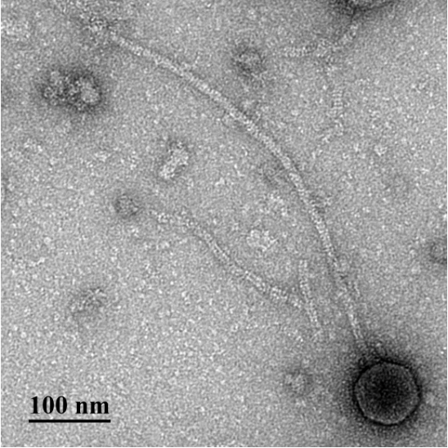

Electron micrograph: Electron micrographs of negatively stained Rhodococcus phage Trogglehumper (https://phagesdb.org/phages/Trogglehumper/). Limited permission was granted by The Actinobacteriophages Database (https://phagesdb.org/), funded by the Howard Hughes Medical Institute, to use this electron micrograph for this taxonomy proposal; it cannot be reused without permission of The Actinobacteriophages Database.

Genome summary:

Phage name | INSDC | Size (kb) | No. of proteins | Mol% G+C | Overall % DNA sequence identity (*) | Overall % homologous proteins (**)
Rhodococcus phage Trogglehumper | OQ709222.1 | 83.6 | 121 | 63.8 | 100 | 100

Conclusion: On the basis of DNA (Fig. 1) and protein (Fig. 2) similarity this is a unique genus.

- Create a new single species genus, Mboduovirus

Origin of the name of this taxon: The name of this taxon derives from the name of the first phage of its type, Rhodococcus phage Mbo2

Historical aspects: This temperate siphophage was isolated against Rhodococcus opacus PD630 from wastewater by Baxin Wang (Texas A & M University-College Station, USA). It has been classified by The Actinobacteriophage Database as a singleton.

Electron micrograph: N/A

Genome summary:

Phage name | INSDC | Size (kb) | No. of proteins | Mol% G+C | Overall % DNA sequence identity (*) | Overall % homologous proteins (**)
Rhodococcus phage Mbo2 | ON191531.1 | 83.1 | 120 | 64.5 | 100 | 100

Conclusion: On the basis of DNA (Fig. 1) and protein (Fig. 2) similarity this is a unique genus.

- Create a new single species genus, Reynauldvirus

Origin of the name of this taxon: The name of this taxon derives from the name of the first phage of its type, Rhodococcus phage Reynauld

Historical aspects: This temperate siphophage was isolated against Rhodococcus equi NRRL B-16538 from soil by Calvin Ritzema (Calvin University, Grand Rapids, MI, USA) as part of the Science Education Alliance-Phage Hunters Advancing Genomics and Evolutionary Science program. The genome possesses 362 bp direct terminal repeats. It has been classified by The Actinobacteriophage Database as a singleton.

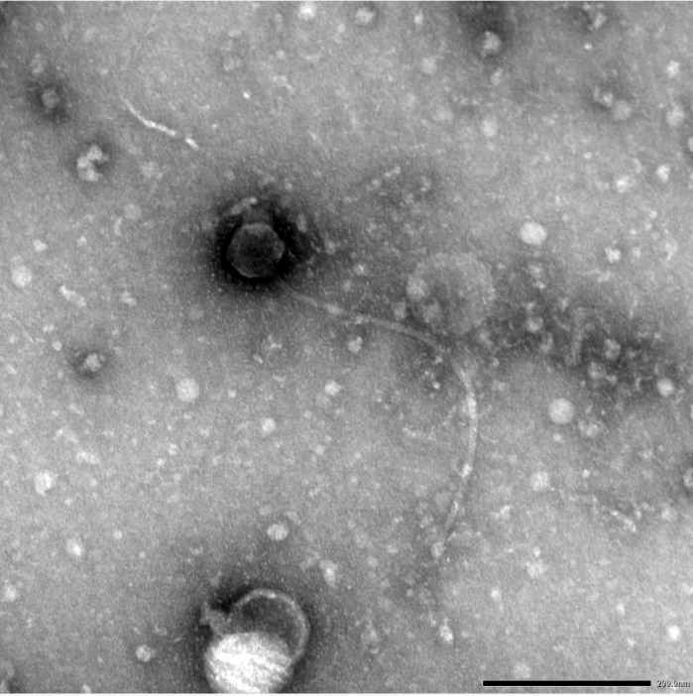
Electron micrograph: Electron micrographs of negatively stained Rhodococcus phage Reynauld (https://phagesdb.org/phages/Reynauld /). Limited permission was granted by The Actinobacteriophages Database (https://phagesdb.org/), funded by the Howard Hughes Medical Institute, to use this electron micrograph for this taxonomy proposal; it cannot be reused without permission of The Actinobacteriophages Database.

Genome summary:

Phage name | INSDC | Size (kb) | No. of proteins | Mol% G+C | Overall % DNA sequence identity (*) | Overall % homologous proteins (**)
Rhodococcus phage Reynauld | OR159659.1 | 81.0 | 103 | 66.5 | 100 | 100

Conclusion: On the basis of DNA (Fig. 1) and protein (Fig. 2) similarity this is a unique genus.

