

The International Committee on Taxonomy of Viruses

Taxonomy Proposal Form, 2024

**Part 1a: Details of taxonomy proposals**

|  |  |  |
| --- | --- | --- |
| **Title:** | Create a new family, *Obscuriviridae* (Class: *Caudoviricetes*) | |
| **Code assigned:** | 2024.025B |

|  |  |  |  |
| --- | --- | --- | --- |
| **Author(s), affiliation and email address(es):** | | | |
| **Name** | **Affiliation** | **Email address** | **Corresponding author(s)** X |
| Bartlau N | Max Planck Institute for Marine Microbiology, Bremen, Germany  Division of Microbial Ecology, Centre for Microbiology and Environmental Systems Science, University of Vienna; Vienna, Austria | nina.bartlau@univie.ac.at | X |
| Moraru C | Environmental Metagenomics, Research Center One Health Ruhr of the University Alliance Ruhr, Faculty of Chemistry, University of Duisburg-Essen, Essen, Germany | cristina.moraru@uni-due.de |  |
| Wichels A | Alfred-Wegner Institute Helmholtz Centre for Polar and Marine Research, Biologische Anstalt Helgoland, Germany | Antje.Wichels@awi.de |  |
| Holmfeldt K | Centre for Ecology and Evolution in Microbial Model Systems (EEMiS), Department of Biology and Environmental Science, Faculty of Health and Life Sciences, Linnaeus University, Kalmar, Sweden | karin.holmfeldt@lnu.se |  |
| Amann RI | Max Planck Institute for Marine Microbiology, Bremen, Germany | ramann@mpi-bremen.de |  |

**Part 1b: Taxonomy Proposal Submission**

|  |  |  |  |
| --- | --- | --- | --- |
| **ICTV Subcommittee:** | | | |
| Animal DNA Viruses and Retroviruses |  | Bacterial viruses | **X** |
| Animal minus-strand and dsRNA viruses |  | Fungal and protist viruses |  |
| Animal positive-strand RNA viruses |  | Plant viruses |  |
| Archaeal viruses |  | General - |  |

|  |
| --- |
| **List the ICTV Study Group(s) that have seen or have been involved in creating this proposal:** |
| *Microviridae Study Group* |
| **Optional – complete only if formally voted on by an ICTV Study Group:** | | | |
| **Study Group** | **Number of members** | | |
| **Votes in support** | **Votes against** | **No vote** |
|  |  |  |  |
|  |  |  |  |

|  |  |
| --- | --- |
| **Submission date:** | 21/06/2024 |

**Part 1c: Feedback from ICTV Executive Committee (EC) meeting**

|  |  |
| --- | --- |
| **Executive Committee Meeting Decision code:** | **X** |
| A – Accept |  |
| Ac – Accept subject to revision by relevant subcommittee chair. No further vote required | **X** |
| U – Accept without revision but with re-evaluation and email vote by the EC |  |
| Uc – Accept subject to revision and re-evaluation and email vote by the EC |  |
| Ud – Deferred to the next EC meeting, with an invitation to revise based on EC comments |  |
| J - Reject |  |
| W - Withdrawn |  |

|  |
| --- |
| **Comments from the Executive Committee:** |
| Following discussion with the proposer and the EC, the Excel module should be altered to create a floating family pending further study. |

**Part 1d: Revised Taxonomy Proposal Submission**

|  |
| --- |
| **Response of proposer:** |
| Corrected |
| **Revision date:** | 30/09/2024 |

**Part 3:** **TAXONOMIC PROPOSAL**

|  |
| --- |
| **Name of accompanying Excel module:** |
| 2024.025B.A.v2.Obscuriviridae.xlsx |

|  |  |  |  |
| --- | --- | --- | --- |
| **Taxonomic changes proposed:** | | | |
| Establish new taxon | **X** | Split taxon |  |
| Abolish taxon |  | Merge taxon |  |
| Move taxon |  | Promote taxon |  |
| Rename taxon |  | Demote taxon |  |
| Move and rename |  |

|  |  |  |
| --- | --- | --- |
| **Is any taxon name used here derived from that of a living person:** | | **N** |
| **Taxon name** | **Person from whom the name is derived** | **Attached X** |
|  |  |  |
|  |  |  |
|  |  |  |

|  |
| --- |
| **Abstract of Taxonomy Proposal:** |
| ***Taxonomic rank(s) affected*:**  Family  ***Description of current taxonomy*:**  The viruses described in this proposal do not have a current taxonomic assignment.  ***Proposed* *taxonomic change(s):***  A new family, *Obscuriviridae*, is proposed, comprising two new genera, *Omtjevirus* and *Cebaduodecimvirus.*  ***Justification*:**  The *Obscuriviridae* family was delineated with two genera. The genus *Omtjevirus* has *Omtjevirus Omtje* as a species and the genus *Cebaduodecimvirus* has *Cebaduodecimvirus phi12duo* and *Cebaduodecimvirus phi12auna* as species. The proposed taxonomic assignments are based on six different methods including nucleotide-, protein-, amino acid-, and core protein-based analysis. |

|  |
| --- |
| **Text of Taxonomy proposal:** |
| This taxonomic proposal aims to classify a new phage infecting *Cellulophaga* sp.*,* as well as related cultured phages. The isolation and characterization of this new flavophage, as well as the retrieval of related phages from sequence databases is described in [3].  The here proposed taxonomic assignments are based on six different methods: i) nucleotide-based intergenomic similarities calculated with the VIRIDIC web-service (viridic.icbm.de, [13]); ii) protein-based hierarchical clustering trees calculated with VirClust ([www.virclust.icbm.de](http://www.virclust.icbm.de)), iii) amino acid-based whole genome trees calculated with the the Viral Proteomic Tree (ViPTree) [15]; iv) amino acid-based whole genome trees calculated with the Virus Classification and Tree Building Online Resource (VICTOR) [12]; v) core-protein based trees using IQ-Trees [14]; and vi) sequence relatedness using GRAViTy [2].  To calculate nucleotide-based intergenomic similarities, VIRIDIC was used with the default parameters.  To calculate protein-based hierarchical clustering trees VirClust was used with the following parameters: i) protein clustering based on “evalue”, after reciprocal BLASTP hits were removed if e-value > 0.0001 and bitscore < 50; ii) hierarchical clustering based on protein clusters, aglomeration method “complete”, 1000 bootstraps, tree cut at a distance of 0.9. As reference for the ICTV dataset, phages belonging to the *Monodnaviria* with bacterial host of the Master Species List release 35 (March 2020, <https://talk.ictvonline.org/files/master-species-lists/m/msl/9601>) [1] updated with the newly approved proposals for 2020 (<https://talk.ictvonline.org/files/master-species-lists/m/msl/12314>) was used.  To calculate phylogenetic trees with ViPTree, the command line tool was used, with default parameters.  To calculate the intergenomic distances and the phylogenetic tree, VICTOR was used with the d6 formula [11]. The resulted tree was visualized with FigTree (<http://tree.bio.ed.ac.uk/software/figtree>). In addition to phylogenetic trees, VICTOR uses the following predetermined distance thresholds to suggest taxon boundaries at the species, genus, subfamily and family level: 0.118980, 0.749680, 0.888940 and 0.985225, respectively [12]. These thresholds yield the highest agreement with the ICTV 2014 classification regarding the investigated taxonomic ranks [12], but not necessarily with the current ICTV recommendations.  The nucleotide-based thresholds for the rank of species and genus used in this proposal are 95% and 70%, as recommended by ICTV. Based on previous observations [4], the VICTOR threshold for subfamily matches the new ICTV recommendations for family, and were considered as such in this proposal.  To calculate the sequence relatedness the web service of GRAViTy ([2] ,<http://gravity.cvr.gla.ac.uk>) was used with the *Obscuriviridae* and the Baltimore Group II - ssDNA viruses + *Papillomaviridae* and *Polyomaviridae* (VMRv34).  The intra-familial structure and relationships was determined by concatenated core proteins, calculated with VirClust, aligned with MUSCLE (v3.8.425,[5]), manually trimmed and trees calculated IQ-Tree with SH-aLRT [14] and ultrafast boostrap values [6] using ModelFinder [10].  The following figures and descriptions are taken from the supplementary information of [3] and demarcation criteria are added. *Obscuriviridae* family The family *Obscuriviridae* is named after the Latin word *obscurus*, which can be translated as ambiguous and uncertain. This word was chosen, because the importance of this family is still unresolved.  **Family demarcation criteria:** Monophyletic group in VirClust (Figure 2), VICTOR (Figure 3), and ViPTree (Figure 4) sharing 11 core genes (replication initiation factor, mannosyl-glycoprotein endo-beta-N-acetylglucosaminidase, structural protein (8), hp, see protein clusters 1 - 11 [3]). Only one protein cluster was shared outside this cluster, with Flavobacterium phage FliP (Figure 2), even when forming protein-superclusters based on HMM similarities (Figure 5). *Omtjeviru*s genus The name originates from the species *Omtjevirus Omtje*.  **Genus demarcation criteria:** 70% intergenomic nucleotide similarity. *Omtjevirus Omtje* species With *Cellulophaga* sp. HaHaR_3_176 (DSM111152) a set of five closely related phages were isolated, to which we refer as Omtje_1-5 (sequence identity > 99.9%). They are all belonging to the species *Omtjevirus Omtje*. Only Omtje_3 was isolated in 2017 and 2018. Omtje had a capsid diameter of 52.3 ± 4.6 nm, and lack a tail. Thin sections of the phages show a potential lipid layer inside the capsid. DNA digestion revealed that they are ssDNA viruses. Their small circular genome of 6,558 bp (MT732445 ) with 31.2% GC content also suggests that they are belonging to the tail-less ssDNA phages. ORF prediction revealed 13 genes, which mostly encoded for structural proteins. In addition, a replication initiation factor and a lysis protein (N-aceylmuramoyl-L-alanine-amidase) were identified. Omtje were 57.6% similar to the *Cellulophaga phage phi12:2* (NC_021797.1), which is a ssDNA phage isolated from the Baltic Sea in 2000 [7, 8].  Omtje is a first name of Frisian origin, the language spoken on Helgoland.  **Species demarcation criteria:** 95% intergenomic nucleotide similarity. *Cebaduodecimvirus* genus The name of the genus *Cebaduodecimvirus* originates from the host *Celluolophaga baltica* and the twelfth virus, in Latin *duodecim*.  **Genus demarcation criteria:** 70% intergenomic nucleotide similarity. *Cebaduodecimvirus phi12duo* species The *Cebaduodecimvirus phi12duo* was isolated with *Cellulophaga* sp. #12 in 2005 from the Öresund strait [7]. It had an icosahedral capsid without a tail, ssDNA as nucleic acid type, and a genome size of 6,453 kb (KC821606.1) [8, 9].  **Species demarcation criteria:** 95% intergenomic nucleotide similarity. *Cebaduodecimvirus phi12auna* species *Cebaduodecimvirus phi12auna* contains the strains *Cellulophaga phage phi12a:1*, *Cellulophaga phage phi18:4*, and *Cellulophaga phage phi48:1*. All strains were isolated from the Öresund strait in 2005. *Cellulophaga phage phi12a:1* infected Cellulophaga sp. OL12a, *Cellulophaga phage phi18:4* infected Cellulophaga sp. #18, and *Cellulophaga phage phi48:1* infected *Cellulophaga* sp. NN016048. All had ssDNA, and icosahedral capsid without tail and a genome size of 6,478 kb (KC821623.1) [8, 9].  **Species demarcation criteria:** 95% intergenomic nucleotide similarity. |
| **References:** |
| 1. Adriaenssens EM, Sullivan MB, Knezevic P, van Zyl LJ, Sarkar BL, Dutilh BE, Alfenas-Zerbini P, Łobocka M, Tong Y, Brister JR, Moreno Switt AI, Klumpp J, Aziz RK, Barylski J, Uchiyama J, Edwards RA, Kropinski AM, Petty NK, Clokie MRJ, Kushkina AI, Morozova VV, Duffy S, Gillis A, Rumnieks J, Kurtböke İ, Chanishvili N, Goodridge L, Wittmann J, Lavigne R, Jang HB, Prangishvili D, Enault F, Turner D, Poranen MM, Oksanen HM, Krupovic M (2020) Taxonomy of prokaryotic viruses: 2018-2019 update from the ICTV Bacterial and Archaeal Viruses Subcommittee. Archives of Virology 165:1253-1260, PMCID:32162068, Doi:10.1007/s00705-020-04577-8  2. Aiewsakun P, Adriaenssens EM, Lavigne R, Kropinski AM, Simmonds P (2018) Evaluation of the genomic diversity of viruses infecting bacteria, archaea and eukaryotes using a common bioinformatic platform: steps towards a unified taxonomy. Journal of General Virology 99:1331-1343, PMCID:PMC6230767, Doi:10.1099/jgv.0.001110  3. Bartlau N, Wichels A, Krohne G, Adriaenssens EM, Heins A, Fuchs BM, Amann R, Moraru C (2021) Highly diverse flavobacterial phages isolated from North Sea spring blooms. *The ISME Journal*, Volume 16, Issue 2, February 2022, Pages 555–568, Doi: 10.1038/s41396-021-01097-4  4. Barylski J, Enault F, Dutilh BE, Schuller MB, Edwards RA, Gillis A, Klumpp J, Knezevic P, Krupovic M, Kuhn JH, Lavigne R, Oksanen HM, Sullivan MB, Jang HB, Simmonds P, Aiewsakun P, Wittmann J, Tolstoy I, Brister JR, Kropinski AM, Adriaenssens EM (2019) Analysis of Spounaviruses as a Case Study for the Overdue Reclassification of Tailed Phages. Systematic Biology 69:110-123, PMCID:PMC7409376, Doi:10.1093/sysbio/syz036  5. Edgar RC (2004) MUSCLE: multiple sequence alignment with high accuracy and high throughput. Nucleic Acids Research 32:1792-1797, PMCID:PMC390337, Doi:10.1093/nar/gkh340  6. Hoang DT, Chernomor O, von Haeseler A, Minh BQ, Vinh LS (2017) UFBoot2: Improving the Ultrafast Bootstrap Approximation. Molecular Biology and Evolution 35:518-522, PMCID:PMC5850222, Doi:10.1093/molbev/msx281  7. Holmfeldt K, Middelboe M, Nybroe O, Riemann L (2007) Large Variabilities in Host Strain Susceptibility and Phage Host Range Govern Interactions between Lytic Marine Phages and Their Flavobacterium Hosts. Applied and Environmental Microbiology 73:6730-6739, PMCID:PMC2074958, Doi:10.1128/aem.01399-07  8. Holmfeldt K, Odić D, Sullivan MB, Middelboe M, Riemann L (2012) Cultivated Single-Stranded DNA Phages That Infect Marine Bacteroidetes Prove Difficult To Detect with DNA-Binding Stains. Applied and Environmental Microbiology 78:892-894, PMCID:PMC3264134, Doi:10.1128/aem.06580-11  9. Holmfeldt K, Solonenko N, Shah M, Corrier K, Riemann L, VerBerkmoes NC, Sullivan MB (2013) Twelve previously unknown phage genera are ubiquitous in global oceans. Proceedings of the National Academy of Sciences 110:12798-12803, PMCID:PMC3732932, Doi:10.1073/pnas.1305956110  10. Kalyaanamoorthy S, Minh BQ, Wong TKF, von Haeseler A, Jermiin LS (2017) ModelFinder: fast model selection for accurate phylogenetic estimates. Nature Methods 14:587-589, PMCID:PMC5453245, Doi:10.1038/nmeth.4285  11. Meier-Kolthoff JP, Auch AF, Klenk H-P, Göker M (2013) Genome sequence-based species delimitation with confidence intervals and improved distance functions. BMC Bioinformatics 14:60, PMCID:PMC3665452, Doi:10.1186/1471-2105-14-60  12. Meier-Kolthoff JP, Göker M (2017) VICTOR: genome-based phylogeny and classification of prokaryotic viruses. Bioinformatics 33:3396-3404, PMCID:PMC5860169, Doi:10.1093/bioinformatics/btx440  13. Moraru C, Varsani A, Kropinski AM (2020) VIRIDIC-A novel tool to calculate the intergenomic similarities of prokaryote-infecting Viruses. Viruses 12:1268, PMCID:PMC7694805, Doi:10.3390/v12111268  14. Nguyen L-T, Schmidt HA, von Haeseler A, Minh BQ (2014) IQ-TREE: A fast and effective stochastic algorithm for estimating maximum-likelihood phylogenies. Molecular Biology and Evolution 32:268-274, PMCID:PMC4271533, Doi:10.1093/molbev/msu300  15. Nishimura Y, Yoshida T, Kuronishi M, Uehara H, Ogata H, Goto S (2017) ViPTree: the viral proteomic tree server. Bioinformatics 33:2379-2380, PMCID:28379287, Doi:10.1093/bioinformatics/btx157  16. Shimodaira H, Terada Y (2019) Selective inference for testing trees and edges in phylogenetics. Frontiers in Ecology and Evolution 7Doi:10.3389/fevo.2019.00174  17. Suzuki R, Shimodaira H (2006) Pvclust: an R package for assessing the uncertainty in hierarchical clustering. Bioinformatics 22:1540-1542, Doi:10.1093/bioinformatics/btl117 |

|  |
| --- |
| **Tables, Figures:** |

**Supporting evidence**

**Table 1:** Additional strains belonging to the same species, classified in this proposal.

|  |  |  |
| --- | --- | --- |
| **Species** | **Exemplar isolate** | **Additional genomes belonging to this species** |
| *Omtjevirus Omtje* | Cellulophaga phage Omtje_1 | MT732446, MT732447, MT732448, MT732449 |
| *Cebaduodecimvirus* *phi12auna* | Cellulophaga phage phi12a:1 | KC821628, KC821631 |

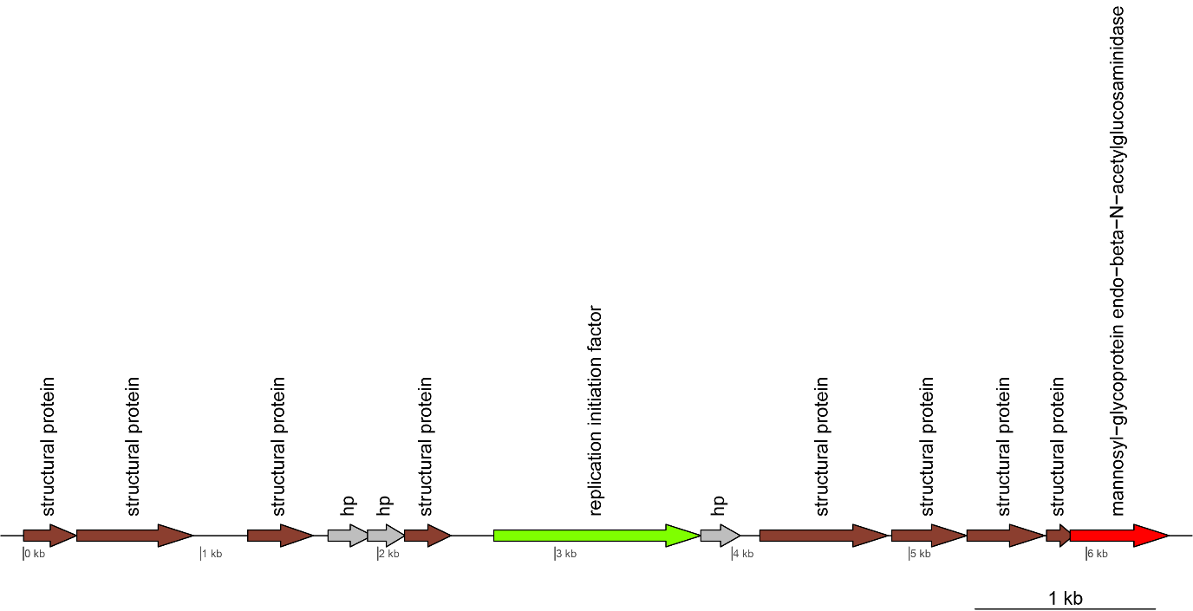

**Figure 1:** Genome Map of Cellulophaga phage Omtje_1.

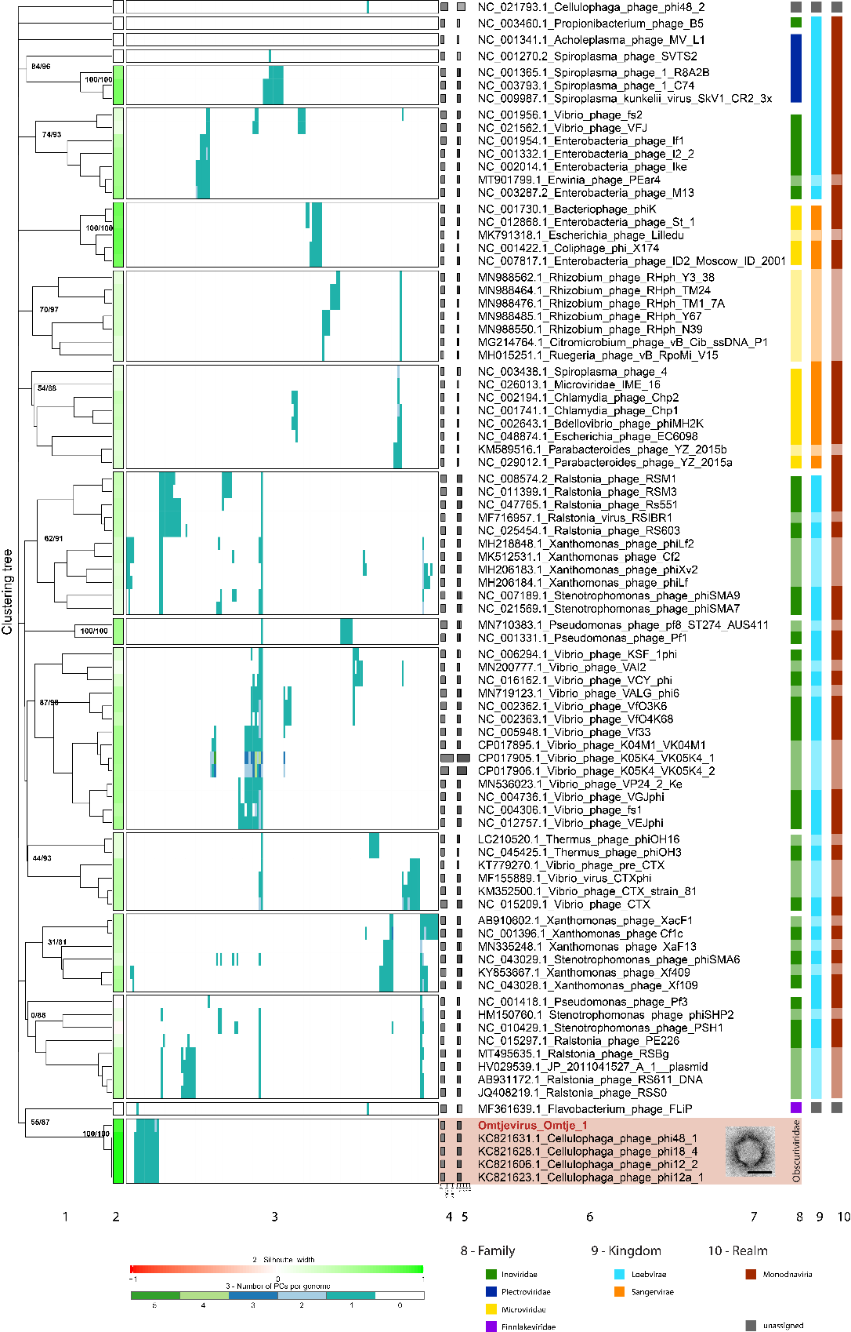

**Figure 2:** VirClust hierarchical clustering of the new ssDNA flavophages and their relatives, based on intergenomic distances calculated using the protein cluster content. **1.** Hierarchical clustering tree. Two support values, selective inference (si [16]) and approximately unbiased (au [17]) are indicated at branching points (si/au) only for the major clades. The tree was cut into smaller viral genome clusters (VGCs) using a 0.9 distance threshold. Each VGC is framed in a rectangle in 2 and 3. **2.** Silhoutte width, measures how related is a virus with other viruses in the same VGCs. Similarity to other VGCs is indicated by values closer to -1 (red). Similarity to viruses in the same VGC is indicated by values closer to 1 (green). **3.** Distribution of the protein clusters (PCs) in the viral genomes. **4.** Genome length (bps). **5.** Fraction of proteins shared with other viruses (dark grey), based on protein assignment to PCs. **6.** Virus names, with flavophages isolated in this study marked in red. **7.** TEM images of the new flavophages, uranyl acetate negative staining. Scale bar in each TEM image has 50 nm. **8.** Family (ICTV). **9.** Kingdom (ICTV). **10.** Realm (ICTV). Lighter colours in column 8- 10 represent phages not recognized by the ICTV, but by publications.

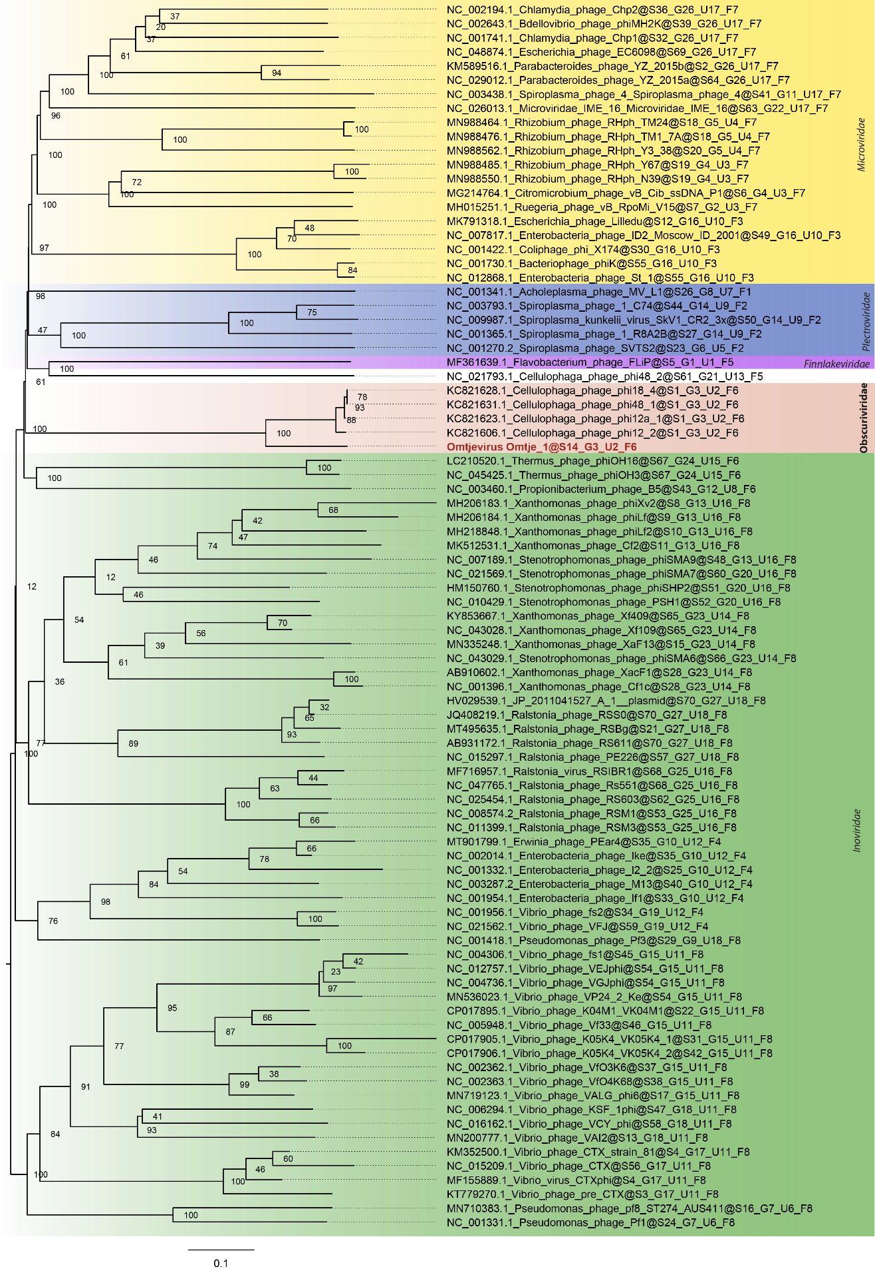

**Figure 3:** Whole-genome phylogeny determined with VICTOR (amino-acid based) for newly isolated ssDNA phage reference phage genomes. New phage isolate is depicted in red. Bootstrap values are indicated at branches. Family (F) and subfamily (U) clustering is indicated at the end of the genome names*.*

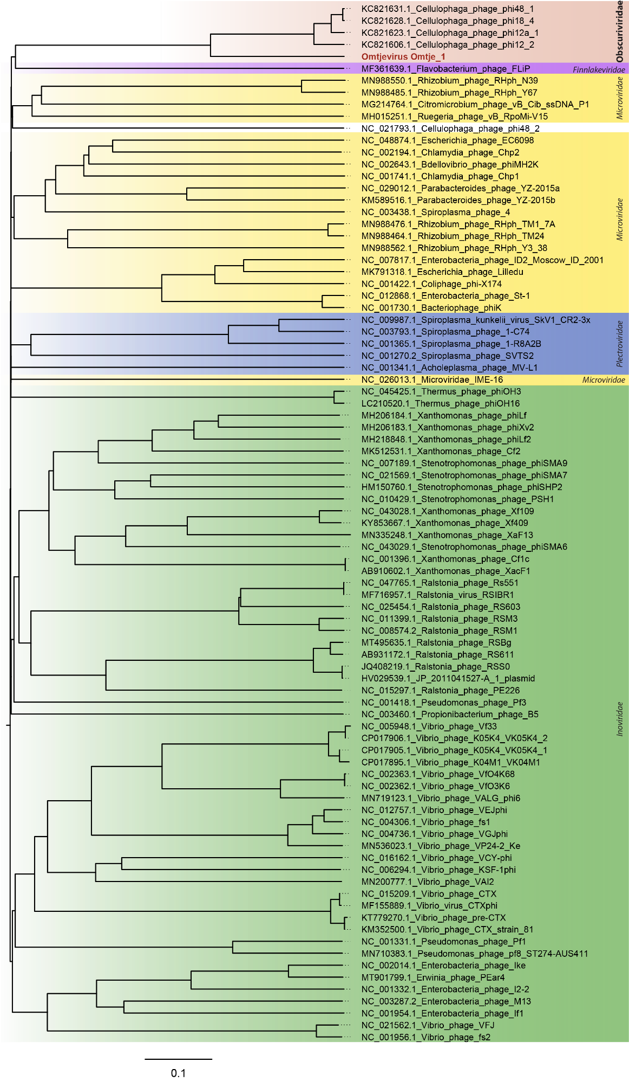

**Figure 4:** ViPTree of ssDNA viruses with our new phage isolate depicted in red.

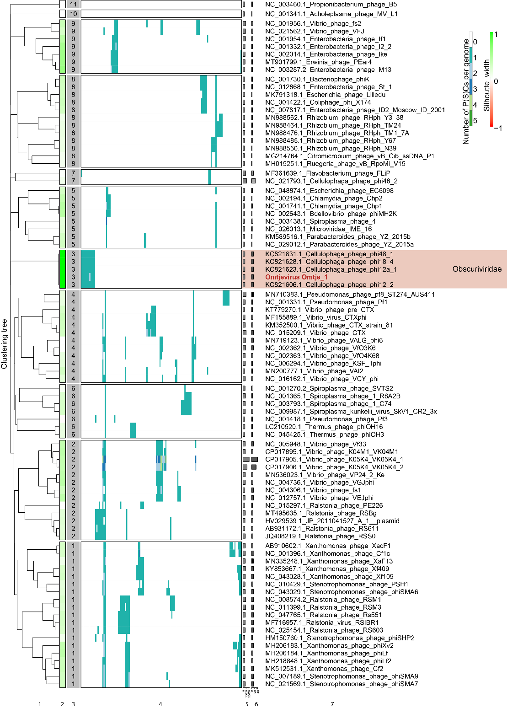

**Figure 5:** VirClust hierarchical clustering of the new **s**sDNA flavophages and their relatives, based on intergenomic distances calculated using the protein super-cluster content (PC clusters were grouped into super-clusters based on HMM profile homology). 1. Hierarchical clustering tree. The tree was cut into smaller viral genome clusters (VGCs) using a 0.9 distance threshold. Each VGC is framed in a rectangle in 2 and 3. 2. Silhoutte width, measures how related is a virus with other viruses in the same VGCs. Similarity to other VGCs is indicated by values closer to -1 (red). Similarity to viruses in the same VGC is indicated by values closer to 1 (green). 3. Distribution of the protein super-clusters (PSCs) in the viral genomes. 4. Genome length (bps). 5. Fraction of proteins shared with other viruses (dark grey), based on protein assignment to PSCs. 6. Virus names, with flavophage isolated in this study marked in red.

**To note:** **The** “**Obscuriviridae**” **share only one protein with a phage from another cluster (the Falvobacterium phage FLIP).**

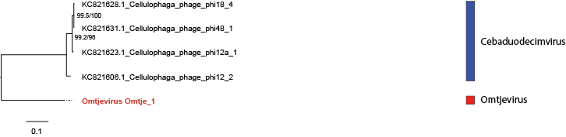

**Figure 6:** Core gene phylogeny of “Obscuriviridae” using MUSCLE aligned core proteins and IQ-Tree. This phylogeny is based on seven core genes which can be found in the annotation file of Omtje in the following protein clusters: 1 (hp), 2 (structural protein), 8 (structural protein), 9 (structural protein), 10 (structural protein), 11 (structural protein), 3 (replication initiation factor), 4 (structural protein), 5 (structural protein), 6 (structural protein), 7 (mannosyl-glycoprotein endo-beta-N-acetylglucosaminidase) (SI file 2, [3]). The first branch support value is the SH-aLRT support in %, the second value is the ultrafast bootstrap support. Using the model finder the LG+F+G4 substitution model was determined as best fitting substitution model and used for the tree calculation.

**Appendix**

**Figure 7:** Intergenomic nucleotide similarity matrix of new isolates, environmental genomes and reference genomes calculated by VIRIDIC. Phage genera are indicated on the right side.

**Figure 8:** GRAViTy heat map with *Obscuriviridae* placed in the *Inoviridae*.