

The International Committee on Taxonomy of Viruses

Taxonomy Proposal Form, 2024

**Part 1a: Details of taxonomy proposals**

|  |  |  |
| --- | --- | --- |
| **Title:** | Create a new genus (*Kononvirus*) with a single species to the *Markadamsvirinae* subfamily (*Caudoviricetes: Demerecviridae*) | |
| **Code assigned:** | 2024.022B |

|  |  |  |  |
| --- | --- | --- | --- |
| **Author(s), affiliation and email address(es):** | | | |
| **Name** | **Affiliation** | **Email address** | **Corresponding author(s)** |
| Wójcicki M | Department of Microbiology, Prof. Wacław Dąbrowski Institute of Agricultural and Food Biotechnology - State Research Institute, Warsaw, Poland | michal.wojcicki@ibprs.pl | X |
| Shymialevich D | Department of Microbiology, Prof. Wacław Dąbrowski Institute of Agricultural and Food Biotechnology - State Research Institute, Warsaw, Poland | diana.szymielewicz@ibprs.pl |  |
| Średnicka P | Department of Microbiology, Prof. Wacław Dąbrowski Institute of Agricultural and Food Biotechnology - State Research Institute, Warsaw, Poland | paulina.srednicka@ibprs.pl |  |
| Gientka I | Department of Biotechnology and Food Microbiology, Institute of Food Sciences, Warsaw University of Life Sciences (WULS-SGGW), Warsaw, Poland | iwona_gientka@sggw.edu.pl |  |
| Błażejak S | Department of Biotechnology and Food Microbiology, Institute of Food Sciences, Warsaw University of Life Sciences (WULS-SGGW), Warsaw, Poland | stanislaw_blazejak@sggw.edu.pl |  |
| Sokołowska B | Department of Microbiology, Prof. Wacław Dąbrowski Institute of Agricultural and Food Biotechnology - State Research Institute, Warsaw, Poland | barbara.sokolowska@ibprs.pl |  |

**Part 1b: Taxonomy Proposal Submission**

|  |  |  |  |
| --- | --- | --- | --- |
| **ICTV Subcommittee:** | | | |
| Animal DNA Viruses and Retroviruses |  | Bacterial viruses | **X** |
| Animal minus-strand and dsRNA viruses |  | Fungal and protist viruses |  |
| Animal positive-strand RNA viruses |  | Plant viruses |  |
| Archaeal viruses |  | General |  |

|  |
| --- |
| **List the ICTV Study Group(s) that have seen or have been involved in creating this proposal:** |
| *Caudoviricetes Study Group* |

|  |  |  |  |
| --- | --- | --- | --- |
| **Optional – complete only if formally voted on by an ICTV Study Group:** | | | |
| **Study Group** | **Number of members** | | |
| **Votes in support** | **Votes against** | **No vote** |
|  |  |  |  |
|  |  |  |  |

|  |  |
| --- | --- |
| **Submission date:** | 16/06/2024 |

**Part 1c: Feedback from ICTV Executive Committee (EC) meeting**

|  |  |
| --- | --- |
| **Executive Committee Meeting Decision code:** |  |
| A – Accept | **X** |
| Ac – Accept subject to revision by relevant subcommittee chair. No further vote required |  |
| U – Accept without revision but with re-evaluation and email vote by the EC |  |
| Uc – Accept subject to revision and re-evaluation and email vote by the EC |  |
| Ud – Deferred to the next EC meeting, with an invitation to revise based on EC comments |  |
| J - Reject |  |
| W - Withdrawn |  |

|  |
| --- |
| **Comments from the Executive Committee:** |
|  |

**Part 1d: Revised Taxonomy Proposal Submission**

|  |
| --- |
| **Response of proposer:** |
|  |

|  |  |
| --- | --- |
| **Revision date:** | DD/MM/YYYY |

**Part 3:** **TAXONOMIC PROPOSAL**

|  |
| --- |
| **Name of accompanying Excel module:** |
| 2024.022B.A.v1.Markadamsvirinae_ng.xlsx |

|  |  |  |  |
| --- | --- | --- | --- |
| **Taxonomic changes proposed:** | | | |
| Establish new taxon | **X** | Split taxon |  |
| Abolish taxon |  | Merge taxon |  |
| Move taxon |  | Promote taxon |  |
| Rename taxon |  | Demote taxon |  |
| Move and rename |  |

|  |  |  |
| --- | --- | --- |
| **Is any taxon name used here derived from that of a living person:** | | **N** |
| **Taxon name** | **Person from whom the name is derived** | **Attached** |
|  |  |  |

|  |
| --- |
| **Abstract of Taxonomy Proposal:** |
| *Taxonomic rank(s) affected*:  Proposal to create a new genus (*Kononvirus*) with a single species (tailed phages from *Caudoviricetes* class, *Demerecviridae* family and *Markadamsvirinae* subfamily).  *Description of current taxonomy*:  In 2022, significant changes to the taxonomy of bacterial viruses were introduced: the paraphyletic morphological families *Podoviridae*, *Siphoviridae*, and *Myoviridae* as well as the order *Caudovirales* were abolished, which is replaced by the class *Caudoviricetes* to group all tailed bacterial and archaeal viruses with icosahedral capsids and a double-stranded DNA genome. Moreover, a binomial system of nomenclature for species was established.  Currently, the *Demerecviridae* family includes 3 subfamilies (*Ermolyevavirinae*, *Markadamsvirinae* and *Mccorquodalevirinae*) and 6 separate genera (*Keyvirus*, *Novosibvirus*, *Pogseptimavirus*, *Priunavirus*, *Shenzhenvirus* and *Sugarlandvirus*) not classified at the subfamily level. The *Markadamsvirinae* subfamily currently includes two genera: *Epseptimavirus* and *Tequintavirus*.  *Proposed* *taxonomic change(s):*  We performed genomic analysis of newly isolated Enterobacter phage KKP_3711. Genome and protein analyses suggest that our bacteriophage belongs to the *Markadamsvirinae* subfamily. Still, the differences are too great to assign it to one of the two genera within this subfamily.  Therefore, we propose to create a new genus, *Kononvirus*, with one species - *Kononvirus KKP_3711*.  *Justification*:  Based on DNA and protein similarity this is a cohesive genus. |

|  |
| --- |
| **Text of Taxonomy proposal:** |
| *Taxonomic rank(s) affected*:  Proposal to create a new genus (*Kononvirus*) with a single species (tailed phages from *Caudoviricetes* class, *Demerecviridae* family and *Markadamsvirinae* subfamily).  *Description of current taxonomy*:  In 2022, significant changes to the taxonomy of bacterial viruses were introduced: the paraphyletic morphological families *Podoviridae*, *Siphoviridae*, and *Myoviridae* as well as the order *Caudovirales* were abolished, which is replaced by the class *Caudoviricetes* to group all tailed bacterial and archaeal viruses with icosahedral capsids and a double-stranded DNA genome. Moreover, a binomial system of nomenclature for species was established.  Currently, the *Demerecviridae* family includes 3 subfamilies (*Ermolyevavirinae*, *Markadamsvirinae* and *Mccorquodalevirinae*) and 6 separate genera (*Keyvirus*, *Novosibvirus*, *Pogseptimavirus*, *Priunavirus*, *Shenzhenvirus* and *Sugarlandvirus*) not classified at the subfamily level. The *Markadamsvirinae* subfamily currently includes two genera: *Epseptimavirus* and *Tequintavirus*.  *Proposed* *taxonomic change(s)*:  We performed genomic analysis of newly isolated Enterobacter phage KKP_3711. Genome and protein analyses suggest that our bacteriophage belongs to the *Markadamsvirinae* subfamily. Still, the differences are too great to assign it to one of the two genera within this subfamily.  Therefore, we propose to create a new genus, *Kononvirus*, with one species - *Kononvirus KKP_3711*.  *Demarcation criteria:*  **Species demarcation criteria:** Two phages are assigned to the same species if their genomes are more than 95% identical over their genome length for isolates.  These values can be calculated by several tools, such as BLASTn [1] – usually calculated using the intergenomic distance calculator VIRIDIC [2].  **Genus demarcation criteria:** In search for criteria that create cohesive and distinct genera that are reproducible and monophyletic, the Bacterial Viruses Subcommittee has established 70% nucleotide identity of the genome length as the cut-off for genera. Genus-level groupings should always be monophyletic in the signature genes, as tested with a phylogenetic tree [3].  **Subfamily demarcation criteria:** Subfamilies are to be created when two or more genera are related below the family level. In practical terms, this usually means that they share a low degree of sequence similarity (usually about 40-50%) and that the genera form a clade in a marker tree phylogeny [4].  *Justification*:  Based on DNA and protein similarity this is a cohesive genus. |

|  |
| --- |
| **References:** |
| 1. Sayers EW, Beck J, Bolton EE, Bourexis D, Brister JR, Canese K, Comeau DC, Funk K, Kim S, Klimke W, Marchler-Bauer A, Landrum M, Lathrop S, Lu Z, Madden TL, O'Leary N, Phan L, Rangwala SH, Schneider VA, Skripchenko Y, Wang J, Ye J, Trawick BW, Pruitt KD, Sherry ST (2021). Database resources of the National Center for Biotechnology Information. Nucleic Acids Res 49(D1):D10-D17. https://doi.org/10.1093/nar/gkaa892. PMID: 33095870. 2. Moraru C, Varsani A, Kropinski AM (2020). VIRIDIC - a novel tool to calculate the intergenomic similarities of prokaryote-infecting viruses. Viruses 12(11):1268. https://doi.org/10.3390/v12111268. PMID: 33172115; PMCID: PMC7694805. 3. Turner D, Kropinski AM, Adriaenssens EM (2021). A roadmap for genome-based phage taxonomy. Viruses 13(3):506. https://doi.org/10.3390/v13030506. PMID: 33803862; PMCID: PMC8003253. 4. Turner D, Kropinski AM, Adriaenssens EM (2021). A roadmap for genome-based phage taxonomy. Viruses 18;13(3):506. https://doi.org/10.3390/v13030506. PMID: 33803862; PMCID: PMC8003253. 5. Nishimura Y, Yoshida T, Kuronishi M, Uehara H, Ogata H, Goto S (2017). ViPTree: the viral proteomic tree server. Bioinformatics 33(15):2379-2380. https://doi.org/10.1093/bioinformatics/btx157. PMID: 28379287. 6. Rohwer F, Edwards R (2002). The Phage Proteomic Tree: a genome-based taxonomy for phage. J Bacteriol 184(16):4529-4535. https://doi.org/10.1128/jb.184.16.4529-4535.2002. PMID: 12142423. 7. Mihara T, Nishimura Y, Shimizu Y, Nishiyama H, Yoshikawa G, Uehara H, Hingamp P, Goto S, Ogata H (2016). Linking virus genomes with host taxonomy. Viruses 8(3):66. https://doi.org/10.3390/v8030066. PMID: 26938550; PMCID: PMC4810256. 8. Shymialevich D, Błażejak S, Średnicka P, Cieślak H, Ostrowska A, Sokołowska B, Wójcicki M (2024). Biological characterization and genomic analysis of three novel Serratia-and Enterobacter-specific virulent phages. Int J Mol Sci 25(11):5944. https://doi.org/10.3390/ijms25115944. 9. Proksee Software. Available online: https://proksee.ca/. Accessed 24 April 2024. |

|  |
| --- |
| **Tables, Figures:** |

**VIRIDIC heat map:** VIRIDIC (Virus Intergenomic Distance Calculator [2]; http://rhea.icbm.uni-oldenburg.de/VIRIDIC/) computes pairwise intergenomic distances/similarities amongst phage genomes. The **red boxes** delineate Enterobacter siphophage vB_Ecl_IAFB_3711.

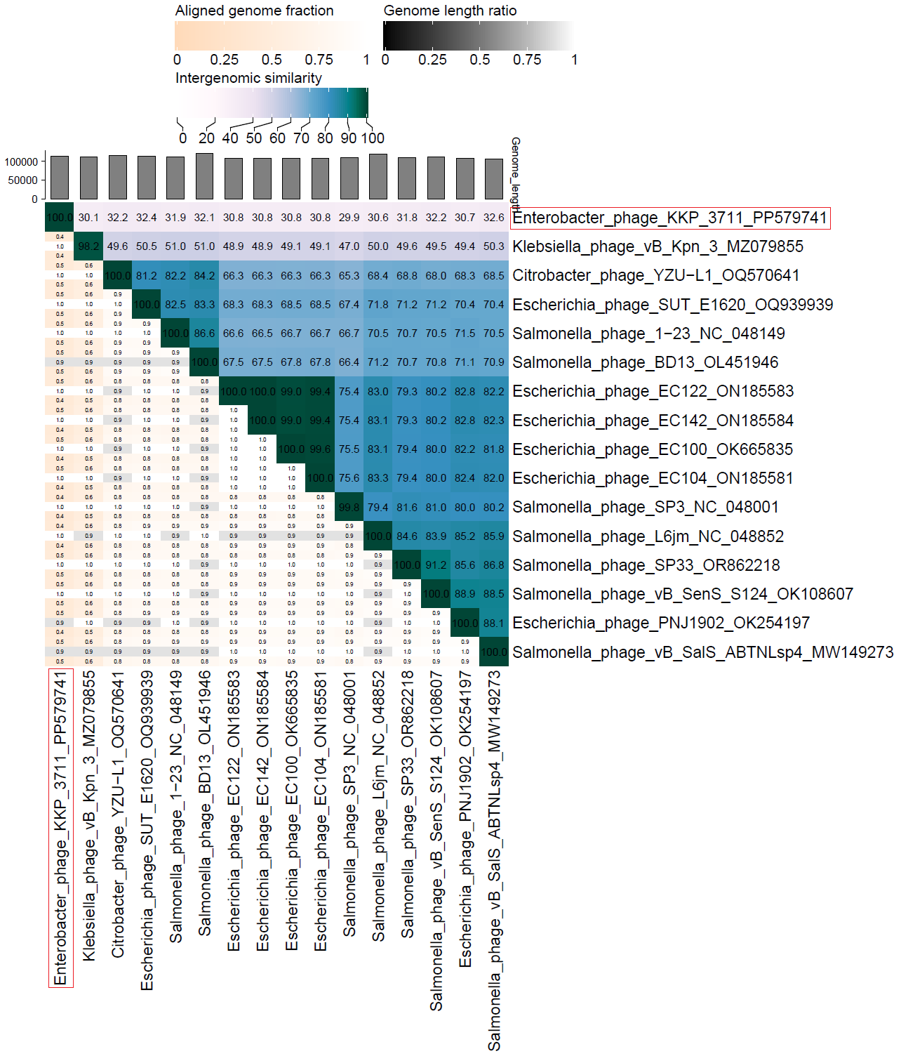

**ViPTree analysis:** ViPTree analysis (https://www.genome.jp/viptree/; [5]) is based upon Rohwer and Edwards (2002) famous Phage Proteomic Tree [6]. The Enterobacter siphophage vB_Ecl_IAFB_3711 is indicated with a **red line**.

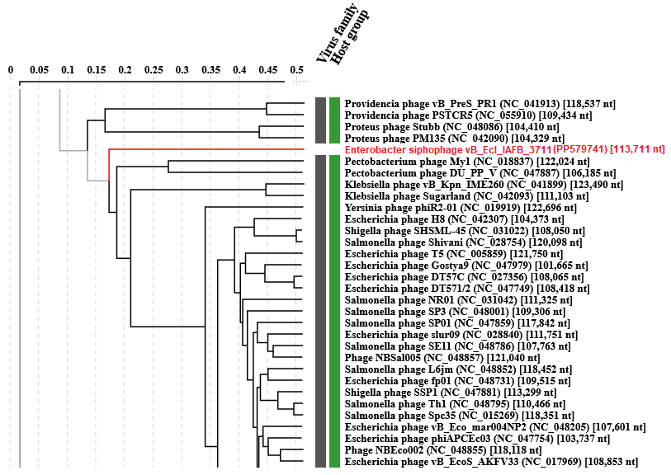

The viral proteomic tree of the Enterobacter siphophage vB_Ecl_IAFB_3711 is below shown in a circular view. The branch represented by the phage under study is marked with a **red asterisk**. The colored rings indicate the virus family (inner rings) and host groups (at the phylum level; outer rings). The tree was calculated by BIONJ based on the genomic distance matrix and rooted at the midpoint. Branch lengths are log-scaled. Sequence and taxonomic data were based on the Virus-Host DB [7]. The trees shown were generated using the ViPTree server [5].

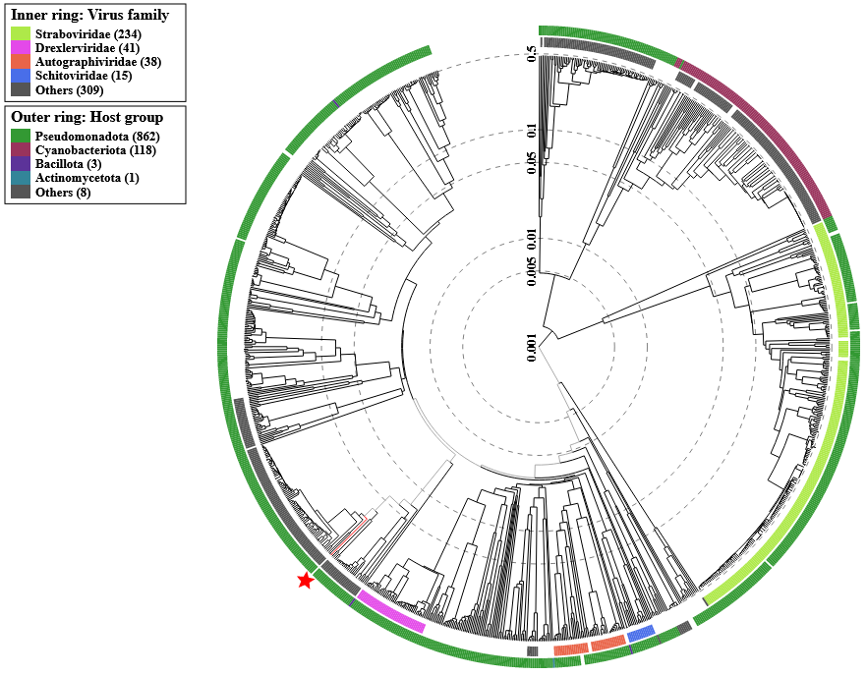

**Proposal A. Create a new single-species genus, *Kononvirus*.**

**Historical aspects:** The lytic Enterobacter siphophage vB_Ecl_IAFB_3711 was isolated from wastewater against the *Enterobacter cloacae* strain KKP 3684 (host strain isolated from salad mix with beetroot). This bacteriophage was characterized in the article by Shymialevich et al. (2024) [8].

**Electron micrograph:** Electronograms obtained using TEM allowed the visualization of the morphology of the bacteriophage. Enterobacter siphophage vB_Ecl_IAFB_3711 belongs to the *Caudoviricetes* class (tailed bacteriophages) and contains an icosahedral head and long non-contractile tail (typical siphovirus morphology). Scale bar of 200 nm.

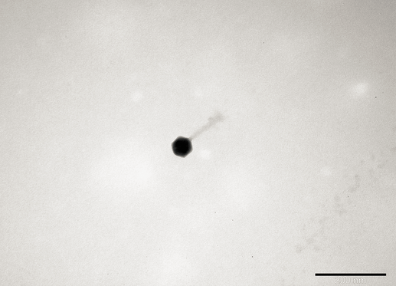

**Genome analysis:** The complete genome of the Enterobacter siphophage vB_Ecl_IAFB_3711 was sequenced and deposited in the GenBank database under the PP579741 accession number. WGS revealed that the Enterobacter siphophage vB_Ecl_IAFB_3711 genome consists of 113,711 bp linear dsDNA with a total G+C content of 37.8%. The described functional proteins have been divided into several groups depending on their functions: related to lysis, structure, DNA metabolisms and replication, and DNA genome packaging.

A map of the genomic organization of Enterobacter siphophage vB_Ecl_IAFB_3711 was generated using the Proksee program [9].

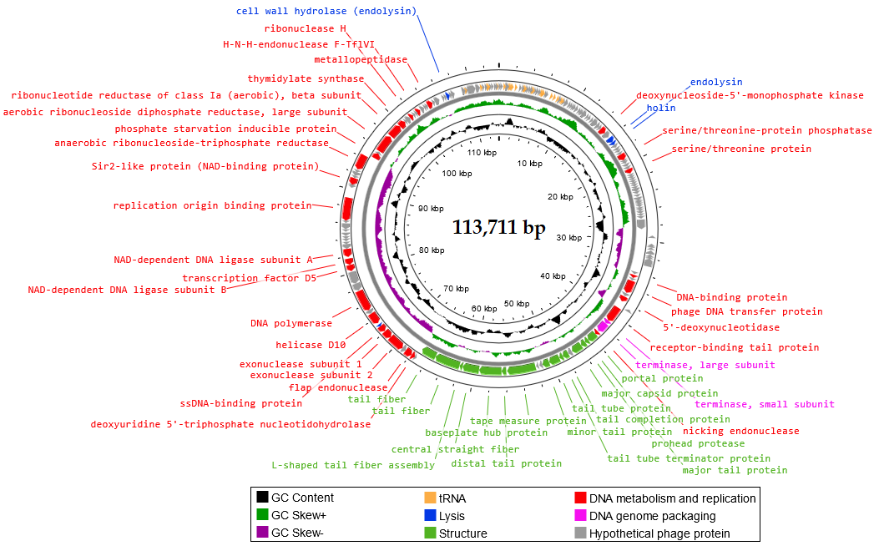

In the Enterobacter siphophage vB_Ecl_IAFB_3711 genome, 48 ORFs are associated with genes encoding proteins with known functions and 120 ORFs encode hypothetical proteins with unknown functions. Moreover, in the Enterobacter siphophage vB_Ecl_IAFB_3711 genome 27 tRNA regions were located. Proteins related to the phage structure, such as tail fiber, tail protein, capsid protein, portal protein, and baseplate hub protein were detected in the Enterobacter siphophage vB_Ecl_IAFB_3711 genome. Highlighted proteins are responsible for the adsorption and specificity of the phage (tail fiber). Other annotated proteins such as holin and endolysin present lytic properties. Large and small subunits of terminase were identified among genes responsible for DNA genome packing. Among the proteins responsible for metabolism and replication, DNA polymerase, exonucleases, endonuclease, helicases, ribonuclease, ligase, and serine/threonine protein were found. No antibiotic resistance genes, genes encoding virulence factors, integrases, recombinases, or repressors, which are markers of temperate bacteriophages, were identified in the Enterobacter siphophage vB_Ecl_IAFB_3711 genome.

**Genome summary:**

|  |  |  |  |  |  |  |
| --- | --- | --- | --- | --- | --- | --- |
| **Phage name** | **GenBank accession number** | **Size (Kb)** | **GC%** | **Genes** | **Protein-coding** | **tRNA** |
| Enterobacter phage KKP_3711 | PP579741.1 | 113.71 | 37.8 | 195 | 168 | 27 |

**Rationale:** Based on the morphology and the comparison of its protein regions, Enterobacter siphophage vB_Ecl_IAFB_3711 was assigned to viruses with complex structures (tailed phages from the *Caudoviricetes* class, *Demerecviridae* family and *Markadamsvirinae* subfamily).Genome and protein analyses suggest that our bacteriophage belongs to the *Markadamsvirinae* subfamily, but the differences are too great to assign it to one of the two genera within this subfamily.Therefore, we propose to create a new genus, *Kononvirus*, with one species - *Kononvirus KKP_3711*.