

The International Committee on Taxonomy of Viruses
Taxonomy Proposal Form, 2024

Part 1a: Details of taxonomy proposals

Title: | Create a new family, Colingsworthviridae, of Streptomyces temperate phages (Class Caudoviricetes)
Code assigned: | 2024.008B

Author(s), affiliation and email address(es):
Name | Affiliation | Email address | Corresponding author(s) X
Kurtböke I | University of the Sunshine Coast, Australia | IKurtbok@usc.edu.au
Moraru C | Carl von Ossietzky Universität Oldenburg, Germany | liliana.cristina.moraru@uol.de
Tolstoy I | National Center for Biotechnology Information, MD, USA | tolstoy@ncbi.nlm.nih.gov
Kropinski AM | University of Guelph, Ontario, Canada [AMK] | Phage.Canada@gmail.com | x

Part 1b: Taxonomy Proposal Submission
ICTV Subcommittee:
Animal DNA Viruses and Retroviruses |  | Bacterial viruses | x
Animal minus-strand and dsRNA viruses |  | Fungal and protist viruses
Animal positive-strand RNA viruses |  | Plant viruses
Archaeal viruses |  | General -

List the ICTV Study Group(s) that have seen or have been involved in creating this proposal:
Actinophage Study Group

Optional – complete only if formally voted on by an ICTV Study Group:
Study Group | Number of members
 | Votes in support | Votes against | No vote

Submission date: | 15/05/2024

Part 1c: Feedback from ICTV Executive Committee (EC) meeting
Executive Committee Meeting Decision code: | X
A – Accept
Ac – Accept subject to revision by relevant subcommittee chair. No further vote required | X
U – Accept without revision but with re-evaluation and email vote by the EC
Uc – Accept subject to revision and re-evaluation and email vote by the EC
Ud – Deferred to the next EC meeting, with an invitation to revise based on EC comments
J - Reject
W - Withdrawn

Comments from the Executive Committee:
Streptomyces phage Shawty falls below the demarcation threshold for inclusion within the Lomovskyavirus genus and forms a separate clade on the core-genome phylogenetic tree.
Legend for table 1 required correction.

Part 1d: Revised Taxonomy Proposal Submission
Response of proposer:
We could create a new genus Shawtyvirus but these are temperate phages where we believe that some latitude is required over strict interpretation the 70% rule. Phage Shawty is classified by The Actinobacteriophage Database into Subcluster BB1 and possesses an identical 10 nt 3'-terminus (CCCGGCCCCA) to other members of the Lomovskyavirus. Furthermore, all the phages belonging to this genus possess short tails. We will re-evaluate this genus in the future as more representative species are isolated.

Revision date: | 30/09/2024

Part 3: TAXONOMIC PROPOSAL

Name of accompanying Excel module:
2024.008B.A.v2.Colingsworthviridae_nf.xlsx

Taxonomic changes proposed:
Establish new taxon | x | Split taxon
Abolish taxon |  | Merge taxon
Move taxon |  | Promote taxon
Rename taxon |  | Demote taxon
Move and rename

Is any taxon name used here derived from that of a living person: |  | N
Taxon name | Person from whom the name is derived | Attached X

Abstract of Taxonomy Proposal:
Taxonomic rank(s) affected:
Realm Duplodnaviria, kingdom Heunggongvirae, phylum Uroviricota, class Caudoviricetes

Description of current taxonomy:
Three taxa of temperate Streptomyces phages exist as floating genera in the order Caudoviricetes, Vashvirus, Tigunavirus and Lomovskayavirus. Up to the present no effort has been made to generate higher taxa.

Proposed taxonomic change(s):
1. Create a new single species genus Shadyvirus
2. Create a new single species genus Sycamorevirus
3. Create a new single species genus Shaekyvirus
4. Create a new genus Sebastisaurusvirus with three species
5. To add a single new species to the genus Vashvirus
6. To add a single new species to the genus Lomovskayavirus
7. To create a new family, Colingsworthviridae, for these genera
8. To transfer Vashvirus, Tigunavirus and Lomovskayavirus to this new family

Justification
As a result of detailed genomic, proteomic and phylogenetic analyses using VIRIDIC, ViPTree, VirClust we propose to create four new genera of Phi-C31-like temperate siphoviruses, in a new family named in honour of the first person to isolate a Streptomyces bacteriophage, Dr. Donald Colingsworth.

- Text of Taxonomy proposal:
Taxonomic rank(s) affected: Realm Duplodnaviria, kingdom Heunggongvirae, phylum Uroviricota, class Caudoviricetes

Description of current taxonomy:
Three taxa of temperate Streptomyces phages exist as floating genera in the order Caudoviricetes, Vashvirus, Tigunavirus and Lomovskayavirus. Up to the present no effort has been made to generate higher taxa.

Proposed taxonomic change(s):
1. Create a new single species genus Shadyvirus
2. Create a new single species genus Sycamorevirus
3. Create a new single species genus Shaekyvirus
4. Create a new genus Sebastisaurusvirus with three species
5. To add a single new species to the genus Vashvirus
6. To add a single new species to the genus Lomovskayavirus
7. To create a new family, Colingsworthviridae, for these genera
8. To transfer Vashvirus, Tigunavirus and Lomovskayavirus to this new family

Demarcation criteria:

Species demarcation criteria: Two phages are assigned to the same species if their genomes are more than 95% identical over their genome length for isolates. These values can be calculated by a number of tools, such as BLASTn [1,2] – usually calculated using intergenomic distance calculator VIRIDIC [3].

Genus demarcation criteria: In search for criteria that create cohesive and distinct genera that are reproducible and monophyletic, the Bacterial Viruses Subcommittee has established 70% nucleotide identity of the genome length as the cut-off for genera. Genus-level groupings should always be monophyletic in the signature genes, as tested with a phylogenetic tree. [10] In the case of temperate phages such as these a lesser value of ca. 60% DNA sequence similar was chosen.

Subfamily demarcation criteria: Subfamilies are to be created when two or more genera are related below the family level. In practical terms, this usually means that they share a low degree of sequence similarity (usually about 40-50%) and that the genera form a clade in a marker tree phylogeny. [10]

Family demarcation criteria: The family is represented by a cohesive and monophyletic group in the main predicted proteome-based clustering tools (VirClust, ViPTree, GRAViTy dendrogram, vConTACT2 network). Members of the family share a significant number of orthologous genes (the number will depend on the genome sizes and number of coding sequences of members of the family). [10]

Justification:
As a result of detailed genomic, proteomic and phylogenetic analyses using VIRIDIC, ViPTree, VirClust we propose to create four new genera of Phi-C31-like temperate siphoviruses, in a new family named in honour of the first person to isolate a Streptomyces bacteriophage, Dr. Donald Colingsworth.

While the delineation of genera of temperate Streptomyces phages is relative easy, the delineation of higher taxa is far more difficult because of the extent of horizontal gene transfer. The current phages appear to fall into two groups (an undefined subfamily): Shaeky, Shady, Sycamore; and, Sebastisaurus, Vash, Phi-C31, and TG1.

References:
1. Sayers EW, Beck J, Bolton EE, Bourexis D, Brister JR, Canese K, Comeau DC, Funk K, Kim S, Klimke W, Marchler-Bauer A, Landrum M, Lathrop S, Lu Z, Madden TL, O'Leary N, Phan L, Rangwala SH, Schneider VA, Skripchenko Y, Wang J, Ye J, Trawick BW, Pruitt KD, Sherry ST. Database resources of the National Center for Biotechnology Information. Nucleic Acids Res. 2021 Jan 8;49(D1):D10-D17. doi: 10.1093/nar/gkaa892. PMID: 33095870
2. O'Leary NA, Wright MW, Brister JR, Ciufo S, Haddad D, McVeigh R, et al. Reference sequence (RefSeq) database at NCBI: current status, taxonomic expansion, and functional annotation. Nucleic Acids Res. 2016;44(D1):D733-45. doi: 10.1093/nar/gkv1189. PMID: 26553804.
3. Moraru C, Varsani A, Kropinski AM. VIRIDIC-A Novel Tool to Calculate the Intergenomic Similarities of Prokaryote-Infecting Viruses. Viruses. 2020 Nov 6;12(11):1268. doi: 10.3390/v12111268. PMID: 33172115; PMCID: PMC7694805. http://kronos.icbm.uni-oldenburg.de/viridic/
4. Nishimura Y, Yoshida T, Kuronishi M, Uehara H, Ogata H, Goto S. ViPTree: the viral proteomic tree server. Bioinformatics. 2017; 33(15):2379-2380. doi:10.1093/bioinformatics/btx157. PubMed PMID: 28379287. https://www.genome.jp/viptree/
5. Rohwer F, Edwards R. The Phage Proteomic Tree: a genome-based taxonomy for phage. J Bacteriol. 2002 Aug;184(16):4529-35. PubMed PMID: 12142423
6. Turner D, Reynolds D, Seto D, Mahadevan P. CoreGenes3.5: a webserver for the determination of core genes from sets of viral and small bacterial genomes. BMC Res Notes. 2013;6:140. doi: 10.1186/1756-0500-6-140. PMID: 23566564.
7. Davis P, Seto D, Mahadevan P. CoreGenes5.0: An Updated User-Friendly Webserver for the Determination of Core Genes from Sets of Viral and Bacterial Genomes. Viruses. 2022 Nov 16;14(11):2534. doi: 10.3390/v14112534. PMID: 36423143; PMCID: PMC9693508.
8. Dereeper A, Guignon V, Blanc G, Audic S, Buffet S, Chevenet F, Dufayard JF, Guindon S, Lefort V, Lescot M, Claverie JM, Gascuel O. Phylogeny.fr: robust phylogenetic analysis for the non-specialist. Nucleic Acids Res. 2008;36(Web Server issue):W465-9. doi: 10.1093/nar/gkn180. Epub 2008 Apr 19. PMID: 18424797.
9. Anisimova M, Gascuel O. Approximate likelihood-ratio test for branches: A fast, accurate, and powerful alternative. Syst Biol. 2006;55(4):539-52. PMID: 16785212. DOI: 10.1080/10635150600755453.
10. Turner D, Kropinski AM, Adriaenssens EM. A Roadmap for Genome-Based Phage Taxonomy. Viruses. 2021 Mar 18;13(3):506. doi: 10.3390/v13030506. PMID: 33803862; PMCID: PMC8003253.
11. Bin Jang H, Bolduc B, Zablocki O, Kuhn JH, Roux S, Adriaenssens EM, Brister JR, Kropinski AM, Krupovic M, Lavigne R, Turner D, Sullivan MB. Taxonomic assignment of uncultivated prokaryotic virus genomes is enabled by gene-sharing networks. Nat Biotechnol. 2019 Jun;37(6):632-639. doi: 10.1038/s41587-019-0100-8. Epub 2019 May 6. PMID: 31061483.
12. Bolduc B, Jang HB, Doulcier G, You ZQ, Roux S, Sullivan MB. vConTACT: an iVirus tool to classify double-stranded DNA viruses that infect Archaea and Bacteria. PeerJ. 2017 May 3;5:e3243. doi: 10.7717/peerj.3243. PMID: 28480138; PMCID: PMC5419219.
13. Moraru C. VirClust-A Tool for Hierarchical Clustering, Core Protein Detection and Annotation of (Prokaryotic) Viruses. Viruses. 2023 Apr 19;15(4):1007. doi: 10.3390/v15041007. PMID: 37112988; PMCID: PMC10143988.
14. Loessner MJ. Improved procedure for bacteriophage typing of Listeria strains and evaluation of new phages. Appl Environ Microbiol. 1991 Mar;57(3):882-4. doi: 10.1128/aem.57.3.882-884.1991. PMID: 2039238; PMCID: PMC182812.
15. Loessner MJ, Inman RB, Lauer P, Calendar R. Complete nucleotide sequence, molecular analysis and genome structure of bacteriophage A118 of Listeria monocytogenes: implications for phage evolution. Mol Microbiol. 2000 Jan;35(2):324-40. doi: 10.1046/j.1365-2958.2000.01720.x. PMID: 10652093.
16. Casey A, Jordan K, Coffey A, McAuliffe O. Complete Genome Sequences of vB_LmoS_188 and vB_LmoS_293, Two Bacteriophages with Specificity for Listeria monocytogenes Strains of Serotypes 4b and 4e. Genome Announc. 2015 Apr 9;3(2):e00040-15. doi: 10.1128/genomeA.00040-15. PMID: 25858822; PMCID: PMC4392134.
17: Dorscht J, Klumpp J, Bielmann R, Schmelcher M, Born Y, Zimmer M, Calendar R, Loessner MJ. Comparative genome analysis of Listeria bacteriophages reveals extensive mosaicism, programmed translational frameshifting, and a novel prophage insertion site. J Bacteriol. 2009 Dec;191(23):7206-15. doi: 10.1128/JB.01041-09. Epub 2009 Sep 25. PMID: 19783628; PMCID: PMC2786548.
18. Nguyen LT, Schmidt HA, von Haeseler A, and Minh BQ (2015) IQ-TREE: A fast and effective stochastic algorithm for estimating maximum likelihood phylogenies. Molecular Biology and Evolution, 32:268-274. https://doi.org/10.1093/molbev/msu300
19. Hoang DT, Chernomor O, von Haeseler A, Minh BQ, Vinh LS (2018) UFBoot2: Improving the ultrafast bootstrap approximation. Molecular Biology and Evolution, 35:518–522. https://doi.org/10.1093/molbev/msx281
20. Kalyaanamoorthy S, Minh BQ, Wong TKF, von Haeseler A, and Jermiin JS (2017) ModelFinder: Fast Model Selection for Accurate Phylogenetic Estimates, Nature Methods, 14:587–589. https://doi.org/10.1038/nmeth.4285

Tables, Figures:

Figure 1. VIRIDIC heat map of a portion of the members of this family: VIRIDIC (Virus Intergenomic Distance Calculator; VIRIDIC (Virus Intergenomic Distance Calculator; [3]; http://rhea.icbm.uni-oldenburg.de/VIRIDIC/) computes pairwise intergenomic distances/similarities amongst phage genomes. Data values which are bordered in black correspond to strains. Abbreviations: phg = phage; Stre = Streptomyces. The coloured accession numbers and phage names in Column A represent ICTV-recognized species.
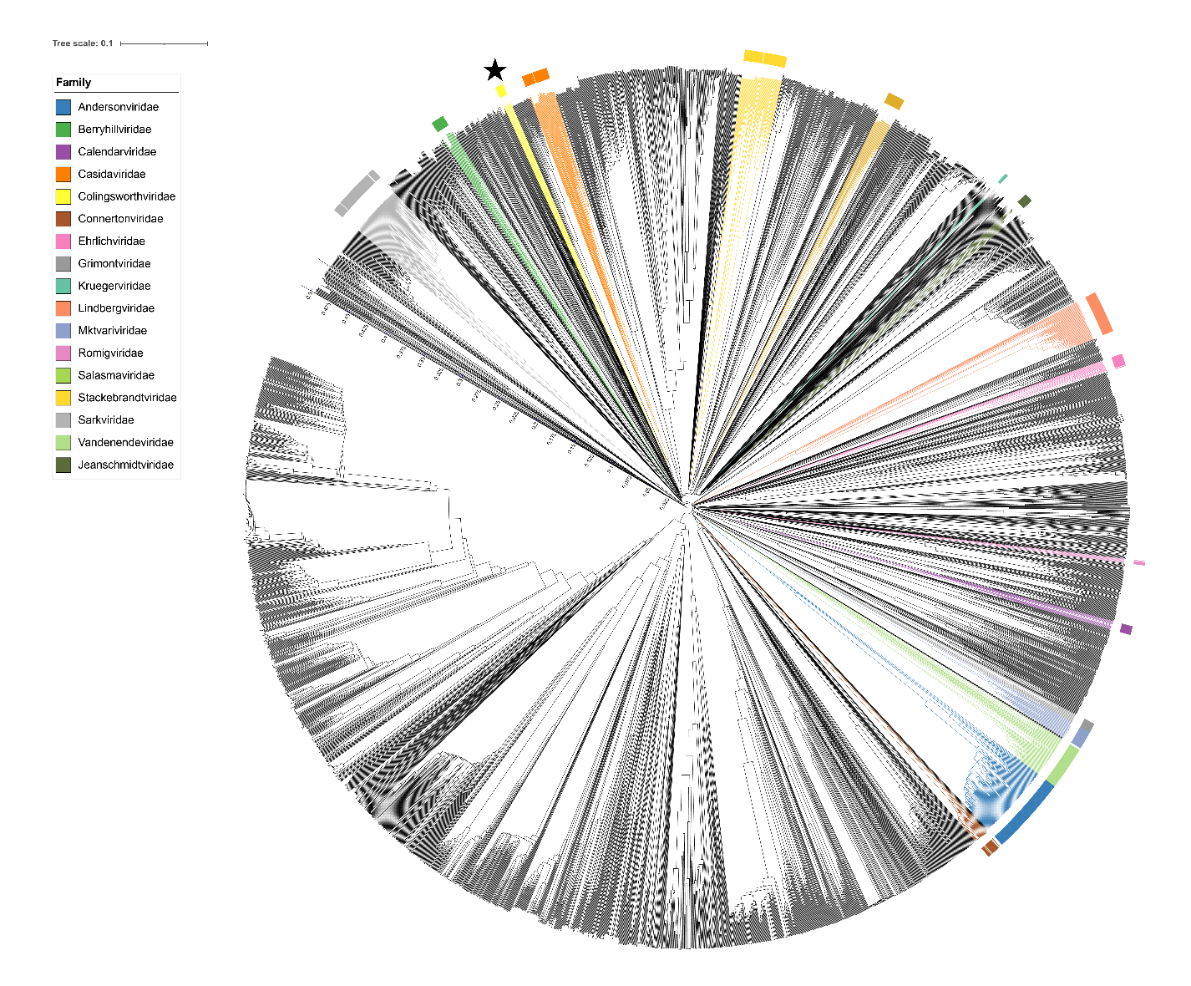
Figure 2. ViPTree [4] analysis Proteomic tree of 4,408 bacterial viruses with proposed viral families labeled by the coloured ring. The Colingsworthviridae are marked with a star symbol. The hierarchical tree was created using ViPTreeGen (version 1.1.2) [4] and annotated using iToL. The tree is based on a dissimilarity matrix generated by pairwise tBLASTx scores between each of the genomes.

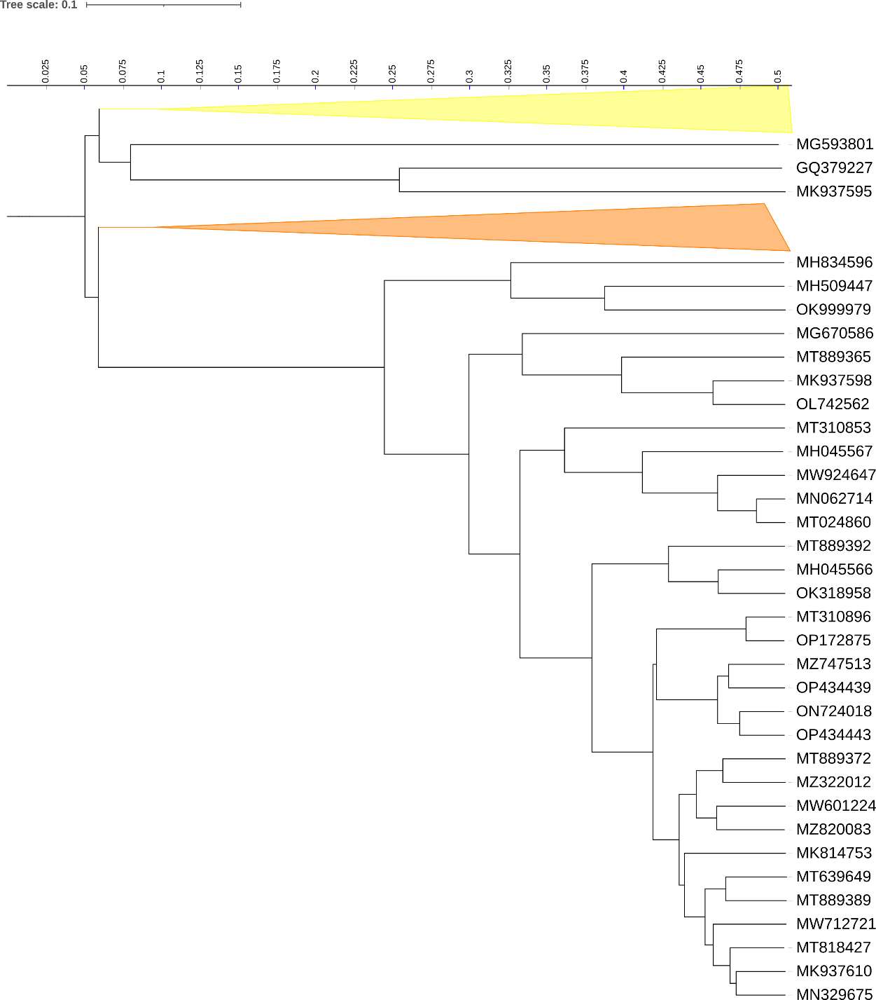
Figure 3. ViPTree [4] hierarchical tree pruned to show the proposed Colingsworthviridae alongside neighbouring clades. The proposed families Colingsworthviridae (yellow) and Casidaviridae (orange) are shown as collapsed clades.

Figure 4. VirClust protein heatmap of representative species of each genus. At the first level, proteins are grouped based on their reciprocal BLASTP similarities into protein clusters, or PCs. At the second level, PCs are grouped based on their Hidden Markov Model (HMM) similarities into protein superclusters, or PSCs. AT the third, still experimental level, PSCs are grouped based on their HMM similarities into protein super-superclusters, or PSSCs [13].
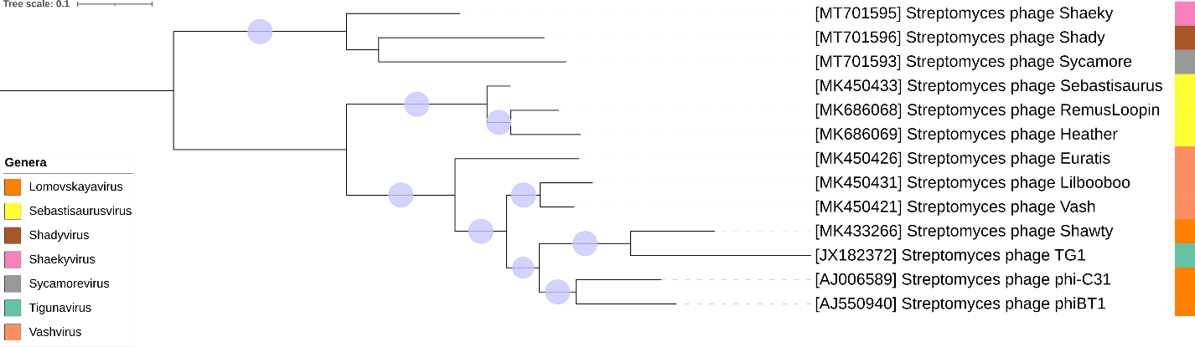
Figure 5. Core genome phylogeny of the proposed Colingsworthviridae family of bacterial viruses. A partitioned protein ML phylogeny was created from 12 genes present in all species of the proposed family. Alignments were performed using MAFFT in e-insi mode and trimmed using trimAl with a gap threshold of 0.5. The tree was calculated using IQ-Tree2 with 1000 ultrafast (UF) bootstrap replicates and SH-Alrt tests with -m TEST to optimise models for each alignment [19-20]. The tree is rooted at the midpoint and UF bootstrap support ≥ 95% are shown. The coloured strips indicate proposed genera and subfamilies.

Table 1. Signature genes in the proposed Colingsworthviridae family of bacterial viruses. Genes were identified by clustering with MMSeqs2, with thresholds of 35% sequence similarity and 50% coverage.
protein cluster | No. of genomes (13 total) | Percentage of genomes present in protein cluster | Predicted gene function
1 | 13 | 100% | DNA polymerase
2 | 13 | 100% | DNA helicase
3 | 13 | 100% | DNA primase
4 | 13 | 100% | hypothetical protein
5 | 13 | 100% | DNA-binding protein
6 | 13 | 100% | hypothetical protein
7 | 13 | 100% | endolysin
8 | 13 | 100% | minor tail protein
9 | 13 | 100% | dNMP kinase
10 | 13 | 100% | HNH endonuclease
11 | 13 | 100% | recombination directionality factor
12 | 13 | 100% | hypothetical protein

Proposals Data:
- Create a new single species genus Shadyvirus
- Create a new single species genus Sycamorevirus
- Create a new single species genus Shaekyvirus
- Create a new genus Sebastisaurusvirus with three species
- To add a single new species to the genus Vashvirus
- To add a single new species to the genus Lomovskayavirus
- To create a new family, Colingsworthviridae, for these genera
- To transfer Vashvirus, Tigunavirus and Lomovskayavirus to this new family
Taxonomic Proposals:
- Create a new single species genus Shadyvirus

Origin of the name of this taxon: This taxon was named after the first virus of its type, Streptomyces phage Shady

Historical aspects: Streptomyces phage Shady was isolated from Houston, TX soil by Isla Hernandez (Center for Phage Technology, TAMU, College Station). It is temperate.

Genomic characterization:

Phage name | INSDC | Size (kb) | Protein | Overall % DNA sequence identity (*) | Overall % homologous proteins (**)
Streptomyces phage Shady | MT701596.1 | 45.1 | 73 | 100 | 100

- Add Create a new single species genus Sycamorevirus

Origin of the name of this taxon: This taxon was named after the first virus of its type, Streptomyces phage Sycamore

Historical aspects: Streptomyces phage Sycamore was isolated from Illinois soil by Madeline Rivera (Center for Phage Technology, TAMU, College Station). It is temperate.

Genomic characterization:

Phage name | INSDC | Size (kb) | Protein | Overall % DNA sequence identity (*) | Overall % homologous proteins (**)
Streptomyces phage Sycamore | MT701593.1 | 44.7 | 64 | 100 | 100

- Create a new single species genus Shaekyvirus

Origin of the name of this taxon: This taxon was named after the first virus of its type, Streptomyces phage Shaeky

Historical aspects: Streptomyces phage Shaeky was isolated from South Jordan, UT soil by Tyler Higbee (Center for Phage Technology, TAMU, College Station). It is temperate.

Genomic characterization:

Phage name | INSDC | Size (kb) | Protein | Overall % DNA sequence identity (*) | Overall % homologous proteins (**)
Streptomyces phage Shaeky | MT701595.1 | 45.6 | 74 | 100 | 100

- Create a new genus Sebastisaurusvirus with three species

Origin of the name of this taxon: This taxon was named after the first virus of its type Streptomyces phage Sebastisaurus

Historical aspects: Streptomyces phage Sebastisaurus was isolated from Easley, SC soil using Streptomyces xanthochromogenes NRRL B-5410 as the host at the University of North Texas, Denton, TX. It is temperate. Phage Heather is a member of the BB2 subcluster as defined by The Actinobacteriophage Database and possesses 10 nt 3' Sticky Overhangs (CCCGGCCCCA).

Genomic characterization:

Phage name | INSDC | Size (kb) | Protein | Overall % DNA sequence identity (*) | Overall % homologous proteins (**)
Streptomyces phage Sebastisaurus | MK450433.1 | 41.6 | 52 | 100 | 100
Streptomyces phage Heather | MK686069.1 | 41.2 | 57 | 80.4 | 94.2
Streptomyces phage RemusLoopin | MK686068.1 | 41.4 | 53 | 86.4 | 96.1
(*) determined using VIRIDIC [3]
(**) determined using CoreGenes 3.5 [6]

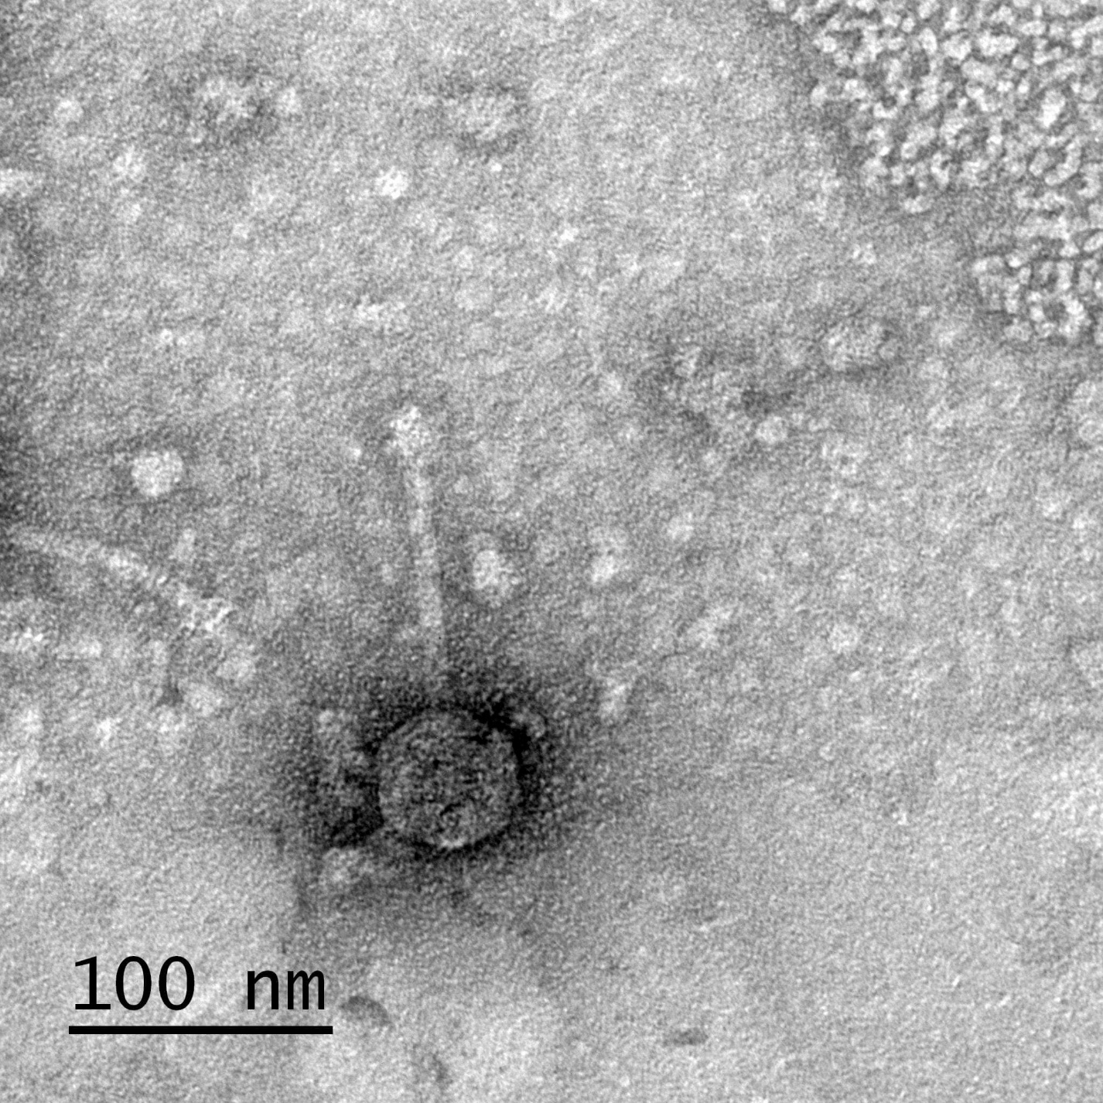
Electron micrograph: Electron micrographs of negatively stained Streptomyces phage Heather (https://phagesdb.org/phages/Heather/). Limited permission was granted by The Actinobacteriophages Database (https://phagesdb.org/), funded by the Howard Hughes Medical Institute, to use this electron micrograph for this taxonomy proposal; it cannot be reused without permission of The Actinobacteriophages Database.

- To add a single new species to the genus Vashvirus

Origin of the name of this taxon: N/A

Historical aspects: This taxon was created through Taxonomy Proposal 2019.102B

Genomic characterization:

Phage name | INSDC | Size (kb) | Protein | Overall % DNA sequence identity (*) | Overall % homologous proteins (**)
Streptomyces phage Vash | MK450421.1 | 41.6 | 54 | 100 | 100
Streptomyces phage Euratis | MK450426.1 | 41.4 | 58 | 72.7 | 92.6
(*) determined using VIRIDIC [3]
(**) determined using CoreGenes 3.5 [6]

- To add a single new species to the genus Lomovskayavirus

Origin of the name of this taxon: N/A

Historical aspects: This taxon was initially created through Taxonomy Proposal 2002.B136-139.Siphoviridae as “phiC31-like viruses” and then renamed via 2018.007B.A.v4.rename137gen6sp

Genomic characterization:

Phage name | INSDC | Size (kb) | Protein | Overall % DNA sequence identity (*) | Overall % homologous proteins (**)
Bacteriophage phi-C31 (Streptomyces phage C31) | AJ006589.3 | 41.5 | 53 | 100 | 100
Streptomyces phage Shawty | MK433266.1 | 40.7 | 56 | 68.9 | 88.7
(*) determined using VIRIDIC [3]
(**) determined using CoreGenes 3.5 [6]

- To create a new family, Colingsworthviridae, for these genera

Origin of the name of this taxon: This taxon was named in honour of American industrial microbiologist Dr. Donald R. Colingsworth (b. 1912, Beaver Dam, WI; d. 2003, Kalamazoo, MI). “In 1938 he earned a Ph.D. at the University of Wisconsin. He had been a Kalamazoo area resident since 1944 and was employed with the Upjohn Company for 33 years before retiring. At Upjohn he obtained several US patents and was co-discoverer of Penicillin O. In 1953, he was awarded the W.E. Upjohn Award. He was a member of the American Chemical Society; and 40 year member of the American Society of Microbiology.” (https://obits.mlive.com/us/obituaries/kalamazoo/name/donald-colingsworth-obituary?id=15075762). Dr. Colingsworth was the first person to isolate a Streptomyces phage [SAUDEK EC, COLINGSWORTH DR. A bacteriophage in the streptomycin fermentation. J Bacteriol. 1947 Jul;54(1):41. PMID: 20344268].

- To transfer Vashvirus, Tigunavirus and Lomovskayavirus to this new family

Rationale: As a result of detailed genomic, proteomic and phylogenetic analyses using VIRIDIC, ViPTree, VirClust we propose to create these three genera and the four new ones described above of Phi-C31-like temperate siphoviruses belong in this new family named in honour of Donald R. Colingsworth. This group of phages share ≥10.2% DNA sequence similarity and 12 shared proteins.

