

The International Committee on Taxonomy of Viruses

Taxonomy Proposal Form, 2024

**Part 1a: Details of taxonomy proposals**

|  |  |  |  |
| --- | --- | --- | --- |
| **Title:** | Create a new family, *Berryhillviridae*, for a group of lytic *Arthrobacter* phages (Class: *Caudoviricetes*) | |  |
| **Code assigned:** | 2024.003B |

|  |  |  |  |
| --- | --- | --- | --- |
| **Author(s), affiliation and email address(es):** | | | |
| **Name** | **Affiliation** | **Email address** | **Corresponding author(s)** X |
| Kurtböke, I | University of the Sunshine Coast, Australia | ikurtbok@usc.edu.au |  |
| Moraru C | Carl von Ossietzky Universität Oldenburg, Germany | liliana.cristina.moraru@uol.de |  |
| Tolstoy I | National Center for Biotechnology Information, MD, USA | tolstoy@ncbi.nlm.nih.gov |  |
| Kropinski AM | University of Guelph, Ontario, Canada [AMK] | Phage.Canada@gmail.com | **x** |

**Part 1b: Taxonomy Proposal Submission**

|  |  |  |  |
| --- | --- | --- | --- |
| **ICTV Subcommittee:** | | | |
| Animal DNA Viruses and Retroviruses |  | Bacterial viruses | **x** |
| Animal minus-strand and dsRNA viruses |  | Fungal and protist viruses |  |
| Animal positive-strand RNA viruses |  | Plant viruses |  |
| Archaeal viruses |  | General - |  |

|  |
| --- |
| **List the ICTV Study Group(s) that have seen or have been involved in creating this proposal:** |
| Actinophages Study group |

|  |  |  |  |
| --- | --- | --- | --- |
| **Optional – complete only if formally voted on by an ICTV Study Group:** | | | |
| **Study Group** | **Number of members** | | |
| **Votes in support** | **Votes against** | **No vote** |
|  |  |  |  |
|  |  |  |  |

|  |  |
| --- | --- |
| **Submission date:** | 25/05/2024 |

**Part 1c: Feedback from ICTV Executive Committee (EC) meeting**

|  |  |
| --- | --- |
| **Executive Committee Meeting Decision code:** | **X** |
| A – Accept | **X** |
| Ac – Accept subject to revision by relevant subcommittee chair. No further vote required |  |
| U – Accept without revision but with re-evaluation and email vote by the EC |  |
| Uc – Accept subject to revision and re-evaluation and email vote by the EC |  |
| Ud – Deferred to the next EC meeting, with an invitation to revise based on EC comments |  |
| J - Reject |  |
| W - Withdrawn |  |

|  |
| --- |
| **Comments from the Executive Committee:** |
|  |

**Part 1d: Revised Taxonomy Proposal Submission**

|  |
| --- |
| **Response of proposer:** |
|  |

|  |  |
| --- | --- |
| **Revision date:** | DD/MM/YYYY |

**Part 3:** **TAXONOMIC PROPOSAL**

|  |
| --- |
| **Name of accompanying Excel module:** |
| 2024.003B.A.v1.Berryhillviridae_nf.xlsx |

|  |  |  |  |
| --- | --- | --- | --- |
| **Taxonomic changes proposed:** | | | |
| Establish new taxon | **x** | Split taxon |  |
| Abolish taxon |  | Merge taxon |  |
| Move taxon |  | Promote taxon |  |
| Rename taxon |  | Demote taxon |  |
| Move and rename |  |  |  |

|  |  |  |
| --- | --- | --- |
| **Is any taxon name used here derived from that of a living person:** | | **N** |
| **Taxon name** | **Person from whom the name is derived** | **Attached X** |
|  |  |  |
|  |  |  |
|  |  |  |

|  |
| --- |
| **Abstract of Taxonomy Proposal:** |
| *Taxonomic rank(s) affected*:  Realm *Duplodnaviria*, kingdom *Heunggongvirae*, phylum *Uroviricota*, class *Caudoviricetes*  *Description of current taxonomy*:  At present the following taxa exist as floating genera in the order Caudoviricetes:  genera *Marthavirus, Vibakivirus*, *Jawnskivirus* and *Ayohtrevirus*  *Proposed* *taxonomic change(s):*  We propose the created of a new family, *Berryhillviridae*, containing the existing genera *Marthavirus, Vibakivirus*, and *Ayohtrevirus* in addition to six new genera, *Jinkiesvirus, Jawnskivirus, Lilmacvirus*, *Altadenavirus,* *Eastwestvirus* and *Sicariusvirus*  *Justification*: We investigated the evolutionary relationships of 21 bacteriophages. Analysis of conserved genes and tblastx distances revealed that these phages form a deeply branching clade at a distance commensurate with the creation of a new family. |

|  |
| --- |
| * **Text of Taxonomy proposal:** |
| *Taxonomic rank(s) affected*: Species, Genus and Family  *Description of current taxonomy*:  Currently phages of this type are recognized in three genera: *Vibakivirus, Ayphtrevirus* and *Marthavirus;* lytic siphophages with circularly permuted genomes infecting *Arthrobacter* species.  *Proposed* *taxonomic change(s)*:   1. To create a new genus, *Jinkiesvirus*, with a single species 2. To create a new genus, *Lilmacvirus*, with four species 3. To create a new genus *Altadenavirus* with two species 4. To create a new genus, *Eastwestvirus* with a single species 5. To create a new genus *Sicariusvirus* with two species 6. To split the genus *Marthavirus* 7. To create a new family, *Berryhillviridae* 8. To transfer these new genera together with *Marthavirus, Vibakivirus*, and *Ayohtrevirus* to this family   *Demarcation criteria:*  **Species demarcation criteria:** Two phages are assigned to the same species if their genomes are more than 95% identical over their genome length for isolates.  These values can be calculated by a number of tools, such as BLASTn [1,2] – usually calculated using intergenomic distance calculator VIRIDIC [3].  **Genus demarcation criteria:** In search for criteria that create cohesive and distinct genera that are reproducible and monophyletic, the Bacterial Viruses Subcommittee has established 70% nucleotide identity of the genome length as the cut-off for genera. Genus-level groupings should always be monophyletic in the signature genes, as tested with a phylogenetic tree [10].  **Subfamily demarcation criteria:** Subfamilies are to be created when two or more genera are related below the family level. In practical terms, this usually means that they share a low degree of sequence similarity (usually about 40-50%) and that the genera form a clade in a marker tree phylogeny [10].  **Family demarcation criteria:** The family is represented by a cohesive and monophyletic group in the main predicted proteome-based clustering tools (VirClust, ViPTree, GRAViTy dendrogram, vConTACT2 network). Members of the family share a significant number of orthologous genes (the number will depend on the genome sizes and number of coding sequences of members of the family) [10].  *Justification*:  The members of this family include the existing taxa *Marthavirus, Vibakivirus*, and *Ayohtrevirus*. All members of this family are lytic myoviruses infectious for *Arthrobacter* species. They share ≥12.7 overall DNA sequence similarity and 17 core genes. |

|  |
| --- |
| **References:** |
| 1. Sayers EW, Beck J, Bolton EE, Bourexis D, Brister JR, Canese K, Comeau DC, Funk K, Kim S, Klimke W, Marchler-Bauer A, Landrum M, Lathrop S, Lu Z, Madden TL, O'Leary N, Phan L, Rangwala SH, Schneider VA, Skripchenko Y, Wang J, Ye J, Trawick BW, Pruitt KD, Sherry ST. Database resources of the National Center for Biotechnology Information. Nucleic Acids Res. 2021 Jan 8;49(D1):D10-D17. doi: 10.1093/nar/gkaa892. PMID: 33095870  2. O'Leary NA, Wright MW, Brister JR, Ciufo S, Haddad D, McVeigh R, et al. Reference sequence (RefSeq) database at NCBI: current status, taxonomic expansion, and functional annotation. Nucleic Acids Res. 2016;44(D1):D733-45. doi: 10.1093/nar/gkv1189. PMID: 26553804.  3. Moraru C, Varsani A, Kropinski AM. VIRIDIC-A Novel Tool to Calculate the Intergenomic Similarities of Prokaryote-Infecting Viruses. Viruses. 2020 Nov 6;12(11):1268. doi: 10.3390/v12111268. PMID: 33172115; PMCID: PMC7694805. http://kronos.icbm.uni-oldenburg.de/viridic/  4. Nishimura Y, Yoshida T, Kuronishi M, Uehara H, Ogata H, Goto S. ViPTree: the viral proteomic tree server. Bioinformatics. 2017; 33(15):2379-2380. doi:10.1093/bioinformatics/btx157. PubMed PMID: 28379287. https://www.genome.jp/viptree/  5. Rohwer F, Edwards R. The Phage Proteomic Tree: a genome-based taxonomy for phage. J Bacteriol. 2002 Aug;184(16):4529-35. PubMed PMID: 12142423  6. Turner D, Reynolds D, Seto D, Mahadevan P. CoreGenes3.5: a webserver for the determination of core genes from sets of viral and small bacterial genomes. BMC Res Notes. 2013;6:140. doi: 10.1186/1756-0500-6-140. PMID: 23566564.  7. Davis P, Seto D, Mahadevan P. CoreGenes5.0: An Updated User-Friendly Webserver for the Determination of Core Genes from Sets of Viral and Bacterial Genomes. Viruses. 2022 Nov 16;14(11):2534. doi: 10.3390/v14112534. PMID: 36423143; PMCID: PMC9693508.  8. Dereeper A, Guignon V, Blanc G, Audic S, Buffet S, Chevenet F, Dufayard JF, Guindon S, Lefort V, Lescot M, Claverie JM, Gascuel O. Phylogeny.fr: robust phylogenetic analysis for the non-specialist. Nucleic Acids Res. 2008;36(Web Server issue):W465-9. doi: 10.1093/nar/gkn180. Epub 2008 Apr 19. PMID: 18424797.  9. Anisimova M, Gascuel O. Approximate likelihood-ratio test for branches: A fast, accurate, and powerful alternative. Syst Biol. 2006;55(4):539-52. PMID: 16785212. DOI: 10.1080/10635150600755453.  10. Turner D, Kropinski AM, Adriaenssens EM. A Roadmap for Genome-Based Phage Taxonomy. Viruses. 2021 Mar 18;13(3):506. doi: 10.3390/v13030506. PMID: 33803862; PMCID: PMC8003253.  11. Bin Jang H, Bolduc B, Zablocki O, Kuhn JH, Roux S, Adriaenssens EM, Brister JR, Kropinski AM, Krupovic M, Lavigne R, Turner D, Sullivan MB. Taxonomic assignment of uncultivated prokaryotic virus genomes is enabled by gene-sharing networks. Nat Biotechnol. 2019 Jun;37(6):632-639. doi: 10.1038/s41587-019-0100-8. Epub 2019 May 6. PMID: 31061483.  12. Bolduc B, Jang HB, Doulcier G, You ZQ, Roux S, Sullivan MB. vConTACT: an iVirus tool to classify double-stranded DNA viruses that infect Archaea and Bacteria. PeerJ. 2017 May 3;5:e3243. doi: 10.7717/peerj.3243. PMID: 28480138; PMCID: PMC5419219.  13. Moraru C. VirClust-A Tool for Hierarchical Clustering, Core Protein Detection and Annotation of (Prokaryotic) Viruses. Viruses. 2023 Apr 19;15(4):1007. doi: 10.3390/v15041007. PMID: 37112988; PMCID: PMC10143988.  14. Letunic I, Bork P. Interactive Tree Of Life (iTOL): an online tool for phylogenetic tree display and annotation. Bioinformatics. 2007 Jan 1;23(1):127-8. doi: 10.1093/bioinformatics/btl529. Epub 2006 Oct 18. PMID: 17050570.  15. Zhou T, Xu K, Zhao F, Liu W, Li L, Hua Z, Zhou X. itol.toolkit accelerates working with iTOL (Interactive Tree of Life) by an automated generation of annotation files. Bioinformatics. 2023 Jun 1;39(6):btad339. doi: 10.1093/bioinformatics/btad339. PMID: 37225402; PMCID: PMC10243930.  16. Nguyen LT, Schmidt HA, von Haeseler A, and Minh BQ (2015) IQ-TREE: A fast and effective stochastic algorithm for estimating maximum likelihood phylogenies. Molecular Biology and Evolution, 32:268-274. <https://doi.org/10.1093/molbev/msu300>  17. Hoang DT, Chernomor O, von Haeseler A, Minh BQ, Vinh LS (2018) UFBoot2: Improving the ultrafast bootstrap approximation. Molecular Biology and Evolution, 35:518–522. <https://doi.org/10.1093/molbev/msx281>  18. Kalyaanamoorthy S, Minh BQ, Wong TKF, von Haeseler A, and Jermiin JS (2017) ModelFinder: Fast Model Selection for Accurate Phylogenetic Estimates, Nature Methods, 14:587–589. <https://doi.org/10.1038/nmeth.4285> |

|  |
| --- |
| **Tables, Figures:** |



Figure 1. VIRIDIC heat map of a portion of the members of this family: VIRIDIC (Virus Intergenomic Distance Calculator; VIRIDIC (Virus Intergenomic Distance Calculator; [3]; http://rhea.icbm.uni-oldenburg.de/VIRIDIC/) computes pairwise intergenomic distances/similarities amongst phage genomes. Data values which are bordered in black correspond to strains. Abbreviations: phg = phage; Arth = *Arthrobacter*. The full VIRIDIC results are attached as supplementary material. The gold highlighted accession numbers and phage names in Column A represent ICTV-recognized species.

Conclusions: The classification of the *Marthavirus* requires attention since we can now recognize that this taxon needs to be split.

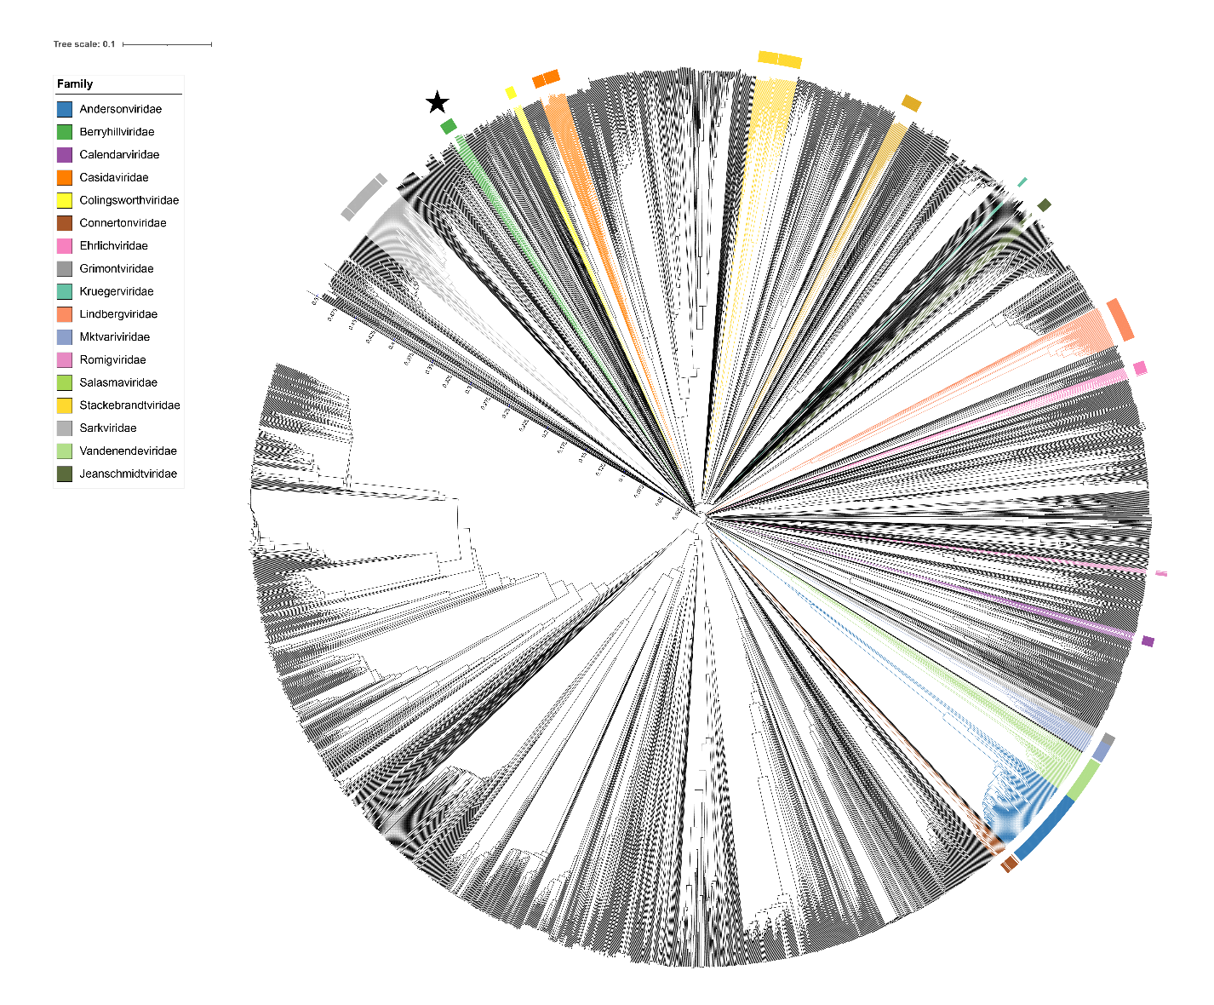

Figure 2. ViPTree [4] analysis Proteomic tree of 4,408 bacterial viruses with proposed viral families labeled by the coloured ring. The *Berryhillviridae* are marked with a star symbol. The hierarchical tree was created using ViPTreeGen (version 1.1.2) [4] and annotated using iToL [15-16]. The tree is based on a dissimilarity matrix generated by pairwise tBLASTx scores between each of the genomes.

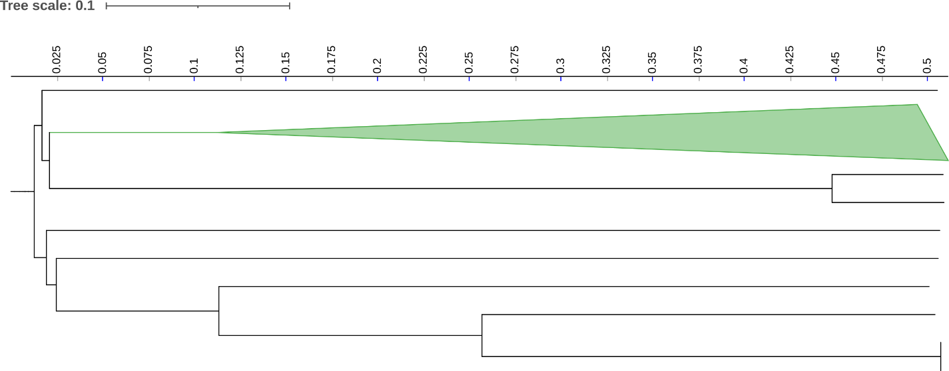Figure 3. ViPTree [4] hierarchical tree pruned to show the proposed *Berryhillviridae* as a green-coloured collapsed clade.

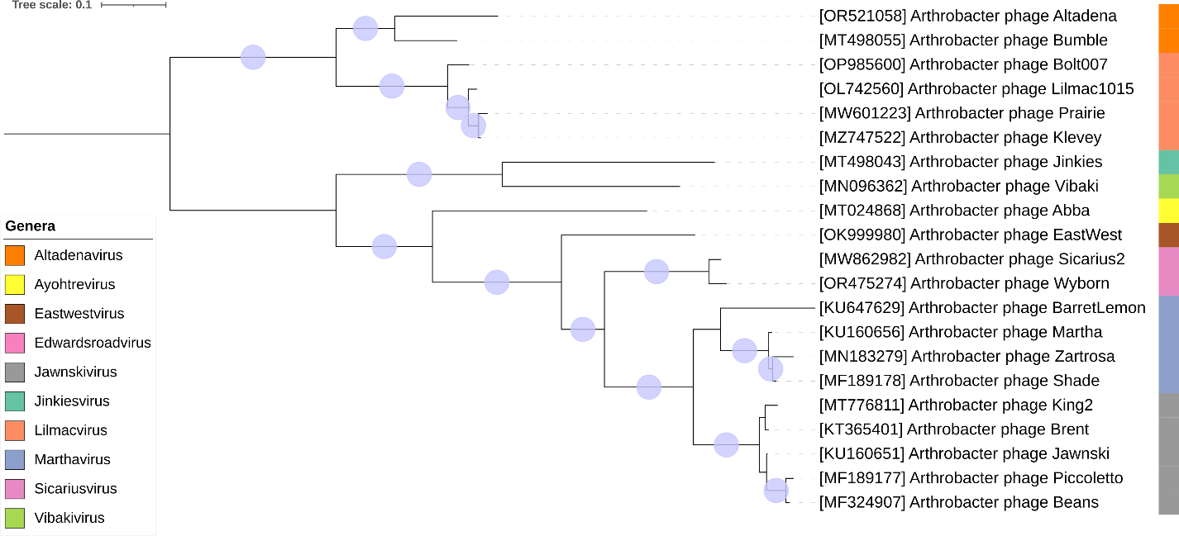

Figure 4. Core genome phylogeny of the proposed *Berryhillviridae* family of bacterial viruses. A partitioned protein ML phylogeny was created from 17 genes present in all species of the proposed family. Alignments were performed using MAFFT in e-insi mode and trimmed using trimAl with a gap threshold of 0.5. The tree was calculated using IQ-Tree2 with 1000 ultrafast (UF) bootstrap replicates and SH-Alrt tests with -m TEST to optimise models for each alignment [16-18]. The tree is rooted at the midpoint and UF bootstrap support ≥ 95% are shown. The coloured strips indicate proposed genera and subfamilies.

Figure 5. VirClust protein heatmap of representative species of each genus. At the first level, proteins are grouped based on their reciprocal BLASTP similarities into protein clusters, or PCs. At the second level, PCs are grouped based on their Hidden Markov Model (HMM) similarities into protein superclusters, or PSCs. AT the third, still experimental level, PSCs are grouped based on their HMM similarities into protein super-superclusters, or PSSCs [13].

Table 1. Signature genes in the proposed X family of bacterial viruses. Genes were identified by clustering with MMSeqs2, with thresholds of 35% sequence similarity and 50% coverage.

|  |  |  |  |
| --- | --- | --- | --- |
| **protein cluster** | **No. of genomes (21 total)** | **Percentage of genomes present in protein cluster** | **Predicted gene function** |
| 1 | 21 | 100% | hypothetical protein |
| 2 | 21 | 100% | tail tube protein |
| 3 | 21 | 100% | hypothetical protein |
| 4 | 21 | 100% | minor capsid protein |
| 5 | 21 | 100% | minor tail protein |
| 6 | 21 | 100% | hydrolase/minor tail protein |
| 7 | 21 | 100% | Terminase, large subunit |
| 8 | 21 | 100% | baseplate wedge protein |
| 9 | 21 | 100% | scaffold |
| 10 | 21 | 100% | major capsid protein |
| 11 | 21 | 100% | LysM-like peptidoglycan-binding protein |
| 12 | 21 | 100% | baseplate J protein |
| 13 | 21 | 100% | Terminase, small subunit |
| 14 | 21 | 100% | hypothetical protein |
| 15 | 21 | 100% | hypothetical protein |
| 16 | 21 | 100% | portal vertex protein |
| 17 | 21 | 100% | tail sheath protein |

**Proposals Data:**

1. **To** **create a new genus, *Jinkiesvirus*, with a single species**
2. **To create a new genus, *Lilmacvirus*, with four species**
3. **To create a new genus *Altadenavirus* with two species**
4. **To** **create a new genus, *Eastwestvirus* with a single species**
5. **To** **create a new genus *Sicariusvirus* with two species**
6. **To split the genus *Marthavirus* in two**
7. **To** **create a new family, *Berryhillviridae***
8. **To transfer these new genera together with *Marthavirus*, *Vibakivirus*, and *Ayohtrevirus* to this family**

**Taxonomic Proposals:**

1. **To create a new genus, *Jinkiesvirus*, with a single species**

**Origin of the name of this taxon:** This taxon was named after a virus of its type *Arthrobacter* phage Jinkies

**Historical aspects:** *Arthrobacter* myophage Jinkieswas isolated from Arab, AL soil by Ben Brazelton and Max Grill using *Arthrobacter globiformis* B-2979as the host at University of Alabama at Birmingham, USA It is lytic and was isolated as part of the Science Education Alliance-Phage Hunters Advancing Genomics and Evolutionary Science program. Phage Jinkies is a member of the FL cluster as defined by The Actinobacteriophage Database and possesses circularly permuted genome.

**Genomic characterization:**

|  |  |  |  |  |  |  |
| --- | --- | --- | --- | --- | --- | --- |
| Phage name | INSDC | Size (kb) | %GC | Protein | Overall % DNA sequence identity (*) | Overall % homologous proteins (**) |
| *Arthrobacter* phage Jinkies | MT498043.1 | 49.1 | 64.7 | 84 | 100 | 100 |

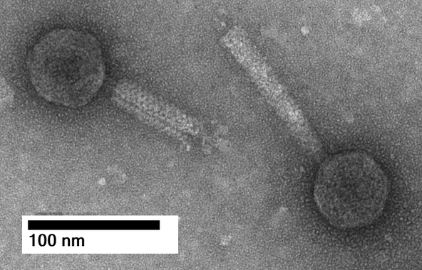

**Electron micrograph:** Electron micrographs of negatively stained Arthrobacter phage Jinkies (<https://phagesdb.org/phages/Jinkies/>). Limited permission was granted by The Actinobacteriophages Database (<https://phagesdb.org/>) funded by the Howard Hughes Medical Institute, to use this electron micrograph for this taxonomy proposal; it cannot be reused without permission of The Actinobacteriophages Database.

1. **To create a new genus, *Lilmacvirus*, with four species**

**Origin of the name of this taxon:** This taxon was named after a virus of its type *Arthrobacter* phage Lilmac1015

**Historical aspects:** *Arthrobacter* myophage Lilmac1015 was isolated from soil by Amanda Inman (Colorado State University-Pueblo) using *Arthrobacter globiformis* B-2979 as the host at James Madison University, Cranford, NJ. It is lytic and was isolated as part of the Science Education Alliance-Phage Hunters Advancing Genomics and Evolutionary Science program. Phage Lilmac1015 is a member of the FH cluster as defined by The Actinobacteriophage Database and possesses a circularly permuted genome.

**Genomic characterization:**

|  |  |  |  |  |  |  |
| --- | --- | --- | --- | --- | --- | --- |
| Phage name | INSDC | Size (kb) | %G+C | Protein | Overall % DNA sequence identity (*) | Overall % homologous proteins (**) |
| *Arthrobacter* phage Lilmac1015 | OL742560.1 | 50.0 | 69.4 | 80 | 100 | 100 |
| *Arthrobacter* phage Bolt007 | OP985600.1 | 49.8 | 69.8 | 78 | 80.2 | 88.7 |
| *Arthrobacter* phage Prairie | MW601223.1 | 49.4 | 69.5 | 78 | 84.3 | 87.5 |
| *Arthrobacter* phage Klevey | MZ747522.1 | 50.1 | 69.4 | 81 | 85.7 | 93.7 |

**(*) determined using VIRIDIC [3]**

**(**) determined using CoreGenes 3.5 [6]**

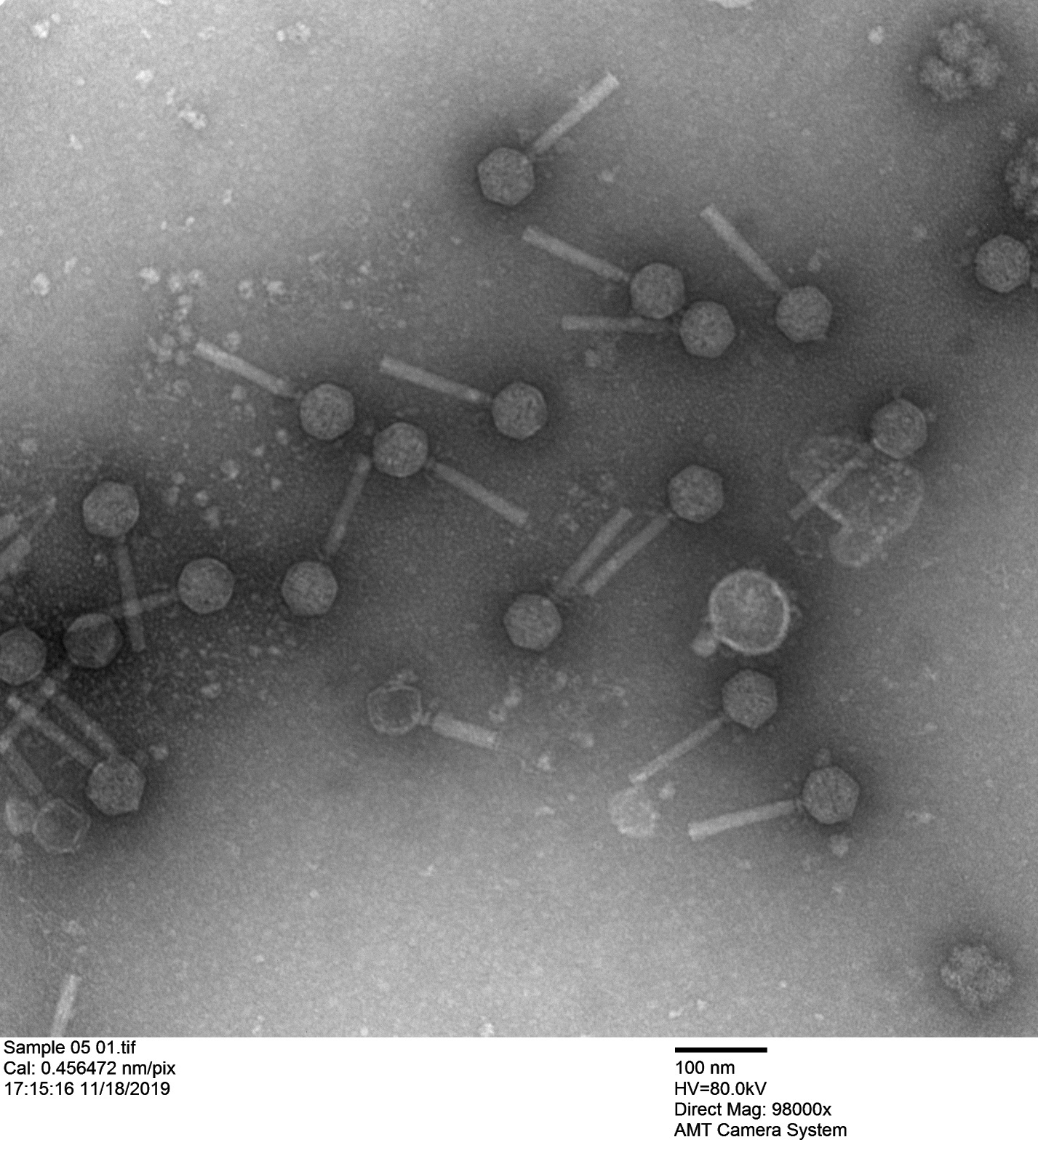

**Electron micrograph:** Electron micrographs of negatively stained *Arthrobacter* phage Klevey (<https://phagesdb.org/phages/Klevey/>). Limited permission was granted by The Actinobacteriophages Database (<https://phagesdb.org/>), funded by the Howard Hughes Medical Institute, to use this electron micrograph for this taxonomy proposal; it cannot be reused without permission of The Actinobacteriophages Database.

1. **To create a new genus *Altadenavirus* with two species**

**Origin of the name of this taxon:** This taxon was named after the first virus of its type *Arthrobacter* phage Altadena

**Historical aspects:** *Arthrobacter* phage Altadena was isolated from Petersburg, VA soil by Davian Clifton (Virginia State University) using *Arthrobacter globiformis* NRRL B-2880 as the host. It is lytic and was isolated as part of the Science Education Alliance-Phage Hunters Advancing Genomics and Evolutionary Science program. Phage Altadena is a member of the EH cluster as defined by The Actinobacteriophage Database and possesses a Circularly Permuted genome

**Genomic characterization:**

|  |  |  |  |  |  |  |
| --- | --- | --- | --- | --- | --- | --- |
| Phage name | INSDC | Size (kb) | %G+C | Protein | Overall % DNA sequence identity (*) | Overall % homologous proteins (**) |
| *Arthrobacter* phage Altadena | OR521058.1 | 48.1 | 70.4 | 76 | 100 | 100 |
| *Arthrobacter* phage Bumble | MT498055.1 | 49.5 | 70.4 | 57(***) | 74.9 | NA |

**(*) determined using VIRIDIC [3]**

**(**) determined using CoreGenes 3.5 [6]**

**(***) Underannotated**

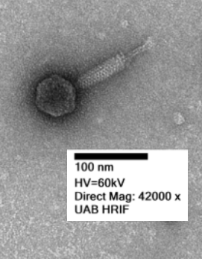

**Electron micrograph:** Electron micrographs of negatively stained *Arthrobacter* phage Bumble (<https://phagesdb.org/phages/Bumble/>) Limited permission was granted by The Actinobacteriophages Database (<https://phagesdb.org/>), funded by the Howard Hughes Medical Institute, to use this electron micrograph for this taxonomy proposal; it cannot be reused without permission of The Actinobacteriophages Database.

1. **To create a new genus, *Eastwestvirus* with a single species**

**Origin of the name of this taxon:** This taxon was named after the first virus of its type *Arthrobacter* phage EastWest

**Historical aspects:** *Arthrobacter* phage EastWestwas isolated from Honoulu, HI USA soil by Ryan Pearce (University of Hawaii at Manoa) using *Arthrobacter globiformis* B-2979as the host. It is lytic and was isolated as part of the Science Education Alliance-Phage Hunters Advancing Genomics and Evolutionary Science program. Phage EastWest is a member of the AO cluster as defined by The Actinobacteriophage Database and possesses a Circularly Permuted genome.

**Genomic characterization:**

|  |  |  |  |  |  |  |
| --- | --- | --- | --- | --- | --- | --- |
| Phage name | INSDC | Size (kb) | %G+C | Protein | Overall % DNA sequence identity (*) | Overall % homologous proteins (**) |
| *Arthrobacter* phage EastWest | OK999980.1 | 50.4 | 61.5 | 83 | 100 | 100 |

**Electron micrograph:** N/A

1. **To create a new genus *Sicariusvirus* with two species**

**Origin of the name of this taxon:** This taxon was named after the first virus of its type *Arthrobacter* phage Sicarius2

**Historical aspects:** *Arthrobacter* phage Sicarius2was isolated from soil by Cody Back using *Arthrobacter globiformis* B-2979as the host at Colorado State University-Pueblo. It is lytic and was isolated as part of the Science Education Alliance-Phage Hunters Advancing Genomics and Evolutionary Science program. Phage Sicarius2 is a member of the AO cluster /Subcluster AO2 as defined by The Actinobacteriophage Database and possesses a Circularly Permuted genome.

**Genomic characterization:**

|  |  |  |  |  |  |  |
| --- | --- | --- | --- | --- | --- | --- |
| Phage name | INSDC | Size (kb) | %G+C | Protein | Overall % DNA sequence identity (*) | Overall % homologous proteins (**) |
| *Arthrobacter* phage Sicarius2 | MW862982.1 | 49.2 | 63.5 | 79 | 100 | 100 |
| *Arthrobacter* phage Wyborn | OR475274.1 | 50.0 | 62.7 | 78 | 86.4 | 92.4 |

**(*) determined using VIRIDIC [3]**

**(**) determined using CoreGenes 3.5 [6]**

**Electron micrograph:** N/A

1. **To split the genus *Marthavirus* in two**

**Origin of the name of this taxon:** N/A

**Historical aspects:** The genus *Marthavirus* was created via Taxonomy Proposal 2016.026a-dB.A.v1.Marthavirus. VIRIDIC analysis (Fig. 1) clearly indicates that this taxon needs to be split. This is also verified by the Actinobacteriophage database which places phage Jawnski in Subcluster AO1 while phage Martha is in Subcluster AO2. We have chosen to name this taxon *Jawnskivirus* after *Arthrobacter* phage Jawnski.

**Genomic characterization:**

|  |  |  |  |  |  |  |
| --- | --- | --- | --- | --- | --- | --- |
| Phage name | INSDC | Size (kb) | %G+C | Protein | Overall % DNA sequence identity (*) | Overall % homologous proteins (**) |
| *Arthrobacter* phage Jawnski | KU160651.1 | 49.4 | 63.4 | 73 | 100 | 100 |
| *Arthrobacter* phage Beans | MF324907.1 | 49.8 | 63.6 | 73 | 89.4 | 94.5 |
| *Arthrobacter* phage Piccoletto | MF189177.1 | 49.8 | 63.6 | 74 | 87.5 | 87.3 |
| *Arthrobacter* phage King2 | MT776811.1 | 50.3 | 63.2 | 73 | 88.7 | 95.9 |
| *Arthrobacter* phage Brent | KT365401.1 | 49.9 | 63.4 | 74 | 80.6 | 100.0 |

**(*) determined using VIRIDIC [3]**

**(**) determined using CoreGenes 3.5 [6]**

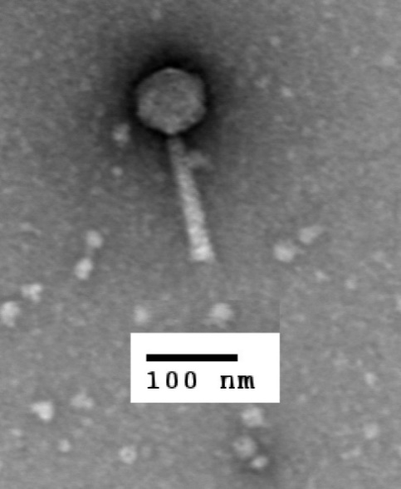

**Electron micrograph:** Electron micrographs of negatively stained *Arthrobacter* phage Jawnski (<https://phagesdb.org/phages/Jawnski/>). Limited permission was granted by The Actinobacteriophages Database (<https://phagesdb.org/>), funded by the Howard Hughes Medical Institute, to use this electron micrograph for this taxonomy proposal; it cannot be reused without permission of The Actinobacteriophages Database.

1. **To create a new family, *Berryhillviridae***

**Origin of the name of this taxon:** This taxon is named in honour of American Microbiologist David Berryhill (b. 1944; d. 2011). “David received a B.A. in Biology from Simpson College, in 1966, a M.S. in Bacteriology from Iowa State University in 1969, and a Ph.D. in Bacteriology from Iowa State University in 1971. After receiving a Ph.D. at ISU he became a faculty member of North Dakota State University in Fargo where he died while serving as Associate Professor and Associate Head of Animal Sciences. He co-authored *The Handbook of Zoonoses*.” He is one of the first people to isolate an Arthrobacter phage (Einck KH, Pattee PA, Holt JG, Hagedorn C, Miller JA, Berryhill DL. Isolation and characterization of a bacteriophage of *Arthrobacter globiformis*. J Virol. 1973 Nov;12(5):1031-3. doi: 10.1128/JVI.12.5.1031-1033.1973. PMID: 4128824; PMCID: PMC356733.)



(Photography copied from: <https://www.legacy.com/us/obituaries/legacyremembers/david-berryhill-obituary?id=26294917>)

**Rationale:** The members of this family include the existing taxa *Marthavirus, Vibakivirus*, and *Ayohtrevirus*. All members of this family are lytic myoviruses infectious for *Arthrobacter* species. They share ≥12.7 overall DNA sequence similarity and 17 homologs.