

The International Committee on Taxonomy of Viruses

Taxonomy Proposal Form, 2024

**Part 1a: Details of taxonomy proposals**

|  |  |  |  |
| --- | --- | --- | --- |
| **Title:** | Create a new family, *Andersonviridae* for the FelixO1-likephages (Class: *Caudoviricetes*) | |  |
| **Code assigned:** | 2024.002B |

|  |  |  |  |
| --- | --- | --- | --- |
| **Author(s), affiliation and email address(es):** | | | |
| **Name** | **Affiliation** | **Email address** | **Corresponding author(s)** X |
| **Moraru C** | **Carl von Ossietzky Universität Oldenburg, Germany** | **liliana.cristina.moraru@uol.de** |  |
| **Tolstoy I** | **National Center for Biotechnology Information, MD, USA** | **tolstoy@ncbi.nlm.nih.gov** |  |
| **Kropinski AM** | **University of Guelph, Ontario, Canada [AMK]** | **Phage.Canada@gmail.com** | **X** |

**Part 1b: Taxonomy Proposal Submission**

|  |  |  |  |
| --- | --- | --- | --- |
| **ICTV Subcommittee:** | | | |
| Animal DNA Viruses and Retroviruses |  | Bacterial viruses | **X** |
| Animal minus-strand and dsRNA viruses |  | Fungal and protist viruses |  |
| Animal positive-strand RNA viruses |  | Plant viruses |  |
| Archaeal viruses |  | General - |  |

|  |
| --- |
| **List the ICTV Study Group(s) that have seen or have been involved in creating this proposal:** |
| Caudoviricetes Study Group |

|  |  |  |  |
| --- | --- | --- | --- |
| **Optional – complete only if formally voted on by an ICTV Study Group:** | | | |
| **Study Group** | **Number of members** | | |
| **Votes in support** | **Votes against** | **No vote** |
|  |  |  |  |
|  |  |  |  |

|  |  |
| --- | --- |
| **Submission date:** | 01/06/2024 |

**Part 1c: Feedback from ICTV Executive Committee (EC) meeting**

|  |  |
| --- | --- |
| **Executive Committee Meeting Decision code:** | **X** |
| A – Accept |  |
| Ac – Accept subject to revision by relevant subcommittee chair. No further vote required | **X** |
| U – Accept without revision but with re-evaluation and email vote by the EC |  |
| Uc – Accept subject to revision and re-evaluation and email vote by the EC |  |
| Ud – Deferred to the next EC meeting, with an invitation to revise based on EC comments |  |
| J - Reject |  |
| W - Withdrawn |  |

|  |
| --- |
| **Comments from the Executive Committee:** |
| Corrections required to wording (figure labels) within the taxonomy proposal. |

**Part 1d: Revised Taxonomy Proposal Submission**

|  |
| --- |
| **Response of proposer:** |
| The text has been corrected. |

|  |  |
| --- | --- |
| **Revision date:** | 30/09/2024 |

**Part 3:** **TAXONOMIC PROPOSAL**

|  |
| --- |
| **Name of accompanying Excel module:** |
| 2024.002B.A.v1.Andersonviridae_nf.xlsx |

|  |  |  |  |
| --- | --- | --- | --- |
| **Taxonomic changes proposed:** | | | |
| Establish new taxon | **x** | Split taxon |  |
| Abolish taxon |  | Merge taxon |  |
| Move taxon |  | Promote taxon |  |
| Rename taxon |  | Demote taxon |  |
| Move and rename |  |  |  |

|  |  |  |
| --- | --- | --- |
| **Is any taxon name used here derived from that of a living person:** | | **N** |
| **Taxon name** | **Person from whom the name is derived** | **Attached X** |
|  |  |  |
|  |  |  |
|  |  |  |

|  |
| --- |
| **Abstract of Taxonomy Proposal:** |
| *Taxonomic rank(s) affected*:  Realm *Duplodnaviria*, kingdom *Heunggongvirae*, phylum *Uroviricota*, class *Caudoviricetes*  *Description of current taxonomy*:  At present the following taxa exist as floating genera in the order *Caudoviricetes*: *Felixounavirus, Kolesnikvirus, Suspvirus,* and *Mooglevirus*.  *Proposed* *taxonomic change(s):*  We propose the creation of one new family, *Andersonviridae*.  To update the genus *Felixounavirus* with 80 new species  To update the genus *Mooglevirus* with 11 new species  To add one new species to the genus *Kolesnikvirus*  To create a new genus *Daniellevirus* with two species  To create a new genus *Arnovirus* with three species  *Justification*:  We investigated the evolutionary relationships of 123 bacteriophages. Analysis of conserved genes revealed that these phages form a deeply branching monophyletic clade with a distance commensurate with the creation of a new family. |

|  |
| --- |
| * **Text of Taxonomy proposal:** |
| *Taxonomic rank(s) affected*: Species, genus and family.  *Description of current taxonomy*:  At present the following taxa exist: The subfamily *Ounavirinae* and genera *Felixounavirus, Kolesnikvirus, Suspvirus,* and *Mooglevirus*.  *Proposed* *taxonomic change(s)*:  **A. To update the genus *Felixounavirus* with 80 new species**  **B. To update the genus *Mooglevirus* with 11 new species**  **C. To add one new species to the genus *Kolesnikvirus***  **D. To create a new genus** ***Daniellevirus* with two species**  **E. To create a new genus *Arnovirus* with three species**  **F. To create a new family *Andersonviridae***  All our analyses reveal that the Felix-O1-like phages are part of a family which we have named *Andersonviridae* in honour of American biophysical chemist and geneticist Thomas Foxen Anderson. Unlike almost every TaxoProp submitted since the development of VIRIDIC there is not a clear distinction based upon overall DNA sequence similarity of members of the *Felixounavirus* and the *Mooglevirus*.  *Demarcation criteria:*  **Species demarcation criteria:** Two phages are assigned to the same species if their genomes are more than 95% identical over their genome length for isolates.  These values can be calculated by a number of tools, such as BLASTn [1,2] – usually calculated using intergenomic distance calculator VIRIDIC [3].  **Genus demarcation criteria:** In search for criteria that create cohesive and distinct genera that are reproducible and monophyletic, the Bacterial Viruses Subcommittee has established 70% nucleotide identity of the genome length as the cut-off for genera. Genus-level groupings should always be monophyletic in the signature genes, as tested with a phylogenetic tree. [10]  **Subfamily demarcation criteria:** Subfamilies are to be created when two or more genera are related below the family level. In practical terms, this usually means that they share a low degree of sequence similarity (usually about 40-50%) and that the genera form a clade in a marker tree phylogeny. [10]  **Family demarcation criteria:** The family is represented by a cohesive and monophyletic group in the main predicted proteome-based clustering tools (VirClust, ViPTree, GRAViTy dendrogram, vConTACT2 network). Members of the family share a significant number of orthologous genes (the number will depend on the genome sizes and number of coding sequences of members of the family). [10]  *Justification*:  This assignment is in keeping with the criteria laid out in [10] |

|  |
| --- |
| **References:** |
| 1. Sayers EW, Beck J, Bolton EE, Bourexis D, Brister JR, Canese K, Comeau DC, Funk K, Kim S, Klimke W, Marchler-Bauer A, Landrum M, Lathrop S, Lu Z, Madden TL, O'Leary N, Phan L, Rangwala SH, Schneider VA, Skripchenko Y, Wang J, Ye J, Trawick BW, Pruitt KD, Sherry ST. Database resources of the National Center for Biotechnology Information. Nucleic Acids Res. 2021 Jan 8;49(D1):D10-D17. doi: 10.1093/nar/gkaa892. PMID: 33095870  2. O'Leary NA, Wright MW, Brister JR, Ciufo S, Haddad D, McVeigh R, et al. Reference sequence (RefSeq) database at NCBI: current status, taxonomic expansion, and functional annotation. Nucleic Acids Res. 2016;44(D1):D733-45. doi: 10.1093/nar/gkv1189. PMID: 26553804.  3. Moraru C, Varsani A, Kropinski AM. VIRIDIC-A Novel Tool to Calculate the Intergenomic Similarities of Prokaryote-Infecting Viruses. Viruses. 2020 Nov 6;12(11):1268. doi: 10.3390/v12111268. PMID: 33172115; PMCID: PMC7694805. http://kronos.icbm.uni-oldenburg.de/viridic/  4. Nishimura Y, Yoshida T, Kuronishi M, Uehara H, Ogata H, Goto S. ViPTree: the viral proteomic tree server. Bioinformatics. 2017; 33(15):2379-2380. doi:10.1093/bioinformatics/btx157. PubMed PMID: 28379287. https://www.genome.jp/viptree/  5. Rohwer F, Edwards R. The Phage Proteomic Tree: a genome-based taxonomy for phage. J Bacteriol. 2002 Aug;184(16):4529-35. PubMed PMID: 12142423  6. Turner D, Reynolds D, Seto D, Mahadevan P. CoreGenes3.5: a webserver for the determination of core genes from sets of viral and small bacterial genomes. BMC Res Notes. 2013;6:140. doi: 10.1186/1756-0500-6-140. PMID: 23566564.  7. Davis P, Seto D, Mahadevan P. CoreGenes5.0: An Updated User-Friendly Webserver for the Determination of Core Genes from Sets of Viral and Bacterial Genomes. Viruses. 2022 Nov 16;14(11):2534. doi: 10.3390/v14112534. PMID: 36423143; PMCID: PMC9693508.  8. Dereeper A, Guignon V, Blanc G, Audic S, Buffet S, Chevenet F, Dufayard JF, Guindon S, Lefort V, Lescot M, Claverie JM, Gascuel O. Phylogeny.fr: robust phylogenetic analysis for the non-specialist. Nucleic Acids Res. 2008;36(Web Server issue):W465-9. doi: 10.1093/nar/gkn180. Epub 2008 Apr 19. PMID: 18424797.  9. Anisimova M, Gascuel O. Approximate likelihood-ratio test for branches: A fast, accurate, and powerful alternative. Syst Biol. 2006;55(4):539-52. PMID: 16785212. DOI: 10.1080/10635150600755453.  10. Turner D, Kropinski AM, Adriaenssens EM. A Roadmap for Genome-Based Phage Taxonomy. Viruses. 2021 Mar 18;13(3):506. doi: 10.3390/v13030506. PMID: 33803862; PMCID: PMC8003253.  11. Bin Jang H, Bolduc B, Zablocki O, Kuhn JH, Roux S, Adriaenssens EM, Brister JR, Kropinski AM, Krupovic M, Lavigne R, Turner D, Sullivan MB. Taxonomic assignment of uncultivated prokaryotic virus genomes is enabled by gene-sharing networks. Nat Biotechnol. 2019 Jun;37(6):632-639. doi: 10.1038/s41587-019-0100-8. Epub 2019 May 6. PMID: 31061483.  12. Bolduc B, Jang HB, Doulcier G, You ZQ, Roux S, Sullivan MB. vConTACT: an iVirus tool to classify double-stranded DNA viruses that infect Archaea and Bacteria. PeerJ. 2017 May 3;5:e3243. doi: 10.7717/peerj.3243. PMID: 28480138; PMCID: PMC5419219.  13. Moraru C. VirClust-A Tool for Hierarchical Clustering, Core Protein Detection and Annotation of (Prokaryotic) Viruses. Viruses. 2023 Apr 19;15(4):1007. doi: 10.3390/v15041007. PMID: 37112988; PMCID: PMC10143988.  14. Letunic I, Bork P. Interactive Tree Of Life (iTOL): an online tool for phylogenetic tree display and annotation. Bioinformatics. 2007 Jan 1;23(1):127-8. doi: 10.1093/bioinformatics/btl529. Epub 2006 Oct 18. PMID: 17050570.  15. Zhou T, Xu K, Zhao F, Liu W, Li L, Hua Z, Zhou X. itol.toolkit accelerates working with iTOL (Interactive Tree of Life) by an automated generation of annotation files. Bioinformatics. 2023 Jun 1;39(6):btad339. doi: 10.1093/bioinformatics/btad339. PMID: 37225402; PMCID: PMC10243930.  16. Nguyen LT, Schmidt HA, von Haeseler A, and Minh BQ (2015) IQ-TREE: A fast and effective stochastic algorithm for estimating maximum likelihood phylogenies. Molecular Biology and Evolution, 32:268-274. <https://doi.org/10.1093/molbev/msu300>  17. Hoang DT, Chernomor O, von Haeseler A, Minh BQ, Vinh LS (2018) UFBoot2: Improving the ultrafast bootstrap approximation. Molecular Biology and Evolution, 35:518–522. <https://doi.org/10.1093/molbev/msx281>  18. Kalyaanamoorthy S, Minh BQ, Wong TKF, von Haeseler A, and Jermiin JS (2017) ModelFinder: Fast Model Selection for Accurate Phylogenetic Estimates, Nature Methods, 14:587–589. <https://doi.org/10.1038/nmeth.4285> |

|  |
| --- |
| **Tables, Figures:** |

Figure 1. VIRIDIC heat map of a small portion of the members of this family: VIRIDIC (Virus Intergenomic Distance Calculator; VIRIDIC (Virus Intergenomic Distance Calculator; [3]; http://rhea.icbm.uni-oldenburg.de/VIRIDIC/) computes pairwise intergenomic distances/similarities amongst phage genomes. Data values which are bordered in black correspond to strains. Abbreviations: phg = phage; vir = virus; Esch = *Escherichia; Shig = Shigella;* Salm = *Salmonella,* Pect = *Pectobacterium;* Hafn = *Hafnia;* Erwi = *Erwinia;*  Ente = Enterobacteria. The full VIRIDIC comparison is provided as supplementary material.

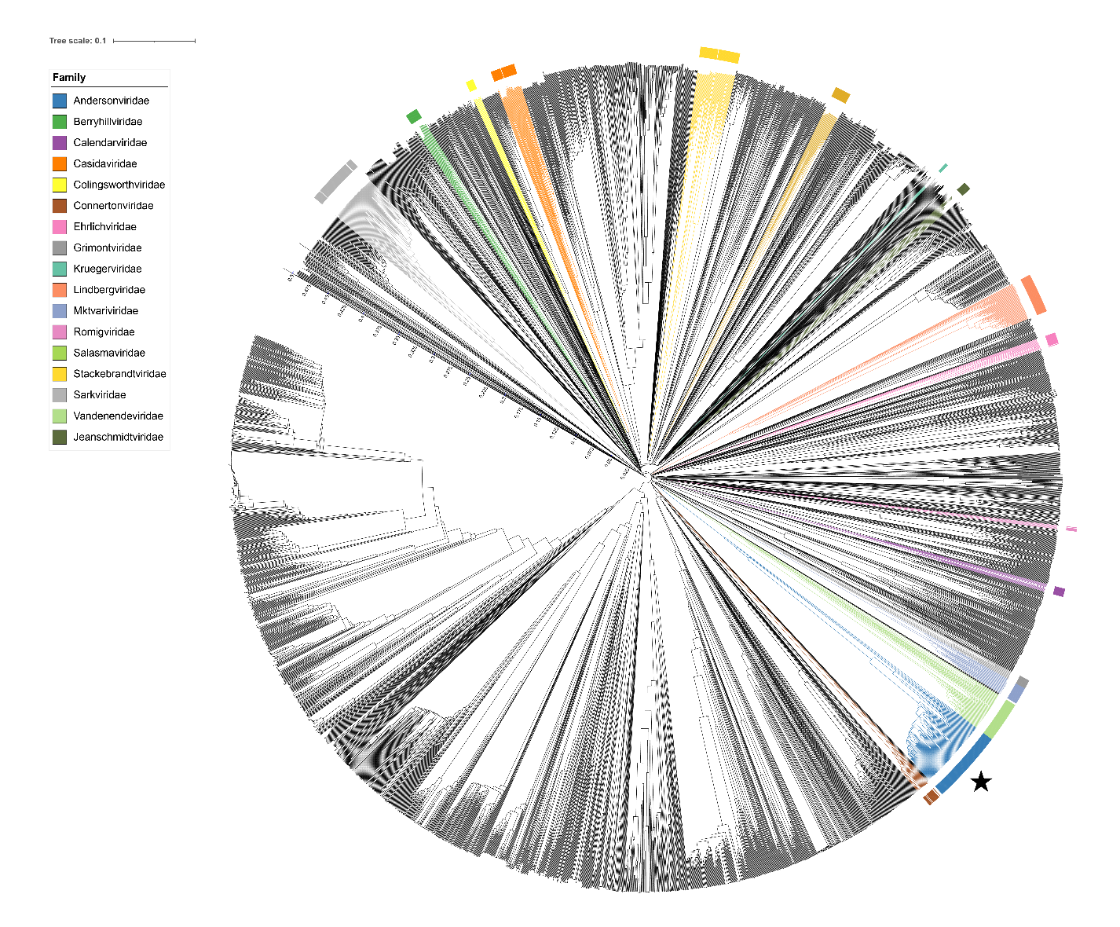Figure 2. ViPTree [4] analysis Proteomic tree of 4,408 bacterial viruses with proposed viral families labeled by the coloured ring. The *Andersonviridae* are marked with a star symbol. The hierarchical tree was created using ViPTreeGen (version 1.1.2) [4] and annotated using iToL [15-16]. The tree is based on a dissimilarity matrix generated by pairwise tBLASTx scores between each of the genomes.

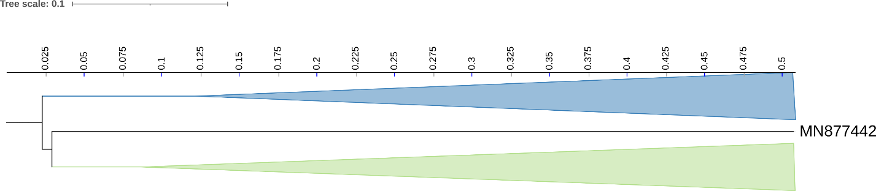Figure 3. ViPTree [4] hierarchical tree pruned to show the proposed *Andersonviridae* alongside neighbouring clades. The proposed family is shown in grey with branches collapsed.

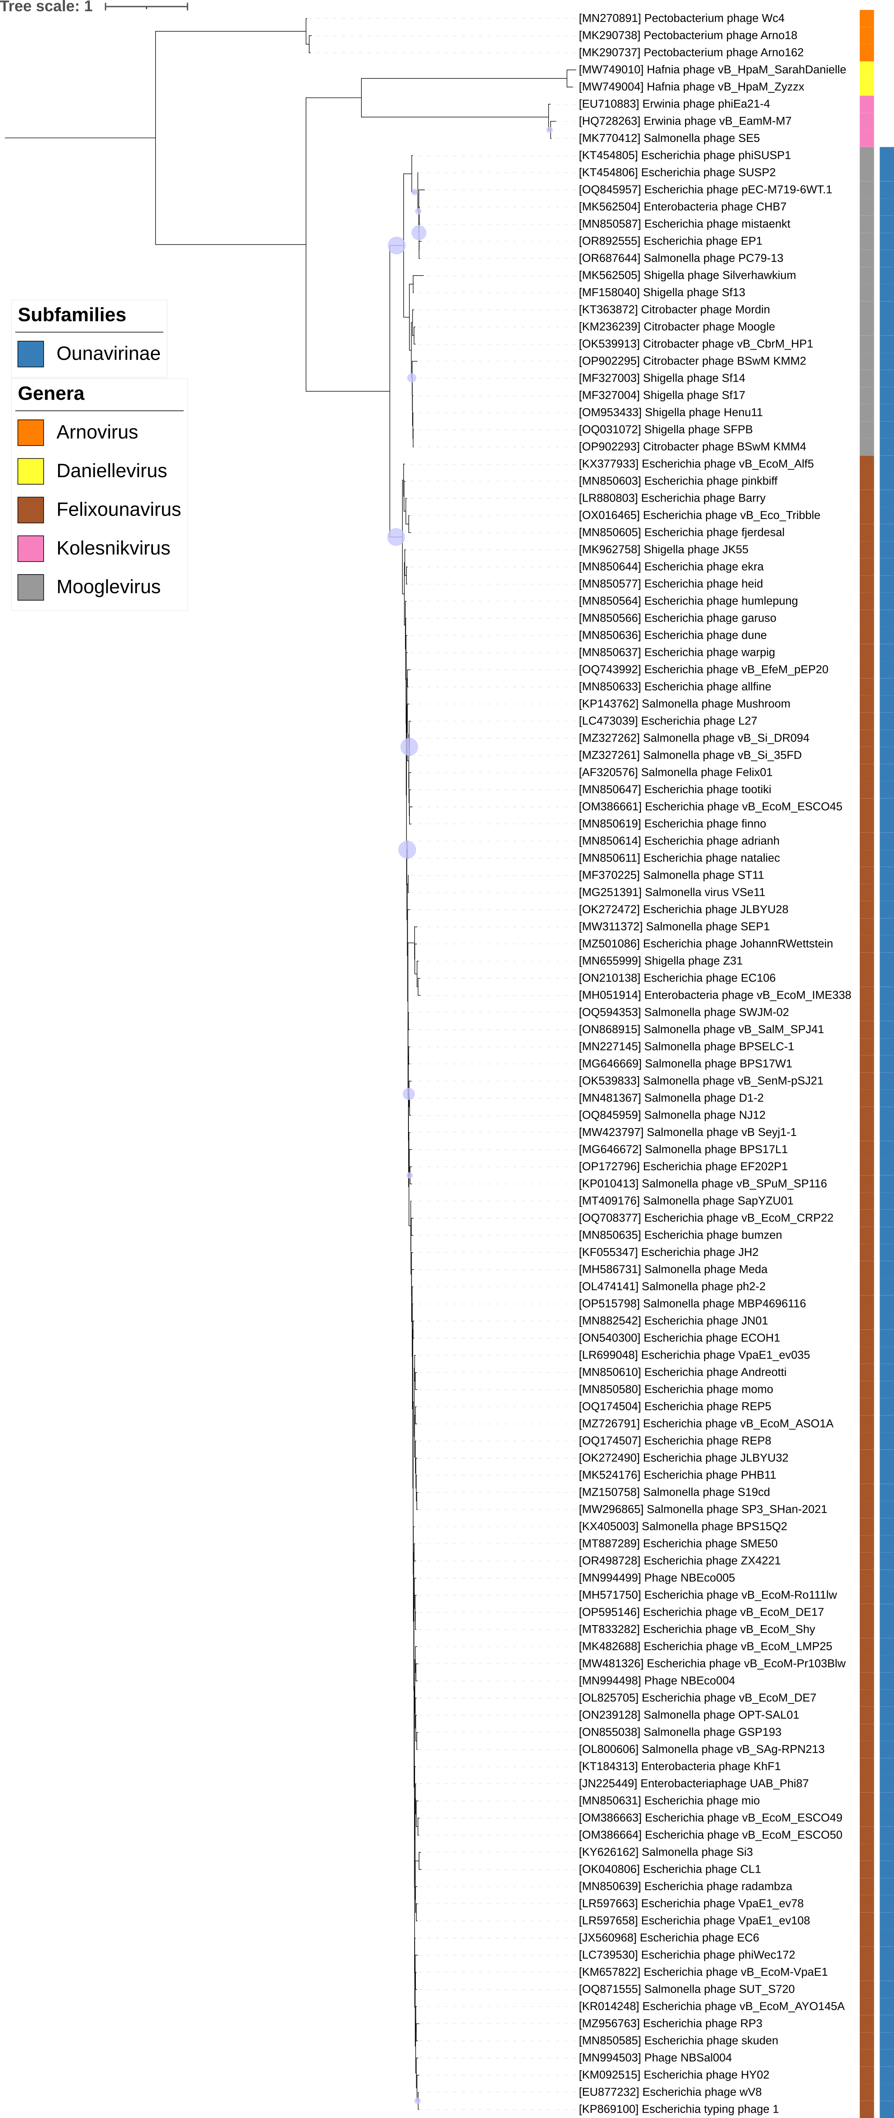

Figure 4. Core genome phylogeny of the proposed *Andersonviridae* family of bacterial viruses. A partitioned protein ML phylogeny was created from 5 genes present in all species of the proposed family. Alignments were performed using MAFFT in e-insi mode and trimmed using trimAl with a gap threshold of 0.5. The tree was calculated using IQ-Tree2 with 1000 ultrafast (UF) bootstrap replicates and SH-Alrt tests with -m TEST to optimise models for each alignment. The tree is rooted at the midpoint and UF bootstrap support ≥ 95% are shown. The coloured strips indicate proposed genera and subfamilies.

Figure 5. VirClust protein heatmap of a portion of species. At the first level, proteins are grouped based on their reciprocal BLASTP similarities into protein clusters, or PCs. At the second level, PCs are grouped based on their Hidden Markov Model (HMM) similarities into protein superclusters, or PSCs. AT the third, still experimental level, PSCs are grouped based on their HMM similarities into protein super-superclusters, or PSSCs [13].

Table 1. Signature genes in the proposed *Andersonviridae* family of bacterial viruses. Genes were identified by clustering with MMSeqs2, with thresholds of 35% sequence similarity and 50% coverage.

|  |  |  |  |
| --- | --- | --- | --- |
| **protein cluster** | **No. of genomes (123 total)** | **Percentage of genomes present in protein cluster** | **Predicted gene function** |
| 1 | 123 | 100% | rIIB |
| 2 | 123 | 100% | virion structural protein |
| 3 | 123 | 100% | lysozyme |
| 4 | 123 | 100% | thymidylate synthase |
| 5 | 123 | 100% | major capsid protein |
| 6 | 122 | 99.19% | hypothetical protein |
| 7 | 122 | 99.19% | hypothetical protein |
| 8 | 122 | 99.19% | hypothetical protein |
| 9 | 122 | 99.19% | hypothetical protein |
| 10 | 122 | 99.19% | baseplate assembly protein |
| 11 | 122 | 99.19% | baseplate wedge subunit |
| 12 | 122 | 99.19% | terminase, large subunit |
| 13 | 122 | 99.19% | baseplate assembly protein |
| 14 | 122 | 99.19% | hypothetical protein |
| 15 | 122 | 99.19% | portal protein |
| 16 | 122 | 99.19% | hypothetical protein |
| 17 | 122 | 99.19% | baseplate protein |
| 18 | 122 | 99.19% | hypothetical protein |

**Proposals Data:**

1. **To** **update the genus *Felixounavirus* with 80 new species**
2. **To update the genus *Mooglevirus with* 11 new species**
3. **To add one new species to the genus *Kolesnikvirus***
4. **To create a new genus *Daniellevirus* with two species**
5. **To create a new genus *Arnovirus* with three species**
6. **To create a new family *Andersonvirida*e**

**Taxonomic Proposals:**

1. **To** **update the genus *Felixounavirus* with 80 new species**

**Origin of the name of this taxon:** N/A

**Historical aspects:** This taxon was created through Taxonomy Proposal 2009.006a-gB.A.v2.FelixO1likevirus.

**Genomic characterization:**

|  |  |  |  |
| --- | --- | --- | --- |
| **Accession No.** | **Exemplar** | **% DNA Sequence similarity (*)** | **Species** |
| NC_005282.1 | Enterobacteria phage Felix01 | 100 |  |
| ON239128.1 | *Salmonella* phage OPT-SAL01 | 88.4 | *Felixounavirus OPTSAL01* |
| MT409176.1 | *Salmonella* phage SapYZU01 | 87.6 | *Felixounavirus CapYZU01* |
| MW423797.1 | *Salmonella* phage vB Seyj1-1 | 87 | *Felixounavirus fv1* |
| ON868915.1 | *Salmonella* phage vB_SalM_SPJ41 | 86.3 | *Felixounavirus SPJ41* |
| OQ594353.1 | *Salmonella* phage SWJM-02 | 85.8 | *Felixounavirus SWJM02* |
| MH586731.1 | *Salmonella* phage Meda | 88 | *Felixounavirus meda* |
| OK539833.1 | *Salmonella* phage vB_SenM-pSJ21 | 86.8 | *Felixounavirus pSJ21* |
| OQ871555.1 | *Salmonella* phage SUT_S720 | 87.8 | *Felixounavirus SUTS720* |
| ON855038.1 | *Salmonella* phage GSP193 | 87.8 | *Felixounavirus GSP193* |
| OL474141.1 | *Salmonella* phage ph2-2 | 87.2 | *Felixounavirus ph22* |
| OP515798.1 | *Salmonella* phage MBP4696116 | 88.3 | *Felixounavirus MBP496116* |
| OQ845959.1 | *Salmonella* phage NJ12 | 87.1 | *Felixounavirus NJ12* |
| MN227145.1 | *Salmonella* phage BPSELC-1 | 87.6 | *Felixounavirus BPSELC1* |
| MN481367.1 | *Salmonella* phage D1-2 | 87.9 | *Felixounavirus D12* |
| OL825705.1 | *Escherichia* phage vB_EcoM_DE7 | 86.8 | *Felixounavirus DE7* |
| MN655999.1 | *Shigella* phage Z31 | 85.3 | *Felixounavirus Z31* |
| OQ708377.1 | *Escherichia* phage vB_EcoM_CRP22 | 87.6 | *Felixounavirus CRP22* |
| MN882542.1 | *Escherichia* phage JN01 | 87.4 | *Felixounavirus JN01* |
| MW296865.1 | *Salmonella* phage SP3_SHan-2021 | 86.1 | *Felixounavirus Sp3Shan2021* |
| OQ743992.1 | *Escherichia* phage vB_EfeM_pEP20 | 86.7 | *Felixounavirus pEP20* |
| MT833282.1 | *Escherichia* phage vB_EcoM_Shy | 86.9 | *Felixounavirus shy* |
| OR498728.1 | *Escherichia* phage ZX4221 | 86.9 | *Felixounavirus ZX4221* |
| MK524176.1 | *Escherichia* phage PHB11 | 86.6 | *Felixounavirus PHB11* |
| MT887289.1 | *Escherichia* phage SME50 | 87.6 | *Felixounavirus SME50* |
| MN994498.1 | Phage NBEco004 | 86.9 | *Felixounavirus NBEco004* |
| MZ150758.1 | *Salmonella* phage S19cd | 86.2 | *Felixounavirus S19cd* |
| OK040806.1 | *Escherichia* phage CL1 | 86.9 | *Felixounavirus CL1* |
| MN994499.1 | Phage NBEco005 | 88.4 | *Felixounavirus NBEco005* |
| OP172796.1 | *Escherichia* phage EF202P1 | 87.4 | *Felixounavirus EF202P1* |
| MW481326.1 | *Escherichia* phage vB_EcoM-Pr103Blw | 87 | *Felixounavirus Pr103Blw* |
| MH571750.1 | *Escherichia* phage vB_EcoM-Ro111lw | 88.3 | *Felixounavirus Ro111lw* |
| OP595146.1 | *Escherichia* phage vB_EcoM_DE17 | 86.5 | *Felixounavirus DE17* |
| LR597663.1 | *Escherichia* phage VpaE1_ev78 | 89.4 | *Felixounavirus ev78* |
| KT184313.1 | Enterobacteria phage KhF1 | 88.3 | *Felixounavirus KhF1* |
| MK482688.1 | *Escherichia* phage vB_EcoM_LMP25 | 87.9 | *Felixounavirus LMP25* |
| LR699048.1 | *Escherichia* phage VpaE1_ev035 | 87.3 | *Felixounavirus ev035* |
| LR597658.1 | *Escherichia* phage VpaE1_ev108 | 88.2 | *Felixounavirus ev108* |
| MZ726791.1 | *Escherichia* phage vB_EcoM_ASO1A | 89.5 | *Felixounavirus ASO1A* |
| MZ501086.1 | *Escherichia* phage JohannRWettstein | 88.4 | *Felixounavirus johannrwettstein* |
| MZ956763.1 | *Escherichia* phage RP3 | 87.1 | *Felixounavirus RP3* |
| MN850585.1 | *Escherichia* phage skuden | 90.2 | *Felixounavirus skuden* |
| MN850619.1 | *Escherichia* phage finno | 89.6 | *Felixounavirus finno* |
| MN850631.1 | *Escherichia* phage mio | 89 | *Felixounavirus mio* |
| MN850637.1 | *Escherichia* phage warpig | 89.6 | *Felixounavirus warpig* |
| LR880803.1 | *Escherichia* phage Barry | 87.5 | *Felixounavirus barry* |
| MN850577.1 | *Escherichia* phage heid | 87.9 | *Felixounavirus heid* |
| OK272490.1 | *Escherichia* phage JLBYU32 | 88.5 | *Felixounavirus JLBYU32* |
| MN850605.1 | *Escherichia* phage fjerdesal | 88.3 | *Felixounavirus fjerdesal* |
| MN850636.1 | *Escherichia* phage dune | 89.5 | *Felixounavirus dune* |
| MN850603.1 | *Escherichia* phage pinkbiff | 89.7 | *Felixounavirus pinkbiff* |
| OX016465.1 | *Escherichia* phage vB_Eco_Tribble | 87 | *Felixounavirus tribble* |
| MN850611.1 | *Escherichia* phage nataliec | 89.1 | *Felixounavirus nataliec* |
| MN850633.1 | *Escherichia* phage allfine | 87.3 | *Felixounavirus allfine* |
| MN850566.1 | *Escherichia* phage garuso | 88.4 | *Felixounavirus garuso* |
| MN850580.1 | *Escherichia* phage momo | 88.9 | *Felixounavirus momo* |
| MN850635.1 | *Escherichia* phage bumzen | 88.2 | *Felixounavirus bumzen* |
| MN850647.1 | *Escherichia* phage tootiki | 89 | *Felixounavirus tootiki* |
| MN850614.1 | *Escherichia* phage adrianh | 89.1 | *Felixounavirus adrianh* |
| MK962758.1 | *Shigella* phage JK55 | 88.9 | *Felixounavirus JK55* |
| MN850644.1 | *Escherichia* phage ekra | 88.6 | *Felixounavirus ekra* |
| MZ327262.1 | *Salmonella* phage vB_Si_DR094 | 88.7 | *Felixounavirus DR094* |
| MN850564.1 | *Escherichia* phage humlepung | 90.2 | *Felixounavirus humlepung* |
| MN850639.1 | *Escherichia* phage radambza | 89.9 | *Felixounavirus radambza* |
| OQ174507.1 | *Escherichia* phage REP8 | 86.5 | *Felixounavirus REP8* |
| OQ174504.1 | *Escherichia* phage REP5 | 86.6 | *Felixounavirus REP5* |
| OK272472.1 | *Escherichia* phage JLBYU28 | 87.2 | *Felixounavirus JLBYU28* |
| MZ327261.1 | *Salmonella* phage vB_Si_35FD | 87.9 | *Felixounavirus fv35FD* |
| LC473039.1 | *Escherichia* phage L27 | 88.2 | *Felixounavirus L27* |
| MN994503.1 | Phage NBSal004 | 89 | *Felixounavirus NBSal004* |
| ON540300.1 | *Escherichia* phage ECOH1 | 85.1 | *Felixounavirus ECOH1* |
| MN850610.1 | *Escherichia* phage Andreotti | 87.9 | *Felixounavirus andreotti* |
| MF370225.1 | *Salmonella* phage ST11 | 95 | *Felixounavirus ST11* |
| MG251391.1 | *Salmonella* virus VSe11 | 90.9 | *Felixounavirus VSe11* |
| OM386661.1 | *Escherichia* phage vB_EcoM_ESCO45 | 85.7 | *Felixounavirus ESCO45* |
| OM386663.1 | *Escherichia* phage vB_EcoM_ESCO49 | 88.2 | *Felixounavirus ESCO49* |
| OM386664.1 | *Escherichia* phage vB_EcoM_ESCO50 | 87.5 | *Felixounavirus ESCO50* |
| ON210138.1 | *Escherichia* phage EC106 | 84 | *Felixounavirus EC106* |
| LC739530.1 | *Escherichia* phage phiWec172 | 86.7 | *Felixounavirus Wec171* |
| MH051914.1 | Enterobacteria phage vB_EcoM_IME338 | 83.1 | *Felixounavirus IME338* |
| MW311372.1 | *Salmonella* phage SEP1 | 84.4 | *Felixounavirus SEP1* |

**(*) determined using VIRIDIC [3]**

1. **To update the genus *Mooglevirus* with 11 new species**

**Origin of the name of this taxon:** N/A

**Historical aspects:** This taxon was created through Taxonomy Proposal 2016.031a-rB.A.v2.Ounavirinae

**Genomic characterization:**

|  |  |  |  |
| --- | --- | --- | --- |
| **Accession or RefSeq No.** | **Exemplar** | **% DNA Sequence similarity (*)** | **Species** |
| NC_027293.1 | *Citrobacter* phage Moogle | 100 |  |
| MK562505.1 | *Shigella* phage Silverhawkium | 79.8 | *Mooglevirus Silverhawkium* |
| OP902293.1 | *Citrobacter* phage BSwM KMM4 | 84.5 | *Mooglevirus KMM4* |
| OQ031072.1 | *Shigella* phage SFPB | 83.4 | *Mooglevirus SFPB* |
| OM953433.1 | *Shigella* phage Henu11 | 83.6 | *Mooglevirus Henu11* |
| OP902295.1 | *Citrobacter* phage BSwM KMM2 | 84.5 | *Mooglevirus KMM2* |
| OK539913.1 | *Citrobacter* phage vB_CbrM_HP1 | 90.2 | *Mooglevirus HP1* |
| OQ845957.1 | *Escherichia* phage pEC-M719-6WT.1 | 76.9 | *Mooglevirus M7196WT1* |
| MK562504.1 | Enterobacteria phage CHB7 | 75.2 | *Mooglevirus CHB7* |
| OR892555.1 | *Escherichia* phage EP1 | 75.6 | *Mooglevirus EP1* |
| MN850587.1 | *Escherichia* phage mistaenkt | 76.0 | *Mooglevirus mistaenkt* |
| OR687644.2 | *Salmonella* phage PC79-13 | 74.2 | *Mooglevirus PC7913* |

**(*) determined using VIRIDIC [3]**

1. **To add one new species to the genus *Kolesnikvirus***

**Origin of the name of this taxon:** N/A

**Historical aspects:** This taxon was created through Taxonomy Proposal 2016.031a-rB.A.v2.Ounavirinae

**Genomic characterization:**

|  |  |  |  |  |  |
| --- | --- | --- | --- | --- | --- |
| Phage name | INSDC | Size (kb) | Protein | Overall % DNA sequence identity (*) | Overall % homologous proteins (**) |
| *Erwinia* phage phiEa21-4 | EU710883.1 | 84.6 | 118 | 100 | 100 |
| *Salmonella* phage SE5 | MK770412.1 | 84.6 | 115 | 94.2 | 94.9 |

**(*) determined using VIRIDIC [3]**

**(**) determined using CoreGenes 3.5 [6]**

1. **To create a new genus *Daniellevirus* with two species**

**Origin of the name of this taxon:** The name of this taxon derived directly from the name of its first isolate *Hafnia* phage vB_HpaM_SarahDanielle

**Historical aspects:** This lytic myovirus was isolated against *Hafnia paralvei*

**Genomic characterization:**

|  |  |  |  |  |  |
| --- | --- | --- | --- | --- | --- |
| Phage name | INSDC | Size (kb) | Protein | Overall % DNA sequence identity (*) | Overall % homologous proteins (**) |
| *Hafnia* phage vB_HpaM_SarahDanielle | MW749010.1 | 86.2 | 119 | 100 | 100 |
| *Hafnia* phage vB_HpaM_Zyzzx | MW749004.1 | 85.9 | 117 | 84.1 | 94.1 |

**(*) determined using VIRIDIC [3]**

**(**) determined using CoreGenes 3.5 [6]**

1. **To create a new genus *Arnovirus* with three species**

**Origin of the name of this taxon:** The name of this taxon derives from the name of one of the first isolates *Pectobacterium* phage Arno18

**Historical aspects:** This phage was isolated from the Arno river in Italy using

*Pectobacterium carotovorum* subsp. *carotovorum* F18 as the host bacterium

**Genomic characterization:**

|  |  |  |  |  |  |
| --- | --- | --- | --- | --- | --- |
| Phage name | INSDC | Size (kb) | Protein | Overall % DNA sequence identity (*) | Overall % homologous proteins (**) |
| *Pectobacterium* phage Arno18 | MK290738.1 | 91.7 | 147 | 100 | 100 |
| *Pectobacterium* phage Wc4 | MN270891.1 | 92.0 | 145 | 88.8 | 89.1 |
| *Pectobacterium* phage Arno162 | MK290737.1 | 91.7 | 146 | 93.2 | 93.5 |

**(*) determined using VIRIDIC [3]**

**(**) determined using CoreGenes 3.5 [6]**

1. **To create a new family *Andersonviridae* for these taxa.**

**Origin of the name of this taxon:** This taxon was named in honour of American biophysical chemist and geneticist Thomas Foxen Anderson (b. 1911 Manitowoc, WI, USA; d. 1991, Philadelphia, PA). “Anderson enrolled the California Institute of Technology from which he received his bachelor's degree and doctorate in 1932 and 1936, respectively. “He joined the faculty of the University of Pennsylvania in 1942, where he was named a professor of biology in 1958. He left the university in 1977 when he became director of the Fox Chase Cancer Center's postdoctoral training program for basic research. He retired in 1983. He pioneered use of the electron microscope to study viruses. His research produced insights of how viruses infect cells, methods of their reproduction and how they alter the cells they infect.” <https://en.wikipedia.org/wiki/Thomas_F._Anderson>

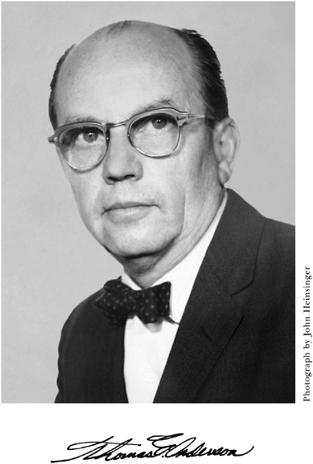

(Photo copied from: <https://nap.nationalacademies.org/read/11522/chapter/4>)

**Rationale:** While they infect different host the members of these genera all exhibit similarities at the DNA, proteome and phylogenetic levels. The members of the *Felixounavirus* predominantly infect *Escherichia* and *Salmonella* species; Moogleviruses are specific for *Shigella* and *Citrobacter* species while *Kolesnikvirus* infect *Erwinia* strains.