

The International Committee on Taxonomy of Viruses

Taxonomy Proposal Form, 2024

**Part 1a: Details of taxonomy proposals**

|  |  |  |
| --- | --- | --- |
| **Title:** | Create three new families (*Alisviridae, Ludisviridae, and Nixviridae*) with 7 new genera and 24 new species | |
| **Code assigned:** | 2024.001B |

|  |  |  |  |
| --- | --- | --- | --- |
| **Author(s), affiliation and email address(es):** | | | |
| **Name** | **Affiliation** | **Email address** | **Corresponding author(s)** X |
| Matrishin CB | Dep. of Oral Biology, University at Buffalo, Buffalo, NY, USA | colematr@buffalo.edu |  |
| Kauffman KM | Dep. of Oral Biology, University at Buffalo, Buffalo, NY, USA | kmkauffm@buffalo.edu | X |
|  |  |  |  |
|  |  |  |  |
|  |  |  |  |
|  |  |  |  |
|  |  |  |  |
|  |  |  |  |

**Part 1b: Taxonomy Proposal Submission**

|  |  |  |  |
| --- | --- | --- | --- |
| **ICTV Subcommittee:** | | | |
| Animal DNA Viruses and Retroviruses |  | Bacterial viruses | **X** |
| Animal minus-strand and dsRNA viruses |  | Fungal and protist viruses |  |
| Animal positive-strand RNA viruses |  | Plant viruses |  |
| Archaeal viruses |  | General - |  |

|  |
| --- |
| **List the ICTV Study Group(s) that have seen or have been involved in creating this proposal:** |
|  |

|  |  |  |  |
| --- | --- | --- | --- |
| **Optional – complete only if formally voted on by an ICTV Study Group:** | | | |
| **Study Group** | **Number of members** | | |
| **Votes in support** | **Votes against** | **No vote** |
|  |  |  |  |
|  |  |  |  |

|  |  |
| --- | --- |
| **Submission date:** | 05/29/2024 |

**Part 1c: Feedback from ICTV Executive Committee (EC) meeting**

|  |  |
| --- | --- |
| **Executive Committee Meeting Decision code:** | **X** |
| A – Accept | **X** |
| Ac – Accept subject to revision by relevant subcommittee chair. No further vote required |  |
| U – Accept without revision but with re-evaluation and email vote by the EC |  |
| Uc – Accept subject to revision and re-evaluation and email vote by the EC |  |
| Ud – Deferred to the next EC meeting, with an invitation to revise based on EC comments |  |
| J - Reject |  |
| W - Withdrawn |  |

|  |
| --- |
| **Comments from the Executive Committee:** |
|  |

**Part 1d: Revised Taxonomy Proposal Submission**

|  |
| --- |
| **Response of proposer:** |
|  |

|  |  |
| --- | --- |
| **Revision date:** | DD/MM/YYYY |

**Part 3:** **TAXONOMIC PROPOSAL**

|  |
| --- |
| **Name of accompanying Excel module:** |
| 2024.001B.A.v1.Alisviridae_Ludisviridae_Nixviridae_3nf.xlsx |

|  |  |  |  |
| --- | --- | --- | --- |
| **Taxonomic changes proposed:** | | | |
| Establish new taxon | **X** | Split taxon |  |
| Abolish taxon |  | Merge taxon |  |
| Move taxon |  | Promote taxon |  |
| Rename taxon |  | Demote taxon |  |
| Move and rename |  |

|  |  |  |
| --- | --- | --- |
| **Is any taxon name used here derived from that of a living person:** | | **Y** |
| **Taxon name** | **Person from whom the name is derived** | **Attached X** |
| *Dewhirstvirus* | Floyd Dewhirst | X |
| *Haasevirus* | Elaine Haase | X |
| *Schifferlevirus* | Robert Schifferle | X |

|  |
| --- |
| **Abstract of Taxonomy Proposal:** |
| *Taxonomic rank(s) affected*:    Realm *Duplodnaviria*, kingdom *Heunggongvirae*, phylum *Uroviricota*, class *Caudoviricetes*  *Description of current taxonomy*:  The viruses classified in this proposal do not have a current taxonomic assignment.  *Proposed* *taxonomic change(s):*  Creation of three new families (*Alisviridae, Ludisviridae, and Nixviridae*) with 7 new genera (*Honmavirus, Ludisvirus, Dewhirstvirus, Nixvirus, Haasevirus, Excelsiorvirus,* and *Schifferlevirus*) and 24 new species.  *Justification*:  A comprehensive analysis of publicly available NCBI *Porphryomonas gingivalis* genomes revealed three new families of viruses, containing 7 new genera and 24 new species. This discovery, using a rigorous, complementary bioinformatic approach, revealed what we believe to be precise nucleotide start and end points of the prophage genomes within bacterial contigs (see Figure 1). These novel prophages represent the first systematically described phages of *P. gingivalis*. This work, including the proposed taxonomic classifications and figures shown in this proposal, are described in the open source publication “Phages are unrecognized players in the ecology of the oral pathogen *Porphyromonas gingivalis”* in *Microbiome* by Matrishin et al. 2023 [[1]](https://paperpile.com/c/avu5zX/meRzk). Phage genomes are available on NCBI within BioProject PRJNA874424. |

|  |
| --- |
| * **Text of Taxonomy proposal:** |
| *Taxonomic rank(s) affected*:  All newly proposed taxa are within the class *Caudoviricetes*.  *Description of current taxonomy*:  All proposed changes are the creation of new taxa within *Caudoviricetes*. There is no current ICTV taxonomy involving the proposed taxa.  *Proposed* *taxonomic change(s)*:   1. To create a new genus, *Honmavirus,* with eight (8) new species 2. To create a new family, *Alisviridae*, for genus *Honmavirus* and one (1) unclassified genus 3. To create a new genus, *Ludisvirus*, with one (1) new species 4. To create a new family, *Ludisviridae*, for genus *Ludisvirus* and one (1) unclassified phage 5. To create a new genus, *Dewhirstvirus*, with four (4) new species 6. To create a new genus, *Nixvirus*, with one (1) new species 7. To create a new genus, *Haasevirus,* with five (5) new species 8. To create a new genus, *Excelsiorvirus,* with one (1) new species 9. To create a new genus, *Schifferlevirus*, with four (4) new species 10. To create a new family, *Nixviridae*, for genera *Dewhirstvirus*, *Nixvirus*, *Haasevirus*, *Excelsiorvirus*, and *Schifferlevirus*   *Demarcation criteria:*  **Species demarcation criteria:** Two phages are assigned to the same species if their genomes have more than 95% identity over their genome length, which was calculated using intergenomic distance calculator VIRIDIC [[2]](https://paperpile.com/c/avu5zX/cZ6tg).  **Genus demarcation criteria:** Two phages are assigned to the same genus if their genomes have more than 70% identity over their genome length, which was calculated using intergenomic distance calculator VIRIDIC [[2]](https://paperpile.com/c/avu5zX/cZ6tg).  **Family demarcation criteria:** Families are represented by a cohesive, monophyletic group identified by complementary findings of well-established proteome-based clustering tools vConTACT2 [[3]](https://paperpile.com/c/avu5zX/JNW6k), ViPTree [[4]](https://paperpile.com/c/avu5zX/YV7S6), VirClust [[5]](https://paperpile.com/c/avu5zX/YhqmK), and VICTOR [[6]](https://paperpile.com/c/avu5zX/0bq4f).  *Justification*:  A comprehensive analysis of publicly available NCBI *Porphryomonas gingivalis* genomes revealed three new families of viruses, containing 7 new genera and 24 new species. This discovery, using a rigorous, complementary bioinformatic approach, revealed what we believe to be precise nucleotide start and end points of the prophage genomes within bacterial contigs (see Figure 1). These novel prophages represent the first systematically described phages of *P. gingivalis*. This work, including the proposed taxonomic classifications and figures shown in this proposal, are described in the open source publication “Phages are unrecognized players in the ecology of the oral pathogen *Porphyromonas gingivalis”* in *Microbiome* by Matrishin et al. 2023 [[1]](https://paperpile.com/c/avu5zX/meRzk). Phage genomes are available on NCBI within BioProject PRJNA874424.  ………………………………………………………  **A. To create a new genus, *Honmavirus*, with eight (8) new species**  **Origin of the name of this taxon:**  This genus is named in honor of Kiyonobu Honma, DDS, PhD, whose contribution to the field of oral microbiology is tremendous. He will be immensely missed following his passing earlier this year (2024).  His work was focused mainly on the molecular-genetic basis of virulence mechanisms of periodontal pathogens.  Kiyonobu was instrumental in developing the first genetic knockout system for the fastidious gram-negative oral pathogen *Tannerella forsythia*. Additionally, he discovered several interesting traits of this pathogen, including a unique beta-glucan degrading enzyme and its regulation in response to the cohabiting oral bacterium *Fusobacterium nucleatum*. Kiyonobu was a passionate scientist who believed in the concept of open science and was always ready to share his knowledge and skills with others.    **Genome summary:**   |  |  |  |  |  |  |  |  |  | | --- | --- | --- | --- | --- | --- | --- | --- | --- | | **proposed species name** | **phage name (species exemplar in bold)** | **GenBank accession** | **phage name in Table 1 (name after “_” represents *Pg* host strain)** | **host GCA** | **host contig ID** | **phage position in contig (length bp)** | **GC%** | **VIRFAM** [[7]](https://paperpile.com/c/avu5zX/ly2aQ) **predicted morphotype** | | *Honmavirus pging00B* | **Porphyromonas phage phage006a_EM3** | BK068089 | phage006a_EM3 | GCA_021406625.1 | JAEMBI010000008.1 | 4,708-39,926 (35,219) | 53.9 | siphovirus | | *Honmavirus pging00C* | **Porphyromonas phage phage007a_Bg4** | PP754929 | phage007a_Bg4 | GCA_029911295.1 | JARYSV010000007.1 | 293,283-328,332 (35,050) | 53.7 | siphovirus | | *Honmavirus pging00D* | **Porphyromonas phage phage008a_KCOM2797** | BK068090 | phage008a_KCOM2797 | GCA_002204455.1 | NHRU01000002.1 | 210,623-245,193 (34,571) | 54.1 | siphovirus | | *Honmavirus pging00D* | Porphyromonas phage 009a_Kyudai3 | BK068091 | phage009a_Kyudai3 | GCA_021406725.1 | JAEMBO010000003.1 | 4,810-39.378 (34,569) | 54.1 | siphovirus | | *Honmavirus pging00E* | **Porphyromonas phage phage010a_HG1691old** | PP754930 | phage010a_HG1691old | GCA_028335085.1 | CP116613.1 | 2,086,664-2,119,885 (33,222) | 53.6 | siphovirus | | *Honmavirus pging00F* | **Porphyromonas phage phage011a_WW2952** | BK068092 | phage011a_WW2952 | GCA_002529345.1 | Pieces of NSLQ01000060, NSLQ01000123, NSLQ01000021 | 1-35,194 (35,194) | 53.5 | siphovirus | | *Honmavirus pging00G* | **Porphyromonas phage phage012a_381OKJP** | BK068093 | phage012a_381OKJP | GCA_003862255.1 | QPGS01000021.1 | 3,625-37,889 (34,265) | 53.3 | siphovirus | | *Honmavirus pging00H* | **Porphyromonas phage phage013a_WW2885** | BK068094 | phage013a_WW2885 | GCA_002529355.1 | NSLT01000006.1 | 1-33,490 | 53.7 | siphovirus | | *Honmavirus pging00I* | **Porphyromonas phage phage014a_Kyudai4** | BK068095 | phage014a_Kyudai4 | GCA_021406735.1 | JAEMBN010000009.1 | 12,595-46,159 (33,565) | 53.6 | siphovirus | | *Honmavirus pging00I* | Porphyromonas phage phage015a_SRR9217400mag3 | BK068096 | phage015a_SRR9217400mag3 | GCA_905372065.1 | CAJPNQ010000014.1 | 16,039-49,263 (33,225) | 53.7 | siphovirus |   **Rationale for proposed taxon classification:**  All phages in the proposed species in *Honmavirus* are transposable phages and are predicted by VIRFAM [[7]](https://paperpile.com/c/avu5zX/ly2aQ) to be siphoviruses.  See Table 1 and Figure 2. VIRIDIC [[2]](https://paperpile.com/c/avu5zX/cZ6tg) genus-level clustering at a 70% nucleotide identity threshold reveals *Honmavirus* is representative of its own genus when clustered with other proposed *Pg* phages and their closest known ViPTree [[4]](https://paperpile.com/c/avu5zX/YV7S6) relatives and Bacteroides phage p00 [[8, 9]](https://paperpile.com/c/avu5zX/bcc4+h76x). Likewise, VIRIDIC [[2]](https://paperpile.com/c/avu5zX/cZ6tg) species-level clustering at a 95% nucleotide identity threshold reveals the 8 proposed species within *Honmavirus* represent new, distinct species.  **B. To create a new family, *Alisviridae*, for genus *Honmavirus* and one (1) unclassified genus**  **Origin of the name of this taxon:**  Like all three families proposed here, we wanted to honor the city in which our lab was started and our team was formed. Therefore, the viral families in this proposal are named as an ode to Buffalo, NY. *Alisviridae* is derived from the latin word “alis” which translates to “wings”. An obvious homage to the infamous Buffalo chicken wing, but also anthropomorphizing these transposable phages by their ability to use their “wings” to “fly” around the bacterial genome and insert randomly.  **Rationale for proposed taxon classification:**  This family consists of the transposable phages (highlighted orange in table and figures) within *Honmavirus* (prop. A) and previously described genus *Hankyvirus* [[8, 9]](https://paperpile.com/c/avu5zX/h76x+bcc4) with exemplar Bacteroides phage p00 (BK010646.1), however this genus is not yet classified at ICTV.  See Figure 3. vConTACT2 [[3]](https://paperpile.com/c/avu5zX/JNW6k) clustering identifies this group of phages as a distinct, cohesive viral cluster. Note that vConTACT2 [[3]](https://paperpile.com/c/avu5zX/JNW6k) defined viral cluster may contain only a subset of nodes appearing together in the same network cluster (see Supplementary Data 3 in Matrishin et al. 2023 [[1]](https://paperpile.com/c/avu5zX/meRzk)).  See Figure 4. ViPTree [[4]](https://paperpile.com/c/avu5zX/YV7S6) genome-wide proteome sequence similarity tree calculated by tBLASTx reveals this group of phages form a clade distinct from all other viral families within the ViPTree [[4]](https://paperpile.com/c/avu5zX/YV7S6) v3.5 Virus-Host DB [[10]](https://paperpile.com/c/avu5zX/i9BBO).  See Figure 5. VirClust [[5]](https://paperpile.com/c/avu5zX/YhqmK) shared protein clustering demarcates this group of phages as its own distinct family-level cluster.  See Figure 6. VICTOR [[6]](https://paperpile.com/c/avu5zX/0bq4f) whole proteome intergenomic distance tree defines this group of phages as its own distinct VICTOR subfamily, which best corresponds to accepted thresholds for ICTV viral families).  **C. To create a new genus, *Ludisvirus*, with one (1) new species**  **Origin of the name of this taxon:**  This genus is named after the family, *Ludisviridae*.  **Genome summary:**   |  |  |  |  |  |  |  |  |  | | --- | --- | --- | --- | --- | --- | --- | --- | --- | | **proposed species name** | **phage name (species exemplar in bold)** | **GenBank accession** | **phage name in Table 1 (name after “_” represents *Pg* host strain)** | **host GCA** | **host contig ID** | **phage position in contig (length bp)** | **GC%** | **VIRFAM** [[7]](https://paperpile.com/c/avu5zX/ly2aQ) **predicted morphotype** | | *Ludisvirus pging00A* | Porphyromonas phage phage005a_ATCC49415 | BK068088 | phage005a_ATCC49415 | GCA_900157255.1 | FUFH01000018.1 | 17,843-66,559 (48,717) | 48.5 | siphovirus | | *Ludisvirus pging00A* | **Porphyromonas phage phage005b_ATCC49417** | PP754928 | phage005b_ATCC49417 | GCA_028335125.1 | CP116614.1 | 1,778,791-1,827,471 (48,681) | 48.6 | siphovirus |   **Rationale for proposed taxon classification:**  The phage in proposed species in *Ludisvirus* inserts into host tRNA-serine and is predicted by VIRFAM [[7]](https://paperpile.com/c/avu5zX/ly2aQ) to be a siphovirus.  See Table 1 and Figure 2. VIRIDIC [[2]](https://paperpile.com/c/avu5zX/cZ6tg) genus-level clustering at a 70% nucleotide identity threshold reveals *Ludisvirus* phages represent a distinct genus when clustered with other proposed *Pg* phages and their closest known ViPTree [[4]](https://paperpile.com/c/avu5zX/YV7S6) relatives and Bacteroides phage p00 [[8, 9]](https://paperpile.com/c/avu5zX/h76x+bcc4). Likewise, VIRIDIC [[2]](https://paperpile.com/c/avu5zX/cZ6tg) species-level clustering at a 95% nucleotide identity threshold reveals the proposed species within *Ludisvirus* represents a new, distinct species.  **D. To create a new family, *Ludisviridae*, for genus *Ludisvirus* and one (1) unclassified phage**  **Origin of the name of this taxon:**  *Ludisviridae* is derived from the Latin word “ludis” which translates to “sports”. This name pays homage to the vibrant sports scene in Buffalo, NY.  **Rationale for proposed taxon classification:**  This family consists of the tRNA-serine inserting phage (highlighted purple in table and figures) within *Ludisvirus* (prop. C) and previously unclassified Reimerella phage RAP44 (NC_019490.1).  See Figure 3. vConTACT2 [[3]](https://paperpile.com/c/avu5zX/JNW6k) clustering identifies this group of phages as a distinct, cohesive viral cluster. Note that vConTACT2 [[3]](https://paperpile.com/c/avu5zX/JNW6k) defined viral cluster may contain only a subset of nodes appearing together in the same network cluster (see Supplementary Data 3 in Matrishin et al. 2023 [[1]](https://paperpile.com/c/avu5zX/meRzk)).  See Figure 4. ViPTree [[4]](https://paperpile.com/c/avu5zX/YV7S6) genome-wide proteome sequence similarity tree calculated by tBLASTx reveals this group of phages form a clade distinct from all other viral families within the ViPTree [[4]](https://paperpile.com/c/avu5zX/YV7S6) v3.5 Virus-Host DB [[10]](https://paperpile.com/c/avu5zX/i9BBO).  See Figure 5. VirClust [[5]](https://paperpile.com/c/avu5zX/YhqmK) shared protein clustering demarcates this group of phages within its own distinct family-level cluster.  See Figure 6. VICTOR [[6]](https://paperpile.com/c/avu5zX/0bq4f) whole proteome intergenomic distance tree defines this group of phages within its own distinct VICTOR subfamily, which best corresponds to accepted thresholds for ICTV viral families.  **E. To create a new genus, *Dewhirstvirus*, with four (4) new species**  **Origin of the name of this taxon:**  This genus is named in honor of Floyd E. Dewhirst, DDS, PhD, who is currently an Emeritus Member of Staff at The ADA Forsyth Institute in Cambridge, MA and an AAAS Fellow. Floyd’s enduring influence on the field of microbiology is exemplified by his role in establishing the Human Oral Microbiome Database (homd.org). The HOMD has been catalytic for the field, resolving the challenges of the burgeoning diversity of 16S sequences in early studies by providing stable provisional taxon names that allowed harmonization across studies. Following his passion for uncovering the limits on cultivation of the yet-to-be-cultured, Floyd and his group have contributed to the ever-expanding proportion of the >700 oral bacterial species for which we have genomes and isolated strains in hand. Now, even in retirement, he continues to play an active role in the evolution of the HOMD, and in serving as a valued and invested mentor.    **Genome summary:**   |  |  |  |  |  |  |  |  |  | | --- | --- | --- | --- | --- | --- | --- | --- | --- | | **proposed species name** | **phage name (species exemplar in bold)** | **GenBank accession** | **phage name in Table 1 (name after “_” represents *Pg* host strain)** | **host GCA** | **host contig ID** | **phage position in contig (length bp)** | **GC%** | **VIRFAM** [[7]](https://paperpile.com/c/avu5zX/ly2aQ) **predicted morphotype** | | *Dewhirstvirus pging00J* | **Porphyromonas phage phage016a_WW2866** | BK068097 | phage016a_WW2866 | GCA_002529185.1 | NSLV01000004.1 | 17,490-67,052 (49,563) | 51.7 | unknown | | *Dewhirstvirus pging00K* | **Porphyromonas phage phage017a_JCVISC001** | BK068098 | phage017a_JCVISC001 | GCA_000380305.1 | CM001843.1 | 1,160,514-1,208,365 (47,852) | 52.1 | unknown | | *Dewhirstvirus pging00L* | **Porphyromonas phage phage018a_AFR5B1** | BK068099 | phage018a_AFR5B1 | GCA_900157345.1 | Pieces of FUFJ0100002, FUFJ01000056 | 22-47,783 (47,762) | 52.3 | likely siphovirus | | *Dewhirstvirus pging00M* | Porphyromonas phage phage019a_ATCC49417 | BK068100 | phage019a_ATCC49417 | GCA_900157255.1 | FUFH01000052.1 | 13,048-61,239 (48,192) | 51.7 | likely siphovirus | | *Dewhirstvirus pging00M* | **Porphyromonas phage phage019b_ATCC49417** | PP754931 | phage019b_ATCC49417 | GCA_028335125.1 | CP116614.1 | 1,259,093-1,307,124 (48,032) | 51.8 | unknown |   **Rationale for proposed taxon classification:**  All phages in the proposed species in *Dewhirstvirus* insert into host tRNA-proline and have mostly unknown morphotypes predicted by VIRFAM [[7]](https://paperpile.com/c/avu5zX/ly2aQ), with the exception of *Dewhirstvirus pging00L and Dewhirstvirus pging00M* which is predicted to likely be a siphovirus.  See Table 1 and Figure 2. VIRIDIC [[2]](https://paperpile.com/c/avu5zX/cZ6tg) genus-level clustering at a 70% nucleotide identity threshold reveals *Dewhirstvirus* phages represent a distinct genus when clustered with other proposed *Pg* phages and their closest known ViPTree [[4]](https://paperpile.com/c/avu5zX/YV7S6) relatives and Bacteroides phage p00 [[8, 9]](https://paperpile.com/c/avu5zX/h76x+bcc4). Likewise, VIRIDIC [[2]](https://paperpile.com/c/avu5zX/cZ6tg) species-level clustering at a 95% nucleotide identity threshold reveals the 4 proposed species within *Dewhirstvirus* represent new, distinct species.  **F. To create a new genus, *Nixvirus*, with one (1) new species**  **Origin of the name of this taxon:**  This genus is named after the family, *Nixviridae*.  **Genome summary:**   |  |  |  |  |  |  |  |  |  | | --- | --- | --- | --- | --- | --- | --- | --- | --- | | **proposed species name** | **phage name (species exemplar in bold)** | **GenBank accession** | **phage name in Table 1 (name after “_” represents *Pg* host strain)** | **host GCA** | **host contig ID** | **phage position in contig (length bp)** | **GC%** | **VIRFAM** [[7]](https://paperpile.com/c/avu5zX/ly2aQ) **predicted morphotype** | | *Nixvirus pging00X* | **Porphyromonas phage phage032a_KCOM2801** | BK068113 | phage032a_KCOM2801 | GCA_002753975.1 | CP024600.1 | 1,482,858-1,524,796 (41,939) | 49.0 | unknown |   **Rationale for proposed taxon classification:**  The phage in the proposed species *Nixvirus* inserts into host tRNA-proline and has an unknown morphotype predicted by VIRFAM [[7]](https://paperpile.com/c/avu5zX/ly2aQ).  See Table 1 and Figure 2. VIRIDIC [[2]](https://paperpile.com/c/avu5zX/cZ6tg) genus-level clustering at a 70% nucleotide identity threshold reveal the *Nixvirus* phage represents a distinct genus when clustered with other proposed *Pg* phages and their closest known ViPTree [[4]](https://paperpile.com/c/avu5zX/YV7S6) relatives and Bacteroides phage p00 [[8, 9]](https://paperpile.com/c/avu5zX/h76x+bcc4). Likewise, VIRIDIC [[2]](https://paperpile.com/c/avu5zX/cZ6tg) species-level clustering at a 95% nucleotide identity threshold reveals the proposed species within *Nixvirus* represents a new, distinct species.  **G. To create a new genus, *Haasevirus,* with five (5) new species**  **Origin of the name of this taxon:**  This genus is named in honor of Elaine M. Haase, PhD, who is currently a Research Professor in the Department of Oral Biology in the School of Dental Medicine at the University at Buffalo. After training as a Medical Technologist at UB, she worked several years at a local hospital specializing in clinical microbiology before catching the research bug. She returned to UB earning a doctorate in the Department of Microbiology and Immunology in the Jacobs School of Medicine and Biomedical Sciences, and then joined the Department of Oral Biology where she rose through the ranks to Research Professor, dedicating nearly 40 years to the university. A career learner, her research has spanned areas from epitope mapping the P2 protein of *Haemophilus influenzae* to gene regulation in *Aggregatibacter actinomycetemcomitans* to functional analyses of the *Streptococcus gordonii* amylase-binding protein and now oral bacteriophage discovery. Elaine’s life-long commitments to research and to actively supporting students and colleagues alike, have been a boon to all those who have called the Department of Oral Biology home over the recent decades.    **Genome summary:**   |  |  |  |  |  |  |  |  |  | | --- | --- | --- | --- | --- | --- | --- | --- | --- | | **proposed species name** | **phage name (species exemplar in bold)** | **GenBank accession** | **phage name in Table 1 (name after “_” represents *Pg* host strain)** | **host GCA** | **host contig ID** | **phage position in contig (length bp)** | **GC%** | **VIRFAM** [[7]](https://paperpile.com/c/avu5zX/ly2aQ) **predicted morphotype** | | *Haasevirus pging00R* | **Porphyromonas phage phage025a_SJD11** | BK068106 | phage025a_SJD11 | GCA_002206105.1 | KZ248399.1 | 3,924-48,289 (44,366) | 50.5 | unknown | | *Haasevirus pging00T* | **Porphyromonas phage phage027a_F0568** | BK068108 | phage027a_F0568 | GCA_000467795.1 | KI258933.1 | 6,600-50,736 (44,137) | 50.3 | siphovirus | | *Haasevirus pging00U* | **Porphyromonas phage phage028a_KCOM2799** | BK068109 | phage028a_KCOM2799 | GCA_002753955.1 | CP024601.1 | 618,203-664,737 (46,535) | 50.4 | siphovirus | | *Haasevirus pging00V* | **Porphyromonas phage phage029a_Kyudai3** | BK068110 | phage029a_Kyudai3 | GCA_021406725.1 | JAEMBO010000008.1 | 8,037-52,450 (44,414) | 50.3 | siphovirus | | *Haasevirus pging00W* | **Porphyromonas phage phage030a_KCOM2803** | BK068111 | phage030a_KCOM2803 | GCA_002754035.1 | CP024592.1 | 894,213-938,907 (44,695) | 50.0 | likely siphovirus | | *Haasevirus pging00T* | Porphyromonas phage phage031a_D83T3 | BK068112 | phage031a_D83T3 | GCA_021406795.1 | Pieces of JAEMBP010000058, JAEMBP010000009 | 8,030-52,166 (44,137) | 50.3 | siphovirus |   **Rationale for proposed taxon classification:**  All phages in the proposed species in *Haasevirus* insert into host tRNA-proline and are mostly predicted by VIRFAM [[7]](https://paperpile.com/c/avu5zX/ly2aQ) to be siphoviruses or likely siphoviruses, with the exception of *Haasevirus pging00R* which has an unknown predicted morphotype.  See Table 1 and Figure 2. VIRIDIC [[2]](https://paperpile.com/c/avu5zX/cZ6tg) genus-level clustering at a 70% nucleotide identity threshold reveals *Haasevirus* phages represent a distinct genus when clustered with other proposed *Pg* phages and their closest known ViPTree [[4]](https://paperpile.com/c/avu5zX/YV7S6) relatives and Bacteroides phage p00 [[8, 9]](https://paperpile.com/c/avu5zX/h76x+bcc4). Likewise, VIRIDIC [[2]](https://paperpile.com/c/avu5zX/cZ6tg) species-level clustering at a 95% nucleotide identity threshold reveals the 5 proposed species within *Haasevirus* represent new, distinct species.  **H. To create a new genus, *Excelsiorvirus,* with one (1) new species**  **Origin of the name of this taxon:**  This genus is named after the motto for New York State.  **Genome summary:**   |  |  |  |  |  |  |  |  |  | | --- | --- | --- | --- | --- | --- | --- | --- | --- | | **proposed species name** | **phage name (species exemplar in bold)** | **GenBank accession** | **phage name in Table 1 (name after “_” represents *Pg* host strain)** | **host GCA** | **host contig ID** | **phage position in contig (length bp)** | **GC%** | **VIRFAM** [[7]](https://paperpile.com/c/avu5zX/ly2aQ) **predicted morphotype** | | *Excelsiorvirus pging00S* | **Porphyromonas phage phage026a_KCOM2802** | BK068107 | phage026a_KCOM2802 | GCA_002754015.1 | CP024591.1 | 550,364-592,527 (42,164) | 50.3 | unknown |   **Rationale for proposed taxon classification:**  The phage in the proposed species in *Excelsiorvirus* inserts into host tRNA-proline and has an unknown morphotype predicted by VIRFAM [[7]](https://paperpile.com/c/avu5zX/ly2aQ).  See Table 1 and Figure 2. VIRIDIC [[2]](https://paperpile.com/c/avu5zX/cZ6tg) genus-level clustering at a 70% nucleotide identity threshold reveals the *Excelsiorvirus* phage represents a distinct genus when clustered with other proposed *Pg* phages and their closest known ViPTree [[4]](https://paperpile.com/c/avu5zX/YV7S6) relatives and Bacteroides phage p00 [[8, 9]](https://paperpile.com/c/avu5zX/h76x+bcc4). Likewise, VIRIDIC [[2]](https://paperpile.com/c/avu5zX/cZ6tg) species-level clustering at a 95% nucleotide identity threshold reveals the proposed species within *Excelsiorvirus* represents a new, distinct species.  **I. To create a new genus, *Schifferelevirus*, with four (4) new species**  **Origin of the name of this taxon:**  This genus is named in honor of Robert E. Schifferle, DDS, PhD, who is a long-time Professor in the Department of Periodontics and Endodontics and Department of Oral Biology in the School of Dental Medicine at the University at Buffalo. Bob began his academic career establishing himself as a prominent investigator of the virulence factors of *Porphyromonas gingivalis*, providing key insights into this periodontal pathogen's capsular polysaccharides and lipopolysaccharides, as well as performing clinical research on the pathogenesis and treatment of periodontal disease. Besides serving the scientific community with his basic science and the public as a periodontist and as a past-Trustee of the American Academy of Periodontology, over his career he has served the next generation of dentists and oral biologists with his locally and nationally recognized award-winning teaching at the School of Dental Medicine, where he delighted students with his knowledge and magic tricks.    **Genome summary:**   |  |  |  |  |  |  |  |  |  | | --- | --- | --- | --- | --- | --- | --- | --- | --- | | **proposed species name** | **phage name (species exemplar in bold)** | **GenBank accession** | **phage name in Table 1 (name after “_” represents *Pg* host strain)** | **host GCA** | **host contig ID** | **phage position in contig (length bp)** | **GC%** | **VIRFAM** [[7]](https://paperpile.com/c/avu5zX/ly2aQ) **predicted morphotype** | | *Schifferlevirus pging00N* | **Porphyromonas phage phage020a_SJD2** | BK068101 | phage020a_SJD2 | GCA_000503975.1 | KI629938.1 | 12,768-56260 (43,493) | 50.7 | likely siphovirus | | *Schifferlevirus pging00N* | Porphyromonas phage phage021a_SJD5 | BK068102 | phage021a_SJD5 | GCA_002206065.1 | ASYN01000130.1 | 4,083-47,556 (43,474) | 50.7 | likely siphovirus | | *Schifferlevirus pging00O* | **Porphyromonas phage phage022a_WW2931** | BK068103 | phage022a_WW2931 | GCA_002529285.1 | NSLR01000007.1 | 2,941-47,412 (44,472) | 50.4 | likely siphovirus | | *Schifferlevirus pging00P* | **Porphyromonas phage phage023a_KCOM2797** | BK068104 | phage023a_KCOM2797 | GCA_002204455.1 | NHRU01000001.1 | 127,869-172,771 (44,903) | 50.5 | likely siphovirus | | *Schifferlevirus pging00Q* | **Porphyromonas phage phage024a_F0570** | BK068105 | phage024a_F0570 | GCA_000467835.1 | Pieces of AWUW01000157,AWUW01000158,AWUW01000159,AWUW01000160 | 2,241-47,345 (45,,105) | 50.4 | likely siphovirus |   **Rationale for proposed taxon classification:**  All phages in the proposed species in *Schifferlevirus* insert into host tRNA-proline and are predicted by VIRFAM [[7]](https://paperpile.com/c/avu5zX/ly2aQ) to be likely siphoviruses.  See Table 1 and Figure 2. VIRIDIC [[2]](https://paperpile.com/c/avu5zX/cZ6tg) genus-level clustering at a 70% nucleotide identity threshold reveals *Schifferlevirus* phages represent a distinct genus when clustered with other proposed *Pg* phages and their closest known ViPTree [[4]](https://paperpile.com/c/avu5zX/YV7S6) relatives and Bacteroides phage p00 [[8, 9]](https://paperpile.com/c/avu5zX/h76x+bcc4). Likewise, VIRIDIC [[2]](https://paperpile.com/c/avu5zX/cZ6tg) species-level clustering at a 95% nucleotide identity threshold reveals the 4 proposed species within *Schifferlevirus* represent new, distinct species.  **J. To create a new family, *Nixviridae*, for genera *Dewhirstvirus*, *Nixvirus*, *Haasevirus*, *Excelsiorvirus*, and *Schifferlevirus***  **Origin of the name of this taxon:**  *Nixviridae* is derived from the Latin word “nix” which translates to “snow”. This name pays homage to the abundance of snow during the winter months in Buffalo, NY.  **Rationale for proposed taxon classification:**  This family consists of tRNA-proline inserting phages (highlighted green in table and figures) within *Dewhirstvirus*, *Nixvirus*, *Haasevirus*, *Excelsiorvirus*, and *Schifferlevirus* (prop. E-I).  See Figure 3. vConTACT2 [[3]](https://paperpile.com/c/avu5zX/JNW6k) clustering identifies this group of phages as a distinct, cohesive viral cluster. Note that vConTACT2 [[3]](https://paperpile.com/c/avu5zX/JNW6k) defined viral cluster may contain only a subset of nodes appearing together in the same network cluster (see Supplementary Data 3 in Matrishin et al. 2023 [[1]](https://paperpile.com/c/avu5zX/meRzk)).  See Figure 4. ViPTree [[4]](https://paperpile.com/c/avu5zX/YV7S6) genome-wide proteome sequence similarity tree calculated by tBLASTx reveals this group of phages form a distinct clade not containing members of any other viral families within the ViPTree [[4]](https://paperpile.com/c/avu5zX/YV7S6) v3.5 Virus-Host DB [[10]](https://paperpile.com/c/avu5zX/i9BBO).  See Figure 5. VirClust [[5]](https://paperpile.com/c/avu5zX/YhqmK) shared protein clustering demarcates this group of phages within its own distinct family-level cluster.  See Figure 6. VICTOR [[6]](https://paperpile.com/c/avu5zX/0bq4f) whole proteome intergenomic distance tree defines this group of phages within its own distinct VICTOR subfamily, which best corresponds to accepted thresholds for ICTV viral families. |
| **References:** |
| 1. [Matrishin CB, Haase EM, Dewhirst FE, et al (2023) Phages are unrecognized players in the ecology of the oral pathogen Porphyromonas gingivalis. Microbiome 11:161. https://doi.org/](http://paperpile.com/b/avu5zX/meRzk)[10.1186/s40168-023-01607-w](http://dx.doi.org/10.1186/s40168-023-01607-w)  2. [Moraru C, Varsani A, Kropinski AM (2020) VIRIDIC---A novel tool to calculate the intergenomic similarities of prokaryote-infecting viruses. Viruses](http://paperpile.com/b/avu5zX/cZ6tg)  3. [Zablocki O, Jang HB, Bolduc B, Sullivan MB (2019) vConTACT 2: A Tool to Automate Genome-Based Prokaryotic Viral Taxonomy. In: Plant and Animal Genome XXVII Conference (January 12-16, 2019). PAG](http://paperpile.com/b/avu5zX/JNW6k)  4. [Nishimura Y, Yoshida T, Kuronishi M, et al (2017) ViPTree: the viral proteomic tree server. Bioinformatics 33:2379–2380](http://paperpile.com/b/avu5zX/YV7S6)  5. [Moraru C (2023) VirClust-A Tool for Hierarchical Clustering, Core Protein Detection and Annotation of (Prokaryotic) Viruses. Viruses 15.: https://doi.org/](http://paperpile.com/b/avu5zX/YhqmK)[10.3390/v15041007](http://dx.doi.org/10.3390/v15041007)  6. [Meier-Kolthoff JP, Göker M (2017) VICTOR: genome-based phylogeny and classification of prokaryotic viruses. Bioinformatics 33:3396–3404](http://paperpile.com/b/avu5zX/0bq4f)  7. [Lopes A, Tavares P, Petit M-A, et al (2014) Automated classification of tailed bacteriophages according to their neck organization. BMC Genomics 15:1027](http://paperpile.com/b/avu5zX/ly2aQ)  8. [Dahlman S, Avellaneda-Franco L, Kett C, et al (2023) Temperate gut phages are prevalent, diverse, and predominantly inactive. bioRxiv 2023.08.17.553642](http://paperpile.com/b/avu5zX/bcc4)  9. [Benler S, Cobián-Güemes AG, McNair K, et al (2018) A diversity-generating retroelement encoded by a globally ubiquitous Bacteroides phage. Microbiome 6:191. https://doi.org/](http://paperpile.com/b/avu5zX/h76x)[10.1186/s40168-018-0573-6](http://dx.doi.org/10.1186/s40168-018-0573-6)  10. [Mihara T, Nishimura Y, Shimizu Y, et al (2016) Linking Virus Genomes with Host Taxonomy. Viruses 8:66. https://doi.org/](http://paperpile.com/b/avu5zX/i9BBO)[10.3390/v8030066](http://dx.doi.org/10.3390/v8030066)  11. [Guo J, Bolduc B, Zayed AA, et al (2021) VirSorter2: a multi-classifier, expert-guided approach to detect diverse DNA and RNA viruses. Microbiome 9:37](http://paperpile.com/b/avu5zX/3AeeA)  12. [Nayfach S, Camargo AP, Schulz F, et al (2021) CheckV assesses the quality and completeness of metagenome-assembled viral genomes. Nat Biotechnol 39:578–585](http://paperpile.com/b/avu5zX/ZrmEV)  13. [Tisza MJ, Belford AK, Domínguez-Huerta G, et al (2021) Cenote-Taker 2 democratizes virus discovery and sequence annotation. Virus Evol 7:veaa100](http://paperpile.com/b/avu5zX/twnkp)  14. [Sirén K, Millard A, Petersen B, et al (2021) Rapid discovery of novel prophages using biological feature engineering and machine learning. NAR Genom Bioinform 3:lqaa109](http://paperpile.com/b/avu5zX/xO5gZ)  15. [Kieft K, Zhou Z, Anantharaman K (2020) VIBRANT: automated recovery, annotation and curation of microbial viruses, and evaluation of viral community function from genomic sequences. Microbiome 8:90](http://paperpile.com/b/avu5zX/o2oZD)  16. [Roux S, Krupovic M, Daly RA, et al (2019) Cryptic inoviruses revealed as pervasive in bacteria and archaea across Earth’s biomes. Nat Microbiol 4:1895–1906](http://paperpile.com/b/avu5zX/bEKd7)  17. [Gautreau G, Bazin A, Gachet M, et al (2020) PPanGGOLiN: Depicting microbial diversity via a partitioned pangenome graph. PLoS Comput Biol 16:e1007732](http://paperpile.com/b/avu5zX/s4KA5)  18. [Russel J, Pinilla-Redondo R, Mayo-Muñoz D, et al (2020) CRISPRCasTyper: Automated Identification, Annotation, and Classification of CRISPR-Cas Loci. CRISPR J 3:462–469](http://paperpile.com/b/avu5zX/2J1oh)  19. [Dion MB, Plante P-L, Zufferey E, et al (2021) Streamlining CRISPR spacer-based bacterial host predictions to decipher the viral dark matter. Nucleic Acids Res 49:3127–3138](http://paperpile.com/b/avu5zX/DjZTS)  20. [Cook R, Brown N, Redgwell T, et al (2021) INfrastructure for a PHAge REference Database: Identification of Large-Scale Biases in the Current Collection of Cultured Phage Genomes. Phage (New Rochelle) 2:214–223. https://doi.org/](http://paperpile.com/b/avu5zX/lH7xs)[10.1089/phage.2021.0007](http://dx.doi.org/10.1089/phage.2021.0007)  21. [Camargo AP, Nayfach S, Chen I-MA, et al (2022) IMG/VR v4: an expanded database of uncultivated virus genomes within a framework of extensive functional, taxonomic, and ecological metadata. Nucleic Acids Res](http://paperpile.com/b/avu5zX/c1hVA)  22. [Camargo AP, Roux S, Schulz F, et al (2023) Identification of mobile genetic elements with geNomad. Nat Biotechnol. https://doi.org/](http://paperpile.com/b/avu5zX/ayjH5)[10.1038/s41587-023-01953-y](http://dx.doi.org/10.1038/s41587-023-01953-y)  23. [Bartlau N, Wichels A, Krohne G, et al (2022) Highly diverse flavobacterial phages isolated from North Sea spring blooms. ISME J 16:555–568. https://doi.org/](http://paperpile.com/b/avu5zX/PjDvX)[10.1038/s41396-021-01097-4](http://dx.doi.org/10.1038/s41396-021-01097-4) |

**PROPHAGE CURATION**

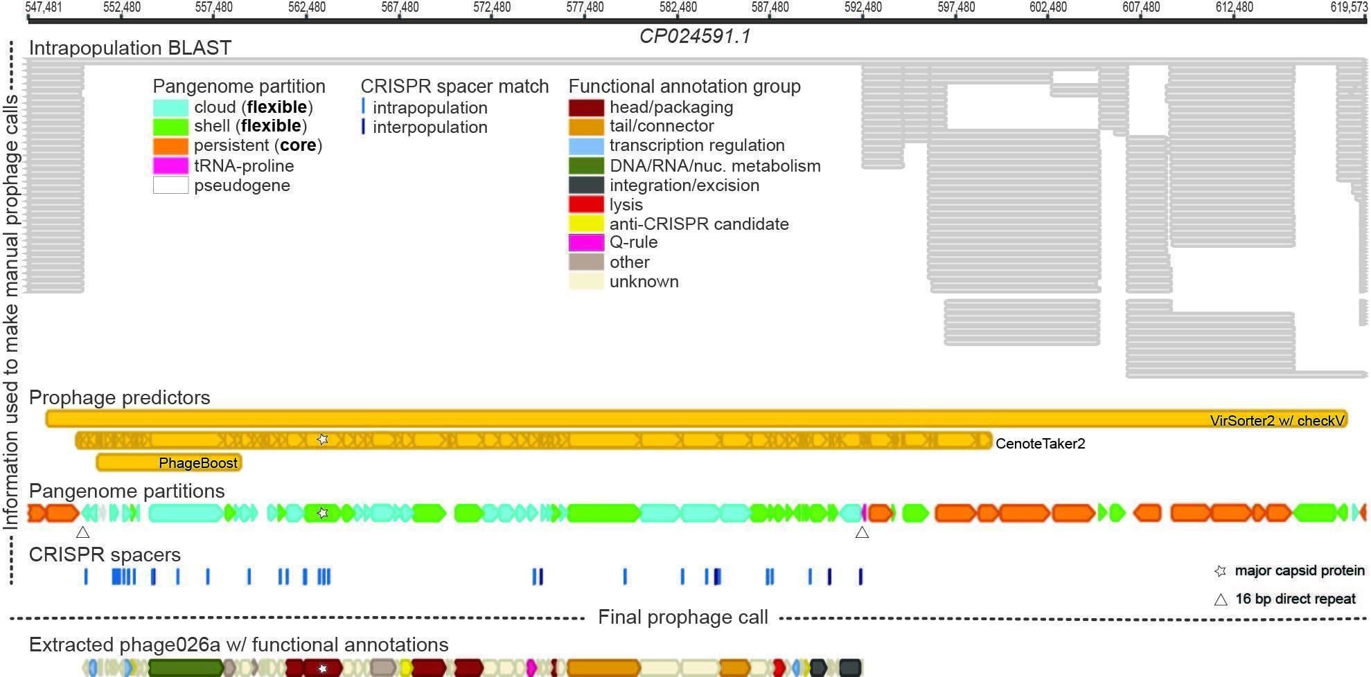

**Figure 1**. Integration of complementary bioinformatic approaches unveiled numerous *Porphyromonas gingivalis* prophages. Example view from Geneious bioinformatic software highlighting numerous analyses used in manually curating *Pg* prophages. Bacterial contig CP024591 (KCOM 2802) was searched with five prophage predicting tools (VirSorter2 [[11]](https://paperpile.com/c/avu5zX/3AeeA) with CheckV [[12]](https://paperpile.com/c/avu5zX/ZrmEV), Cenote-Taker2 [[13]](https://paperpile.com/c/avu5zX/twnkp), PhageBoost [[14]](https://paperpile.com/c/avu5zX/xO5gZ), VIBRANT [[15]](https://paperpile.com/c/avu5zX/o2oZD), and Inovirus Detector [[16]](https://paperpile.com/c/avu5zX/bEKd7)); hits indicated in yellow bars. Annotations performed by Cenote-Taker2 [[13]](https://paperpile.com/c/avu5zX/twnkp) aided in determining the validity of the phage predictions through sensitive detection of major capsid proteins (marked by white stars). Pangenome partitions, predicted by PPanGGOLiN [[17]](https://paperpile.com/c/avu5zX/s4KA5), designate “flexible” protein-coding genes (light blue and light green block arrows), as compared to those that are “core” (orange block arrows); direct repeats were also identified as an indicator of insertion (those used by the phage marked by white triangles). Matches of CRISPR spacers (100% identity) found from *Pg* strains (shown as blue hash marks; identified by CCTyper [[18]](https://paperpile.com/c/avu5zX/2J1oh)) and strains of other species (shown as dark blue hash marks; mapped from CRISPROpenDB [[19]](https://paperpile.com/c/avu5zX/DjZTS)) elucidate regions targeted by intra- and interpopulation CRISPR-Cas systems, respectively. All-by-all intrapopulation BLAST used to compare each *Pg* genome against all other *Pg* genomes shows areas that lack conservation; hits indicated by gray bars. The final manually curated prophage region (phage026 with functional annotations), inserted into a tRNA-pro gene (pink block arrow), is defined taking into account all analyses.

**VIRIDIC**

**Table 1.** Genus- and species-level clusters were generated with nucleotide-based whole genome intergenomic differences calculated by VIRIDIC [[2]](https://paperpile.com/c/avu5zX/cZ6tg) at 70% and 95% nucleotide identity thresholds, respectively. Proposed new genera and species are within proposed new families *Nixviridae* (green genome name; light green indicates partial phage and was not proposed as a new species), *Alisviridae* (orange genome name), and *Ludisviridae* (purple genome name; light purple indicates partial phage and was not proposed as a new species). Three closest relatives to *Pg* phages present in ViPTree [[4]](https://paperpile.com/c/avu5zX/YV7S6) database and Bacteroides phage p00 [[8, 9]](https://paperpile.com/c/avu5zX/h76x+bcc4) (BK010646.1) were used as references (gray genome name).

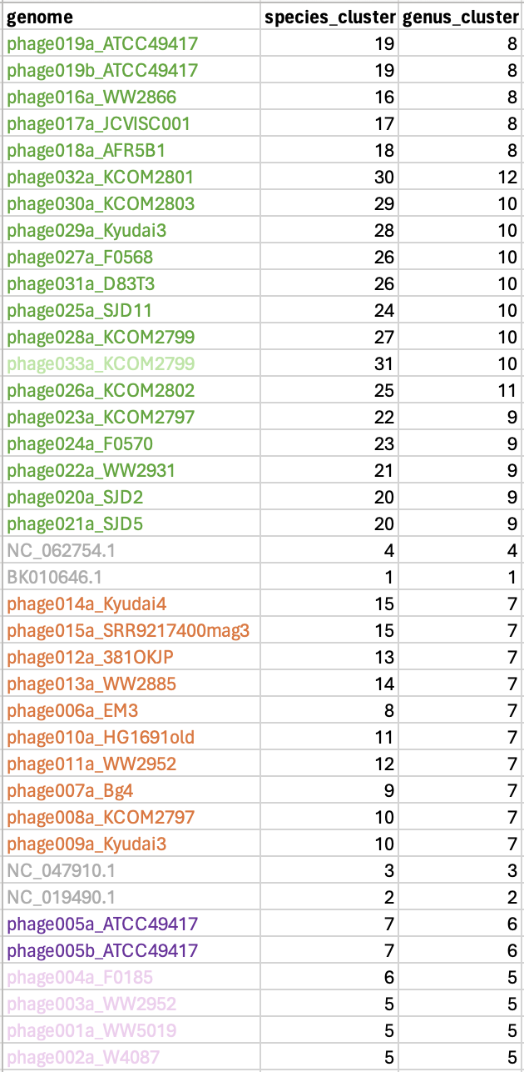

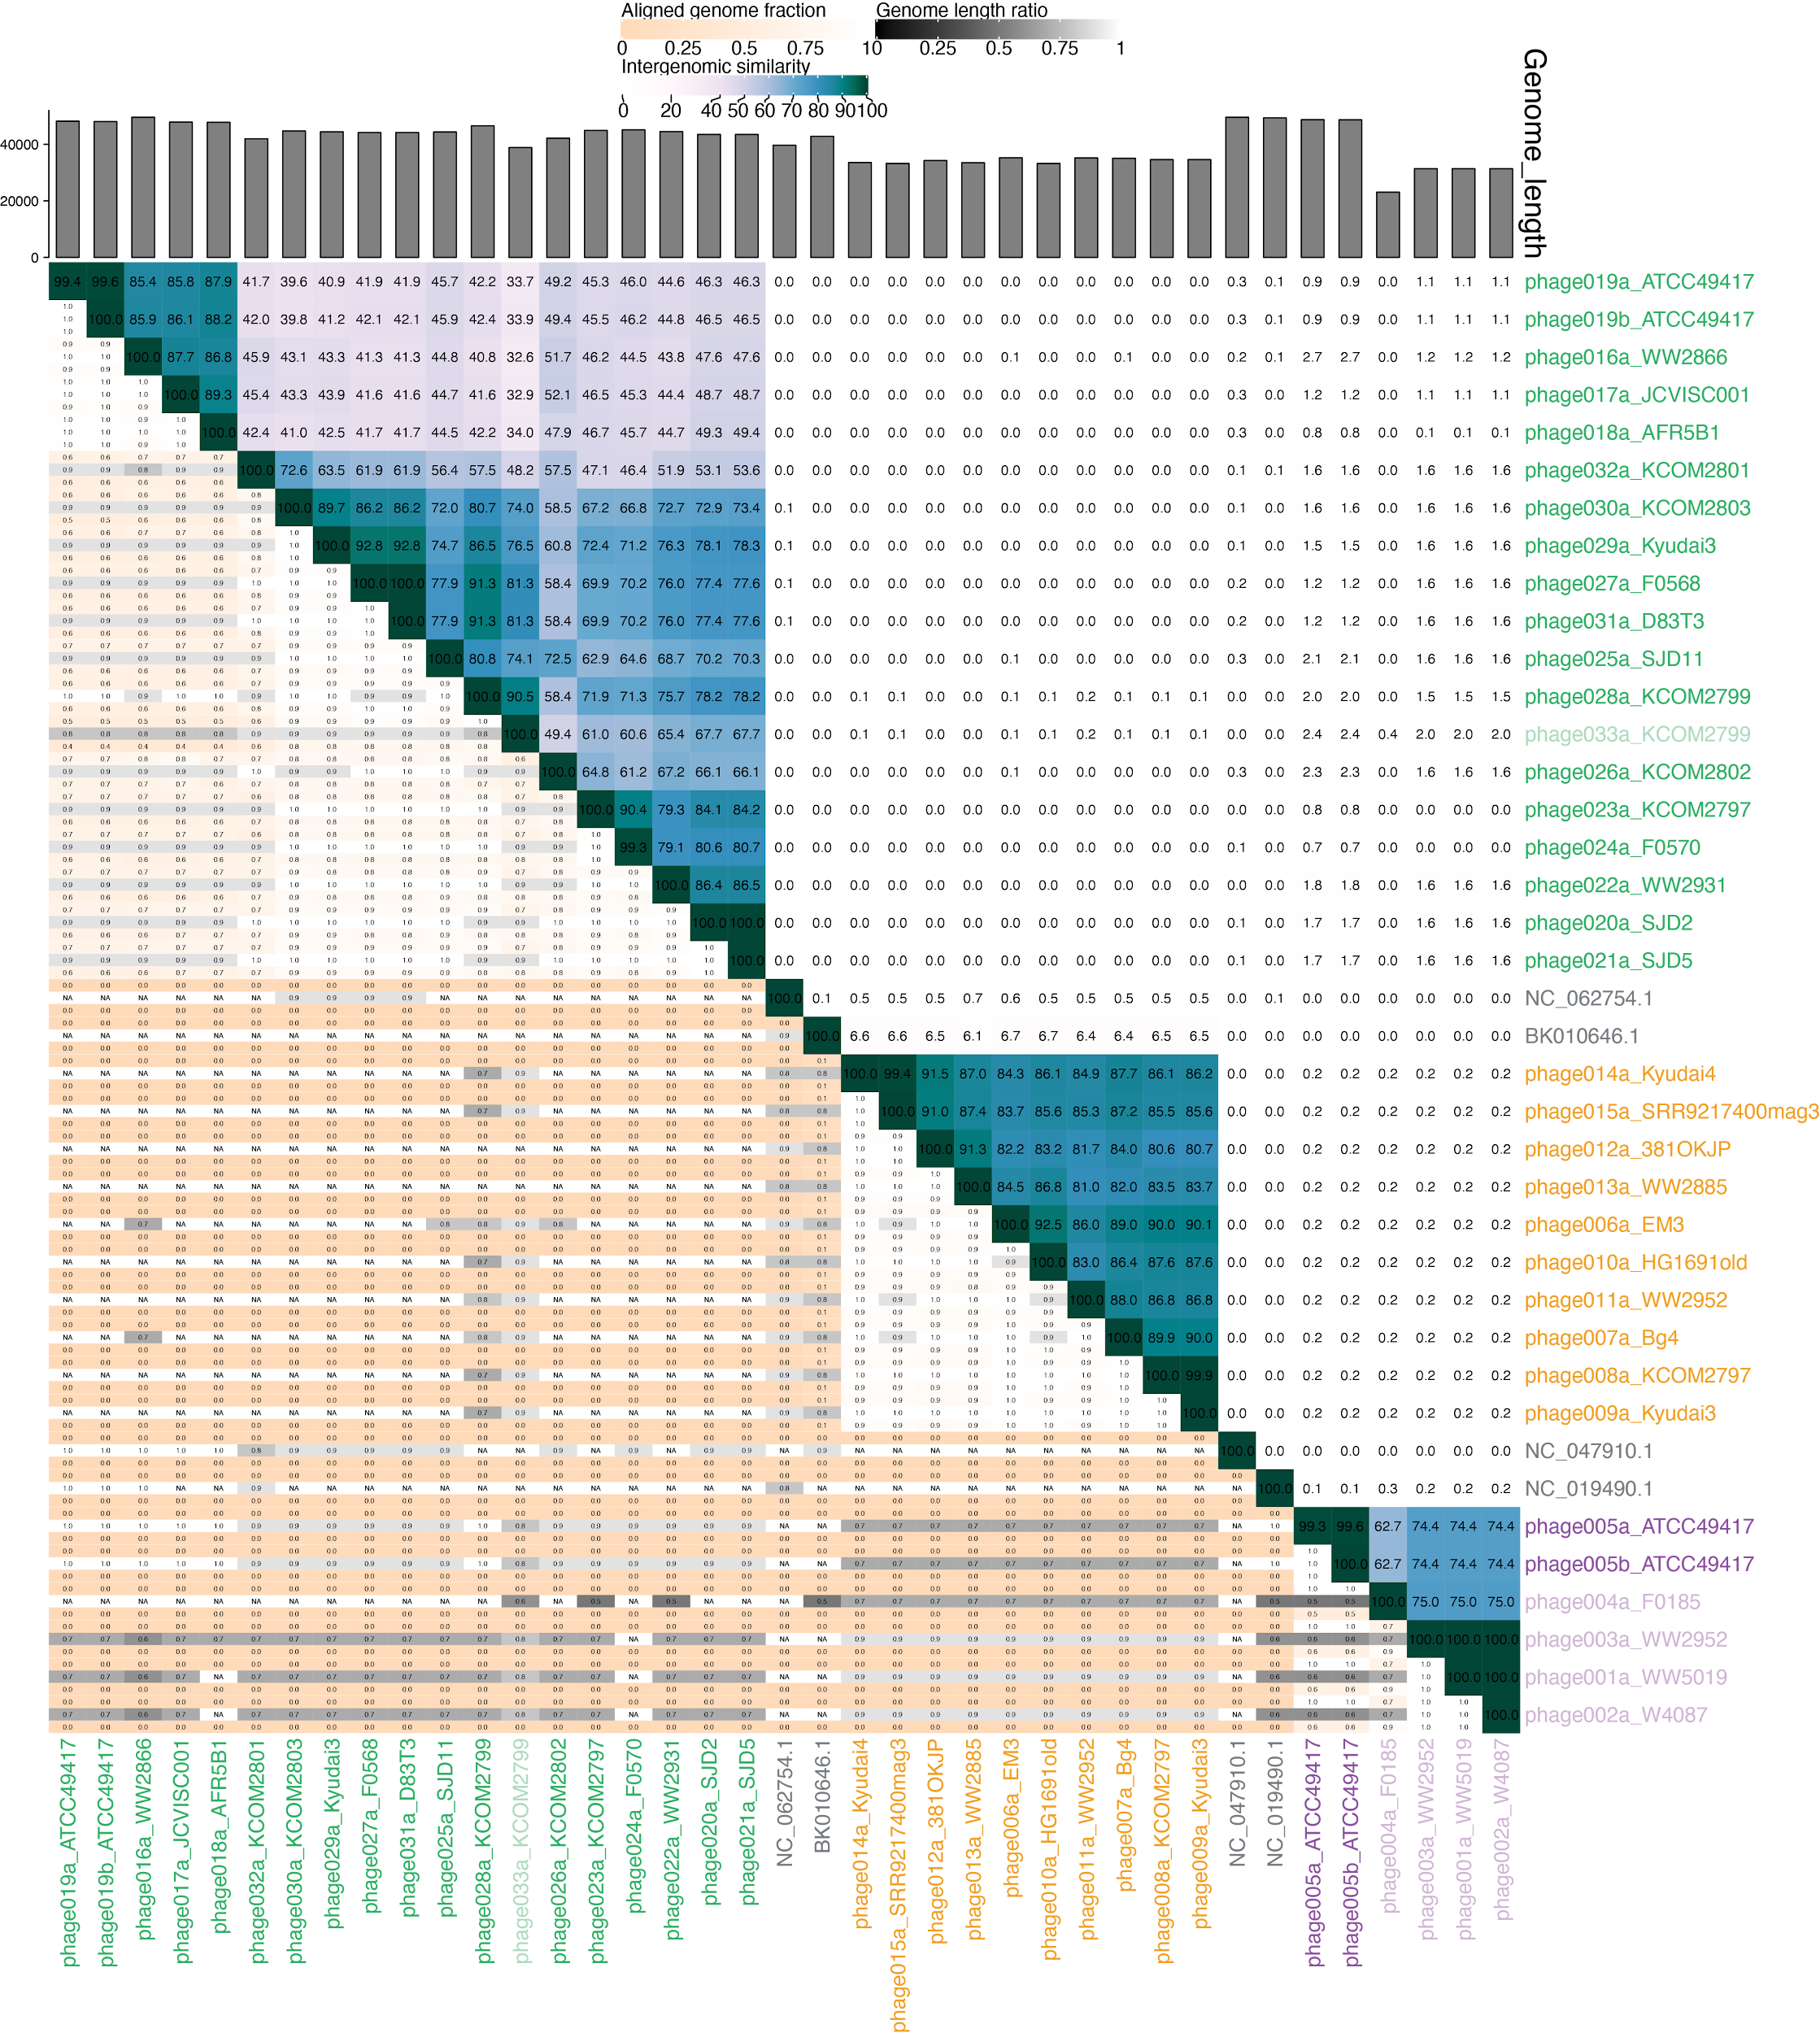

**Figure 2.** Pairwise intergenomic distances/similarities computed by VIRIDIC [[2]](https://paperpile.com/c/avu5zX/cZ6tg) of proposed *Pg* phages. Proposed new genera and species are within proposed new families *Nixviridae* (green genome name; light green indicates partial phage and was not proposed as a new species), *Alisviridae* (orange genome name), and *Ludisviridae* (purple genome name; light purple indicates partial phage and was not proposed as a new species). Three closest relatives to *Pg* phages present in ViPTree [[4]](https://paperpile.com/c/avu5zX/YV7S6) database and Bacteroides phage p00 [[8, 9]](https://paperpile.com/c/avu5zX/h76x+bcc4) were used as references (gray genome name).

**vConTACT2**

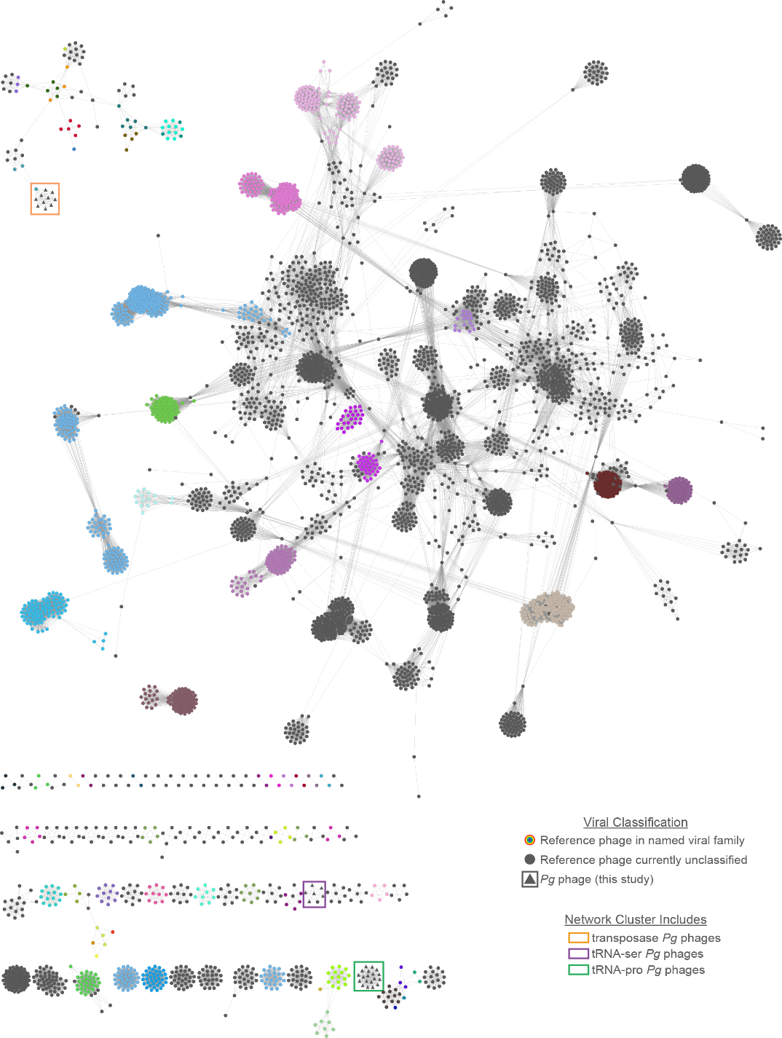

**Figure 3.** Network representation of vConTACT2 [[3]](https://paperpile.com/c/avu5zX/JNW6k) whole proteome similarity among all proposed *Pg* phages and 4,912 dsDNA Prokaryote-infecting viruses in the ViPTree [[4]](https://paperpile.com/c/avu5zX/YV7S6) v3.5 Virus-Host DB [[10]](https://paperpile.com/c/avu5zX/i9BBO) reference set, based on RefSeq release 217. Nodes represent viral genomes and are colored based on family-level classification, determined per ViPTree [[4]](https://paperpile.com/c/avu5zX/YV7S6) and Inphared [[20]](https://paperpile.com/c/avu5zX/lH7xs) (1May2023_itol_family_annotations), with colors defined per those assigned in the latter. Network clusters proposed as new families containing *Pg* phages are highlighted with colored boxes (orange, *Alisviridae*; purple, *Ludisviridae*; green, *Nixviridae*). Note that vConTACT2 [[3]](https://paperpile.com/c/avu5zX/JNW6k) defines cohesive Viral Clusters (VCs) that may contain only subsets of nodes appearing together in the same network cluster (see Supplementary Data 3 in Matrishin et al. 2023 [[1]](https://paperpile.com/c/avu5zX/meRzk)).

**ViPTree**

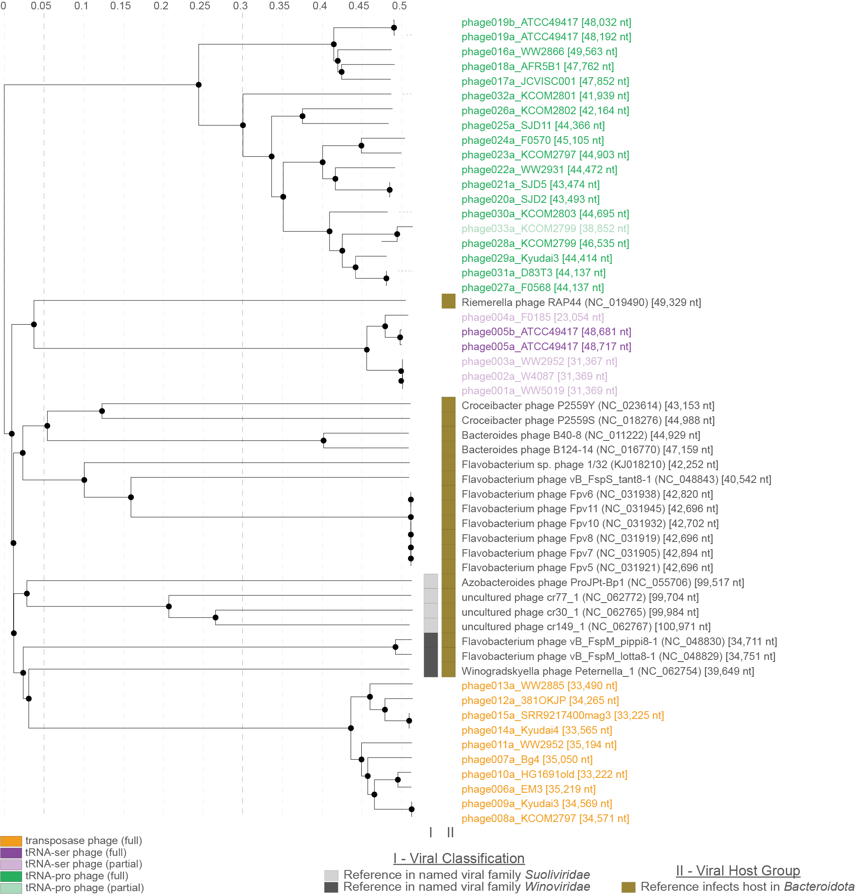

**Figure 4.** Identification of nearest-neighbors of *Porphyromonas gingivalis*phages among reference phages, on the basis of ViPTree [[4]](https://paperpile.com/c/avu5zX/YV7S6) tBLASTx-based intergenomic distances. Placement of *Pg* phages among most sequence-similar reference phages in the 4,912 dsDNA Prokaryote-infecting viruses in the ViPTree [[4]](https://paperpile.com/c/avu5zX/YV7S6) v3.5 Virus-Host DB [[10]](https://paperpile.com/c/avu5zX/i9BBO) reference set, based on genome-wide tBLASTx-based sequence similarities. *Pg* phages are highlighted with labels colored corresponding to their insertion group type and proposed families: *Nixviridae* (green genome name; light green indicates partial phage and was not proposed as a new species), *Alisviridae* (orange genome name), and *Ludisviridae* (purple genome name; light purple indicates partial phage and was not proposed as a new species). Reference phages in named families are indicated with boxes in shades of grey adjacent to their names (I), and reference phages infecting in the *Bacteroidetes* are indicated with a brown box adjacent to their names (II). All sequences reported in this clade are reported in Supplementary Data 3 in Matrishin et al. 2023 [[1]](https://paperpile.com/c/avu5zX/meRzk).

**VirClust**

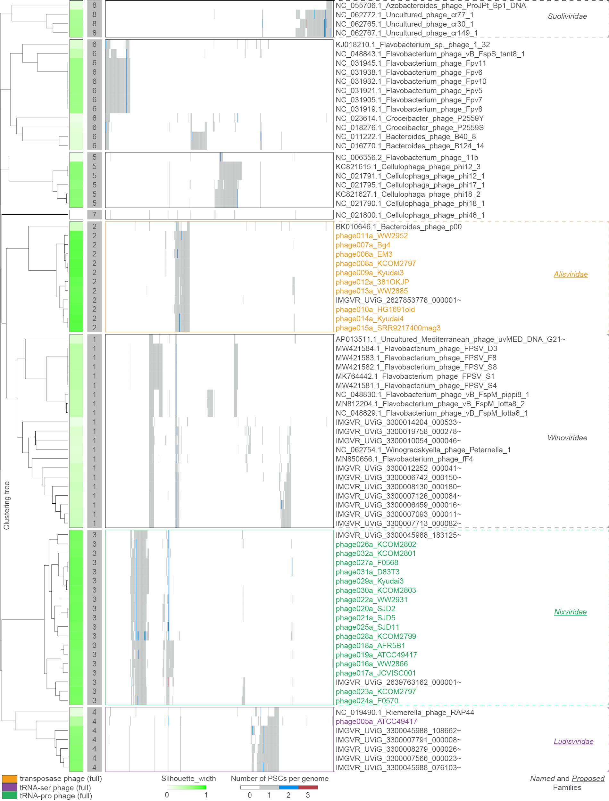

**Figure 5.** Resolution of *Porphyromonas gingivalis*phages to three family level units, on the basis of VirClust [[5]](https://paperpile.com/c/avu5zX/YhqmK) Protein Super Cluster (PSC)-based intergenomic distances. The set of 82 phages included in this analysis was comprised of: all full-length *Pg* phages; all *Porphyromonadaceae* UViGs in IMG/VRv4 [[21]](https://paperpile.com/c/avu5zX/c1hVA) assigned to the same vConTACT2 [[3]](https://paperpile.com/c/avu5zX/JNW6k) (see Supplementary Data 3 in Matrishin et al. 2023 [[1]](https://paperpile.com/c/avu5zX/meRzk)) Viral Cluster with the *Pg* phages, but not including those representing redundant geNomad [[22]](https://paperpile.com/c/avu5zX/ayjH5) versions of the *Pg* phages; all reference phages identified in the ViPTree [[4]](https://paperpile.com/c/avu5zX/YV7S6) placement tree as occurring within the same clade containing all*Pg* phages; all representatives of the closely-related viral family *Winoviridae* [[23]](https://paperpile.com/c/avu5zX/PjDvX) identified in GenBank and the publication describing this group, as well as phages identified in the aforementioned publication as potentially related to the *Winoviridae* but lying outside the family (e.g. *Bacteroides* phage p00 and *Cellulophaga* phage phi46); all sequence accessions are reported in Supplementary Data 3 in Matrishin et al. 2023 [[1]](https://paperpile.com/c/avu5zX/meRzk). The VirClust [[5]](https://paperpile.com/c/avu5zX/YhqmK) tree on the left reflects hierarchical clustering based on whole genome protein supercluster similarity; the silhouette width measures relatedness of a virus to other viruses within its own viral genome cluster (VGC) and to viruses outside of its VGC, with -1 indicating greatest similarity to viruses in other VGCs and 1 indicating greatest similarity to viruses within the same VGC (none <0, only range from 0 to 1 shown); the matrix represents all protein super clusters (PSCs) identified in the entire dataset (columns), with the number of PSCs per genome indicated by cell color. *Pg* phages are highlighted with leaf labels colored corresponding to insertion group type and proposed families (orange, *Alisviridae*; purple, *Ludisviridae*; green, *Nixviridae*), clades identified as distinct family-level clusters by VirClust [[5]](https://paperpile.com/c/avu5zX/YhqmK) are highlighted with dashed outlines, named and proposed families of phages are indicated in italics and underlined italics, respectively.

**VICTOR**

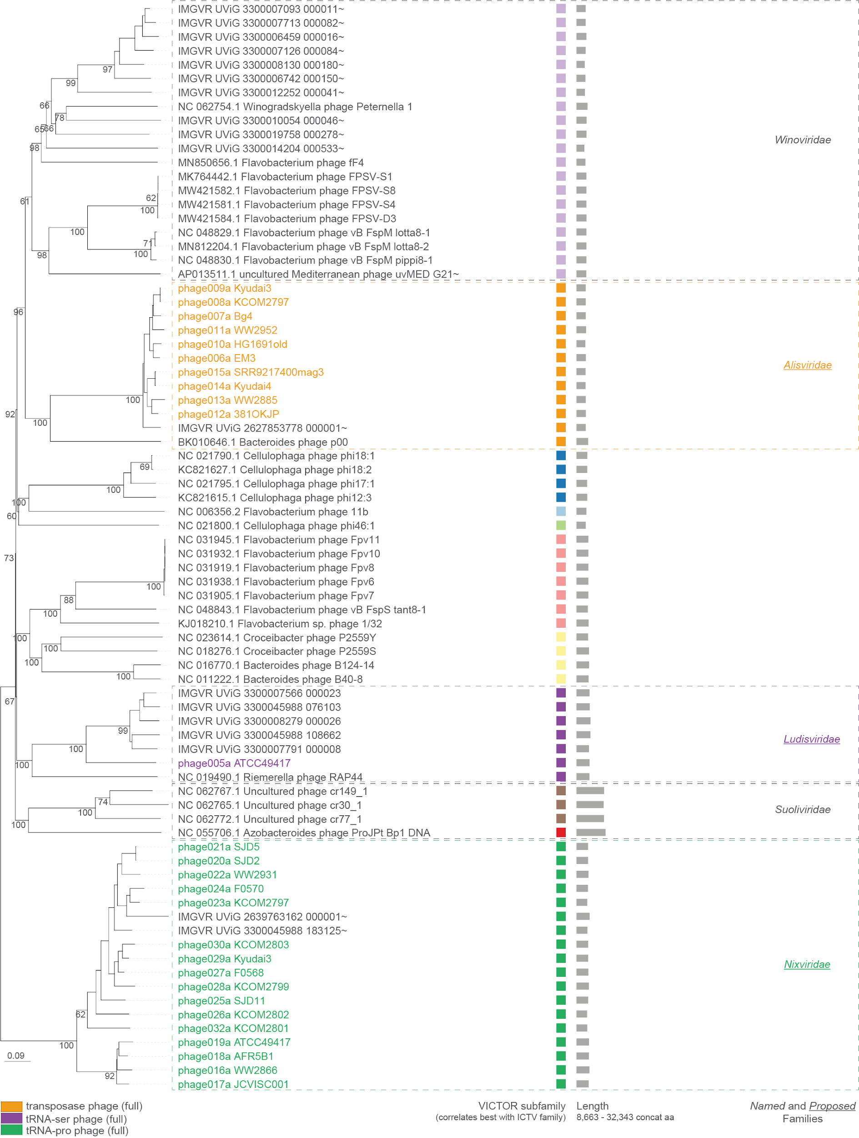

**Figure 6.** Resolution of *Porphyromonas gingivalis*phages to three family level units, on the basis of VICTOR [[6]](https://paperpile.com/c/avu5zX/0bq4f) whole proteome intergenomic distances. The set of 82 phages included in this analysis was comprised of: all full-length *Pg* phages; all *Porphyromonadaceae* UViGs in IMG/VRv4 [[21]](https://paperpile.com/c/avu5zX/c1hVA) assigned to the same vConTACT2 [[3]](https://paperpile.com/c/avu5zX/JNW6k) Viral Cluster with the *Pg* phages, but not including those representing redundant geNomad [[22]](https://paperpile.com/c/avu5zX/ayjH5) versions of the *Pg* phages; all reference phages identified in the ViPTree [[4]](https://paperpile.com/c/avu5zX/YV7S6) placement tree as occurring within the same clade containing all*Pg* phages; all representatives of the closely-related viral family *Winoviridae* [[23]](https://paperpile.com/c/avu5zX/PjDvX) identified in GenBank and the publication describing this group, as well as phages identified in the aforementioned publication as potentially related to the *Winoviridae* but lying outside the family (e.g. *Bacteroides* phage p00 and *Cellulophaga* phage phi46); all sequence accessions are reported in Supplementary Data 3 in Matrishin et al. 2023 [[1]](https://paperpile.com/c/avu5zX/meRzk). The tree on the left reflects whole proteome similarity based on VICTOR [[6]](https://paperpile.com/c/avu5zX/0bq4f) d6 (recommended for amino acid datasets) formula whole proteome distances, with branch supports based on 100 pseudo-bootstrap replicates; *Pg* phages are highlighted with leaf labels colored corresponding to insertion group type and proposed families (orange, *Alisviridae*; purple, *Ludisviridae*; green, *Nixviridae*); clades identified as distinct subfamily-level clusters by VICTOR [[6]](https://paperpile.com/c/avu5zX/0bq4f) (best corresponding to currently accepted thresholds for ICTV viral families) are indicated with colored boxes and highlighted with dashed outlines for named and proposed families of phages, indicated in italics and with underlines, respectively.