

Part 1: TITLE, AUTHORS, APPROVALS, etc

Code assigned: | 2023.063B
Short title: To create a new subfamily, Stanbayleyvirinae, with two genera – Subavirus & Shirevirus [Caudoviricetes]
Author(s) and email address(es)
Erdrich S, Frunzke J, Ansalldi M, Ginet N, Lebrun C, Clavijo-Coppens F, Turner D, Moraru C, Tolstoy I, Kropinski AM | s.erdrich@fz-juelich.de; j.frunzke@fz-juelich.de; ansaldi@imm.cnrs.fr; nginet@imm.cnrs.fr; clebrun@imm.cnrs.fr; clavijo.d.f@gmail.com; Dann2.Turner@uwe.ac.uk; liliana.cristina.moraru@uol.de; tolstoy@ncbi.nlm.nih.gov; Phage.Canada@gmail.com
Author(s) institutional address(es) (optional)

Forschungszentrum Jülich GmbH, Jülich, Germany [SE, JF]
CNRS, Aix-Marseille University, France [MA, NG, CL, FC]
University of the West of England, Bristol, UK [DT]
Carl von Ossietzky Universität Oldenburg, Germany [CM]
National Center for Biotechnology Information, MD, USA [IT]
University of Guelph, Ontario, Canada [AMK]

Corresponding author
Andrew M. Kropinski
List the ICTV Study Group(s) that have seen this proposal

Caudoviricetes Study Group

ICTV Study Group comments and response of proposer

ICTV Study Group votes on proposal

Study Group | Number of members
 | Votes support | Votes against | No vote
Authority to use the name of a living person

Is any taxon name used here derived from that of a living person (Y/N) | N

Taxon name | Person from whom the name is derived | Permission attached (Y/N)

Submission dates
Date first submitted to SC Chair | May 2023
Date of this revision (if different to above)
ICTV-EC comments and response of the proposer

Part 2: NON-TAXONOMIC PROPOSAL
Text of proposal

Part 3: TAXONOMIC PROPOSAL
Name of accompanying Excel module
2023.063B.N.v1.Stanbayleyvirinae_nsf.xlsx
Abstract

The new subfamily Stanbayleyvirinae contains two genera of Xanthomonas siphoviruses – Subavirus and Shirevirus. Their members share ca. 32% DNA sequence similarity, and 61.7% homologous proteins.

Text of proposal
Species demarcation criteria: Two phages are assigned to the same species if their genomes are more than 95% identical over their genome length for isolates.
These values can be calculated by a number of tools, such as BLASTn [1,2] – usually calculated using intergenomic distance calculator VIRIDIC [3].

Genus demarcation criteria: In search for criteria that create cohesive and distinct genera that are reproducible and monophyletic, the Bacterial Viruses Subcommittee has established 70% nucleotide identity of the genome length as the cut-off for genera. Genus-level groupings should always be monophyletic in the signature genes, as tested with a phylogenetic tree [10].

Supporting evidence

- Create a new single species genus, Subavirus
- Create a new genus, Shirevirus with three species
- Create a few subfamily, Stanbayleyvirinae, for these two genera

Figure 1. VIRIDIC heat map: VIRIDIC (Virus Intergenomic Distance Calculator; VIRIDIC (Virus Intergenomic Distance Calculator; [3]; http://rhea.icbm.uni-oldenburg.de/VIRIDIC/) computes pairwise intergenomic distances/similarities amongst phage genomes. Data values which are bordered in black correspond to strains. Abbreviations: phg = phage; Para = Paracoccus; Sphi = Sphingomonas; Xant = Xanthomonas; Esch = Escherichia

Figure 2. ViPTree analysis: ViPTree analysis (https://www.genome.jp/viptree/; [4]) is based upon Rohwer and Edwards (2002) Phage Proteomic Tree [5]. The phages of interest are indicated with red lines and stars.

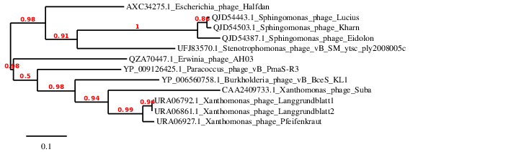

Figure 3. Phylogeny: The phylogenetic tree was constructed using the large subunit terminase proteins from these and related phages with phylogeny.fr in “one click” mode [8]. "The "One Click mode" targets users that do not wish to deal with program and parameter selection. By default, the pipeline is already set up to run and connect programs recognized for their accuracy and speed (MUSCLE for multiple alignment and PhyML for phylogeny) to reconstruct a robust phylogenetic tree from a set of sequences." It also includes the use of Gblocks to eliminate poorly aligned positions and divergent regions. "The usual bootstrapping procedure is replaced by a new confidence index that is much faster to compute. See: Anisimova M., Gascuel O. Approximate likelihood ratio test for branches: A fast, accurate and powerful alternative [9] for details.”

- Create a new single species genus, Subavirus
- Create a new genus, Shirevirus with three species
- Create a few subfamily, Stanbayleyvirinae, for these two genera

Origin of the name of this taxon: The name of this taxon is directly derived from the first virus of its type, Xanthomonas phage Suba

Historical aspects: This lytic siphophage was isolated from French sewage water against Xanthomonas albilineans by M. Ansaldi and F. Clavijo and described by Clavijo-Coppens et al. 2021. Phage Suba possesses a 61.2 nm isometric head and a flexible, 199.5 nm tail [Clavijo-Coppens et al. 2021]. These authors proposed the name Subavirus. Suba is a district of Bogota, the capital city of Colombia.

Electron micrograph: Phage Suba negatively stained with 2% uranyl acetate; magnification bar: 100 nm. Reproduced from: https://www.ncbi.nlm.nih.gov/pmc/articles/PMC8143317/

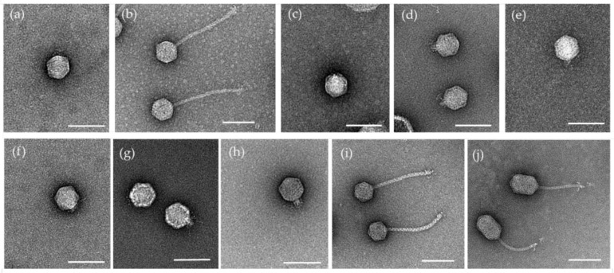

Genome summary: .

Phage name | INSDC | Size (Kb) | GC% | Protein | Overall % DNA sequence identity (*) | Overall % homologous proteins (**)
Xanthomonas phage Suba | LR743530.1 | 45.51 | 52.3 | 60 | 100 | 100

Conclusion: A genus comprised of a single species is proposed on the basis of DNA (Fig. 1) and protein (Fig. 2) similarity; and phylogenetic analysis of the TerL proteins (Fig. 3) this is a cohesive genus which is distinct from all others phages.

Specific reference:
Clavijo-Coppens F, Ginet N, Cesbron S, Briand M, Jacques MA, Ansaldi M. Novel Virulent Bacteriophages Infecting Mediterranean Isolates of the Plant Pest Xylella fastidiosa and Xanthomonas albilineans. Viruses. 2021 Apr 21;13(5):725. doi: 10.3390/v13050725. PMID: 33919362; PMCID: PMC8143317.

- Create a new genus, Shirevirus with three species

Origin of the name of this taxon: The name of this taxon was proposed in the publication by S.H. Erdrich et al. [2022]

Historical aspects: Lytic siphophages Langgrundblatt1, Langgrundblatt2 and Pfeifenkraut were isolated from sewage against Xanthomonas translucens pv. translucens (DSM 18974). The average dimensions of these three phages are: capsid 56 nm in diameter; tail 161 nm in length [Erdrich et al., 2022]

Electron micrograph: Negatively stained phages Langgrundblatt1, Langgrundblatt2 and Pfeifenkraut kindly provided by Dr. Sebastian Erdrich. Stain: 2% uranyl acetate. Scale bar: 100 nm.

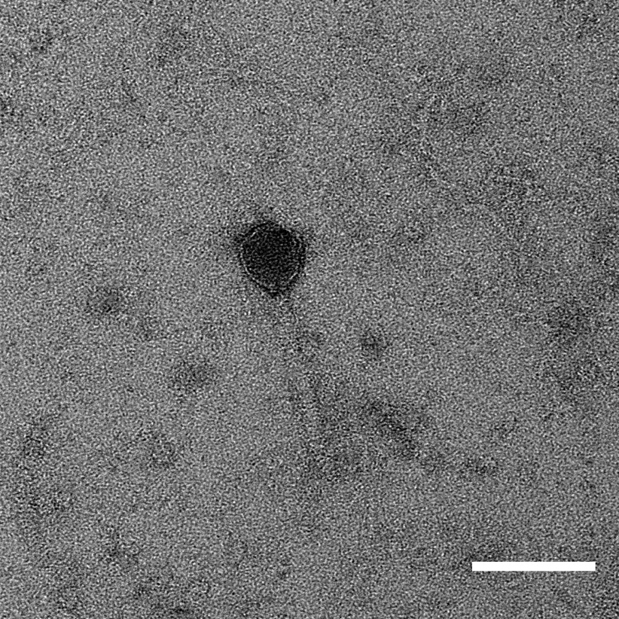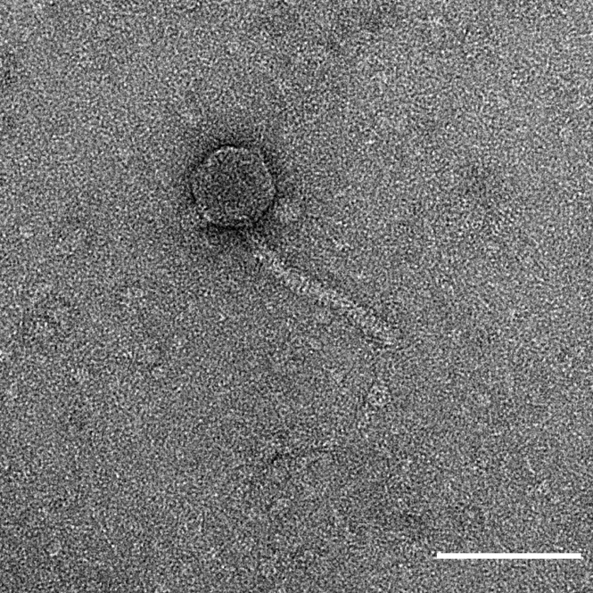

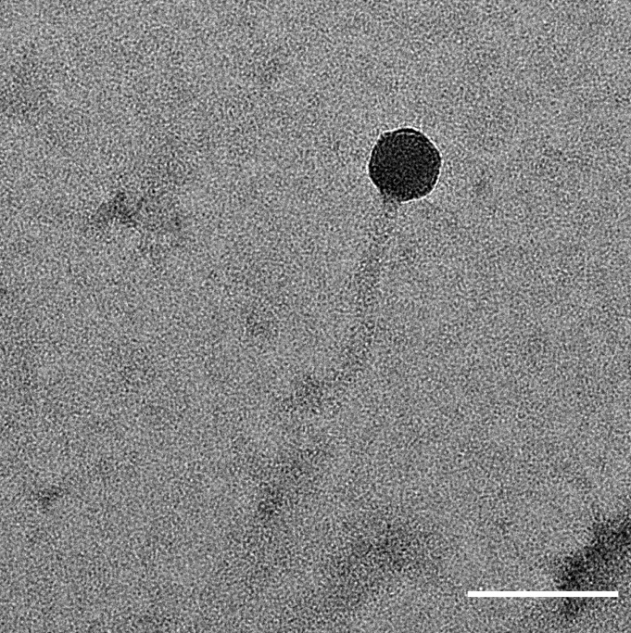

Genome summary:

Phage name | INSDC | Size (Kb) | GC% | Protein | Overall % DNA sequence identity (*) | Overall % homologous proteins (**)
Xanthomonas phage Langgrundblatt1 | ON189042.1 | 44.24 | 53.4 | 66 | 100 | 100
Xanthomonas phage Langgrundblatt2 | ON189043.1 | 44.77 | 53.4 | 67 | 94.2 | 86.4
Xanthomonas phage Pfeifenkraut | ON189044.1 | 43.79 | 53.4 | 70 | 77.9 | 83.3
(*) determined using VIRIDIC [3]
(**) determined using CoreGenes 3.5 [6]

Conclusion: On the basis of DNA (Fig. 1) and protein (Fig. 2) similarity; and phylogenetic analysis of the TerL proteins (Fig. 3) this is a cohesive genus.

Specific reference:
Erdrich SH, Sharma V, Schurr U, Arsova B, Frunzke J. Isolation of Novel Xanthomonas Phages Infecting the Plant Pathogens X. translucens and X. campestris. Viruses. 2022 Jun 30;14(7):1449. doi: 10.3390/v14071449. PMID: 35891434; PMCID: PMC9316219.

- Create a few subfamily, Stanbayleyvirinae, for these two genera

Origin of the name of this taxon: This taxon is named in honour of Dr. Stanley Thomas Bayley (b. 1926 Grays, Essex, England; d. 2019 St. Catharines, Ontario, Canada). He earned his PhD in Physics from the University of London in 1950 under the supervision of Sir John Randall in the new field of biophysics. In 1952 he emigrated to Canada to work in the National Research Council Division of Applied Biology in Ottawa before moving again in 1967 to become a professor of Biology at McMaster University in Hamilton, Ontario. [provided by Liz Bayley, Director (retired), Health Sciences Library, McMaster University]

He was one of the first scientists to isolate phages against Xanthomonas [KATZNELSON H, SUTTON MD, BAYLEY ST. The use of bacteriophage of Xanthomonas phaseoli in detecting infection in beans, with observation on its growth and morphology. Can J Microbiol. 1954 Aug;1(1):22-9. doi: 10.1139/m55-004. PMID: 14352035.]


(Reproduced from: https://dartefuneralhome.com/tribute/details/7156/Stanley-Bayley/obituary.html)

Rationale: Members of the Subavirus and Shirevirus share ca. 32% DNA sequence similarity, and 61.7% homologous proteins. These values are well within the parameters outlined for the creation of subfamilies [10].

References
1. Sayers EW, Beck J, Bolton EE, Bourexis D, Brister JR, Canese K, Comeau DC, Funk K, Kim S, Klimke W, Marchler-Bauer A, Landrum M, Lathrop S, Lu Z, Madden TL, O'Leary N, Phan L, Rangwala SH, Schneider VA, Skripchenko Y, Wang J, Ye J, Trawick BW, Pruitt KD, Sherry ST. Database resources of the National Center for Biotechnology Information. Nucleic Acids Res. 2021 Jan 8;49(D1):D10-D17. doi: 10.1093/nar/gkaa892. PMID: 33095870
2. O'Leary NA, Wright MW, Brister JR, Ciufo S, Haddad D, McVeigh R, et al. Reference sequence (RefSeq) database at NCBI: current status, taxonomic expansion, and functional annotation. Nucleic Acids Res. 2016;44(D1):D733-45. doi: 10.1093/nar/gkv1189. PMID: 26553804.
3. Moraru C, Varsani A, Kropinski AM. VIRIDIC-A Novel Tool to Calculate the Intergenomic Similarities of Prokaryote-Infecting Viruses. Viruses. 2020 Nov 6;12(11):1268. doi: 10.3390/v12111268. PMID: 33172115; PMCID: PMC7694805. http://kronos.icbm.uni-oldenburg.de/viridic/
4. Nishimura Y, Yoshida T, Kuronishi M, Uehara H, Ogata H, Goto S. ViPTree: the viral proteomic tree server. Bioinformatics. 2017; 33(15):2379-2380. doi:10.1093/bioinformatics/btx157. PubMed PMID: 28379287. https://www.genome.jp/viptree/
5. Rohwer F, Edwards R. The Phage Proteomic Tree: a genome-based taxonomy for phage. J Bacteriol. 2002 Aug;184(16):4529-35. PubMed PMID: 12142423
6. Turner D, Reynolds D, Seto D, Mahadevan P. CoreGenes3.5: a webserver for the determination of core genes from sets of viral and small bacterial genomes. BMC Res Notes. 2013;6:140. doi: 10.1186/1756-0500-6-140. PMID: 23566564.
7. Davis P, Seto D, Mahadevan P. CoreGenes5.0: An Updated User-Friendly Webserver for the Determination of Core Genes from Sets of Viral and Bacterial Genomes. Viruses. 2022 Nov 16;14(11):2534. doi: 10.3390/v14112534. PMID: 36423143; PMCID: PMC9693508.
8. Dereeper A, Guignon V, Blanc G, Audic S, Buffet S, Chevenet F, Dufayard JF, Guindon S, Lefort V, Lescot M, Claverie JM, Gascuel O. Phylogeny.fr: robust phylogenetic analysis for the non-specialist. Nucleic Acids Res. 2008;36(Web Server issue):W465-9. doi: 10.1093/nar/gkn180. Epub 2008 Apr 19. PMID: 18424797.
9. Anisimova M, Gascuel O. Approximate likelihood-ratio test for branches: A fast, accurate, and powerful alternative. Syst Biol. 2006;55(4):539-52. PMID: 16785212. DOI: 10.1080/10635150600755453.
10. Turner D, Kropinski AM, Adriaenssens EM. A Roadmap for Genome-Based Phage Taxonomy. Viruses. 2021 Mar 18;13(3):506. doi: 10.3390/v13030506. PMID: 33803862; PMCID: PMC8003253.

