

**Part 1:** **TITLE, AUTHORS, APPROVALS, etc**

|  |  |  |
| --- | --- | --- |
| **Code assigned:** | ***2023.060B*** |  |
| **Short title:** Create a new species in the genus *Saphexavirus* (*Caudoviricetes*) | | |
|  | | |

**Author(s) and email address(es)**

|  |  |
| --- | --- |
| Tkachev PV, Pchelin IM, Goncharov AE | weaver.paul94@gmail.com; arcella.oraia@gmail.com; phage1@yandex.ru |

**Author(s) institutional address(es) (optional)**

|  |
| --- |
| FSBSI “Institute of Experimental Medicine” [PVT, IMP, AEG] |

**Corresponding author**

|  |
| --- |
| Ivan M. Pchelin, arcella.oraia@gmail.com |

**List the ICTV Study Group(s) that have seen this proposal**

|  |
| --- |
|  |

**ICTV Study Group comments and response of proposer**

|  |
| --- |
|  |

**ICTV Study Group votes on proposal**

|  |  |  |  |
| --- | --- | --- | --- |
| **Study Group** | **Number of members** | | |
| **Votes support** | **Votes against** | **No vote** |
|  |  |  |  |
|  |  |  |  |

**Authority to use the name of a living person**

|  |  |
| --- | --- |
| **Is any taxon name used here derived from that of a living person (Y/N)** | N |

**Submission dates**

|  |  |
| --- | --- |
| Date first submitted to SC Chair | April 2023 |
| Date of this revision (if different to above) |  |

**ICTV-EC comments and response of the proposer**

|  |
| --- |
|  |

**Part 2:** **NON-TAXONOMIC PROPOSAL**

**Text of proposal**

|  |
| --- |
|  |

**Part 3:** **TAXONOMIC PROPOSAL**

**Name of accompanying Excel module**

|  |
| --- |
| 2023.060B.N.v1.Saphexavirus_1ns.xlsx |

**Abstract**

|  |
| --- |
| Hereby we would like to propose a new species for a bacteriophage described in our recent paper “Two novel lytic bacteriophages infecting *Enterococcus* spp. are promising candidates for targeted antibacterial therapy” PMID: 35458561 [1]. |

**Text of proposal**

|  |  |
| --- | --- |
| |  | | --- | | The complete genome sequence of SSsP-1 bacteriophage is deposited with the accession number MZ333457 [1]. As can be shown by MegaBLAST search against NCBI Nucleotide database, its closest match is Enterococcus phage Entf1 genome MK800154 at 87.2% identity. Current species demarcation criteria in bacteriophages imply a 95%-similarity threshold [2], and therefore SSsP-1 belongs to a species of its own, with a proposed name *Saphexavirus SSsP1*. | |

**Supporting evidence**

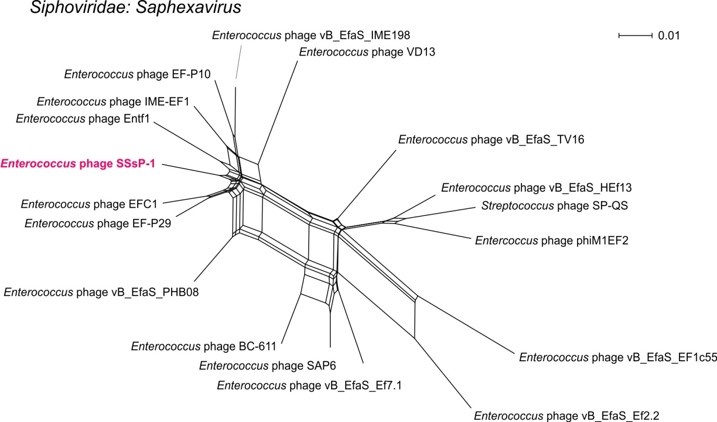

**Figure 1. Evolutionary relationships of *Enterococcus* phage SSsP-1 within *Saphexavirus* visualized by NeighborNet phylogenetic network.**

**References**

1. Tkachev PV, Pchelin IM, Azarov DV, Gorshkov AN, Shamova OV, Dmitriev AV, Goncharov AE (2022) Two novel lytic bacteriophages infecting *Enterococcus* spp. are promising candidates for targeted antibacterial therapy. Viruses 14(4):831. https://doi.org/10.3390/v14040831. PMID: 35458561

2. Turner D, Kropinski AM, Adriaenssens EM (2021) A roadmap for genome-based phage taxonomy. Viruses 13(3):506. https://doi.org/10.3390/v13030506. PMID: 33803862