

**Part 1:** **TITLE, AUTHORS, APPROVALS, etc**

|  |  |  |
| --- | --- | --- |
| **Code assigned:** | ***2023.046B*** |  |
| **Short title:** To create one new family *Madridviridae* with one genus *Cepunavirus* moved from the *Salasmaviridae* (*Caudoviricetes).* | | |
|  | | |

**Author(s) and email address(es)**

|  |  |
| --- | --- |
| Łobocka M, Stefańczyk E, Adriaenssens EM, Kropinski AM, Turner D | [lobocka@ibb.waw.pl](mailto:lobocka@ibb.waw.pl); [e.stefanczyk@ibb.waw.pl](mailto:e.stefanczyk@ibb.waw.pl); [evelien.adriaenssens@quadram.ac.uk](mailto:evelien.adriaenssens@quadram.ac.uk); [Phage.Canada@gmail.com](mailto:Phage.Canada@gmail.com); [dann2.turner@uwe.ac.uk](mailto:dann2.turner@uwe.ac.uk) |

**Author(s) institutional address(es) (optional)**

|  |
| --- |
| Institute of Biochemistry and Biophysics of the Polish Academy of Sciences Poland [MŁ]  Institute of Biochemistry and Biophysics of the Polish Academy of Sciences Poland [ES]  Quadram Institute Bioscience, UK [EMA]  University of Guelph, Canada [AMK]  University of the West of England [DT] |

**Corresponding author**

|  |
| --- |
| Małgorzata Łobocka |

**List the ICTV Study Group(s) that have seen this proposal**

|  |
| --- |
| *Salasmaviridae, Rountreeviridae* and *Guelinviridae* Study Groups, Bacterial Viruses Subcommittee |

**ICTV Study Group comments and response of proposer**

|  |
| --- |
|  |

**ICTV Study Group votes on proposal**

|  |  |  |  |
| --- | --- | --- | --- |
| **Study Group** | **Number of members** | | |
| **Votes support** | **Votes against** | **No vote** |
| *Salasmaviridae, Rountreeviridae, Guelinviridae* Study Group | 2 | 0 | 0 |
|  |  |  |  |

**Authority to use the name of a living person**

|  |  |
| --- | --- |
| **Is any taxon name used here derived from that of a living person (Y/N)** | N |

|  |  |  |
| --- | --- | --- |
| **Taxon name** | **Person from whom the name is derived** | **Permission attached (Y/N)** |
|  |  |  |
|  |  |  |
|  |  |  |

**Submission dates**

|  |  |
| --- | --- |
| Date first submitted to SC Chair | June 2023 |
| Date of this revision (if different to above) |  |

**ICTV-EC comments and response of the proposer**

|  |
| --- |
|  |

**Part 2:** **NON-TAXONOMIC PROPOSAL**

**Text of proposal**

|  |
| --- |
|  |

**Part 3:** **TAXONOMIC PROPOSAL**

**Name of accompanying Excel module**

|  |
| --- |
| 2023.046B.N.v1.Madridviridae_nf.xlsx |

**Abstract**

|  |
| --- |
| In a review of phages belonging formerly to the family *Salasmaviridae* usingVIRIDIC and ViPTree, we have discovered that the *Cepunavirus* genus phages are so distantly related to all other phages that should be included in a new family, which we propose to be named *Madridviridae* to honour the city of Madrid in Spain where the first phage of this family, Cp-1, and its close relative Cp-7 were isolated. |

**Text of proposal**

|  |  |
| --- | --- |
| |  | | --- | | **Species demarcation criteria:** Two phages are assigned to the same species if their genomes are more than 95% identical over their genome length for isolates.  These values can be calculated by a number of tools, such as BLASTn [1,2] – usually calculated using intergenomic distance calculator VIRIDIC [3].  **Genus demarcation criteria:** In search for criteria that create cohesive and distinct genera that are reproducible and monophyletic, the Bacterial Viruses Subcommittee has established 70% nucleotide identity of the genome length as the cut-off for genera. Genus-level groupings should always be monophyletic in the signature genes, as tested with a phylogenetic tree [4].  **Subfamily demarcation criteria:** Subfamilies are to be created when two or more genera are related below the family level. In practical terms, this usually means that they share a low degree of sequence similarity (usually about 40-50%) and that the genera form a clade in a marker tree phylogeny [4]. | |

**Supporting evidence**

**Proposal 1: To exclude the genus *Cepunavirus* from the family *Salasmaviridae***

**Proposal 2: To create a new family *Madridviridae* with one genus *Cepunavirus* and two species *Cepunavirus Cp1* and *Cepunavirus Cp7***

**Origin of the name of this taxon:** This taxon is named to memorize the city of Madrid, a capitol of Spain, where phages that are proposed to belong to this family were isolated.

**History:** The first phage of this genus Cp-1 was isolated from throat cultures of children in the Hospital Central de la Cruz Roja in Madrid, as infecting Streptococcus pneumoniae*,* but it can also infect Streptococcus mitis(Lopez et al., 1981; Ouennane et al., 2015). It has a podovirus morphology with a prolate head and appendages and tail fibers. The genome contains 236 bp terminal repeats at its ends (Escarmis et al., 1984). The 5' ends are covalently linked to protein (Martin et al., 1996). Genome replication is protein primed. The genus was established via Taxonomy Proposal *2016.009-fB.A.v1Cp1virus* with name *Cp1virus* and one species, within subfamily *Picovirinae* of family *Podoviridae*. It was supplemented with a second species, renamed in Taxonomy Proposal 2018.007B.A.v1.rename137gene6sp.zip to *Cepunavirus,* and mistakenly placed in the *Salasmaviridae* family in ICTV_Master_Species_list_2020.

**GenBank Summary:**

|  |  |  |  |  |  |  |  |  |
| --- | --- | --- | --- | --- | --- | --- | --- | --- |
| Phage name(****) | RefSeq No. | INSDC | Size (Kb) | GC% | Protein | tRNAs* | Overall % DNA sequence identity (**) | Overall % homologous proteins (***) |
| Cp-1 | NC_001825 | Z47794 | 19.43 | 38.0 | 25 | 0 | 100 | 100 |
| Cp-7 | NC_042114 | LK392619 | 19.74 | 38.0 | 28 | 0 | 74.7 | 88 |

N.B. Exemplar representative of *Cepunavirus* genus is Streptococcus phage Cp-1 (Z47794).

(*) determined using RNAscan-SE [5]

(**) determined using Viridic [3]

(***) determined using CoreGenes 5.0 [4,5]

(****) Phage SOCP which is a representative of *Cepunavirus Cp1* species was initially deposited in Canadian Felix d'Herelle phage collection as Cp-1 but because it differs slightly from Cp-1 (99.84% sequence identity) its name was changed to SOCP (Ouennane et al., 2015)

**Specific References:**

Lopez R, Garcia E, Ronda C. Bacteriophages of Streptococcus pneumoniae. Rev Infect Dis. 1981 Mar-Apr;3(2):212-23. doi: 10.1093/clinids/3.2.212. PMID: 7020041.

Escarmís C, Gómez A, García E, Ronda C, López R, Salas M. Nucleotide sequence at the termini of the DNA of Streptococcus pneumoniae phage Cp-1. Virology. 1984 Feb;133(1):166-71. doi: 10.1016/0042-6822(84)90435-5. PMID: 6702104.

Martín AC, López R, García P. Analysis of the complete nucleotide sequence and functional organization of the genome of Streptococcus pneumoniae bacteriophage Cp-1. J Virol. 1996 Jun;70(6):3678-87. doi: 10.1128/JVI.70.6.3678-3687.1996. PMID: 8648702; PMCID: PMC190243.

Ouennane S, Leprohon P, Moineau S. Diverse virulent pneumophages infect Streptococcus mitis. PLoS One. 2015 Feb 18;10(2):e0118807. doi: 10.1371/journal.pone.0118807. PMID: 25692983; PMCID: PMC4334900.

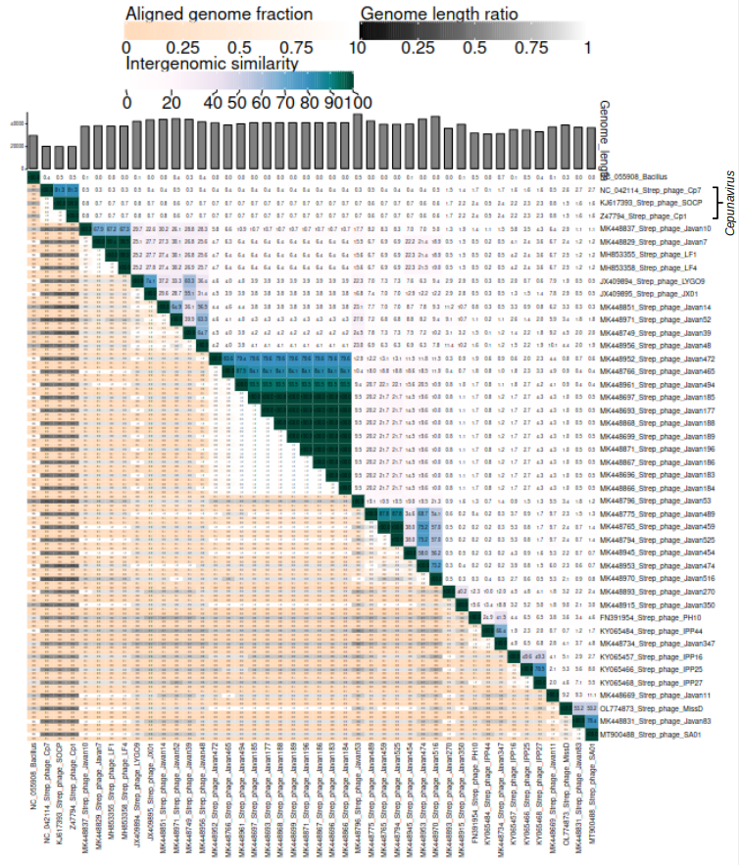

**Viridic analysis.** The prototypical phage of this genus Cp-1 exhibits only 0.4 % similarity to its most closest relative of *Salasmaviridae* family, Bacillus phage DLc1 ([NC_055908.1](https://www.ncbi.nlm.nih.gov/nucleotide/NC_055908.1?report=genbank&log$=nuclalign&blast_rank=11&RID=7U7BN444016))

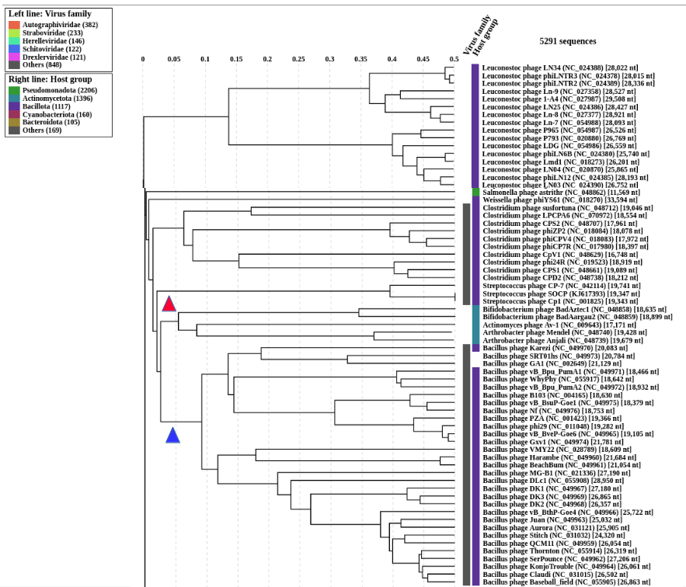

**ViPTree analysis:** ViPTree analysis (https://www.genome.jp/viptree/; [6]) is based upon Rohwer and Edwards (2002) famous Phage Proteomic Tree [7]. The red arrowhead marks the family *Madridviridae* created in this proposal. The blue arrow marks the family *Salasmaviridae*.

**References**

1. Sayers EW, Beck J, Bolton EE, Bourexis D, Brister JR, Canese K, Comeau DC, Funk K, Kim S, Klimke W, Marchler-Bauer A, Landrum M, Lathrop S, Lu Z, Madden TL, O'Leary N, Phan L, Rangwala SH, Schneider VA, Skripchenko Y, Wang J, Ye J, Trawick BW, Pruitt KD, Sherry ST. Database resources of the National Center for Biotechnology Information. Nucleic Acids Res. 2021 Jan 8;49(D1):D10-D17. doi: 10.1093/nar/gkaa892. PMID: 33095870

2. O'Leary NA, Wright MW, Brister JR, Ciufo S, Haddad D, McVeigh R, et al. Reference sequence (RefSeq) database at NCBI: current status, taxonomic expansion, and functional annotation. Nucleic Acids Res. 2016;44(D1):D733-45. doi: 10.1093/nar/gkv1189. PMID: 26553804.

3. Moraru C, Varsani A, Kropinski AM. VIRIDIC-A Novel Tool to Calculate the Intergenomic Similarities of Prokaryote-Infecting Viruses. Viruses. 2020 Nov 6;12(11):1268. doi: 10.3390/v12111268. PMID: 33172115; PMCID: PMC7694805. http://kronos.icbm.uni-oldenburg.de/viridic/

4. Turner D, Kropinski AM, Adriaenssens EM. A Roadmap for Genome-Based Phage Taxonomy. Viruses. 2021 Mar 18;13(3):506. doi: 10.3390/v13030506. PMID: 33803862; PMCID: PMC8003253.

5. Turner D, Reynolds D, Seto D, Mahadevan P. CoreGenes3.5: a webserver for the determination of core genes from sets of viral and small bacterial genomes. BMC Res Notes. 2013;6:140. doi: 10.1186/1756-0500-6-140. PMID: 23566564.

6. Davis P, Seto D, Mahadevan P. CoreGenes5.0: An Updated User-Friendly Webserver for the Determination of Core Genes from Sets of Viral and Bacterial Genomes. Viruses. 2022 Nov 16;14(11):2534. doi: 10.3390/v14112534. PMID: 36423143; PMCID: PMC9693508.

7. Nishimura Y, Yoshida T, Kuronishi M, Uehara H, Ogata H, Goto S. ViPTree: the viral proteomic tree server. Bioinformatics. 2017; 33(15):2379-2380. doi:10.1093/bioinformatics/btx157. PubMed PMID: 28379287. https://www.genome.jp/viptree/

8. Rohwer F, Edwards R. The Phage Proteomic Tree: a genome-based taxonomy for phage. J Bacteriol. 2002 Aug;184(16):4529-35. PubMed PMID: 12142423