

**Part 1:** **TITLE, AUTHORS, APPROVALS, etc**

|  |  |  |
| --- | --- | --- |
| **Code assigned:** | ***2023.045B*** |  |
| **Short title:** Create one new genus (*Layangcvirus*) and news species (*Layangcvirus* *LY3*) in the subfamily *Northropvirinae* | | |
|  | | |

**Author(s) and email address(es)**

|  |  |
| --- | --- |
| Yang M | [ymy@scau.edu.cn](mailto:ymy@scau.edu.cn); |

**Author(s) institutional address(es) (optional)**

|  |
| --- |
| South China Agricultural University, Guangzhou, China [MY] |

**Corresponding author**

|  |
| --- |
| Meiyan Yang |

**List the ICTV Study Group(s) that have seen this proposal**

|  |
| --- |
| Bacterial Viruses Subcommittee,  *Caudoviricetes* Study Group |

**ICTV Study Group comments and response of proposer**

|  |
| --- |
|  |

**ICTV Study Group votes on proposal**

|  |  |  |  |
| --- | --- | --- | --- |
| **Study Group** | **Number of members** | | |
| **Votes support** | **Votes against** | **No vote** |
|  |  |  |  |
|  |  |  |  |

**Authority to use the name of a living person**

|  |  |
| --- | --- |
| **Is any taxon name used here derived from that of a living person (Y/N)** | N |

|  |  |  |
| --- | --- | --- |
| **Taxon name** | **Person from whom the name is derived** | **Permission attached (Y/N)** |
|  |  |  |
|  |  |  |
|  |  |  |

**Submission dates**

|  |  |
| --- | --- |
| Date first submitted to SC Chair | May 2023 |
| Date of this revision (if different to above) |  |

**ICTV-EC comments and response of the proposer**

|  |
| --- |
|  |

**Part 2:** **NON-TAXONOMIC PROPOSAL**

**Text of proposal**

|  |
| --- |
|  |

**Part 3:** **TAXONOMIC PROPOSAL**

**Name of accompanying Excel module**

|  |
| --- |
| 2023.045B.N.v1.Layangcvirus_ng.xlsx |

**Abstract**

|  |
| --- |
| In this study, a new phage vB_BceP_LY3 was isolated from the Datansha Wastewater Treatment Plant in Guangzhou, China, with low similarity and coverage (76.15% similarity and 22% coverage) to the known Bacillus phage SerPounce. For accuracy, further comparisons were performed using VIRIDIC, which showed that the similarity of vB_BceP_LY3 was less than 46.5%, well below the defined threshold of 70% in this genus. More importantly, the results of vConTACT2 analysis revealed that vB_BceP_LY3 formed a new subset of VC clusters with phages of the subfamily *Northropvirinae*, which was further supported by the phylogenetic tree of the terminase large subunit. In summary, we propose to create a genus *Layangcvirus* within the subfamily *Northropvirinae*. |

**Text of proposal**

|  |  |
| --- | --- |
| |  | | --- | | **Species demarcation criteria:** The intergenomic similarity matrix made with the VIRIDIC tool, possibly better estimating the intergenomic similarities [1]. Its defining threshold is default 95% for species and 70% for genus [2].  **Origin of genus name:** The origin of names etymology (Layang) is derived from the Chinese word for *Bacillus cereus*. The 'c' immediately after it represents the third taxon discovered by our group. The genus will represent a new *Bacillus cereus* phage taxon. | |

**Supporting evidence**

**Source of the name of this taxon:** *Bacillus cereus* phage vB_BceP_LY3 isolated from Datansha Wastewater Treatment Plant, Guangzhou, China.

**VIRIDIC heat map:** VIRIDIC (Virus Intergenomic Distance Calculator; [2]) computes pairwise intergenomic distances/similarities amongst phage genomes. VIRDIC analysis of strains with high similarity after BLAST comparison showed that Bacillus phage vB_BceP_LY3 had the highest similarity with *Claudivirus* (SerPounce, Aurora and KonjoTrouble) and *Hemphillvirus*(DLn1, DK2 and DK3)phage, but both were well below the genus level (< 70%) similarity threshold. Therefore, phage vB_BceP_LY3 was an unclassified phage in the subfamily *Northropvirinae*.

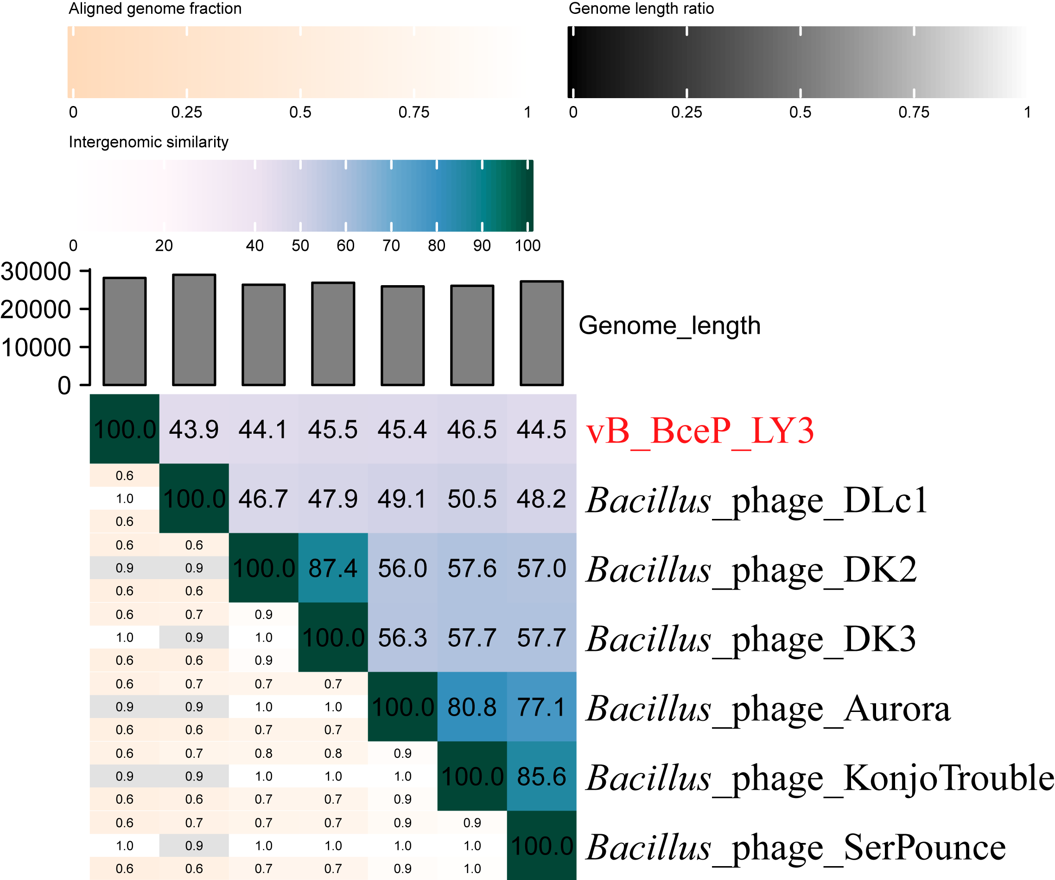

**Figure 1. The heat map by VIRIDIC analysis**

**vConTACT2 analysis:** vConTACT2 [3] is a network based on the shared proteins for virus classification. There are 18,324 phages (nodes) in Figure 2A, which show 835,836 relationships between them (connecting lines), and twenty-three phages with association with phage vB_BceP_LY3 were selected for analysis (Figure 2B). and these phages separated from the core viral cluster and formed a small cluster independently, both belonging to the family *Salasmaviridae*. It is known that the phages associated with phage vB_BceP_LY3 are both *Bacillus* phages and belong to two viral clusters (VC_782_0 and VC_785_0). Among them, vB_BceP_LY3 belongs to VC_785_0, a cluster containing the genus *Huangshavirus* under the family *Salasmaviridae* and the genera *Claudivirus*, *Hemphillvirus* and *Klosterneuburgvirus* under the subfamily *Northropvirinae*, family *Salasmaviridae*.

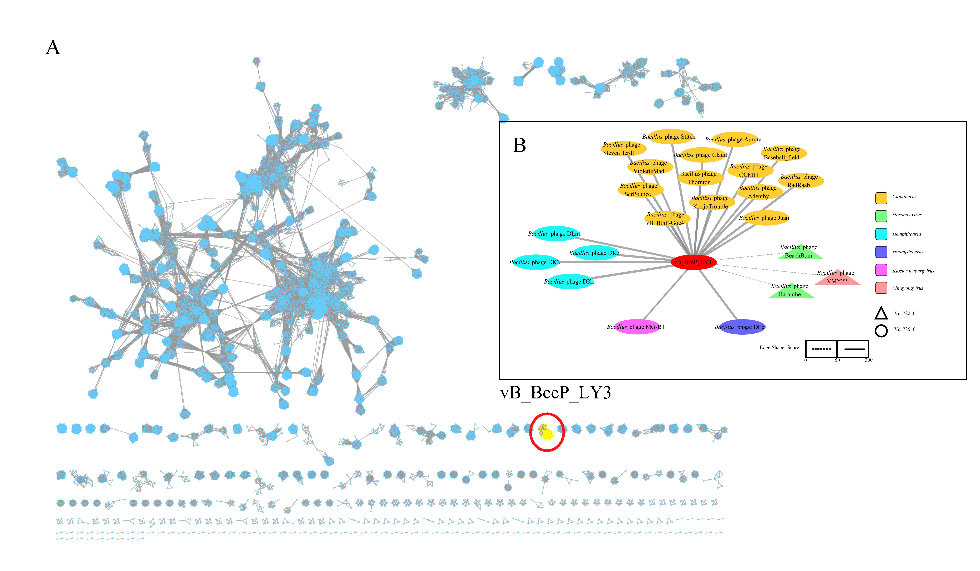

**Figure 2. The gene sharing networks analysis**

**Phylogenetic analysis**: Phylogenetic tree was conducted using the maximum likelihood estimation method in IQ-TREE by terminase large subunit(terL). The results indicate that phage vB_BceP_LY3 is located in the same branch as the family *Salasmaviridae*, especially the subfamily *Northropvirinae* phages, which are most recently evolutionarily related to the *Claudivirus* genus phages. In conclusion, we propose to create a genus *Layangcvirus* under the subfamily *Northropvirinae*.

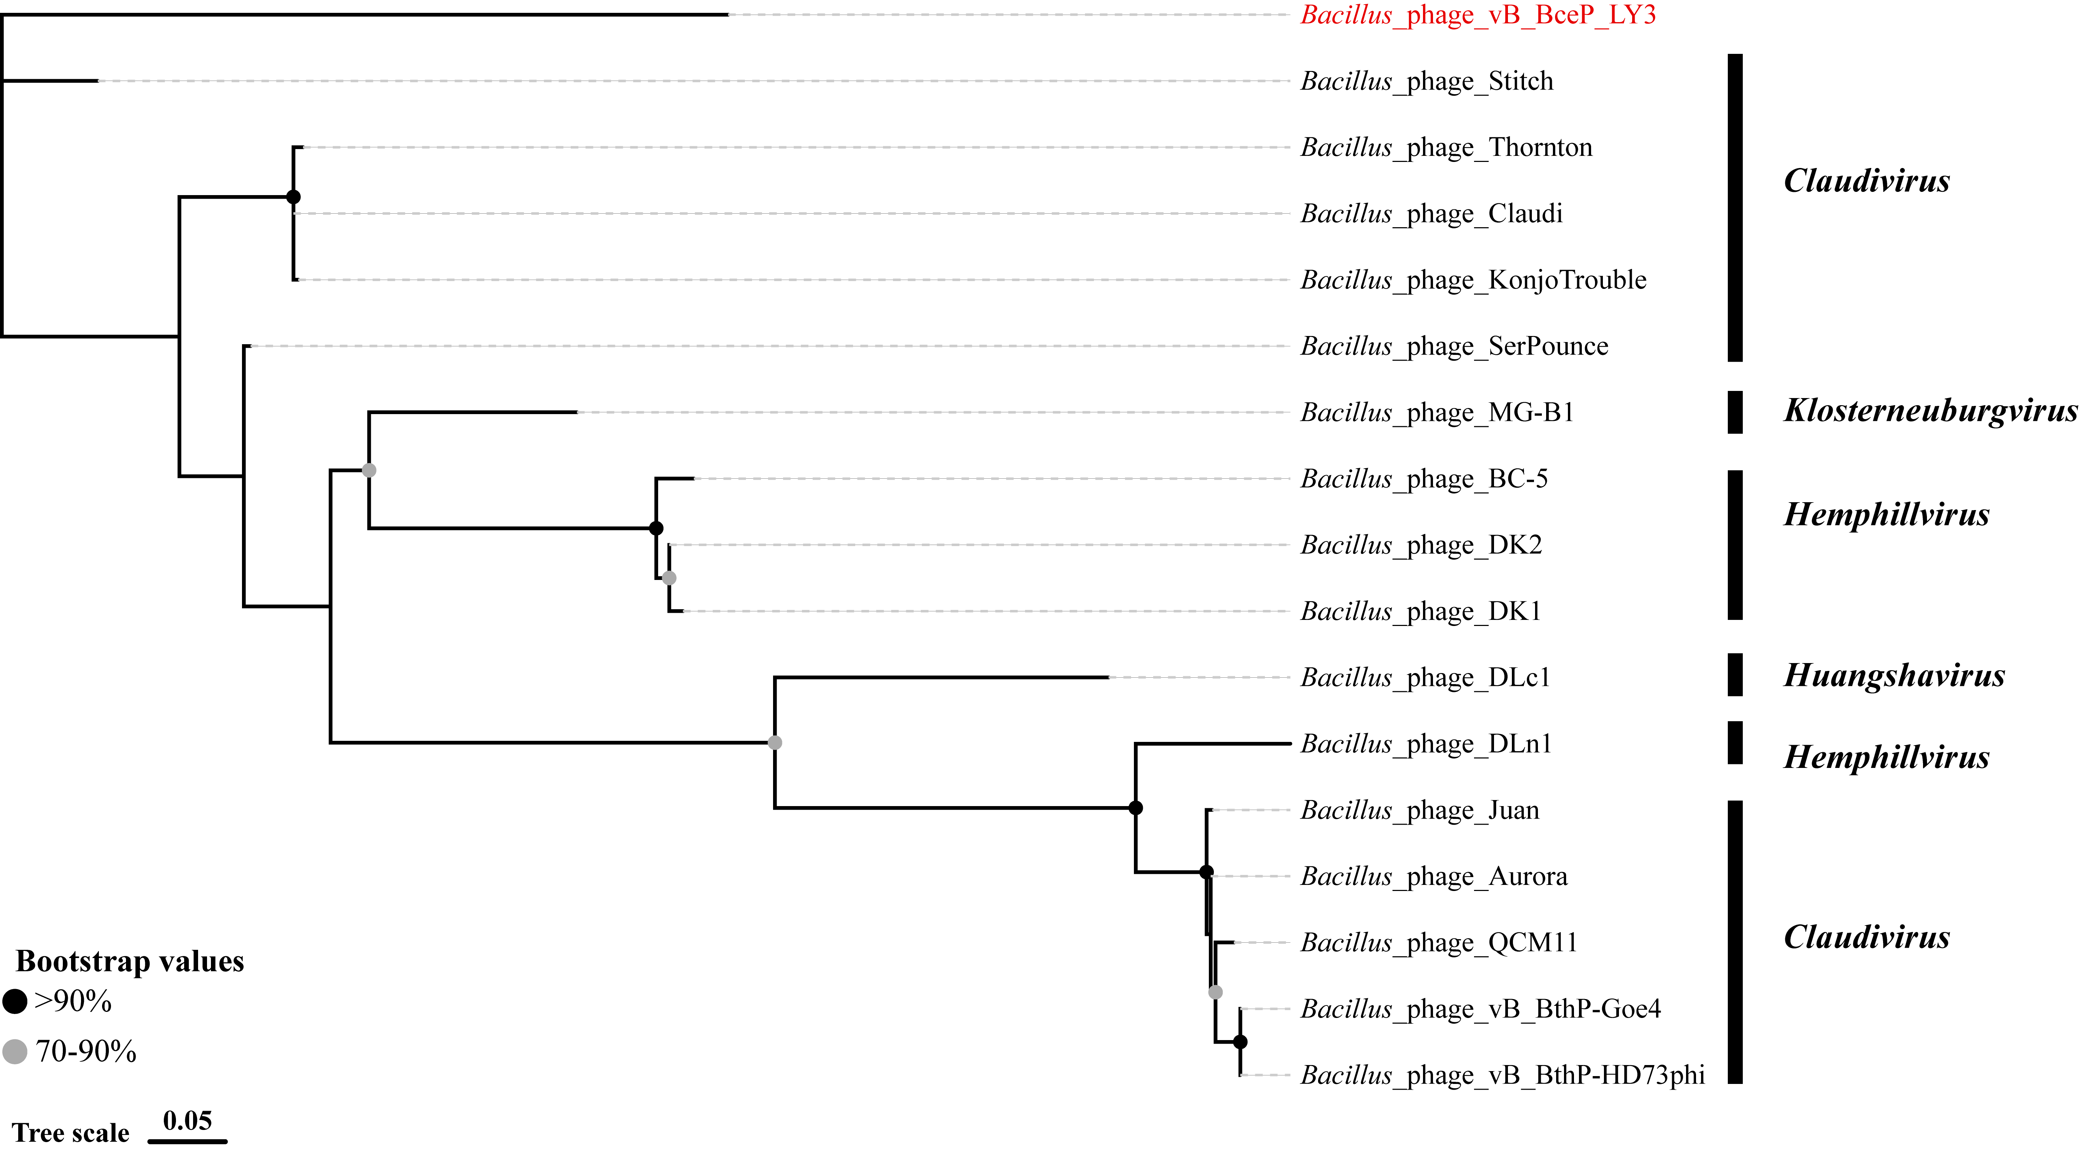

**Figure 3.** Phylogenetic tree of phage vB_BceP_LY3based on the terminase large subunit

**GenBank Summary:**

|  |  |  |  |  |  |
| --- | --- | --- | --- | --- | --- |
| Phage name | INSDC | Size (Kb) | GC% | Protein | tRNAs |
| *Bacillus* phage vB_BceP_LY3 | ON366412 | 28.1 | 29.92 | 47 | 0 |

**Electron micrograph:**

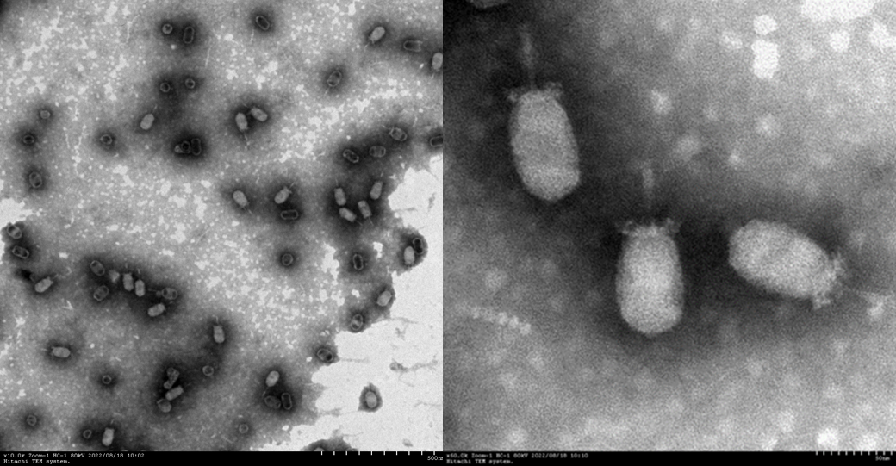

**References**

1. Timoshina OY, Shneider MM, Evseev PV, Shchurova AS, Shelenkov AA, Mikhaylova YV, Sokolova OS, Kasimova AA, Arbatsky NP, Dmitrenok AS, Knirel YA, Miroshnikov KA, Popova AV. Novel Acinetobacter baumannii Bacteriophage Aristophanes Encoding Structural Polysaccharide Deacetylase. Viruses. 2021 Aug 26;13(9):1688. doi: 10.3390/v13091688. PMID: 34578271; PMCID: PMC8471582.
2. Moraru C, Varsani A, Kropinski AM. VIRIDIC-A Novel Tool to Calculate the Intergenomic Similarities of Prokaryote-Infecting Viruses. Viruses. 2020 Nov 6;12(11):1268. doi: 10.3390/v12111268. PMID: 33172115; PMCID: PMC7694805.
3. Bin Jang H, Bolduc B, Zablocki O, et al. Taxonomic assignment of uncultivated prokaryotic virus genomes is enabled by gene-sharing networks. Nat Biotechnol. 2019;37(6):632-639. doi:10.1038/s41587-019-0100-8 PMID: 31061483