

**Part 1:** **TITLE, AUTHORS, APPROVALS, etc**

|  |  |  |
| --- | --- | --- |
| **Code assigned:** | ***2023.041B*** |  |
| **Short title:** Create one new genus (*Keyvirus*) including two new species in the family *Demerecviridae* | | |
|  | | |

**Author(s) and email address(es)**

|  |  |
| --- | --- |
| Zlatohurska MA, Gorb TY, Romaniuk LV, Shenderovska NA, Faidiuk YV, Kropinski AM, Kushkina AI, Tovkach FI | zlatohurska@gmail.com; tanyagorb@gmail.com; lyuromanyuk@gmail.com;  Nataliia.Korol@uf.ua;  i.v.faidiuk@gmail.com; phage.Canada@gmail.com; a.kushkina@gmail.com; fedir.i.tovkach@gmail.com |

**Author(s) institutional address(es) (optional)**

|  |
| --- |
| D. K. Zabolotny Institute of Microbiology and Virology, National Academy of Sciences of Ukraine, Ukraine [ZMA, GTY, RLV, SNA, FYV, KAI, TFI]  Pharmaceutical Corporation YURiA-PHARM, Ukraine [SNA]  Taras Shevchenko National University of Kyiv, Ukraine [FYV]  University of Guelph, Canada [AMK] |

**Corresponding author**

|  |
| --- |
| Zlatohurska MA |

**List the ICTV Study Group(s) that have seen this proposal**

|  |
| --- |
| Caudoviricetes Study Group |

**ICTV Study Group comments and response of proposer**

|  |
| --- |
|  |

**ICTV Study Group votes on proposal**

|  |  |  |  |
| --- | --- | --- | --- |
| **Study Group** | **Number of members** | | |
| **Votes support** | **Votes against** | **No vote** |
|  |  |  |  |
|  |  |  |  |

**Authority to use the name of a living person**

|  |  |
| --- | --- |
| **Is any taxon name used here derived from that of a living person (Y/N)** | N |

|  |  |  |
| --- | --- | --- |
| **Taxon name** | **Person from whom the name is derived** | **Permission attached (Y/N)** |
|  |  |  |
|  |  |  |
|  |  |  |

**Submission dates**

|  |  |
| --- | --- |
| Date first submitted to SC Chair | 12 Aug 2022 |
| Date of this revision (if different to above) |  |

**ICTV-EC comments and response of the proposer**

|  |
| --- |
|  |

**Part 2:** **NON-TAXONOMIC PROPOSAL**

**Text of proposal**

|  |
| --- |
|  |

**Part 3:** **TAXONOMIC PROPOSAL**

**Name of accompanying Excel module**

|  |
| --- |
| 2023.041B.A.v1.Keyvirus_ng.xlsx |

**Abstract**

|  |
| --- |
| Here we create one new genus comprising two new species in the family *Demerecviridae*. |

**Text of proposal**

|  |  |
| --- | --- |
| |  | | --- | | The new genus contains two species ‒ *Erwinia* phage Key and *Pantoea* phage AAS21. Phage Key was isolated from quince samples with symptoms of fire blight collected during the period of active plant vegetation in the Zakarpattia region of Ukraine in 2012 [1, 2]. Phage AAS21 was originally isolated from the outwash of jostaberries collected in Lithuania in 2017 [3].  We have used 95% DNA sequence identity as the criterion for species demarcation in genus [4]. According to the scored phylogenomic distances calculated using VIRIDIC, Key and AAS21 phages shared 92.2% nucleotide identity over the entire genome length, while the maximum similarity between them and other phages was about 30%.  As supported by the phylogenetic analyses based on concatenated amino acid sequences of conserved phage proteins and whole-genome comparison, phages Key and AAS21 were not grouped into clusters with known T5-like phages forming a separate branch.    Phage AAS21 was published first [3]. Its name seems too complicated in pronunciation, so we propose to name the new genus after the second representative, the phage Key. This virus was called so because the curved form of its tail resembled authors a key to the lock. From another point, the initial phage isolate was heterogeneous and phage Key was the dominant representative (“a key factor”). | |

**Supporting evidence**

**VIRIDIC analysis.** The nucleotide identity of Key, AAS21 and other T5-like phages was analyzed using VIRIDIC with default settings [5].

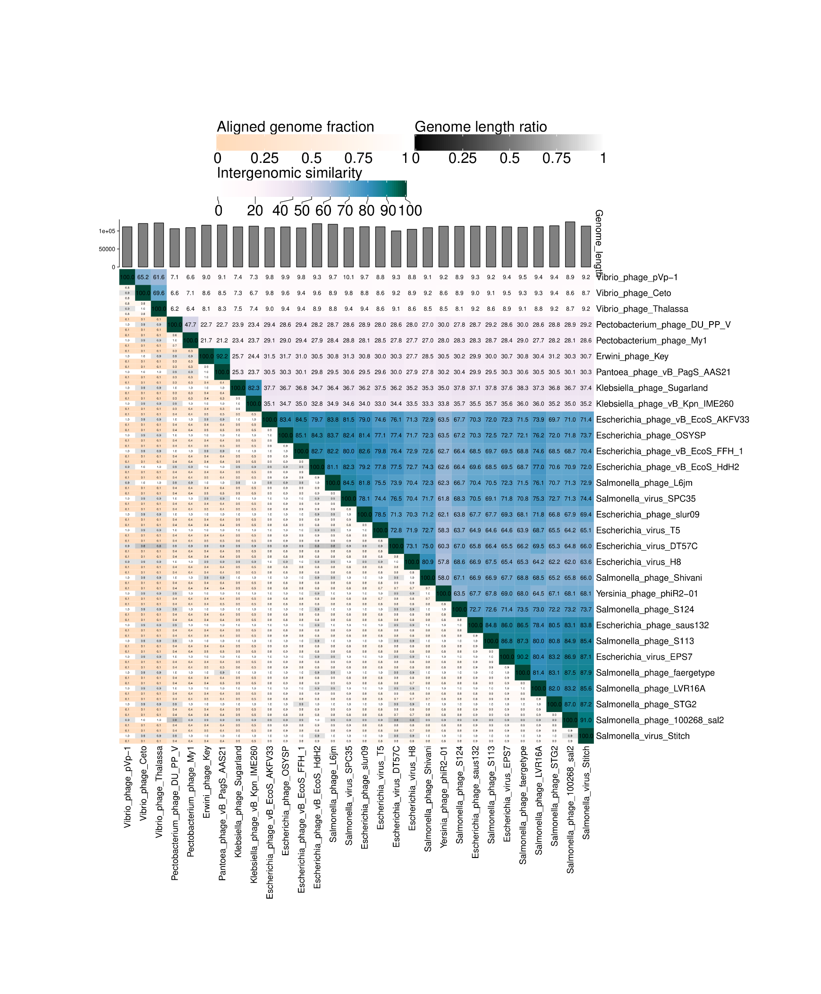

**Phylogeny.** The genome-based phylogeny of phages Key, AAS21 and 28 representatives of the family *Demerecviridae* was performed by VICTOR [6].

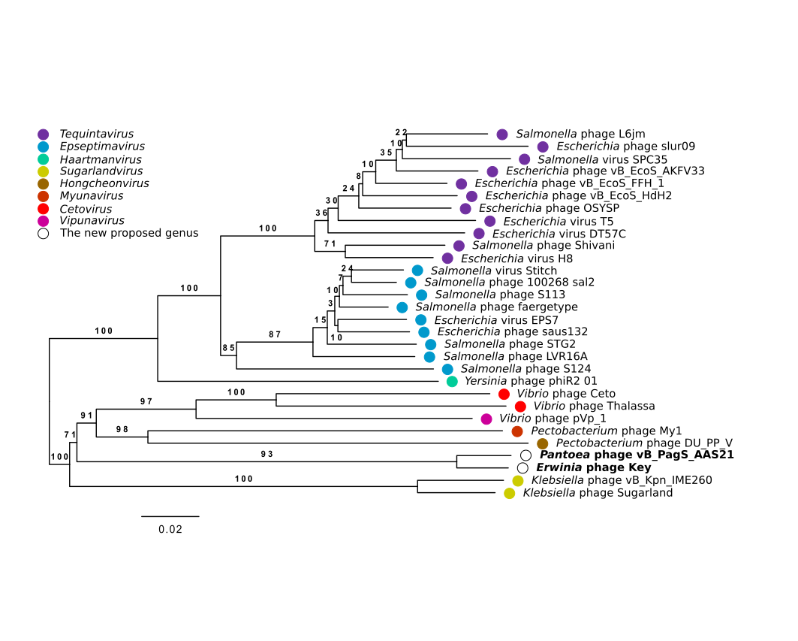

Phylogenetic analysis of studied phageswas also carried out based on comparison of concatenated amino acid sequences of conserved phage proteins commonly used as the phylogenetic markers, namely the terminase large subunit protein, portal protein, and major capsid protein [7]. Phylogenetic trees were created in MEGA XI with the maximum likelihood algorithm after alignment with Clustal W and evaluated with the bootstrap test (500) [8].

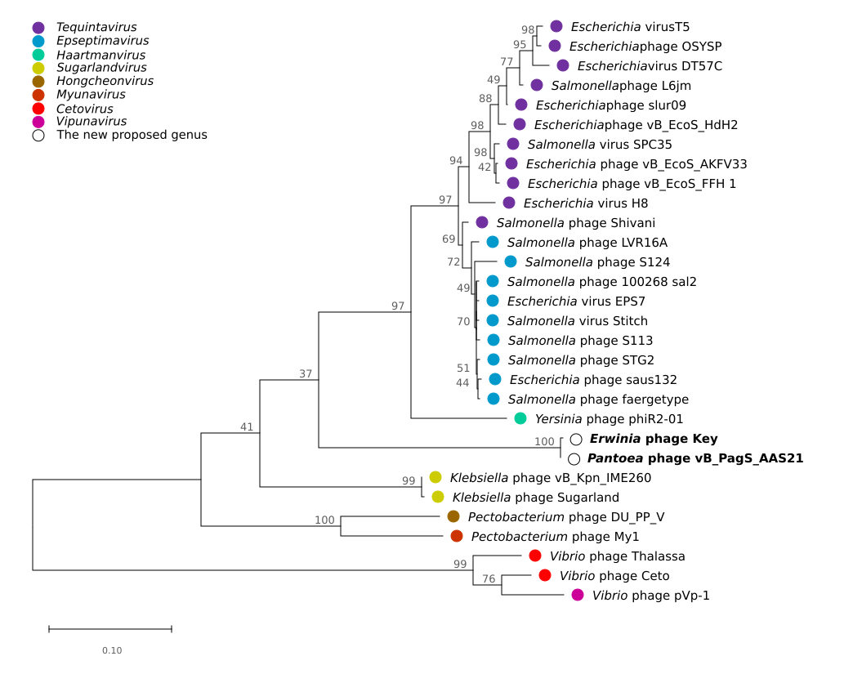

**GenBank Summary:**

|  |  |  |  |  |  |  |
| --- | --- | --- | --- | --- | --- | --- |
| Species name | Phage name | Accession | Size (KB) | GC% | Protein | tRNA |
| *Keyvirus AAS21* | *Pantoea* phage vB_PagS_AAS21 | MK770119.1 | 116.649 | 39.01 | 213 | 29 |
| *Keyvirus Key* | *Erwinia* phage Key | MZ616364 | 115.651 | 39.03 | 182 | 27 |

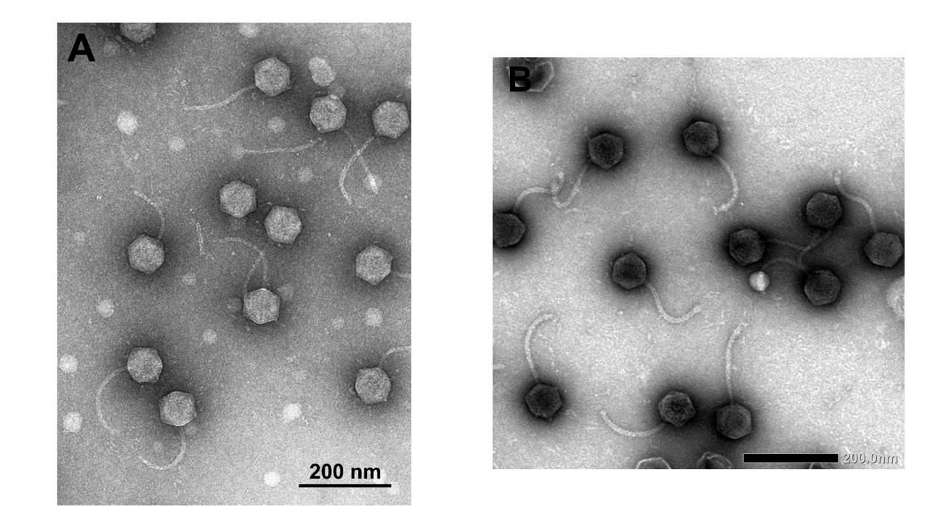**Electron micrograph:** Electron micrographs of negatively stained *Pantoea* phage vB_PagS_AAS21 (A) and *Erwinia* phage Key (B). The TEM photo of the AAS21 virions was adopted from [3].

**References**

1. Tovkach F, Moroz S, Korol N, et al (2013) Polyvalence of bacteriophages isolated from fruit trees, affected by bacterial fire blight. Microbiol Zh 75:80–88. PMID: 23720968

2. Tovkach F, Faidiuk I, Korol N, et al (2013) Electron microscopy and restriction analysis of bacteriophages isolated from quince and pear with symptoms of fire blight. Microbiol Zh 75:67–75. PMID: 24479316

3. Šimoliūnienė M, Truncaitė L, Petrauskaitė E, et al (2020) Pantoea agglomerans-Infecting Bacteriophage vB_PagS_AAS21: A Cold-Adapted Virus Representing a Novel Genus within the Family Siphoviridae. Viruses 12:1–8. https://doi.org/10.3390/v12040479

4. Turner D, Kropinski AM, Adriaenssens EM (2021) A Roadmap for Genome-Based Phage Taxonomy. Viruses 13:506. https://doi.org/10.3390/v13030506

5. Moraru C, Varsani A, Kropinski AM (2020) VIRIDIC—A Novel Tool to Calculate the Intergenomic Similarities of Prokaryote-Infecting Viruses. Viruses 12:1268. https://doi.org/10.3390/v12111268

6. Meier-Kolthoff JP, Göker M (2017) VICTOR: genome-based phylogeny and classification of prokaryotic viruses. Bioinformatics 33:3396–3404. https://doi.org/10.1093/bioinformatics/btx440

7. Adriaenssens EM, Cowan DA (2014) Using signature genes as tools to assess environmental viral ecology and diversity. Appl Environ Microbiol 80:4470–4480. https://doi.org/10.1128/AEM.00878-14

8. Tamura K, Stecher G, Kumar S (2021) MEGA11: Molecular Evolutionary Genetics Analysis Version 11. Mol Biol Evol 38:3022–3027. https://doi.org/10.1093/molbev/msab120