

**Part 1:** **TITLE, AUTHORS, APPROVALS, etc**

|  |  |  |
| --- | --- | --- |
| **Code assigned:** | ***2023.030B*** |  |
| **Short title:** To create seven new species within the family *Guelinviridae* (*Caudoviricetes*) | | |
|  | | |

**Author(s) and email address(es)**

|  |  |
| --- | --- |
| Stefańczyk E, Łobocka M, Adriaenssens EM, Kropinski AM, Turner D | e.stefanczyk@ibb.waw.pl;  lobocka@ibb.waw.pl;  evelien.adriaenssens@quadram.ac.uk;  Phage.Canada@gmail.com; dann2.turner@uwe.ac.uk |

**Author(s) institutional address(es) (optional)**

|  |
| --- |
| Institute of Biochemistry and Biophysics of the Polish Academy of Sciences Poland [ES]  Institute of Biochemistry and Biophysics of the Polish Academy of Sciences Poland [MŁ]  Quadram Institute Bioscience, UK [EMA]  University of Guelph, Canada [AMK]  University of the West of England [DT] |

**Corresponding author**

|  |
| --- |
| Malgorzata Łobocka |

**List the ICTV Study Group(s) that have seen this proposal**

|  |
| --- |
| *Salasmaviridae, Rountreeviridae, Guelinviridae* Study Group, Bacterial Viruses Subcommittee |

**ICTV Study Group comments and response of proposer**

|  |
| --- |
|  |

**ICTV Study Group votes on proposal**

|  |  |  |  |
| --- | --- | --- | --- |
| **Study Group** | **Number of members** | | |
| **Votes support** | **Votes against** | **No vote** |
| *Salasmaviridae, Rountreeviridae, Guelinviridae* Study Group | 2 | 0 | 0 |

**Authority to use the name of a living person**

|  |  |
| --- | --- |
| **Is any taxon name used here derived from that of a living person (Y/N)** | N |

|  |  |  |
| --- | --- | --- |
| **Taxon name** | **Person from whom the name is derived** | **Permission attached (Y/N)** |
|  |  |  |
|  |  |  |
|  |  |  |

**Submission dates**

|  |  |
| --- | --- |
| Date first submitted to SC Chair | June 2023 |
| Date of this revision (if different to above) |  |

**ICTV-EC comments and response of the proposer**

|  |
| --- |
|  |

**Part 2:** **NON-TAXONOMIC PROPOSAL**

**Text of proposal**

|  |
| --- |
|  |

**Part 3:** **TAXONOMIC PROPOSAL**

**Name of accompanying Excel module**

|  |
| --- |
| 2023.030B.N.v1.Guelinviridae_7ns.xlsx |

**Abstract**

|  |
| --- |
| The family *Guelinviridae* of the Bacillus phage phi-29-like podoviruses currently contains 10 species grouped in five genera. This proposal expands the family with additional seven species. |

**Text of proposal**

|  |  |
| --- | --- |
| |  | | --- | | **Species demarcation criteria:** Two phages are assigned to the same species if their genomes are more than 95% identical over their genome length for isolates.  These values can be calculated by a number of tools, such as BLASTn [1,2] – usually calculated using intergenomic distance calculator VIRIDIC [3].  **Genus demarcation criteria:** In search for criteria that create cohesive and distinct genera that are reproducible and monophyletic, the Bacterial Viruses Subcommittee has established 70% nucleotide identity of the genome length as the cut-off for genera. Genus-level groupings should always be monophyletic in the signature genes, as tested with a phylogenetic tree. [10]  **Subfamily demarcation criteria:** Subfamilies are to be created when two or more genera are related below the family level. In practical terms, this usually means that they share a low degree of sequence similarity (usually about 40-50%) and that the genera form a clade in a marker tree phylogeny. [10] | |

**Supporting evidence**

**Proposal Data:**

1. **To create three new species within *Gregsiragusavirus***
2. **To create two new species within *Brucesealvirus***
3. **To create** **two new species within *Susfortunavirus***

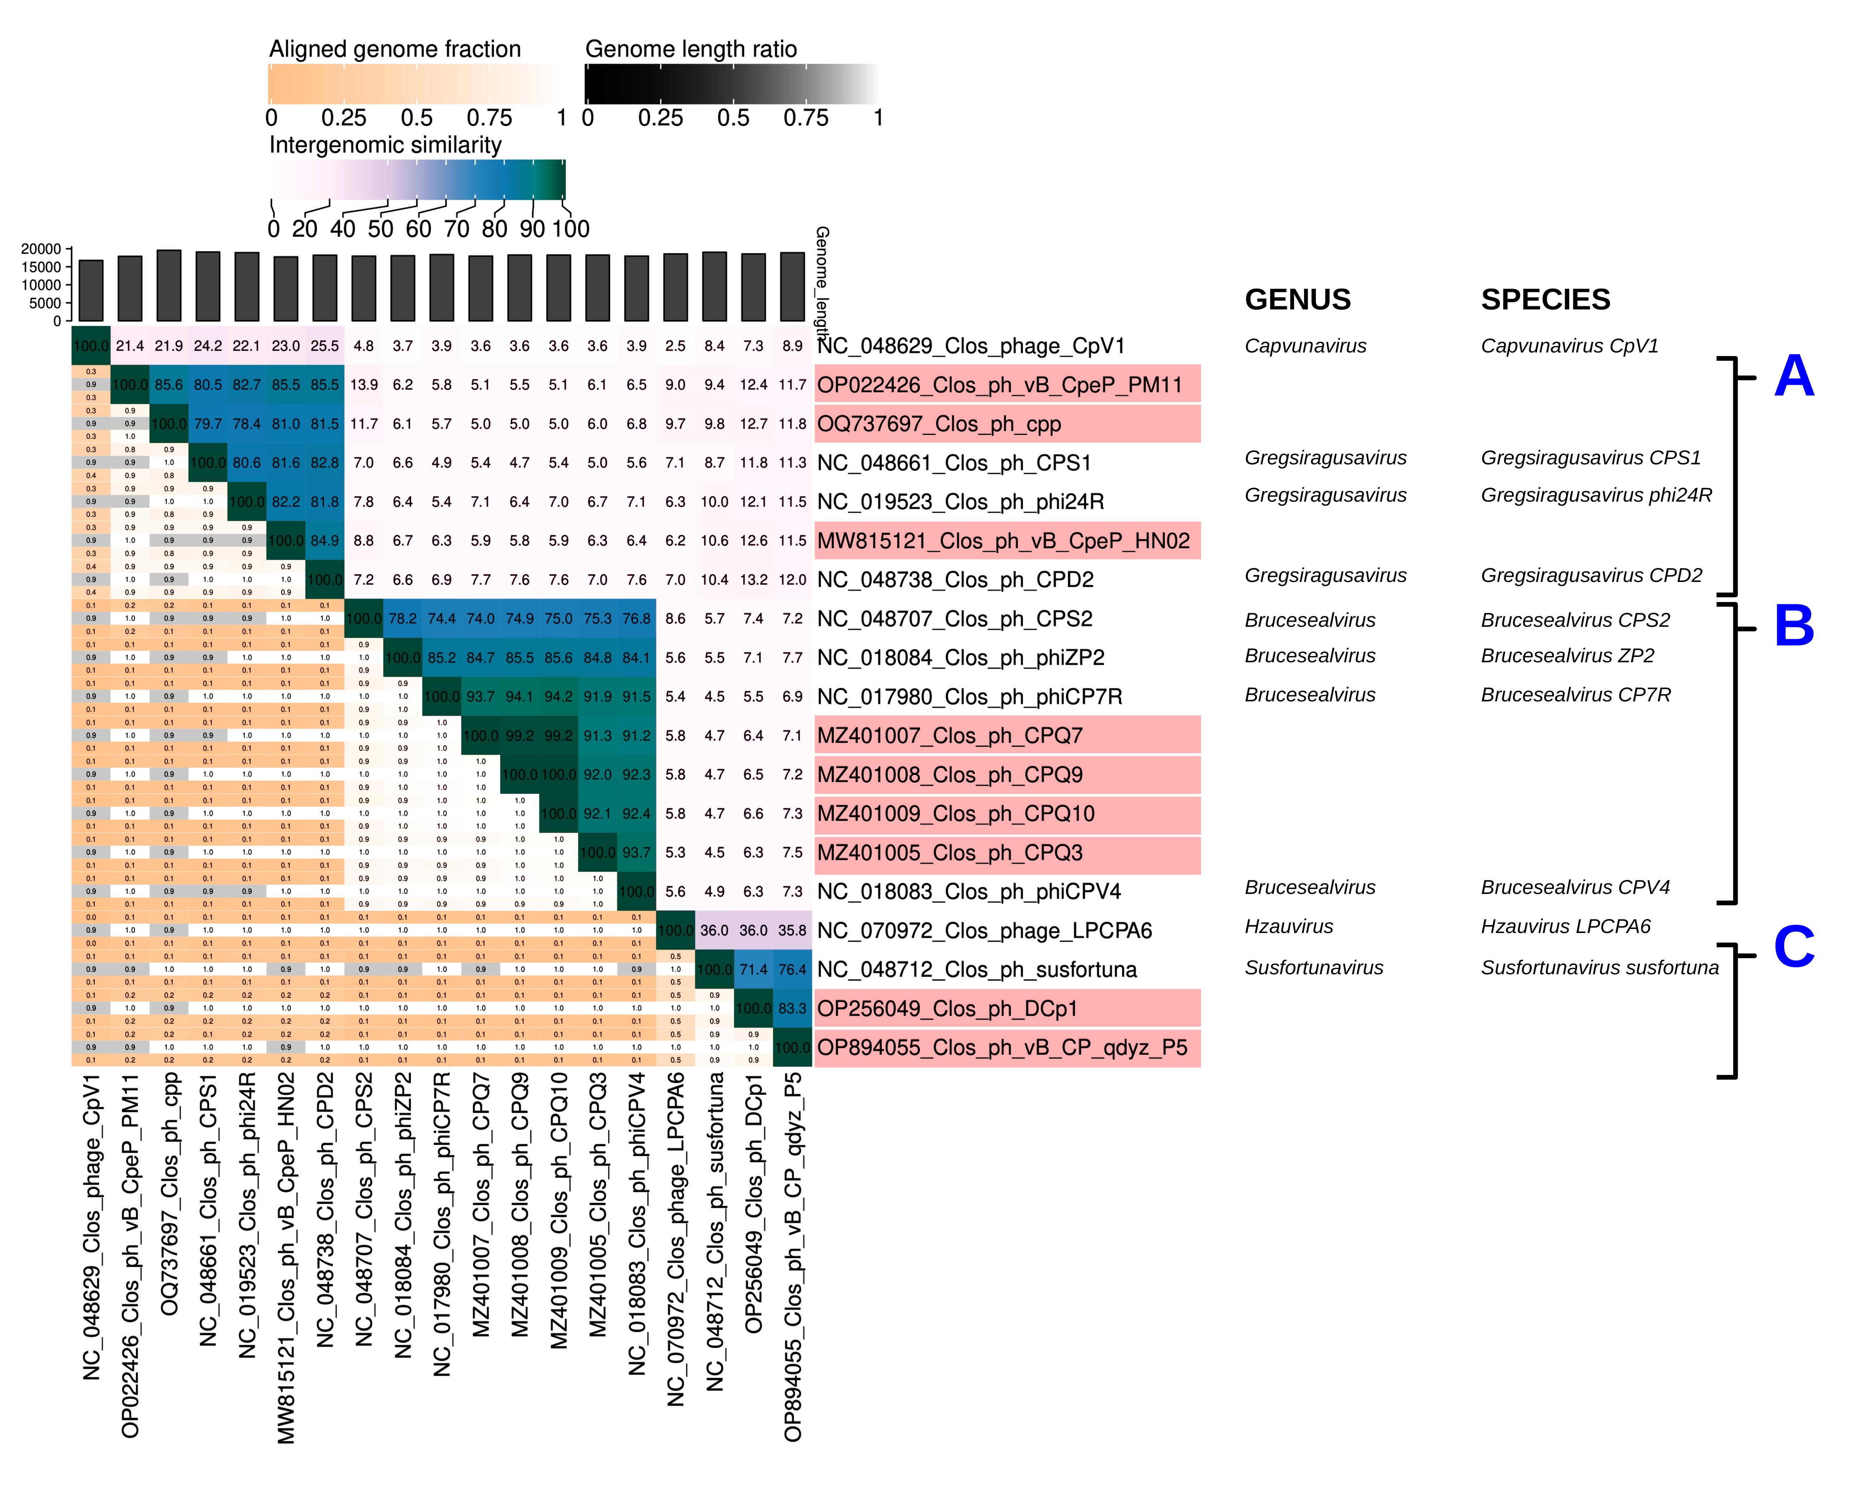

**Figure 1. VIRIDIC heat map:** VIRIDIC (Virus Intergenomic Distance Calculator; VIRIDIC (Virus Intergenomic Distance Calculator; [3]; http://rhea.icbm.uni-oldenburg.de/VIRIDIC/) computes pairwise intergenomic distances/similarities amongst phage genomes. The reference strains listed with NCBI Accessions starting with "NC_" contain additional information about their genera and species. Proposal data concerning expansion of a given genus are marked with capital A, B and C letters shown in blue, while phages of new species are labelled red.

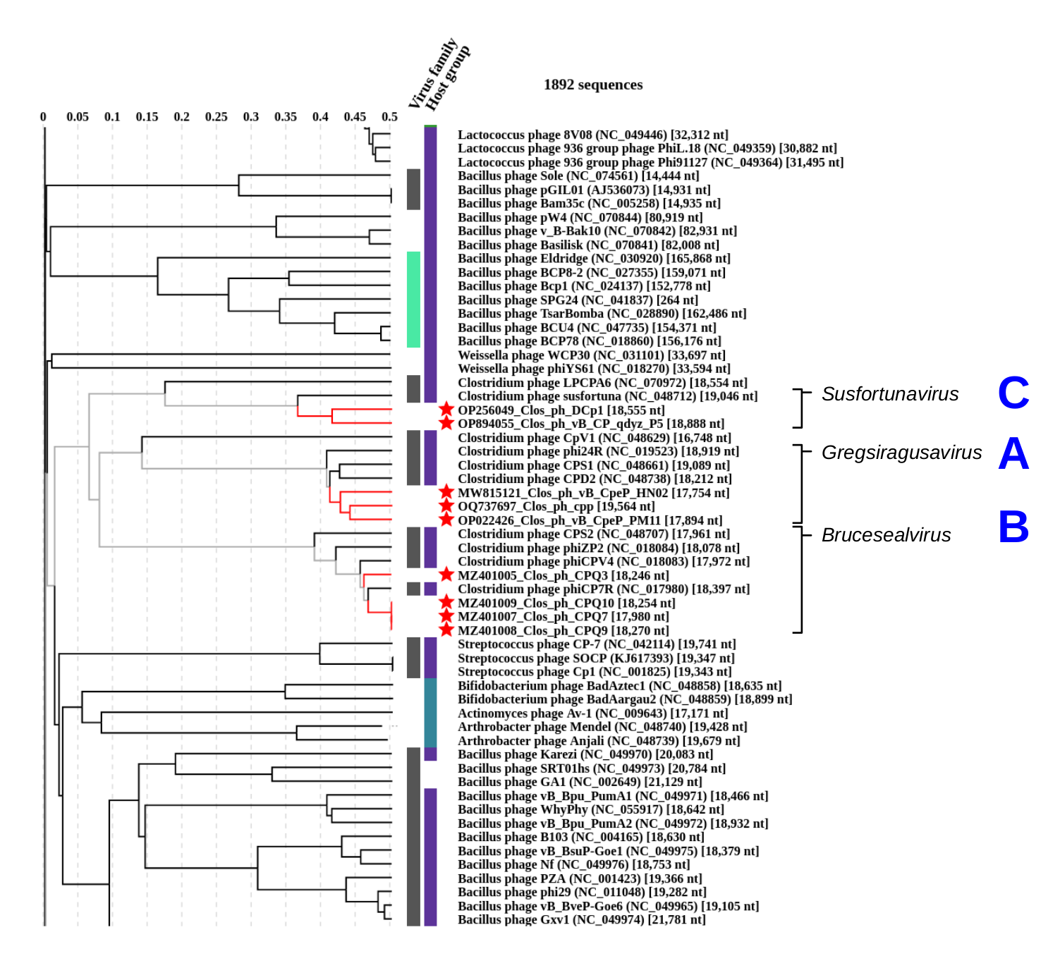

**Figure 2. ViPTree analysis:** ViPTree analysis (https://www.genome.jp/viptree/; [4]) is based upon Rohwer and Edwards (2002) famous Phage Proteomic Tree [5]. The phages of interest are indicated with **red lines and stars**.

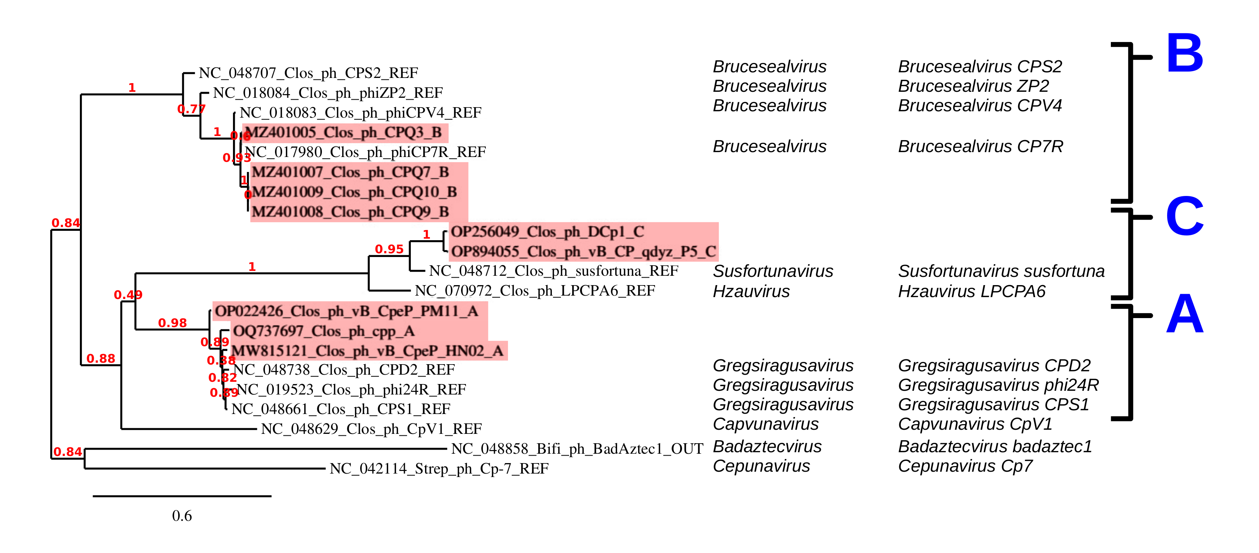

**Figure 3. Phylogeny:** The phylogenetic tree was constructed using the DNA polymerase proteins from these and related phages with phylogeny.fr in “one click” mode [8]. "The "One Click mode" targets users that do not wish to deal with program and parameter selection. By default, the pipeline is already set up to run and connect programs recognized for their accuracy and speed (MUSCLE for multiple alignment and PhyML for phylogeny) to reconstruct a robust phylogenetic tree from a set of sequences." It also includes the use of Gblocks to eliminate poorly aligned positions and divergent regions. "The usual bootstrapping procedure is replaced by a new confidence index that is much faster to compute. See: Anisimova M., Gascuel O. Approximate likelihood ratio test for branches: A fast, accurate and powerful alternative [9] for details.”

**Taxonomic Proposals:**

1. Create three new species, *Gregsiragusavirus pm11, Gregsiragusavirus cpp and Gregsiragusavirus hn02* within genus *Gregsiragusavirus*

**Origin of the name of this taxon:** See: *2020.066B.R.Guelinviridae*

**Historical aspects:** This genus was established within the Taxonomy Proposal *2020.066B.R.Guelinviridae* and assigned in the same proposal to the subfamily *Denniswatsonvirinae*

**Genome summary:**

|  |  |  |  |  |  |  |
| --- | --- | --- | --- | --- | --- | --- |
| Phage name | INSDC | Size (Kb) | GC% | Protein | Overall % DNA sequence identity (*) | Overall % homologous proteins (**) |
| Clostridium phage vB_CpeP_PM11 | OP022426.1 | 17.89 | 28.2 | 21 | 82.7 | 80.96 |
| Clostridium phage cpp | OQ737697.1 | 19.56 | 28.3 | 23 | 78.4 | 82.6 |
| Clostridium phage vB_CpeP_HN02 | MW815121.1 | 17.75 | 28.2 | 22 | 82.2 | 81.81 |

(*) determined using VIRIDIC [3], (**) determined using CoreGenes 3.5 [6]

and compared to the *Gregsiragusavirus* type species *Gregsiragusavirus phi24R* (NC_019523.1)

Distances determined using VIRIDIC [3]

|  |  |  |  |
| --- | --- | --- | --- |
|  | **OP022426.1** | **OQ737697.1** | **MW815121.1** |
| **OP022426.1** | 100 |  |  |
| **OQ737697.1** | 85.6 | 100 |  |
| **MW815121.1** | 85.5 | 81.0 | 100 |

1. Create two new species, *Brucesealvirus cpq9 and Brucesealvirus cpq3* within genus *Brucesealvirus*

**Origin of the name of this taxon:** See: *2020.066B.R.Guelinviridae*

**Historical aspects:** This genus was established within the Taxonomy Proposal *2020.066B.R.Guelinviridae* and assigned in the same proposal to the subfamily *Denniswatsonvirinae*

**Genome summary:**

|  |  |  |  |  |  |  |
| --- | --- | --- | --- | --- | --- | --- |
| Phage name | INSDC | Size (Kb) | GC% | Protein | Overall % DNA sequence identity (*) | Overall % homologous proteins (**) |
| Clostridium phage CPQ9 | MZ401008.1 | 18.27 | 34.7 | 28 | 94.1 [100] | 82.1  [100] |
| Clostridium phage CPQ7 | MZ401007.1 | 17.98 | 34.8 | 27 | 93.7 [99.3] | 85.2  [96.4] |
| Clostridium phage CPQ10 | MZ401009.1 | 18.25 | 34.7 | 28 | 94.2 [100] | 85.7  [100] |
|  | | | | | | |
| Clostridium phage CPQ3 | MZ401005.1 | 18.25 | 34.7 | 28 | 91.9 | 82.1 |

(*) determined using VIRIDIC [3], (**) determined using CoreGenes 3.5 [6]

and compared to the *Brucesealvirus* type species *Brucesealvirus CP7R* (NC_017980.1);

square brackets contain values for internal comparisons of CPQ7 and CPQ10 to the CPQ9 phage

Distances determined using VIRIDIC [3]

|  |  |  |  |  |
| --- | --- | --- | --- | --- |
|  | **MZ401008.1** | **MZ401007.1** | **MZ401009.1** | **MZ401005.1** |
| **MZ401008.1** | 100 |  |  |  |
| **MZ401007.1** | 99.2 | 100 |  |  |
| **MZ401009.1** | 100 | 99.2 | 100 |  |
| **MZ401005.1** | 92.0 | 91.3 | 92.1 | 100 |

1. Create two new *Susfortunavirus dcp1* and *Susfortunavirus gdyzp5* species withingenus *Susfortunavirus*

**Origin of the name of this taxon:** See: *2020.066B.R.Guelinviridae*

**Historical aspects:** This genus was established within the Taxonomy Proposal *2020.066B.R.Guelinviridae* and assigned in the same proposal to the subfamily *Denniswatsonvirinae*

**Genome summary:**

|  |  |  |  |  |  |  |
| --- | --- | --- | --- | --- | --- | --- |
| Phage name | INSDC | Size (Kb) | GC% | Protein | Overall % DNA sequence identity (*) | Overall % homologous proteins (**) |
| Clostridium phage DCp1 | OP256049.1 | 18.55 | 28.2 | [25](https://www.ncbi.nlm.nih.gov/genome/browse/#!/proteins/122731/2070007|Bifidobacterium phage BD811P2/viral segment/) | 71.4 | 92.0 |
|  | | | | | | |
| Clostridium phage vB_CP_qdyz_P5 | OP894055.1 | 18.89 | 28.8 | 27 | 76.4 | 92.6 |

(*) determined using VIRIDIC [3], (**) determined using CoreGenes 3.5 [6]

and compared to the *Susfortunavirus* type species *Susfortunavirus susfortuna* (NC_048712.1)

Distances determined using VIRIDIC [3]

|  |  |  |
| --- | --- | --- |
|  | **OP256049.1** | **OP894055.1** |
| **OP256049.1** | 100 |  |
| **OP894055.1** | 83.3 | 100 |

**References**

1. Sayers EW, Beck J, Bolton EE, Bourexis D, Brister JR, Canese K, Comeau DC, Funk K, Kim S, Klimke W, Marchler-Bauer A, Landrum M, Lathrop S, Lu Z, Madden TL, O'Leary N, Phan L, Rangwala SH, Schneider VA, Skripchenko Y, Wang J, Ye J, Trawick BW, Pruitt KD, Sherry ST. Database resources of the National Center for Biotechnology Information. Nucleic Acids Res. 2021 Jan 8;49(D1):D10-D17. doi: 10.1093/nar/gkaa892. PMID: 33095870

2. O'Leary NA, Wright MW, Brister JR, Ciufo S, Haddad D, McVeigh R, et al. Reference sequence (RefSeq) database at NCBI: current status, taxonomic expansion, and functional annotation. Nucleic Acids Res. 2016;44(D1):D733-45. doi: 10.1093/nar/gkv1189. PMID: 26553804.

3. Moraru C, Varsani A, Kropinski AM. VIRIDIC-A Novel Tool to Calculate the Intergenomic Similarities of Prokaryote-Infecting Viruses. Viruses. 2020 Nov 6;12(11):1268. doi: 10.3390/v12111268. PMID: 33172115; PMCID: PMC7694805. http://kronos.icbm.uni-oldenburg.de/viridic/

4. Nishimura Y, Yoshida T, Kuronishi M, Uehara H, Ogata H, Goto S. ViPTree: the viral proteomic tree server. Bioinformatics. 2017; 33(15):2379-2380. doi:10.1093/bioinformatics/btx157. PubMed PMID: 28379287. https://www.genome.jp/viptree/

5. Rohwer F, Edwards R. The Phage Proteomic Tree: a genome-based taxonomy for phage. J Bacteriol. 2002 Aug;184(16):4529-35. PubMed PMID: 12142423

6. Turner D, Reynolds D, Seto D, Mahadevan P. CoreGenes3.5: a webserver for the determination of core genes from sets of viral and small bacterial genomes. BMC Res Notes. 2013;6:140. doi: 10.1186/1756-0500-6-140. PMID: 23566564.

7. Davis P, Seto D, Mahadevan P. CoreGenes5.0: An Updated User-Friendly Webserver for the Determination of Core Genes from Sets of Viral and Bacterial Genomes. Viruses. 2022 Nov 16;14(11):2534. doi: 10.3390/v14112534. PMID: 36423143; PMCID: PMC9693508.

8. Dereeper A, Guignon V, Blanc G, Audic S, Buffet S, Chevenet F, Dufayard JF, Guindon S, Lefort V, Lescot M, Claverie JM, Gascuel O. Phylogeny.fr: robust phylogenetic analysis for the non-specialist. Nucleic Acids Res. 2008;36(Web Server issue):W465-9. doi: 10.1093/nar/gkn180. Epub 2008 Apr 19. PMID: 18424797.

9. Anisimova M, Gascuel O. Approximate likelihood-ratio test for branches: A fast, accurate, and powerful alternative. Syst Biol. 2006;55(4):539-52. PMID: 16785212. DOI: 10.1080/10635150600755453.

10. Turner D, Kropinski AM, Adriaenssens EM. A Roadmap for Genome-Based Phage Taxonomy. Viruses. 2021 Mar 18;13(3):506. doi: 10.3390/v13030506. PMID: 33803862; PMCID: PMC8003253.