

Part 1: TITLE, AUTHORS, APPROVALS, etc

Code assigned: | 2023.027B
Short title: To create a new subfamily Gorskivirinae with five genera [Caudoviricetes]
Author(s) and email address(es)
Turner D, Moraru C, Tolstoy I, Adriaenssens EM, Kropinski AM | Dann2.Turner@uwe.ac.uk; liliana.cristina.moraru@uol.de; tolstoy@ncbi.nlm.nih.gov; evelien.adriaenssens@quadram.ac.uk; Phage.Canada@gmail.com
Author(s) institutional address(es) (optional)
University of the West of England, Bristol, UK [DT]
Carl von Ossietzky Universität Oldenburg, Germany [CM]
National Center for Biotechnology Information, MD, USA [IT]
Quadram Institute Bioscience, UK [EMA]
University of Guelph, Ontario, Canada [AMK]

Corresponding author
Andrew M. Kropinski
List the ICTV Study Group(s) that have seen this proposal
Caudoviricetes Study Group

ICTV Study Group comments and response of proposer
ICTV Study Group votes on proposal
Study Group | Number of members
 | Votes support | Votes against | No vote

Authority to use the name of a living person

Is any taxon name used here derived from that of a living person (Y/N) | Y

Taxon name | Person from whom the name is derived | Permission attached (Y/N)
Gorskivirinae | Andrzej Gόrski | Y

Submission dates
Date first submitted to SC Chair | April 2023
Date of this revision (if different to above)
ICTV-EC comments and response of the proposer

Part 2: NON-TAXONOMIC PROPOSAL
Text of proposal

Part 3: TAXONOMIC PROPOSAL
Name of accompanying Excel module
2023.027B.N.v1.Gorskivirinae_nsf.xlsx
Abstract
This new subfamily, Gorskivirinae, consists of five genera: Dilongvirus, Shenlongvirus, Kremarvirus, Otagovirus and Flaumdravirus. All members of this subfamily probably have terminally redundant 96.2 kb genomes (46.8 mol% G+C), infect Pseudomonas species and encode ca. 173 proteins and 9-21 tRNAs. Their genomes share at least 41.4% DNA sequence similarity and 78 protein homologs (<48.4%). These values are consistent with the establishment of a subfamily.
Text of proposal
Species demarcation criteria: Two phages are assigned to the same species if their genomes are more than 95% identical over their genome length for isolates.
These values can be calculated by a number of tools, such as BLASTn [1,2] – usually calculated using intergenomic distance calculator VIRIDIC [3].

Genus demarcation criteria: In search for criteria that create cohesive and distinct genera that are reproducible and monophyletic, the Bacterial Viruses Subcommittee has established 70% nucleotide identity of the genome length as the cut-off for genera. Genus-level groupings should always be monophyletic in the signature genes, as tested with a phylogenetic tree [10].

Subfamily demarcation criteria: Subfamilies are to be created when two or more genera are related below the family level. In practical terms, this usually means that they share a low degree of sequence similarity (usually about 40-50%) and that the genera form a clade in a marker tree phylogeny [10].

Supporting evidence

Proposal Data:
- Create a new single-species genus, Dilongvirus
- Create a new single-species genus, Shenlongvirus
- Create a new genus, Kremarvirus
- Create a new subfamily, Gorskivirinae, for these three genera
- To update Otagovirus and transfer to this subfamily
- To transfer Flaumdravirus to this subfamily

Figure 1. VIRIDIC heat map: VIRIDIC (Virus Intergenomic Distance Calculator; VIRIDIC (Virus Intergenomic Distance Calculator; [3]; http://rhea.icbm.uni-oldenburg.de/VIRIDIC/) computes pairwise intergenomic distances/similarities amongst phage genomes. Data values which are bordered in black correspond to strains. Names highlighted in green are existing species in the genus Flaumdravirus; while those in gold are existing species in the genus Otagovirus. Abbreviations: phg = phage; Pseu = Pseudomonas. Because of the magnification of this diagram, we have appended the original Excel heat map (2023.027B.N.v1.Gorskivirinae_nsf_Suppl.xlsx).

Figure 2. ViPTree analysis: ViPTree analysis (https://www.genome.jp/viptree/; [4]) is based upon Rohwer and Edwards (2002) famous Phage Proteomic Tree [5]. The phages of interest are indicated with red lines and stars.

Taxonomic Proposals:
- Create a new single species genus, Dilongvirus

Origin of the name of this taxon: In Chinese mythology, dilong 地龍 "earth dragon" is one of many types of -long 龍 dragons (https://en.wikipedia.org/wiki/Dilong)

Historical aspects: Lytic Pseudomonas myophage PHB09 was isolated against Pseudomonas syringae pv. actinidiae by Y. Liu (College of Biological Science and Technology, Beijing Forestry University, China)

Genome summary:

Phage name | INSDC | Size (Kb) | GC% | Protein | tRNA | Overall % DNA sequence identity (*) | Overall % homologous proteins (**)
Pseudomonas phage PHB09 | OK040171.1 | 94.84 | 45.3 | 185 | 21(***) | 100 | 100
(***) None indicated in the GenBank record; these discovered using tRNAScan-SE at http://lowelab.ucsc.edu/tRNAscan-SE/ [11]

Conclusion: A genus comprised of a single species is proposed based on DNA (Fig. 1) and protein (Fig. 2) similarity.

- Create a new single-species genus, Shenlongvirus

Origin of the name of this taxon: Shenlong (神龍) is a spiritual dragon from Chinese mythology who is the master of storms and also a bringer of rain. He is of equal significance to other creatures such as Tianlong, the celestial dragon. (https://en.wikipedia.org/wiki/Shenlong)

Historical aspects: Lytic Pseudomonas myophage PPSC2 was isolated from soil against Pseudomonas fluorescens SA1 by Qiang Li (Biotechnology and Nuclear Technology
Research Institute, Sichuan Academy of Agricultural Sciences, China)

Genome summary:

Phage name | INSDC | Size (Kb) | GC% | Protein | tRNA | Overall % DNA sequence identity (*) | Overall % homologous proteins (**)
Pseudomonas phage PPSC2 | MF893340.1 | 97.33 | 47.5 | 168 | 20 | 100 | 100

Conclusion: A genus comprised of a single species is proposed based on DNA (Fig. 1) and protein (Fig. 2) similarity.

- Create a new genus, Kremarvirus with three species
Origin of the name of this taxon: The name of this taxon derives directly from the name of one of the first virus of its type Pseudomonas phage Kremar.

Historical aspects: Lytic Pseudomonas myophage Kremar was isolated from organic waste against Pseudomonas syringae by M. Gylling (Microbial Ecology and Biotechnology,
Copenhagen University, Denmark). Pseudomonas phage VCM is currently classified to the genus/species Otagovirus VCM.

Genome summary:

Phage name | INSDC | Size (Kb) | GC% | Protein | tRNA | Overall % DNA sequence identity (*) | Overall % homologous proteins (**)
Pseudomonas phage Kremar | OM982620.1 | 97.64 | 48.6 | 173 | 17 | 100 | 100
Pseudomonas phage VCM | LN887844.1 | 98.77 | 48.5 | 172 | 17 | 82.5 | 85.5
Pseudomonas phage M5.1 | MZ826350.1 | 98.54 | 49.0 | 174 | 19 | 73.7 | 87.3
(*) determined using VIRIDIC [3]
(**) determined using CoreGenes 3.5 [6]

Conclusion: On the basis of DNA (Fig. 1) and protein (Fig. 2) similarity this is a cohesive genus.

- Create a new subfamily, Gorskivirinae, for these three genera

Origin of the name of this taxon: This taxon is named in honour of Polish immunologist Prof. dr hab.n. med. Andrzej Gόrski (b. 1946 Wrocław, Poland). He was vice-president of the Polish Academy of Sciences (2007-2015) and rector of the Medical Academy in Warsaw (1996-1999). He is a professor at the Institute of Immunology and Experimental Therapy, Ludwik Hirszfeld PAS, he was the director of this unit (1999–2007). He has contributed significantly to research in phage therapy. (https://pl.wikipedia.org/wiki/Andrzej_G%C3%B3rski_(immunolog)). Recently, he was
“included in the prestigious group of 2% of the most influential scientists included in the TOP 2% of cited researchers in the world for 2019 (The World's Top 2% Scientists). The list was prepared by the American Stanford University in cooperation with the Elsevier publishing house and the SciTech Strategies company, based on the scientific achievements of individual people according to the bibliometric index. The evaluation criteria included: the Hirsch index, the number of citations by other authors, as well as the position and role of each scientist in the list of authors of the publication.” (https://hirszfeld.pl/blog/2021/03/30/prof-andrzej-gorski-wsrod-najbardziej-wplywowych-naukowcow-na-swiecie/)

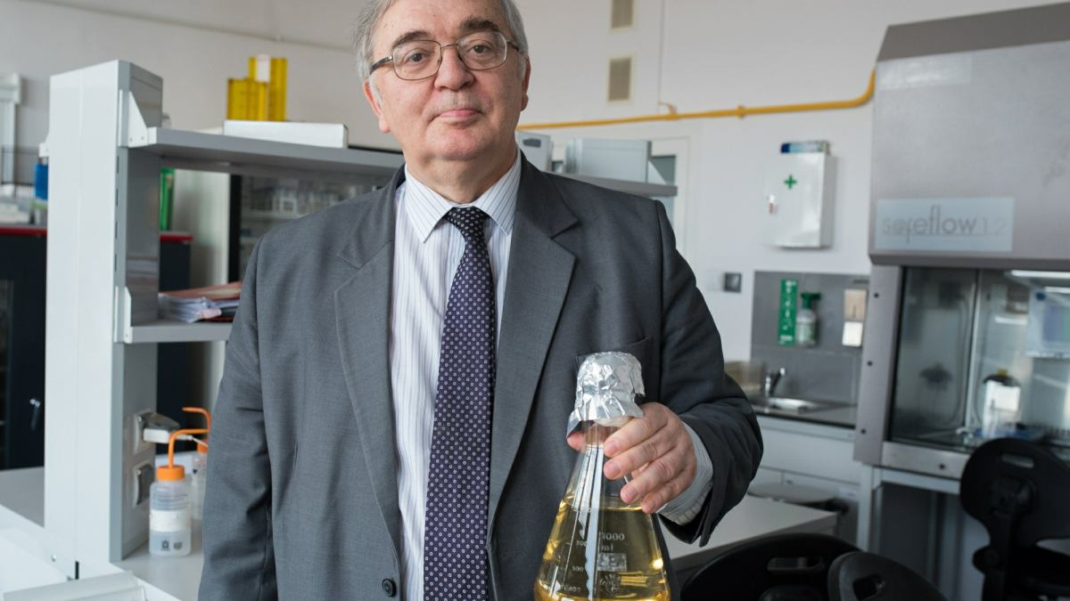
(reproduced from: https://wyborcza.pl/TylkoZdrowie/7,137474,19666788,fagi-zamiast-antybiotyku-na-niegojace-sie-rany-i-ciezkie-zakazenia.html?disableRedirects=true)

Rationale: (this also takes into consideration Proposals E & F) This new subfamily, Gorskivirinae, consists of five genera: Dilongvirus, Shenlongvirus, Kremarvirus, Otagovirus and Flaumdravirus. All members of this subfamily probably have terminally redundant genomes of approximately 96.2 kb (46.8 mol% G+C), infect Pseudomonas species and encode ca. 173 proteins and 9-21 tRNAs. Their genomes share at least 41.4% DNA sequence similarity and 78 protein homologs (<48.4%). These values are consistent with the establishment of a subfamily [10].

- To updated Otagovirus and transfer it to this subfamily
Origin of the name of this taxon: N/A

Historical aspects: This genus was created through Taxonomy Proposal 2018.083B.A.v1.Otagovirus to have two species Otagovirus Psa374 and Otagovirus VCM. Our new analyses reveal that the latter taxon is not part of the genus Otagovirus. Phages phiPsa374 and phiPsa381 526 bp direct terminal repeats, phiPsa397 525 bp, phiPsa347 522 bp, phiPsa267 510 bp, phiPsa300 523 bp, and phiPsa315 329 bp.

Genome summary:

Phage name | INSDC | Size (Kb) | GC% | Protein | tRNA | Overall % DNA sequence identity (*) | Overall % homologous proteins (**)
Pseudomonas phage phiPsa374 | KJ409772.2 | 98.29 | 47.7 | 170 | 11 | 100 | 100
Pseudomonas phage psageK4 | MZ348426.1 | 98.44 | 47.8 | 179 | 18 | 93.4 | 94.1
Pseudomonas phage psageK4e | MZ868713.1 | 94.02 | 47.9 | 185 | 14 | 91.8 | 90.6
Pseudomonas phage phiPsa397 | MT670422.1 | 98.95 | 47.7 | 173 | 9 | 95.3 | 94.1
Pseudomonas phage phiPsa381 | MT670421.1 | 98.8 | 47.8 | 173 | 11 | 96.4 | 95.3
Pseudomonas phage phiPsa347 | MT670420.1 | 99.69 | 47.7 | 174 | 12 | 94.0 | 94.7
Pseudomonas phage phiPsa267 | MT670417.1 | 100.18 | 47.7 | 176 | 11 | 93.9 | 97.6
Pseudomonas phage phiPsa300 | MT670418.1 | 99.27 | 47.7 | 171 | 12 | 95.6 | 96.5
Pseudomonas phage phiPsa315 | MT670419.1 | 98.74 | 48.0 | 172 | 10 | 85.8 | 90.6
Pseudomonas phage PE09 | MN905160.1 | 99.46 | 48.1 | 179 | 19 | 80.6 | 88.8
Pseudomonas phage PN09 | MW175491.1 | 99.23 | 48.2 | 177 | 9 | 80.8 | 89.4
(*) determined using VIRIDIC [3]
(**) determined using CoreGenes 3.5 [6]

- To transfer Flaumdravirus to this subfamily

Origin of the name of this taxon: N/A

Historical aspects: This genus was created through Taxonomy Proposal 2018.071B.A.v3.Flaumdravirus to have two species Flaumdravirus KIL2 and Flaumdravirus KIL4. This proposal moves this genus to the Gorskivirinae but does not change the number of species.

References
1. Sayers EW, Beck J, Bolton EE, Bourexis D, Brister JR, Canese K, Comeau DC, Funk K, Kim S, Klimke W, Marchler-Bauer A, Landrum M, Lathrop S, Lu Z, Madden TL, O'Leary N, Phan L, Rangwala SH, Schneider VA, Skripchenko Y, Wang J, Ye J, Trawick BW, Pruitt KD, Sherry ST. Database resources of the National Center for Biotechnology Information. Nucleic Acids Res. 2021 Jan 8;49(D1):D10-D17. doi: 10.1093/nar/gkaa892. PMID: 33095870
2. O'Leary NA, Wright MW, Brister JR, Ciufo S, Haddad D, McVeigh R, et al. Reference sequence (RefSeq) database at NCBI: current status, taxonomic expansion, and functional annotation. Nucleic Acids Res. 2016;44(D1):D733-45. doi: 10.1093/nar/gkv1189. PMID: 26553804.
3. Moraru C, Varsani A, Kropinski AM. VIRIDIC-A Novel Tool to Calculate the Intergenomic Similarities of Prokaryote-Infecting Viruses. Viruses. 2020 Nov 6;12(11):1268. doi: 10.3390/v12111268. PMID: 33172115; PMCID: PMC7694805. http://kronos.icbm.uni-oldenburg.de/viridic/
4. Nishimura Y, Yoshida T, Kuronishi M, Uehara H, Ogata H, Goto S. ViPTree: the viral proteomic tree server. Bioinformatics. 2017; 33(15):2379-2380. doi:10.1093/bioinformatics/btx157. PubMed PMID: 28379287. https://www.genome.jp/viptree/
5. Rohwer F, Edwards R. The Phage Proteomic Tree: a genome-based taxonomy for phage. J Bacteriol. 2002 Aug;184(16):4529-35. PubMed PMID: 12142423
6. Turner D, Reynolds D, Seto D, Mahadevan P. CoreGenes3.5: a webserver for the determination of core genes from sets of viral and small bacterial genomes. BMC Res Notes. 2013;6:140. doi: 10.1186/1756-0500-6-140. PMID: 23566564.
7. Davis P, Seto D, Mahadevan P. CoreGenes5.0: An Updated User-Friendly Webserver for the Determination of Core Genes from Sets of Viral and Bacterial Genomes. Viruses. 2022 Nov 16;14(11):2534. doi: 10.3390/v14112534. PMID: 36423143; PMCID: PMC9693508.
8. Dereeper A, Guignon V, Blanc G, Audic S, Buffet S, Chevenet F, Dufayard JF, Guindon S, Lefort V, Lescot M, Claverie JM, Gascuel O. Phylogeny.fr: robust phylogenetic analysis for the non-specialist. Nucleic Acids Res. 2008;36(Web Server issue):W465-9. doi: 10.1093/nar/gkn180. Epub 2008 Apr 19. PMID: 18424797.
9. Anisimova M, Gascuel O. Approximate likelihood-ratio test for branches: A fast, accurate, and powerful alternative. Syst Biol. 2006;55(4):539-52. PMID: 16785212. DOI: 10.1080/10635150600755453.
10. Turner D, Kropinski AM, Adriaenssens EM. A Roadmap for Genome-Based Phage Taxonomy. Viruses. 2021 Mar 18;13(3):506. doi: 10.3390/v13030506. PMID: 33803862; PMCID: PMC8003253.
11. Chan PP, Lin BY, Mak AJ, Lowe TM. tRNAscan-SE 2.0: improved detection and functional classification of transfer RNA genes. Nucleic Acids Res. 2021 Sep 20;49(16):9077-9096. doi: 10.1093/nar/gkab688. PMID: 34417604; PMCID: PMC8450103.

